Analysis of NBA Breakout Seasons
Author: Sidharth Shyam

Abstract
Among 660 breakouts with an eligible following season, 58.6% retained less than 80% of their improvement and were classified as regressed, 15.3% retained between 80% and 100%, and 26.1% improved further. Overall, 41.4% sustained or exceeded the breakout improvement.
Scoring and playmaking were the most persistent dimensions, with median retention of 74.9% and 73.8%, respectively. The strongest common profile combined scoring, playmaking, and rebounding, but a greater number of improved dimensions did not consistently increase sustainability.
Age and NBA experience had the strongest relationships: players age 22 or younger sustained or improved 60.6% of the time, compared with 22.0% for players age 29 or older. Position, height, weight, and draft group showed much smaller differences.
Across 18 alternative breakout definitions using the same 80% retention standard, the sustainability rate ranged from 36.9% to 43.3%. Fewer than half of eligible breakouts were sustained under every tested definition.

Introduction
Every NBA season, some players experience sudden increases in production and receive greater attention from fans, analysts, and teams, but not every improvement lasts. Some players turn a larger role into long-term development, while others benefit from temporary circumstances such as unusually accurate shooting, injuries to teammates, or a short-term increase in playing time.
Distinguishing a sustainable breakout from a one-season outlier matters because teams make contract, trade, roster, and player-development decisions partly from recent performance. Fans and analysts face the same problem: points per game can make a season appear transformative even when the increase primarily reflects more minutes. This project therefore evaluates several rate and efficiency dimensions rather than relying on raw scoring alone.
The goal is not to claim that historical statistics can perfectly predict a player’s future because many external factors and circumstances are not represented in the data. Instead, the analysis identifies historical patterns that distinguish more sustainable improvements from temporary or unusual changes.

Dataset
This study uses the public NBA Statistics Repository created by Thomas Brescou. It contains player and team statistics from the 1996–97 through 2022–23 seasons, including separate CSV files for traditional statistics, advanced statistics, usage, and player information. The analysis includes the 2000-01 through 2022-23 seasons.
Source file | Information used
Traditional regular season | Player ID, season, games, MPG, points, team
Advanced regular season | Age, TS%, AST%, and REB%
Usage regular season | Total minutes and usage rate
Player index | Position, height, weight, draft information, first NBA year

The three season-level files contain one aggregate row per player-season, including for players traded during the year. PLAYER_ID and SEASON therefore form the merge key. The player index contains one row per player and is merged by matching PLAYER_ID to PERSON_ID.
The season-level statistics files had no missing values in the variables used for breakout detection. The player-information file included naturally missing demographic and draft fields, especially for undrafted players and incomplete historical records. In the final eligible sustainability sample, age, position, height, and weight were available for all 660 observations. Missing draft number was treated as undrafted in the grouped draft analysis.

Variables
Dimension | Measure | Purpose
Scoring | PTS/36 | Scoring production adjusted for playing time
Efficiency | TS% | Shooting efficiency including twos, threes, and free throws
Playmaking | AST% | Share of teammates’ made field goals assisted
Rebounding | REB% | Share of available rebounds collected
Context | MPG, USG% | Role changes reported but not breakout triggers

Method

Breakout Identification
Player-seasons were sorted by PLAYER_ID and season. A current season was paired with the player’s immediately preceding observation only when the starting years differed by exactly one. Both seasons were required to contain at least 500 total minutes. This produced 6,002 eligible consecutive-season pairs.
For each pair, year-over-year changes were calculated in PTS/36, TS%, AST%, and REB%. Changes were ranked within the current NBA season, so a player was compared with other eligible players developing in the same league environment. A dimension qualified when its improvement was at or above the 85th percentile. A player-season was classified as a breakout when at least two of the four dimensions qualified. The procedure identified 808 breakout seasons from the 2000-01 to 2022-23 season.
MPG and USG% were retained as contextual variables but did not trigger breakouts. Defensive rating, PIE, and BPM were considered but excluded from the final definition to preserve interpretability and because the supplied files did not contain a consistent BPM measure.

Following Season and Retention
Each breakout was matched to the player’s next consecutive season. Sustainability was evaluated only when that follow-up season existed and contained at least 500 minutes, which left 660 breakouts. This restriction prevents missing follow-up seasons and very small samples from being automatically labeled as regression, but it also means the findings describe players who remained sufficiently active.
Retention = (Follow-up value − Pre-breakout value) / (Breakout value − Pre-breakout value)
Retention was calculated only for dimensions that originally qualified for a breakout. Overall retention was the unweighted mean across those qualifying dimensions. Values above 1.00 indicate further improvement, 0.80–1.00 indicate that at least 80% was sustained, and values below 0.80 indicate regression relative to the study threshold. Negative retention means the player fell below the pre-breakout value.

Comparative Analyses
The dimension analysis compared median retention and sustainability rates across individual dimensions, qualifying-dimension combinations, and the number of dimensions. The player-characteristic analysis grouped breakouts by age, experience, position, and draft status. Experience was calculated as breakout starting year minus FROM_YEAR; height strings were converted to inches. Median retention was emphasized because extreme retention ratios can strongly influence means.

Robustness Checks
A sensitivity analysis tested whether the main conclusion depended on the selected thresholds. The analysis combined minute cutoffs of 500, 750, and 1,000; breakout thresholds at the 80th, 85th, and 90th percentiles; and requirements of at least two or three qualifying dimensions. Each of these 18 breakout definitions was evaluated using 70%, 80%, and 90% retention standards, producing 54 specifications. The baseline specification remained 500 minutes, the 85th percentile, two qualifying dimensions, and 80% retention.

Exploratory Data Analysis
Exploratory data analysis helped verify file sizes, column meanings, merge keys, missingness, and the scale of candidate variables. It also exposed an important difference between files: MIN represented minutes per game in the traditional file but total minutes in the usage file. Those columns were renamed MPG and TOTAL_MIN before merging. Duplicate checks confirmed that each file contained no repeated PLAYER_ID–SEASON combinations.
The early PTS/36 summaries contained extreme values from players with almost no playing time. The scatterplot in Figure 1 shows these unstable rate values near zero MPG and was a reason for the 500-minute eligibility rule. It also shows meaningful variation in scoring rate among players with similar minutes, supporting the decision to separate opportunity from production.
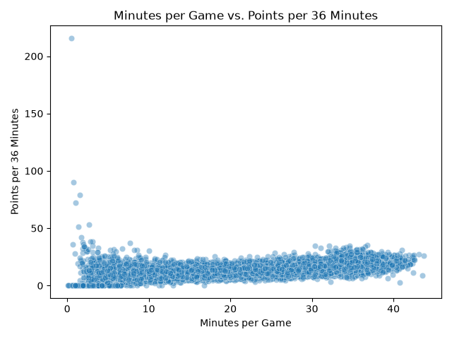
Figure 1. Minutes per game versus points per 36 minutes. Very-low-minute seasons create extreme rate outliers, while scoring production varies substantially at similar playing-time levels.
Additional histograms showed that minutes, usage, and true shooting were concentrated in plausible middle ranges with thinner tails. Usage and PIE were related only imperfectly, reinforcing that a larger offensive role does not guarantee stronger overall performance. Position and draft-pick plots also revealed unequal group sizes, which informed the use of counts and cautious interpretation in the player-characteristic analysis.

Results

Sustainability of Breakout Seasons
Of the 660 breakout seasons with an eligible follow-up, 387 regressed under the study’s definition, 101 sustained between 80% and 100% of their improvement, and 172 improved further. The median overall retention was 68.9%, while the upper quartile began at 101.1%. Thus, the typical breakout lost some of its improvement, but approximately one quarter of players turned the breakout into an additional step forward.
Following-season outcome | Count | Percent
Regressed (<80% retained) | 387 | 58.6%
Sustained (80%–100%) | 101 | 15.3%
Improved further (>100%) | 172 | 26.1%
Sustained or improved | 273 | 41.4%

However, the term regressed should be interpreted carefully. It does not necessarily mean that a player became worse than before the breakout; it means that the player retained less than the selected 80% threshold. A player retaining 70% still preserved most of the original gain but was placed in the regression category because it maintains consistency with the research question.

Interpretation
The distribution of following-season outcomes reveals two contrasting patterns. Most breakout players regress to some degree, potentially because of changes in their role, playing time, health, or team situation. However, a substantial group sustains most of its improvement or improves even further, suggesting that some breakouts reflect lasting skill development and an ability to handle greater responsibility. Breakout sustainability should not be viewed as a simple yes-or-no outcome. A player can regress in the following season while still retaining a meaningful portion of the improvement achieved during the breakout.
The analysis also excludes breakouts without a 500-minute follow-up. Of 808 detected breakouts, 739 had any next-season row and 660 met the follow-up minute cutoff. Consequently, the reported percentages apply to qualifying returners and likely understate career disruption caused by injury, retirement, or leaving the league.

Sensitivity Analysis
At the 80% retention standard, sustainability ranged from 36.9% to 43.3% across the 18 alternative breakout definitions. The baseline estimate of 41.4% fell near the middle of this range. Although the number of detected breakouts varied from 47 to 1,226 under the full set of definitions, no specification classified a majority of eligible breakouts as sustained.
Specification | Breakouts | Eligible follow-ups | Sustainability rate
Baseline: 500 min, 85th percentile, 2 dimensions | 808 | 660 | 41.4%
750-minute cutoff | 689 | 571 | 42.0%
1,000-minute cutoff | 581 | 465 | 43.0%
80th-percentile breakout threshold | 1,226 | 1,012 | 41.7%
90th-percentile breakout threshold | 440 | 358 | 42.5%
At least 3 qualifying dimensions | 153 | 130 | 36.9%
Table 2. Selected one-at-a-time sensitivity comparisons using the 80% retention standard.
Changing the minute or percentile threshold substantially altered the number of players labeled as breakouts but changed the sustainability rate by only a few percentage points. Requiring three improved dimensions produced fewer breakouts and a lower sustainability rate, so broader improvement was not necessarily more persistent. Using the baseline breakout definition, the sustainability rate was 48.5% under a 70% retention standard, 41.4% under the primary 80% standard, and 33.5% under a 90% standard. The exact percentage therefore depends on where sustainability is defined, but the central finding remains stable under the primary 80% criterion.

Persistence by Performance Dimension
Scoring and playmaking were the most persistent individual dimensions. Median retention was 74.9% for PTS/36 and 73.8% for AST%, compared with 65.6% for TS% and 57.1% for REB%. Playmaking had the highest rate of further improvement (36.3%), while rebounding had the lowest percentage retaining at least 80% (33.8%).
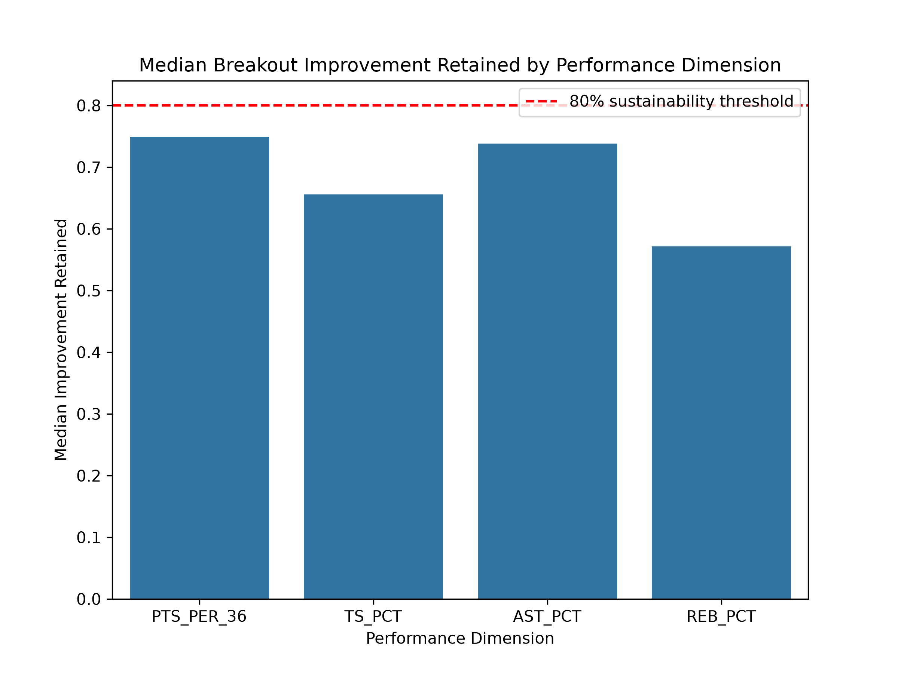
Figure 2. Median improvement retained by qualifying dimension. The dashed line marks the 80% sustainability threshold; no dimension reached it at the median.
These results suggest that improvements in offensive creation (scoring and playmaking) may be more durable than improvements in rebounding rate. Scoring and playmaking can reflect expanded skill and responsibility, whereas rebounding changes may depend more heavily on lineup role, teammates, and where a player is positioned on the floor. Efficiency also regressed more than scoring volume, consistent with shooting percentages being sensitive to year-to-year variation.

Breakout Profiles and Breadth
The strongest common profile combined scoring, playmaking, and rebounding: its median retention was 82.8% and 51.7% of its 29 observations sustained or improved. The larger scoring-plus-playmaking profile also performed relatively well, with 76.1% median retention and a 46.4% sustainability rate across 140 observations.
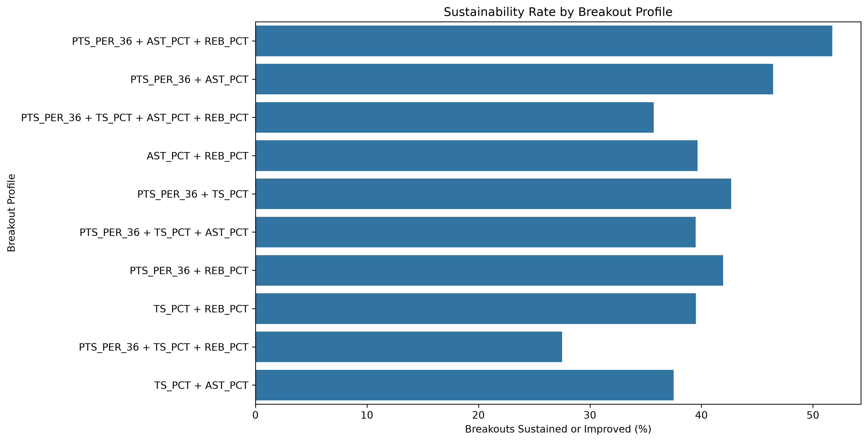
Figure 3. Sustainability rate for breakout profiles represented by at least ten eligible observations. Scoring-plus-playmaking profiles rank among the strongest combinations.
Breadth of dimensions alone did not improve persistence though. Two-dimensional breakouts sustained or improved 42.5% of the time, compared with 37.1% for three dimensions and 35.7% for four. The four-dimensional group contained only 14 observations, so its rate is imprecise. Overall, the composition of improvement was more informative than the number of qualifying dimensions.

Player Characteristics and Sustainability
Age and prior NBA experience showed the strongest relationships with sustainability. Players age 22 or younger sustained or improved 60.6% of the time, declining to 46.6% at ages 23–25, 38.1% at ages 26–28, and 22.0% at age 29 or older. The corresponding median-retention values fell from 88.4% to 48.9%.
Experience followed a similar gradient: players with 0–2 years sustained or improved 53.9% of the time, compared with 42.8% for 3–5 years and 24.4% for 6 or more years. Because age and experience are closely related, they should be interpreted as overlapping measures of career stage rather than independent causal effects.
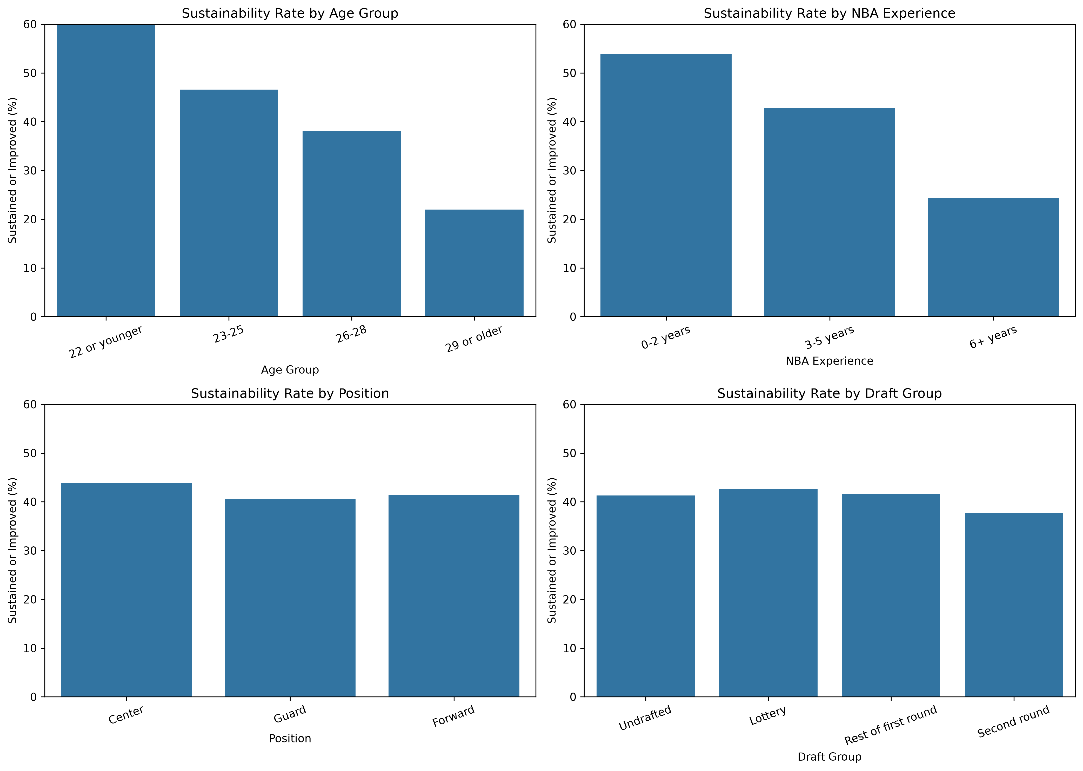
Figure 4. Sustainability rates by age, NBA experience, primary position, and draft group. Career-stage differences are much larger than position or draft-group differences.
Position produced little separation: centers, forwards, and guards sustained or improved at rates between 40.5% and 43.8%. Draft groups were also similar, ranging from 37.7% for second-round picks to 42.7% for lottery picks; undrafted players reached 41.3%. Median height was 79 inches in every outcome category, and median weights differed by only seven pounds. Career stage therefore appears substantially more informative than physical profile or original draft status.

Impact and Limitations

Potential Impact
The findings may help fans, analysts, and team decision-makers understand breakout seasons more realistically. Recent improvement should not automatically be projected forward: fewer than half of qualifying returners retained at least 80%. At the same time, younger players and breakouts involving scoring plus playmaking deserve greater attention because those patterns were more persistent historically. These findings should be treated as contextual evidence rather than deterministic forecasts.

Limitations
First, the 500-minute cutoff, 85th-percentile threshold, two-dimension rule, and 80% retention boundary are defensible but not uniquely correct. The sensitivity analysis showed that the number of detected breakouts was highly definition-dependent. However, using an 80% retention standard, every tested breakout definition produced a sustainability rate below 50%, ranging from 36.9% to 43.3%. This supports the central conclusion while showing that the exact rate and the identities of classified players remain sensitive to threshold selection. The tested grid does not prove that one definition is uniquely valid.
Second, the retention ratio can become extreme when the original improvement is small. Restricting calculations to dimensions above the 85th percentile reduces this concern, and medians reduce the influence of outliers, but the ratio remains imperfect. Third, the study is observational. Age, experience, and breakout profile are associated with sustainability, but these relationships should not be interpreted as causal. Injuries, team changes, coaching systems, lineup role, and contract incentives are not modeled.
Fourth, the follow-up cutoff creates survivorship selection. Players without a next-season row or with fewer than 500 minutes are excluded rather than classified as unsuccessful. This prevents injury and retirement from being mislabeled as performance regression, but it means the results do not represent every detected breakout. Fifth, traded players are represented by one aggregated season row whose team abbreviation reflects the final team, so within-season effects regarding the team cannot be separated.
Finally, the dataset ends in 2022–23 and does not include defense or an all-in-one metric in the final trigger. Physical and draft information may also be incomplete for some historical players. The results should therefore be used to describe historical patterns among eligible player-seasons, not to make deterministic forecasts about a particular athlete.

Data and Code Availability
The source data, analysis code, generated summaries, and visualization files are available in the project repository.
GitHub Repository: github.com/sidharthshyam/nba-breakout-project

References and Research Transparency
Brescou, Thomas. NBA Statistics Repository. GitHub, https://github.com/Brescou/NBA-dataset-stats-player-team. Raw traditional, advanced, usage, and player-index CSV files were used for this project.
Software documentation consulted included the pandas documentation for merging, grouping, ranking, and missing values; the Matplotlib and seaborn documentation for programmatic visualizations; the Python documentation for file execution and testing; and the Plotly documentation for interactive visualization. ChatGPT was used for package-installation guidance, code organization, and debugging assistance. The author reviewed and tested the resulting code and is responsible for the analysis and interpretation.
The study was completed independently by the author.

