Encoder / Decoder
Description of Module Functionality
A convolutional code encoder of constraint length 4, traceback depth 16 and generator polynomials 12_{o} and 15_{o} was used. It takes clock and reset inputs since it uses registers and sequential logic to shift bits and apply convolution. The data input is a single bit input from serialized data. The convolutional code is applied by sending the current bit and subsequent bits through registers and applying the generator polynomials on each clock cycle. The resulting output is two encoded bits, which are separated into two bit streams, an odd-position bit stream, and an even-position bit stream, which are fed into the modulator. Upon sending out its first outputs, the encode_valid signal is held high for the duration of the system being on in order to signal to the receiver and transmitter to accept input.
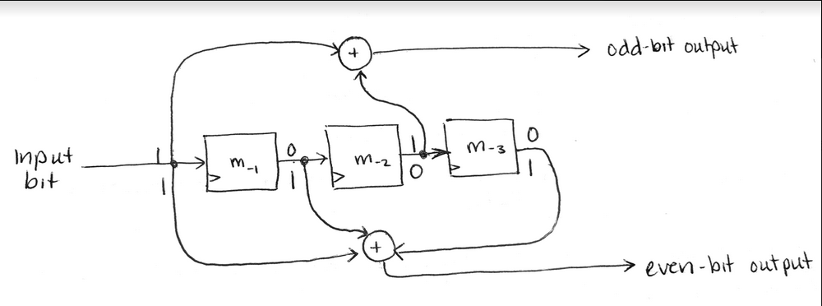
Upon returning from the channel, the Viterbi decoder receives the odd-position and even-position bits from the demodulator as inputs. It also takes clk and reset since it uses sequential logic. The Viterbi decoder used in the implementation was generated from the HDL Coder and requires multiple additional modules and submodules due to its complexity. It does add additional delay into the system due to the traceback depth requiring recursion. The Viterbi decoder uses recursion and a trellis structure to determine flipped or missing bits to reconstruct the correct signal. The output of the Viterbi decoder is a single bit that is fed through the deserializer to reconstruct the 8-bit sample frame. Upon outputting its first output, the decode_valid signal is changed to high and held at high for the remainder of the system being on.
Testing Strategy
The testbench tests both the encoder and decoder modules to check that the input into the encoder matches the output of the decoder. The testbench was also used to determine the delay in the system caused by the Viterbi decoder so that a delay module could be created with the appropriate delay. Random bit inputs were generated to check if the input matched the output with the appropriate delay. Around 200 trials were conducted to ensure the modules worked as expected.
