Modulator / Demodulator
Description of Module Functionality:
The modulator takes in 2 bits from the encoder. One bit is from the odd-positioned bitstream and the other is from the even-positioned bitstream. The modulator checks the values of the two bits (odd is in the MSB position and even is in the LSB position), and outputs the appropriate symbol for that bit combination using a LUT.
The outputs of the modulator are a real and an imaginary number of 16-bit signed fixed data type to match the expected data type for sending the signal in the channel.
The QPSK symbols are Grey coded, and at positions of pi/4, 3pi/4, 5pi/4 and 7pi/4 around the unit circle. Given the position on the unit circle, the real and imaginary values that make up the rectangular coordinates of the symbols are all of equal magnitude at sqrt(2)/2. Thus, the signed fixed 16-bit representation consists of only two values: -sqrt(2)/2 and sqrt(2)/2.
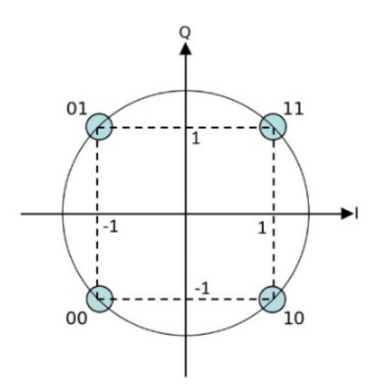
Due to the real and imaginary parts of the symbol being of equal magnitude, the real and imaginary symbol parts can be separated and are therefore outputted in separate streams in parallel out of the modulator.

The demodulator receives from the receiver an approximation of the real and imaginary symbols following pulse shaping and noise disturbances in the channel.
The demodulator uses comparators to determine if the received symbol is less than, greater than, or equal to zero, and maps the received symbols back to the pre-defined four QPSK symbols to reconstruct the signal. From the mapped symbol, the demodulator converts the symbol back into its 2-bit equivalents.

Testing Strategy:
Tested the input of the modulator and the output of the demodulator to compare if the output matches the input.
Initially tested the four known 2-bit inputs for given symbols to verify that the two bits are correctly recovered.
For the remaining tests, tested that any random combination of 2 bits is recovered as expected when going through modulation and demodulation
