B. Tech. PROJECT REPORT (Mid-Semester Evaluation)

EXPLAINABLE DEEP LEARNING FRAMEWORK FOR AUTOMATED ECG ARRHYTHMIA DETECTION AND CLASSIFICATION

Submitted by:

SIDHESH MAHESH TAVARE (2314037)
NIKHIL KUMAR SINGH (2314055)

Under the Guidance of :
DR. ARNAB NANDI



DEPARTMENT OF ELECTRONICS AND COMMUNICATION ENGINEERING

NATIONAL INSTITUTE OF TECHNOLOGY SILCHAR, ASSAM (INDIA)-788010

Abstract
Deep learning models for automated electrocardiogram (ECG) arrhythmia classification frequently report accuracies above 98%, yet published evidence shows that these figures fall considerably when models are evaluated on patients not seen during training, on external databases, or on noisy signals, and that the explanations attached to such models are rarely validated against clinical ECG knowledge [1], [2], [3]. This project aims to develop an explainable deep learning framework for automated ECG arrhythmia detection and classification that addresses these issues together.
The project has three objectives:
- To develop a hybrid deep learning classifier evaluated under a strict inter-patient protocol on the MIT-BIH Arrhythmia Database with external testing on a second database
- To apply and evaluate explainable AI (XAI) methods, such as SHAP and Grad-CAM, by measuring the consistency of explanations and their agreement with recognised ECG features
- To assess how classification performance and explanation stability degrade under realistic noise from the MIT-BIH Noise Stress Test Database, using uncertainty estimates to flag unreliable predictions.
The expected outcomes are a patient-independent arrhythmia classifier with per-class and macro-averaged results, a quantitative evaluation of explanation quality, and a robustness analysis of both predictions and explanations under noise.
Up to the mid-semester evaluation, a working training, evaluation and Grad-CAM pipeline has been built and tested on the pre-segmented MIT-BIH heartbeat dataset of Kachuee et al. [35] (five AAMI classes, intra-patient split). A baseline 1D convolutional neural network reached 94.41% accuracy but only 76.29% macro F1, because of very low precision on the rare Fusion (26.0%) and supraventricular (55.9%) classes.
Five step-by-step changes were then tested; selecting the epoch on validation macro F1, using softer (square-root) class weights and a residual network gave the largest gains, and the final model reached 98.41% accuracy and 91.10% macro F1 on the same 21,892-beat test set. Grad-CAM heatmaps were produced for every class. These results are intra-patient and are therefore treated as a development baseline for the patient-independent framework.

Introduction
Background and Motivation
The ECG is a widely used non-invasive tool for detecting cardiac arrhythmias, and automating its interpretation is an active research area. Deep learning has therefore been widely applied to automated arrhythmia classification: convolutional neural networks (CNNs) are used in 58.7% of 368 studies reviewed by Xiao et al. [1] and in 62% of 119 studies reviewed by Kulkarni et al. [2], with hybrid CNN-recurrent and Transformer-based models increasingly common [1], [2].
Significance of the Problem
Three issues limit the clinical usefulness of current models. First, reported performance depends heavily on the evaluation protocol: in studies reporting both paradigms, F1 fell from 95.52% under intra-patient evaluation to 83.89% under inter-patient evaluation [1], and only 30.3% of 122 reviewed articles followed the inter-patient paradigm [4]. Second, deep models are often regarded as black boxes, and although SHAP and saliency methods are increasingly used, fewer than 10% of studies validated explanation maps against clinically meaningful ECG structures [2]. Third, robustness to realistic noise is tested narrowly, often with additive white Gaussian noise only [5].
Problem Statement
There is a need for an ECG arrhythmia classification framework whose performance is measured on unseen patients, whose explanations are checked for consistency and clinical plausibility, and whose predictions and explanations are evaluated for robustness under realistic noise.
Objectives
• Objective 1 – Patient-independent baseline: develop a hybrid deep learning arrhythmia classifier evaluated under a strict inter-patient protocol (MIT-BIH DS1/DS2) with external testing on a second database, reporting per-class and macro F1 alongside accuracy.
• Objective 2 – Validated explanations: apply post-hoc XAI methods (e.g. SHAP and Grad-CAM) to the patient-independent model and measure the within-class consistency of explanations and their agreement with recognised ECG features (P wave, QRS complex, RR interval).
• Objective 3 – Robustness of predictions and explanations: assess how classification performance and explanation stability degrade under realistic NSTDB noise (baseline wander, muscle artefact, electrode motion) at graded SNRs, using uncertainty estimates to flag unreliable predictions.

Literature Review
A literature survey of 36 papers (5 reviews and 31 original studies) on deep learning and explainable AI for ECG arrhythmia classification was carried out. The findings are grouped into four themes below.
Architectures
CNNs remain the dominant architecture for ECG arrhythmia classification [6], [7], [1], [2], but hybrid designs pairing a convolutional front end with a recurrent or attention module for temporal context are increasingly common, including CNN-LSTM [8], [9], [10], CNN-BiLSTM [11], [12], multi-scale CNN-BiLSTM [13] and dual-branch BiLSTM/capsule fusion [5]. Transformers are the newest development, including bidirectional Transformers [14], [15], CNN-BERT hybrids [16], Stockwell-transform CNN-Transformers [17] and LLM-assisted models using patient age and sex [18]. Meta-regression attributes a gain of 0.845% to attention/Transformer models over 1D-CNNs, at increased cost beyond about 1 M parameters [2]. Lightweight designs remain competitive: a 0.16 MB CNN-LSTM ran at 5.127 ms per rhythm on a Raspberry Pi [8], and a 165,061-parameter spatio-temporal CNN reached a macro AUC of 93.41% on PTB-XL [19]. Graph networks [20] and interpretable handcrafted features with XGBoost [21] offer alternatives.

Explainable AI Methods
SHAP is the most widely used explanation method in the surveyed papers [8], [3], [21], [22], [23], [24], [19], followed by Grad-CAM [25], [18] and class activation maps [17]. Generative counterfactual ECGs captured rhythm irregularity and beat-to-beat variability that saliency maps missed [26]. Several studies report clinically plausible explanations, such as absent P waves and wide QRS complexes [8], slurred S waves for RBBB [19] and the PR interval for first-degree AV block [21]. However, Beck and John found that explanations for APB and PVC beats were inconsistent within a class and had not been validated by medical professionals, and they removed the LSTM from their model because it hampered the XAI methods; all five clinicians surveyed preferred saliency maps over counterfactuals [3]. Fewer than 10% of studies validated explanation maps against clinically meaningful ECG structures [2].

Datasets and Evaluation
The MIT-BIH Arrhythmia Database dominates the field, used in 61% [1] and 78.7% [4] of reviewed studies, while PTB-XL is the main 12-lead benchmark [18], [27], [19], [28]. Evaluation protocol strongly affects reported results: F1 fell from 95.52% (intra-patient) to 83.89% (inter-patient) in studies reporting both [1], and a single study reported 99.00% accuracy on a beat-wise split but 91.69% on a patient-wise split, with Fusion recall of only 0.021 [11]. Only 4.1% of 122 reviewed articles met all of the AAMI, inter-patient, MIT-BIH and embedded-feasibility criteria [4]. External validation was performed in only 18.5% of studies, with a mean accuracy drop of 8.7% [2]; performance was about 16% lower on external data in [21] and more than 20% lower when a second dataset was added in [3].

Robustness
Robustness testing is uneven. Hassoon et al. tested only additive white Gaussian noise, with F1 falling to 32.46% at 5 dB [5]; Tenepalli and Navamani did not test under noise [25]; and Huang et al. state that performance on wearable signals with motion artefacts has not been verified [15]. Ashhad et al. showed that Dempster-Shafer uncertainty-aware fusion was more robust than score- or feature-level fusion under NSTDB baseline wander, muscle artefact and electrode motion noise from 15 to 0 dB [30]. Denoising front ends include wavelet methods [12], [13], [15], adaptive LMS filtering [31] and a Jacobian-regularised denoising autoencoder not yet validated for diagnosis [32]. Rejecting high-uncertainty predictions raised macro F1 from 0.6635 to 0.8688, and cardiologists attributed most high-uncertainty cases to noise [33].

Comparison of Key Studies
Table 1 compares the eight surveyed papers most relevant to this project.
Table 1: Comparison of the eight most relevant surveyed studies
Ref. | Dataset(s) | Model | XAI | Split | Key result
[8] | MIT-BIH + LTAF | Lightweight CNN-LSTM | SHAP | Not stated (85/15) | Acc 98.24%, Se 86.1%; 0.16 MB
[3] | MIT-BIH + 12-lead (Zheng et al.) | 1D CNN | 4 SHAP variants | Not stated (80/20) | Val acc 98.30%; 73.45% on combined data
[29] | MIT-BIH; Chapman-Shaoxing | Adversarial SE-ResNet | Not stated | Inter-patient | AFib F1 77.9% vs 61.0%
[5] | MIT-BIH; INCART, SVDB, PTB | CNN-BiLSTM + CapsNet fusion | Branch weights | Inter-patient | Acc 99.55%; F1 32.46% at 5 dB AWGN
[11] | MIT-BIH | CNN-BiLSTM + cGAN | Not stated | Both | 99.00% beat-wise vs 91.69% patient-wise
[30] | MIT-BIH; INCART; NSTDB | BiLSTM + ViT, D-S fusion | Not stated | Not stated (80/20) | Acc 98.8%; robust 15–0 dB noise

Research Gaps
• Gap 1 – Explanations are rarely validated and often inconsistent: SHAP and Grad-CAM are widely applied [8], [21], [22], [25], [24], but fewer than 10% of studies validated explanation maps against clinical ECG structures [2], explanations were inconsistent within a class [3], and only a few studies involved clinical review of highlighted features [19], [26].
• Gap 2 – Explainability is seldom combined with patient-independent evaluation: several XAI studies do not describe patient separation in their splits [8], [3], [22], [25], although inter-patient evaluation substantially lowers performance [1], [11] and is used by only 30.3% of reviewed studies [4]; strong inter-patient studies often include no XAI [29], [11], [12].
• Gap 3 – Robustness to realistic noise is tested narrowly and is not linked to explanations: noise tests are limited to AWGN [5] or Gaussian noise [13], or are absent [25], [15]; NSTDB-based robustness work [30] and denoising work [32] include no explanation analysis; none of the surveyed papers tests whether explanations remain stable under noise, although noise is a main source of predictive uncertainty [33].
• Gap 4 – Minority classes and external generalisation remain weak: patient-wise Fusion and S recall were only 0.021 and 0.209 [11]; the F and S classes remain hardest in [14], [9], [34], [15]; and only 18.5% of studies validate externally, with a mean accuracy drop of 8.7% [2].

Methodology / Proposed Work

The proposed framework follows directly from the three objectives. It consists of the stages below and is summarised in Figure 1. Choices that were tested in the preliminary experiments are noted in each subsection; the experiments themselves are described in the next chapter.
Block Diagram
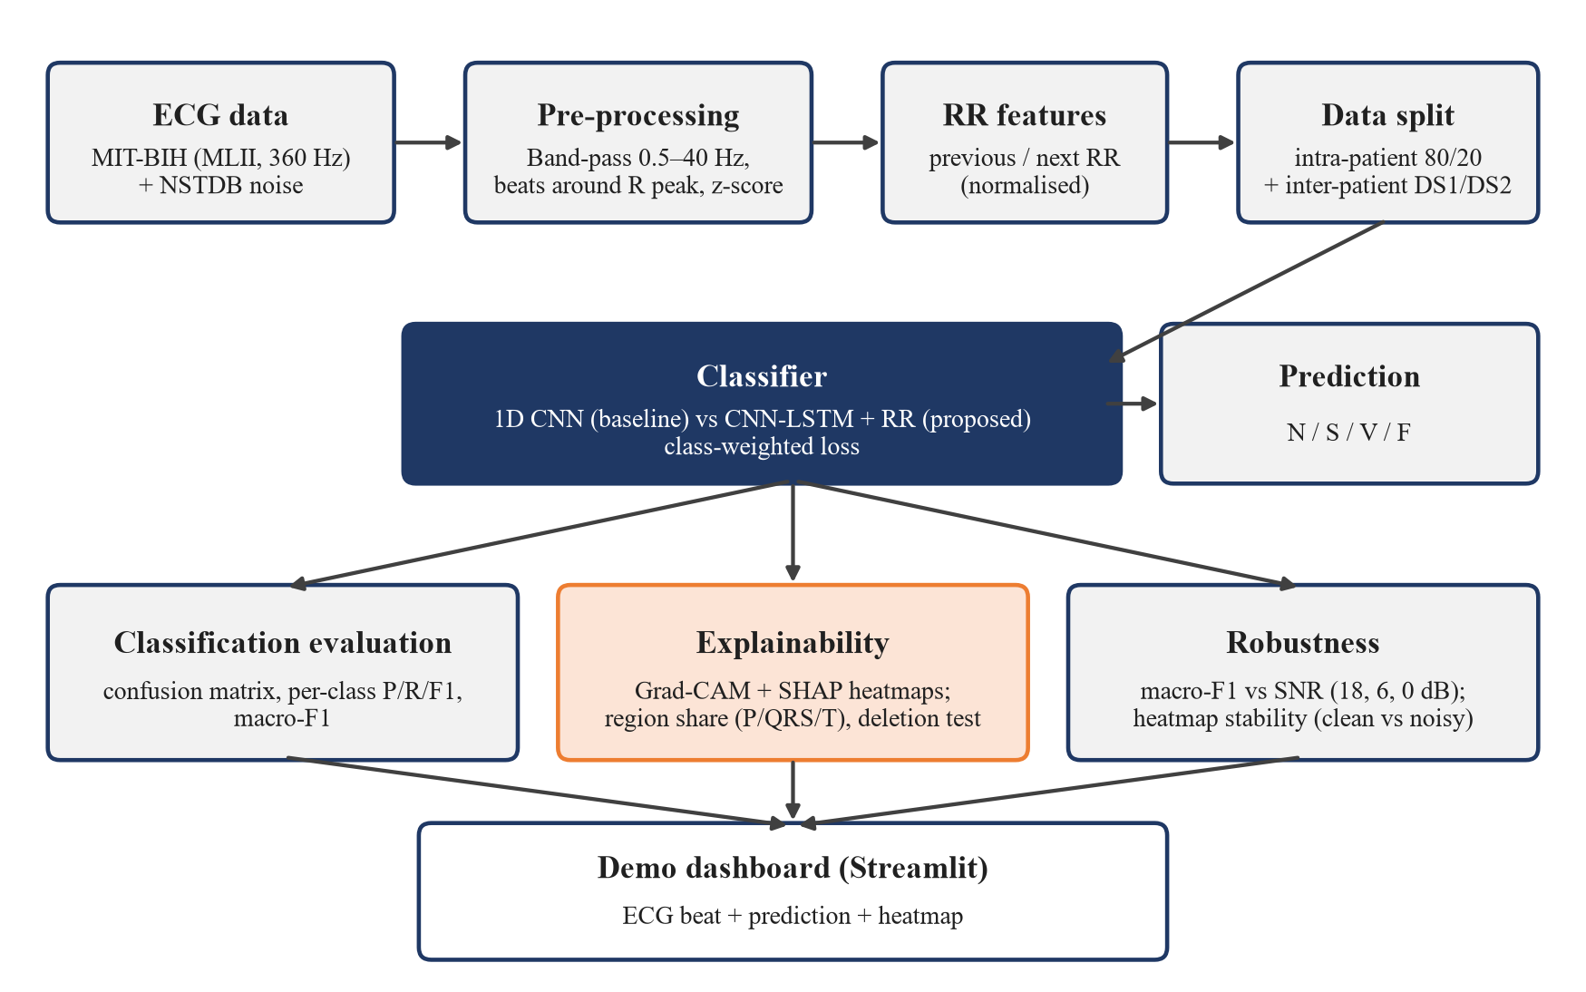
Figure 1: Block diagram of the proposed framework
Datasets
• MIT-BIH Arrhythmia Database with AAMI classes N, S, V, F, Q and the inter-patient DS1/DS2 split (Objective 1).
• An external database for cross-database testing, such as INCART or PTB-XL, both used in the surveyed literature [5], [12], [19], [15]. The INCART database is the preferred candidate because, like MIT-BIH, it provides beat-level annotations; external testing is treated as a stretch goal and is otherwise listed as future work.
• MIT-BIH Noise Stress Test Database (baseline wander, muscle artefact, electrode motion) for robustness tests (Objective 3), as used in [30].

Classification Model
A hybrid model combining a convolutional front end with a recurrent or attention module for temporal context, a design family that a recent systematic review judged the most clinically translatable [2]. Class imbalance will be handled on the training partition only.
• Baseline: a 1D CNN with three convolutional blocks (32, 64 and 128 filters, kernel sizes 7, 5 and 3; each followed by batch normalisation, ReLU and max-pooling), global average pooling, a 64-unit dense layer and a softmax output (about 44,700 parameters). This network has already been implemented and trained (next chapter).
• Proposed: the same convolutional front end followed by an LSTM layer with 64 units; its last hidden state is concatenated with the previous and next RR intervals (each divided by the record's mean RR) before a 64-unit dense layer and a softmax over N, S, V and F. A residual CNN, which gave the best preliminary results, will be kept as an additional comparison model.
• Class imbalance: class-weighted cross-entropy on the training partition only. The preliminary experiments showed that fully balanced weights (F:N weight ratio 113:1) caused many false Fusion predictions, while square-root-balanced weights (10.6:1) gave the best results, so square-root weights are used.
• Training: Adam optimiser, batch size 128, at most 30 epochs, with the best epoch chosen on validation macro F1 rather than validation loss (this alone raised test macro F1 from 76.29% to 83.96% in the preliminary experiments). The learning rate will be tuned on the validation set.
Explainability
Post-hoc XAI methods (e.g. SHAP and Grad-CAM) will be applied. Explanations will be evaluated for within-class consistency and for agreement with recognised ECG features such as the P wave, QRS complex and RR interval. The two methods are Grad-CAM [37], already implemented for the preliminary models, and Gradient SHAP [38]. Three measures will be used:
• Region share: the share of total absolute attribution that falls in fixed windows around the R peak: P wave [−250, −80] ms, QRS complex [−50, +50] ms and T wave [+100, +400] ms, averaged per class.
• Deletion test: the 10% of samples with the highest attribution are set to zero and the drop in the predicted class probability is compared with the drop when 10% of samples are removed at random. A faithful map should give a much larger drop.
• Stability: the Pearson correlation between the attribution map of a clean beat and of the same beat with noise added (used in the robustness study).
Robustness and Uncertainty
Classification metrics and explanation stability will be measured as NSTDB noise is added at graded SNR levels. Uncertainty estimates (for example Monte Carlo dropout, as in [33]) will be used to flag unreliable predictions. The muscle-artefact ('ma') record of the NSTDB will be scaled and added to the test beats at SNR = 18, 6 and 0 dB, where SNR = 10·log10(P_signal / P_noise), and macro F1 will be plotted against SNR for both models. Monte Carlo dropout is the planned uncertainty method if time permits; otherwise it is listed as future work.
Evaluation Metrics
Accuracy, per-class precision, recall and F1, and macro F1 will be reported, since overall accuracy alone can hide poor minority-class performance [1].
Tools
Python 3 with TensorFlow 2.20 / Keras for model building and training; NumPy and pandas for data handling; scikit-learn for data splits, class weights and metrics; Matplotlib and seaborn for figures; the wfdb package for reading the PhysioNet MIT-BIH and NSTDB records; the SHAP library for SHAP attributions; and Streamlit for the demonstration dashboard. Experiments are run on Kaggle notebooks with an NVIDIA Tesla T4 GPU.

Work Done Till Mid-Semester

The work completed up to the mid-semester evaluation covers the literature survey, the design of the framework and two rounds of preliminary experiments, referred to as V1 (baseline) and V2 (step-by-step improvements). Both were run as Kaggle notebooks.
Completed Tasks
• Literature survey of deep learning and XAI methods for ECG arrhythmia classification, and identification of the research gaps (Literature Review chapter).
• Design of the framework: AAMI class mapping, intra- and inter-patient (DS1/DS2) evaluation protocols, explanation metrics and noise test settings (Methodology chapter).
• V1: a baseline 1D CNN with a class-weighted loss, full test-set evaluation (accuracy, per-class precision / recall / F1, macro F1, confusion matrix) and Grad-CAM heatmaps for each class.
• V2: five controlled improvement experiments (E1–E5) and validation-based threshold tuning, raising test macro F1 from 76.29% to 91.10%, followed by Grad-CAM on the final model.
Dataset Used in the Preliminary Experiments
To develop and debug the pipeline before building our own pre-processing, the preliminary experiments use the pre-segmented MIT-BIH heartbeat dataset published by Kachuee et al. [35]. Each beat is 187 samples long (1.5 s at 125 Hz), scaled to [0, 1] and zero-padded, and is labelled with one of five AAMI classes (N, S, V, F, Q). The provided training file (87,554 beats) was split 80/20 with stratification (random seed 42) into training (70,043) and validation (17,511) sets; the provided test file (21,892 beats) was used only for final evaluation. Table 2 shows the strong class imbalance: a model that always predicts N would already exceed 80% accuracy, so macro F1 is the main metric. Because this split is by beat, the same patients appear in training and test data, so all preliminary results are intra-patient results.
Table 2: Class distribution of the dataset used in the preliminary experiments [35]
Class | Training file | % | Test file | %
N – Normal | 72,471 | 82.77 | 18,118 | 82.76
S – Supraventricular ectopic | 2,223 | 2.54 | 556 | 2.54
V – Ventricular ectopic | 5,788 | 6.61 | 1,448 | 6.61
F – Fusion | 641 | 0.73 | 162 | 0.74
Q – Unknown / paced | 6,431 | 7.35 | 1,608 | 7.35
Total | 87,554 | 100 | 21,892 | 100

The split used in all preliminary experiments is summarised in Table 3. After the stratified split, the training portion contains 57,977 N, 1,778 S, 4,630 V, 513 F and 5,145 Q beats. Figure 2 shows the class counts and Figure 3 one example beat of each class. Every beat starts at its R peak, contains a second large peak later in the window (most likely the next R peak) and is then zero-padded to 187 samples. The notebooks perform no filtering or segmentation of their own; this was done by the dataset authors [35].
Table 3: Data split used in the preliminary experiments
Set | Beats | Input shape | Source | Used for
Training | 70,043 | (187, 1) | 80% of training file (stratified, seed 42) | Fitting the weights
Validation | 17,511 | (187, 1) | 20% of training file | Epoch, model and threshold selection
Test | 21,892 | (187, 1) | Provided test file | Final evaluation only

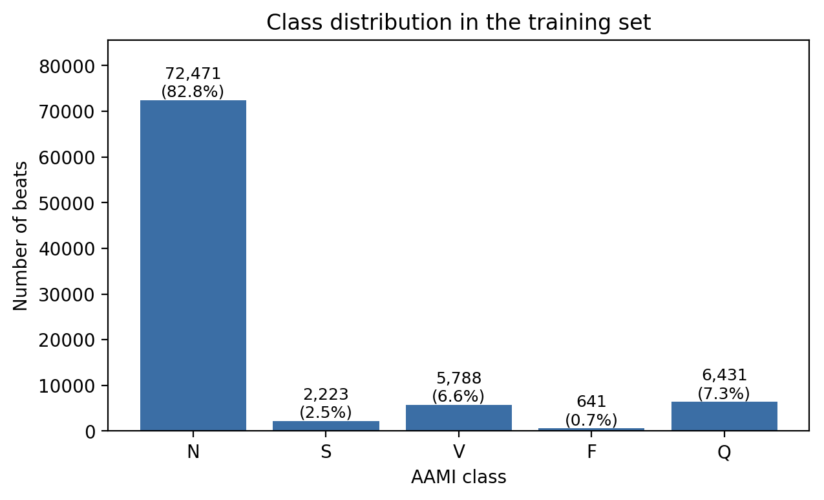
Figure 2: Class distribution of the training file (N ≈ 83%, F < 1%)
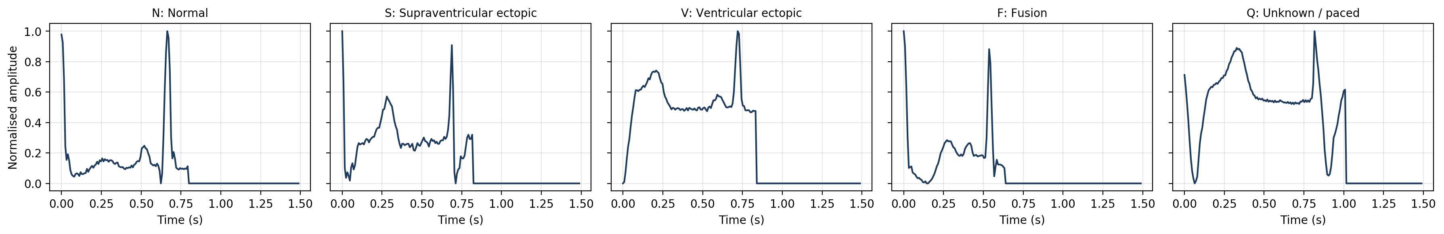
Figure 3: One example beat of each class (187 samples, 125 Hz, zero-padded)
V1: Baseline 1D CNN
Table 4 lists the layers of the baseline network and Table 5 its training settings.
Table 4: Architecture of the baseline 1D CNN
Layer | Output shape | Parameters
Input (one beat) | (187, 1) | 0
Conv1D 32, k = 7 → BN → ReLU → MaxPool 2 | (93, 32) | 256 + 128
Conv1D 64, k = 5 → BN → ReLU → MaxPool 2 | (46, 64) | 10,304 + 256
Conv1D 128, k = 3 → BN → ReLU (Grad-CAM layer) → MaxPool 2 | (23, 128) | 24,704 + 512
Global average pooling | (128) | 0
Dense 64, ReLU → Dropout 0.3 | (64) | 8,256
Dense 5, softmax | (5) | 325
Total (trainable / non-trainable) |  | 44,741 (44,293 / 448)

Table 5: Training settings of the V1 baseline
Setting | Value
Optimiser / learning rate | Adam, 10⁻³
Loss | Sparse categorical cross-entropy with balanced class weights
Class weights (N, S, V, F, Q) | 0.24, 7.88, 3.03, 27.31, 2.72 (F:N ≈ 113:1)
Batch size / maximum epochs | 128 / 30
Early stopping | Validation loss, patience 6, best weights restored
Learning-rate schedule | ReduceLROnPlateau on validation loss, factor 0.5, patience 3, min 10⁻⁵
Augmentation | None
Random seed | 42 (Python, NumPy, TensorFlow)

The baseline is the 1D CNN described in the Methodology chapter (44,741 parameters) with a five-class output. It was trained with the Adam optimiser (learning rate 10⁻³), batch size 128 and fully balanced class weights w_c = N / (K·n_c), which give N a weight of 0.24 and F a weight of 27.31. Early stopping monitored validation loss with a patience of 6 epochs; training stopped after 17 epochs and the weights of epoch 11 were restored. Table 6 gives the test results and Figure 4 the confusion matrix.
Table 6: Test-set results of the V1 baseline 1D CNN
Class | Precision | Recall | F1-score | Test beats
N | 0.9813 | 0.9594 | 0.9702 | 18,118
S | 0.5586 | 0.6691 | 0.6088 | 556
V | 0.8713 | 0.8605 | 0.8659 | 1,448
F | 0.2602 | 0.8642 | 0.4000 | 162
Q | 0.9896 | 0.9502 | 0.9695 | 1,608
Macro average | 0.7322 | 0.8607 | 0.7629 | 21,892

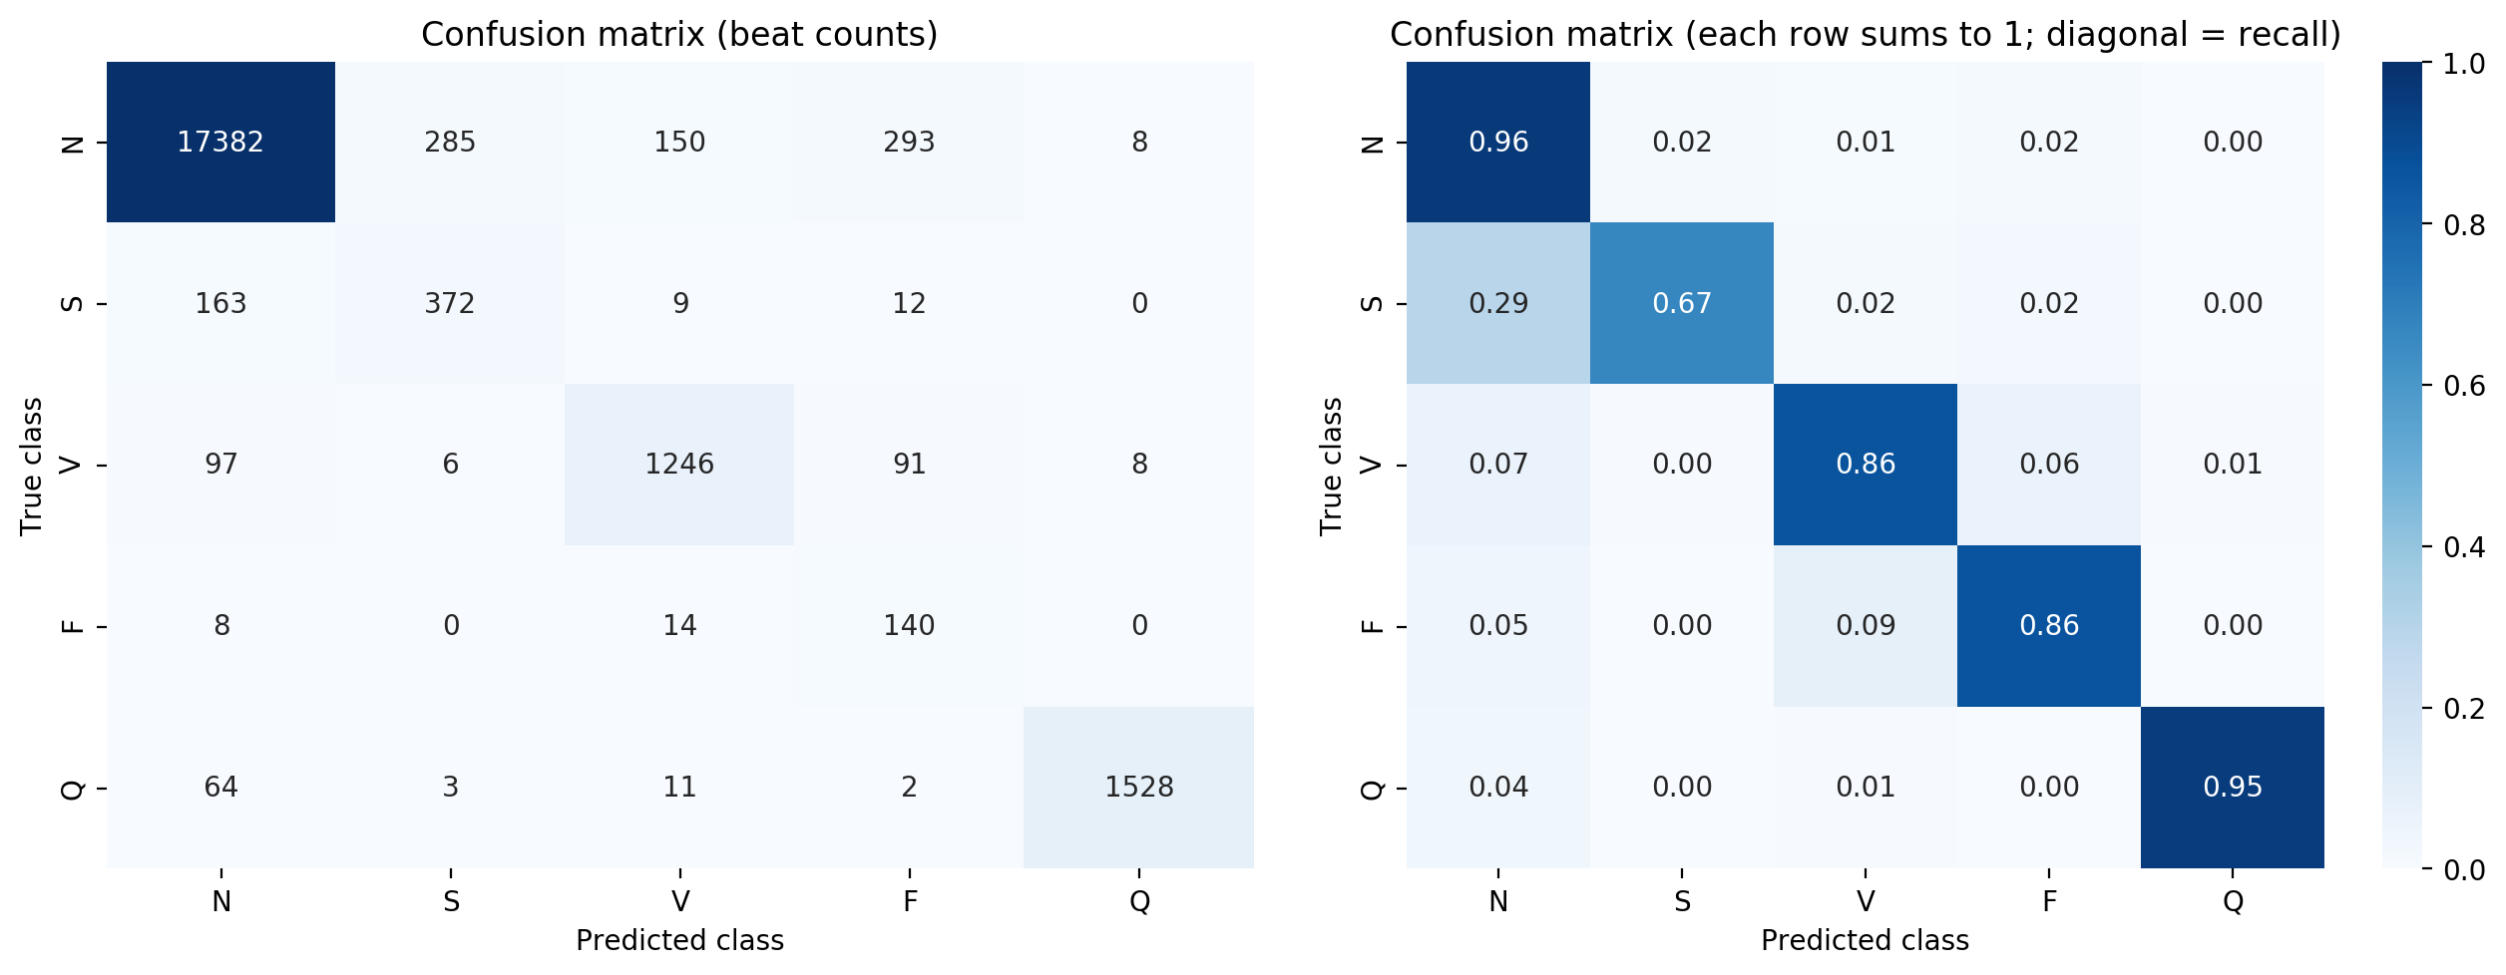
Figure 4: Confusion matrix of the V1 baseline (left: counts; right: row-normalised, diagonal = recall)
The baseline reached 94.41% accuracy but only 76.29% macro F1. Class weighting gave high recall on the rare classes (F recall 86.4%), but at the cost of precision: of the 538 beats predicted as F, only 140 were truly F (293 were N), giving an F precision of 26.0%. The largest error for S was S → N (163 of 556 S beats, 29%). Training was also unstable: validation accuracy jumped between 14.5% and 95.1% from one epoch to the next while training loss fell smoothly.
Figure 5 shows the training curves. Training loss fell smoothly from 0.706 to 0.175 and training accuracy was still rising (90.93% at epoch 17), while validation loss ranged from 0.349 (epoch 11, the restored epoch) to 4.29 (epoch 2). This gap between training and inference behaviour, rather than overfitting, is what V2 set out to fix. Figure 6 shows the per-class scores: the F and S precision bars are clearly below the recall bars, the typical sign of over-weighting the rare classes. The weighted F1 was 94.98% and macro precision / recall were 73.22% / 86.07%.
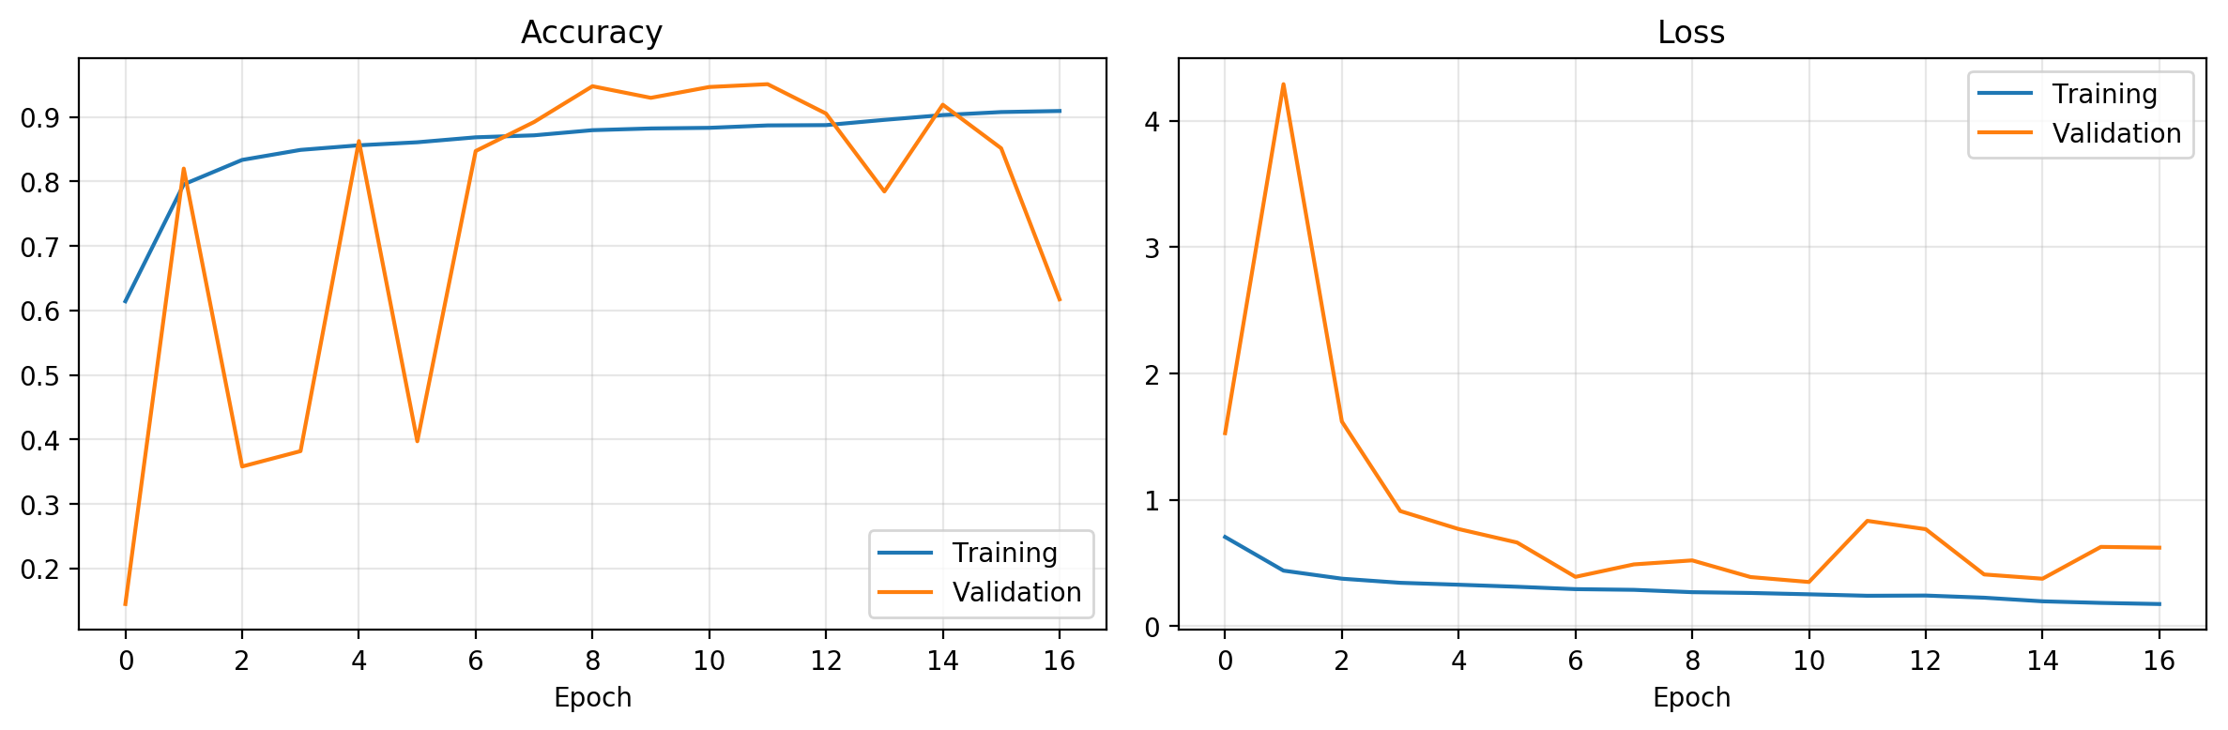
Figure 5: Training and validation accuracy and loss of the V1 baseline (17 epochs; best validation loss at epoch 11)
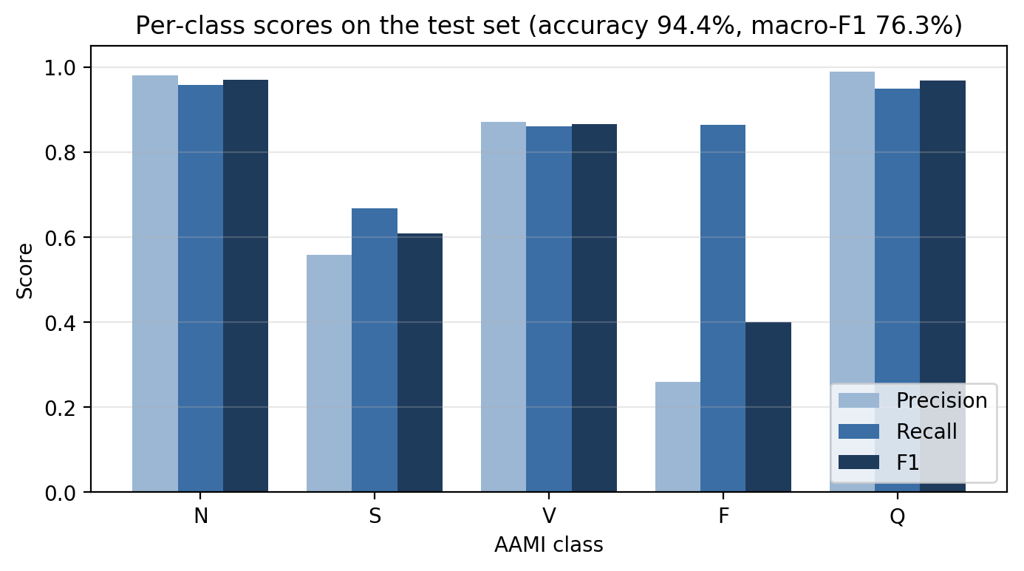
Figure 6: Per-class precision, recall and F1 of the V1 baseline on the test set

V2: Step-by-step Improvements
Each V2 experiment keeps the same data split and seed as V1 and adds one change to the previous experiment, so that the effect of each change can be seen. The test set was never used to choose an epoch, a model or a threshold. The changes were: E1, choose the best epoch by validation macro F1 instead of validation loss; E2, lower learning rate (5×10⁻⁴), gradient clipping (norm 1.0) and batch normalisation momentum 0.9; E3, square-root class weights (F:N ratio 10.6:1 instead of 113:1); E4, light training-time augmentation (amplitude scaling ±10%, Gaussian noise σ = 0.01, time shift ±3 samples); and E5, a residual CNN [36] with three residual blocks (185,477 parameters). Finally, the experiment with the highest validation macro F1 (E5) was selected and per-class probability scale factors were tuned on the validation set; the only factor that changed was N × 3. Table 10 and Figure 11 summarise the results.
Table 7 compares the two class-weighting schemes and Table 8 lists the configuration of every experiment. All experiments use Adam, sparse categorical cross-entropy (with per-sample weights), batch size 128, at most 30 epochs and a custom training loop: after each epoch the validation macro F1 is computed, the best weights are stored, the learning rate is halved after every 3 epochs without improvement (minimum 10⁻⁵) and training stops after 8.
Table 7: Class weights used in the experiments
Class | Training beats | Balanced weight (B0, E1, E2) | Square-root weight (E3–E5)
N | 57,977 | 0.24 | 0.49
S | 1,778 | 7.88 | 2.81
V | 4,630 | 3.03 | 1.74
F | 513 | 27.31 | 5.23
Q | 5,145 | 2.72 | 1.65
F : N ratio |  | 113 : 1 | 10.6 : 1

Table 8: Configuration of the V2 experiments (each keeps all earlier changes)
ID | Network | Params | LR | Clip norm | BN momentum | Class weights | Augment.
E1 | CNN | 44,741 | 1×10⁻³ | – | 0.99 | Balanced | No
E2 | CNN | 44,741 | 5×10⁻⁴ | 1.0 | 0.9 | Balanced | No
E3 | CNN | 44,741 | 5×10⁻⁴ | 1.0 | 0.9 | Square-root | No
E4 | CNN | 44,741 | 5×10⁻⁴ | 1.0 | 0.9 | Square-root | Yes
E5 | Residual CNN | 185,477 | 5×10⁻⁴ | 1.0 | 0.9 | Square-root | Yes

The residual network (E5) uses a Conv1D 32 (k = 7) stem followed by three residual blocks with 32, 64 and 128 filters; each block has two Conv1D (k = 5) + BN layers added to a shortcut (a 1×1 convolution when the channel count changes), then ReLU and max-pooling, and the same pooling and dense head as the baseline. The augmentation of E4 and E5 is applied afresh to every training beat in every epoch: amplitude scaling by U(0.9, 1.1), Gaussian noise (σ = 0.01) added only to the non-padded part, and a time shift of −3 to +3 samples (±24 ms). Figure 7 shows that the augmented copies stay close to the original beat.
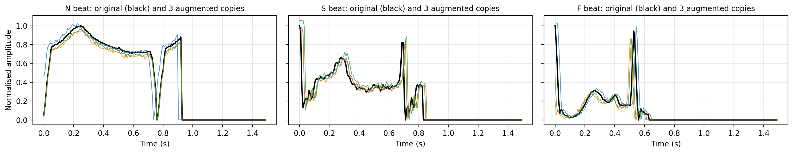
Figure 7: Original and three augmented copies of an N, S and F beats

Table 9: Training runs of the V2 experiments
ID | Best epoch / epochs run | Stopped early | Best val. macro F1 (%) | Δ test macro F1 | Time (s)
E1 | 16 / 24 | Yes | 85.43 | +7.67 (vs B0) | 70
E2 | 28 / 30 | No (cap) | 79.35 | −5.66 | 80
E3 | 23 / 30 | No (cap) | 88.65 | +9.28 | 80
E4 | 25 / 30 | No (cap) | 88.01 | −1.38 | 95
E5 | 18 / 26 | Yes | 93.19 | +4.57 | 158

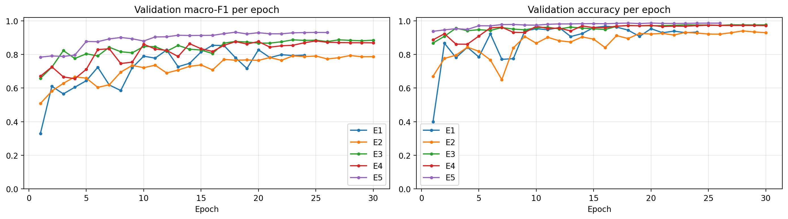
Figure 8: Validation macro F1 and validation accuracy per epoch for E1–E5
Table 9 summarises each training run. Figure 8 shows that E5 trains highest and most smoothly (validation macro F1 0.78 after the first epoch, validation accuracy between 0.94 and 0.99), E1 is the most jagged, and E2 is the lowest; E2, E3 and E4 all reached the 30-epoch cap, so they may be slightly under-trained. All five experiments together took 8.1 minutes on a Tesla T4 GPU.
Table 10: Results of the step-by-step experiments (test set, %)
ID | Change | Acc. | Macro F1 | S F1 | F F1 | Prec. F | Rec. F
B0 | V1 baseline | 94.41 | 76.29 | 60.90 | 40.00 | 26.02 | 86.42
E1 | Epoch chosen on val. macro F1 | 96.28 | 83.96 | 63.48 | 68.12 | 55.95 | 87.04
E2 | + lower LR, clipping, BN 0.9 | 93.58 | 78.30 | 49.13 | 58.49 | 43.73 | 88.27
E3 | + square-root class weights | 97.39 | 87.58 | 69.84 | 76.97 | 75.60 | 78.40
E4 | + light augmentation | 97.02 | 86.20 | 66.16 | 76.25 | 72.63 | 80.25
E5 | + residual network | 98.29 | 90.77 | 81.22 | 78.53 | 78.05 | 79.01
Final | E5 + tuned thresholds | 98.41 | 91.10 | 82.14 | 79.23 | 82.12 | 76.54

Figure 9 plots test macro F1 together with S and F recall for each step, Figure 10 compares test accuracy and macro F1, and Table 11 gives the F1 of every class.

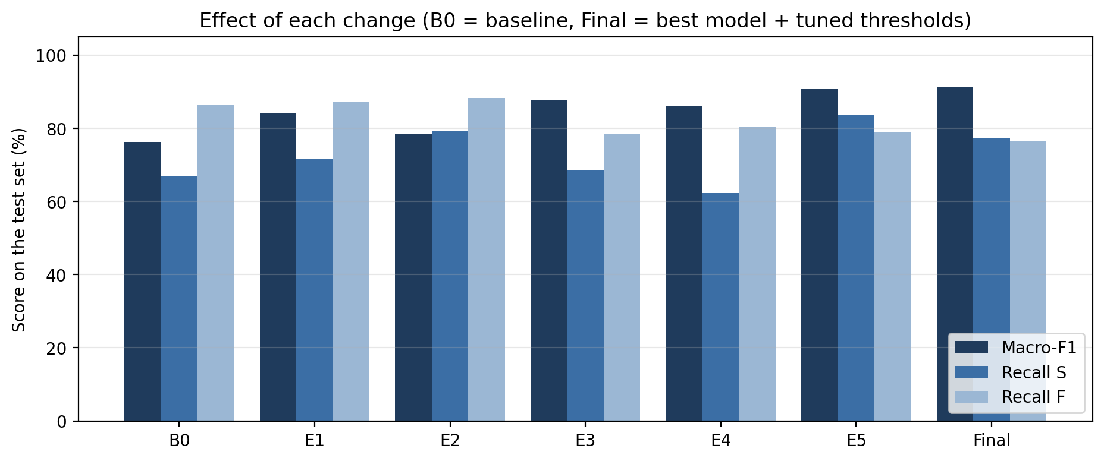
Figure 9: Test macro F1, S recall and F recall for each step
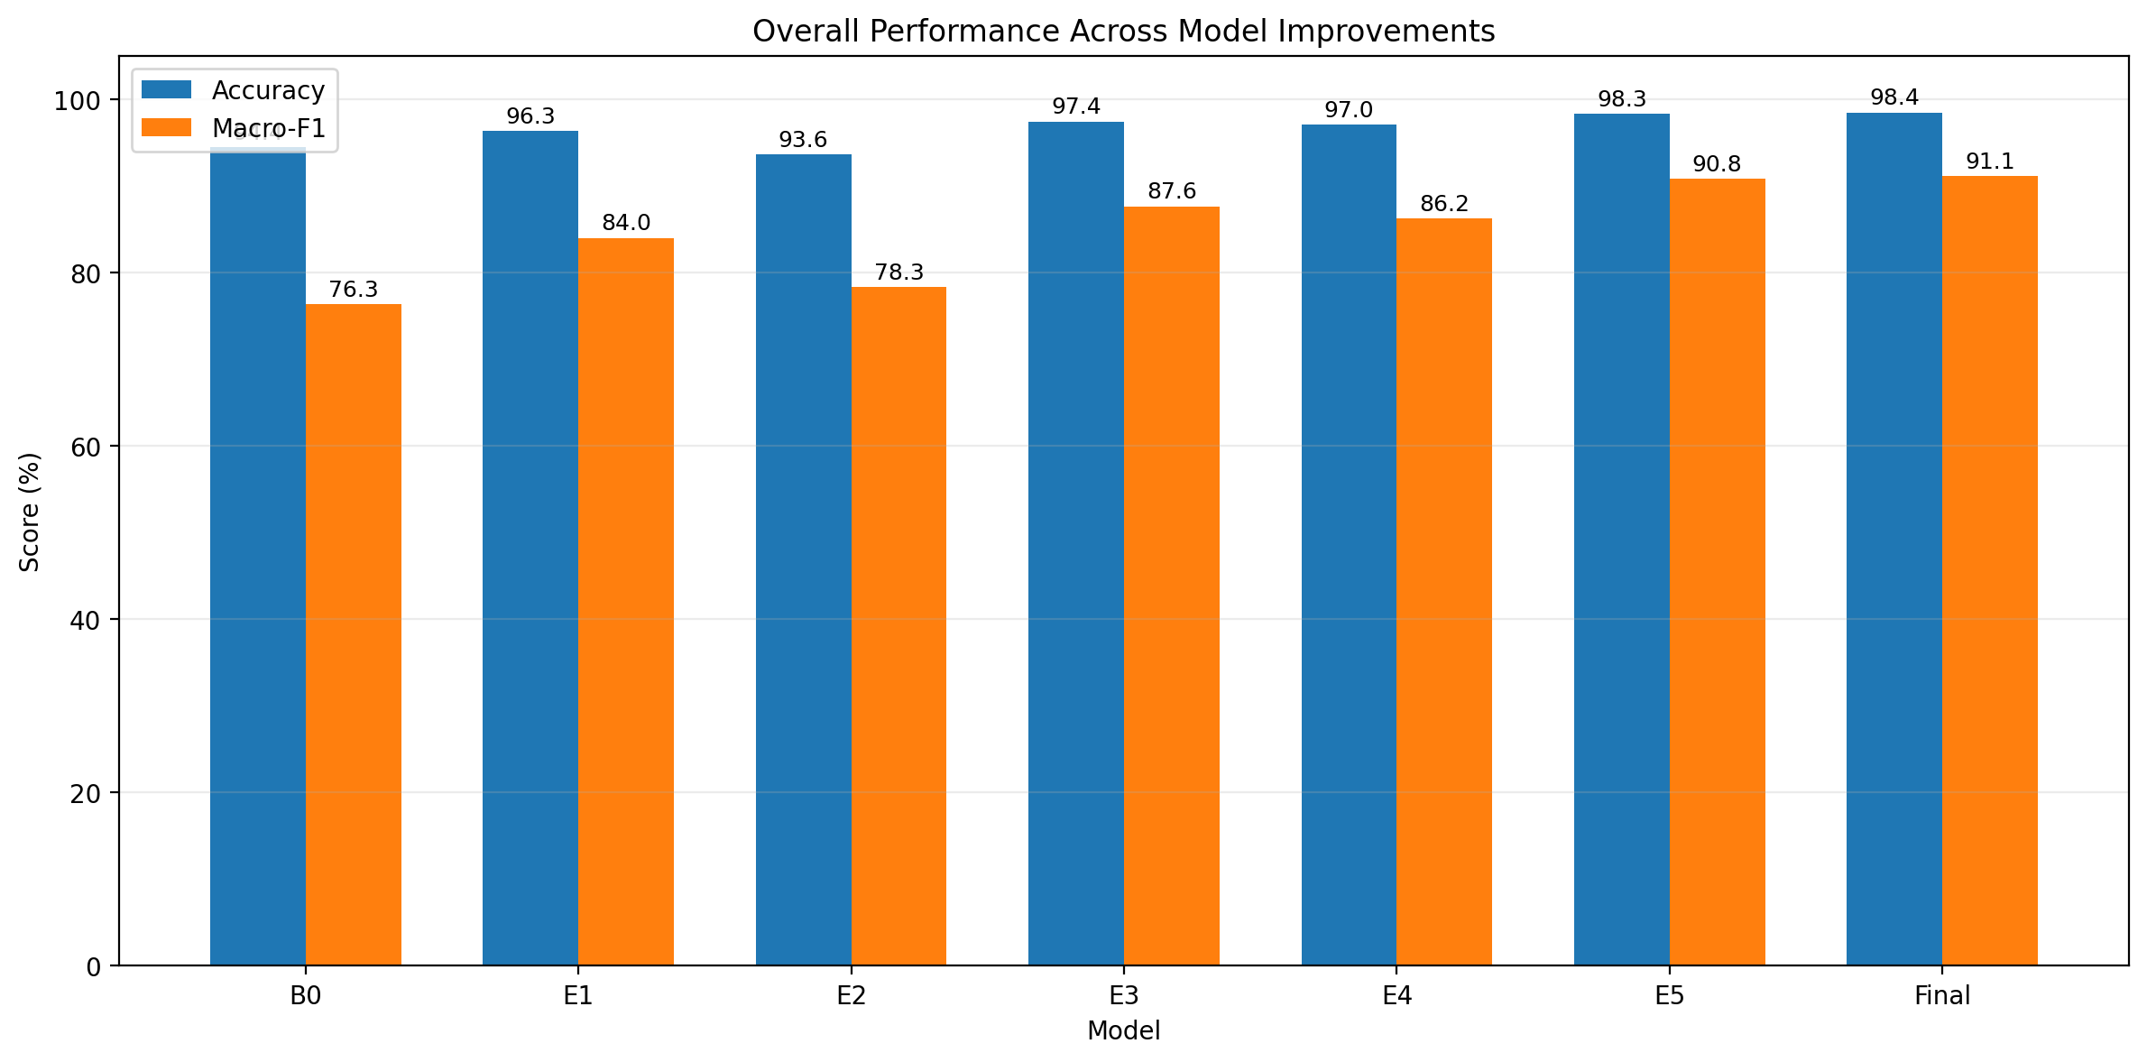
Figure 10: Test accuracy and macro F1 from the baseline (B0) to the final model

Table 11: Per-class test F1 (%) of every model
Model | Acc. | Macro F1 | N | S | V | F | Q
B0 | 94.41 | 76.29 | 97.00 | 60.90 | 86.60 | 40.00 | 97.00
E1 | 96.28 | 83.96 | 97.92 | 63.48 | 92.51 | 68.12 | 97.77
E2 | 93.58 | 78.30 | 96.27 | 49.13 | 90.77 | 58.49 | 96.84
E3 | 97.39 | 87.58 | 98.58 | 69.84 | 94.19 | 76.97 | 98.29
E4 | 97.02 | 86.20 | 98.40 | 66.16 | 91.93 | 76.25 | 98.29
E5 | 98.29 | 90.77 | 99.13 | 81.22 | 95.70 | 78.53 | 99.28
Final | 98.41 | 91.10 | 99.18 | 82.14 | 95.87 | 79.23 | 99.06

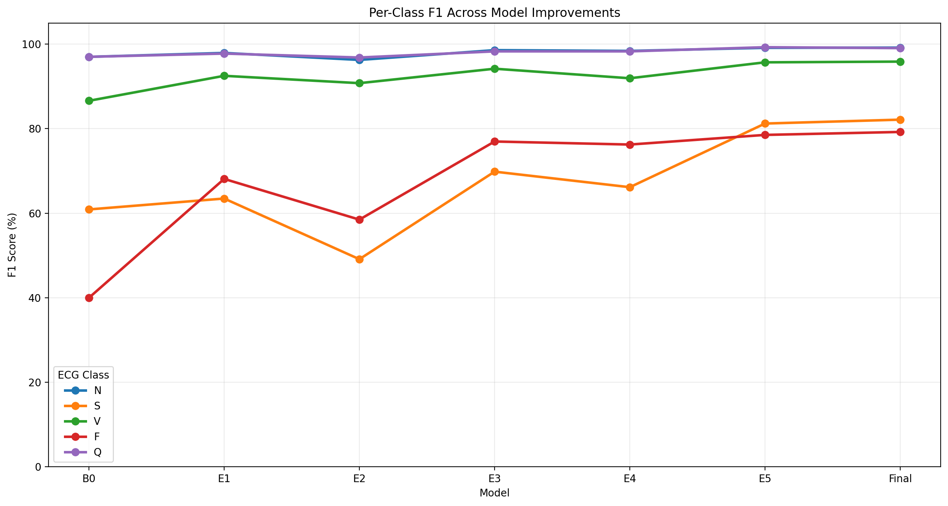
Figure 11: Per-class F1 across the V2 experiments
The largest gains came from three changes: selecting the epoch on validation macro F1 (E1, +7.67 macro F1), square-root class weights (E3, +9.28 over E2) and the residual network (E5, +4.57 over E4). Two changes did not help on their own: the training-stability settings of E2 lowered macro F1 by 5.66 points and did not visibly remove the validation swings, and augmentation (E4) lowered it by 1.38 points. Threshold tuning added only 0.33 points and traded some S and F recall for precision.

Final Model Results
Table 12: Test-set results of the final model (residual CNN + tuned thresholds)
Class | Precision | Recall | F1-score | Test beats
N | 0.9874 | 0.9962 | 0.9918 | 18,118
S | 0.8758 | 0.7734 | 0.8214 | 556
V | 0.9805 | 0.9378 | 0.9587 | 1,448
F | 0.8212 | 0.7654 | 0.7923 | 162
Q | 0.9981 | 0.9832 | 0.9906 | 1,608
Macro average | 0.9326 | 0.8912 | 0.9110 | 21,892

The final model is E5, which had the highest validation macro F1 (93.19%). The probability scale factors tuned on the validation set were N = 3.0 and 1.0 for every other class, so the model must be more confident before predicting any non-N class. This raised test accuracy from 98.29% to 98.41% and macro F1 from 90.77% to 91.10%. The weighted-average F1 is 98.37%. Figure 12 shows the per-class scores.
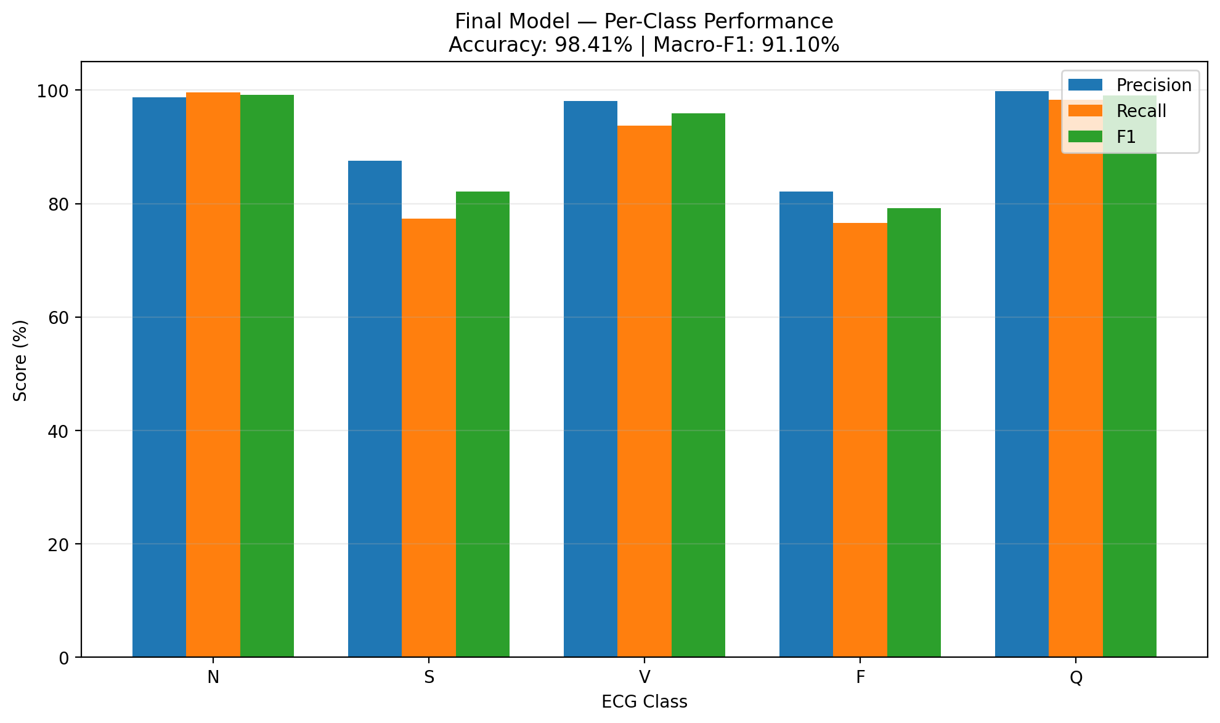
Figure 12: Per-class precision, recall and F1 of the final model on the test set
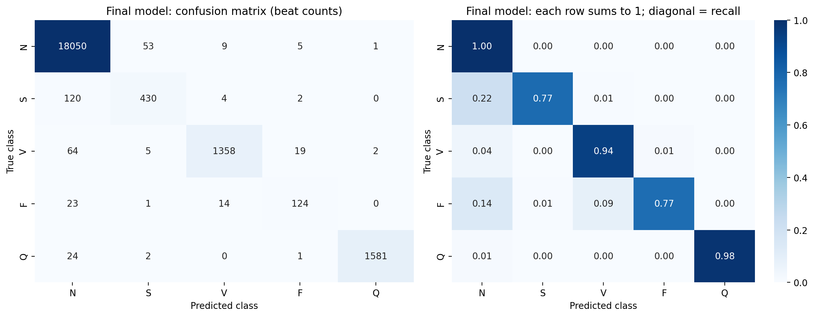
Figure 13: Confusion matrix of the final model
Compared with the baseline, accuracy rose from 94.41% to 98.41% and macro F1 from 76.29% to 91.10%. F1 improved for every class (S 60.9 → 82.1, V 86.6 → 95.9, F 40.0 → 79.2). False Fusion predictions fell from 398 to 27 and false S predictions from 294 to 61. Fusion recall, however, is lower than the baseline's (76.5% vs 86.4%), because the baseline's high recall came from over-predicting F. The largest remaining error is S → N (120 of 556 S beats, 22%); S beats differ from N beats mainly in timing, which supports adding explicit RR-interval features in the proposed model.
Table 13 summarises the change from the baseline to the final model.
Table 13: Baseline (V1) and final model (V2) compared on the same 21,892-beat test set
Metric | Baseline (B0) | Final model (V2) | Change
Accuracy (%) | 94.41 | 98.41 | +4.00
Macro F1 (%) | 76.29 | 91.10 | +14.81
Weighted F1 (%) | 94.98 | 98.37 | +3.39
Precision S / Recall S (%) | 55.86 / 66.91 | 87.58 / 77.34 | +31.72 / +10.43
Precision F / Recall F (%) | 26.02 / 86.42 | 82.12 / 76.54 | +56.10 / −9.88
Beats wrongly predicted as F | 398 | 27 | −371
Beats wrongly predicted as S | 294 | 61 | −233
S beats predicted as N | 163 (29%) | 120 (22%) | −43
Parameters | 44,741 | 185,477 | ≈ 4×

Grad-CAM Explanations
Grad-CAM [37] was applied to the last convolutional activation of each model (46 time steps, interpolated to the 187-sample beat). For each class, the most confidently and correctly classified test beat was explained (Figures 14 and 15).
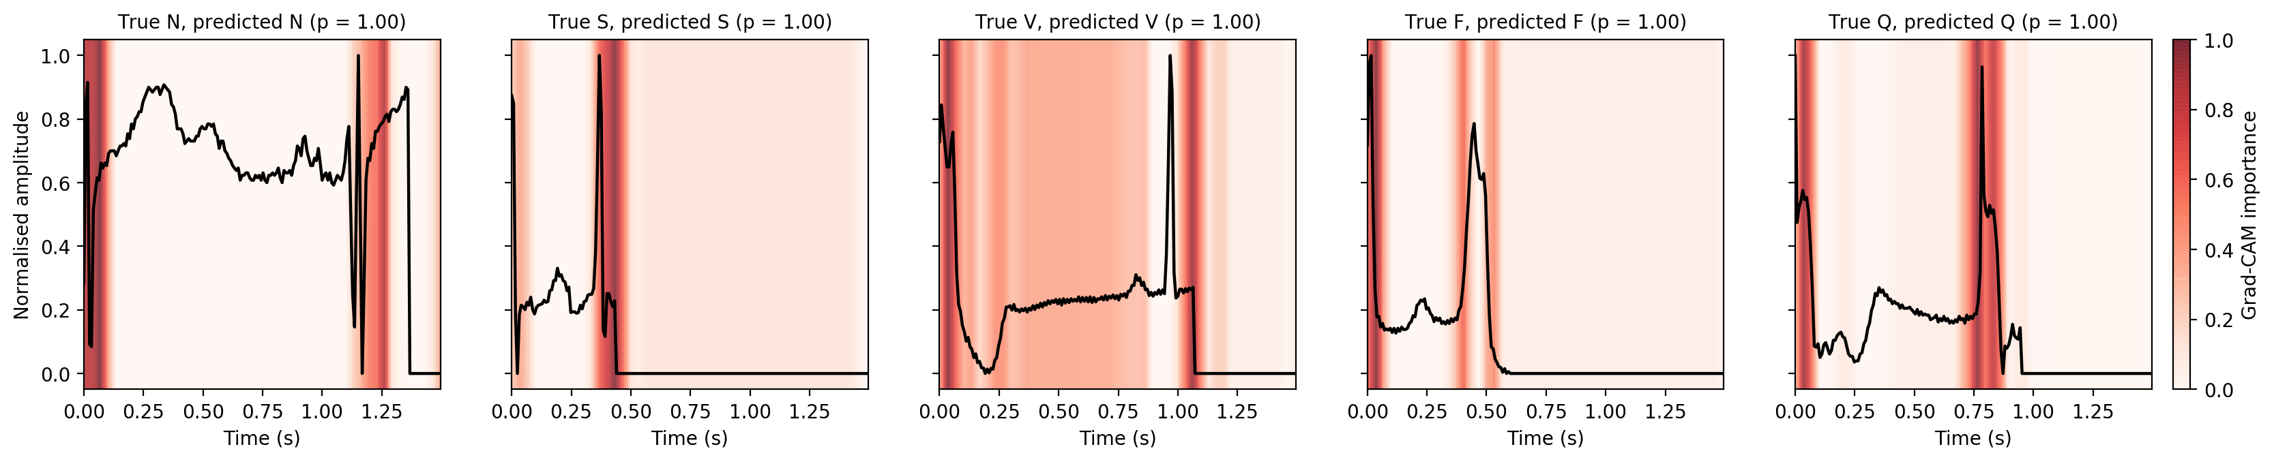
Figure 14: Grad-CAM heatmaps of the V1 baseline, one beat per class
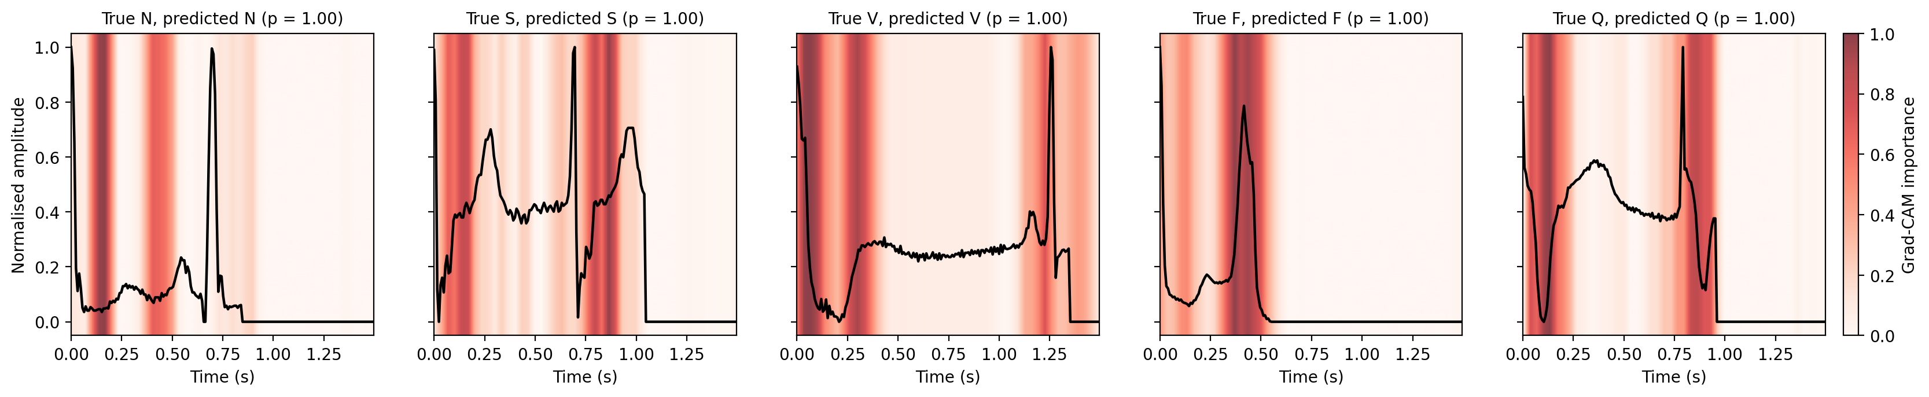
Figure 15: Grad-CAM heatmaps of the V2 final model, one beat per class
Both models concentrate their attention on a few narrow regions. The baseline focuses mostly on the start of the window and on the second large peak or the end of the signal; the final model's maps are broader and more often cover waveform features such as bumps and troughs. Since each window starts at the current R peak, the second peak is likely the next R peak, which suggests that the models partly use the timing of the next beat (an implicit RR cue) as well as beat shape. These observations are qualitative only; they will be tested with the region-share and deletion measures defined in the Methodology chapter.
Table 14 describes the heatmaps of both models class by class.
Table 14: Where the Grad-CAM heat is concentrated (read from the heatmap figures; all beats predicted with p = 1.00)
Class | V1 baseline CNN | Final model (residual CNN)
N | Window start (0–0.1 s) and 1.15–1.3 s around the second peak / start of padding | 0.12–0.2 s and 0.4–0.5 s, before the second R peak (P-wave-like bump); second peak itself low
S | 0.35–0.45 s over the second (sharp) peak and the drop into padding | Window start (0–0.2 s) and 0.75–0.9 s just after the second peak
V | Window start, broad 0.3–0.9 s region, strong band at 1.0–1.1 s where the signal ends | Window start, 0.27–0.35 s, and 1.15–1.3 s around the second peak / end of signal
F | Window start and two narrow bands either side of the second peak (~0.4 and ~0.53 s) | One strong broad band at 0.3–0.5 s centred on the second peak
Q | Window start and a strong band at 0.75–0.85 s over the second peak | ~0.1 s (deep trough) and 0.75–0.95 s around the second peak

Grad-CAM is computed from a layer with 46 time steps, so each step covers about 4 samples (≈ 32 ms) before interpolation; strong heat at the very first samples may partly be an edge effect of the 'same' padding. Because the length of the non-zero part of each window depends on heart rate, heat at the start of the padding may also reflect beat timing. Both points will be checked with the region-share and deletion measures.
Challenges Faced
• Severe class imbalance: fully balanced class weights made the baseline over-predict the rare classes (F precision 26.0%). Softer, square-root weights fixed most of this.
• Unstable training: the baseline's validation accuracy swung between 14.5% and 95.1%, so early stopping on validation loss stopped training too early. Choosing the epoch on validation macro F1 and the residual network gave smoother, better results.
• Not every planned improvement helped: the stability settings (E2) and augmentation (E4) lowered macro F1, and because the experiments were cumulative, the best combination of changes is not yet known.
• The preliminary data are pre-processed, intra-patient and include the Q class, so the results are optimistic and not directly comparable with the planned four-class, inter-patient results. Each experiment was also run only once with one seed.

Work Plan for Next Phase

The following tasks follow from the project objectives and build on the pipeline developed so far. Table 15 gives the planned timeline.
• Port the pipeline from the pre-segmented Kaggle beats to the raw MIT-BIH dataset
• Implement pre-processing and the inter-patient DS1/DS2 split of the MIT-BIH database.
• Implement and train the hybrid classifier; report per-class and macro F1; test on the external database.
• Apply XAI methods and evaluate explanation consistency.
• Generate NSTDB noise at graded SNRs; evaluate classification, explanation stability and uncertainty.
• Analyse results, prepare the final report and presentation.

Expected Outcomes
Deliverables
• A patient-independent ECG arrhythmia classifier with per-class and macro-averaged results under an inter-patient protocol and on an external database.
• A quantitative evaluation of explanation with two XAI methods.
• A robustness and uncertainty analysis of both predictions and explanations under realistic NSTDB noise.
• Final report and presentation.
Expected Results
On the intra-patient split, macro F1 of about 90% is expected, in line with the 91.10% already reached in the preliminary experiments. On the inter-patient DS1/DS2 split, performance is expected to be clearly lower, as reported in the literature [1], [11], with S and F remaining the hardest classes; the RR features are expected to improve S recall in particular. For the explanations, V beats are expected to place a larger share of importance on the QRS region than N beats, and deleting the most important samples should lower model confidence much more than deleting random samples. Under NSTDB noise, macro F1 and explanation stability are expected to fall as the SNR decreases from 18 dB to 0 dB.

References
[1] Q. Xiao, K. Lee, S. A. Mokhtar, I. Ismail, A. L. bin Md Pauzi, Q. Zhang, and P. Y. Lim, "Deep learning-based ECG arrhythmia classification: A systematic review," Applied Sciences, vol. 13, Art. no. 4964, 2023.
[2] N. N. Kulkarni, Nagaraja G. S., B. G. Sudarshan, and Yeriswamy M. C., "Recent advances in deep learning based arrhythmia classification using ECG and PPG signals: A systematic review," Discover Computing, vol. 29, Art. no. 666, 2026.
[3] J. Beck and A. John, "Explainable AI (XAI) for arrhythmia detection from electrocardiograms," arXiv:2508.17294, 2025.
[4] G. A. L. Silva, P. H. L. Silva, G. J. P. Moreira, V. L. S. Freitas, J. C. Gertrudes, and E. J. S. Luz, "A systematic review of ECG arrhythmia classification: Adherence to standards, fair evaluation, and embedded feasibility," arXiv:2503.07276, 2025.
[5] B. A. Hassoon, S. Xiong, M. A. Hasson, R. Salahudeen, A. O. Abdulsalami, and T. Khan, "Dual-branch bidirectional attention fusion of temporal and hierarchical representations for robust ECG arrhythmia classification," Expert Systems with Applications, vol. 331, Art. no. 133409, 2026.
[6] Z. Ebrahimi, M. Loni, M. Daneshtalab, and A. Gharehbaghi, "A review on deep learning methods for ECG arrhythmia classification," Expert Systems with Applications: X, vol. 7, Art. no. 100033, 2020.
[7] Y. Ansari, O. Mourad, K. Qaraqe, and E. Serpedin, "Deep learning for ECG arrhythmia detection and classification: An overview of progress for period 2017–2023," Frontiers in Physiology, vol. 14, Art. no. 1246746, 2023.
[8] N. Alamatsaz, L. Tabatabaei, M. Yazdchi, H. Payan, N. Alamatsaz, and F. Nasimi, "A lightweight hybrid CNN-LSTM explainable model for ECG-based arrhythmia detection," Biomedical Signal Processing and Control, vol. 90, Art. no. 105884, 2024.
[9] P. Pramkeaw, W. Leangruttananon, P. Suksomboon, T. Tapianthong, and S. Kitdanarakorn, "Deep learning-based ECG arrhythmia detection system: A comparative study of CNN, RNN, and LSTM architectures," in Proc. 2026 IEEE Int. Conf. Cybernetics and Innovations (ICCI), 2026, doi: 10.1109/ICCI68752.2026.11506504.
[10] Y. Wang and S. Rani, "Hybrid CNN-LSTM model for ECG-based arrhythmia detection in internet of medical things," Discover Internet of Things, vol. 6, Art. no. 7, 2026.
[11] Sa. I. Ibrahim, "A hybrid deep learning algorithm for ECG-based heart disease classification," Scientific Reports, vol. 16, Art. no. 29911, 2026.
[12] S. Qin, L. Han, X. Zhang, Y. Zhang, and N. Li, "ECG beat classification based on dilated multi-scale ResNet and BiLSTM," Measurement Science and Technology, vol. 37, Art. no. 285701, 2026.
[13] K. K. Reddy C., A. Daduvy, V. S. Kaza, M. Shuaib, M. Mohzary, S. Alam, and A. Sheneamer, "A multi-scale convolutional LSTM-dense network for robust cardiac arrhythmia classification from ECG signals," Computers in Biology and Medicine, vol. 191, Art. no. 110121, 2025.
[14] H. El-Ghaish and E. Eldele, "ECGTransForm: Empowering adaptive ECG arrhythmia classification framework with bidirectional transformer," Biomedical Signal Processing and Control, vol. 89, Art. no. 105714, 2024.
[15] S. Huang, S. Chen, Z. Guo, K. Ji, and M. Zhang, "MSCA-TNet based deep learning method for ECG arrhythmia classification," Scientific Reports, vol. 16, Art. no. 28152, 2026, doi: 10.1038/s41598-026-58850-y.
[16] H. Liu, "A hybrid model combining 1D-CNN and BERT for intelligent ECG arrhythmia classification," Scientific Reports, vol. 15, Art. no. 44456, 2025.
[17] D. Kim, K. R. Lee, D. S. Lim, K. H. Lee, J. S. Lee, D.-Y. Kim, and C.-B. Sohn, "A novel hybrid CNN-transformer model for arrhythmia detection without R-peak identification using stockwell transform," Scientific Reports, vol. 15, Art. no. 7817, 2025.
[18] Q. Chen, C. Lian, B. Xu, Q. Zhou, Y. Su, and Z. Zeng, "Large language model-assisted multi-scale hierarchical classification of ECG signals," Knowledge-Based Systems, vol. 324, Art. no. 113807, 2025.
[19] A. Anand, T. Kadian, M. K. Shetty, and A. Gupta, "Explainable AI decision model for ECG data of cardiac disorders," Biomedical Signal Processing and Control, vol. 75, Art. no. 103584, 2022.
[20] M. Lee, J. Lim, and J. Kim, "ECG-GraphNet: Advanced arrhythmia classification based on graph convolutional networks," Heart Rhythm O2, vol. 6, no. 8, pp. 1199–1211, 2025.
[21] J. J. Kolliyil and M. C. Brindise, "Automated detection of arrhythmias using a novel interpretable feature set extracted from 12-lead electrocardiogram," Computers in Biology and Medicine, vol. 189, Art. no. 109957, 2025.
[22] M. A. Talukder, A. S. Talaat, N. J. Muna, A. Alazab, M. Kazi, and U. K. Das, "An explainable deep learning framework for trustworthy arrhythmia detection from ECG signals," Scientific Reports, vol. 15, Art. no. 39496, 2025.
[23] V. Asha, P. Kavitha, R. Sri Gokulam, S. Ciyamala Kushbu, M. Jayashree, and N. Gayathri, "ECG arrhythmia classification a lightweight, explainable, and web-deployable deep learning framework using knowledge-distilled GAN features and Flask," Natural Resources for Human Health, vol. 6, no. 14s, pp. 289–296, 2026.
[24] P. Kavitha and L. Shakkeera, "An explainable deep learning framework for accurate and automated cardiac arrhythmia classification using electrocardiogram signals," Biomedical Signal Processing and Control, vol. 117, Art. no. 109590, 2026.
[25] D. Tenepalli and T. M. Navamani, "Design of an explainable deep learning framework for ECG-based arrhythmia prediction," IEEE Access, vol. 13, pp. 200754–, 2025, doi: 10.1109/ACCESS.2025.3636481.
[26] J.-H. Jang, Y.-Y. Jo, S. Kang, J. M. Son, H. S. Lee, J. Kwon, and M. S. Lee, "A novel XAI framework for explainable AI-ECG using generative counterfactual XAI (GCX)," Scientific Reports, vol. 15, Art. no. 23608, 2025.
[27] S. Smigiel, K. Palczynski, and D. Ledzinski, "ECG signal classification using deep learning techniques based on the PTB-XL dataset," Entropy, vol. 23, Art. no. 1121, 2021.
[28] N. A. Mehdi and A. A. Drigh, "ECG classification on PTB-XL: A data-centric approach with simplified CNN-VAE," arXiv:2603.07558, 2026.
[29] Y. Jeong, J. Lee, and M. Shin, "Enhancing inter-patient performance for arrhythmia classification with adversarial learning using beat-score maps," Applied Sciences, vol. 14, Art. no. 7227, 2024.
[30] M. Ashhad, S. Rahmani, M. Fayiz, A. Etemad, and J. Hashemi, "Uncertainty-aware multi-view arrhythmia classification from ECG," arXiv:2506.06342, 2025 (published at IJCNN 2024).
[31] R. S. Pashikanti, A. A. Shinde, and C. Y. Patil, "Adaptive predictive control-based noise cancellation with deep learning for arrhythmia classification from ECG signals," in Proc. 2022 Int. Conf. Intelligent Innovations in Engineering and Technology (ICIIET), 2022, doi: 10.1109/ICIIET55458.2022.9967602.
[32] J. P. Maurya, M. Manoria, and S. Joshi, "A proposed deep learning model for multichannel ECG noise reduction," Discover Artificial Intelligence, vol. 5, Art. no. 65, 2025, doi: 10.1007/s44163-025-00292-y.
[33] W. Zhang, X. Di, G. Wei, S. Geng, Z. Fu, and S. Hong, "Cardiac arrhythmia classification with rejection of ECG recordings based on uncertainty estimation from deep neural networks," Neural Computing and Applications, vol. 36, pp. 4047–4058, 2024.
[34] K. Mallikarjunamallu and S. Khasim, "Arrhythmia classification using noise filtering and 1D CNN," Traitement du Signal, vol. 41, no. 4, pp. 1847–1859, Aug. 2024.
[35] M. Kachuee, S. Fazeli, and M. Sarrafzadeh, "ECG heartbeat classification: A deep transferable representation," in Proc. IEEE Int. Conf. Healthcare Informatics (ICHI), 2018, pp. 443–444.
[36] K. He, X. Zhang, S. Ren, and J. Sun, "Deep residual learning for image recognition," in Proc. IEEE Conf. Computer Vision and Pattern Recognition (CVPR), 2016, pp. 770–778.
[37] R. R. Selvaraju, M. Cogswell, A. Das, R. Vedantam, D. Parikh, and D. Batra, "Grad-CAM: Visual explanations from deep networks via gradient-based localization," in Proc. IEEE Int. Conf. Computer Vision (ICCV), 2017, pp. 618–626.
[38] S. M. Lundberg and S.-I. Lee, "A unified approach to interpreting model predictions," in Proc. Advances in Neural Information Processing Systems (NeurIPS), 2017, pp. 4765–4774.

