**Front End Details**

Created Ubuntu 18 instance on aws ec2 and installed packages Apache,Php And cloned below git repository, installed composer.

**Demo Url** : http://54.155.240.163/

**Technologies** : Laravel,Twitter Bootstrap

**GitHub Url** : <https://github.com/sidhilsivadas/teamotely-test.git>

Screen shot:

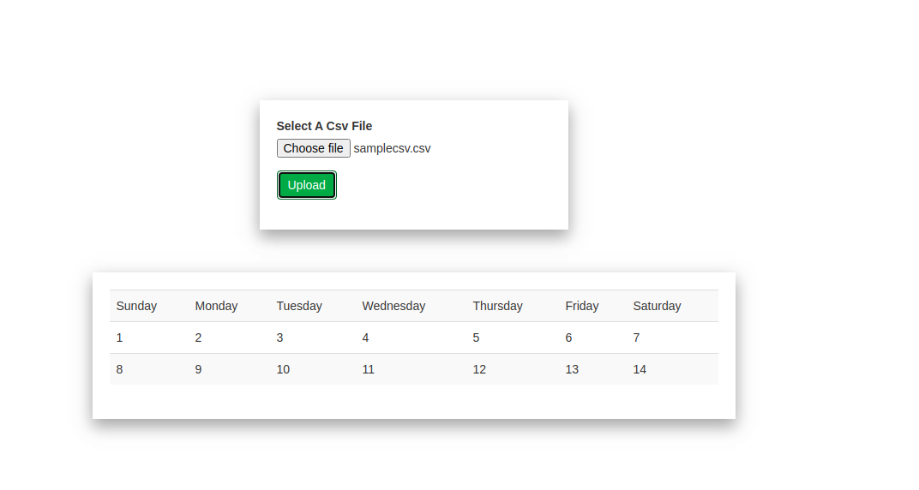

**BackEnd Api Details**

As I faced some issues creating lambda functions on your aws console I have used my personal aws details to create backend.

I have created the Back end api using AWS Lambda and aws api gateway ,used **Nodejs** for scripting

**Api url** : <https://bbv0eeq0c5.execute-api.ap-south-1.amazonaws.com/testing/gettabdata>

**Method** : post

**Request Data**: {“data”:[[col1,col2],[col1,col2]]}

**Headers** : content-type : application/json

api_key : testkey //Hard Coded

1)PostMan Screen Shot of api

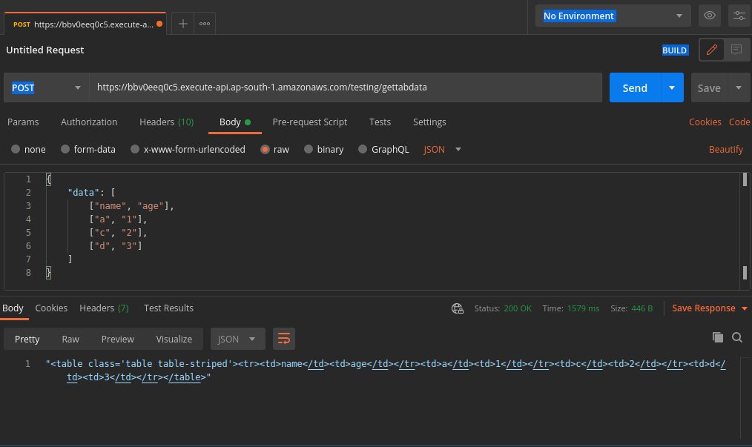

2)Aws Lambda screenshot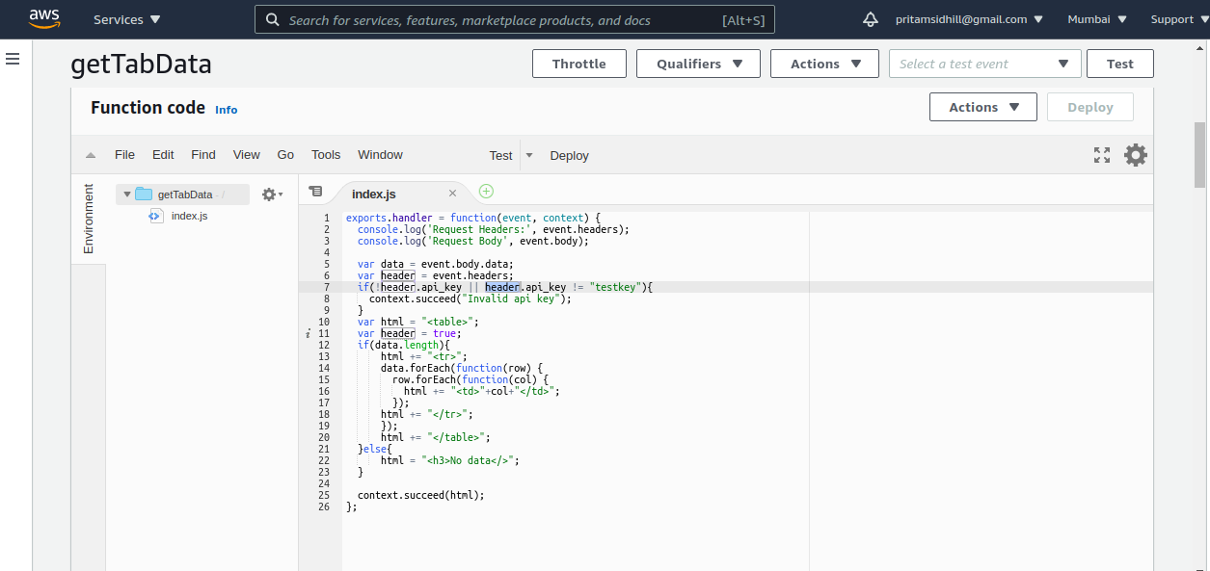

3)Aws Api gateway screenshot

