**Recipe App Documentation**

**Github-repo:** <https://github.com/sidhu2002/Mitt-Arv>

**Introduction**

Welcome to the documentation for the Meal Recipe Application! This document provides an overview of the features, functionalities, and setup instructions for the Meal Recipe Application developed using the MERN (MongoDB, Express.js, React.js, Node.js) stack. The application allows users to register, login, view recipes, search for recipes, filter recipes, view recipe details, and paginate through the recipe list.

**Table of Contents:-**

Features

Technologies Used

Usage

API Documentation

Database Schema

**Features:**

**User Registration**: Users can create a new account with a unique username and password.

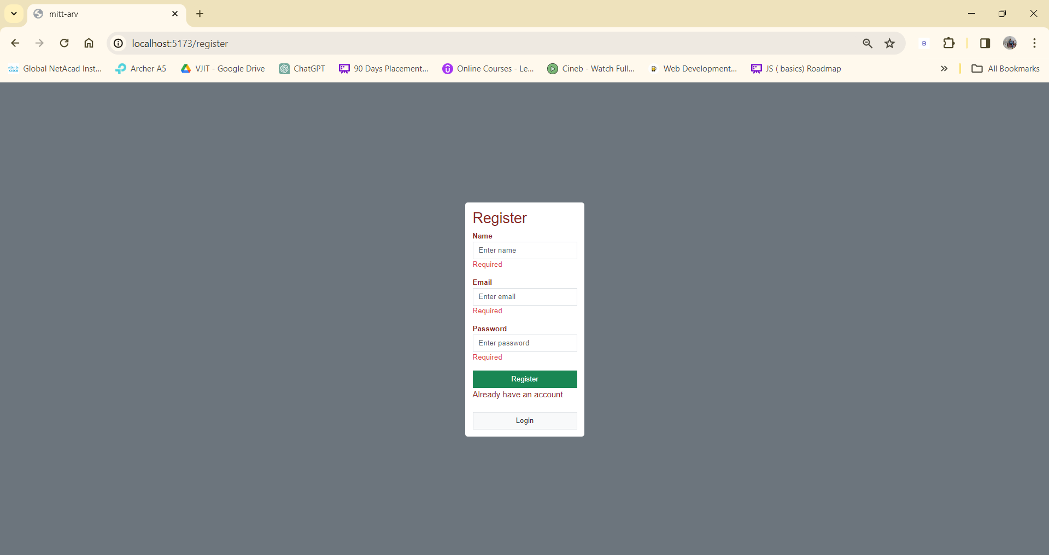

**Input Validation**: I have used the zod library to perform input validation from users.

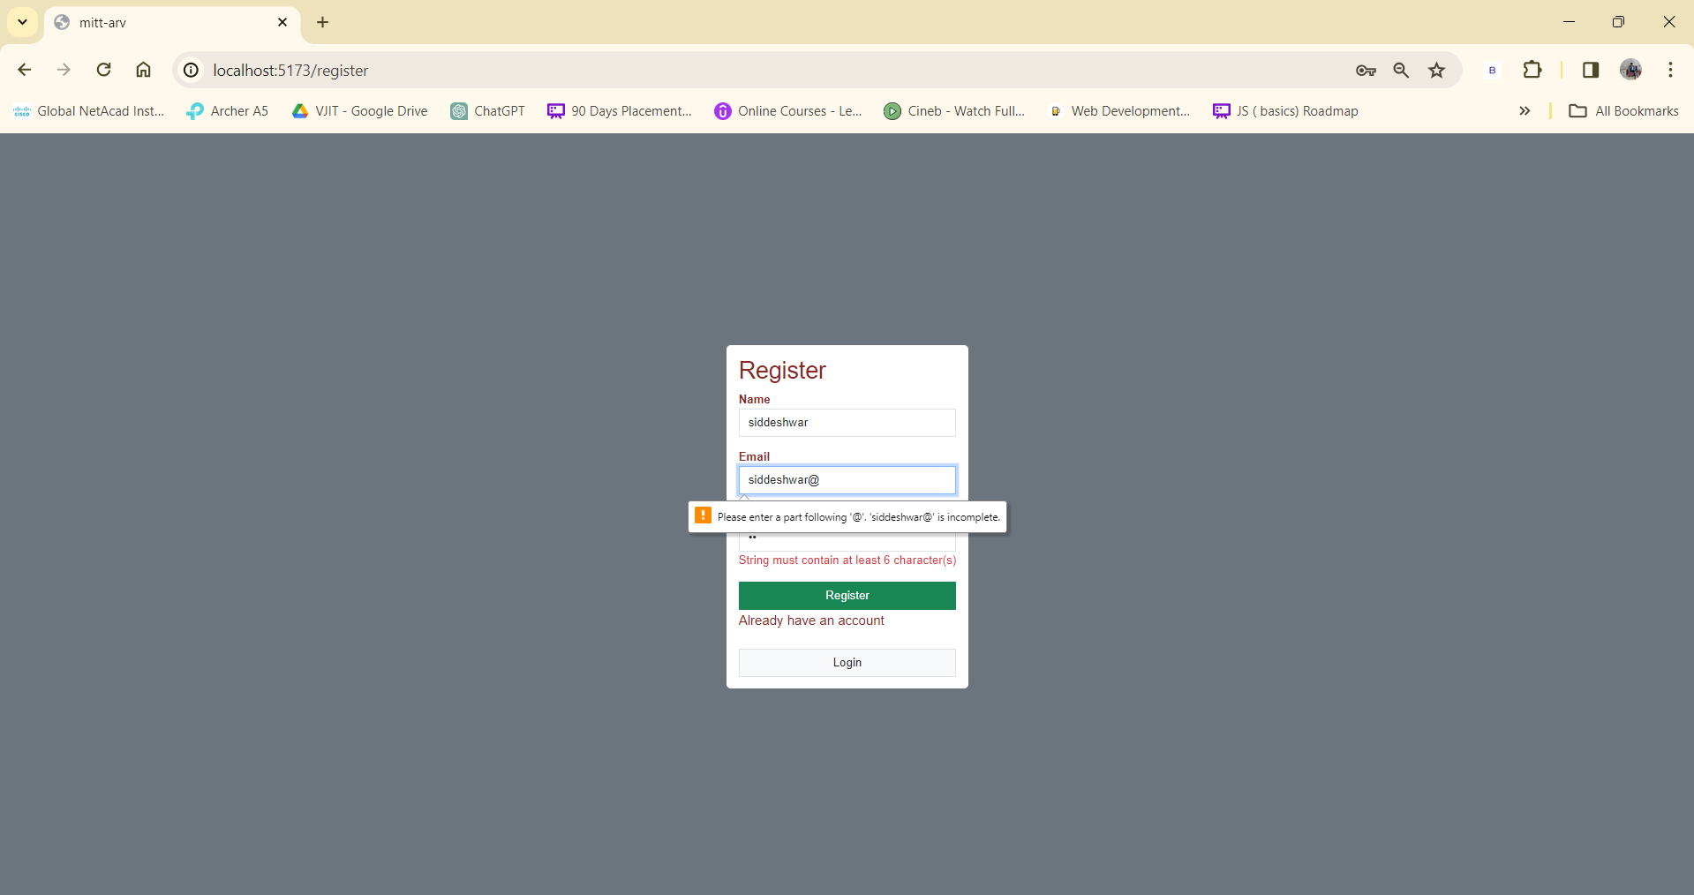

**User Login/Logout**: Registered users can securely log in and log out of their accounts using JWT authentication.

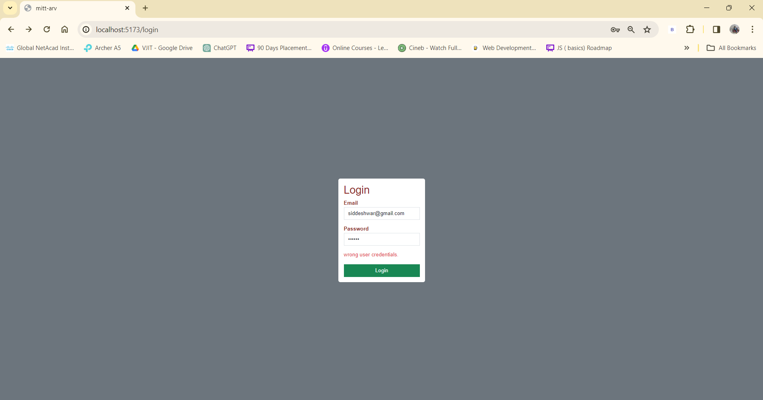

**API Key Integration**: Used api key from themeakdb.com to fetch the recipe’s.

**Recipe Display**: Upon login, users can view recipes fetched from themealdb.com using their API key.

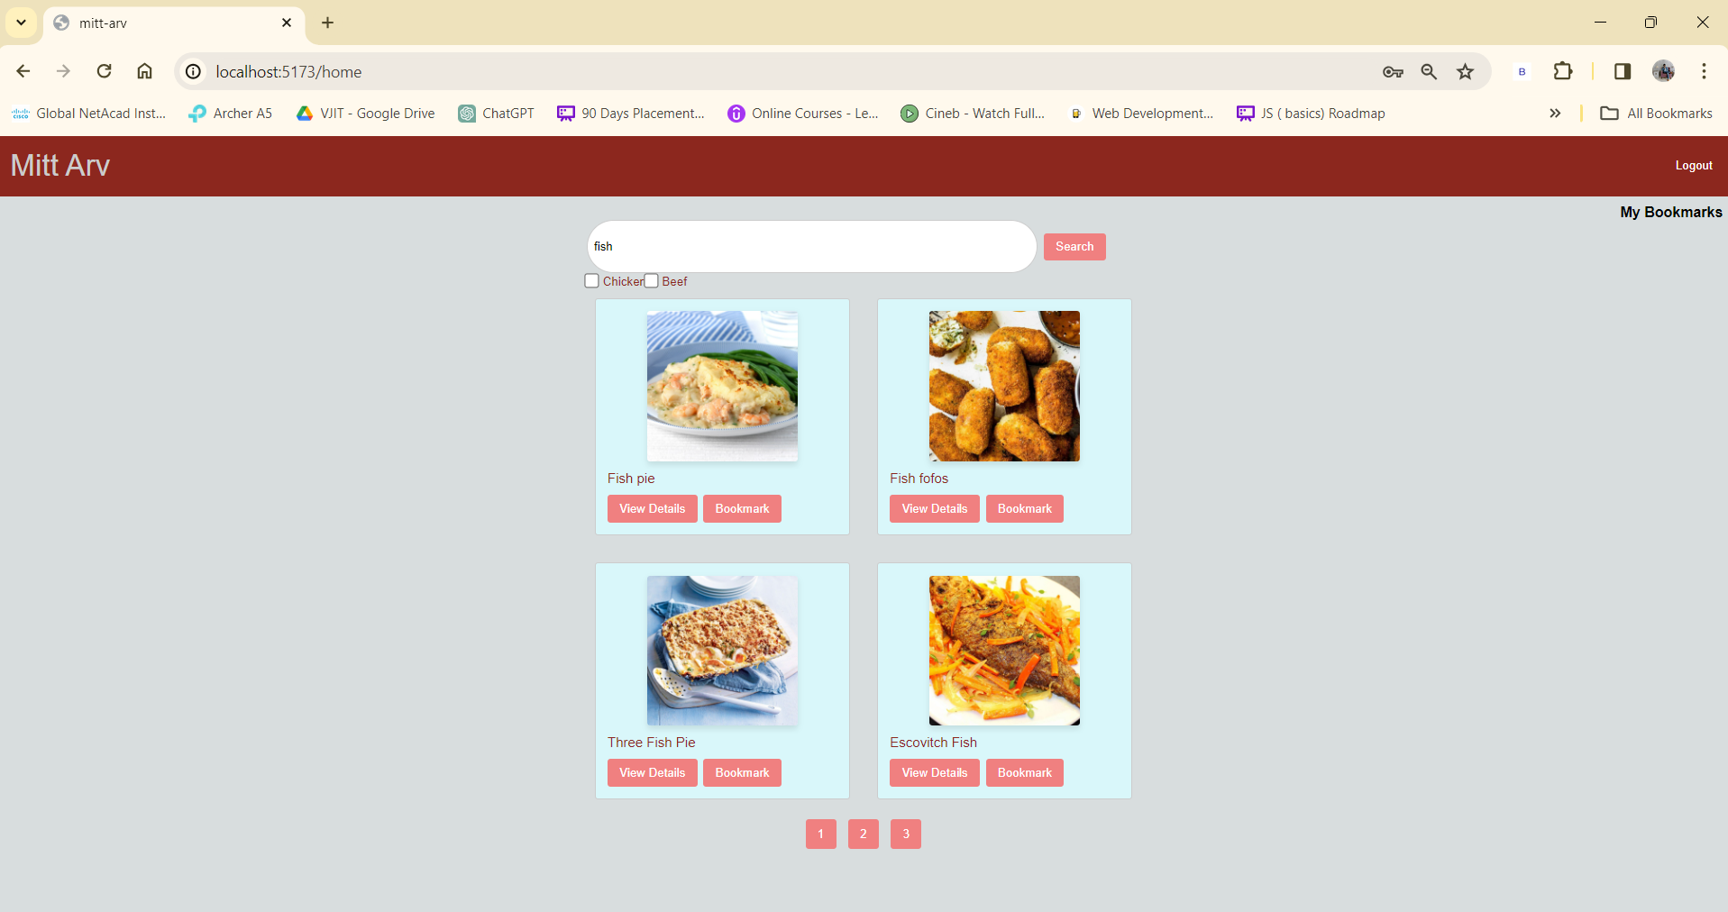

**Search Functionality**: Users can search for recipes based on keywords.

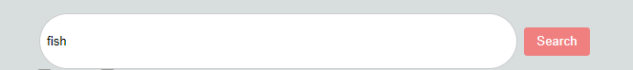

**Filter Functionality**: Users can filter recipes based on categories, cuisines, etc.



**Pagination**: Recipes are displayed in paginated format for better navigation.



**Recipe Details**: Users can view detailed information about each recipe, including ingredients, instructions, etc… on a separate page when clicked on it.

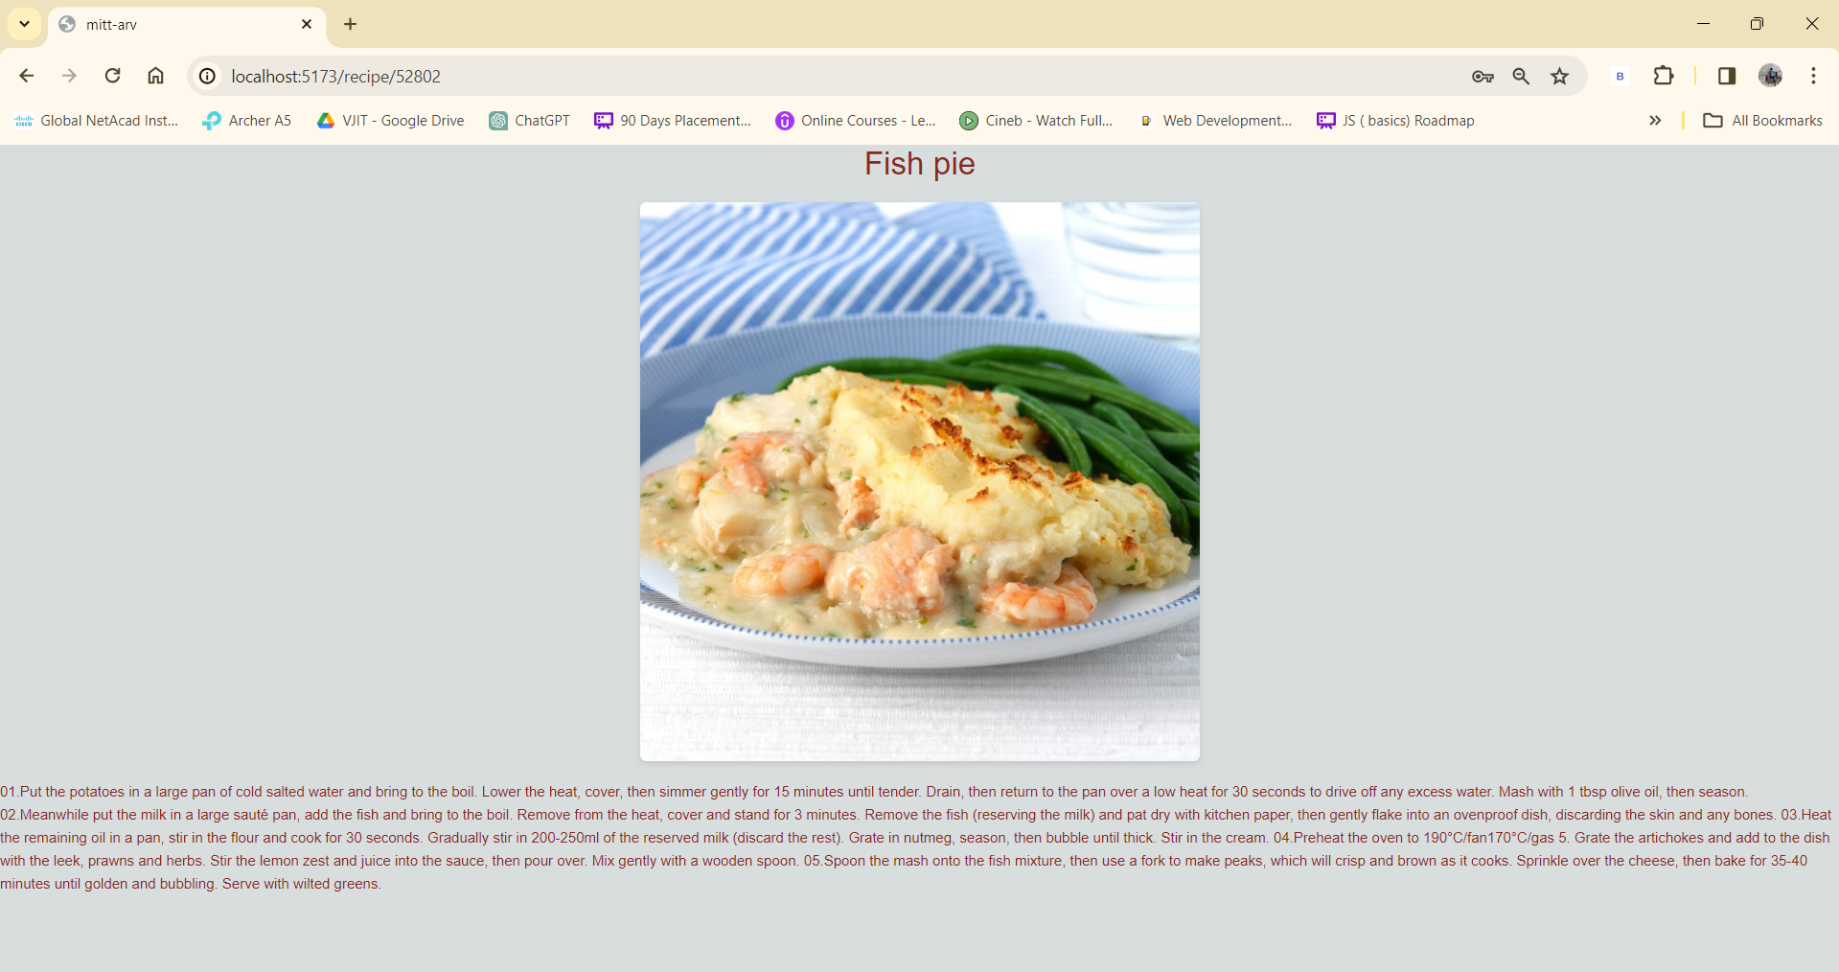

**Bookmark:** Users can bookmark their favorite recipe and check them out later.



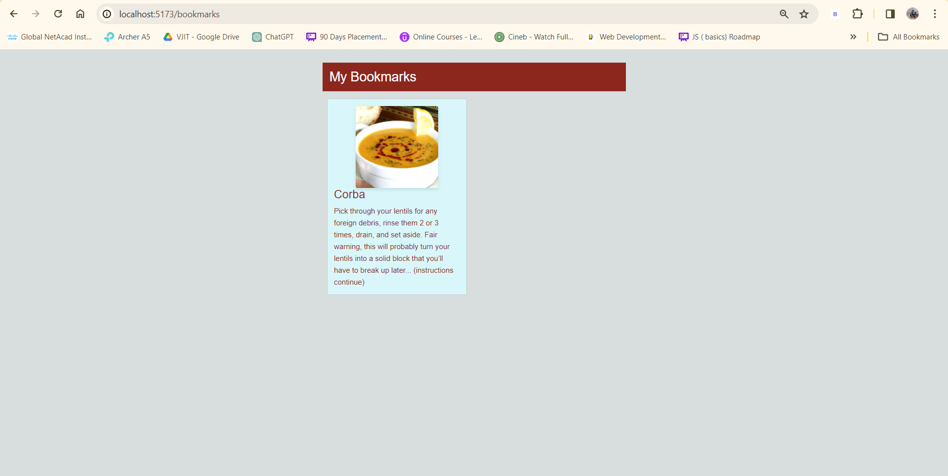

**Technologies Used**

**Frontend**: html, css, React.js, Axios.

**Backend**: Node.js, Express.js, JWT (JSON Web Tokens)

**Database**: MongoDB

**Libraries/Tools**: Zod (for schema validation), Cookie-parser (for handling cookies), Mongoose (for MongoDB object modeling), etc.

**Usage**

**User Registration/Login:**

Navigate to the registration page and fill in the required details to create a new account.

After registration, log in using your credentials.

**Recipe Display:**

Upon successful login, you will be redirected to the homepage where recipes fetched from themealdb.com will be displayed.

**Search, Filter, and Pagination:**

Utilize the search bar to find recipes based on keywords.

Use the filter options to narrow down recipes based on categories, cuisines, etc.

Navigate through the paginated recipe list for better exploration.

**View Recipe Details**:

Click on any recipe card to view detailed information about that recipe, including ingredients, instructions, etc.

**Logout:**

Click on the logout button to securely log out of your account.

**API Documentation:**

The application integrates with themealdb.com API to fetch recipes. Refer to the documentation of themealdb.com for more details on the available endpoints and usage instructions.

**Database Schema**

The application uses MongoDB as its database, with the following schema:

User {

Name : String,

Email : String,

Password : String

}

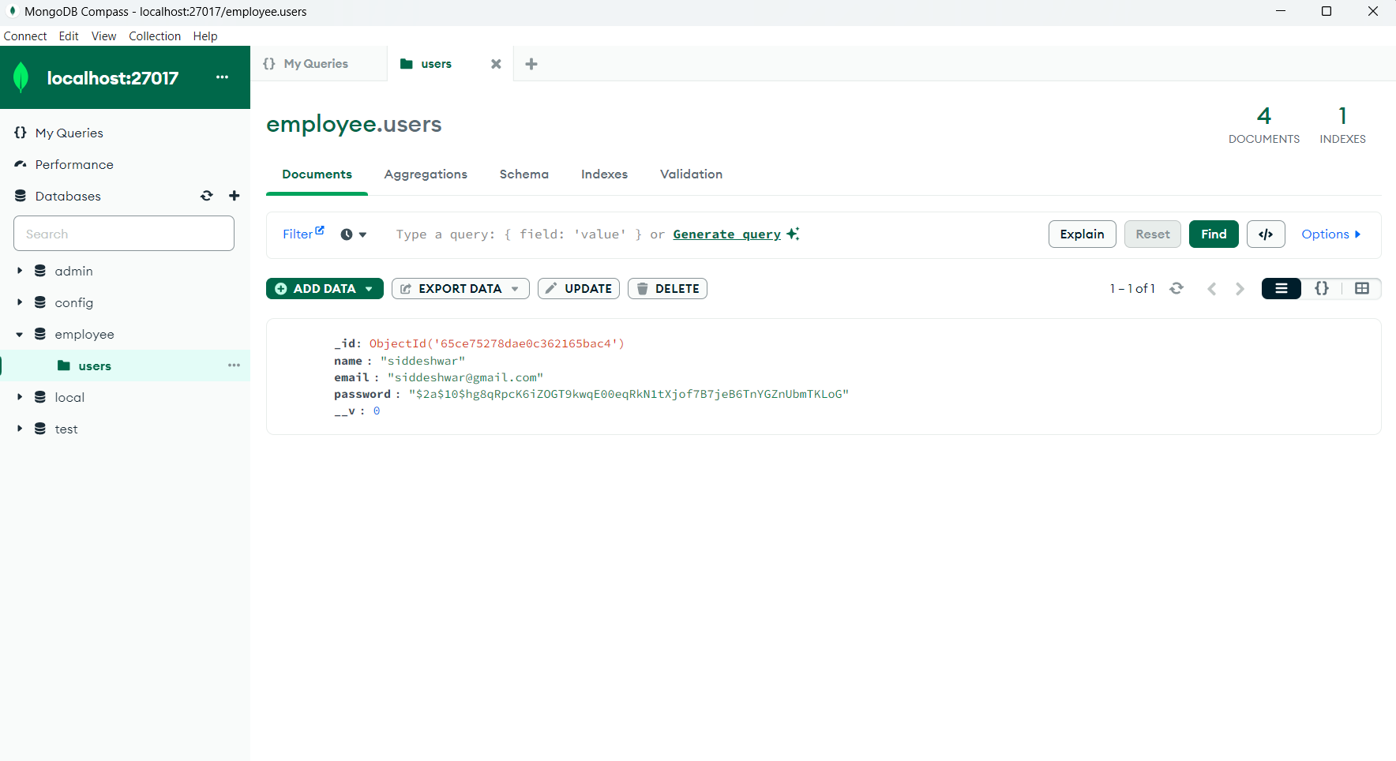

This schema represents the structure of user documents stored in the MongoDB database. Each user document contains a username, password (hashed for security), and an API key for accessing recipe data from themealdb.com.

**Android emulator view** :

