PARDEEP SIDHU

100364731

ABHIJIT SEN

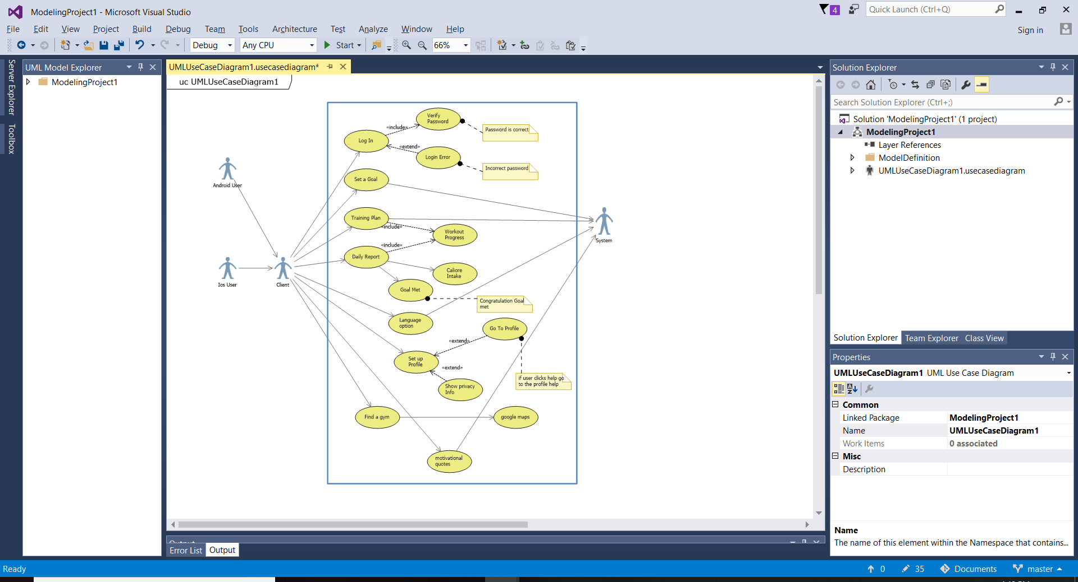

**Repositray**

https://github.com/sidhu742/free-education.git

|  |  |
| --- | --- |
| **Use case title:** | Login |
| **Primary actor** | user |
| **Level:** | Kite |
| **Stakeholder:** | User |
| **Preconditions:** | Internet connection and acces to world wide web |
| **Minimal guarantee:** | One should know his password and and username |
| **Success guarantee:** | One can forget his password and by successfully completing security question. |
| **trigger** | Download the app and Remember username. |
| **Main success scenario** | 1. Succesfull login. 2. Successful and fast internet connection |
| **Extension:** | Failed login  Wrong username or password. |