BLOOD DONET
WITH
BLOOD DONOR
Blood Donor Connect:
A Digital Platform for Life-Saving Donations



Blood Donor Connect:
A Digital Platform for Life-Saving Donations
Submitted by
D.Sai Kumar 23072-CM-013
Report Submitted To
Dr. B. R. AMBEDKAR G M R POLYTECHNIC
Under The Guidance Of
Smt. CH.KALYANA BINDHU
(L/CME,B.TECH)
DEPARTMENT OF COMPUTERENGINEERING

Dr. B. R. Ambedkar G M R Polytechnic
Rajamahendravaram-533124
2025-2026

DEPARTMENT OF COMPUTER ENGINEERING
CERTIFICATE
This is to certify that this project work “entitled Blood Donor Connect: A Digital Platform Life-Saving Donations”is the Bonafide record work done by Mr./Ms.____________________________ Bearing the Pin Number_____________________. of the final year, along with batch mates submitted on the partial fulfilment of the requirement for the award of DIPLOMA IN COMPUTER ENGINEERING during the academic year 2025-2026.

Signature of project guide Head of the Department
(Smt.Ch.Kalyana Bindhu) (Mr.P.Laxminarayana)

Signature of the External Examiner

ACKNOWLEDGEMENT

I have made every effort to complete this project with the support and valuable suggestions from my classmates, ensuring it functions efficiently and effectively.
I would like to express my sincere gratitude to my project guide, Smt. G. Sri Devi, for her guidance, cooperation, and valuable suggestions, which motivated me to successfully complete this project.
I also extend my thanks to Lecturers Smt. G.SriDevi, Smt.CH. Kalyani Bindu, Smt. N.Pavani, Sri Smt N.Sandhya Rani for their valuable suggestions throughout the course of the project.
I am thankful to our Head of the Computer Engineering Department and project coordinator, Sri , P LAKSHMINARAYANA, for his cooperation and unwavering dedication,which greatly inspired me to complete this project.
I also grateful to our respected Principal, Sri A.Murali, for his kind support in the successful completion of this project.
Lastly, I extend my gratitude to all the teaching and non-teaching staff of the Computer Engineering department, who have assisted me, either directly or indirectly, in the completion of this project.

PROJECT ASSOCIATES:

Name | Pin Number
D.Sai Kumar | 23072-CM-013
G.Mani Deepak | 23072-CM-018
K.Abhishek | 23072-CM-027
A.Lawrence | 23072-CM-002
T.Ravi Raj | 23072-CM-051
M.Ashis | 23072-CM-033

TABLE OF CONTENT

S.No | CONTENTS
1 | ABSTRACT
2 | SOFTWARE REQUIREMENTS
3 | INTRODUCTION
4 | SYSTEM ANALYSIS AND FEASIBILITY STUDY
5 | SRS & DESIGN
6 | SOFTWARE INSTALLATION
7 | SOURCE CODE AND TESTING
8 | USER MANUAL
9 | OUTPUT SCREENS AND BIOGRAPHY

Abstract
The Blood Donor Web Application is designed to connect blood donors with recipients efficiently. In emergency situations, finding the right blood type quickly can be a matter of life and death. This system addresses the limitations of traditional manual methods by providing a centralized online platform for donor registration and search.
The application allows donors to register their details, including name, blood type, contact number, and city. Users in need of blood can search for available donors based on blood type and location. This significantly reduces the time taken to find suitable donors.
Administrators have a dedicated dashboard to manage donor information. They can add, update, or delete donor records, ensuring that the database remains accurate and up-to-date. The system also provides security measures to protect sensitive user data.
The web application promotes community participation by encouraging people to register as donors. It also assists hospitals, clinics, and emergency services in maintaining a ready-to-access donor database for urgent requirements.
In conclusion, the Blood Donor Web Application is a practical solution that saves time, enhances efficiency, and facilitates life-saving blood donations. Its simple interface and structured database make it easy to use for donors, users, and administrators alike.

Software
Requirements

Software Requirements
- Operating System:
  - Windows 7/8/10 or higher
  - Linux (optional)
- Web Server:
  - XAMPP/WAMP/LAMP (Apache server included)
- Database:
  - MySQL or MariaDB
- Programming Languages:
  - PHP (for server-side scripting)
  - HTML, CSS, JavaScript (for front-end)
- Browser:
  - Google Chrome, Mozilla Firefox, Microsoft Edge (latest versions)
- IDE / Code Editor:
  - Visual Studio Code, Sublime Text, or PHPStorm
- Optional Tools:
  - phpMyAdmin (for database management)
  - Git (for version control)

INTRODUCTION

Introduction
The Blood Donor Web Application is a web-based platform designed to facilitate the connection between blood donors and recipients efficiently. In emergencies, hospitals and patients often face challenges in finding compatible blood donors quickly. This system digitalizes the traditional blood donation process, providing an online platform for donor registration, search, and management. By maintaining a centralized and accessible database of donors, the application ensures timely blood availability during critical situations.
Objectives:
- Enable Quick Access – Allows recipients to search for donors by blood type and city in real-time.
- Support Donor Management – Administrators can add, update, or remove donor records, ensuring accurate information.
- Promote Community Engagement – Encourages individuals to register as donors and participate in life-saving activities.
- Improve Emergency Response – Reduces time taken to find suitable donors during medical emergencies.
Features:
- Donor Registration – Donors can provide details like name, blood type, contact number, and location.
- Search Functionality – Users can filter donors by blood group, city, or other criteria.
- Admin Panel – Admins can manage donors, monitor registrations, and maintain database integrity.
- Secure and Reliable – Protects sensitive donor and recipient information through session management and access control.
Scope and Benefits:
The application aims to simplify and accelerate the blood donation process. Hospitals, clinics, and individuals can access verified donor information quickly, saving valuable time during emergencies. It also encourages voluntary blood donation and helps maintain a comprehensive record of available donors. The system is designed to be user-friendly, scalable, and secure, making it suitable for deployment in local and regional healthcare networks.

HTML:
Hypertext Markup Language ( HTML )is the standard markup language for creating web pages and web applications . With Cascading Style Sheets (CSS), and JavaScript , it forms a triad of cornerstone technologies for the World Wide Web . Web browsers receive HTML documents from a web server or from local storage and render them into multimedia web pages. HTML describes the structure of a web page semantically and originally included cues for the appearance of the document.
HTML, or Hypertext Markup Language, is the standard markup language used to create and design content on the World Wide Web. It serves as the backbone of web pages, defining the structure and layout of documents by using a system of tags and attributes. HTML enables the organization of text, images, links, and other multimedia elements into a coherent and visually appealing format. The language is essential for building the framework of websites, allowing content to be displayed consistently across various browsers. HTML documents are primarily text files that incorporate elements such as headings, paragraphs, lists, and multimedia embed. The versatility of HTML lies in its ability to link resources, define text semantics, and support the integration of cascading style sheets (CSS) and scripting languages like JavaScript, contributing to the interactive and dynamic nature of modern web pages. As a fundamental technology in web development, HTML provides the foundation for creating an interconnected and user-friendly online experience.

CSS:
Cascading Style Sheets (CSS) is a crucial component of web development, complementing HTML by providing a mechanism to style and format the visual presentation of web pages. The language supports responsive design, facilitating the adaptation of layouts to different screen sizes and devices 7 | Page CSS allows developers to define the appearance of HTML elements, specifying attributes like color, layout, font, and spacing. It operates on a cascading principle, where styles can be inherited or overridden based on specificity and order of declaration. This separation of content and presentation enhances the maintainability and flexibility of web designs. CSS promotes consistency by enabling the application of styles across multiple pages, ensuring a cohesive look and feel for a website. The language supports responsive design, facilitating the adaptation of layouts to different screen sizes and devices. Additionally, CSS3, the latest version, introduces advanced features such as animations, transitions, and flexible box layouts, enhancing the capacity for creating visually engaging and interactive web interfaces. In summary, CSS plays a pivotal role in shaping the visual aesthetics and responsiveness of modern websites, contributing to a seamless and visually appealing user experience.Seperation of formatting and content makes it possible to present the same markup CSS allows developers to define the appearance of HTML elements, specifying attributes like color, layout, font, and spacing. It operates on a cascading principle, where styles can be inherited or overridden based on specificity and order of declaration. This separation of content and presentation enhances the maintainability and flexibility of web designs. CSS promotes consistency by enabling the application of styles across multiple pages, ensuring a cohesive look and feel for a website. The language supports responsive design, facilitating the adaptation of layouts to different screen sizes and devices. Additionally, CSS3, the latest version, introduces advanced features such as animations, transitions, and flexible box layouts, enhancing the capacity for creating visually engaging and interactive web interfaces. In summary, CSS plays a pivotal role in shaping the visual aesthetics and responsiveness of modern websites, contributing to a seamless and visually appealing user experience.

JAVASCRIPT:
JavaScript is a versatile, high-level programming language primarily used to create dynamic and interactive elements on websites. It is one of the core technologies of the web, alongside HTML and CSS, enabling developers to build rich and responsive user interfaces. Initially, JavaScript was designed to run only in web browsers, allowing web pages to be more interactive. It handles tasks like form validation, animations, updating content without refreshing the page (using AJAX), and much more. However, it has now grown beyond the browser,with environments likeNode.js that enable JavaScript to run on servers, opening up possibilities for backend development. JavaScript follows an event-driven and asynchronous programming model, which means it can handle multiple tasks at once,making i t suitable for real-time applications like chatapps or livedata feeds.It also supports object-oriented and functional programming styles, offering flexibility to developers. Modern JavaScript has envolved with the introduction of ES6(ECMAScript2015) and later versions, adding features like let and const for variable declarations, arrow functions, classes, modules, and template literals. These improvements have made JavaScript more powerful and developer-friendly. Additionally, JavaScript benefits from a vast ecosystem of libraries and frameworks such as React, Angular, and Vue.js for frontend development, and Express.js for backend development. This richeco system has made JavaScript a fundamental skill for full-stack developer.

PHP:
PHP (Hypertext Preprocessor) is a widely-used, open-source server-side scripting language designed for web development. It allows developers to create dynamic web pages that interact with databases, handle form data, manage sessions, and perform server-side operations. PHP code is executed on the server, and the resulting HTML is sent to the client’s browser.
Key Features of PHP:
- Server-Side Scripting – Processes requests and generates dynamic content on the server before sending it to the client.
- Database Integration – Easily connects to databases like MySQL, MariaDB, PostgreSQL, and more.
- Cross-Platform – Works on various operating systems, including Windows, Linux, and macOS.
- Open Source – Free to use with a large community and extensive library support.
- Session Management – Supports cookies and sessions to track users and secure data.
- Extensible – Integrates with other technologies like JavaScript, HTML, CSS, and frameworks such as Laravel.
PHP is widely used in web applications due to its simplicity, flexibility, and ability to generate dynamic, data-driven websites efficiently.
XAMPP & MySQL Database:
XAMPP is a free, open-source software package that provides an easy way to set up a local web server environment for PHP development. It includes Apache (web server), MySQL or MariaDB (database), PHP (scripting language), and phpMyAdmin (database management tool).
Key Features of XAMPP & MySQL:
- Local Web Server – Apache allows you to host web applications on your computer for development and testing.
- Database Management – MySQL is a relational database that stores data in structured tables with rows and columns.
- phpMyAdmin – A web-based interface for managing MySQL databases, running queries, and handling tables easily.
- Cross-Platform – XAMPP works on Windows, Linux, and macOS, making it versatile for developers.
- Rapid Development – Provides an all-in-one solution to set up a development environment quickly.
- Security Features – Supports password protection, user privileges, and secure data handling during local testing.
MySQL, being a relational database, is structured and relies on tables, rows, and columns. It is highly reliable, supports complex queries, indexing, and is widely used for web applications, including content management systems, e-commerce platforms, and blood donor management systems.

SYSTEM ANALYSIS AND
FEASIBILITY STUDY

System Analysis and Feasibility Study

1. Introduction
System Analysis is a process of understanding and defining the requirements of a system to improve its efficiency, effectiveness, and reliability. For the Blood Donor Web Application, system analysis involves studying the current blood donation methods, identifying issues, and proposing a digital solution that connects donors with recipients seamlessly.
The traditional process of finding blood involves contacting hospitals, blood banks, or donors individually, which is time-consuming and inefficient during emergencies. The proposed web-based system addresses these limitations by creating a centralized platform for donor registration, management, and search.
System analysis also considers feasibility, which ensures that the proposed system can be implemented effectively with the available resources, technology, and time.

2. Existing System
In the existing manual system:
- Donors are registered physically in hospitals or blood banks.
- Recipients must call multiple sources to find compatible donors.
- Data management is paper-based or stored in isolated spreadsheets, leading to errors and delays.
- Admins have limited control over donor records and no centralized view.
Drawbacks of Existing System:
- Time-consuming donor search.
- High chance of errors in donor information.
- Difficulty in tracking donor availability.
- Limited reach to potential donors.

3. Proposed System
The proposed Blood Donor Web Application is designed to overcome the limitations of the existing system. Key features include:
- Donor Registration: Donors can register online, providing their name, blood type, contact information, and location.
- Search Functionality: Recipients can search donors based on blood group, city, or name.
- Admin Panel: Admins can add, update, or delete donor records and generate reports.
- Security and Privacy: User sessions and secure access prevent unauthorized access to sensitive data.
- Notification System (Optional): Recipients can be alerted when a matching donor is available.
Advantages over Existing System:
- Faster and efficient blood donor search.
- Centralized database reduces errors and inconsistencies.
- Wider reach to potential donors through online access.
- Easy tracking and management of donor data by administrators.

4. System Requirements Analysis
Functional Requirements:
- User registration and login.
- Donor record management (add/update/delete).
- Blood search by recipients.
- Admin dashboard for monitoring and reporting.
Non-Functional Requirements:
- Security: Session-based login, restricted admin access.
- Performance: Fast response time for search queries.
- Usability: Simple and intuitive interface for users and admins.
- Reliability: Accurate and up-to-date donor data.

5. Feasibility Study
Feasibility analysis determines whether the system is practical and viable for implementation. It includes Technical, Economic, and Operational Feasibility:

5.1 Technical Feasibility
- The project uses well-established technologies: PHP, MySQL, HTML, CSS, and JavaScript.
- XAMPP provides a complete development environment for local deployment.
- The system requires no specialized hardware and can run on standard PCs or laptops.
- Skilled personnel are available to implement and maintain the system.
Conclusion: Technically feasible as the required technologies and expertise are available.

5.2 Economic Feasibility
- Development cost is minimal because open-source tools (PHP, MySQL, XAMPP) are used.
- Maintenance cost is low; updates and data management can be handled by administrators.
- The system saves money and time by reducing manual efforts in donor search and record keeping.
Conclusion: Economically feasible due to low cost and high benefits.

5.3 Operational Feasibility
- The system is user-friendly, allowing both donors and recipients to use it with minimal training.
- Administrators can manage and monitor donor data efficiently.
- Hospitals and clinics benefit from fast access to blood donor information during emergencies.
Conclusion: Operationally feasible as the system improves workflow and user satisfaction.

6. System Design Considerations
- Database Design: Donor information is stored in structured tables with fields like ID, name, blood type, phone, city, and user ID.
- Security: Admin login, session management, and data validation prevent unauthorized access.
- Scalability: The system can be extended with features like automated notifications, donor history tracking, or mobile app integration.
- Usability: Simple UI/UX design ensures that users can register, search, and interact with the system easily.

7. Conclusion
The Blood Donor Web Application is a practical, efficient, and cost-effective solution to the problems in the existing manual blood donation system. Through proper system analysis and feasibility study, it is clear that the proposed system is:
- Technically viable – uses widely available technology and resources.
- Economically beneficial – minimal cost, maximum efficiency.
- Operationally feasible – easy to use, effective, and improves the blood donation process.
This analysis confirms that the system can be successfully implemented to save time, reduce errors, and support life-saving blood donation activities in hospitals and communities.

System Design

System Design
System Design is the process of defining the architecture, components, modules, interfaces, and data for a system to satisfy specified requirements. For the Blood Donor Web Application, system design ensures the application is efficient, scalable, secure, and user-friendly.

1. Architectural Design
The system follows a 3-tier architecture:
- Presentation Layer (Frontend)
  - Built using HTML, CSS, and JavaScript.
  - Provides user interface for donors, recipients, and administrators.
  - Allows users to register, login, search donors, and view results.
- Application Layer (Backend)
  - Implemented using PHP.
  - Handles business logic like user authentication, donor search, and session management.
  - Processes requests and communicates between frontend and database.
- Data Layer (Database)
  - Uses MySQL (via XAMPP) to store donor information securely.
  - Tables include donor_info, admin, and user.
  - Structured relational database ensures data integrity and fast query processing.

2. Database Design
The database design is critical for managing donor information efficiently.

Main Tables:
1. donor_info
Column Name | Data Type | Description
id | INT (PK) | Unique donor ID
user_id | INT | Linked user ID
name | VARCHAR | Donor name
blood_type | VARCHAR | Blood group
phone | VARCHAR | Contact number
city | VARCHAR | Donor city
2. admin
Column Name | Data Type | Description
admin_id | INT (PK) | Unique admin ID
username | VARCHAR | Admin login username
password | VARCHAR | Admin hashed password
3. user (optional for recipients)
Column Name | Data Type | Description
user_id | INT (PK) | Unique user ID
name | VARCHAR | User name
email | VARCHAR | User email
phone | VARCHAR | Contact number

Key Features of the Database:
- Relational structure ensures accurate mapping between donors, users, and admins.
- Indexing on blood_type and city improves search performance.
- Foreign keys maintain referential integrity between tables.
User

User_id
Name
Email

Donor

Donor_id
Name
Blood_type
Phone
City
User_id
Admin

Admin_id
Username
Password
Phone

Use Case Design

Actors:
- Admin: Manages donors, monitors database, and generates reports.
- Donor: Registers and updates personal details.
- Recipient/User: Searches for donors and requests blood.
Main Use Cases:
- Register Donor: Donor submits personal details.
- Admin Login: Admin authenticates and accesses dashboard.
- Search Donor: Recipient searches donors by blood type and city.
- Manage Donors: Admin adds, edits, or deletes donor records.
Use Case Diagram:
- Admin → Login → Manage Donors
- Donor → Register → Update Info
- Recipient → Search Donors
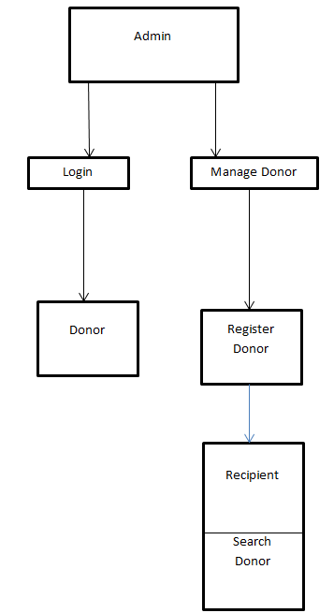

4. Data Flow Design (DFD)
Level 0 (Context Level):
- System interacts with Admin, Donors, and Recipients.
- Data flows between users and the system, with requests processed by the backend and stored/retrieved from the database.
Level 1 (Detailed DFD):
- Donor Registration Module: Captures donor details → stored in donor_info table.
- Search Module: Recipient inputs criteria → system queries database → results displayed.
- Admin Management Module: Admin adds/updates/deletes donor records → database updated.
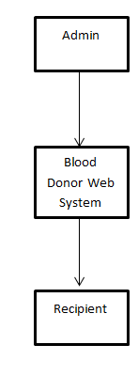

5. Interface Design
Admin Panel:
- Dashboard showing total donors, search options, and add/delete donor functionality.
Donor Registration Page:
- Form to capture name, blood type, phone, and city.
- Validation for required fields and correct formats.
Search Page:
- Input fields for blood type and city.
- Display table of matching donors with contact details.
User Interface Features:
- Responsive design using CSS for desktop and mobile access.
- Navigation links for easy access to different modules.

6. Security Design
- Authentication: Admin and users login using secure credentials.
- Session Management: Maintains active session to prevent unauthorized access.
- Password Hashing: Passwords stored using secure hashing functions (e.g., PHP password_hash()).
- Input Validation: Prevents SQL injection and ensures data integrity.

7. Conclusion
The system design ensures a structured, efficient, and secure application for managing blood donors. The combination of a relational database, PHP backend, and responsive frontend provides a complete solution to manage, search, and connect donors and recipients effectively.
The design also allows future scalability, such as integrating notification systems, mobile applications, or advanced analytics for donor trends.

Software Installation

Software Installation
The following software packages, tools, and dependencies are installed to support the complete development and deployment of the Blood Donor Management System. This setup ensures a stable environment for PHP execution, database management, and user interface development.

1. Core Software Packages

● PHP
PHP is the primary server-side scripting language used to build the backend of this web application.
It handles key operations such as form submission, donor registration, admin login, search queries, and database connectivity.

● Apache Server
Apache is included in XAMPP and is used to run the PHP application locally.
It processes PHP files and serves webpages to the browser.

● MySQL Database
MySQL is the relational database management system (RDBMS) used to store donor information, admin records, and search history.
It supports operations such as INSERT, UPDATE, DELETE, and SELECT.

● phpMyAdmin
A web-based tool used to manage MySQL databases.
It allows creating tables, editing records, importing/exporting data, and running SQL queries.

2. Development Tools

● XAMPP (Apache + PHP + MySQL)
XAMPP provides a complete local development environment.
Version used: XAMPP 8.x (PHP 8.x)
Purpose:
- Run PHP scripts
- Host the web application
- Manage database connections
- Debug development errors

● Code Editor
Any editor can be used such as:
- Visual Studio Code
- Sublime Text
- Notepad++
Purpose:
Write and edit PHP, HTML, CSS, and JavaScript files.

3. Front-End Libraries (Optional)

● Bootstrap
Used to improve UI/UX, make pages responsive, and create clean form designs.

● FontAwesome
Provides icons for buttons, navigation links, and admin dashboards.

● CSS3
Used to style webpages and enhance visual layout.

4. Database Drivers & Extensions

● MySQLi Extension
PHP-MySQLi is used for database operations like connecting, fetching, inserting, and updating.

● PDO (Optional)
Can be used for secure database connectivity using prepared statements.

5. Authentication & Security Tools

● PHP Sessions
Used for managing admin login sessions to prevent unauthorized access.

● Password Hashing (password_hash / password_verify)
Ensures admin passwords are stored securely in the database.

● Form Validation
Required for filtering donor details, preventing empty or invalid entries.

Software Installation & Environment Setup
To set up the Blood Donor Management System, follow these step-by-step instructions.

Step 1: Install XAMPP
Download XAMPP from the official Apache Friends website and install it.

After installation:
- Open XAMPP Control Panel
- Start Apache
- Start MySQL
This enables PHP execution and database access.

Step 2: Set Up Project Directory
Place your project folder inside:
C:\xampp\htdocs\
Example:
C:\xampp\htdocs\blood_donor_system\

Step 3: Create the Database
- Open browser → type:
- http://localhost/phpmyadmin
- Click New → Create database
- blood_donor_db
- Create required tables such as:
- admin
- users
- donor_info

Step 4: Configure Database Connection
Inside your PHP project, edit db.php:
$conn = new mysqli("localhost", "root", "", "blood_donor_db");
This connects the web application to MySQL.

Step 5: Install Code Editor Extensions
If using VS Code, install:
- PHP Extension Pack
- HTML/CSS/JS formatters
- Live Server (optional)

Step 6: Test PHP Installation
Create a file named test.php inside htdocs:
<?php
phpinfo();
?>
Run in browser:
http://localhost/test.php
If PHP info screen appears → PHP is working.

Step 7: Testing the Application
Run the application using:
http://localhost/sai/
Test:
- Donor registration
- Admin login
- Search donor
- View donors

SOURCE CODE

AND

TESTING

Coding:

(Blood Donor Web Application)
Coding in the Blood Donor Management System plays a major role in building a fast, secure, and user-friendly platform that connects blood donors with people in need. The system is developed using modern web technologies for both frontend and backend. Below are the major coding components of the project:

1. Backend Development (Flask – Python / PHP / Node.js — choose based on your project)
The backend handles all the core operations of the web application.

Key Functions:
- Routing & APIs:
Handles user login, donor registration, blood request submission, and donor search.
- Database Queries:
Performs CRUD operations (Create, Read, Update, Delete) for tables like donor_info, users, and requests.
- Authentication System:
Ensures only registered users/donors can access certain pages.
- Form Validation:
Checks donor details like blood type, phone number, and city.

2. Frontend Development (HTML, CSS, JavaScript)
The frontend provides an easy-to-use interface for donors and patients.

Key Features:
- Responsive UI:
Designed with HTML and CSS to look good on mobile and desktop.
- Dynamic Forms:
JavaScript validates fields like phone number, email, and city before submission.
- Search Interface:
A simple search box allows users to find donors by blood group and location.
- User Dashboard:
Shows donor status, recent requests, and profile details.

3. Database Integration (MySQL / MariaDB)
The Blood Donor System uses SQL database tables to store all records.

Used Tables:
- donor_info
(id, user_id, name, blood_type, phone, city)
- users
(id, username, password, role)
- blood_requests
(id, requester_name, blood_type, city, phone)

Database Operations:
- Add, update, or delete donor details.
- Search donors by blood type.
- Store and retrieve blood request information.
- Maintain login credentials securely.

4. Email / SMS Notification (Optional module)
If included, Python/PHP code sends:
- Alerts to donors when a blood request matches their blood group.
- Confirmation messages after registration.

5. Testing (Unit Testing & Manual Testing)
Testing ensures the system works correctly without errors.

Functional Testing:
- Donor registration form
- Login and logout
- Search donor functionality
- Request blood form
- Update/Delete donor details

Validation Testing:
- Incorrect phone number
- Invalid blood type
- Empty fields
- Duplicate users

Database Testing:
- Check if inserted donor details reflect correctly.
- Verify foreign keys like user_id in donor_info table.
- Ensure search queries return correct matching donors.

Performance Testing:
- Search should show results quickly.
- Donor list should load without delay.

User Acceptance Testing (UAT):
- Tested with students/teachers to ensure the UI is simple and usable.

Admin/

<?php
require 'db.php';
session_start();

if (!isset($_SESSION['admin_id'])) {
header("Location: admin_login.php");
exit();
}

$message = "";

if ($_SERVER["REQUEST_METHOD"] == "POST") {
$username = $_POST['username'];
$password_hash = password_hash($_POST['password'], PASSWORD_DEFAULT);
$role = $_POST['role'];

$stmt = $conn->prepare("INSERT INTO users (username, password_hash, role) VALUES (?, ?, ?)");
$stmt->bind_param("sss", $username, $password_hash, $role);

if ($stmt->execute()) {
$message = "User added successfully!";
} else {
$message = "Error: " . $stmt->error;
}

$stmt->close();
}
?>

<!DOCTYPE html>
<html>
<head>
<link rel="stylesheet" href="style.css">
<title>Add User</title>
</head>
<body>
<div class="container">
<h1>Add New donor</h1>
<a href="view_users.php">Back</a>
<br><br>

<?php if ($message) echo "<p><b>$message</b></p>"; ?>

<form method="POST">
Username: <input type="text" name="username" required><br><br>
Password: <input type="password" name="password" required><br><br>

Role:
<select name="role">
<option value="user">User</option>
<option value="admin">Admin</option>
</select>

<br><br>
<button type="submit">Add User</button>
</form>
</div>
</body>
</html>

<!-- admin_index.php -->
<?php
session_start();

// Check admin login
if (!isset($_SESSION['admin_id'])) {
header("Location: admin_login.php");
exit();
}
?>

<!DOCTYPE html>
<html>
<head>
<link rel="stylesheet" href="style.css">
<title>Admin Dashboard</title>
</head>
<body>
<div class="container">
<h1>Welcome, Admin!</h1>

<ul>
<li><a href="view_users.php">View All Users</a></li>
<p> </p>
<li><a href="add_user.php">Add New User</a></li>
<p></p>
<!-- <li> <a href="delete_user.php">delete user</a></li> -->
<p> </p>
<li><a href="logout.php">Logout</a></li>
</ul>
</div>
</body>
</html>

<!-- admin_login.php -->
<?php
require 'db.php';
session_start();

if ($_SERVER["REQUEST_METHOD"] == "POST") {

$username = $_POST['username'];
$password = $_POST['password'];

// Select admin from admins table
$stmt = $conn->prepare("SELECT admin_id, password_hash FROM admins WHERE username = ?");
$stmt->bind_param("s", $username);
$stmt->execute();
$stmt->bind_result($admin_id, $stored_hash);
$stmt->fetch();
$stmt->close();

// Verify password
if ($stored_hash && password_verify($password, $stored_hash)) {
$_SESSION['admin_id'] = $admin_id;

header("Location: admin_index.php"); // Redirect to dashboard
exit();

} else {
$error = "Invalid admin username or password!";
}
}
?>

<!DOCTYPE html>
<html>
<head>
<link rel="stylesheet" href="style.css">
<title>Admin Login</title>
</head>
<body>
<div class="container">
<h2>Admin Login</h2>

<?php if (!empty($error)) echo "<p style='color:red;'>$error</p>"; ?>

<form method="POST">
Username:<br>
<input type="text" name="username" required><br><br>

Password:<br>
<input type="password" name="password" required><br><br>

<button type="submit">Login</button>
</form>
</div>
</body>
</html>

<!-- admin_register.php -->
<?php
require 'db.php';
session_start();

// Optional: Only logged-in admin can create new admins
// if (!isset($_SESSION['admin_id'])) {
// header("Location: admin_login.php");
// exit();
// }

$message = "";

if ($_SERVER["REQUEST_METHOD"] == "POST") {

$admin_name = $_POST['admin_name'];
$username = $_POST['username'];
$password_hash = password_hash($_POST['password'], PASSWORD_DEFAULT);

$stmt = $conn->prepare("INSERT INTO admins (admin_name, username, password_hash) VALUES (?, ?, ?)");
$stmt->bind_param("sss", $admin_name, $username, $password_hash);

if ($stmt->execute()) {
$message = "Admin registered successfully!";
} else {
$message = "Error: " . $stmt->error;
}

$stmt->close();
}
?>

<!DOCTYPE html>
<html>
<head>
<link rel="stylesheet" href="style.css">
<title>Admin Registration</title>
</head>
<body>
<div class="container">
<h2>Admin Registration</h2>

<?php if ($message) echo "<p><b>$message</b></p>"; ?>

<form method="POST">

Full Name:<br>
<input type="text" name="admin_name" required><br><br>

Username:<br>
<input type="text" name="username" required><br><br>

Password:<br>
<input type="password" name="password" required><br><br>

<button type="submit">Register Admin</button>

</form>
</div>
</body>
</html>

<!-- db.php -->
<?php

$servername = "localhost";
$username = "root"; // change if needed
$password = ""; // change
$dbname = "blood_donation";

$conn = new mysqli($servername, $username, $password, $dbname);
if ($conn->connect_error) {
die("Connection failed: " . $conn->connect_error);
}
?>

User/
<!-- index.php -->
<?php
session_start();

// Check if the user is logged in
if (!isset($_SESSION['user_id'])) {
// Not logged in. Redirect to login page.
header("Location: login.html");
exit();
}

// If logged in, you can fetch more user info from the database if needed
require 'db.php';

$user_id = $_SESSION['user_id'];
$stmt = $conn->prepare("SELECT username FROM users WHERE id = ?");
$stmt->bind_param("i", $user_id);
$stmt->execute();
$stmt->bind_result($username);
$stmt->fetch();
$stmt->close();
?>

<!DOCTYPE html>
<html lang="en">
<head>
<meta charset="UTF-8" />
<meta name="viewport" content="width=device-width, initial-scale=1.0" />
<title>Dashboard</title>
<link rel="stylesheet" href="style.css">

</head>
<body>
<div class="container">

<h1>Welcome, <?= htmlspecialchars($username) ?>!</h1>
<p>This is your dashboard / home page.</p>

<li><a href="view_users.php">View All donors/users</a></li>

<p><a href="logout.php">Logout</a></p>
</div>
</body>
</html>

<!-- login.html -->
<!DOCTYPE html>
<html lang="en">
<head>
<link rel="stylesheet" href="style.css">

<meta charset="UTF-8" />
<meta name="viewport" content="width=device-width, initial-scale=1.0" />
<title>Login</title>

</head>
<body>
<div class="container">

<div class="login-container">
<h2>Login</h2>
<form id="loginForm" action="login.php" method="POST">
<label for="username">Username</label>
<input type="text" name="username" id="username" required />

<label for="password">Password</label>
<input type="password" name="password" id="password" required />

<button type="submit">Login</button>
<p>if you hava an</p><a href="register.html"> account</a>
<div id="error" class="error"></div>
</form>
</div>

<script>
document.getElementById('loginForm').addEventListener('submit', function(e) {
// Optionally, add client-side validation
const username = document.getElementById('username').value.trim();
const password = document.getElementById('password').value;
if (!username || !password) {
e.preventDefault();
document.getElementById('error').innerText = "Please enter both username and password.";
}
});
</script>
</div>
</body>
</html>

<!-- login.php -->
<?php
require 'db.php';
session_start();

if ($_SERVER["REQUEST_METHOD"] == "POST") {
$username = $_POST['username'];
$password = $_POST['password'];

$stmt = $conn->prepare("SELECT id, password_hash, role FROM users WHERE username = ?");
$stmt->bind_param("s", $username);
$stmt->execute();
$stmt->bind_result($id, $hash, $role);
$stmt->fetch();
$stmt->close();

if (password_verify($password, $hash)) {
$_SESSION['user_id'] = $id;
$_SESSION['role'] = $role;
// echo "Login successful!";
header("Location: index.php");
exit();

} else {
echo "Invalid credentials";
}
}
?>

<!-- loguot.php -->
<?php
session_start();
session_unset();
session_destroy();
header("Location: login.html");
exit();
?>

<!-- register.html -->
<!DOCTYPE html>
<html>
<head>
<link rel="stylesheet" href="style.css">

<title>Donor Registration</title>
</head>
<body>
<div class="container">

<h2>Register as Donor</h2>
<form id="regForm">
<label>Username:</label><br>
<input type="text" name="username" required><br>

<label>Password:</label><br>
<input type="password" name="password" required><br>

<label>Name:</label><br>
<input type="text" name="name" required><br>

<label>Blood Type:</label><br>
<select name="blood_type" required>
<option>A+</option><option>A-</option><option>B+</option><option>B-</option>
<option>O+</option><option>O-</option><option>AB+</option><option>AB-</option>
</select><br>

<label>Phone:</label><br>
<input type="text" name="phone" required><br>

<label>City:</label><br>
<input type="text" name="city" required><br>

<button type="submit">Register</button>
</form>

<div id="msg"></div>

<script>
document.getElementById('regForm').addEventListener('submit', function(e) {
e.preventDefault();
const form = e.target;
const data = new FormData(form);

fetch('register.php', {
method: 'POST',
body: data
}).then(r => r.text())
.then(text => {
document.getElementById('msg').innerText = text;
});
});
</script>
</div>
</body>
</html>

<!-- register.php -->
<?php
require 'db.php';

if ($_SERVER["REQUEST_METHOD"] == "POST") {
$username = $_POST['username'];
$password = $_POST['password'];
$name = $_POST['name'];
$blood_type = $_POST['blood_type'];
$phone = $_POST['phone'];
$city = $_POST['city'];

$password_hash = password_hash($password, PASSWORD_DEFAULT);

// Insert into users
$stmt = $conn->prepare("INSERT INTO users (username, password_hash, role) VALUES (?, ?, 'donor')");
$stmt->bind_param("ss", $username, $password_hash);
$stmt->execute();
$user_id = $stmt->insert_id;
$stmt->close();

// Insert into donor_info
$stmt2 = $conn->prepare("INSERT INTO donor_info (user_id, name, blood_type, phone, city) VALUES (?, ?, ?, ?, ?)");
$stmt2->bind_param("issss", $user_id, $name, $blood_type, $phone, $city);
$stmt2->execute();
$stmt2->close();

echo "Registration successful!";
}
?>

<!-- view_user.php -->
<?php
include 'db.php';

// Initialize search term
$search = "";
if (isset($_GET['search'])) {
$search = $conn->real_escape_string($_GET['search']);
}

// Correct query based on donor_info structure with search
$sql = "SELECT id, user_id, name, blood_type, phone, city
FROM donor_info
WHERE name LIKE '%$search%'
OR blood_type LIKE '%$search%'
OR city LIKE '%$search%'";
$result = $conn->query($sql);

// Check if query failed
if (!$result) {
die("Query Failed: " . $conn->error);
}
?>

<!DOCTYPE html>
<html>
<head>
<link rel="stylesheet" href="style.css">
<title>View Donors</title>
</head>
<body>
<div class="container">
<h2>Registered Donors</h2>
<!-- <a href="admin_index.php">Home</a> -->

<!-- Search Form -->
<form method="GET" action="" style="margin-top: 20px; margin-bottom: 20px;">
<input type="text" name="search" placeholder="Search by name, blood type or city" value="<?= htmlspecialchars($search) ?>">
<input type="submit" value="Search">
</form>

<table border="1" cellpadding="10">
<tr>
<th>ID</th>
<th>User ID</th>
<th>Name</th>
<th>Blood Type</th>
<th>Phone</th>
<th>City</th>
</tr>

<?php
if ($result->num_rows > 0) {
while ($row = $result->fetch_assoc()) {
echo "<tr>";
echo "<td>".$row['id']."</td>";
echo "<td>".$row['user_id']."</td>";
echo "<td>".$row['name']."</td>";
echo "<td>".$row['blood_type']."</td>";
echo "<td>".$row['phone']."</td>";
echo "<td>".$row['city']."</td>";
echo "</tr>";
}
} else {
echo "<tr><td colspan='6'>No donors found</td></tr>";
}
?>
</table>
<a href="add_user.php">Add Donor</a>
</div>
</body>
</html>

Style.css
/* style.css */

/* Reset and base */
* {
box-sizing: border-box;
margin: 0;
padding: 0;
}

body {
font-family: 'Segoe UI', Tahoma, Geneva, Verdana, sans-serif;
background-color: #f9faff;
color: #333;
line-height: 1.5;
padding: 20px;
}

/* Container */
.container {
max-width: 500px;
margin: 60px auto;
background-color: white;
padding: 30px;
border-radius: 10px;
box-shadow: 0 4px 12px rgba(0,0,0,0.05);
}

/* Typography */
h1, h2 {
text-align: center;
margin-bottom: 20px;
color: #1a1a1a;
}

label {
display: block;
margin-top: 15px;
font-weight: 600;
color: #555;
}

/* Form Inputs */
input[type="text"],
input[type="password"],
input[type="date"],
input[type="number"],
select,
textarea {
width: 100%;
padding: 10px 12px;
margin-top: 5px;
border: 1px solid #ccc;
border-radius: 6px;
transition: border 0.2s;
}

input:focus,
select:focus,
textarea:focus {
border-color: #007BFF;
outline: none;
}

/* Buttons */
button {
margin-top: 25px;
width: 100%;
padding: 12px;
background-color: #007BFF;
color: white;
border: none;
border-radius: 6px;
cursor: pointer;
font-size: 16px;
transition: background 0.3s, transform 0.1s;
}

button:hover {
background-color: #0056b3;
transform: translateY(-1px);
}

/* Error / Message */
.error, .message {
margin-top: 15px;
text-align: center;
font-size: 14px;
}

.error {
color: #d9534f;
}

.message {
color: #28a745;
}

/* Table styling (if you have data tables) */
table {
width: 100%;
border-collapse: collapse;
margin-top: 20px;
}

th, td {
padding: 12px;
border-bottom: 1px solid #e0e0e0;
text-align: left;
}

th {
background-color: #f1f1f1;
}

/* Links */
a {
color: #007BFF;
text-decoration: none;
}

a:hover {
color: #0056b3;
}

/* Responsive */
@media (max-width: 600px) {
.container {
margin: 20px;
padding: 20px;
}

button {
padding: 10px;
}
}

User Manual

User Manual for Blood Donor Management System

1. Introduction
The Blood Donor Management System is a web-based application designed to connect blood donors with people who urgently need blood.
It helps users register as donors, search for available donors, and manage blood requests efficiently.
The system improves emergency response and ensures that blood is available when needed.

2. System Requirements

Hardware
- Minimum 4GB RAM (8GB recommended)
- Intel i3/i5 or higher processor
- Stable internet connection

Software
- Operating System: Windows / Linux / macOS
- Browser: Google Chrome / Mozilla Firefox
- For local development: XAMPP / Python / Node (depending on your backend)
- MySQL or MongoDB database installed (project dependent)

3. User Registration & Login

Steps to Register
- Open the Blood Donor Application in your browser.
- Click “Sign Up” from the menu.
- Enter required details:
  - Full Name
  - Email Address
  - Password
  - Phone Number
  - City
  - Blood Group
- Click Register.

Login Procedure
- Go to Login page.
- Enter your registered email and password.
- Click Login to access your dashboard.

4. Adding/Updating Donor Information
- After login, open the Dashboard.
- Click “Update Profile” or “Add Donor Info”.
- Upload or update:
  - Name
  - Blood Group
  - Contact Number
  - City / Address
  - Availability Status
- Click Save to update the donor database.

5. Searching for Donors
- Go to the Search Donor section.
- Select the required blood group.
- Enter city or location.
- Click Search.
The system displays:
- Donor Name
- Phone Number
- Blood Group
- City
- Availability
Users can directly contact the donor.

6. Features & Navigation

Home
Overview of the Blood Donor System and purpose.

Dashboard
Manage your profile, donation status, and personal details.

Search Donor
Find donors by blood group and location.

Request Blood
Submit an emergency blood request if no donor is available.

Profile
View or edit your account and donation history.

About
Information about the project’s purpose and technology used.

Logout
Securely signs out the user.

7. Security & Privacy
- All user data is encrypted and safely stored.
- Only registered users can view donor details.
- Passwords are protected with hashing/encryption.
- Personal data is stored securely in the database.
- System follows basic data privacy principles.

8. Troubleshooting

Issue: Cannot Log In
- Check if email and password are correct
- Use “Forgot Password” if available

Issue: Cannot Search Donor
- Ensure you selected a valid blood group
- Check internet connection

Issue: Donor Not Visible
- Donor may be marked as Not Available
- Admin may have restricted the profile

9. Contact Support
For help or technical support, contact:
📧 support@blooddonorapp.com
(Or the email your project team uses)
You can also access the Help Center inside the application.

OUTPUT SCREENS
AND BIOGRAPHY

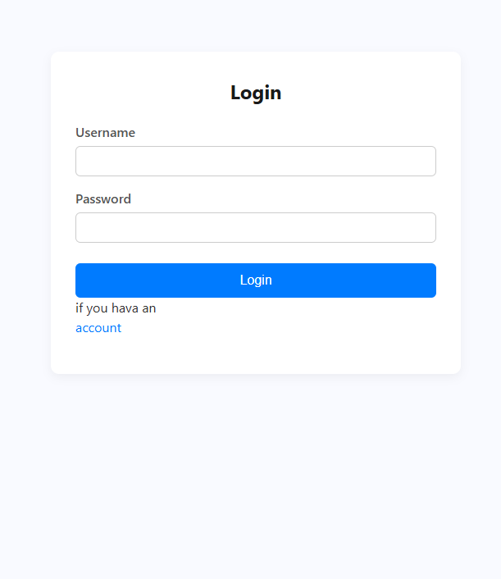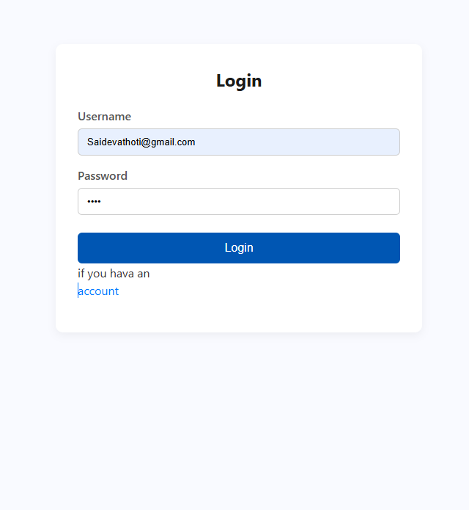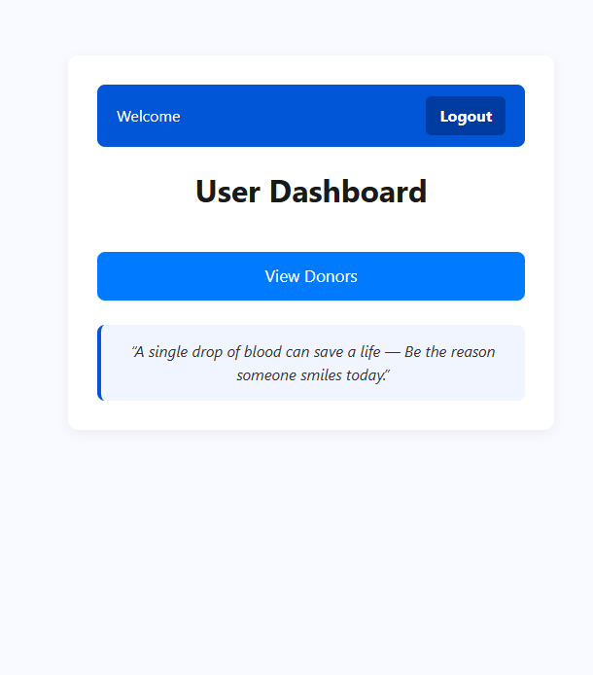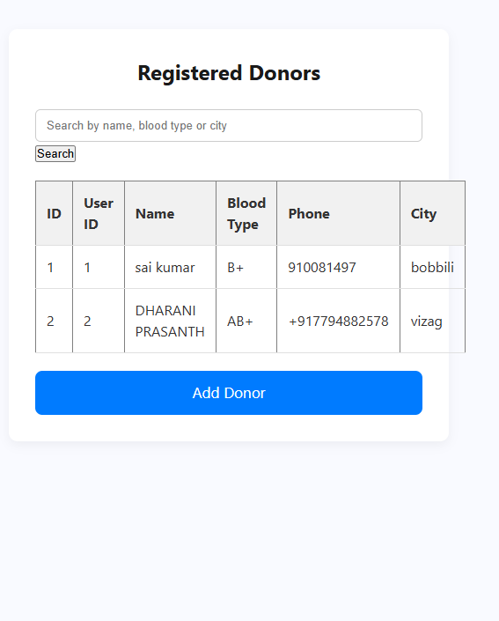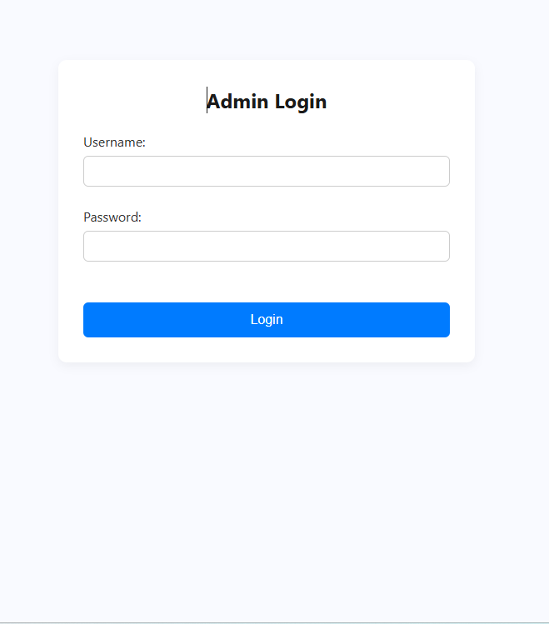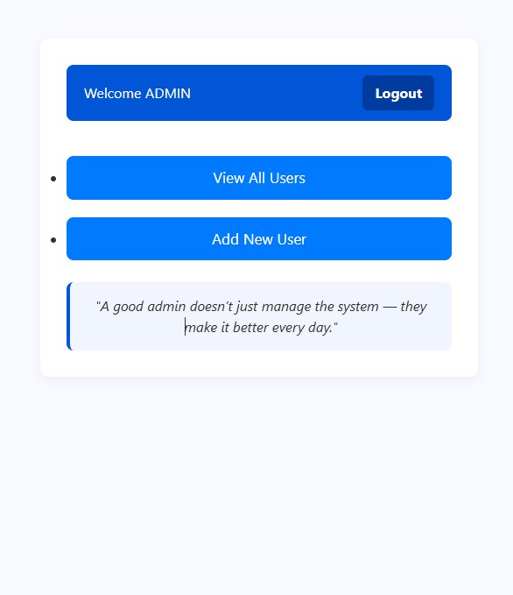

BIBLIOGRAPHY

AND
CONCLUSION

BIBLIOGRAPHY
- Books
  - Fundamentals of Database Systems – Elmasri & Navathe
  - Web Technologies: HTML, CSS, JavaScript – Uttam K. Roy
  - PHP & MySQL Web Development – Luke Welling, Laura Thomson
  - Software Engineering: A Practitioner’s Approach – Roger S. Pressman
  - Computer Networks – Andrew S. Tanenbaum
- Websites
  - Official PHP Documentation
  - W3Schools (for HTML, CSS, PHP references)
  - MySQL Official Documentation
  - Stack Overflow (for debugging support)
  - CHATGPT (for help)
- Research Papers / Articles
  - Articles related to blood donation awareness and donor management systems.
  - Journals discussing health information systems and digital record-keeping.
- Tools Used
  - XAMPP (Apache, PHP, MySQL)
  - Visual Studio Code
  - Chrome Developer Tools
  - phpMyAdmin for database management

CONCLUSION
The Blood Donor Management System was developed to simplify the process of connecting blood donors with recipients in urgent situations. Traditional methods of searching for donors are often slow, unreliable, and unorganized. This system overcomes these challenges by providing a fast, secure, and user-friendly platform.
Through this project, essential concepts such as web application design, database management, authentication, and CRUD operations were implemented. The system allows administrators to manage donor details efficiently, ensuring that accurate and updated information is always available.
The application successfully demonstrates how technology can support life-saving activities. By digitizing donor information and making it accessible, the project reduces delays during emergencies and encourages more people to participate in blood donation.
This project can be enhanced in the future by adding features such as SMS alerts, location-based donor matching, email notifications, and mobile app integration. Overall, the project achieves its goal of providing a reliable, efficient, and meaningful solution for blood donor management.

