RUNTIME TEST EVIDENCE
Create DI and Submit MIGO via Standard SEGW OData
Postman execution, persisted document creation, and OData readback in QS4/700
Client | Shree Cement | Execution date | 26 August 2026
System | QS4 / client 700 | Execution user | QNOVATE8
Outcome
PROVEN END TO END. The standard delivery and material-document OData services both completed real business writes. Create DI produced outbound delivery 9004953278; Submit MIGO produced material document 5007138638 / 2026. Independent GETs confirmed persistence. No BAPI was called.

API state at the close of this evidence run
API / route | State | Evidence-based meaning
Create DI / API_OUTBOUND_DELIVERY_SRV;v=2 | PROVEN | Authenticated, CSRF-enabled, deep insert accepted, HTTP 201 returned, and the created document was readable by header and predecessor-linked item.
Submit MIGO / API_MATERIAL_DOCUMENT_SRV | PROVEN | A fully goods-issued STO delivery was validated, the OData POST returned HTTP 201, and an expanded GET returned the persisted movement-101 item with its delivery link.

Create DI execution flow and evidence register
The Create DI evidence is ordered from controlled Postman setup to persisted SAP readback. The later Submit MIGO section continues the same client-facing evidence pattern without repeating setup or configuration screens.
Step | Action | Observed result | What the result establishes
01 | Import certified Postman assets | 4 of 4 imported | Both collections and both QS4 environments were available in the workspace.
02 | Fetch CSRF token from delivery service | HTTP 200 | Authentication, service activation, CSRF issuance and session continuity worked.
03 | Read STO predecessor deliveries | HTTP 200; 50 TO already delivered | The selected predecessor was valid and retained sufficient capacity for a 1 TO create.
04 | POST Create DI | HTTP 201; delivery 9004953278 | The standard deep-insert route created a real SAP outbound-delivery document.
05 | Read created delivery header | HTTP 200; header persisted | The returned key was not transient; the document header existed in SAP.
06 | Read predecessor-linked item | HTTP 200; 1 TO item persisted | The created quantity, unit and STO predecessor linkage were independently readable.

Test identity
service | API_OUTBOUND_DELIVERY_SRV;v=2 | entity | A_OutbDeliveryHeader
business operation | Create DI from STO predecessor | predecessor | 5600084222 / 000010
shipping point | 1002 | requested quantity | 1 TO
created delivery | 9004953278 / 000010 | execution mode | Postman Desktop Agent through VPN
STEP 01
Certified Postman assets imported PASS
import result | 4 of 4 elements | collections | 2
environments | 2 | workspace | Siddharth Shrivastav's Workspace
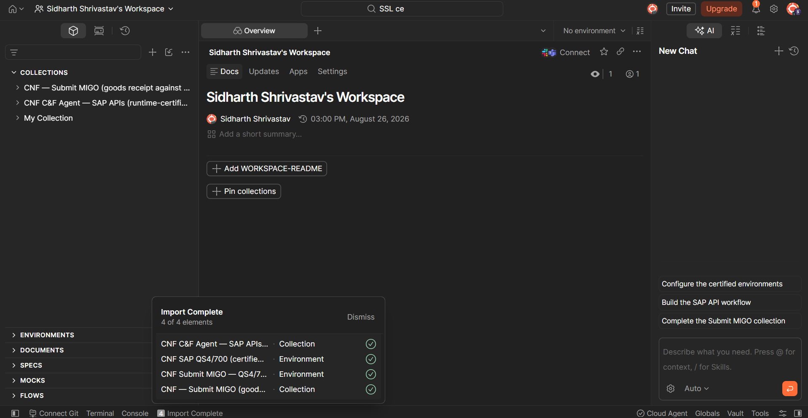
Figure 1. Postman confirms successful import of both collections and both QS4 environments.
Meaning for API state -> The test assets were available as controlled collections and environments rather than manually assembled URLs. This reduces payload drift between operators.
STEP 02
Delivery service responds and issues CSRF PASS
executor | Desktop Agent | method | GET
service | API_OUTBOUND_DELIVERY_SRV;v=2 | HTTP status | 200 OK
elapsed | 964 ms | response size | 1.02 KB
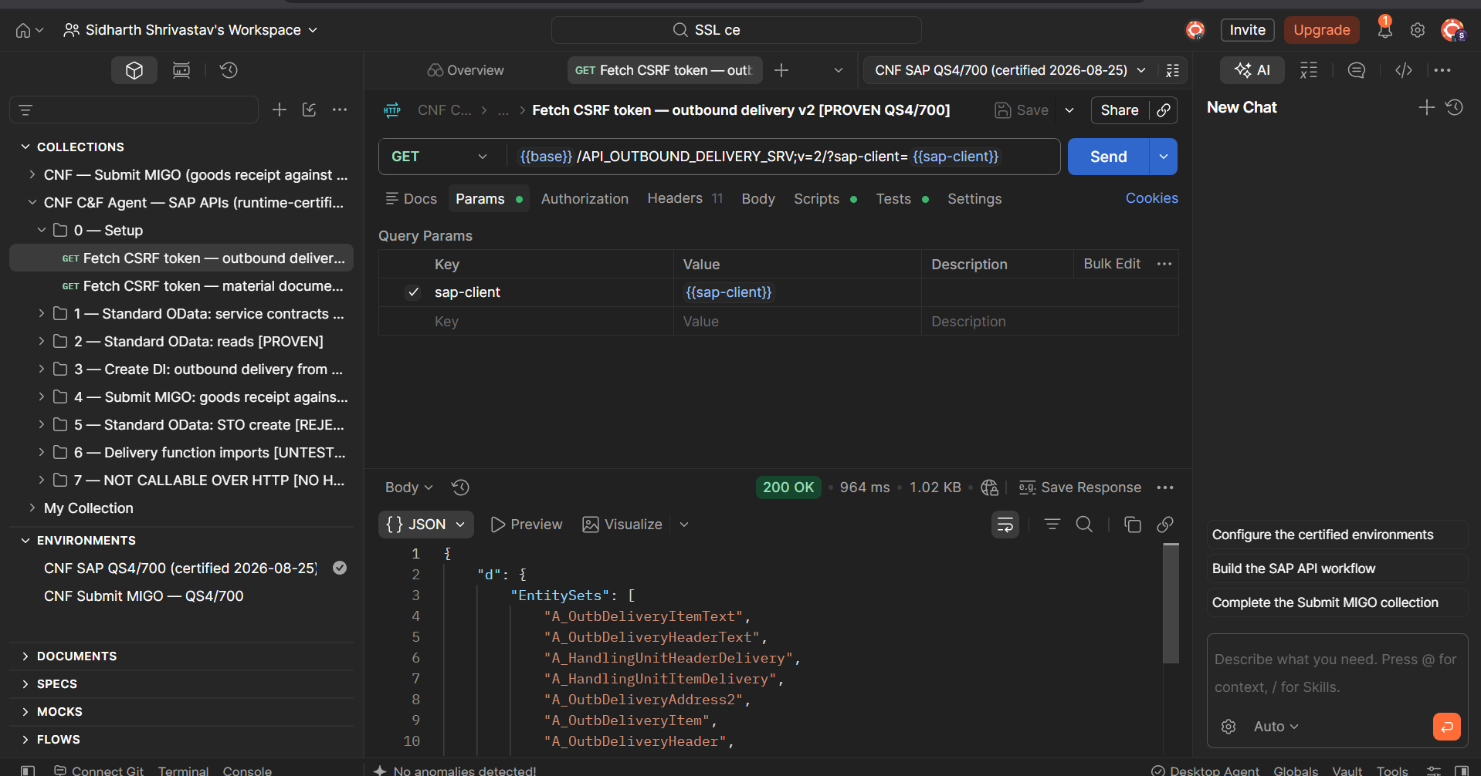
Figure 2. The delivery-service root returns HTTP 200 and supplies the CSRF token.
Meaning for API state -> The delivery service was reachable and authenticated, returned HTTP 200, and issued the CSRF token required for the controlled write. The collection stored the token automatically.
STEP 03
Predecessor read validates the Create DI candidate PASS
method | GET | HTTP status | 200 OK
STO predecessor | 5600084222 / 000010 | existing delivery | 9004953191 / 000010
existing quantity | 50.000 TO | planned create | 1 TO
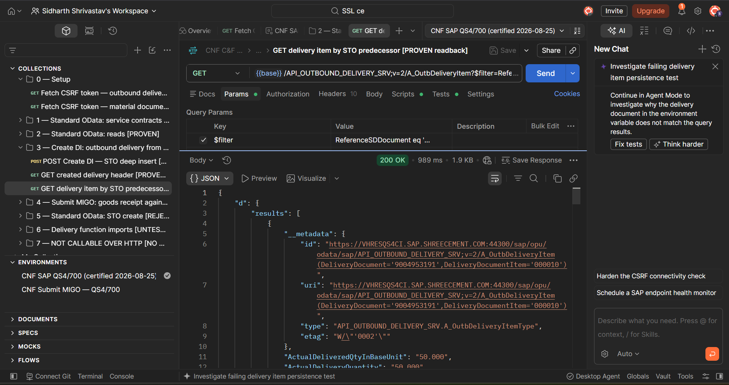
Figure 3. OData predecessor read returns the existing 50 TO delivery before the write.
Meaning for API state -> The predecessor query returned a real outbound-delivery item for the selected STO. Against the documented 1,000 TO PO quantity, 50 TO was already delivered, leaving 950 TO capacity before the 1 TO create. The side-panel persistence warning is expected at this preflight stage because the new delivery key did not yet exist.
STEP 04
Create DI deep insert creates a real delivery PASS
method | POST | entity | A_OutbDeliveryHeader
HTTP status | 201 Created | elapsed | 1.07 s
created delivery | 9004953278 | requested quantity | 1 TO
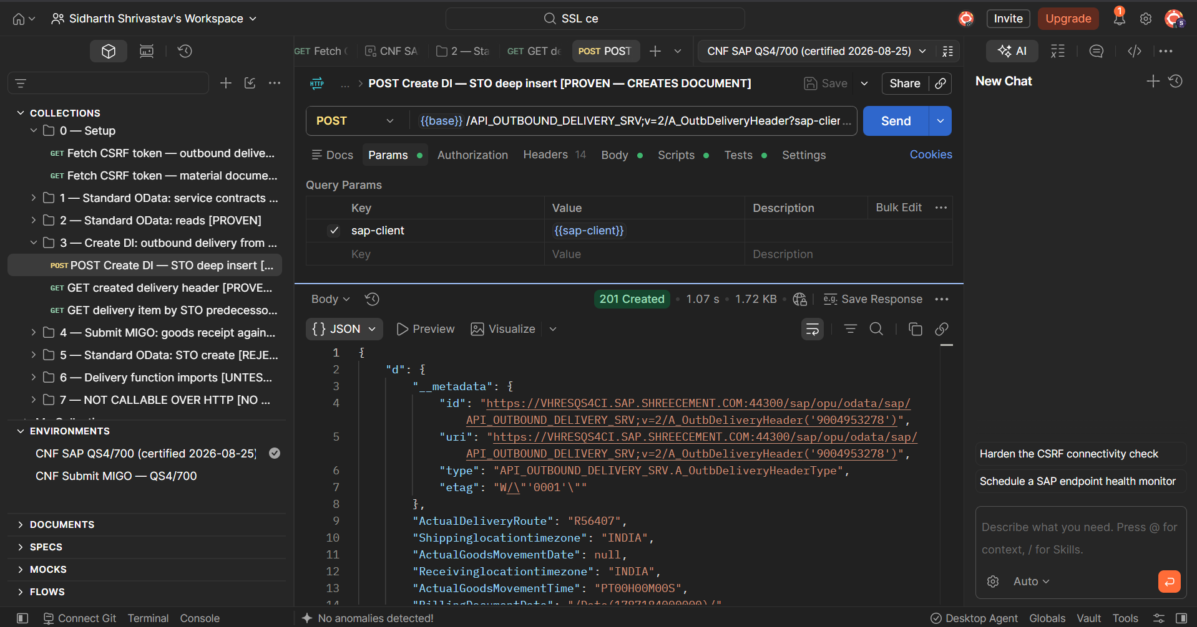
Figure 4. HTTP 201 response identifies outbound delivery 9004953278.
Meaning for API state -> The standard SEGW OData deep-insert route performed the business write successfully. The response returned a numeric SAP delivery key; no BAPI or custom wrapper was involved.
STEP 05
Created delivery header is independently readable PASS
method | GET | HTTP status | 200 OK
delivery | 9004953278 | entity | A_OutbDeliveryHeader
elapsed | 1.31 s | response size | 1.67 KB
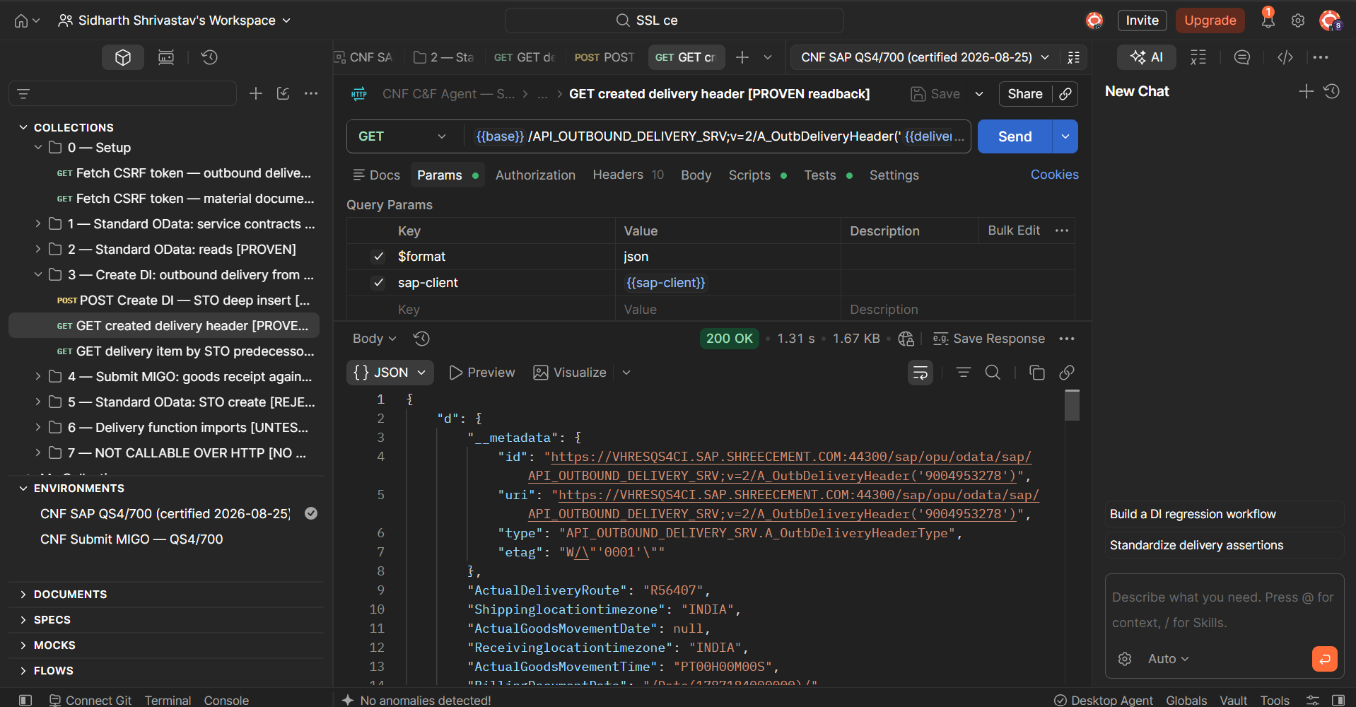
Figure 5. Independent header readback returns delivery 9004953278 with HTTP 200.
Meaning for API state -> A separate GET resolved the exact key returned by the POST. This eliminates the risk of treating an allocated-but-uncommitted document number as proof of persistence.
STEP 06
Item-level readback confirms quantity and predecessor linkage PASS
HTTP result | 200 OK | delivery document | 9004953278
delivery item | 000010 | created by | QNOVATE8
actual quantity | 1.000 TO | original quantity | 1.000 TO
material | 14000035 | plant | 1002
predecessor | 5600084222 / 000010 | movement type / status | 641 / A

Captured OData response facts
DeliveryDocument | 9004953278
DeliveryDocumentItem | 000010
ActualDeliveryQuantity | 1.000
DeliveryQuantityUnit | TO
ReferenceSDDocument | 5600084222
ReferenceSDDocumentItem | 000010
Final technical conclusion
The Create DI API is materially proven in QS4/700. Connectivity, authentication, CSRF handling, deep insert, SAP document creation, header persistence, item persistence, quantity, unit and predecessor linkage were all observed. The result is sufficient to classify the standard OData route as ready for integration hardening and controlled downstream testing.
Flow continuation -> The created-delivery evidence is complete. The following section records the separate Submit MIGO write and material-document readback using the same Postman and SEGW OData test method.

Submit MIGO execution flow
Only the client-relevant document flow is retained below: readiness GET, controlled POST, and independent GET readback. Exploratory candidates, environment edits, duplicate screenshots and request-correction screens are intentionally excluded.
Step | Action | Observed result | What the result establishes
07 | GET eligible delivery and pre-write controls | HTTP 200; status C; 52.330 TO | The selected delivery was fully goods-issued, matched the STO, and had no active 52.330 TO movement-101 receipt before posting.
08 | POST Submit MIGO | HTTP 201; document 5007138638 / 2026 | The standard material-document OData route created a real goods-receipt document.
09 | GET created material document + items | HTTP 200; tests 6/6 | The material-document header and movement-101 item persisted with reference type B, receiving plant and delivery linkage.

Posting identity
service | API_MATERIAL_DOCUMENT_SRV | entity | A_MaterialDocumentHeader
business operation | Goods receipt against STO delivery | movement | 101 / reference type B
STO | 5600084246 / 00010 | delivery | 9004953161 / 000010
material | 12000009 | quantity | 52.330 TO
receiving location | Plant 1025 / RMYD | created document | 5007138638 / 2026

Pre-write duplicate control
Existing active 101 quantity -> 50.750 TO (49.890 + 0.860) under material document 5007138566, corresponding to the other delivery. Active 52.330 TO receipt -> none found before POST.
STEP 07
Readiness GET confirms a fully goods-issued delivery PASS
method | GET | HTTP status | 200 OK
delivery | 9004953161 / 000010 | goods movement status | C
quantity / material | 52.330 TO / 12000009 | receiving location | 1025 / RMYD
STO | 5600084246 / 000010 | duplicate 52.330 receipt | none found
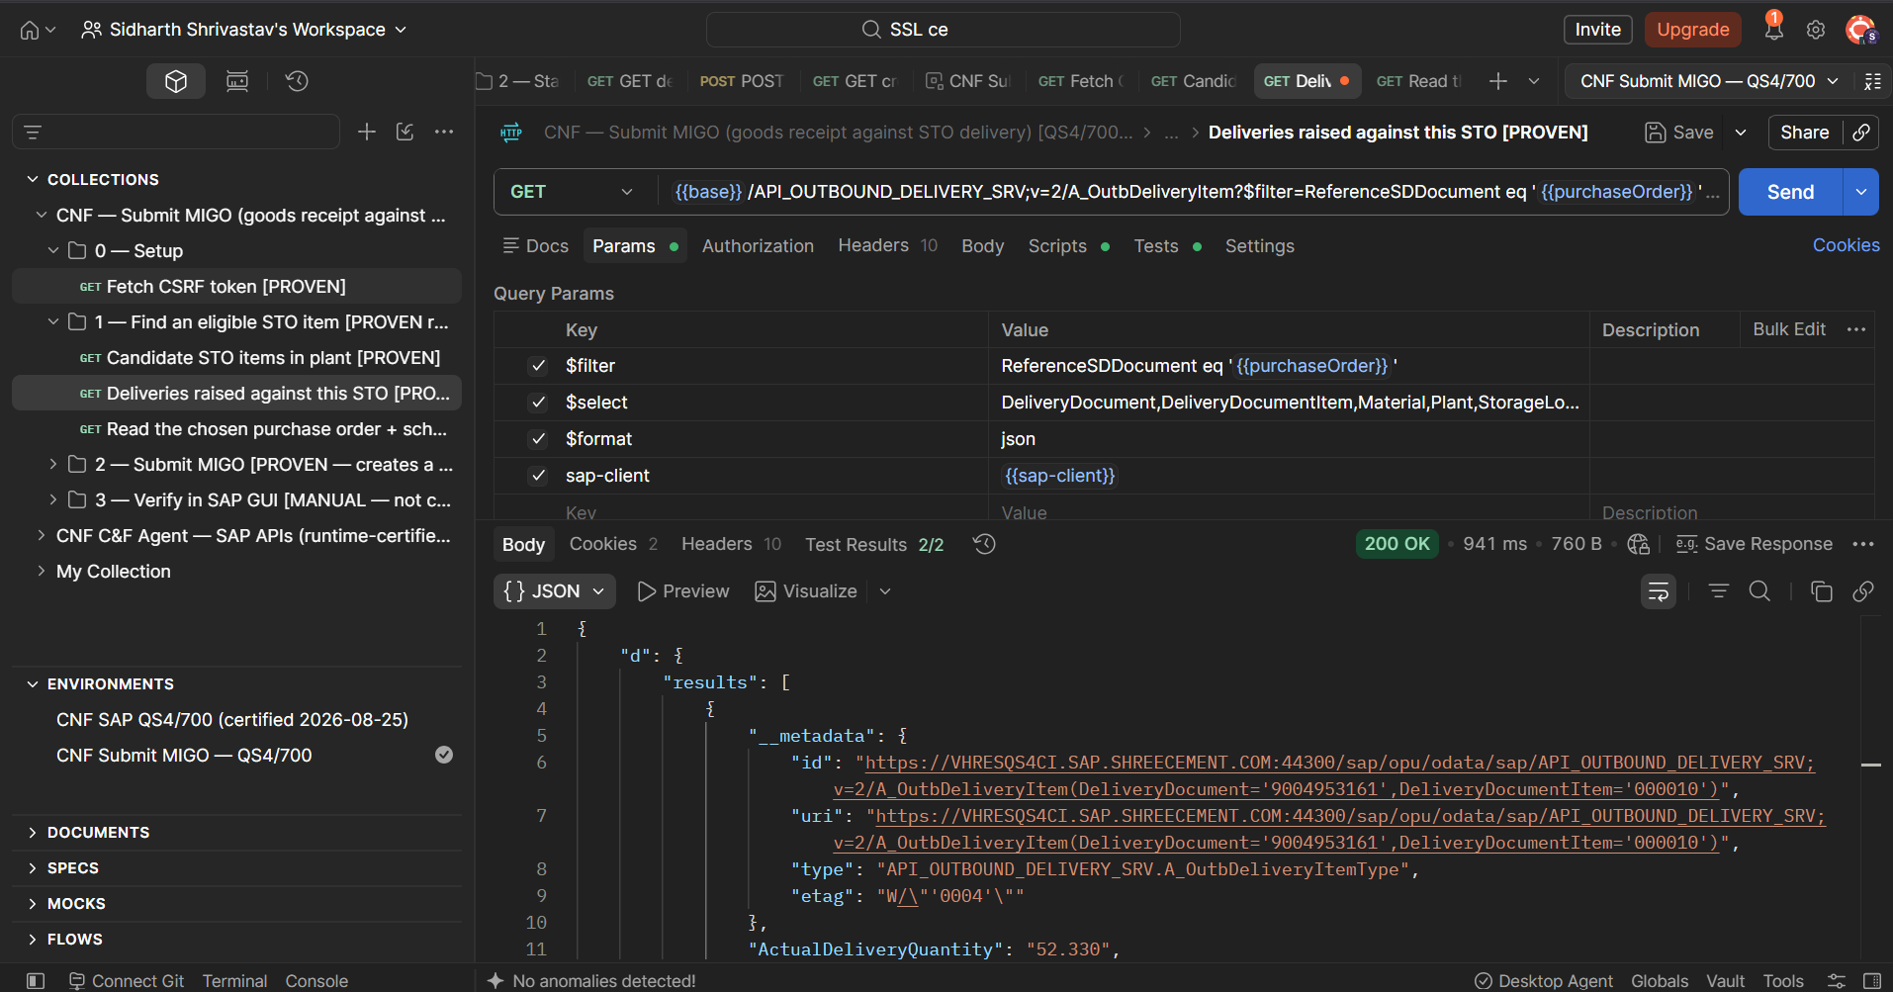
Figure 6. The selected STO delivery resolves with HTTP 200 before the goods-receipt write.
Meaning for API state -> The delivery read returned the exact STO-linked item with GoodsMovementStatus C, proving the 641 goods issue was complete. A separate read-only material-document scan found only the other delivery's 50.750 TO receipt and no active 52.330 TO receipt before the controlled POST.
STEP 08
Submit MIGO creates a real material document PASS
method | POST | HTTP status | 201 Created
tests | 5 / 5 passed | service | API_MATERIAL_DOCUMENT_SRV
movement | 101 / reference type B | transaction type | WE
material document | 5007138638 / 2026 | created by | QNOVATE8
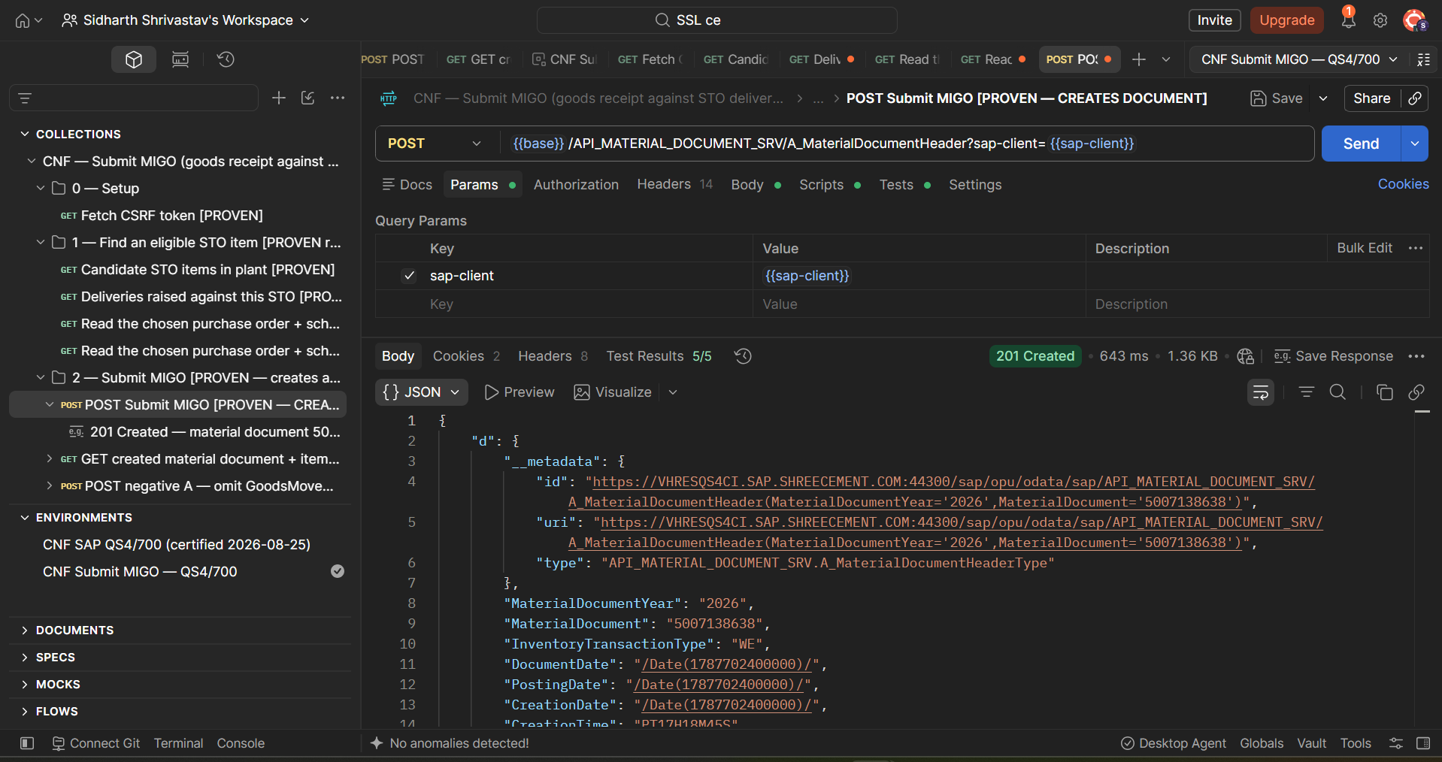
Figure 7. HTTP 201 identifies material document 5007138638 / 2026 and five passing creation assertions.
Meaning for API state -> The standard material-document SEGW OData route accepted the delivery-linked goods-receipt payload and returned a committed SAP material-document key. The collection reset the one-shot posting confirmation after the response.
STEP 09
Material-document GET proves persisted goods receipt PASS
method | GET | HTTP status | 200 OK
tests | 6 / 6 passed | material document | 5007138638 / 2026
movement type | 101 | reference type | B
receiving plant | 1025 | delivery link | 9004953161 / 000010
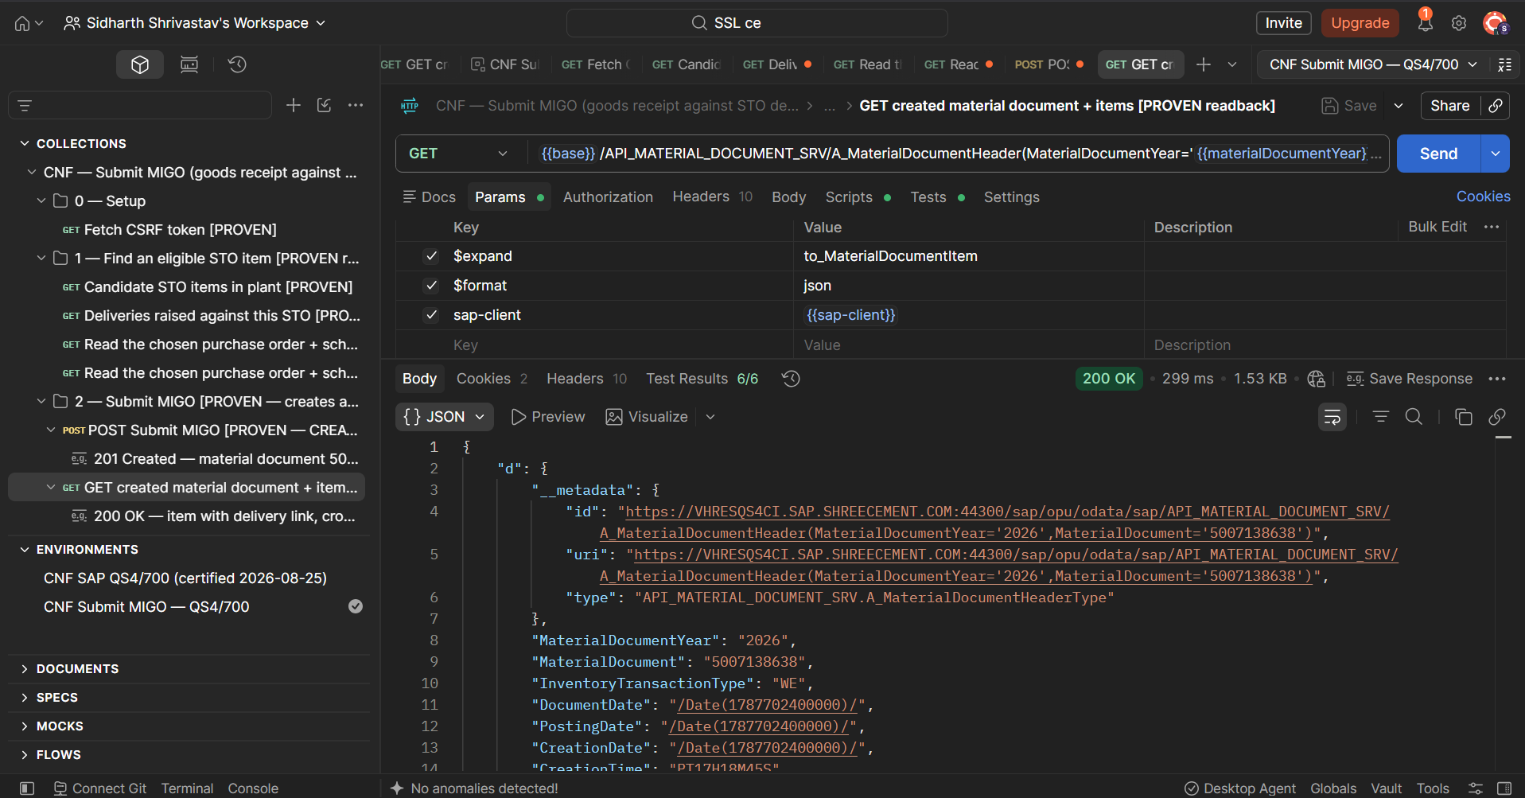
Figure 8. Independent expanded GET returns material document 5007138638 with HTTP 200 and six passing persistence assertions.
BOTH STANDARD ODATA OPERATIONS ARE PROVEN. Create DI produced and persisted outbound delivery 9004953278. Submit MIGO produced and persisted material document 5007138638 / 2026 for delivery 9004953161. The evidence covers pre-write reads, HTTP 201 business writes and independent post-write OData readbacks without calling a BAPI.

