TASK 3.1 Computing the Dimensions of a Box

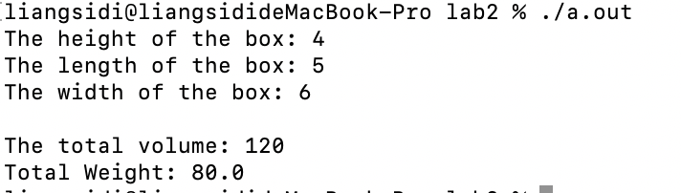

//

// task3_1.c

// Sidi Liang

//

#include <stdio.h>

#include <math.h>

int main(){

const short height = 4, length = 5, width = 6;

const int volume = height * length * width;

const float weight = volume / 1.5;

printf("The height of the box: %hd \nThe length of the box: %hd \nThe width of the box: %hd \n \nThe total volume: %d \nTotal Weight: %0.1f \n", height, length, width, volume, weight);

return 0;

}

Code for TASK 3.1

Figure 1: Output of Code in Task 3.1.

TASK 3.1.1 Value ranges of variables

Use of undeclared identifier 'marks'

int marks;

marks = 23;

TASK 3.2 Mathematical Expressions



//

// task3_2.c

//

// Sidi Liang

//

#include <stdio.h>

#include <math.h>

int main(){

int x = 1;

//scanf("%d", &x);

float exp_x = 1 + x + (float)x * x / 2 + (float)x * x * x / 6 + (float)x * x * x * x / 24;

printf("%.3f\n", exp_x);

return 0;

}

Code for TASK 3.2

Figure 2: Output of Code in Task 3.2.

TASK 3.3 Variable Types

/ //

// task3_3.c

//

// Sidi Liang

//

#include <stdio.h>

#include <math.h>

int main(){

const int a = 6, b = 7;

float c = (float)a / (float)b;

printf("%d\n%d\n%.3f\n", a, b, c);

return 0;

}

Code for TASK 3.3

Figure 1: Output of Code in Task 3.3.

