TASK In Scotland, the tax is calculated based on the information given in Table 1. Write a program, that will input the gross salary (taxable salary) from the user, and based on the tax rate, calculates the take-home salary (net salary). For example, if one earns £40,000 a year, they pay:

nothing on the first £12,500

19% (£396.15) on the next £2,085 20% (£2,114.60) on the next £10,573 21% (£3,116.82) on the next £14,842 --

Total Tax: £5627.57.

An example input/output dialog is shown below:

Enter Gross Income in GBP: 40000 Your Take-home salary is: 34372.43, The total tax paid is: 5627.57

// The number of digits depends on the data type that you use, which may not be same as above.

//

// Lab3

// 3/11/20

// Sidi Liang

//

#include <stdio.h>

float calculateTax(float grossIncome, float tax); //The function for calculating total tax, takes grossIncome and current tax (must be 0 in the first call) as input, returns the total tax(float)

int main(){

float grossIncome;

printf("%s", "Enter Gross Income in GBP: ");

scanf("%f", &grossIncome);

printf("Your Take-home salary is: %.2f\n", grossIncome - calculateTax(grossIncome, 0));

printf("The total tax paid is: %.2f\n", calculateTax(grossIncome, 0));

return 0;

}

float calculateTax(float grossIncome, float tax){

if(grossIncome <= 12500) return tax; //Exits the recurtion

else if(grossIncome <= 14585){ //Calculates Starter rate

tax += 0.19 \* (grossIncome - 12500);

return calculateTax(12500, tax);

}else if(grossIncome <= 25158){ //Calculates Basic rate

tax += 0.2 \* (grossIncome - 14585);

return calculateTax(14585, tax);

}else if(grossIncome <= 43430){ //Calculates Intermediate rate

tax += 0.21 \* (grossIncome - 25158);

return calculateTax(25158, tax);

}else if(grossIncome <= 150000){ //Calculates Higher rate

tax += 0.41 \* (grossIncome - 43430);

return calculateTax(43430, tax);

}else{ //Calculates Top rate

tax += 0.46 \* (grossIncome - 150000);

return calculateTax(150000, tax);

}

}

Code for TASK 3.1

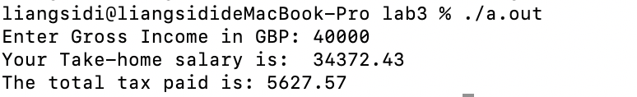

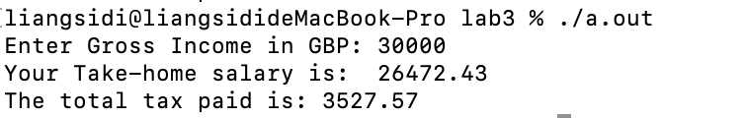

Figure 1: Output of Code in Task 3.1.