TASK 1 Create a "guessing game" program. Set a number to be 16. Tell the user to guess an int between 1 and 32 (inclusive).

//

// LAB guessinggame.c

// 7/11/20

// Sidi Liang

//

#include <stdio.h>

int main(){

puts("Guess an int between 1 and 32 (inclusive).");

int presetAnswer = 16; //The preset anwser 16

int userInput, resultFlag = 0; //resultFlag: 0 if user loses, 1 if user wins

for(int i = 0; i < 5; i++){

scanf("%d", &userInput); //input to userInput

if(userInput < presetAnswer) puts("too low");

else if(userInput > presetAnswer) puts("too high");

else{

puts("correct");

resultFlag = 1; //user wins

break;

}

}

if(resultFlag) puts("you win");

else puts("you lose");

return 0;

}

Code for TASK 1

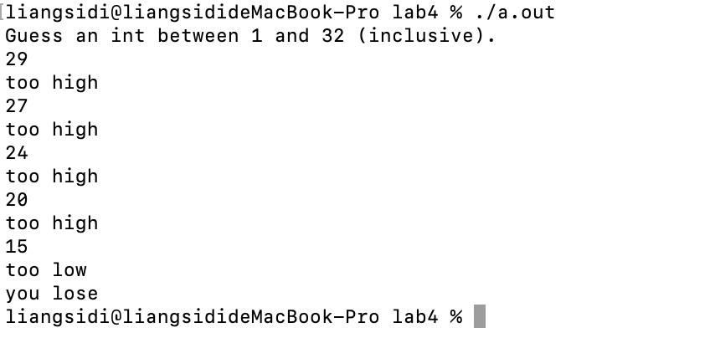

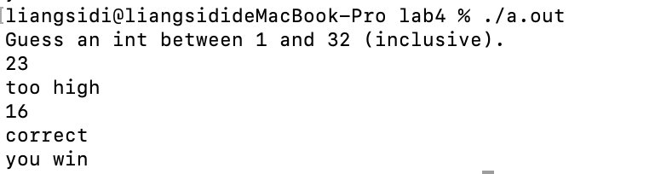

Figure 1: Output of Code in Task 1.

TASK 1.2 Modify your guessing game:

//

// LAB guessinggame_2.c

// 7/11/20

// Sidi Liang

//

#include <stdio.h>

#include <stdlib.h>

#include <time.h>

int gameSession(int presetAnswer);

int main(){

int score = 0, bestScore = 0;

int presetAnswer = 16;

srand((unsigned)time(NULL)*10);

score = gameSession(presetAnswer);

bestScore = score;

while(1){

presetAnswer = rand() % 32 + 1;

score = gameSession(presetAnswer);

if(score < bestScore) bestScore = score;

printf("your best score (fewest number of guesses) is %d \n", bestScore);

if(score <= 4) break;

}

return 0;

}

int gameSession(int presetAnswer){

puts("Guess an int between 1 and 32 (inclusive).");

int userInput, attempts = 0; //resultFlag: 0 if user loses, 1 if user wins

while(1){

attempts += 1;

scanf("%d", &userInput); //input to userInput

if(userInput < presetAnswer) puts("too low");

else if(userInput > presetAnswer) puts("too high");

else{

puts("correct");

break;

}

}

puts("you win");

printf("you took %d guesses to win\n", attempts);

return attempts;

}

Code for TASK 1.2

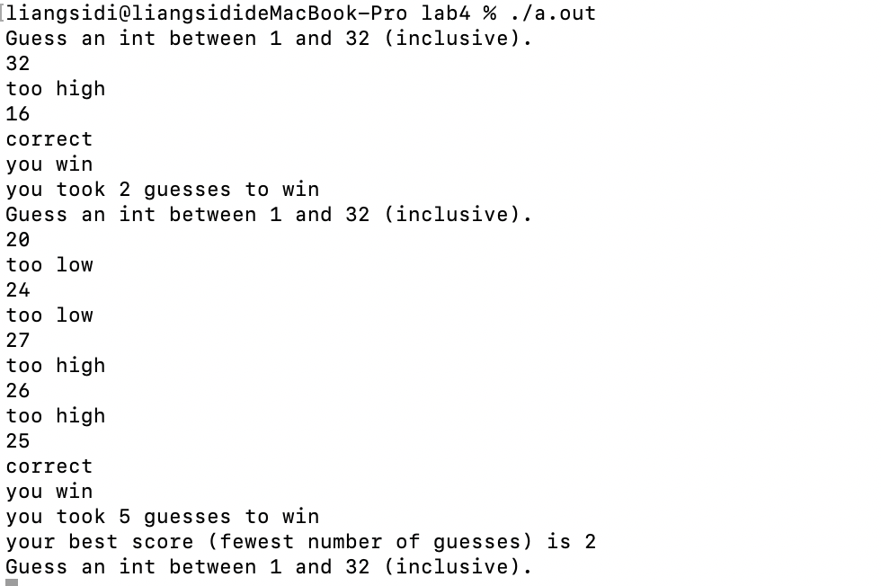

Figure 2: Output of Code in Task 1.2.

TASK 2 Your task is to draw a room from a family of games called Roguelikes ‐‐ the player (represented by the @ symbol) must explore a dungeon.

//

// LAB Loops

// 10/11/20

// Sidi Liang

//

#include <stdio.h>

void drawHorizontalLine(int length); //draw a horizontal +----+ line

void drawLineWithoutPlayer(int length);//draw a line without the player |....|

void drawLineWithPlayer(int length, int playerPosition);//draw the line with the player |..@.| at given position

int main(){

int length, height, positionX, positionY;

scanf("%d%d%d%d", &length, &height, &positionX, &positionY);//input the room and player position

drawHorizontalLine(length); //Draw the frame

for(int i = 0; i < positionY; i++){

drawLineWithoutPlayer(length);

}

drawLineWithPlayer(length, positionX);

for(int i = positionY + 1; i < height; i++){

drawLineWithoutPlayer(length);

}

drawHorizontalLine(length);//Draw the frame

return 0;

}

void drawHorizontalLine(int length){

printf("%c", '+');

for(int i = 0; i < length; i++){

printf("%c", '-');

}

printf("%c\n", '+');

}

void drawLineWithoutPlayer(int length){

printf("%c", '|');

for(int i = 0; i < length; i++){

printf("%c", '.');

}

printf("%c\n", '|');

}

void drawLineWithPlayer(int length, int playerPosition){

printf("%c", '|');

for(int i = 0; i < playerPosition; i++){

printf("%c", '.');

}

printf("%c", '@');

for(int i = playerPosition + 1; i < length; i++){

printf("%c", '.');

}

printf("%c\n", '|');

}

Code for TASK 2

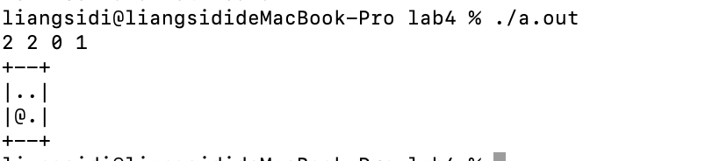

Figure 3: Output of Code in Task 2.

TASK 2.1 combine this exercise with keyboard input ‐‐ let the player move around in the room, bump into walls, etc..

//

// LAB Loops

// 10/11/20

// Sidi Liang

//

#include <stdio.h>

void drawHorizontalLine(int length); //draw a horizontal +----+ line

void drawLineWithoutPlayer(int length);//draw a line without the player |....|

void drawLineWithPlayer(int length, int playerPosition);//draw the line with the player |..@.| at given position

int main(){

int length, height, positionX, positionY;

scanf("%d%d%d%d", &length, &height, &positionX, &positionY);//input the room and player position

getchar();//Prevents the first print to run twice

puts("Use w, a, s, d to move around");

while(1){

//bounce back if out of bounds

if(positionX < 0) positionX = 0 - positionX;

else if(positionX > length - 1) positionX = length - 2;

if(positionY < 0) positionY = 0 - positionY;

else if(positionY > height - 1) positionY = height - 2;

drawHorizontalLine(length); //Draw the frame

for(int i = 0; i < positionY; i++){

drawLineWithoutPlayer(length);

}

drawLineWithPlayer(length, positionX);

for(int i = positionY + 1; i < height; i++){

drawLineWithoutPlayer(length);

}

drawHorizontalLine(length);//Draw the frame

getchar();//Wait for user input

int userControl = getchar();

if(userControl == 'w') positionY -= 1;

else if (userControl == 's') positionY += 1;

else if (userControl == 'a') positionX -= 1;

else if (userControl == 'd') positionX += 1;

puts("");//New Line

}

return 0;

}

void drawHorizontalLine(int length){

printf("%c", '+');

for(int i = 0; i < length; i++){

printf("%c", '-');

}

printf("%c\n", '+');

}

void drawLineWithoutPlayer(int length){

printf("%c", '|');

for(int i = 0; i < length; i++){

printf("%c", '.');

}

printf("%c\n", '|');

}

void drawLineWithPlayer(int length, int playerPosition){

printf("%c", '|');

for(int i = 0; i < playerPosition; i++){

printf("%c", '.');

}

printf("%c", '@');

for(int i = playerPosition + 1; i < length; i++){

printf("%c", '.');

}

printf("%c\n", '|');

}

Code for TASK 2.1

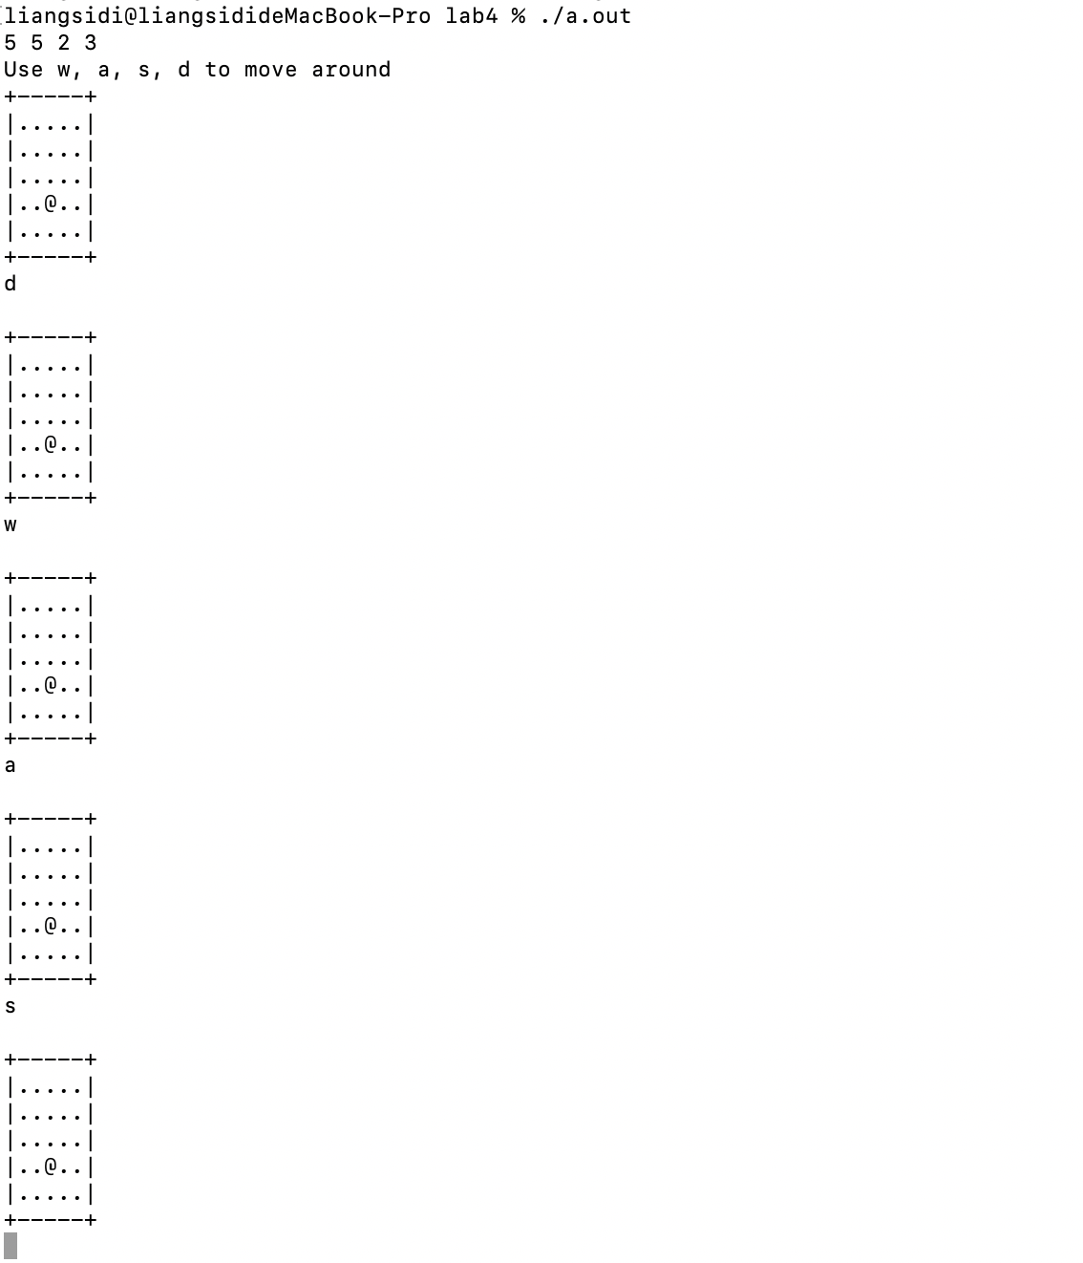

Figure 4: Output of Code in Task 2.1.