TASK 1 Calling time(NULL) gives you a large integer. Use this value to calculate today's year, date, hours, and minutes.

//

// LAB POINTERS TASK 1

// 4/12/20

// Sidi Liang

//

#include <stdio.h>

#include <time.h>

#define TOTAL_SEC_IN_DAY 86400

void calculateYearAndDay(time_t now, int *year, int *day); //Function to calculate Year and Day

void calculateHourAndMinute(time_t now, long *hour, long *minute);//Function to calculate hour and minute

void printTime(int year, int day, long hour, long minute);//Function to print time

int main() {

time_t now;

now = time(NULL); //total seconds

//printf("%li\n", now);

int year = 0, day = 0;

long hour = 0, minute = 0;

calculateYearAndDay(now, &year, &day);

calculateHourAndMinute(now, &hour, &minute);

printTime(year, day, hour, minute);

return 0;

}

void calculateYearAndDay(time_t now, int *year, int *day){

long int totalDay = now / TOTAL_SEC_IN_DAY;

*year = (int)totalDay / 365 + 1970;

*day = (int)totalDay - (*year - 1970) * 365 + 1;

}

void calculateHourAndMinute(time_t now, long *hour, long *minute){

long totalDay = now / TOTAL_SEC_IN_DAY;

long totalMinute = now / 60, totalHour = now / 3600;

*hour = totalHour - (24 * totalDay);

*minute = totalMinute - totalHour * 60;

}

void printTime(int year, int day, long hour, long minute){

printf("%d, %d\n%ld, %ld\n", year, day, hour, minute);

}

Code for TASK 1

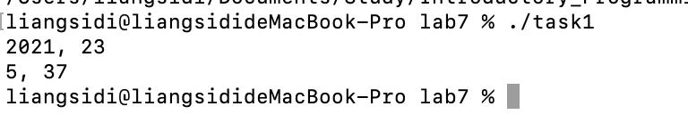

Figure 1: Output of Code in Task 1.

1. TASK 1 optional optional: handle leap-years correctly, and print the month as well

//

// LAB POINTERS TASK 1

// 4/12/20

// Sidi Liang

//

#include <stdio.h>

#include <time.h>

#define TOTAL_SEC_IN_DAY 86400

void calculateYearAndDay(time_t now, int *year, int *day, int *month); //Function to calculate Year and Day

void calculateHourAndMinute(time_t now, long *hour, long *minute);//Function to calculate hour and minute

void printTime(int year, int day, int month, long hour, long minute);//Function to print time

int isLeapYear(int year){

if(year % 100 == 0 && year % 400 != 0){

return 0;

}

if(year % 4 == 0){

return 1;

}

return 0;

}

int main() {

time_t now;

now = time(NULL); //total seconds

//printf("%li\n", now);

int year = 0, day = 0, month = 0;

long hour = 0, minute = 0;

calculateYearAndDay(now, &year, &day, &month);

calculateHourAndMinute(now, &hour, &minute);

printTime(year, day, month, hour, minute);

return 0;

}

void calculateYearAndDay(time_t now, int *year, int *day, int *month){

long int totalDay = now / TOTAL_SEC_IN_DAY - 12; //hard coded leap year

*year = (int)totalDay / 365 + 1970;

*day = (int)totalDay - (*year - 1970) * 365 + 1;

if(*day <= 31){

*month = 1;

}else if(*day <= 60){

*month = 2;

*day -= 31;

}else if(*day <= 91 && isLeapYear(*year)){//hard coded 2020

*month = 3;

*day -= 60;

}else if(*day <= 90 && !isLeapYear(*year)){//hard coded 2020

*month = 3;

*day -= 60;

}else if(*day <= 121){

*month = 4;

if(isLeapYear(*year)) *day -= 91;

else *day -= 90;

}else if(*day <= 152){

*month = 5;

*day -= 121;

}else if(*day <= 182){

*month = 6;

*day -= 152;

}else if(*day <= 213){

*month = 7;

*day -= 182;

}else if(*day <= 244){

*month = 8;

*day -= 213;

}else if(*day <= 274){

*month = 9;

*day -= 244;

}else if(*day <= 305){

*month = 10;

*day -= 274;

}else if(*day <= 335){

*month = 11;

*day -= 305;

}

else if(*day <= 366){

*month = 12;

*day -= 335;

}

}

void calculateHourAndMinute(time_t now, long *hour, long *minute){

long totalDay = now / TOTAL_SEC_IN_DAY;

long totalMinute = now / 60, totalHour = now / 3600;

*hour = totalHour - (24 * totalDay);

*minute = totalMinute - totalHour * 60;

}

void printTime(int year, int day, int month, long hour, long minute){

printf("%d, %d, %d\n%ld, %ld\n", year, month, day, hour, minute);

}

Code for TASK 1.1

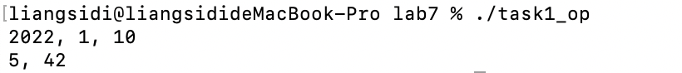

Figure 2: Output of Code in Task 1.1.