Digital marketing

MGMT 6460 – ADVANCED QUANTITATIVE METHODS FOR BUSINESS

RENSSELAER POLYTECHNIC INSTITUTE

**TAZIEN FATMA  
SIDDHARTH JAIN**

**ANKUR JOSHI**

# **Overview:**

Mammalsrus.com is an educational website providing information about 5000 species of mammals. Currently the owners are using Google Adwords for increasing the traffic on the website and an associated blog. As a consultation team, we feel that the budget for the marketing campaigns on Google Analytics could be optimized constrained to the requirements put forth by the owner, we could improve on the budget allocation. This would result in an increased traffic for the website and the blog. Also, the owners plan to explore future commercialization options by selling merchandise. This in itself would require a new marketing campaigns on other online avenues to target the possible collaborations in form of distributors. These collaborations could come from local pet shops, retailing stores or different bloggers for further advertising and endorsing of the company’s products for increased sales. This project has helped us get an insight into the digital advertising/marketing world and how value could be added using optimization techniques for different objectives pertaining to the targets.

# **Techniques:**

**Task 1:**  Involved optimizing the current budget being put into Google Adwords. This is necessary to increase the reach of the website and blog. This provides a long-term benefit for the company by increasing online presence and consumer base. Also, this could indirectly provide an organic growth which will add on to increasing the reach even more. For this task, the techniques that are used is Non-Linear Programming and Set-Covering concepts.

**Task 2:** Involves optimizing the budget for the marketing campaign required for possible future partnerships. We are using the three different channels (Facebook, Email and Twitter) due to an added advantage over Google Adwords. The aforementioned channels have an option to define and target specific demographic which would help the company target partners with aligned interests. Campaigns pertaining to this goal have certain consultation fees associated with it, which are fixed for a given week. Hence, we use Mixed Integer Programming.

# **Data Collection:**

**Task 1:** We are using the historical data from Google Adwords existing campaigns. Following data is extracted for each day of the week:

1. Campaign Name
2. Cost
3. Sessions

The sessions generated here refer to the traffic generated through the marketing campaign. The data required manipulation to generate a new metric which gave the information of number of sessions generated for each campaign on each day separately. This helps us understand the current trend, which is used for the budget allocation. This trend is set to improve which would require more iterations on the current optimization model in future as the reach improves. Please refer [here](https://github.com/sidj-14/aqrm_project) for the manipulated table.

**Task 2:** No initial marketing was done by the company on the mentioned channels. Due to non-availability of any historical data for the other three marketing channels, we relied on secondary research to optimize the current budget. The reach generated through these marketing campaigns would result in lead generation (assuming a lead conversion percentage of 2.5% on the sessions/clicks generated from that campaign). After the research, the estimated values for each of the marketing avenues is given below in the table.

|  |  |  |
| --- | --- | --- |
| Marketing Channel | Fixed Cost | Cost Per Click |
| Facebook | $ 250 | $0.27 |
| Email | $ 150 | $0.38 |
| Twitter | 0 | $0.84 |

For our target, the owner is not willing to obtain any consultation for the Twitter campaigns.

# **Problem Formulation:**

Below is the mathematical problem formulation for the above two business targets.

## Task 1:

Objective: Optimization of weekly budget distribution to increase the visits on the website ensuring relative uniformity of visitors.

As we need to use consumer engagement, we need to maximize the number of visits by ensuring somewhat uniform engagement on each day for each campaign. This is required because as any new website is launched, without constantly showing the brand to the customers, it is difficult to increase customer loyalty and interaction. This is also called educating the customer. This is a major reason for an increased organic growth.

Problem Formulation:

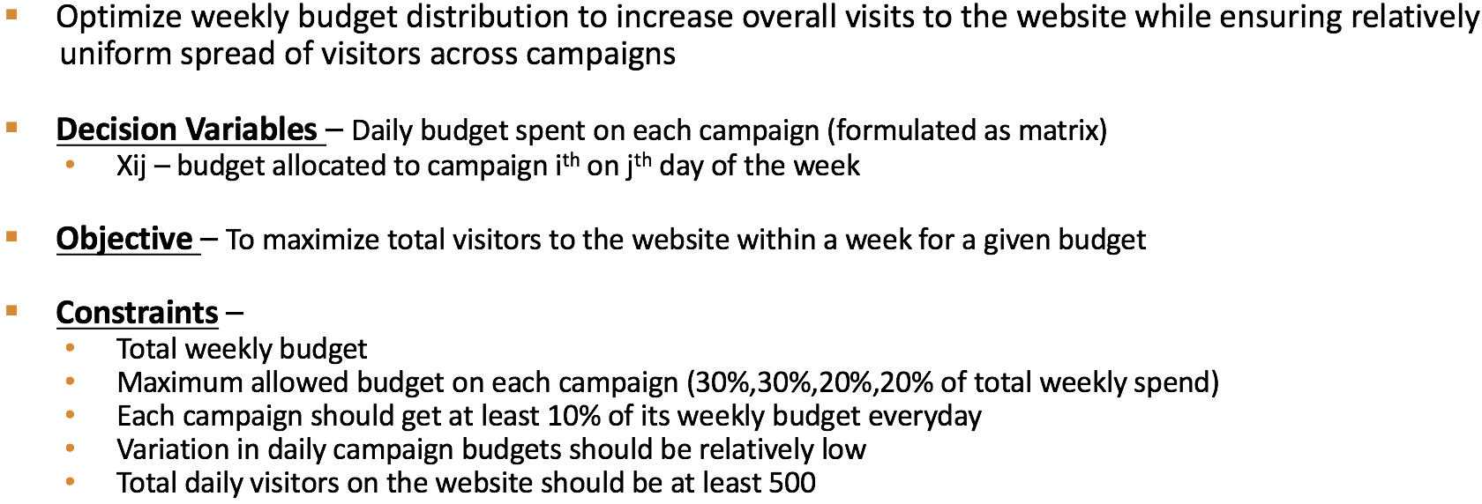

The decision variables here are the budget allocated to each campaign on each day for the whole week. These variables are also subject to constraints as put by the owner of the website. Firstly, the total weekly spent needs to be $180. Also at the same time as two of the campaigns refers to regularly updated sections of the website and blog, the owner wants a skewed spread of the total budget favoring those sections. Please refer to the budget division for each campaign [here](https://github.com/sidj-14/aqrm_project).

As the current stats show an inclination towards a single day which harms the consumer engagement. This is avoided by using the minimum budget allocation for each day (10% of the weekly total budget) and a controlled variance for the predicted sessions. Also deriving from the historical data, we are optimistically targeting minimum of 500 sessions each day across all campaigns, which is higher than what the existing campaign generated without optimization.

As the constraints of variance and daily budget allocation dependent on weekly spend which is the sum of all the decision variables for that campaign, there is non-linearity introduced in the problem. Hence, we need to use GRG-Nonlinear engine to solve this set covering optimization.

## **Task 2:**

Objective: Budget Allocation to the advertising channels (Facebook, Email & Twitter) which are used for partnership possibilities.

This marketing is different from the marketing used to increase the reach of consumers visiting the website. As the owner is thinking of future commercialization plans, possible partners need to be searched for merchandising distribution. As these channels provide an added advantage of defining the demographic which could help in targeting people with specific behaviors like pet stores owners who could become a partner for any future plans. This feature is available in all three, Facebook, Twitter and Email. However, as the commercialization aspect is involved a more professional approach is required in the marketing strategy. Hence there is a fixed cost available with these avenues pertaining to any required consultation. These consultations could range from buying emails, developing content, identifying the right demographic. The cost researched for were given monthly. To make it consistent with the weekly budget allocation to these channels, the fixed costs are assumed to be weekly.

Problem Formulation:  
  
 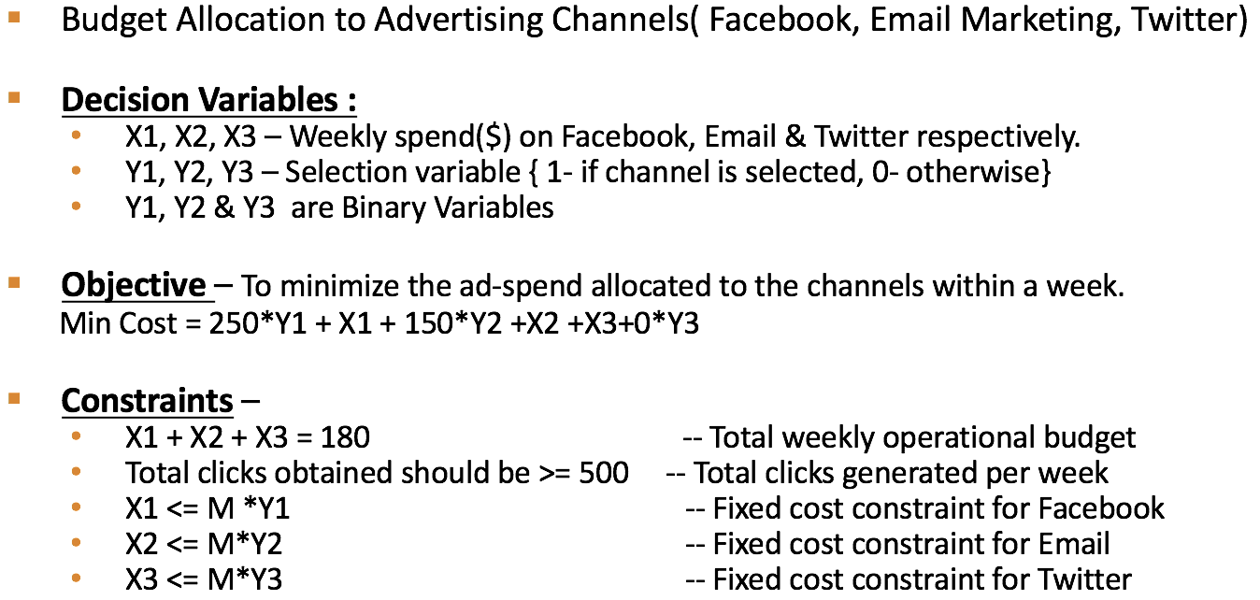   
  
There are two sets of decision variables required for this optimization problem. As there is a fixed cost is involved, we need to be sure that if that channel is selected, the net cost is minimized which involves both the variable cost and the fixed cost for that week. Hence in total we have six decision variables, three of which are binary which help in implementing the “If-Then” constraint in the problem using the Big-M method. As per the owner the total weekly budget allocated is $180 for the three channels. We also require at least 500 impressions to be served. These are then funneled down to leads with an average lead conversion percentage of 2.5%. The rest of the constraints are the implementation of “If-Then” conditions using binary variables.

# **Results & Recommendations:**

**Adwords Optimization Solution:**

As per the solution provided by solver:

1. Website should spend following amounts on campaigns specified for day of the week:

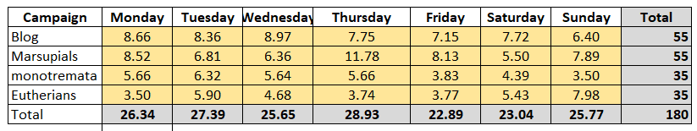

Company should see there is recommended variation as depicted by the chart above on how much amount to spend on each day of the week. For example, “marsupials” campaign has a peak on “Thursday”, so they should spend more here to get maximum benefit, in terms of visits.

2. These are the clicks generated every day of the week based on the ad-spend suggested by solver. Total weekly clicks are almost 4340, using the ad-spend of $180.

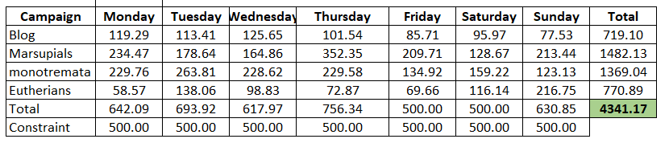

We recommend Mammalsrus.com to follow the above suggested budget allocation for maximizing visits to the site. Website can scale up or down their weekly budget based on above criteria.

**Budget Allocation to the advertising channels (Facebook, Email & Twitter):**

As per the solution provided by solver:

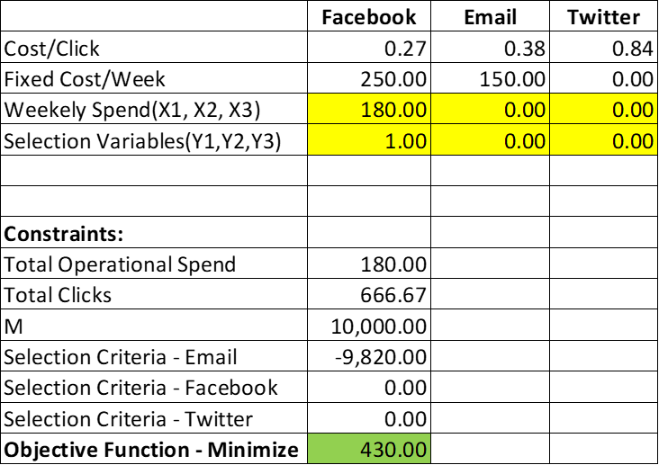

* Website should focus on **Facebook Advertising** at the current budget constraints. Selecting other channels within this budget range is not optimal.
* Assuming a 2.5% lead conversion from lead generation advertising, we can say that at least **16 leads** could be generated with the current budget.
* We also found that if the weekly budget is changed the channel selection also changes. So, if owners want to change the budget in future they can select other channels as well.

**--------------------------------**