Application for Employment
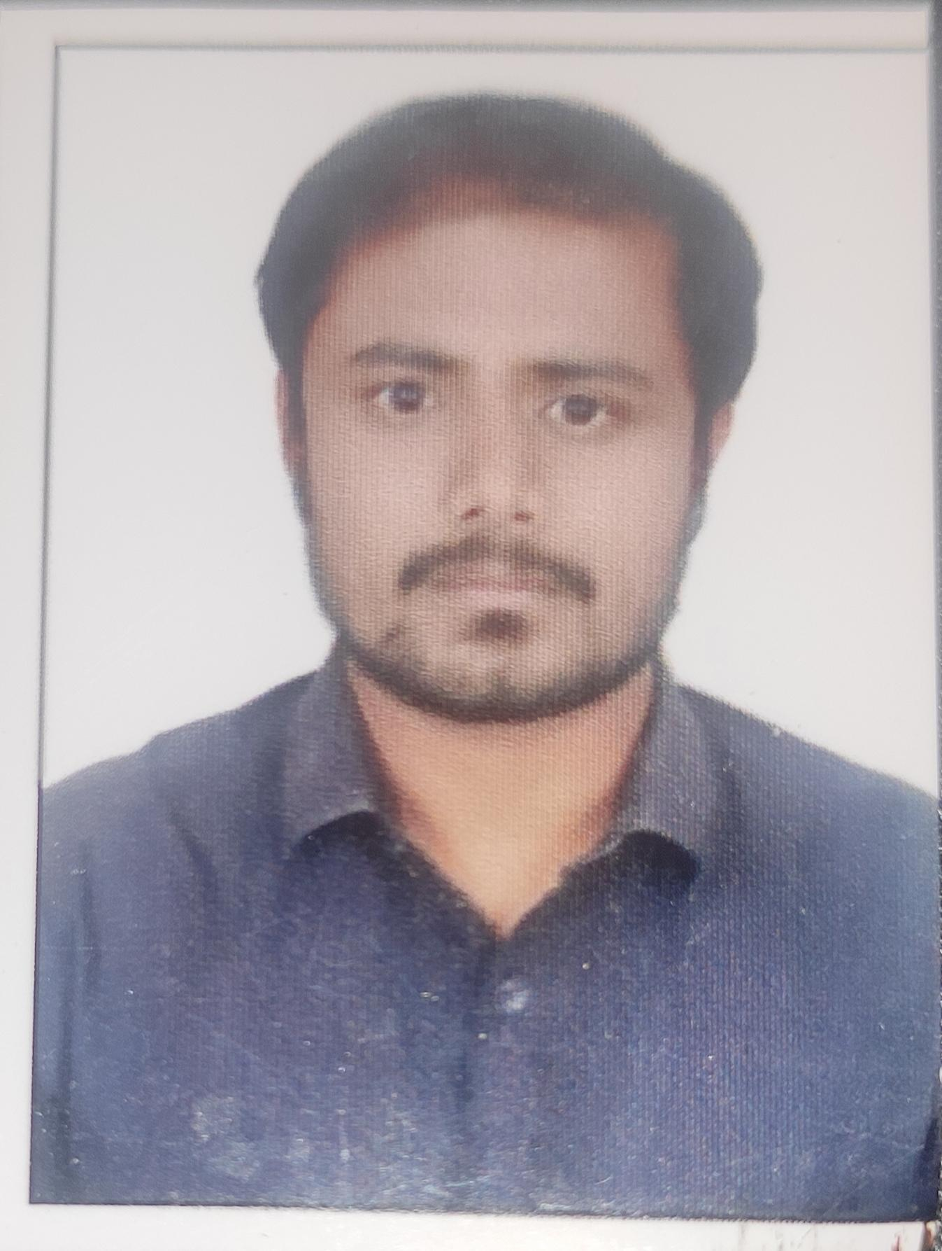se affix passport size photograph
Position Applied for: ANGULAR DEVELOPER *

* Mandatory to fill data.

* Personal Details (To be filled as per your passport):
*Last Name |  | JEER |  |  |  |  | First Name | SIDDRAMESHWAR |  |  |  | Middle Name | JEER
*Place and Date of Birth |  |  |  |  | GADAG 30/05/1994 |  |  |  | *Marital Status |  |  | UNMARRIED
*Present Address |  |  | SHAPETH STREET NEAR M M SAJJAN OIL MILL VIJAYAPURA, KARNATAKA-586101
Tel (R) * |  |  |  |  |  |  |  |  | (M) * 8710892214
*E-mail | SIDJEER@GMAIL.COM
*Permanent Address |  |  |  | SHAPETH STREET NEAR M M SAJJAN OIL MILL VIJAYAPURA, KARNATAKA-586101
*Permanent Tel (R)
Four Wheeler Driving License No. |  |  |  |  |  | KA2820120009364 |  |  |  | IDP No

Passport / Visa Details
*Passport No | P3880089 |  | Place of Issue | BENGALURU
Dt. of Issue | 04/08/2016 |  | Dt. of Expiry | 03/08/2026
*Nationality | INDIAN |  | ECNR Status
*PAN No: |  | AUFPJ9604G
If not, have you applied for a Passport?
Place and Date of Application
Countries travelled abroad
Have you been refused Visa any time? If yes, give details
Do you have a valid Visa currently? If yes, give details

* Family Background
 | Name |  | Name
Father | RAJSHEKHAR JEER | Spouse
Mother | RAJASHREE JEER | Children

* Educational Qualifications (List in chronological order starting with Xth Standard)
School/College/University | Period |  | Degree/Diploma | Specialization | % | Class/Div. | Scholarship/  Prize
School/College/University | From | To
VP DR PGH CET | 2012 | 2016 | BE | CSE | 59 | SC

Employment Details
*Total experience (in years) | 5.4 | *Relevant Experience (in years) | 5.4

Current Employment Details
Employer | ITC INFOTECH |  |  |  | Type of business
Address | No.18, Gate No:1 & 2, Dodda Banaswadi Main Rd, Maruthi Sevanagar, Bengaluru, Karnataka 560005
Reason for seeking change/leaving |  |  | FINANCIAL COMMITMENTS
Period of Service |  |  |  |  | From | JULY 2019 |  | To | TILL
Salary Drawn (CTC) |  | 10.10 LPA
Ph. No. (s)
Designation |  | ASSOCIATE IT CONSULTANT
Name & Designation of immediate senior |  |  |  | SIVA SUBRAHAMANAYAM

Current Role and Salary
Mention description of your role and responsibilities.  - Point 1  - Point 2  - Point 3  - and so on | Provide details of your current salary
 | Current Annual CTC | 1012500
 | Basic (monthly) | 17258
 | HRA (monthly) | 8629
 | Conveyance (monthly)
 | P.F. (monthly) | 2071
 | Other Allow. (monthly) | 51643
 | Project allow (monthly)
 | Gross Total (monthly)
 | Deduction (monthly)
 | Net Total (monthly) | 62915

*Previous Employment (Mention in chronological order, starting with the most recent)
Sr. No | Name and Address of Employer  (Please also give Telephone Nos.) | Period |  |  | Designation | Last Drawn Salary
Sr. No |  | From | To | Total | Designation | Last Drawn Salary
1 | INDEGENE | JULY-2016 | OCT-2018 | 2.3 | JUNIOR SOFTWARE ENGINEER | 3.4 LPA
2 | CSS CORP | OCT-2018 | JULY-2019 | 0.9 | SENIOR SOFTWARE ENGINEER | 7.5 LPA

*Current CTC | 10.10 LPA | *Expected CTC | 27 FIXED
*Joining Time required |  | 1 WEEK
*Do you need Relocation? Yes / No (if eligible) |  | NO

Additional Details
Trainings Attended / Imparted (if any)

Computer Knowledge
Programming Language | JAVASCRIPT
Application(s) Software / Packages
Certifications (Mention version & date)

Language Known (please mention yes/no against the appropriate proficiency levels)
Languages | Beginner | Intermediate | Expert
English |  |  | YES
Hindi |  |  | YES
KANNADA |  |  | YES

Have you applied to us or Mahindra & Mahindra Group companies earlier? If yes, give details.
Any relatives in Mahindra & Mahindra Ltd., or its group companies? If yes, give details:
Name |  | Position |  |  | Relationship

* References (Compulsory)
 | 1) | 2)
Name | CHANDINI PM | SANDEEP
Designation | ASSOCIATE IT CONSULTANT | ASSOCIATE IT CONSULTANT
Company | ITCINFOTECH | ITCINFOTECH
Address
Tel. No. | 9553749760 | 9740253782
E-mail ID | Chandini.Muni@itcinfotech.com | Sandeep.Gangavali@itcinfotech.com
Can a reference be taken now? Yes / No | YES | YES

Declaration: -
I certify that the information furnished above is factually correct and subject to verification by Bristlecone India Ltd.

Signature of Applicant Date :14/12/2021  Place : BENGALURU

Privacy Consent Form and No Objection Certificate

I hereby declare that I am submitting copies of all the educational, professional, and personal documents as mentioned in the checklist to Bristlecone as part of interview and joining process.

I hereby give my consent to Bristlecone for obtaining, storing and processing, any of my personal data under the Privacy Rules for the purpose of work administration, in its regular course of business towards fulfilment of any objectives of my employment/ contract.

Further, I acknowledge that under prevailing laws and regulations my personal records/data can be disclosed for a legal obligation based on request by government agency, court of law, investigation or for legal liability prescribed under the prevailing law.

I also have no objection and convey my consent to Bristlecone to send my documents to Bristlecone’s DMS and BGV partner, subject to the usage only by Bristlecone authorities.

However, at any point during the course of my interview process with Bristlecone I can withdraw this consent by providing valid reason/s. In this case, candidate recruitment process will not progress.

Candidate Name: SIDDRAMESHWAR JEER

Candidate Signature:

Date: 14/12/2021

