|  |
| --- |
|  |
| [Type the document title] |
| [Type the document subtitle] |
|  |
| **Siddharth Joshi** |
| **[Pick the date]** |

|  |
| --- |
| [Type the abstract of the document here. The abstract is typically a short summary of the contents of the document. Type the abstract of the document here. The abstract is typically a short summary of the contents of the document.] |

**Index**

|  |  |  |
| --- | --- | --- |
| **Sr No** | **Description** | **Page No** |
| 1. | Softwares Requirements | 3 |
| 2. | Installation | 4 |
| 3. | Reporting Services Configuration Manager | 4 |
| 4. | RDL Development | 7 |
| 4.1 | New Report Creation | 7 |
| 4.2 | Parameters | 8 |
| 4.3 | Data Source | 13 |
| 4.4 | Data Set | 13 |
| 5 | Grouping | 14 |
| 6 | Table Report | 17 |
| 7 | Matrix Report | 18 |
| 8 | List Control | 19 |
| 9 | Image Control | 19 |
| 10 | Sub Reports | 19 |
| 11 | Expressions | 20 |
| 12 | Report Configuration manager | 20 |
| 13 | Report Server Database | 20 |
| 14 | Report Server | 20 |
| 15 | Report Server Manager | 20 |

**Softwares Requirements**

1. SQL Server
2. Reporting Services Configuration Manager
3. Visual Studio 2012
4. Microsoft SQL Server Data Tools - Business Intelligence for Visual Studio 2012

Download Links:

SQL Server and Reporting Services Configuration Manager

<https://www.microsoft.com/en-in/download/details.aspx?id=42299>

File Name: File Size:

For 32Bit ExpressAdv 32BIT\SQLEXPRADV_x86_ENU.exe 1.1 GB

For 64Bit ExpressAdv 64BIT\SQLEXPRADV_x64_ENU.exe 1.1 GB

Microsoft SQL Server Data Tools - Business Intelligence for Visual Studio 2012

<https://www.microsoft.com/en-in/download/details.aspx?id=36843>

File Name: File Size:

SSDTBI_VS2012_x86_ENU.exe 789.8 MB

**Report Server Configuration Manage**

Start -> All Programs -> Microsoft SQL Server 2014 -> Configuration Tools -> SQL Server 2014 Reporting Services Configuration Manager

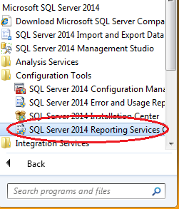 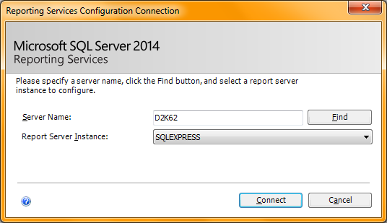

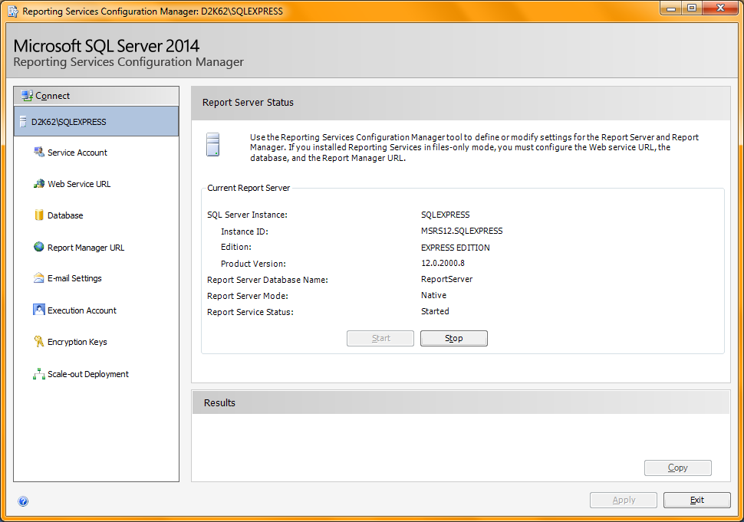

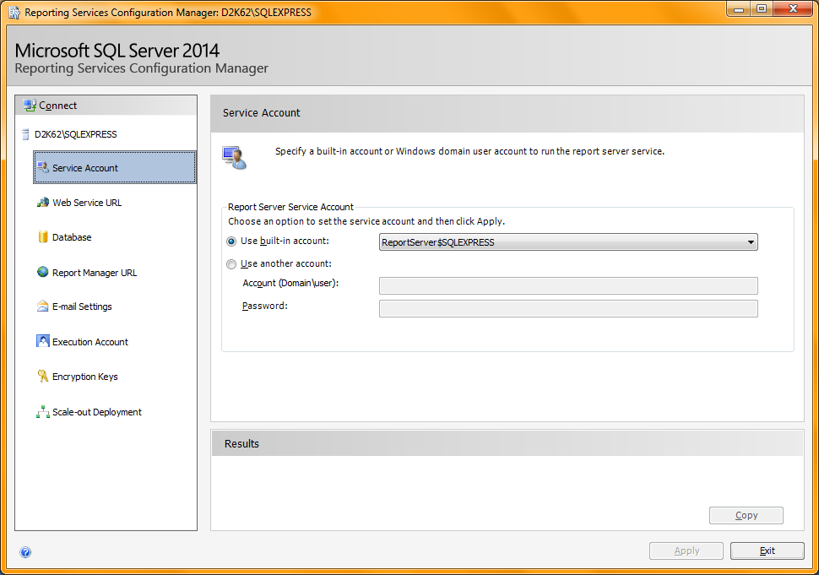

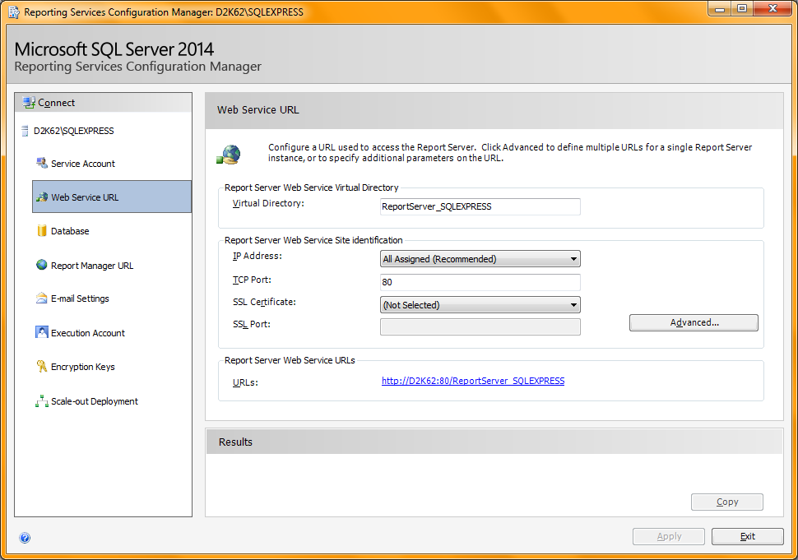

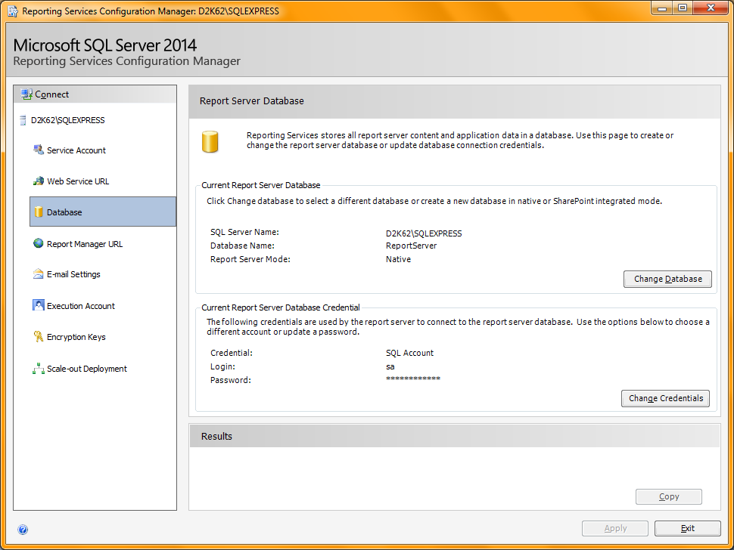

Change Database -> Create a new Server Report Database -><Follow Instructions>

This Will Adds two database at SQL Server ReportServer and ReportServerTempDB. Report definition will be store in this database, so don’t miss this step.

Report Manager URL : Report Server Admin Panel Which provides add, delete, download, modify reports with all user rights.

Used for modifying report connection string and rdl report.

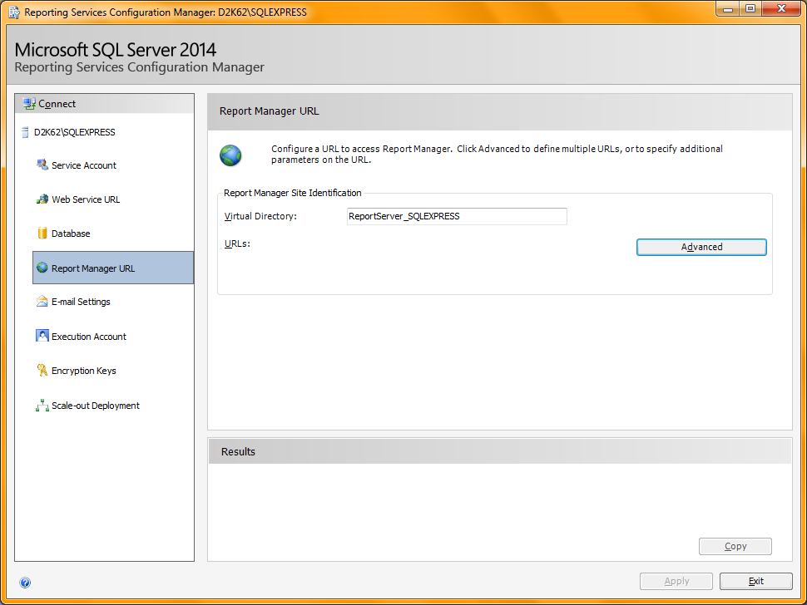

Click on Apply Button. Report Server URL will generate at this screen. Using this URL we can View and Deploy reports at report server.

Report_Configuration_22-10-201915.mp4 31:21- till end <Not Cleared>

**Common Issues and Troubleshooting**

Always run Visual Studio Run as Administrator for report deployment.

**4.1 RDL Report Development**

1. Open Visual Studio

File -> New Project -> Business Intelligence->Report Server Project

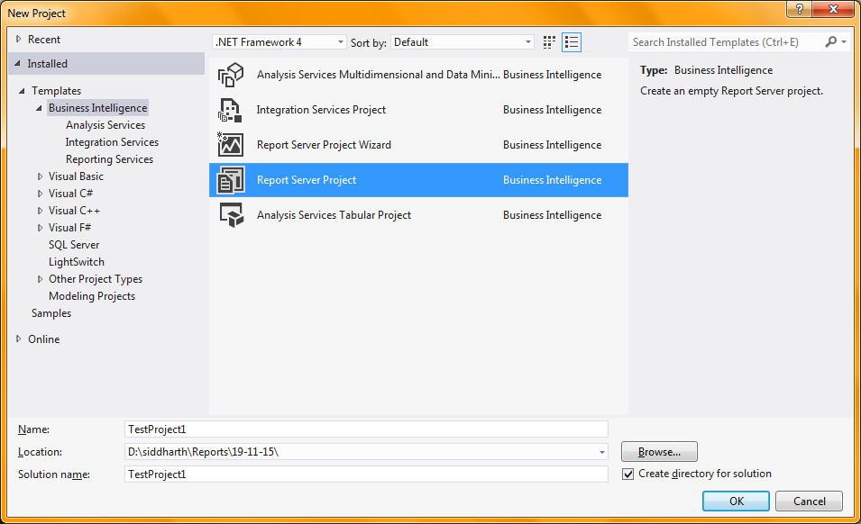

Shared Data Sources:

Under Solution Explorer Right on **Shared Data Sources** folder -> Add New Data Source

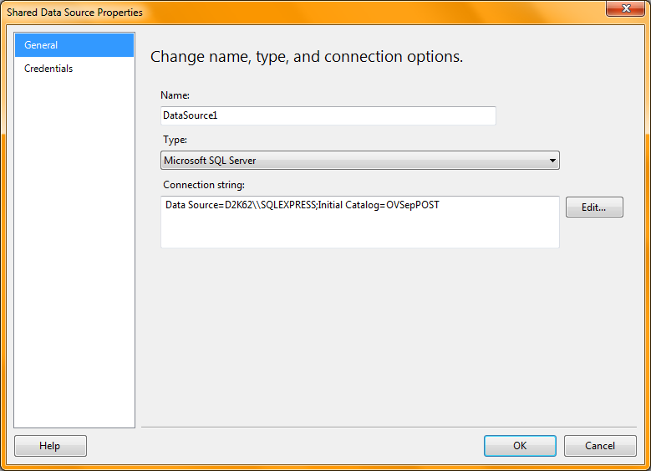

Right Click on **Reports** Folder-> Add New Report

->Next -> Shared Data Source <Select> -> Next -> Add SQL Query with parameter -> Next select Tabular -> Next

Add fields in Detail Section of Report-> Next Choose Table Style-> Next-> Finish

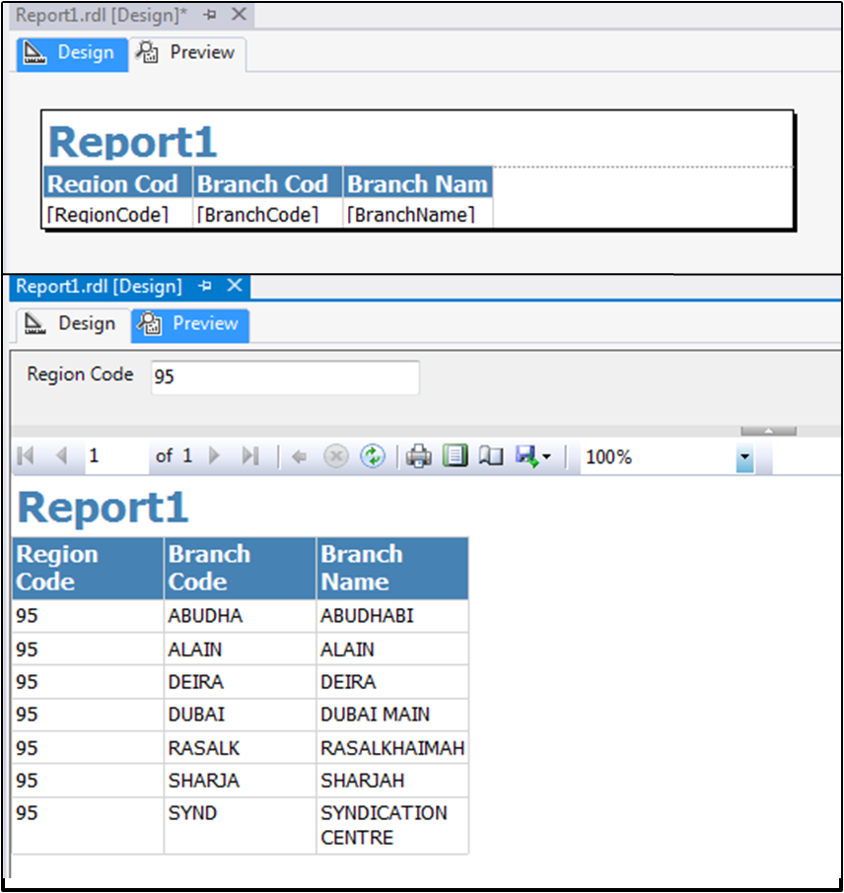

**4.2 Parameters**

View -> Report Data -> Parameters

Under this directory you will find all the parameters used in your project.

Right click parameter -> Parameter Property

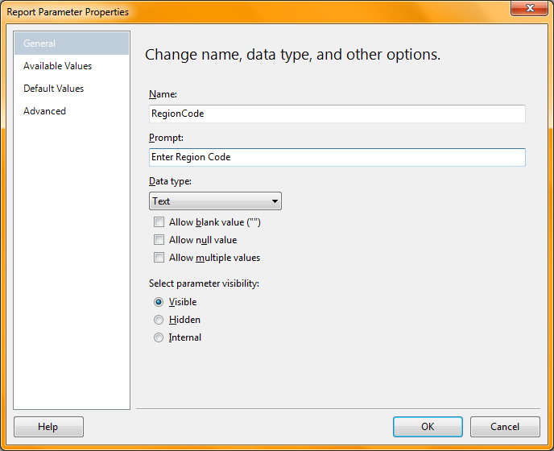

General Tab:

Name : Shows Parameter Name

Prompt : Shows Prompt Label for Parameter Value.

Data Type : Data Type of Parameter (Default is Text).

Allow Blank Value(“”) :

Allow Null Value :

Allow Multiple Values : Make sure that your sql query or sp should support multiple values.

Ex. @RegionCode in(1,2,3….)

Parameter Visibility

Visible : Visible to input value

Hidden : Hidden at parameter selection.

Internal :

Available Values Tab :

This tab is used to predefine values for parameters.

None : No Predefine values for Parameter

Specify values : Allows defining Parameter values

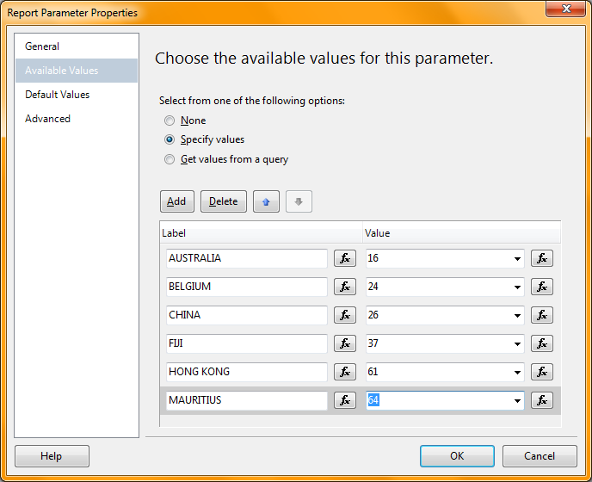

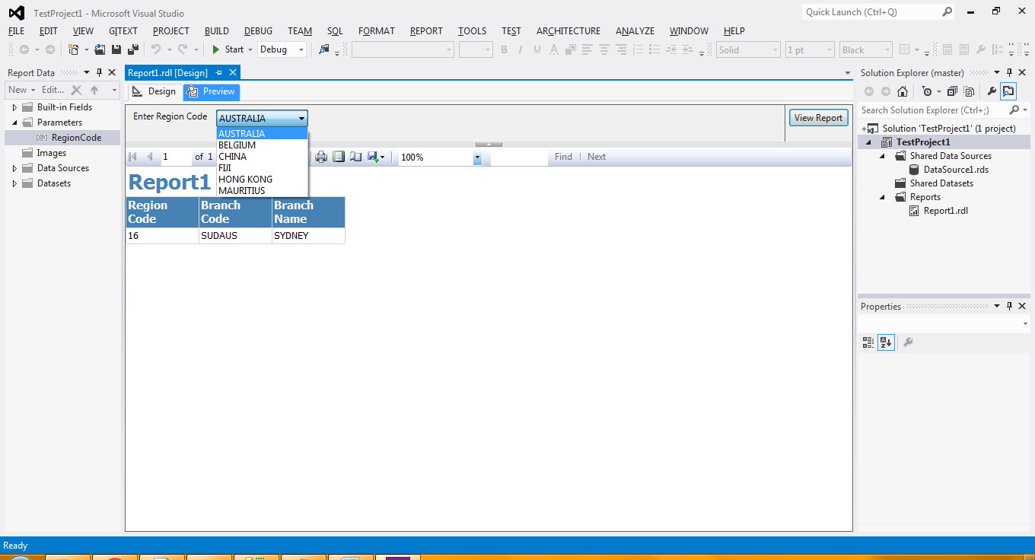

Get Values from query

To use this we have to create dataset for fetching possible parameter values from database. To do this add 1 dataset in project.

1. Right Click Dataset -> Add DataSet

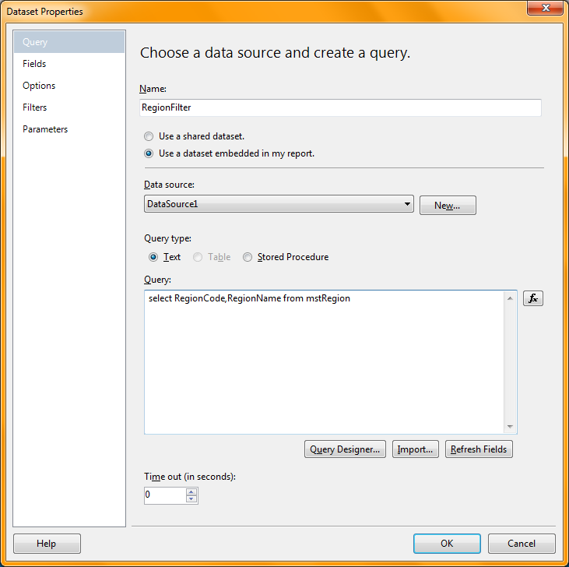

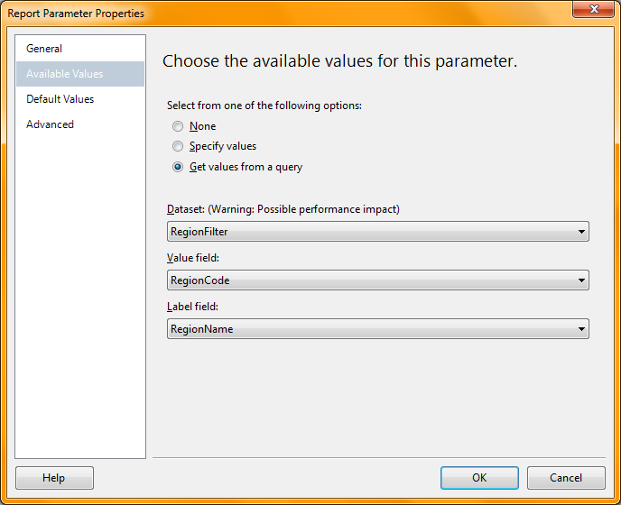

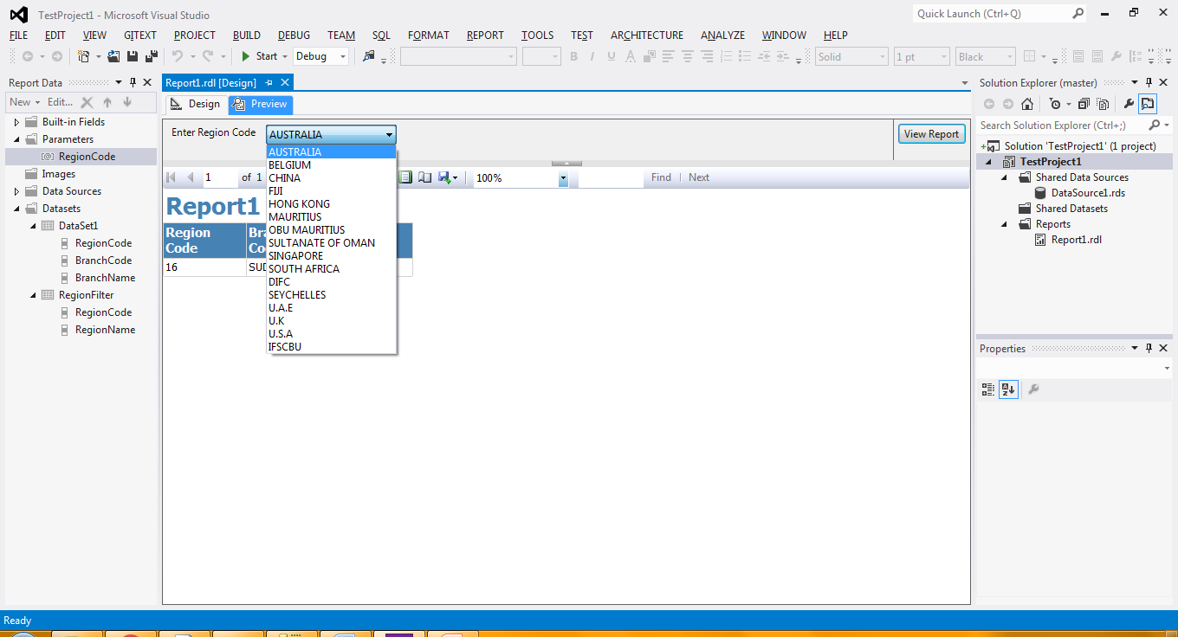

Default Values Tab:

Used to set Default Value for parameter.

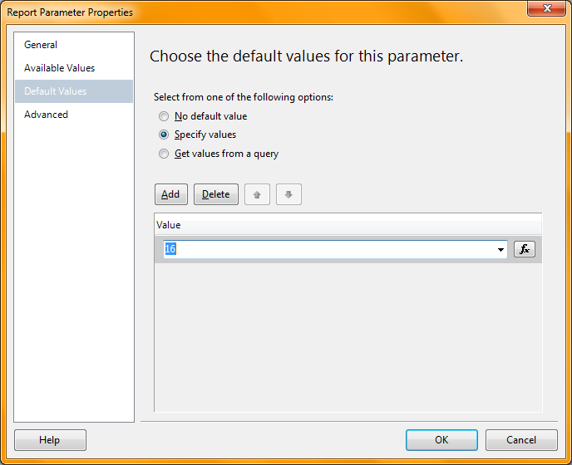

Specify Value : Report will not prompt for parameter if we set this value. Report will generate default parameter value provided in this field.

Get Values from Query:

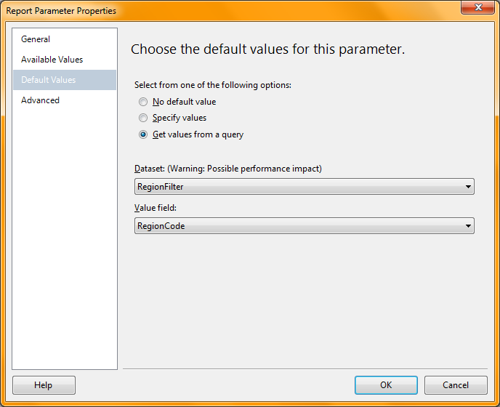

**4.3 Data Source**

Data Source is used to connect SQL Server, It stores connection string to connect SQL Server.

Types of Data Source

i) Shared Data Source

ii) Embedded Data Source

Shared Data Source is accessible Across all reports from same project.

Embedded Data Source can be accessible from only a particular report where it is created.

**4.4 Data Set**

It is used to get data from SQL Server, It can be a sql query or stored procedure.

Types of Data Set

i) Shared Data Set

ii) Embedded Data Set

Shared Data Set is Common for all reports from same project.

Embedded Data set is report specific data set and can be accessed from particular report only.

**4.5 Built In Fields**

|  |  |  |  |
| --- | --- | --- | --- |
| **Sr No** | **Function** | **Description** | **Example** |
| 1 | Execution Time | Displays Report Generation Date and Time | 11/16/2019 10:08:36 AM |
| 2 | Language | Server Language | en-US |
| 3 | Overall Page Number | Current Page Number w r t report total pages |  |
| 4 | Overall Total Pages | Report Total number of Pages |  |
| 5 | Page Name |  |  |
| 6 | Page Number | Current Page Number of particular group | It shows current page number from group and will resets after change of group. |
| 7 | Render Format IsInteractive |  |  |
| 8 | Render Format Name |  | RPL |
| 9 | Report Folder | Report Deployed Folder name | /TestProject1 |
| 10 | Report Name | Shows Report RDL Name | Report1 |
| 11 | Report Server URL | Report deployment Path of report server | http://d2k62/ReportServer_SQLEXPRESS |
| 12 | Total Pages | Total Pages of group before page break | If report group contains 5 pages then it will shows 5 |
| 13 | User ID | Report Server Windows Login Name | D2KT\dm400 |

**5 Grouping**

Group Addition :

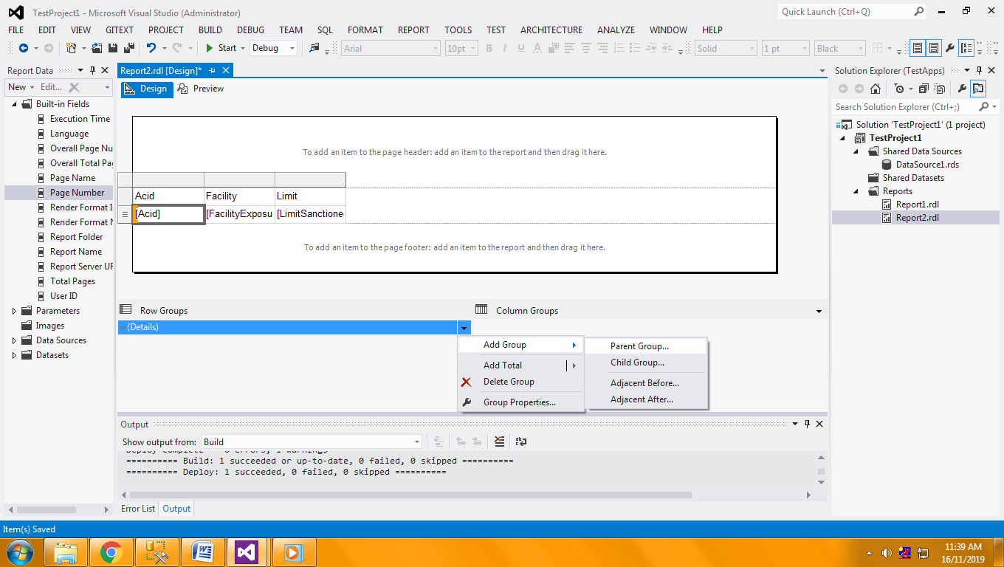

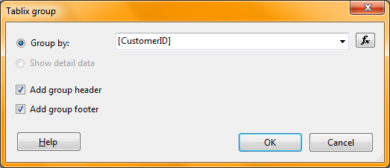

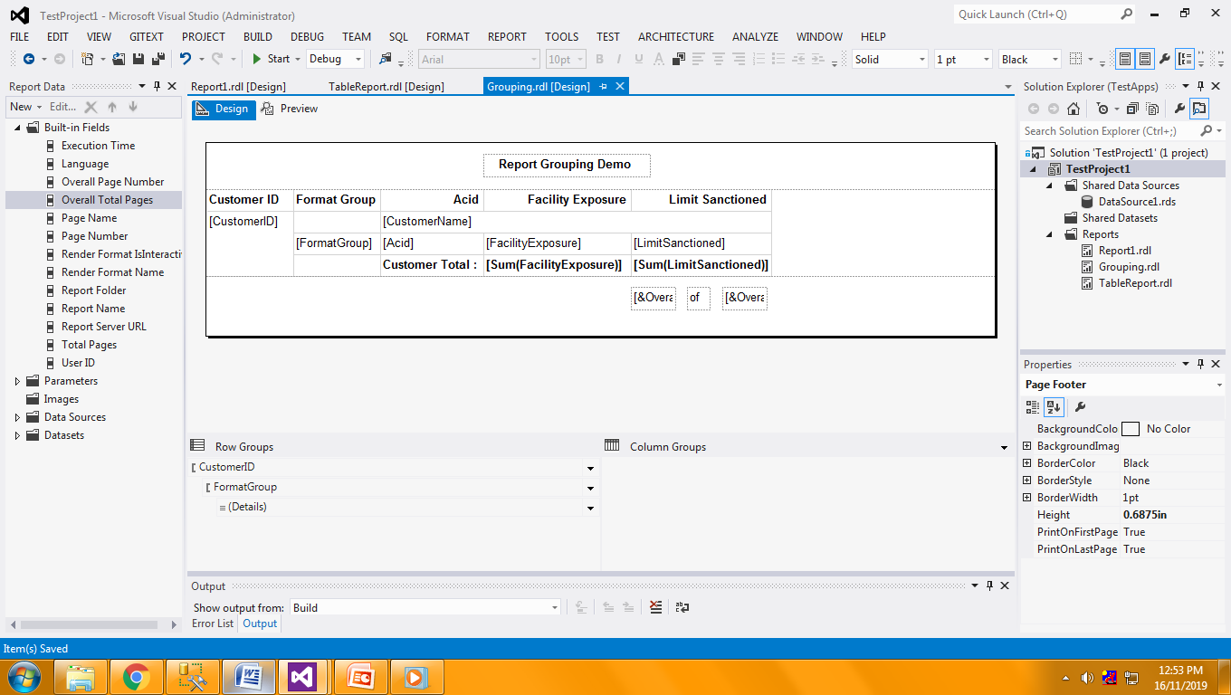

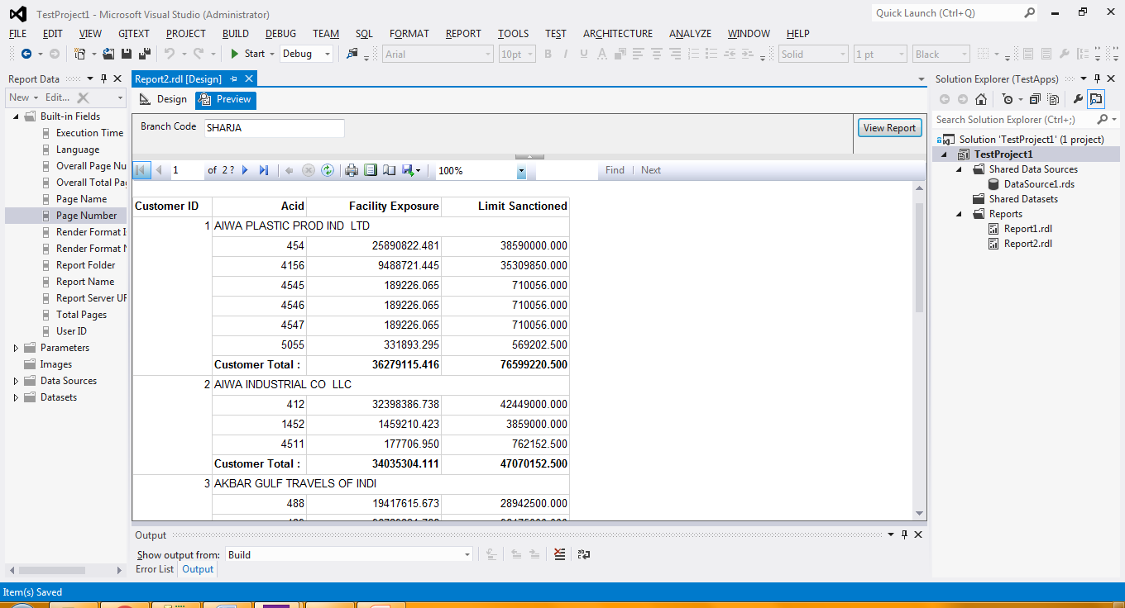

Similarly we can add Child Group.

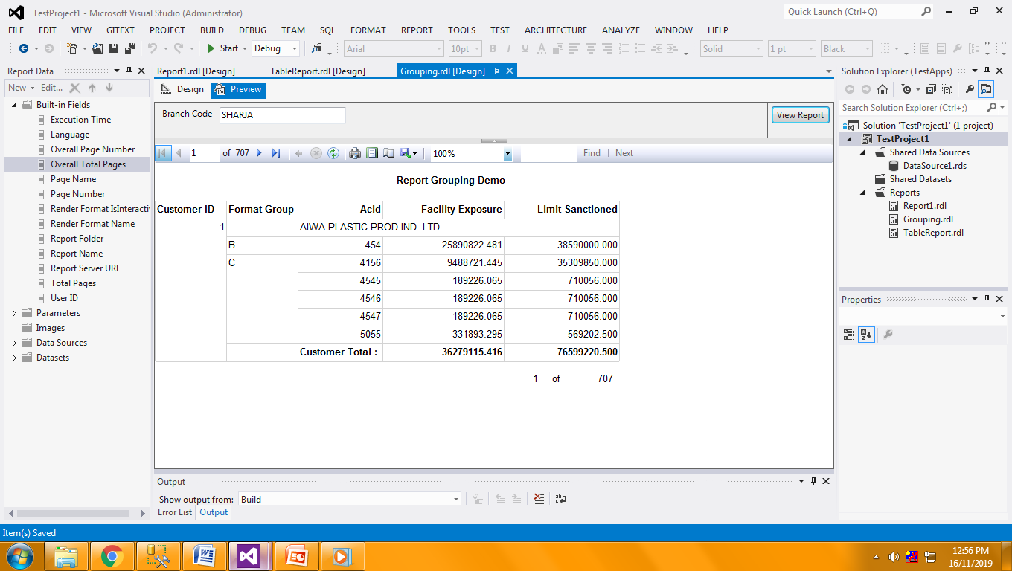

**6 Table Report**

In Table Report no of columns will be fixed and number of rows depends upon data and grouping of report. To Add Table in report Right Click on RDL report Insert-> Table

Right Click on Table Header -> Tablix Properties

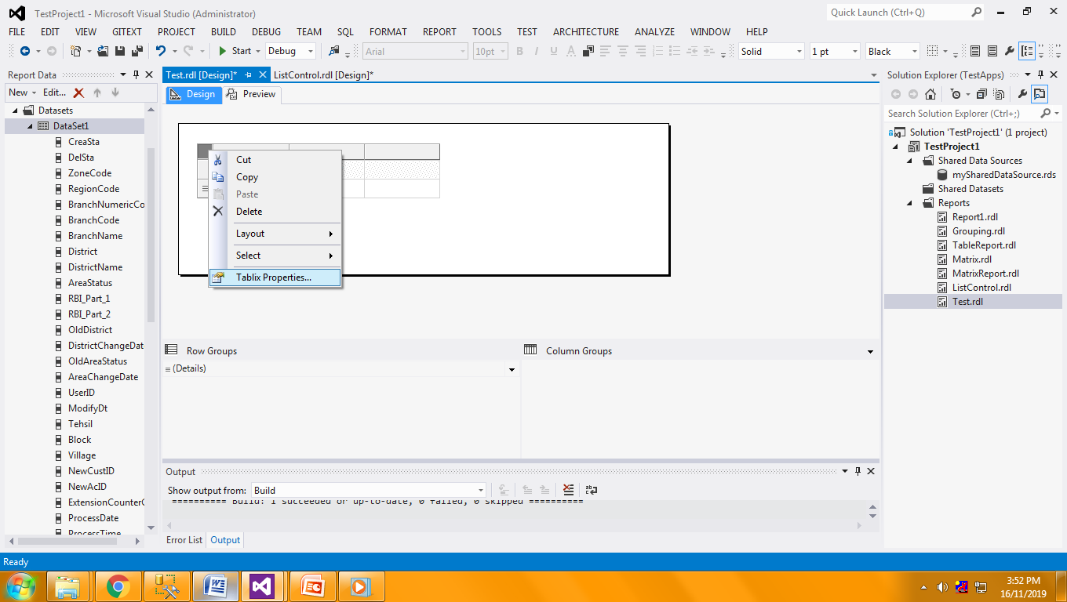

Set DataSet for the table.

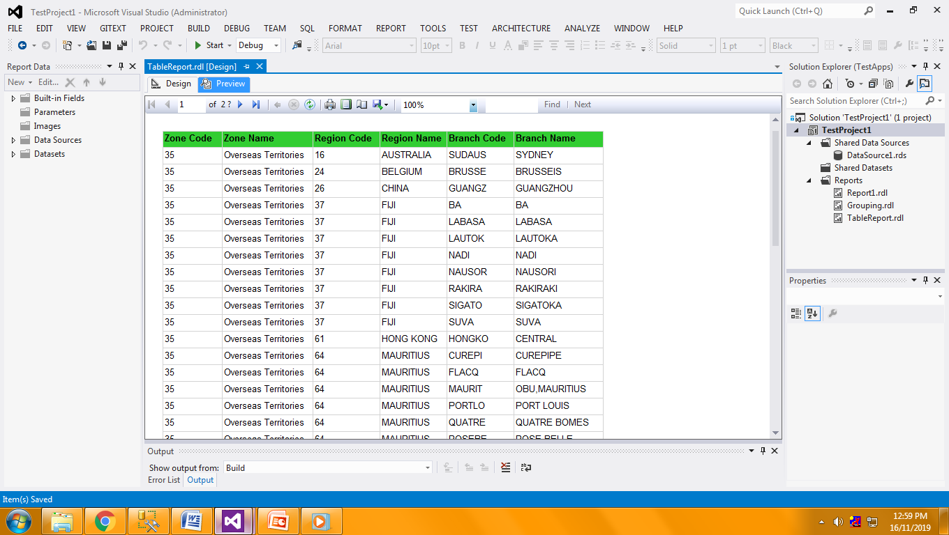

**7 Matrix Report**

It’s just like Cross Tab Report. In this type of report columns will dynamically added in report on the basis of column group Added.

To Add Matrix Report just right click on report -> Insert -> Matrix.

Ex.

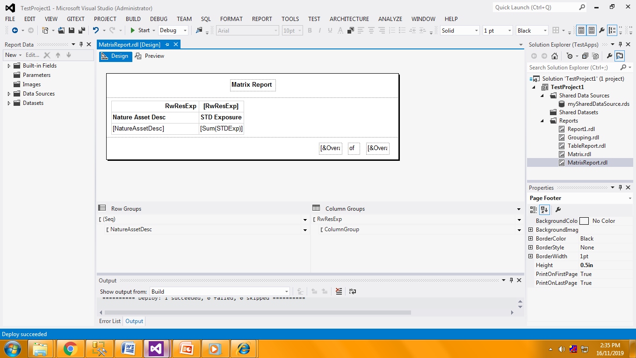

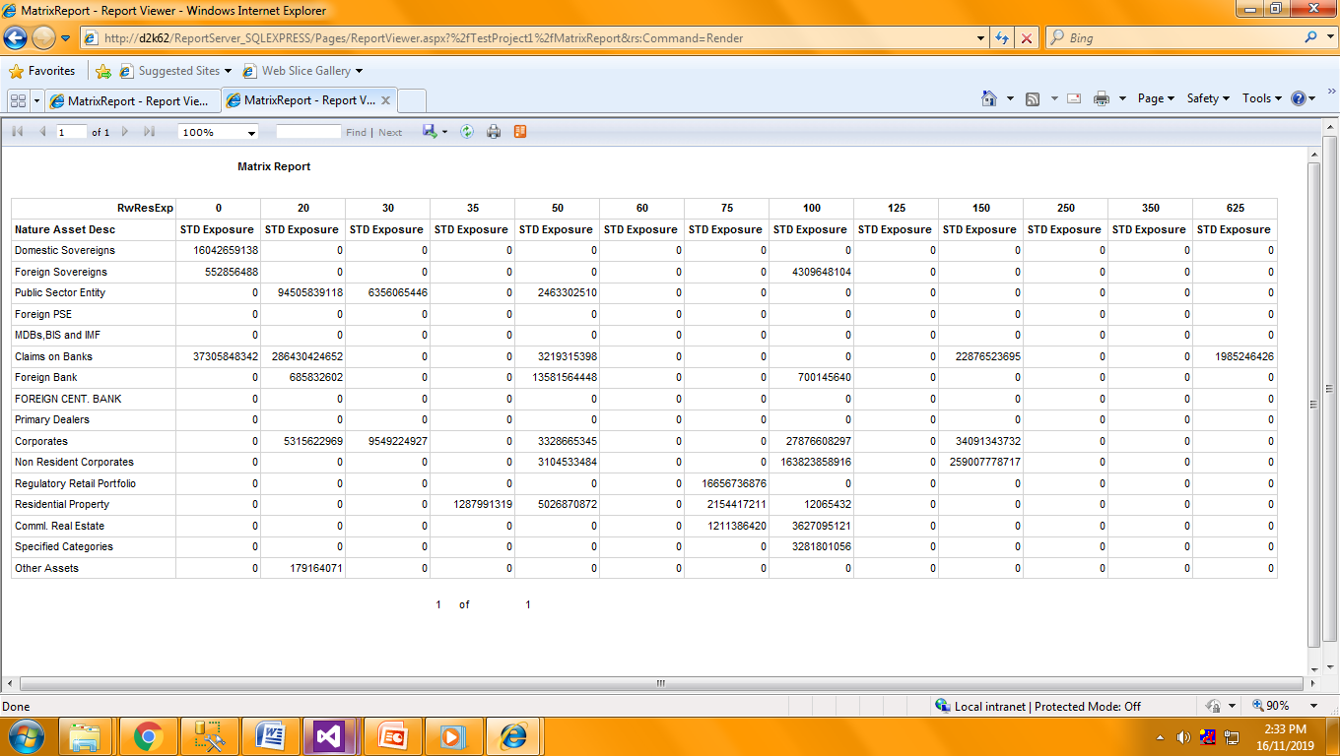

**8 List Control**

<Not Cleared>

**9 Image Control**

Right click on report -> Insert Image

There are three ways to insert image in report

i. External : <Not Cleared>

ii. Embedded : We can Insert image stored in server directory.

iii. Database : We can fetch database for image.

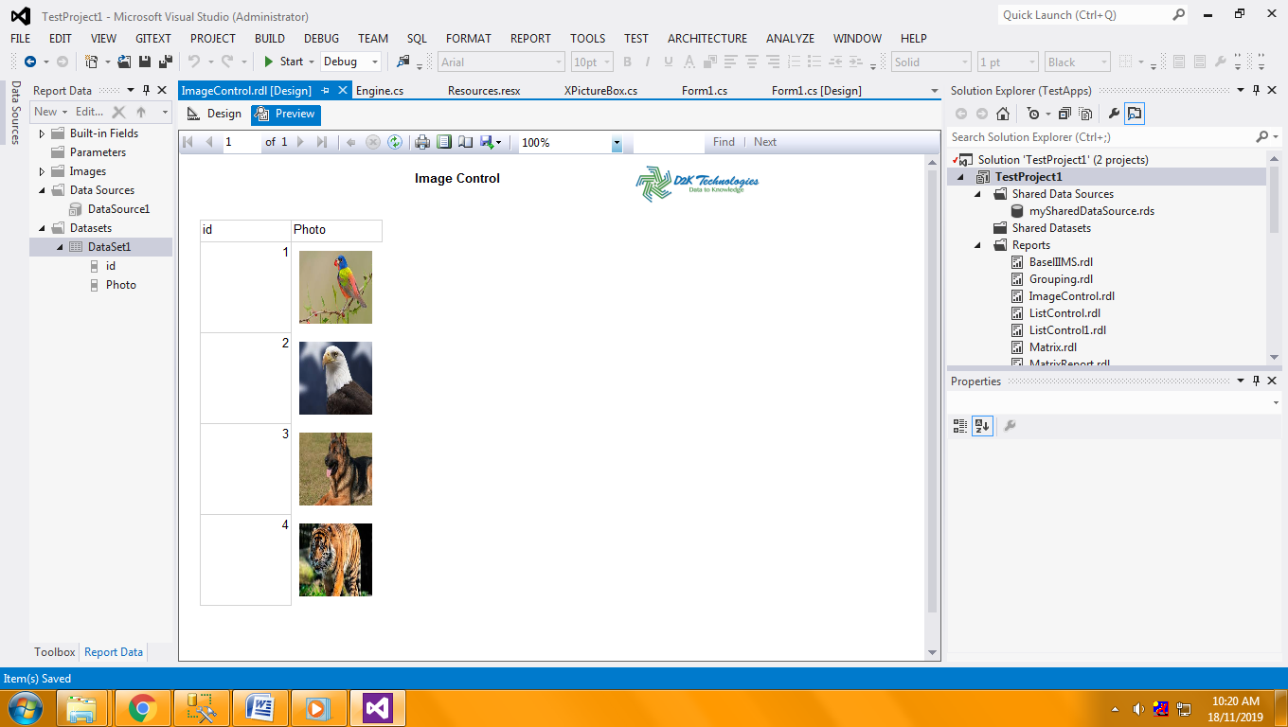

**10 Sub Report**

Add two reports rdl individually (MainReport and ChildReport).

Right Click at main Report table -> Insert Sub Report

Select Sub Report from list

Link Sub report to main report by parameters.

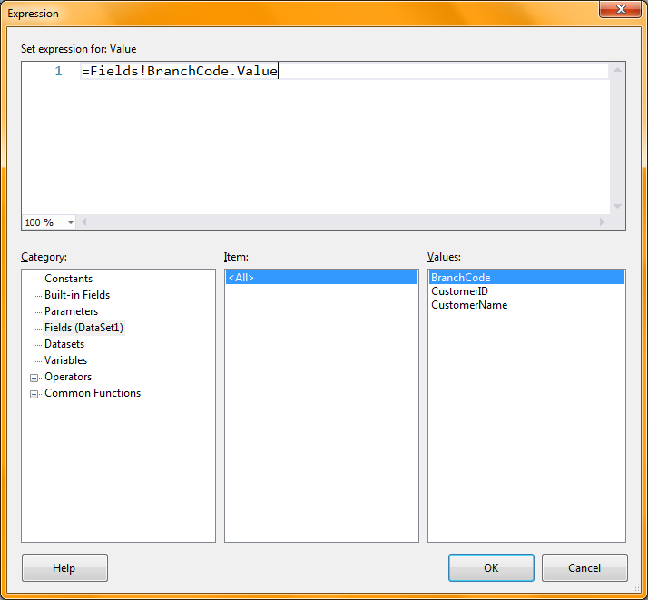

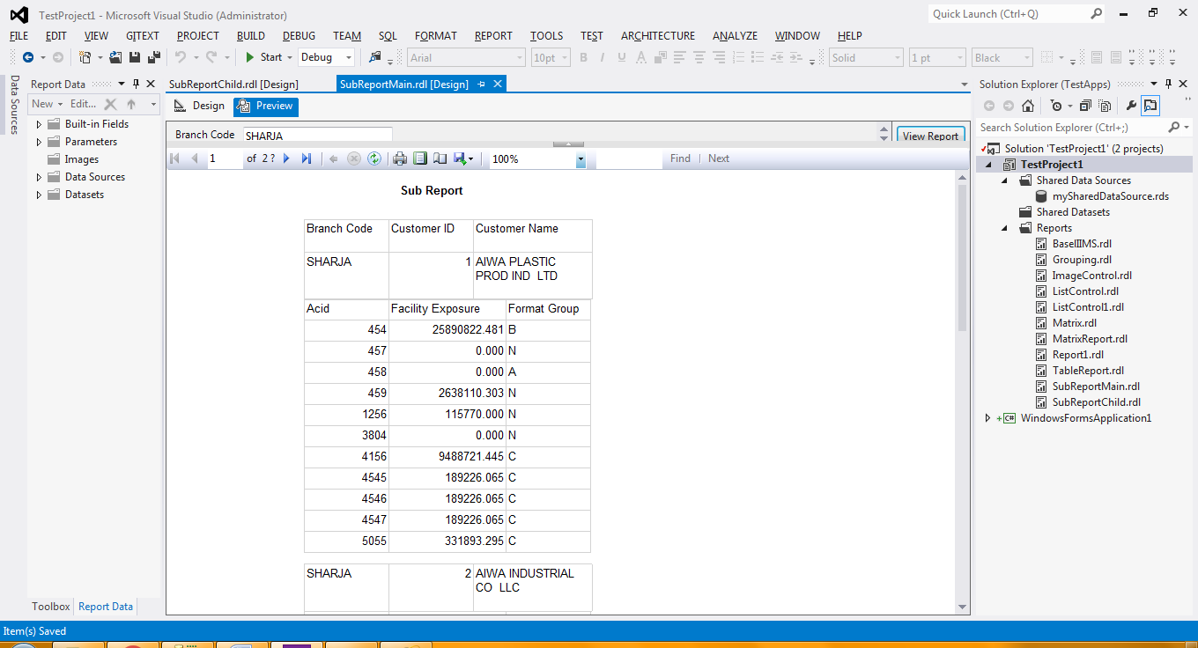

**11 Expressions**

Expressions are used to customize report on the bases of data condition. Using Expressions we can control cell text, color, back color, visibility, format, fonts etc…

Ex we wants to change back color of cell. If cell data is even number then red else yellow, this can be done using following formula.

**=iif(Fields!Acid.Value mod 2=0,"Red","Yellow")**

**12 Report Server Database**

A report server is a stateless server that uses the SQL Server Database Engine to store metadata and object definitions.

The report server database is a SQL Server database that stores the following content:

i) Items managed by a report server (reports and linked reports, shared data sources, report models, folders, resources) and all of the properties and security settings that are associated with those items.

ii) Subscription and schedule definitions.

iii) Report snapshots (which include query results) and report history.

iv) System properties and system-level security settings.

v) Report execution log data.

vi) Symmetric keys and encrypted connection and credentials for report data sources.

**13 Report Server**

Which Shows All deployed reports in view mode. We cannot delete or modify reports in this section.

**14 Report Server Manager**

Report Server Admin Panel Which provides add, delete, download, modify reports with all user rights.

SSRS_Part3_inducation_Akash Thakur_ 11-07-2019_04.15pm_Final Output.mp4 <Not Cleared>D:\siddharth\ProgramFiles\CS1\CS1\bin\Debug\op\e2541.png

**15. Common Parameters Used in Reports**

|  |  |  |  |  |  |  |
| --- | --- | --- | --- | --- | --- | --- |
| **Parameter** | **Parameter Prompt** | **Stored Procedure** | | | | |
| **Procedure Name** | | **Parameters / Default Value** | | |
| UserName | UserName |  | | PC Login Name | |  |
| UserLoginID | UserLoginID |  | | D2K | |  |
| UserLocation | UserLocation |  | | D2K | |  |
| UserLocationCode | UserLocationCode |  | | D2K | |  |
| MisLocation | MisLocation | Rpt-SysAD | | UserName | |  |
| TimeKey | Select Date | Rpt-SysDates | |  | |  |
| ReportName | ReportName | =Globals!ReportName | | <RDL Name> | |  |
| DynamicGrp | Select Admin Group | Rpt-SysDynamicGrp | | UserName  UserLoginID  UserLocation  UserLocationCode  MisLocation | | dsDynamicGrp |
| AdminValue | Select Admin Location | Rpt-SysAdminValue_Grp | | TimeKey  UserName  UserLoginID  UserLocation  UserLocationCode  MisLocation  DynamicGrp | |  |
| ReportType | ReportType | Rpt-SysReportVersion | | ReportName  TimeKey | |  |
| CustFacility | CustFacility | Rpt-SysReportoutputType | | ReportType | |  |
| SubDynamicGrp | Select Sub Group | Rpt-SysSubDynamicGrp | | UserName  UserLoginID  UserLocation  UserLocationCode  MisLocation  DynamicGrp  ReportType  CustFacility | |  |
| Tier | Tier | | Rpt-SysReportFormat | |  |  |
| ReportID | ReportID | | Rpt-SysReportVersion | | ReportName  TimeKey |  |
| Cost | Amount In | | Rpt-SysCost | | ReportID |  |
| BankName | BankName | | Rpt-SysReportFormat | |  |  |
| BankAdd | BankAdd | | Rpt-SysReportFormat | |  |  |
| ReportPath | ReportPath | | Rpt-SysReportFormat | |  |  |
| Version | Version | | Rpt-SysReportVersion | | ReportName  TimeKey |  |