**Efficient Frontier Analysis Report**

1. **Introduction and Project Overview**

This project aims to construct and analyze efficient portfolios using a selection of 10 stocks from the S&P 500 index. The primary objective is to invest $10 million into a portfolio that holds the magnificent seven, Berkshire Hathaway, UnitedHealth Group Incorporated, and Eli Lilly & Co., exploring various scenarios and constraints to understand their impact on portfolio performance and risk-return characteristics.

1. **Apple (AAPL)**
   1. Sector: Technology
   2. Market cap: $3.437T
2. **Microsoft (MSFT)**
   1. Sector: Technology
   2. Market cap: $3.111T
3. **Amazon (AMZN)**
   1. Sector: Consumer Cyclical
   2. Market cap: $1.865T
4. **Nvidia Corp (NVDA)**
   1. Sector: Technology
   2. Market cap: $3.046T
5. **Alphabet Inc. Class A (GOOGL)**
   1. Sector: Communication Services
   2. Market cap: $2.027T
6. **Meta Platforms, Inc Class A (META)**
   1. Sector: Communication Services
   2. Market cap: $1.342T
7. **Tesla, Inc. (TSLA)**
   1. Sector: Consumer Cyclical
   2. Market cap: $690.841B
8. **Berkshire Hathaway Class B (BRK.B)**
   1. Sector: Financial Services
   2. Market cap: $956.28B
9. **UnitedHealth Group Incorporated (UNH)**
   1. Sector: Healthcare
   2. Market cap: $533.255B
10. **Eli Lilly & Co. (LLY)**
    1. Sector: Healthcare
    2. Market cap: $835.726B

Using a combination of the stocks above, we will highlight three different scenarios with varying investment restrictions aimed to replicate different strategies used in financial markets. For each scenario, we will identify the Global Minimum Variance Portfolio (GMVP) and the Maximum Sharpe Ratio Portfolio (Tangent Portfolio), considering the current 10-year T-bond rate (3.92%) as the risk-free rate. Firstly, we will track and plot these portfolios without constraints or limitations on asset weights. This allows us to construct a more precise portfolio with more flexibility in achieving the highest returns with a given level of risk or the lowest level of risk given a specific return. We will repeat this process without short-selling, demonstrating more stringent risk management and considering regulatory and ethical restrictions. Finally, we will construct the efficient frontier and portfolios without short selling and allocating at least 5% ($500,000) to each stock and no more than 60% ($6,000,000) to any of the ten stocks.

1. **Importance of the Efficient Frontier**

The efficient frontier is a fundamental concept in modern portfolio theory. It represents the set of optimal portfolios that offer the highest expected return for a given level of risk or the lowest risk for a given level of expected return. The efficient frontier compares the trade-off between risk (variance or volatility) and expected return. By combining assets with different risk-return profiles, investors can create portfolios that offer better risk-adjusted returns than investing in individual assets. The efficient frontier can also plot ideal portfolios such as the Global Minimum Variance Portfolio, the portfolio on the efficient frontier with the lowest possible risk (standard deviation), or the Tangent Portfolio, which offers the highest risk-adjusted return. The Capital Market Line (CML) connects the risk-free rate to the tangent portfolio, representing the optimal risk-return trade-off when combining the risk-free asset with the market portfolio.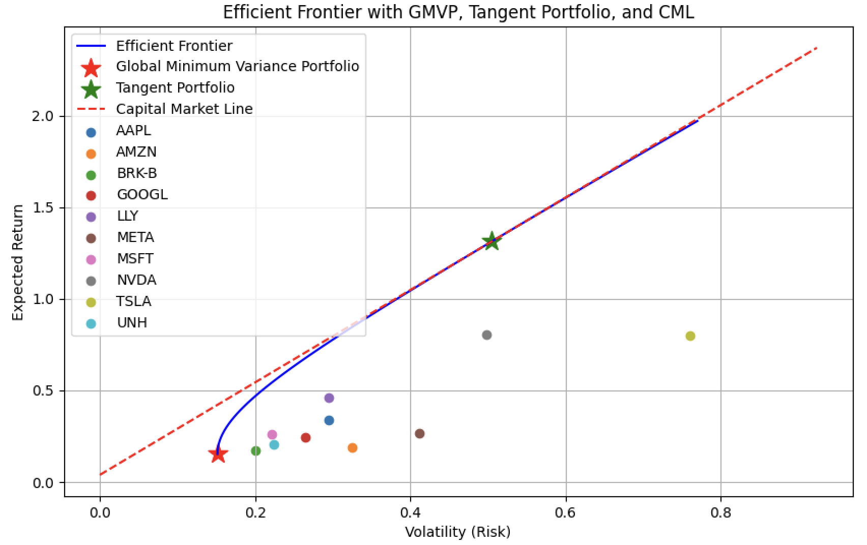

The graph above illustrates the efficient frontier for our portfolio of 10 stocks. The blue curve represents the efficient frontier, showing the trade-off between expected return (y-axis) and risk (x-axis). The red star indicates the Global Minimum Variance Portfolio, while the green star shows the Tangent Portfolio. The individual stocks are represented by scattered points, demonstrating how diversification can lead to better risk-adjusted returns than holding individual stocks.

**III. Code Application & Analysis**

**Data Acquisition and Preprocessing**

import yfinance as yf

def download_stock_data(tickers, start_date, end_date):

data = yf.download(tickers, start=start_date, end=end_date, interval='1mo')['Adj Close']

returns = data.pct_change().dropna()

return returns

This function imports the yfinance library and uses it to download monthly adjusted closing prices for the specified tickers. It then calculates the monthly returns, which will be used for portfolio optimization.

**3.2 Portfolio Statistics Calculation**

def calculate_portfolio_stats(weights, returns):

portfolio_return = np.sum(returns.mean() * weights) * 12

portfolio_volatility = np.sqrt(np.dot(weights.T, np.dot(returns.cov() * 12, weights)))

return portfolio_return, portfolio_volatility

This function computes the expected return and volatility of a portfolio given a set of weights and historical returns. The returns are annualized by multiplying by 12 (as we're using monthly data).

**3.3 Optimization Functions**

def negative_sharpe_ratio(weights, returns, risk_free_rate):

portfolio_return, portfolio_volatility = calculate_portfolio_stats(weights, returns)

sharpe_ratio = (portfolio_return - risk_free_rate) / portfolio_volatility

return -sharpe_ratio

def optimize_portfolio(returns, risk_free_rate, target_function, bounds):

num_assets = len(returns.columns)

args = (returns, risk_free_rate)

constraints = ({'type': 'eq', 'fun': lambda x: np.sum(x) - 1})

result = minimize(target_function, num_assets * [1./num_assets], args=args,

method='SLSQP', bounds=bounds, constraints=constraints)

return result.x

These functions are crucial for portfolio optimization. The negative_sharpe_ratio function calculates the Sharpe ratio (inverted for minimization), while optimize_portfolio uses scipy's minimize function to find the optimal weights that maximize the Sharpe ratio or minimize volatility, depending on the target function provided.

**3.4 Efficient Frontier Generation**

def get_efficient_frontier(returns, risk_free_rate, num_portfolios=100, bounds=None):

*# ... (code for generating efficient frontier points)*

return (gmvp_return, gmvp_volatility, gmvp_weights), (tangent_return, tangent_volatility, tangent_weights), (returns_array, volatilities_array)

This function generates the efficient frontier by optimizing portfolios for a range of target returns. It also identifies the Global Minimum Variance Portfolio (GMVP) and the Tangent Portfolio.

**3.5 Visualization and Analysis**

def plot_efficient_frontier(returns, risk_free_rate, bounds=None):

*# ... (code for plotting the efficient frontier)*

def cumulative_returns_versus_benchmark(returns, benchmark, gmvp, tangent):

*# ... (code for calculating and plotting cumulative returns)*

These functions create visualizations of the efficient frontier and compare the performance of the GMVP and Tangent Portfolio against the benchmark (S&P 500).

**IV. Results and Analysis**

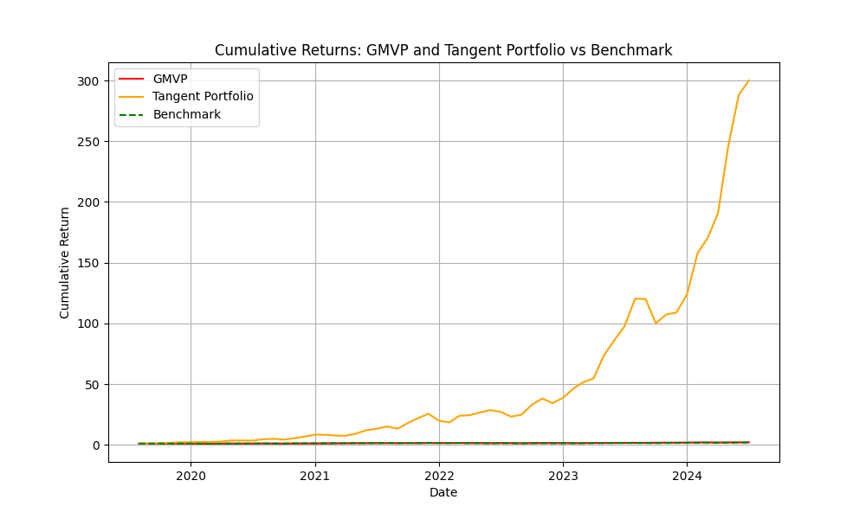**4.1 Scenario 1: No Constraints:** Unrestricted weights, with short selling.

**Global Minimum Variance Portfolio (GMVP):**

* Return: 15.32%
* Volatility: 15.15%
* Top 3 Weights:
  + BRK-B: 35.72%
  + UNH: 22.61%
  + MSFT: 20.19%



**Tangent Portfolio:**

* Return: 131.32%
* Volatility: 50.54%
* Top 3 Weights:
  + LLY: 126.85%
  + NVDA: 97.41%
  + UNH: 79.91%

**Analysis**

The GMVP achieves a relatively low volatility (15.15%) while still providing a decent return (15.32%). This portfolio is heavily weighted towards more stable stocks such as Berkshire Hathaway, UnitedHealth Group, and Microsoft. On the other hand, the Tangent Portfolio shows extremely high returns (131.32%) but at the cost of much higher volatility (50.54%). It takes significant long positions in Eli Lilly, Nvidia, and UnitedHealth while heavily shorting Microsoft and Amazon. The ability to short-sell allows for more diverse strategies, potentially leading to higher returns but also increasing risk. Both portfolios significantly outperform the S&P 500 benchmark in terms of cumulative returns, as seen in the graph. However, the Tangent Portfolio's performance is exceptionally high, likely due to the unrestricted weights allowing for extreme positions. These results demonstrate the potential benefits of optimization but also highlight the need for constraints in real-world scenarios, as the extreme weights in the Tangent Portfolio may not be practical or desirable for most investors.

**4.2 Scenario 2: No Short Selling:** Constraining all weights to be non-negative.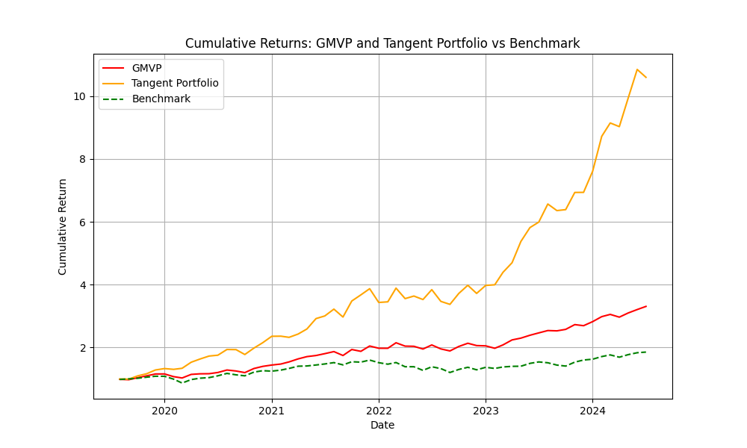

**Global Minimum Variance Portfolio (GMVP):**

* Return: 25.39%
* Volatility: 15.94%
* Top 3 Weights:
  + BRK-B: 33.66%
  + UNH: 27.90%
  + LLY: 19.11%

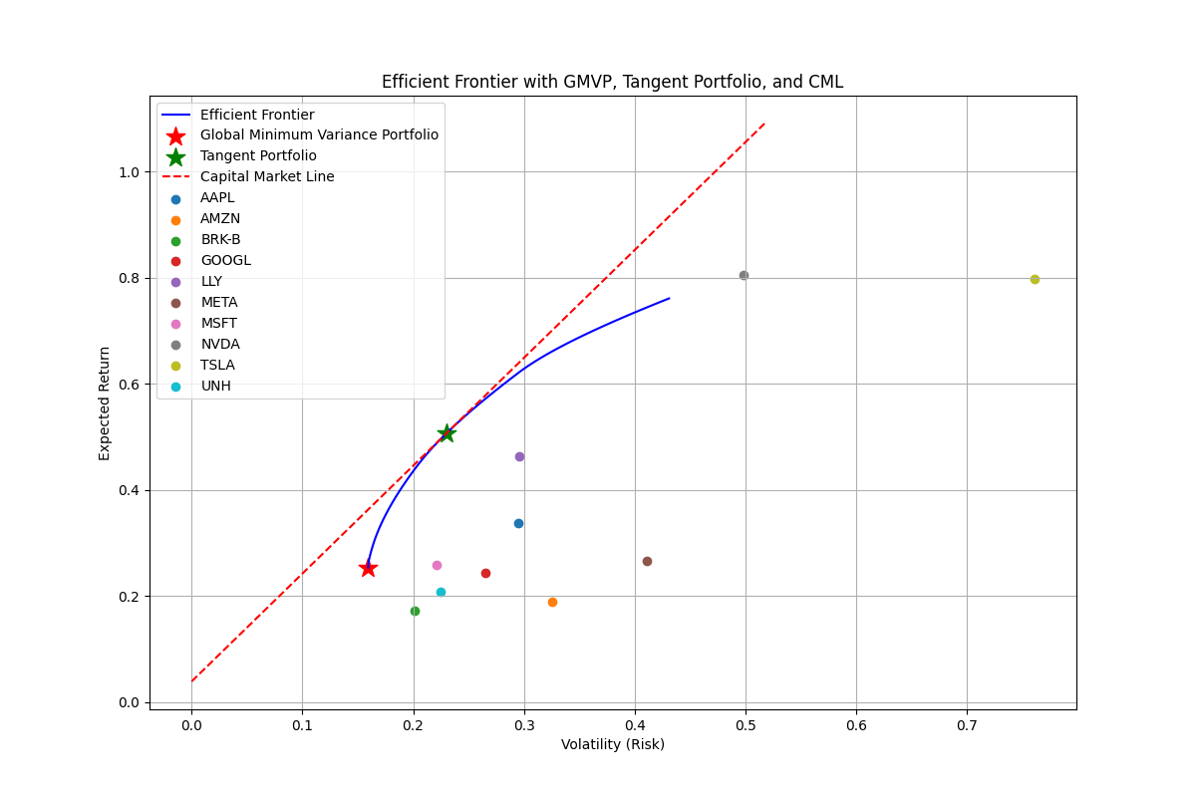

**Tangent Portfolio:**

* Return: 50.71%
* Volatility: 23.02%
* Top 3 Weights:
  + LLY: 44.23%
  + NVDA: 27.10%
  + UNH: 24.48%

**Analysis**

The GMVP in this scenario has a higher return (25.39%) compared to the unconstrained scenario (15.32%) but also a slightly higher volatility (15.94% vs 15.15%). This suggests that the short positions in the unconstrained GMVP were helping to reduce overall portfolio volatility. The Tangent Portfolio shows a significantly lower return (50.71%) compared to the unconstrained scenario (131.53%) but also with much lower volatility (23.02% vs 50.54%). This demonstrates how the removal of short-selling constraints can lead to more conservative portfolios. The weights in both portfolios are more evenly distributed compared to the unconstrained scenario. This is a natural consequence of prohibiting short selling, which forces the optimizer to find positive weights for all assets. Both portfolios still outperform the S&P 500 benchmark, but the outperformance is less dramatic than in the unconstrained scenario. This suggests that some of the extreme outperformance in the unconstrained scenario was due to the ability to take large short positions. The lack of short-selling constraints leads to more realistic and implementable portfolios, as many investors, especially retail investors, may not have the ability or desire to short stocks.

**4.3 Scenario 3: Weight Constraints (5% minimum, 60% maximum)**

In this scenario, we add further constraints: no short selling, each stock must account for at least 5% of the portfolio, and no stock can account for more than 60% of the portfolio.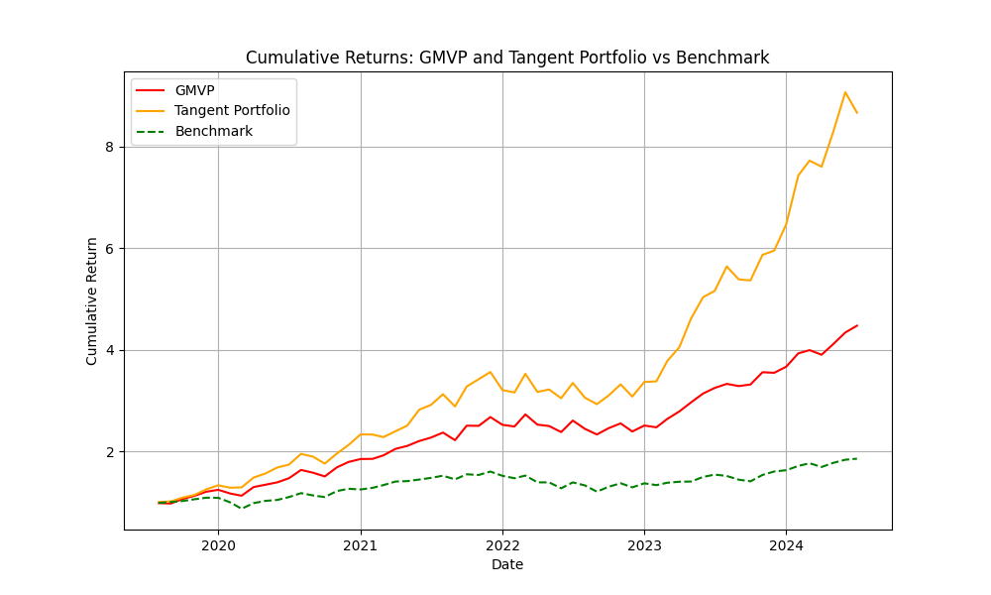

**Global Minimum Variance Portfolio (GMVP):**

* Return: 31.94%
* Volatility: 18.30%
* Top 3 Weights:
  + UNH: 27.77%
  + BRK-B: 19.17%
  + LLY: 18.06%

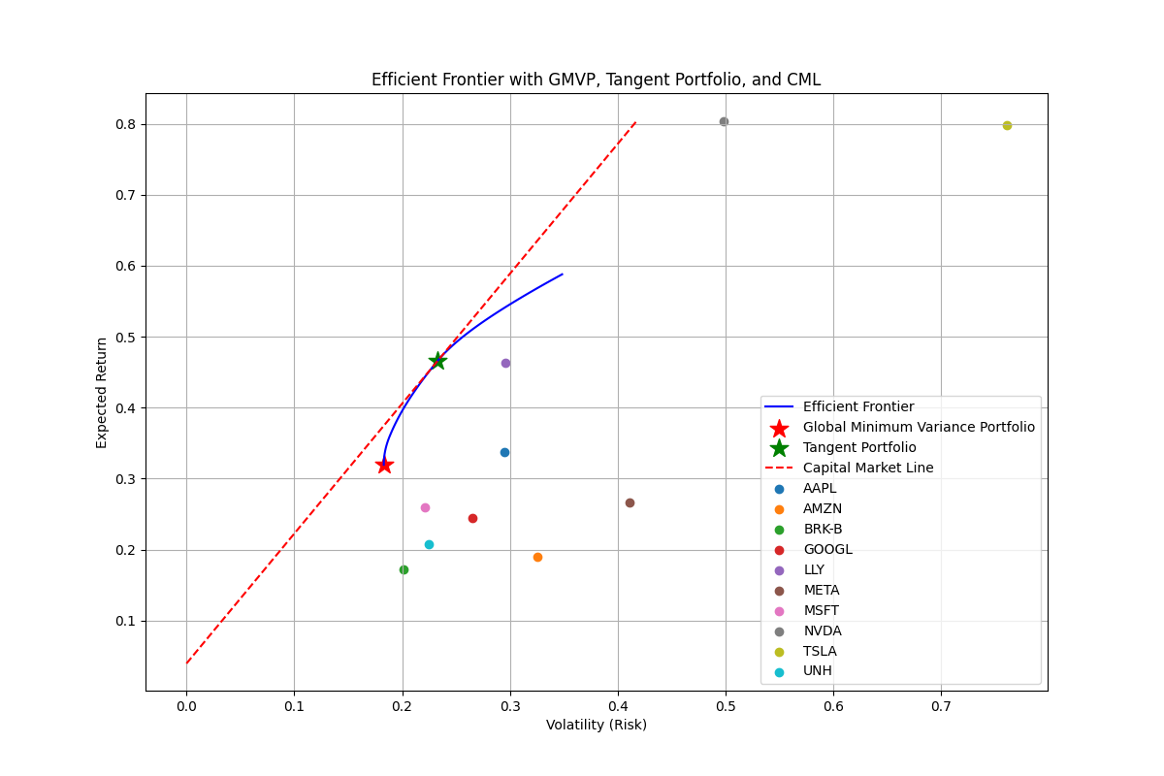

**Tangent Portfolio:**

* Return: 46.60%
* Volatility: 23.30%
* Top 3 Weights:
  + LLY: 41.17%
  + NVDA: 18.83%
  + All others: 5.00%

**Analysis**

The GMVP in this scenario has the highest return (31.94%) among all three scenarios, but also the highest volatility (18.30%). This increase in both return and risk is due to the forced diversification imposed by the minimum weight constraint. The Tangent Portfolio in this scenario has a slightly lower return (46.60%) compared to the no short selling scenario (50.71%), with a similar level of volatility. This suggests that the additional constraints have a relatively small impact on the optimal risk-return trade-off. The weight constraints lead to more diversified portfolios, with all assets represented in both the GMVP and Tangent Portfolio. This forced diversification can be beneficial for risk management but may slightly reduce potential returns. The maximum weight constraint of 60% is not binding in either portfolio, indicating that the optimizer didn't see a need to allocate more than 60% to any single stock. Both portfolios continue to outperform the S&P 500 benchmark, demonstrating that even with these constraints, the optimization process can still create portfolios that beat the market.

**V. Comparative Analysis and Implications**

When comparing the results across all three scenarios, several portfolio management strategies, including Risk-Return Trade-off, diversification, and practicality, present themselves. As we add more constraints, we generally see an increase in the return of the GMVP, but also an increase in its volatility. This demonstrates how constraints can force the portfolio into a different part of the risk-return spectrum. Furthermore, the weight-constrained scenario forces a minimum level of diversification, which can help mitigate risk by allocating money in different places. However, this comes at the cost of potentially lower returns compared to less constrained scenarios.

Additionally, the weight-constrained scenario produces the most practical and implementable portfolios because they are within the regulatory bounds and would appeal to risk-averse investors in the real world. With that being said, across all scenarios, both the GMVP and Tangent Portfolio consistently outperform the S&P 500 benchmark, indicating that even with constraints, portfolio optimization can potentially lead to superior investment outcomes. Lastly, the scenario with no short selling and weight constraint produced more stable portfolios over time, as evidenced by the smoother cumulative return curves. This stability can be attractive to investors who prefer consistent performance.

**VI. Limitations and Future Work**

While this analysis provides valuable insights, it's important to acknowledge its limitations. Supported by the efficient market hypothesis, the analysis relies on historical data, and the returns we present are not necessarily indicative of future performance.Our model also doesn't account for transaction costs, which could significantly impact real-world performance, especially in the unconstrained scenario where extreme positions are taken (which are often very costly upfront). The analysis here is also limited to only 10 large-cap stocks, assuming a buy-and-hold strategy and only using standard deviation as a risk measure.

Future work could incorporate forward-looking estimates or scenario analysis of macroeconomic trends. By expanding our code to incorporate this information, we will be able to more accurately predict future market conditions. We could also improve how we are measuring risk by introducing other risk measures such as Value at Risk (VaR) or Conditional Value at Risk (CVaR). Lastly, adding more securities to our portfolio will ultimately increase diversification and provide us with more opportunities to experiment with different portfolios.

**VII. Conclusion**

This project shows us how portfolio optimization can help create portfolios that perform better than the market. By testing different constraints on asset weight in the portfolio, we were able to see changes in the portfolio's effectiveness directly. It affects aspects like risk or performance to ultimately create a higher-quality portfolio.

In the weight-constrained scenario, with its forced diversification and realistic allocation limits, provides a balanced approach that may be most suitable for practical implementation. It offers strong performance while managing risk through diversification.

Ultimately, the choice between these approaches depends on an investor's specific goals, risk tolerance, and any regulatory or practical constraints they face. This analysis provides a framework for making informed decisions about portfolio construction and highlights the importance of considering various constraints in the optimization process.

Financial markets are always adapting with each passing day, but the core principles of portfolio optimization will always be relevant. Possible future research could implement more advanced risk measures, looking into dynamic optimization strategies or using machine learning to improve predictions. Moreover, examining how external economic factors and market outlook influence portfolios would also help provide insight into their stability. With continuous research and ever-evolving strategies, we can help investors better face the unpredictable nature of the stock market to reach their financial goals.