University of Central Florida
Department of Computer Science
CDA 5106: Spring 2020
Machine Problem 2: Branch Prediction
by
Siddharth Mal

Honor Pledge: "I have neither given nor received unauthorized aid on this test or assignment."

Student’s electronic signature: Siddharth Mal
(sign by typing your name)

Graphs for Bimodal:
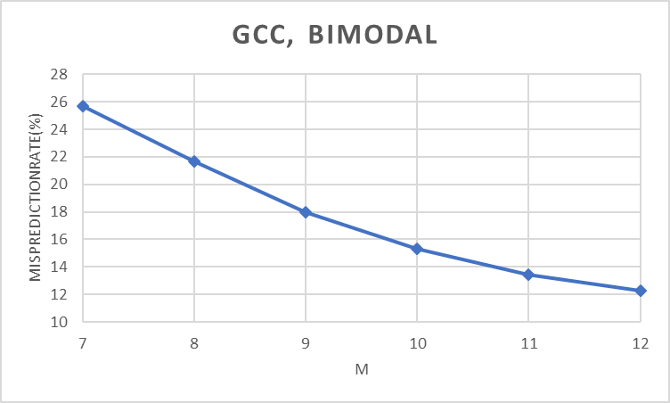
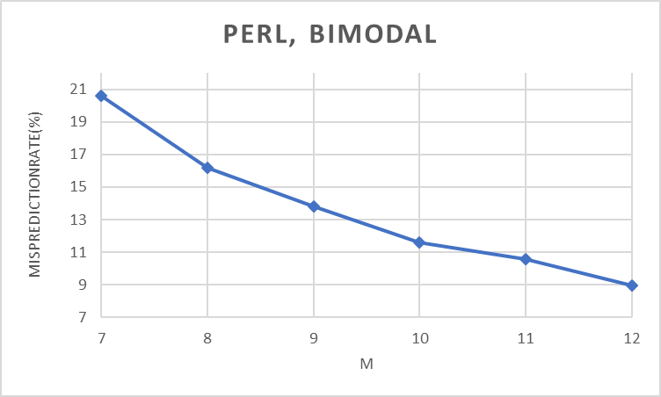
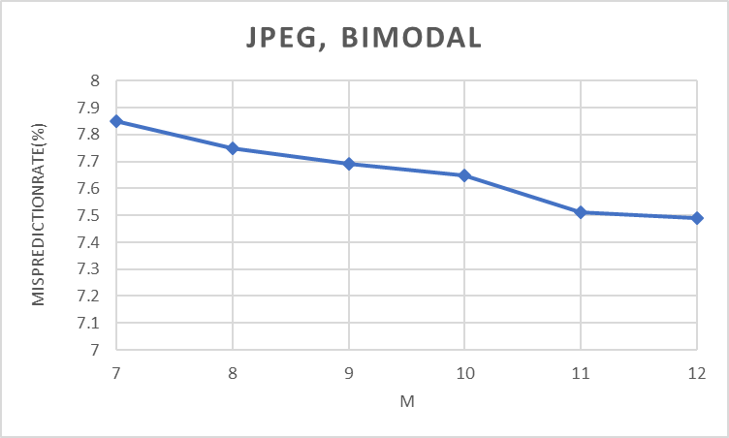
Graphs for GSHARE:
