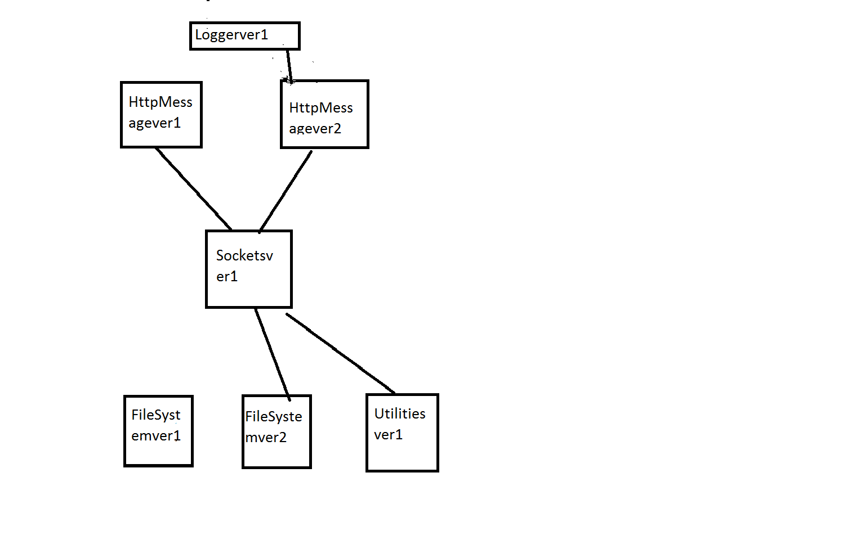

**CHECK INTO REPO WITH VERSIONS AND DEPENDENCIES**

**STEPS**

* The above diagram represents a Dependency Diagram of packages which I am going to check into the repository(Server)
* Check in FileSystem (Version 1) without any dependencies (run.bat “FileSystem”)
* Check in FileSystem (Version 2) without any dependencies (run.bat “FileSystem” )
* Check in Utilities (Version 1) without any dependencies ( run.bat “Utilities”)
* Check in Sockets (Version 1) with FileSystem and Utilities as dependencies ( run.bat “Sockets” “FileSystem” “Utilities”)
* Check in HttpMessage (Version 1) with Sockets as a dependency ( run.bat “HttpMessage” “Sockets”)
* Check in HttpMessage(Version 2) with Sockets as a dependency ( run.bat “HttpMessage” “Sockets” )
* Check in Logger ( Version 1) with HttpMessage as a dependency ( run.bat “Logger” “HttpMessage” )