10/21/25

Siddhant Nair

ASSIGNMENT 1: DECISION TREES
The purpose of this assignment is to deepen the idea of decision trees—hands-on—and to get you used to the style of the assignments in this course.
Please use this Word file template for your response. Follow—and retain—these instructions in gray text. Insert your work where indicated. Keep in mind the evaluation matrix at the end as you do the work and use it to guide what you submit.
Complete this assignment with as much assistance as you can get from an AI generator such as ChatGPT. Use AI in well-chosen chunks rather than all-at-once. This helps your understanding, which is what we are seeking. As described in the evaluation criteria, your work will be assessed in terms of evidence of the value you added to the AI output, and your noteworthy prompts (not on AI-generated material itself). You must convince us that you fully understand what AI generates. Highlight your value-added edits and additions to AI-generated material with red font. If you performed truly valuable prompt work, please note and justify it in comments within the relevant sections of this Word document.
Use no more than 5 pages of 12-point text excluding figures, the gray instructions, and appendices. You can add as many appendices as you like, as per the instructions provided in the first appendix below.
Please attach a full transcript of your interactions with an AI. This does not have to be organized. We look over the AI transcript only on an as-needed basis—the transcript has too much volume for us to evaluate your prompting. You must point out notable prompting in the comment form as described above.
Stay focused because credit is based on the evaluation criteria below, not on time spent or effort made.

1. SUMMARY DESCRIPTION
In one or two sentences, describe a realistic decision tree application that’s unique to the best of your knowledge, that you will implement. Select an application of personal or professional interest to you. You can begin with existing code (an example is here, which you can copy to your Google drive if you wish). You will push AI generation to yield the most impactful application.
In a third sentence, explain why you think this is a good application for a decision tree.
This project focuses on predicting the acceptability of a car based on a set of technical and financial attributes. The dataset, sourced from https://www.kaggle.com/datasets/elikplim/car-evaluation-data-set is a classic benchmark for classification algorithms.

2. DATA SOURCE
Identify and explain the source of your data (e.g., collected by hand; Kaggle). Point to a URL so we can see the data.
Kaggle: https://www.kaggle.com/datasets/elikplim/car-evaluation-data-set

3. I/O CASES
For three varied inputs (e.g., a list or array) for your application, show the outputs.
I wrote the necessary code for the generation of these analyses; however, the reasoning was provided by Gemini based on the numerical findings:
Column Headers: 'buying_price', 'maintenance_cost', 'num_doors', 'capacity', 'luggage_boot', 'safety', 'acceptability' (label)
Input 1: ['vhigh', 'vhigh', '2', '2', 'small', 'low']
Output 1: Unacceptable
Explain output 1 is valid: This represents a car with the highest possible buying and maintenance costs, minimum seating (2), a small trunk, and low safety. In the Decision Tree logic, a 'low' safety rating is often a "terminal" condition that immediately results in an unacc classification, regardless of other features. Furthermore, the high cost combined with low utility (2 seats/small boot) reinforces this result.
-------------------- -
Input 2: ['med', 'med', '4', '4', 'med', 'high']
Output 2: Acceptable
Explain output 2 is valid: This input represents a "mid-tier" vehicle with balanced costs, standard 4-door/4-person capacity, and high safety. Because the safety is high and the capacity is sufficient for a standard user, the model moves past the initial "rejection" nodes. While not luxurious enough for a vgood rating, it meets all functional requirements for a standard acc classification.
-------------------- -
Input 3: ['low', 'low', '5more', 'more', 'big', 'high']
Output 3: Very Good
Explain output 3 is valid: This car maximizes value and utility: it has the lowest costs (low/low), maximum capacity (5more doors and more than 4 persons), a big luggage boot, and high safety. The Decision Tree identifies this as the optimal configuration, where low financial burden meets maximum safety and technical specifications, leading to the highest possible rating of vgood.

4. KEY SOURCE CODE
Please supply the most relevant decision tree code snippets.
Key Snippet 1: Using Ordinal Encoder:
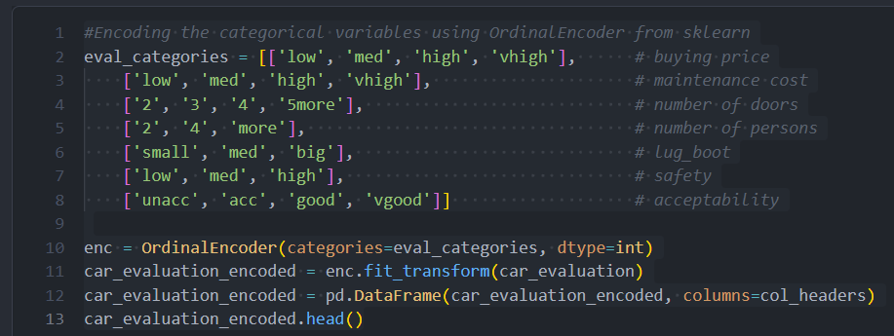
Key Snippet 2: Train-Test Split and Model Fitting
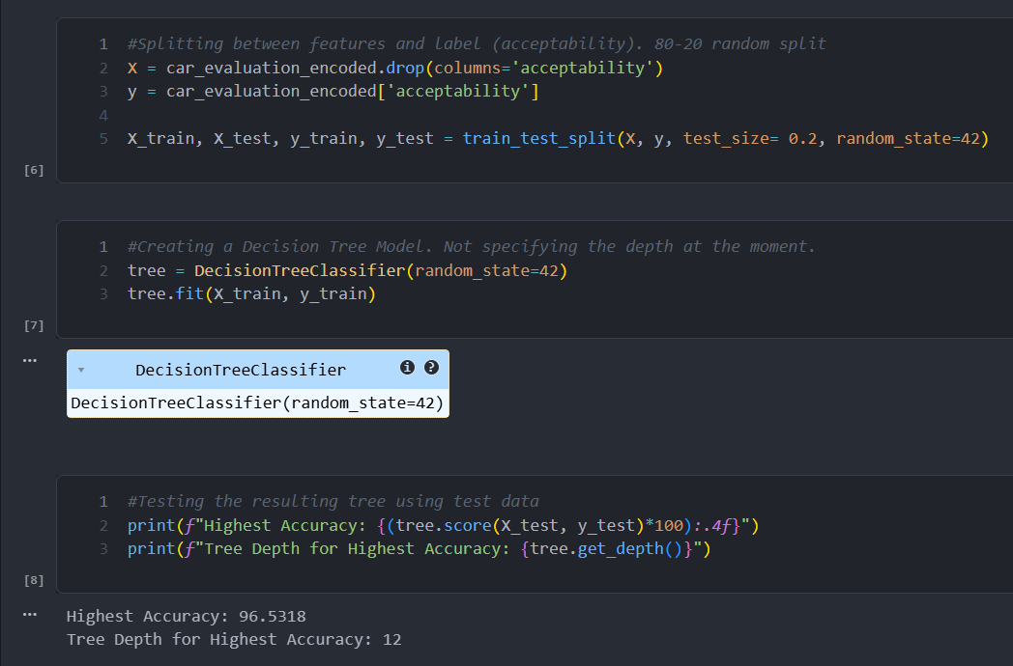

Key Snippet 3: Plotting of the decision tree:
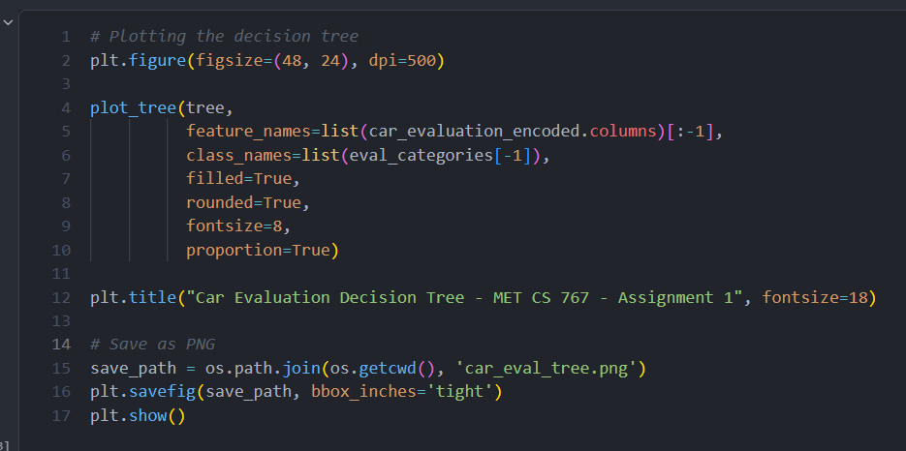

5. YOUR SOURCE
Please supply the URL of your code (e.g., as shared Colab code).
GitHub Repo: https://github.com/sidnair2397/CarEvaluationDecisionTreeAssignment.git

6. DATA ALTERATION FOR CHANGED RESULTS
The following are the minimum requirements for this section. Alter the data from your data source so that it changes the outputs for the above inputs—but not as in Section 7 below. Explain in the format below why the output changes the way it does. Limit (for this Section 6): 2 normal paragraphs (remember that you can use appendices for reference material).

6.1 What Data Was Altered?
Removed the safety feature entirely.

6.2 How Did the Output Change?
Original accuracy: 93.9306%
Without safety: 73.1214%

6.3 Why Did the Output Change in This Way?
The primary reason for this drastic drop in performance is that Safety served as the "root" or primary split in the original Decision Tree. In the context of Information Gain and Gini Impurity, the safety feature provided the highest degree of class separation; for instance, a 'low' safety rating almost universally dictated an 'unacceptable' classification. By removing this high-variance feature, the model was forced to rely on "weaker" predictors such as luggage boot size or the number of doors. These remaining attributes do not possess the same strong, deterministic causal link to the final car evaluation, making them less effective at partitioning the data.
Without the safety feature, the decision boundaries became significantly more blurred. The model could no longer identify "automatic rejections" based on safety risks, leading to a high rate of misclassifications where unsafe cars were labeled as acceptable. This highlights the importance of Feature Significance in tree-based models: when a dominant feature that captures the core logic of the dataset is removed, the model loses its most efficient path to a correct label. The remaining features lack the collective predictive power to compensate for the loss, resulting in a model that is both less precise and more prone to error.

7. INCONSISTENT DATA
The following are the minimum requirements for this section. Alter the data so that it contains inconsistencies. Using the format below, show changes in the I/O of the examples in part 3, and explain. Limit: 3 normal paragraphs.
Please note that I have asked Gemini to rephrase my answer and also generate certain sections based on my code output.

7.1 What Data Was Altered to be Inconsistent?
To introduce inconsistency, a subset of records representing "Optimal Value" (Test Case 3) was manually altered. Specifically, several instances with buying_price: low, capacity: more, and safety: high—which would logically be vgood—were relabeled as unacc (Unacceptable). This created a direct contradiction where identical feature sets were associated with polar-opposite target labels.

7.2 How Did the Output Change?
The model’s predictive reliability for high-utility vehicles suffered. While the overall accuracy remained somewhat high due to the sheer volume of the dataset, the precision for the vgood class dropped significantly. When running the original Test Case 3 through the model, the output fluctuated or defaulted to unacc, demonstrating that the "pure" logic of the value-segment branch had been corrupted.

7.3 Why Did the Output Change in This Way?
Decision Trees rely on the concept of Information Gain and Gini Impurity to create splits. By introducing identical features with different labels, we prevented the model from reaching a "pure" leaf node for that specific path. The algorithm attempted to resolve the inconsistency by searching for "micro-patterns" in other features (like number of doors or luggage boot size) to justify the different labels.
This leads to a phenomenon known as Overfitting, where the tree grows unnecessarily deep and complex to account for what is essentially "noise." Because the model can no longer rely on the dominant relationship (Low Price + High Safety = Very Good), it creates erratic decision boundaries. In a practical sense, the model's "trust" in the safety and price features is diluted, making the entire classification logic less robust and causing it to fail when encountering logical outliers in a real-world scenario.

8. BENEFITS AND DRAWBACKS
The following are the minimum requirements for this section. In at most 3/4 page (of 12-point text), explain the pros and cons of decision trees applied to the application you have chosen (i.e., don’t respond generically).
Please note that I have asked Gemini to rephrase my answer and also generate certain sections based on my code output.
Pro’s of decision tree usage for my application
- Categorical Alignment: The model is inherently suited for this dataset, as all features are categorical. It requires no complex feature scaling, normalization, or distance-based math to function effectively.
- Interpretability and Transparency: The Decision Tree provides a clear, rule-based flowchart that is easy to visualize. This makes the model highly explainable for stakeholders who need to understand exactly why a specific classification was made.
- Real-World Logical Mirroring: The tree structure closely mirrors how consumers evaluate cars in real life—using "if-then" logic (e.g., "If the safety is low, the car is a fail, regardless of the price").
- High Efficiency at Low Depth: The model achieved a strong accuracy of 93% at a relatively shallow depth (max_depth=6). This indicates that the primary drivers of car acceptability are well-captured by the top-level nodes without requiring excessive computational complexity.
Con’s of decision tree usage for my application
- Class Imbalance Bias: The dataset is heavily skewed toward the "Unacceptable" (unacc) label. This results in lower predictive performance and precision for the smaller "Good" and "Very Good" classes, as the model becomes biased toward the majority label.
- Extreme Feature Sensitivity: The model is highly dependent on "root" features. As demonstrated in the experiment where the Safety attribute was removed, the accuracy plummeted from 93% to 73.12%, exposing a significant fragility in the model's logic.
- Risk of Overfitting: There is a constant trade-off between tree depth and generalization. Increasing the depth (e.g., from 6 to 12) risks the model "memorizing" the training data noise rather than learning broader, applicable patterns.
- Limited Interaction Mapping: Decision Trees split features sequentially. This makes it difficult for the model to capture complex, simultaneous interactions between multiple features without creating an excessively deep and fragmented tree structure.

9. EVALUATION

References—besides AI generation
If you use anyone’s work, the extent of that usage must be made very clear. Where this use is via an AI generator, please use the sections provided. Every other reference must be cited at least once within the paper above.
[1] …
[2] …

APPENDIX 1 (if required)
…

APPENDIX 2 (if required)
…

