**Data Source:**

* Data were collected from Kaggle.com also data from Twitter for some of the Top ranked universities for sentiment analysis.

**Challenges faced:**

* Getting the data for Twitter Sentiment Analysis
* Getting the clean data for the visualization
* Cleaning the data
* Modify the dataset due to improper format.

**Calculated Fields and Parameters:**

* Staff Ratio Calculation
* Sort By
* Rank International
* Count University in a Country
* Rank Research
* Top N university
* Ideal Student Staff Ratio
* Dimension

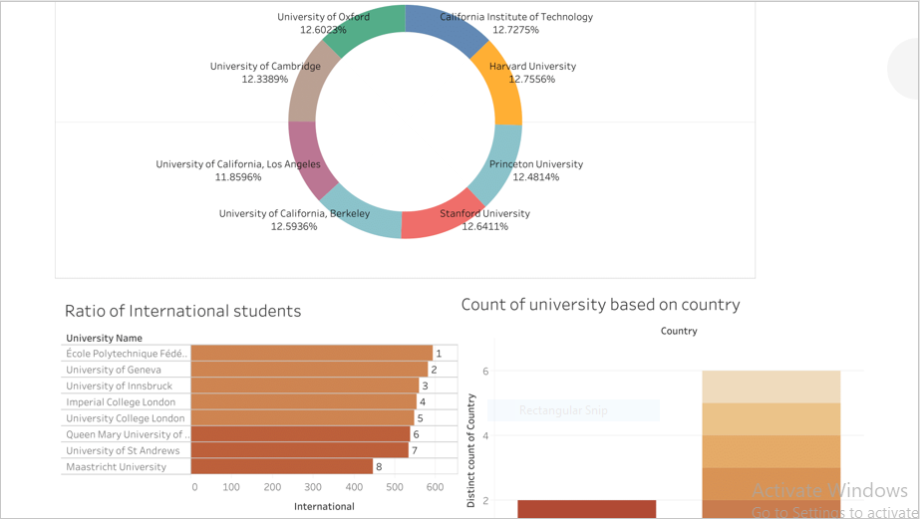

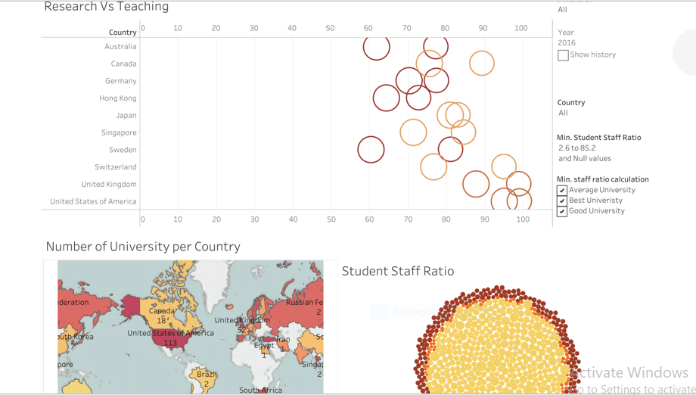

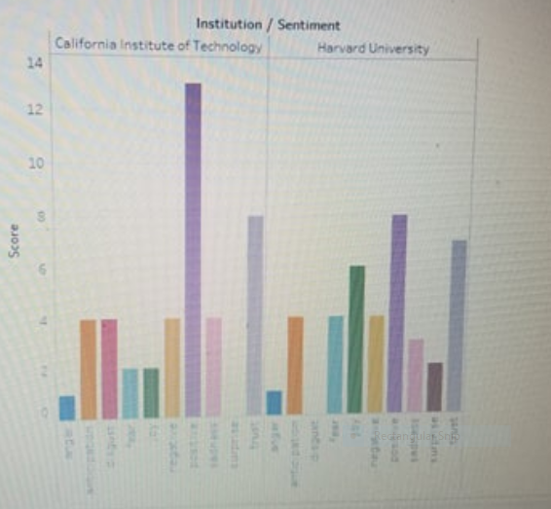

**Conclusion:**

* Research and Teaching has greater impact on the university ranking
* Number of students and International students doesn’t correlate with the ranking of the university
* The ratio of the Top universities in the USA is more than 70% in comparison to all other countries
* Top Universities has low student faculty ratio which has an impact on the ranking of the university
* Tweets of the individual generated from the Twitter sentiment analysis of the Top universities is not a good measure to learn more about the university.