CAP 799: Illustrations to Support the Problem Statement

Sidney Wells

January 17, 2022

Dr. Michael Jones

This weekly report will focus on multiple illustrations, charts, and visual materials that aim to potentially supplement the final report that will be submitted at the end of this capstone course. The emphasis of illustrations this week is to practice using different information conveying strategies to drive home various key points with emphasis that may otherwise not be well understood or described well in the final paper using just words. For example, one important section of the final report will be the problem statement. The problem statement describes a context to a problem that will be addressed throughout the paper. However, how can the problem statement be simplified in the least amount of words possible, perhaps so it's better understood by the reader? In this paper, a flow chart will be used to help clarify the problem statement in just a few words so that it can be visually displayed to the reader. When writing reports, visual aids like charts and graphs can help the reader understand research, concepts, and key ideas better. And since the problem statement is a crucial section of the final report, then it’s important that it’s understood by the reader. Moreover, this essay will describe other key concepts and ideas fundamental to the final report, including the barrier and SWOT analysis techniques, using visual aids. Next week, the report will attempt this same exercise using the data collected during the focus groups, but for now this report will focus on the problem statement and analysis techniques used to accomplish research goals.
To begin with the problem statement, one visual aid tool that may help the reader is a flow chart. A flow chart is a stepwise visualization tool that shows processes more easily than just sentences and paragraphs. For example, the simple flow chart designed to illustrate the problem statement via Appendix A has just four steps in the process that it’s illustrating. In this particular example, the first step refers to TAP, which is described within the report as a program that provides a comprehensive overview of important information about healthcare, family planning, relocation, and career support that is deemed important for members of the organization planning to transition out of the organization. But in the illustration that was built to simplify understanding what TAP is, it's described as a program that provides an overview for all veteran benefits. The next step in the flow chart is low career development support, pointing to the fact that TAP is only a 3-day program that is responsible for providing an overview on various veteran benefits and services. As the data points out, this is significantly missing the bar in terms of supporting members transitioning to a new career from the organization. So this second step refers to the first step while simplifying all the data and information collected using a couple words within the context of a flow chart. Next, the third step is that there is no mechanism to provide feedback to those that administer this program. Given the data in the report pointing to a study by the United States Government Accountability Office, there is a lack of information about how members feel about the TAP program or how effective it is in supporting members achieve their post-service goals. As a result, there's also no mechanism to providing ongoing support to these members unless they put forth the effort on their own. And this step leads to the next step of the problem statement, which is that it's up to the member to do the extra work in order to supplement or build from the TAP program. So members are forced to learn networking skills, how to build their resume, how to leverage LinkedIn and other professional skills, and how to interview well on their own, just to name a few of those pieces lacking in this program. Altogether, these four steps form the crux of the problem statement, which is why this illustration is so valuable. While each of these steps will be described in-depth with their own data and explanations, the visual aid can help the reader visualize the problem statement in a simplified and concise manner.
The second visualization tools that may be added to the final report in order to help the reader understand key concepts and ideas about the problem is an iceberg image. This image is commonly used to convey what the world sees happening isn't entirely what occurs in the world to make it happen. Just as what an iceberg looks like above says nothing above how much larger it is unseen beneath water, what a person does often pales in comparison to what they've achieved or accomplished. For example, when a player in the National Football League wins the MVP proving to the world they are the most valuable player, what isn't shown by their incredible performance that year is all the practice and behind the scenes work they had to exert in order to perform at that level. This image is useful for the barrier analysis technique because it can help illustrate the barriers that prevent members from reaching their post-service goals. The data from the research fills in the information about what people see and what they don't. So, for example, in order to have a great interview, practicing in front of someone many times is something that ought to be done. Passing the interview is part of the iceberg above the water, while the hours and hours of interview prep is part of the iceberg beneath the water. But this idea doesn't just apply to interviewing well. This idea applies to crafting the best resume, networking well, dressing for success, negotiating salary, and also to so many other important career development and progression skills commonly understood as being necessary to be successful. And another ingredient to success is motivation. Among everything that is said to be necessary for crushing the transition, motivation is also important and that's often not something talked about enough. Few companies give away jobs to individuals with low motivation. This is all depicted in Appendix B. For these reasons and more, the iceberg image depicts the many ideas and concepts related to the barriers that prevent service members from transitioning successfully.
Finally, an additional visualization tool that might be used for this project are illustrations that summarize which analysis tools that was used to perform the research for this project. The reason visualization tools may be useful in this context is because the final report should be about the research rather than about the analysis tools to perform the research. Ultimately, there's enough research and data that also describing the research strategies might bore the reader and distract from the results of the research being performed. However, what an illustration can do is complement the final report with a quick overview of the analysis technique without too much detail and outside the context of the research part of the final report. For example, Appendix C is a SWOT analysis illustration meant to describe what the research technique is by using as few words as possible. In fact, this kind of illustration can be used for providing detailed information about a concept as well except outside the essay. Again, this kind of illustration can be used as a reference but instead for giving the reader more information that would otherwise be unnecessary in the essay such as Appendix D. These illustrations are not important but morose supplemental to the essay. And they add value because they give the reader information that can be used later as a reference.
In conclusion, the emphasis of illustrations this week was to practice using different information conveying strategies to drive home various key points with emphasis that may otherwise not be well understood or described well in the final paper using just words. When writing reports, visual aids like charts and graphs can help the reader understand research, concepts, and key ideas better. In this essay, visualization aids that described key concepts and ideas fundamental to the final report were including the problem statement workflow, the barrier analysis iceberg, the SWOT analysis technique definition visualization, and the CFETP training plan diagram for 3N members. Next week, this report will attempt this same exercise using the data collected during the focus groups. Given the nature of the research, part of the upcoming work will require determining the best mechanism for translating the data to the reader. One idea is word cloud because it shows the most commonly used words by the participants, but another idea is simply compiling the most common responses to specific questions. Furthermore, the report will include more information about the project solution now that the problem statement has been determined and described with data. The project solution also needs to be carefully described with a budget, set of deliverables, a timeline, and long term progression of the project. The hope behind the project is that the software tool developed to address the problem statement in this essay will ultimately bring tremendous value not only to members, but to the organization as well.

Appendix A
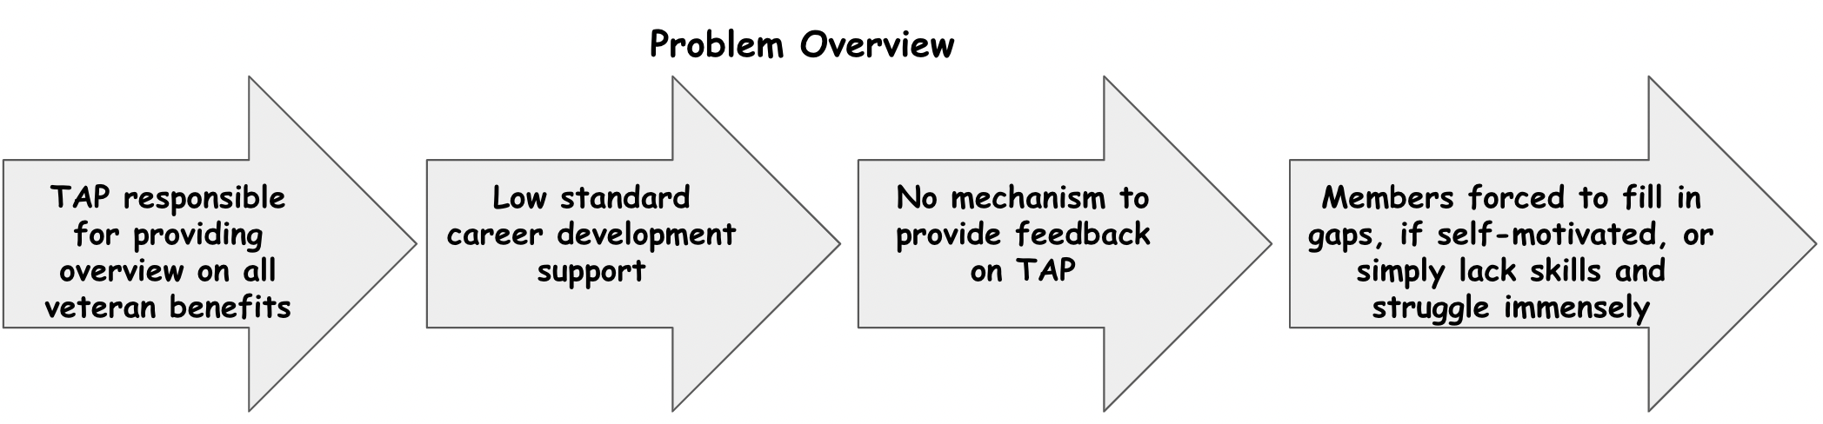
Appendix B
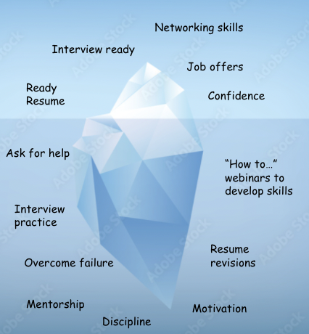
Appendix C
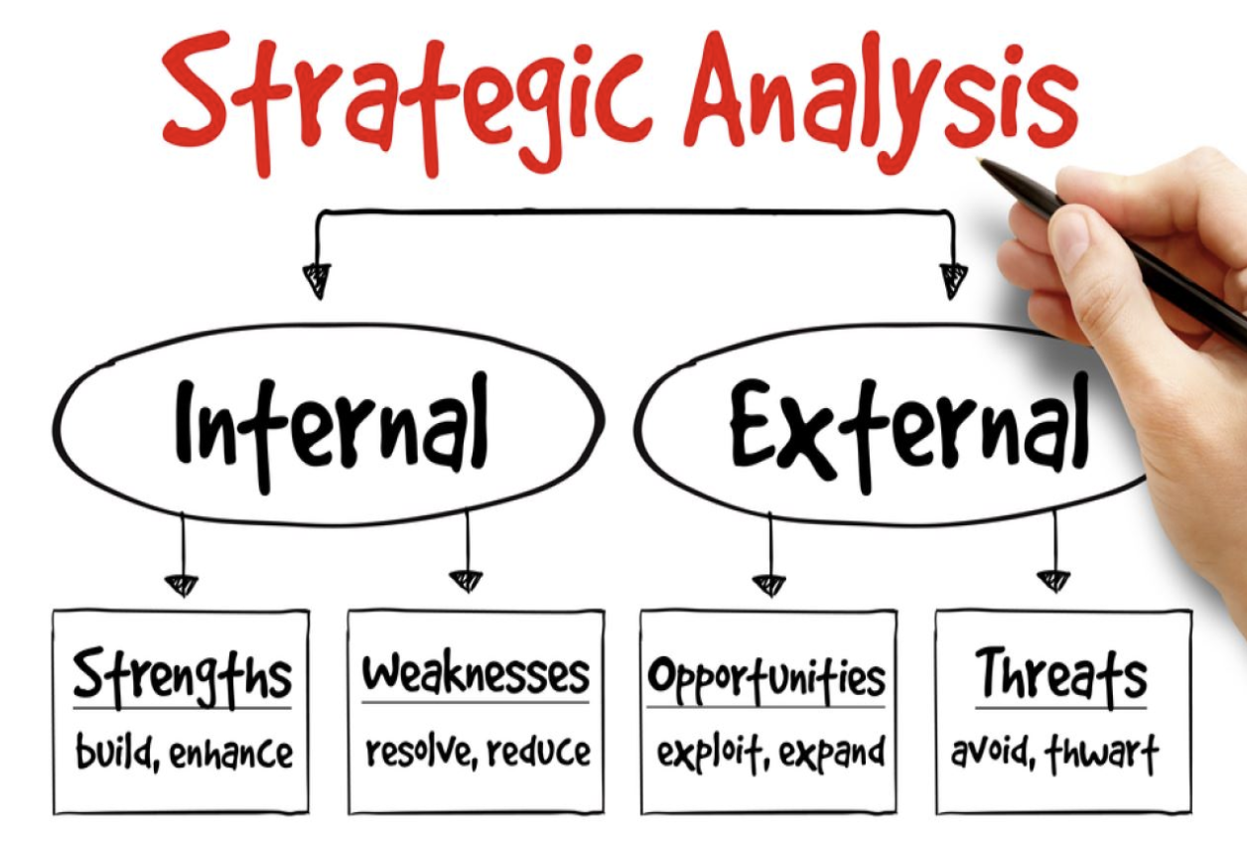

Appendix D

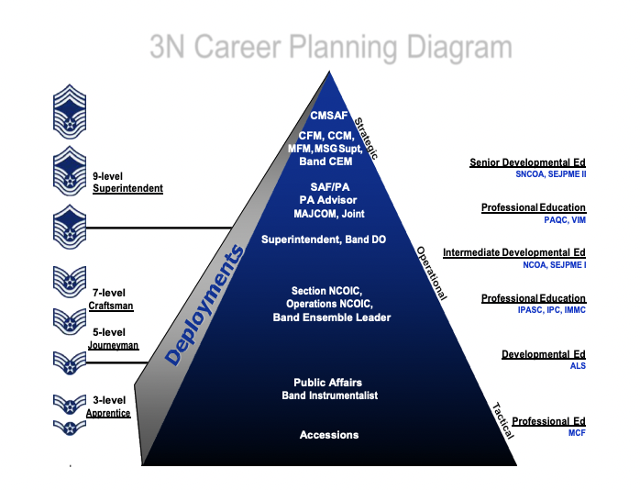

References
CFETP 3N0XX Parts I and II Air Force Specialty Code (AFSC) 3N0XX Public Affairs Specialties
` CAREER FIELD EDUCATION AND TRAINING PLAN (CFETP). (2020, June 1). Department of the Air Force. Retrieved January 18, 2022, from https://static.e- publishing.af.mil/production/1/saf_pa/publication/cfetp3n0xx/cfetp3n0xx.pdf
Harrison, K. (2020, June 1).. Make the most of SWOT analysis for communication planning. Cutting Edge PR Insights. https://cuttingedgepr.com/swot-analysis-for-communication-planning/

