CAP 799: Transforming the Transitioning Assistance Program

Sidney Wells

February 13, 2022

Dr. Michael Jones

Abstract
This paper is aimed towards delivering a project proposal that is designed to address a need that exists within a particular organization. This paper is also meant to serve as the capstone project for the Masters of Science in Information Systems with a specialization in Enterprise Application Development program at Aspen University. Therefore, this project will include both a management and technical perspective given the scope of my degree program. With this in mind, the plan for this project is to diagnose a particular need within the organization and build a software solution that can leverage the core concepts of the graduate learning journey to propose a project solution. More specifically, the plan is to illustrate the problem, identify goals that address the situation using a software solution, and determine concrete deliverables along with a timeline and budget in order to drive a business case for this project proposal as well.
The Problem
The problem this project is trying to resolve is the lack of information about the quality of transitioning service programs that are available to all members when they separate or retire from the organization as well as data about the efficacy of those programs. The clients are the enlisted active duty service members across the Department of Defense because they will benefit the most from knowing how to approach managing their careers, whether within or outside the organization. According to Schwalbe (2013), this information can support decision makers who fund and manage transitioning service programs at the highest level. Decision makers need information to assess the quality of the programs they are meant to achieve certain organizational goals. As Sham points out (2013) Without metrics or data, how are they supposed to know the effectiveness of these programs? Shockingly, that data is scarce. That is a large part of the problem this project is meant to solve. And this is important because there is a great deal of potential through these programs. By exposing retiring or separating members to transitioning programs like the DoD Skillbridge program, for example, service members can make a more informed decision about whether staying or not is a good idea for them. And for those who decided staying within the organization right for them, they'll be able to still consider a program that will help them succeed outside the military once they separate or retire later in their careers. Members who decide to remain inside the organization will always be able to reference their transitioning resources whenever they’d like.
Now, to be clear, the organization does have transitioning programs required for all members of the organization to participate in before they can retire or separate. And these programs have intentions to accomplish specific goals related to transitioning service members. But, the question is this: how effective are these programs? How do the users know that they’re receiving quality training and support? The software application that would be created through this project will amplify that data that answers those questions and highlights the realities of how effective those programs are. My goal in this project is to provide organizational personnel with information so that they can make the best decisions for their careers and families. If the intention behind these already existing programs is to provide a service, this project’s goal is to cultivate a software solution that will, ideally, improve the quality of those programs to better deliver on that promise. To do this, the plan is to build a software tracker application that uses surveys and volunteer reporting to collect information about the efficiency of transitioning service programs.
The Goals
The main goal of this project is to provide a software solution meant to monitor service members' career while they're in the organization as well as after they leave post–service. This would be accomplished, in part, via voluntary surveys provided by the organization throughout the member’s career within the organization.
The second goal of this project is to collect data, analyze it using modern technological tools, and leverage that data into business intelligence that can be beneficial for decision makers so they can make informed decisions. Currently, the transitioning programs offered around the world are developed within any real data to track their effectiveness and any means to track their efficacy. That needs to change.
And the third goal and final goal of this project is to develop a sustainable, secure, and customer-driven software application leveraging modern software development practices and collected data to address the gaps identified from the tracker application. This long-term goal is considered a long-term goal given that it’s requirements and features will, in large part, be determined by the data collected in the project. For this reason, it’s a long-term goal that is a guiding light for project managers working on this project.
The Deliverables
The primary deliverable for this project will be an overview of the problem, the software application's minimum viable product (MVP) including the main use cases, the budget, and the timeline by which deployments will occur over the short-term. Additionally, a rough budget outline for the resources required will be mentioned as well as strong considerations about how the budget will change over the duration of the project's iterative software development lifecycle from MVP and onward.
The Deadlines
The goal is to complete this project by the end of this 8 week course. All research and writing will be an ongoing process which will culminate to a 8-page paper. This paper will include the deliverables mentioned earlier: an overview of the software application designed to meet the client, transitioning members' needs, a breakdown of the budget, timeline, technological resources, and iterative development that will proceed over the duration of the 6 month projected development plan, and a detailed description of the mechanisms that will ensure the application is sustainable and secure over the duration of the software development cycle.
The Cost/Budget
The budget of this software application will follow a standard big data application development budget. The anticipated user count will be in the thousands at one time so the application will need to meet the demands of thousands of concurrent users being able to access the application’s resources, perform user operations, and do so in a smooth and secure manner. From the deployment side, the goal is to have this be a cloud-native application, resilient and benefiting from what the cloud has to offer. These numbers are currently unknown, but will be determined as a breakdown of the resources required are identified in more detail. There is likely to be a startup cost when the initial launch is deployed, but further iterative development steps will follow a more consistent budget flow.

The analytical framework that was used for this project was the SWOT technique, which encourages a careful look into the strengths, weaknesses, opportunities, and threats to an organization. Since this project is aimed towards solving the problem of ignorance about career development within the organization, one of the core areas that will be evaluated within the organization is the Human Resources department because they are responsible for the selection, career development, and retainment of employees within most organizations (Open Learn, 2020). Additionally, since career development and retention efforts may be incorporated into different areas of the organization from management to education/training, another important key area to analyze is the strategy or leadership departments within the organization. According to Lumen (2021), For any project or program to succeed that touches nearly every member of the organization, it will need to be incorporated within the vision and mission of the organization as well. Other notable departments that will not be as relevant to this project are finance, marketing, research and development, and technology/IT. Although these departments do exist within an organization and will likely be affected by the project in some way, they are much less relevant to this project proposal and can be discussed later.
Furthermore, to help understand the problem better, this project used the barrier analysis technique because it focuses on what controls are in place in the process to either prevent or detect a problem (What is Root Cause Analysis, 2022). In order to perform this analysis, mostly qualitative data analysis techniques such as focus groups were implemented in order to carry out the barrier analysis. Focus groups provide the ability for members to convey their experience and, most importantly, help the project by identifying the real barriers preventing the project's goal, or target, from being achieved. And because the customers of the project are also the people in the focus groups, the goal was to engage with ideas through conversations around this topic as the development of the project begins addressing these barriers after it is launched.
Some of the key insights from the barrier and SWOT analysis work were the following. One individual said he was able to find private organizations willing to help him work on his resume, build a LinkedIn profile, and practice networking. Another individual said they were relying on mentors outside the organization to provide support on how to navigate the transition from the organization. One woman said she never thought about a post-military career while serving within the organization. A different individual said there is a prejudice against leaving the organization because leaders believe they are somehow better for staying in. As a result, talking about leaving or other opportunities outside the organization is frowned upon. One person said his leaders encouraged him to get schooling, certifications, and experience before leaving the organization. However, when asked what the best resources were available for transitioning, the leaders didn’t know. One leader told a person that they didn’t know much about seeking post-military opportunities, but that the leader said they would be willing to support in the process. One leader said many people who leave don’t have plans when they separate or retire and she learned from that to do her own work to ensure that she did not follow the same path. These are some of the key takeaways from the barrier analysis work. An overview of the feedback can be found here, Appendix A.
From the SWOT analysis work, some of the information gathered was that there are two core components that are strengths within the organization that pertain to career development. The first is the Transition Assistance Program (TAP), which is introduced to service members who are 1-yr or less from the end of their contract. The TAP program is a strength because it provides comprehensive, up-to-date information about healthcare, family planning, relocation, and career support. Additionally, when service members first begin their careers, they operate within the Career Field Education and Training Plan (CFETP). This document, or something similar across the organization, is meant to ensure service members have the right knowledge, skills, abilities and tools to deliver the capabilities to meet their organization's mission and to ensure the organization will rise to the challenge of tomorrow’s highly competitive environment. On the other hand, the issue with the training programs, including the documents that manage career development is that they are typically outdated, updating once every decade or so. Additionally, the TAP program fails to deliver much on career development support. The most useful aspects of the program are about entitlements to members once they leave the organization. However, in many source documents they provide for their transition include advice like finding a mentor and creating a LinkedIn. These actions are important but the support and coaching to execute a career transition from the organization is lacking in this program.
And finally to conclude the data portion, it was learned that career development is introduced to members through training plans that are tailored to their job or career field. This happens once they pass specific orientation programs, usually two months after they begin. This training plan manages their career goals and training, but service members are encouraged to seek other opportunities via on the job training or other opportunities external to the organization. Moreover, each sub-organization has a manager that tracks everyone’s training. And on a micro-level, each person has a supervisor that tracks their folks' training. Career development beyond this training plan is not a part of the formal process. But oftentimes, there are resources for individuals to pursue opportunities if they desire to do so. Next, a study from the United States Government Accountability Office from 2019 about transitioning members' career assistance will be reviewed with a critical lens.
In 2019, the U.S. Accountability Office published a report about transitioning members. The report provided information on career assistance centers, which are mandated by federal law. These centers provide various services through the Transitioning Assistance Program (TAP) such as supporting resume writing, offering tips on interviewing, providing advice on conducting a job search, as well as assisting in understanding personal skills during career exploration, just to name a few (Government Accountability Office, 2019). Altogether, approximately 200,000 servicemembers transition each year so these services should be extremely helpful this period in a servicemembers’ career. However, although there are nearly 300 employment assistance centers on military installations to support transitioning service members, there is far less information and data about the reliability of these programs to deliver quality context, the efficacy of each program to meet their desired objectives, and whether the mandated program is given sufficient resources to provide the programs it provides. While there is participation data for members who enroll in the TAP program and data about the thousands of services provided, that data is certainly not a reliable metric to determine whether a service member is now prepared, or evenly a little more closely prepared, for their transition. So how do service members know that the TAP program works or meets the goals they intend to meet? If these programs are so important, then why are statistics about the success of these programs, like the TAP program, nowhere to be found? An overview of this problem can be found here, Appendix B.
To address the lack of information and accountability about career development and transitioning service programs is a tracker app, or data analysis software tool, used for understanding the state of members pre and post transition. The goals of this application would be to explore the efficacy of the TAP program with real, meaningful data across the organization, explore the findings from previous research done in this course about the lack of career development support within the TAP program, and to shout out the best practices within our organization with regards to career development support. This tracker, essentially, will explore how well the TAP program is across the organization so next steps can be explored. The goal of this tracker application would be to figure out what’s going on in these programs.
Since the tracker application is oriented towards the members as the main end users, several of the features will be different as well. Aside from the mandatory organizational, security, and login requirements discussed in the previous paragraph, the first feature for the tracker application is that it can send and collect data via surveys or forms from users. The forms and surveys need to be created based upon the metrics deemed to be important and responses tracked in a meaningful way that proves useful to the end users, which are the leadership members of the organization who are interested in knowing the state of the TAP program within the organization. This is an important decision because this is the information that will be tracked over time so responses’ options ought to be consistent over the long haul. If the ways of measurement are changed at any point, it’ll be difficult to truly know the differences over time from one survey to another. Another feature will be the backend, big data side of the application. This is where most of the analytics, algorithms, and data storing will reside. Since the user data will span many topics over a long period of time, pending funding, the ability to collect, store, and process the data is fundamental to the application. And finally, the last of the three main features of this tracker application is the reporting. What use is the data if it only exists in the database? Reports need to be generated and customizable to the leadership members of the organization who are interested in knowing more about the state of the TAP program. Reports generated weekly, quarterly, or annually would be useful as well as those generated from filters such as years within the organization. These reports would be the main drivers for decision makers to make informed decisions. Thus, the tracker application would be something similar to a business intelligence application for decision makers. Although the purpose of the application is different here, this suggestion may actually prove more beneficial in the long run since it’ll track data currently unknown.
The long-term plan after a few years with data in hand is a transitioning assistance program portal that would support military members during their time within the organization as well as post-service. The emphasis of the TAP portal would be career development, however, rather than military training. It wouldn't be mandatory, of course, for members, but rather a resource available for members who are interested in using the application. For the user, there will be several important features that will help them develop their career skills not only over the course of their military career, but of their professional life. Those can be found here, in Appendix C.
Having a six month deadline for the purposes of developing and delivering this project to the customers seems like a realistic goal given the scope of the work required to build this project. One critical aspect for this to be successful, as Pusz (2019) mentions, managing costs is one of the most important responsibilities of a project manager if they want to be able to complete their project, including each deliverable, within the budget constraints provided to them. Within the planning phase, requirements need to be discussed along with the associated costs required to deliver those requirements to the customer within the discussed timeline. According to Martinez (2021), included in these costs are direct costs and indirect costs that relate to the software, hardware, personnel, and training required to finish the project. Bottom-up estimating is a technique that involves estimations on a granular level for parts of a project. It is often referred to as one of the most accurate ways of estimating because the calculations are performed at the level of activities, so the anticipated effort of work required for the whole project is the sum of all granular estimates. Appendix D displays the cost estimation described in the previous paragraph where the required resources necessary to complete the minimum viable product of the project is displayed within a work breakdown structure (Westland, 2021). Based on the numbers shown in Appendix A, the budget is projected to cost a little over half a million dollars for six months of work. This is a high estimate and might change as resources, like cloud resources, are more accurately determined through usage. But that’s the estimate for this project, including the technical resources and members of the project team, such as the project manager, the software engineers, and the software licenses necessary to perform the work needed to build the software. Additionally, reserves and training resources are common budget items to ensure that the project is funded even if the budget costs go up and that individuals using the software gain access to the resources to leverage it in their work.
From the software development perspective, there are various methodologies that development teams can implement into their workflow to improve collaboration between information systems departments and end-users. In particular, the agile methodology is beneficial because it places the customers and users as the drivers of the software development lifecycle. With this software development methodology in mind, how does the theory apply to the suggestions mentioned last week. With customer engagement as the highest priority, upon approval, this project will focus on ensuring the requirements discussed are aligned within the goals of the customers and stakeholders. Except instead of waiting until all of the functional requirements are approved and verified, developers would build the software while the rest of the requirements are being discussed with the customers. Meanwhile, as development proceeds forward and future requirements are discussed, the current work being developed is tested for quality by the customer. Now, what if the project doesn’t go perfectly, what happens? For instance, what if there are not enough computer resources, or human resources, or if the quality is not up to par, what happens? Project management theory includes many different controlled processes that include the change control process, which helps project teams identify, evaluate, and manage changes during a project life cycle. So if the development team, the customer, or any stakeholders needs to make an adjustment to the project, then there is a process within this methodology in order to manage those changes quickly. The agile methodology offers tremendous benefits to all stakeholders whose project hopes to leverage the methodology.

Appendix A

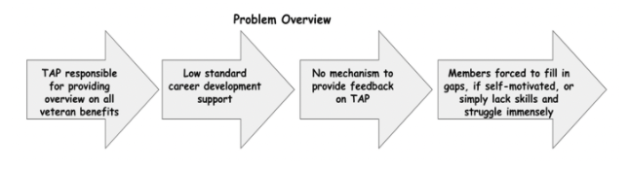

Appendix B

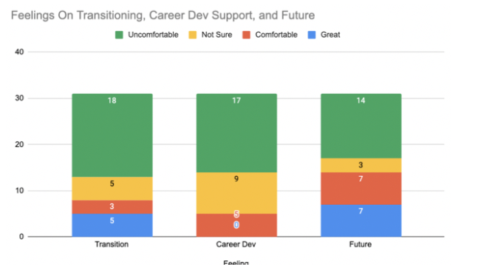
Appendix C

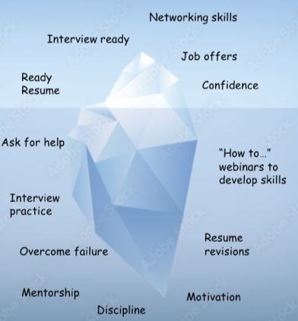

Appendix D
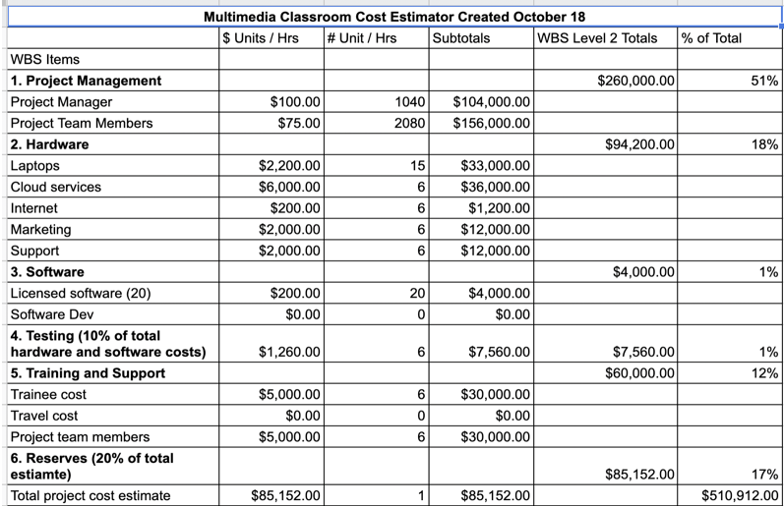

References
Government Accountability Office. (2019, June 17). Transitioning Servicemembers: Information on
Military Employment Assistanceneed Centers. Https://Www.Gao.Gov/.
https://www.gao.gov/assets/gao-19-438r.pdf
Lumen. (2021). McClelland’s acquired needs theory. Lumen Learning. https://courses.lumenlearning.com/wm-introductiontobusiness/chapter/mcclellands-acquired- needs-theory/
Rybak, M. (2020, December 3). Sharpen your saw. Exude. https://www.exudeinc.com/blog/sharpen- your-saw/
Martinez, M. A. (2021). Project cost estimating tools and techniques. Project Management Skills. https://www.project-management-skills.com/project-cost-estimating.html
Open Learn. (2020). Msds.open.edu. Retrieved January 3, 2022, from
https://www.open.edu/openlearn/money-business/organisations-and-management-
accounting/content-section-4.3)
Pusz, J. (2019, May 22). How project management can provide a competitive advantage. LinkedIn. https://www.linkedin.com/pulse/how-project-management-can-provide-competitive-joe-pusz- pmo-joe/
Schwalbe, K. (2013). Information technology project management, revised. Cengage Learning.
What is Root Cause Analysis (2022)? American Society for Quality. https://asq.org/quality- resources/root-cause-analysis
Westland, J. (2021). Work Breakdown Structure (WBS): The Ultimate Guide with Examples. ProjectManager. https://www.projectmanager.com/work-breakdown-structure

