# Inspiration

## existing app research

### Colour and Space

#### I like the simplicity of this design [left] and the balance of the content found through equal spacing and leaving space at the bottom. I also like the subtle gradient background and the lack of a header, I hope to incorporate a simple title design like this one. ­­

#### As far minimalism goes, this application design [right] is probably my limit. This design does, in my opinion, still work as any content can quickly look cluttered on a phone due to the small size of the screen. I like the lack of colour and the simplicity that brings as well as the attention that is attracted by the use of white space.

### 

### Gamification

#### Gamification is the evolution of mobile and web applications to include incentives such as levels, XP or goals to expand and deepen the interaction between user and device. This technique can be found in apps such as Duolingo, the language tutoring application. This could be useful in our application as motivation for our users to reduce their carbon footprint. Other techniques such as characters and animations used in Duolingo we could also consider. Techniques such as ‘streaks’ can also be used to increase user participation on a day to day basis.

### Ignazio Lucenti’s Portfolio Website

#### The minimal use of navigation and well-presented typography has made this website interface very dynamic. Through this it can appeal to a wide range of audience. I also feel with this site the content is very professionally structured to give it that acquired taste.

#### 

### Plastic Footprint Application

#### This plastic footprint app clearly demonstrates its institution with the help of plastic in the ocean. I like how it provides friendly knowledge on how your own footprint can help the ocean and what is also being done to promote it. The design of this app is very detailed in the way they have used plastic sketches within the water to help provide the audience with how toxic it can be to make the user more aware.

### Headspace (Mediation App)

Headspace is a mediation app focused around a personalised development system. Starting from the very basics of mediation and continuing to help the user develop their meditative ability.

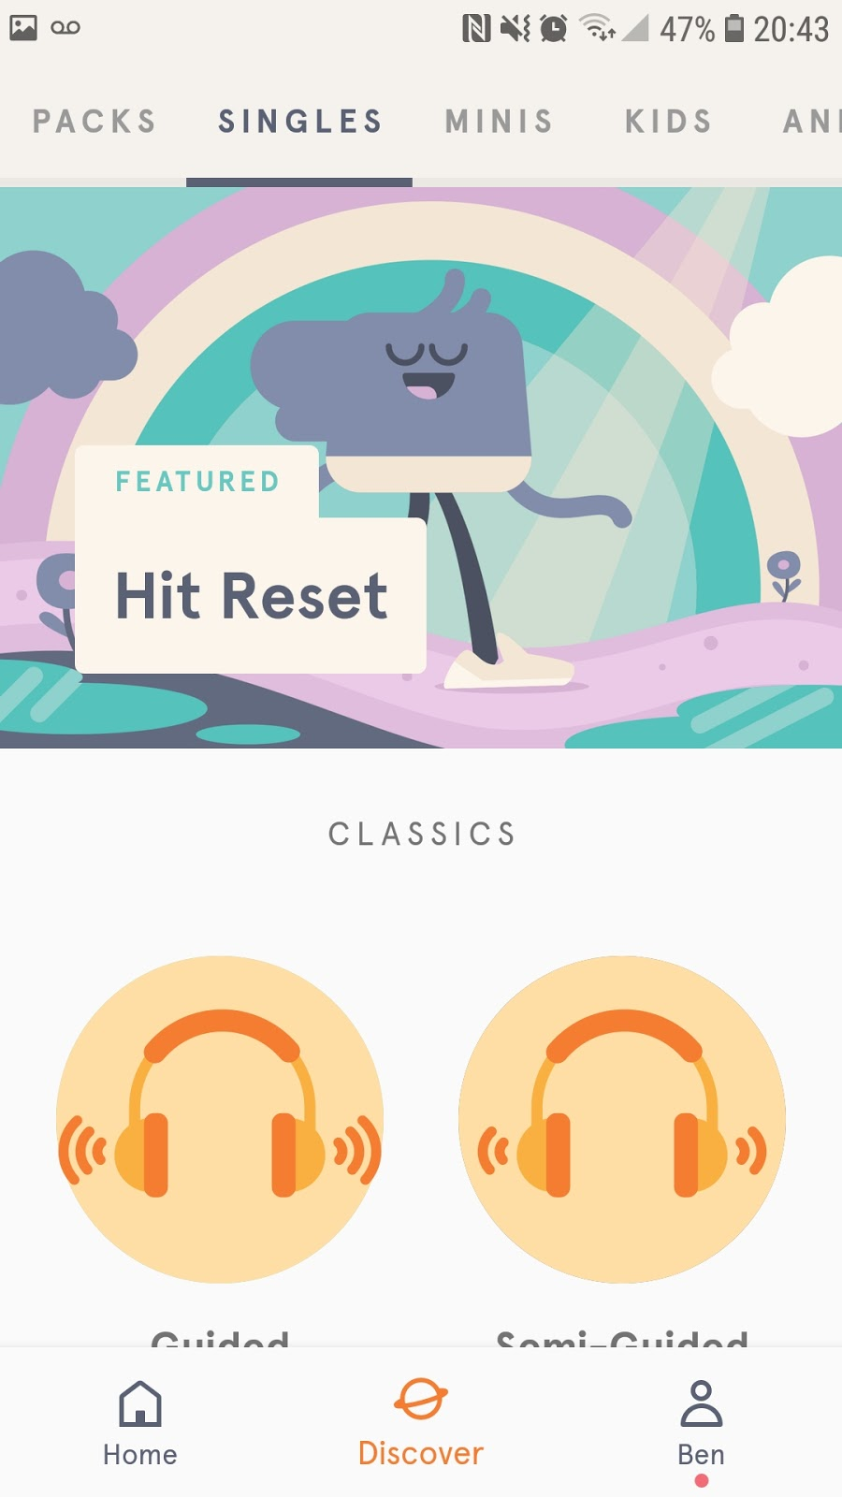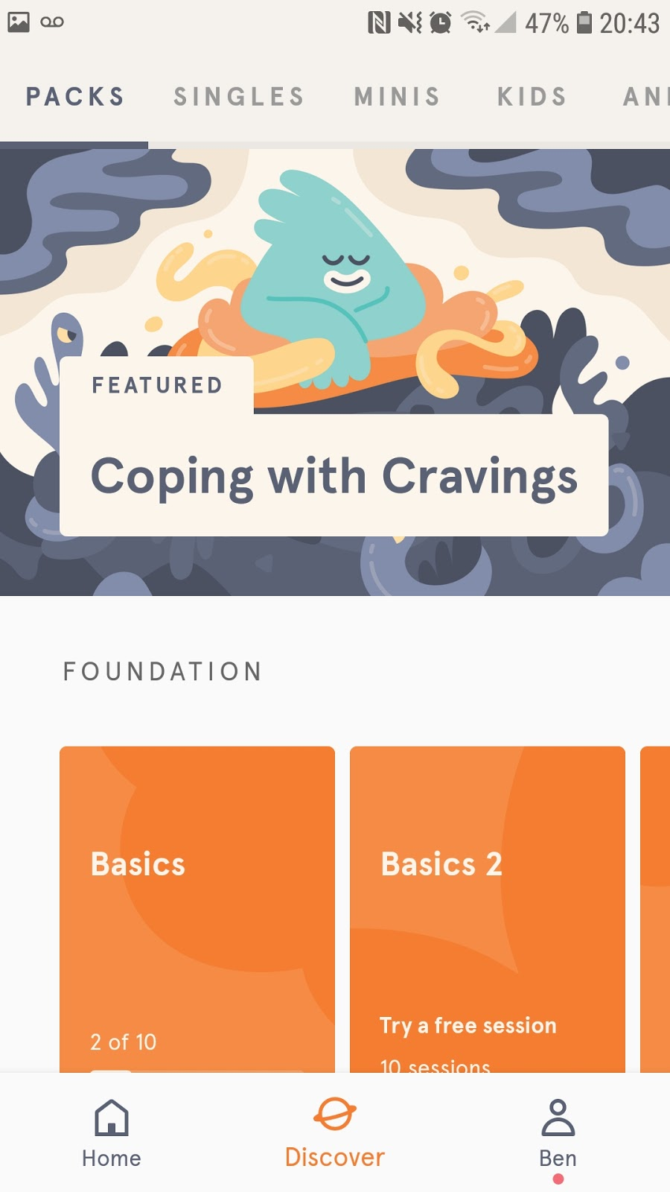

The overall UI design focuses on ease of use, the app is clean and concise without the need for clutter. Using soft pastel colours in combination with the simple design makes the user experience very welcoming and calming. Adding to the overall experience of a meditative app, making sure that the apps design only adds to the user experience.

The app focuses mainly on separating different training courses out using cards, these are displayed in a manner that allows the user to navigate quickly without too much information on-screen. This is complimented by the intelligent use of negative space to highlight important sections and allows the user to mediate with very little distractions.

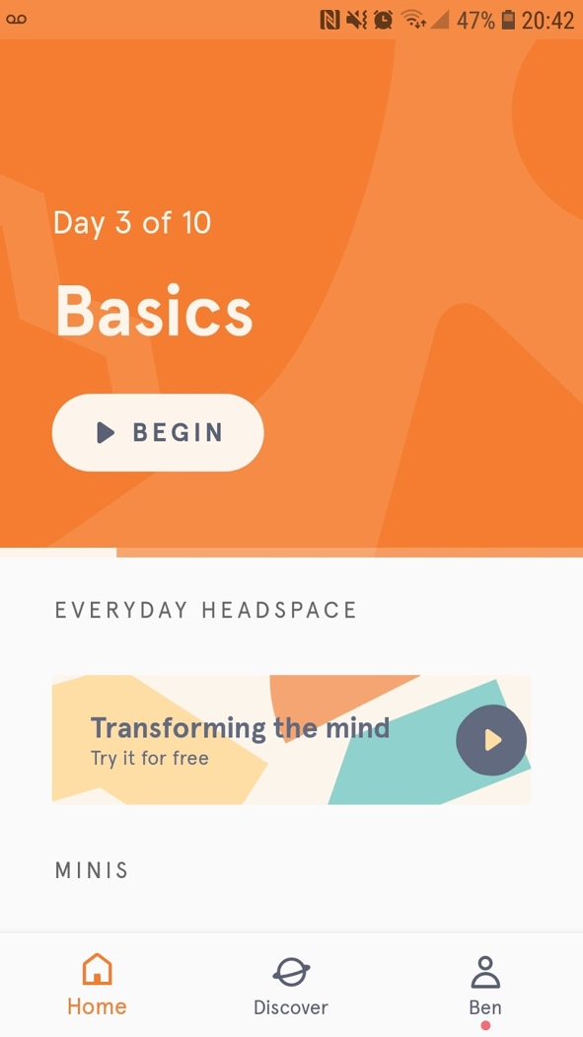

Each section contains an illustration at the top, using a pastel colour scheme which will be calming to most users. The layout of this design has been developed for the change in smartphone aspect ratios. Keeping the selectable data at the bottom to help with one-handed use. This will be the focus of our application’s UI design due to the change in aspect ratios and the increase in smartphone size it is practical to keep import, selectable data in the lower part of the application to aid in ease of use.

### Audible (Audiobook App)

#### Audible is an audiobook application from Amazon, similar to Amazon’s Kindle app it allows you to build a library of your favourite books but in an audio format.

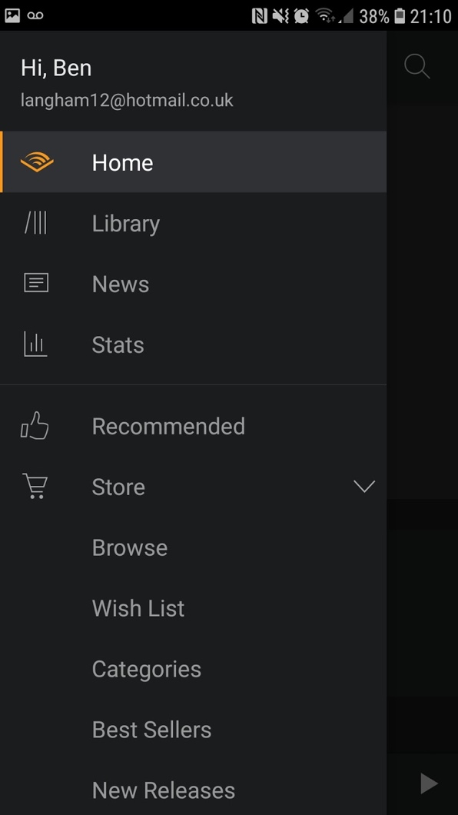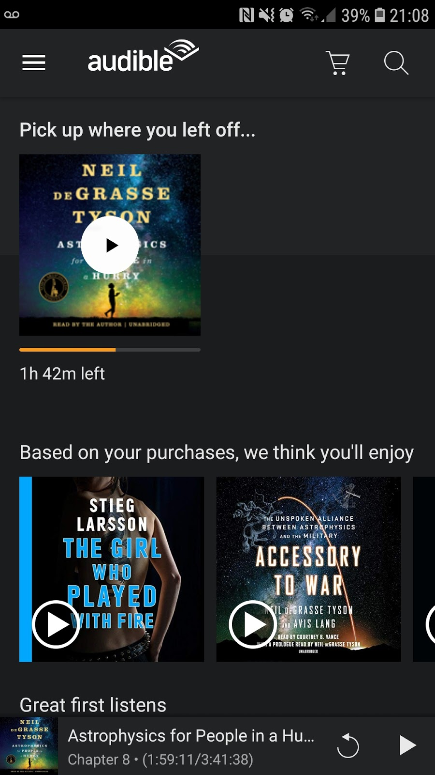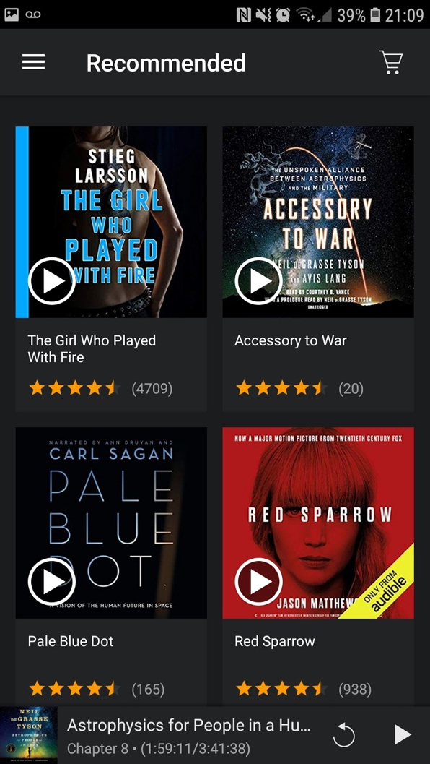

#### I enjoy the simple navigation menu that Audible uses, two very muted colours with an icon that changes to an orange (fitting with Audible's logo) just to highlight which page you've selected. I find this to be the perfect use of colour injection as it's not too overpowering and helps the user to navigate.

#### Audible's UI design uses a colour scheme that doesn't invade the vibrant audio book covers. The muted colours allow for the covers to shine through and aids the user in finding a suitable audio book.

#### Certain sections of the UI design are not fully incorporated, being that the app launches a web-browser when looking for items on the store does take away from the app’s integration, also introduces a large amount of delay (this can also be down to internet connectivity) but overall it breaks the sleekness of the user experience.

#### Overall the user experience and design elements keep the application simple and easy to use, the colour scheme helps keep the audiobooks central.

### IFTTT (Allows App to App communication)

IFTTT’s UI design has a similar style to Headspace. Breaking the user interface down into three sections to help with navigation, also using a card style design to break up the different options inside of the sections. I find the card system is the most effective when trying to keep an applications UI clutter free, using different colours to differentiate between the options aids in usability. It also allows for the cards to be stacked and kept in categories. Adding an extra dimension that allows more user control.

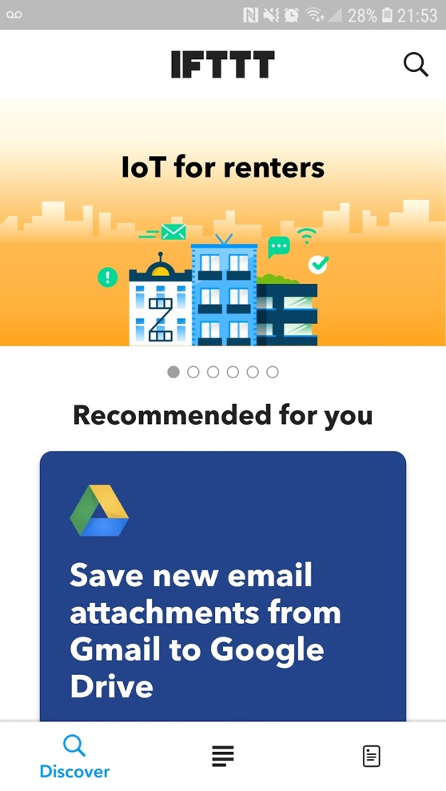

Following on from IFTTT’s similarities to Headspace, it focuses on an intelligent use of negative space to keep the overall UI clutter free. This is something I personally enjoy as it makes every part of the application accessible.

Overall impression of the UI design is that it is accessible and simplistic as to not hinder the user’s interactions. Allowing you to complete the tasks the application is intended for without the clutter of a messy UI. When looking at our own application, key features that are represented in this application will be vital to creating a well-balanced and efficient application of our own. Keeping our application concise and easy to navigate, such as the bottom navigation menu that allows for quick cycling between a variety of sections. This compared to Audible’s side menu which can at times feel cluttered and overbearing.

