DAT502

Inspiration

Sources:

https://99designs.co.uk/blog/trends/mobile-app-design-trends-2018/

https://www.shopify.co.uk/partners/blog/mobile-design

29/11/18

Transcribe App

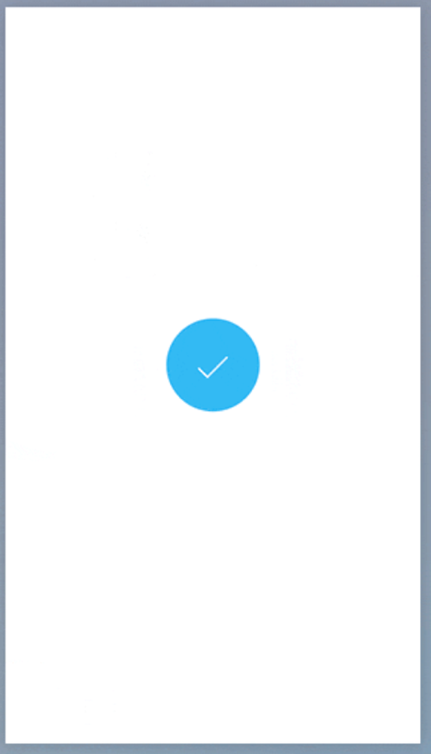
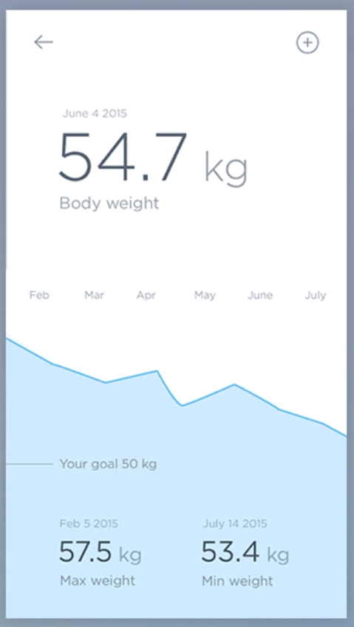
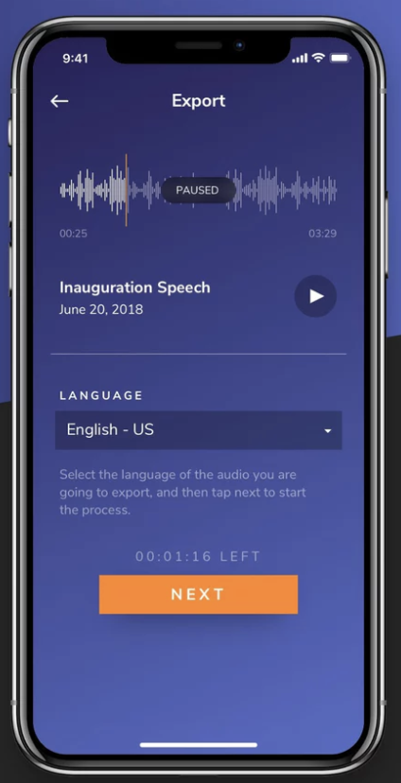
I like the simplicity of this design and the balance of the content found through equal spacing and leaving space at the bottom. I also like the subtle gradient background and the lack of a header, I hope to incorporate a simple title design like this one.

