job.setInputFormatClass(CombineTextInputFormat.class);
CombineTextInputFormat.setMaxInputSplitSize(job, 67108864); //64 MB

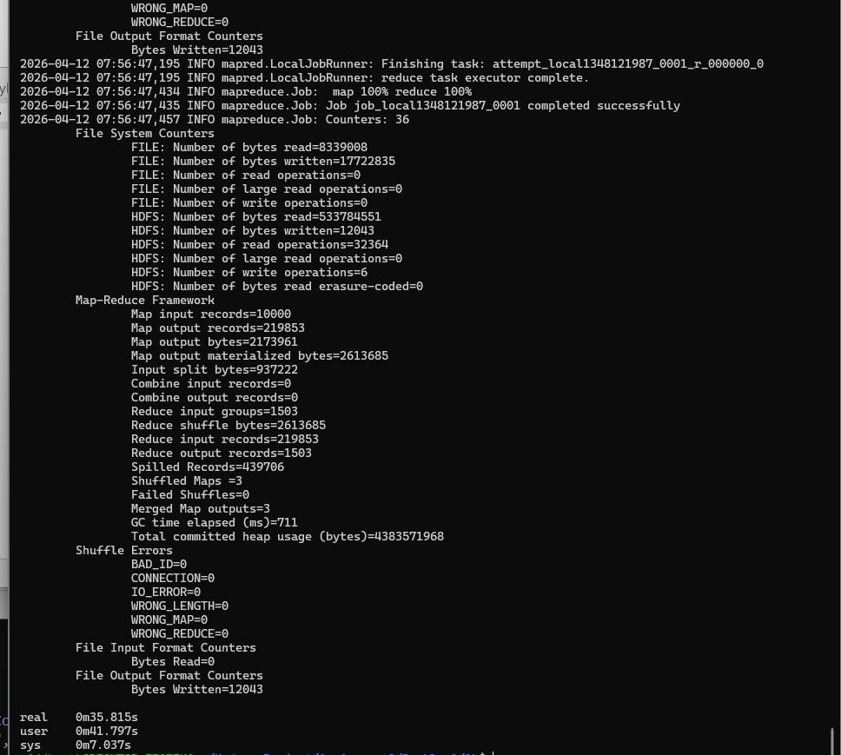
Problem 2:
A

Time:
real 1m56.062s
user 2m11.019s
sys 0m9.638s

/problem2/2a/df.tsv

Using this got top100.txt:
hdfs dfs -cat /problem2/2a/df.tsv | sort -k2 -nr | head -100 > top100.txt

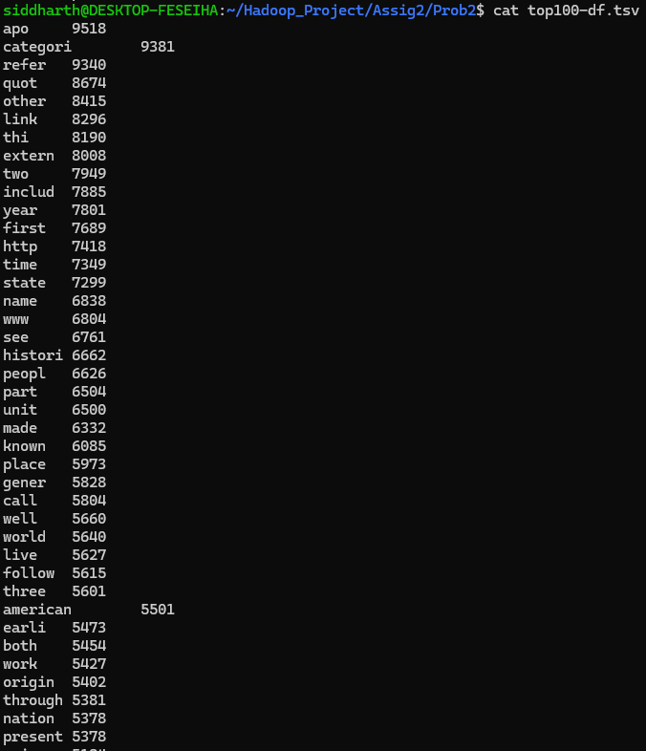

B
Time:
real 0m52.046s
user 0m59.602s
sys 0m6.379s
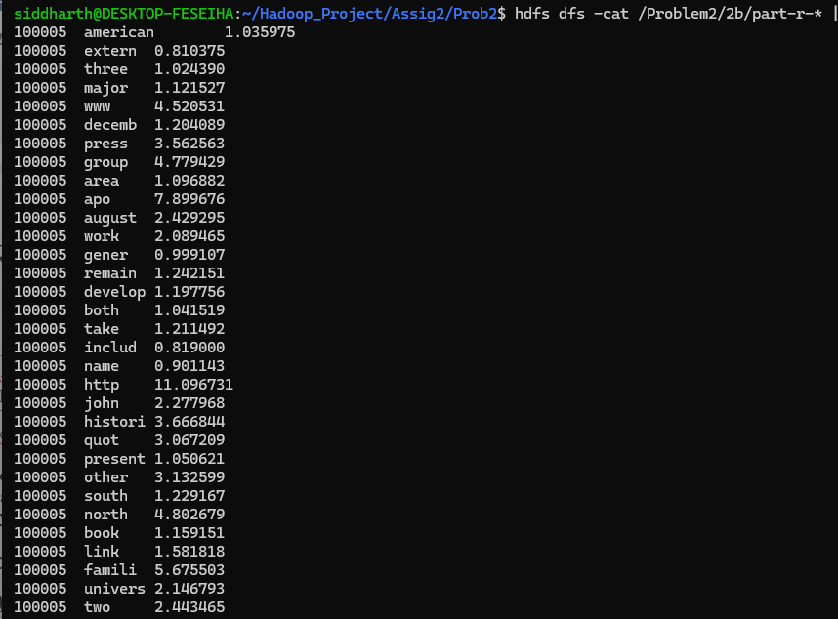

Problem 1:
Aa
setup() → runs once
map() → runs many times
reduce() → runs many times
cleanup() → runs once at the end [no need to call]

WordCount2Mod Run:
time hadoop jar WordCount2Mod.jar WordCount2Mod /largerDataset/Wikipedia-EN-20120601_ARTICLES /problem1_Large/output1aM1 -skippatterns /problem1_Large/stopwords.txt

Using cleanup function
real 2m59.224s
user 2m44.710s
sys 0m12.177s 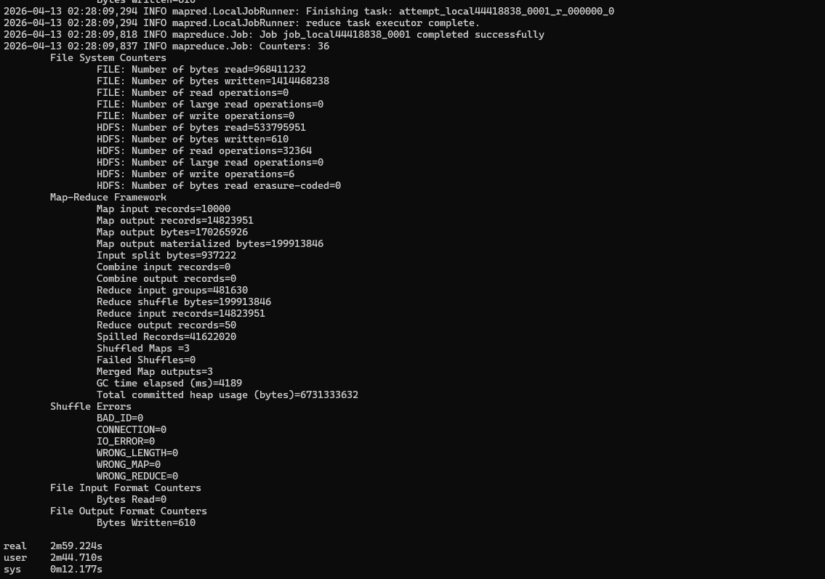
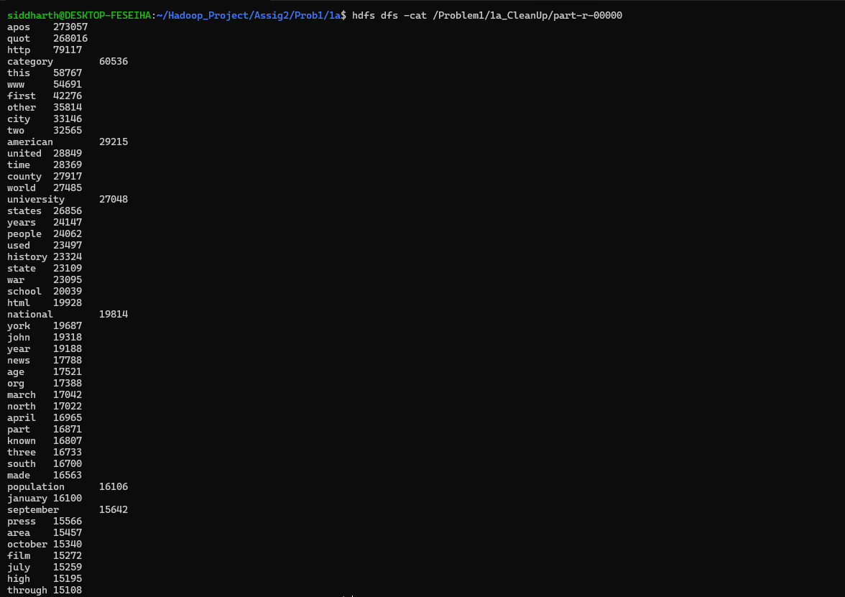
Ab
Run:
time hadoop jar WordCount2.jar WordCount2 /largerDataset/Wikipedia-EN-20120601_ARTICLES /problem1_Large/output1aM2 -skippatterns /problem1_Large/stopwords.txt

hdfs dfs -cat /problem1_Large/output1aM2/part-r-* | sort -k2 -nr | head -50 > top50.txt
then sorting

Time:
real 1m59.412s
user 2m10.697s
sys 0m13.220s
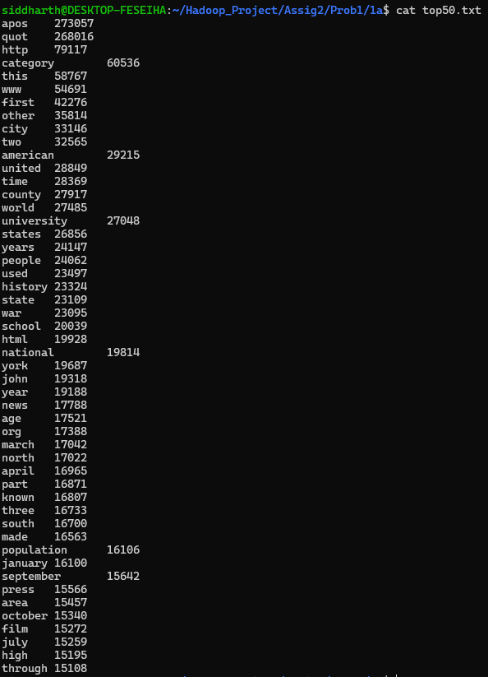
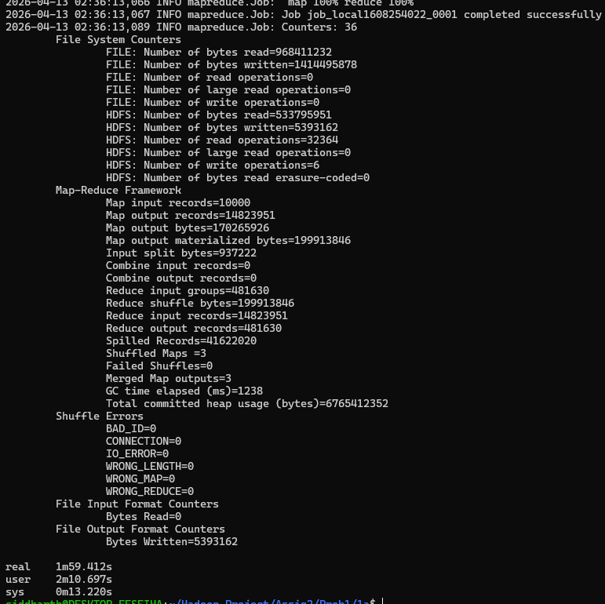

B.
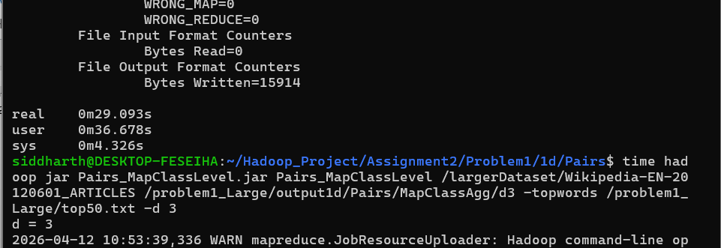
D1:
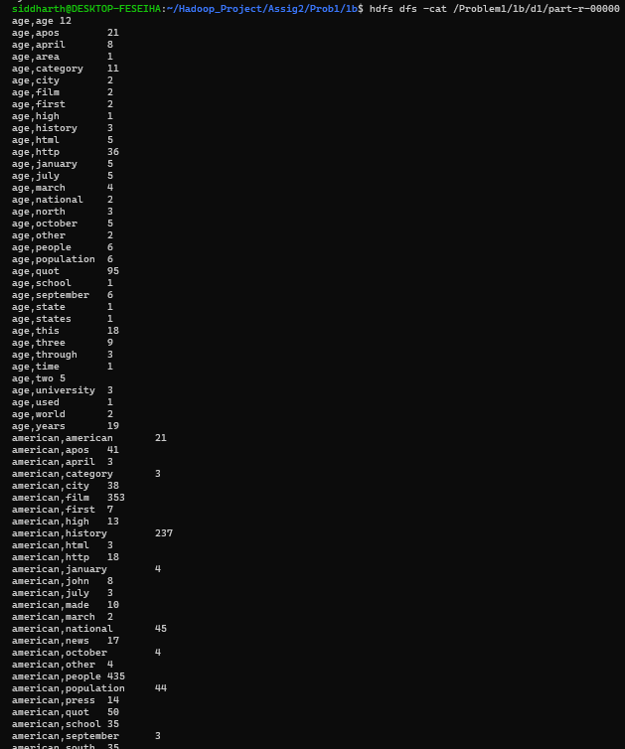
Time:

real 1m14.085s
user 1m22.719s
sys 0m7.745s
D2:
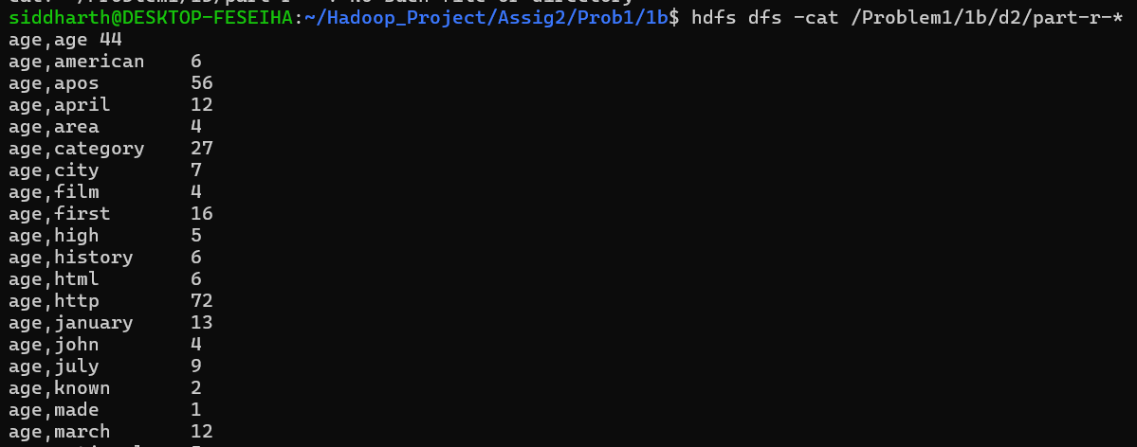
Time:
real 1m35.938s
user 1m47.486s
sys 0m10.501s
D3:
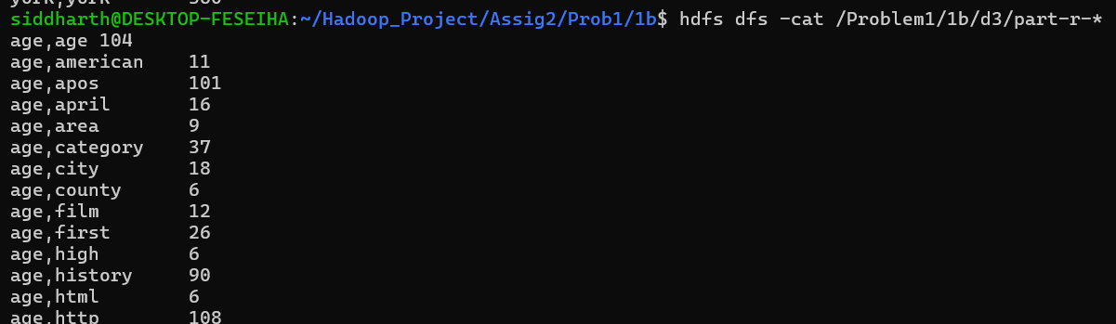
real 3m9.851s
user 3m38.855s
sys 0m24.832s
D4:
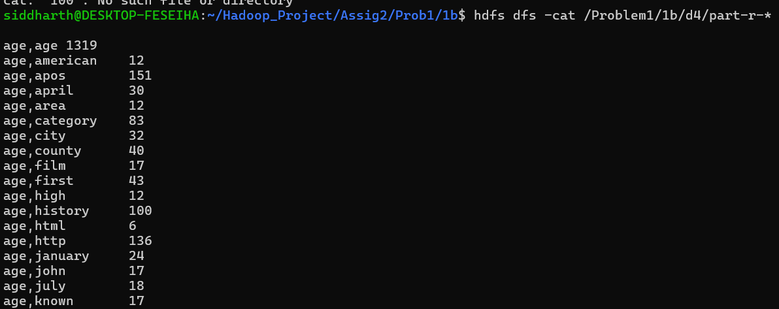

real 1m54.944s
user 2m8.878s
sys 0m13.347s

C.
javac -classpath `hadoop classpath` CoOccurrenceStripesM1.java
jar cf CoOccurrenceStripesM1.jar CoOccurrenceStripesM1*.class
time hadoop jar CoOccurrenceStripesM1.jar CoOccurrenceStripesM1 /largerDataset/Wikipedia-EN-20120601_ARTICLES /problem1_Large/output1cM1/d1 -topwords /problem1_Large/top50.txt -d 1

D1;
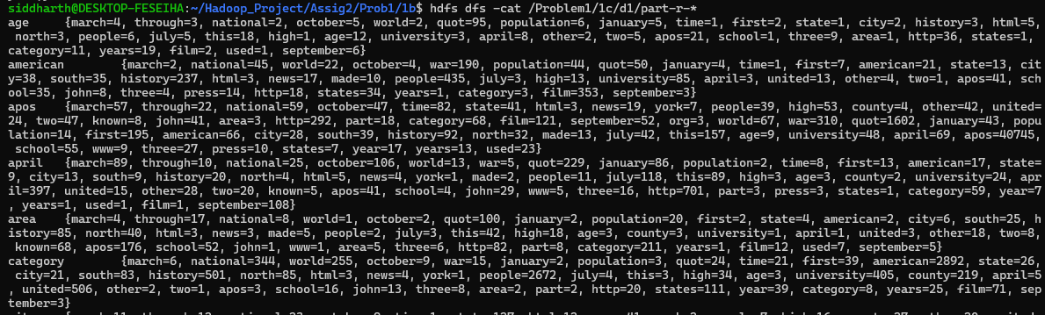
real 1m31.684s
user 1m39.614s
sys 0m10.104s
D2;
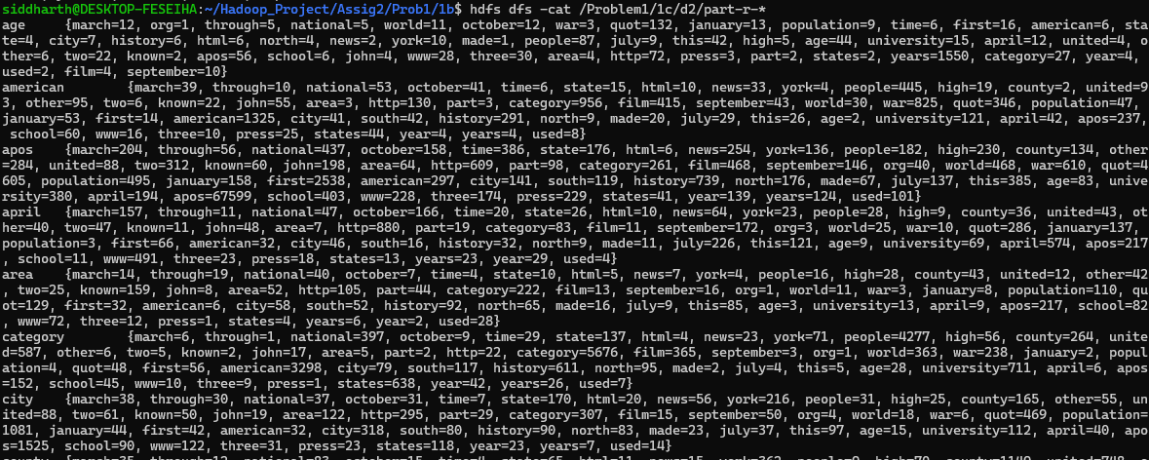
real 1m38.362s
user 1m51.021s
sys 0m10.491s
D3:
real 1m49.707s
user 1m59.632s
sys 0m10.749s
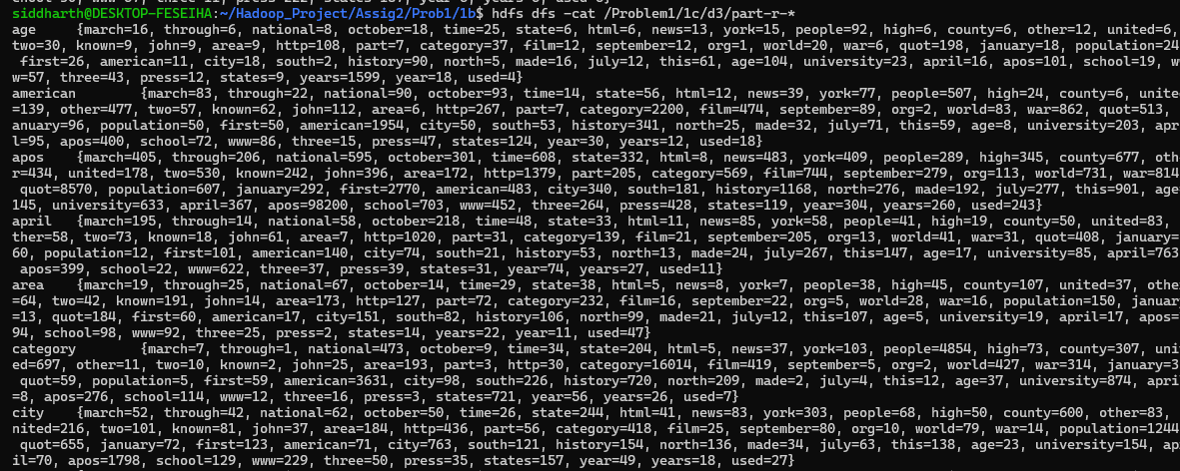
D4:
real 3m14.572s
user 3m33.349s
sys 0m21.066s
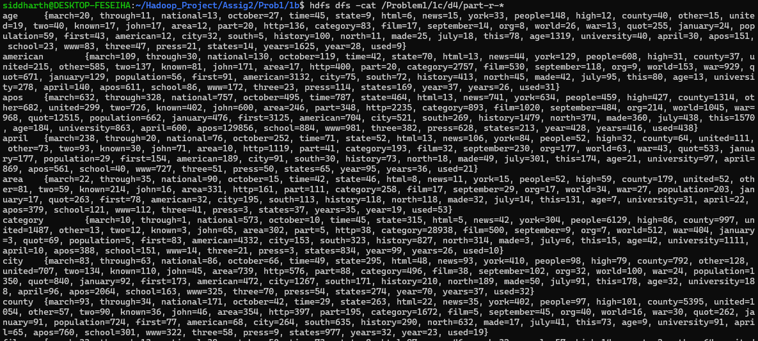

D.
PAIRS APPROACH – Map Class Level
Compile-
javac -classpath `hadoop classpath` Pairs_MapClassLevel.java

jar cf Pairs_MapClassLevel.jar Pairs_MapClassLevel*.class

RUN;
time hadoop jar Pairs_MapClassLevel.jar Pairs_MapClassLevel /largerDataset/Wikipedia-EN-20120601_ARTICLES /problem1_Large/output1d/Pairs/MapClassAgg/d1 -topwords /problem1_Large/top50.txt -d 1

D1:
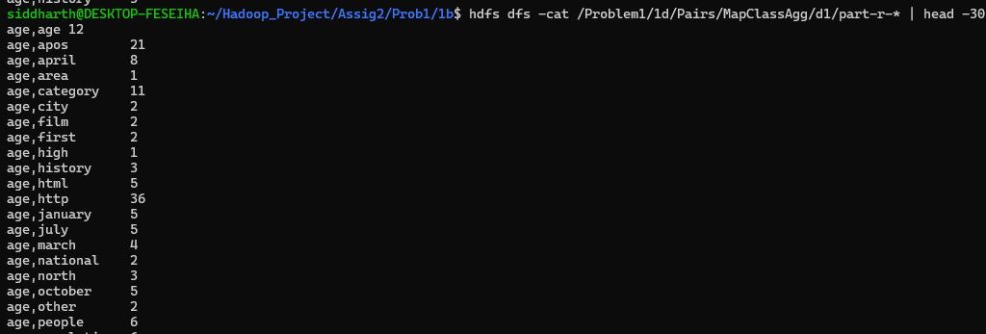
Time:
real 1m33.533s
user 1m48.284s
sys 0m11.218s
D2:
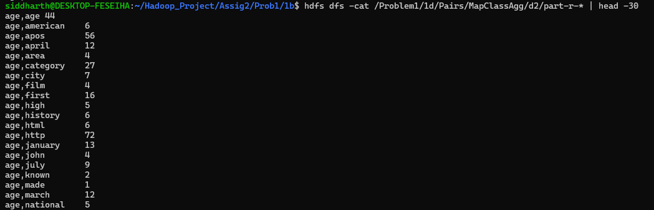
real 1m32.204s
user 1m45.605s
sys 0m9.785s
D3:
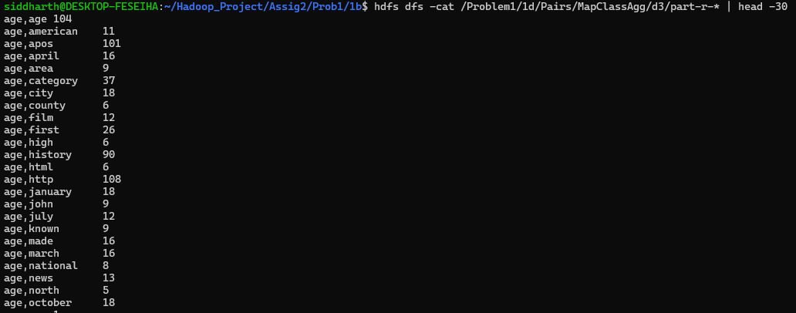
real 4m10.047s
user 4m40.957s
sys 0m19.640s
D4:

real 3m20.290s
user 3m34.725s
sys 0m22.398s
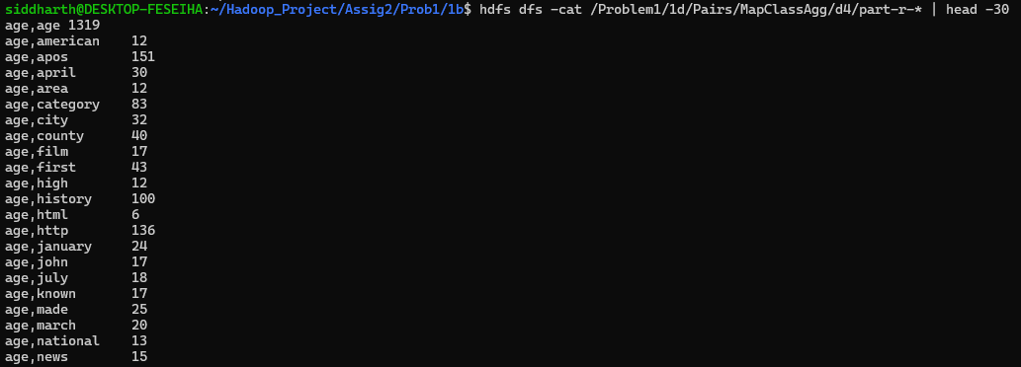

PAIRS APPROACH – Map Function Level
Compile-
javac -classpath `hadoop classpath` Pairs_MapFunctionLevel.java

jar cf Pairs_MapFunctionLevel.jar Pairs_MapFunctionLevel*.class

RUN;
time hadoop jar Pairs_MapFunctionLevel.jar Pairs_MapFunctionLevel /largerDataset/Wikipedia-EN-20120601_ARTICLES /problem1_Large/output1d/Pairs/MapFunctionAgg/d1 -topwords /problem1_Large/top50.txt -d 1

D1:
real 2m58.455s
user 2m42.638s
sys 0m21.392s
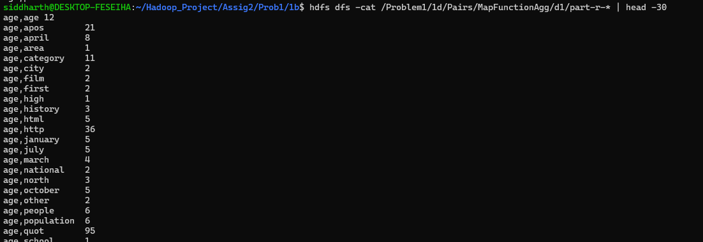
D2:
real 3m38.643s
user 4m14.404s
sys 0m23.974s
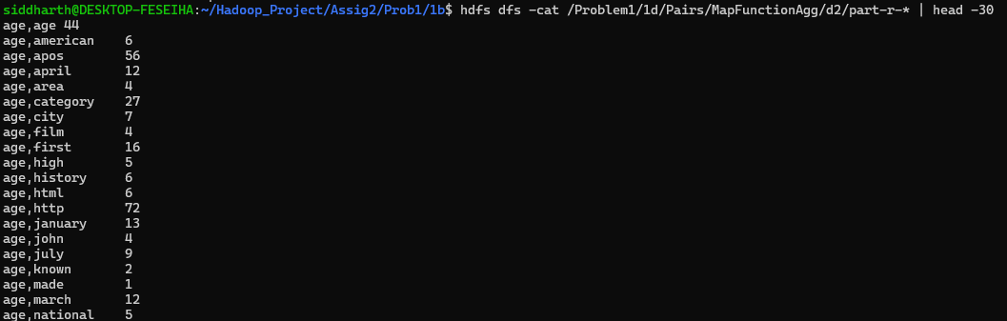
D3:
real 2m51.831s
user 3m28.939s
sys 0m20.737s
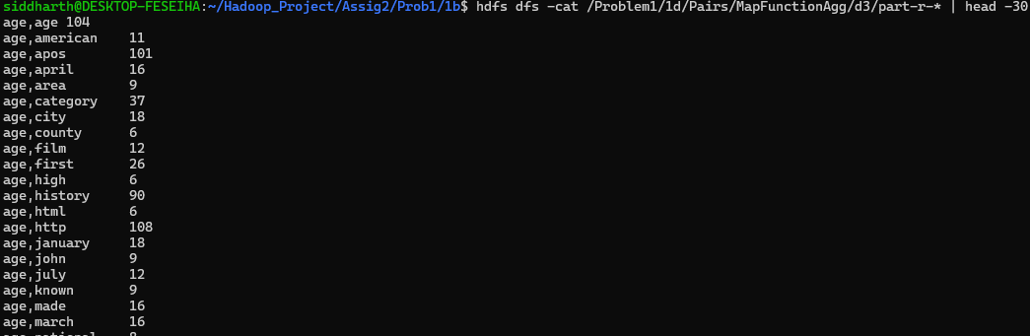
D4:
real 2m10.394s
user 2m25.423s
sys 0m17.873s
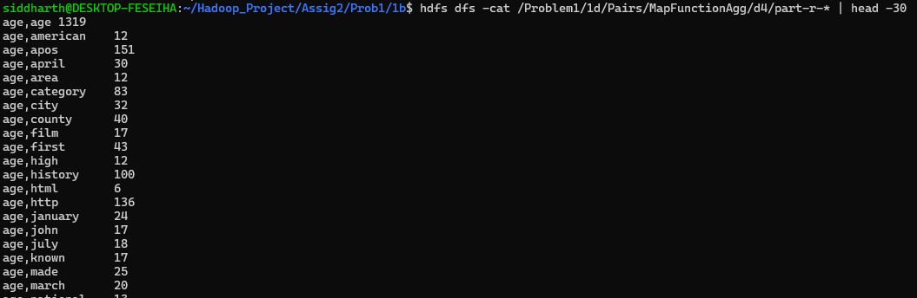
Stripes APPROACH – Map Function Level
Compile-

javac -classpath `hadoop classpath` Stripes_MapFunctionLevel.java

jar cf Stripes_MapFunctionLevel.jar Stripes_MapFunctionLevel*.class

RUN;
time hadoop jar Stripes_MapFunctionLevel.jar Stripes_MapFunctionLevel /largerDataset/Wikipedia-EN-20120601_ARTICLES /problem1_Large/output1d/Stripes/MapFunctionAgg/d1 -topwords /problem1_Large/top50.txt -d 1
D1:
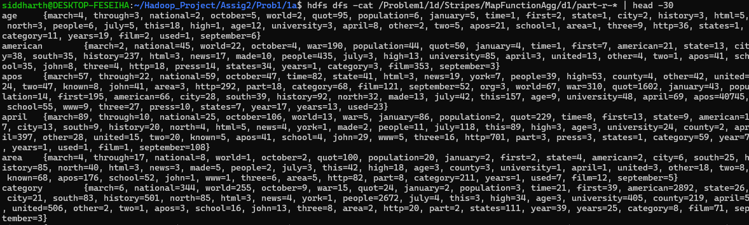
real 1m38.217s
user 1m50.191s
sys 0m10.000s
D2:
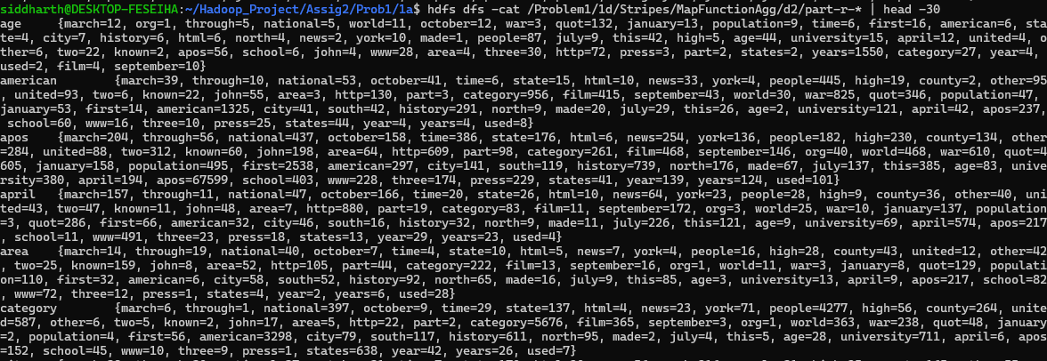
real 1m42.627s
user 2m0.027s
sys 0m11.174s
D3:
real 2m19.048s
user 2m45.673s
sys 0m20.009s
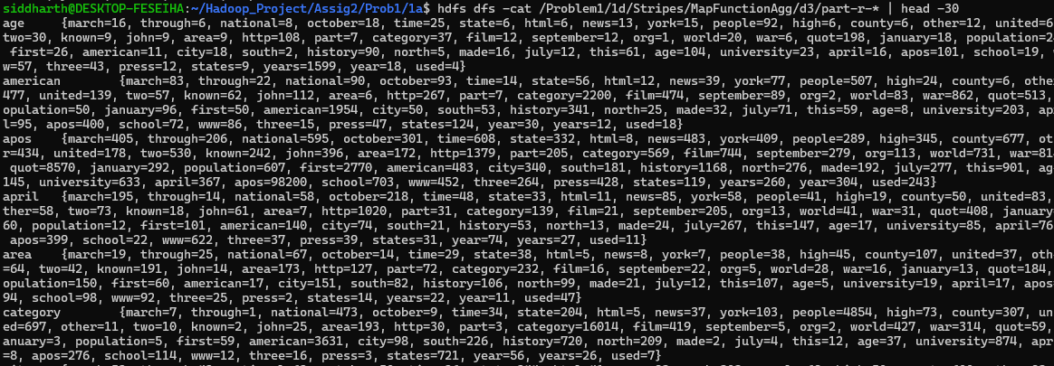
D4:
real 5m6.088s
user 5m36.322s
sys 0m32.163s
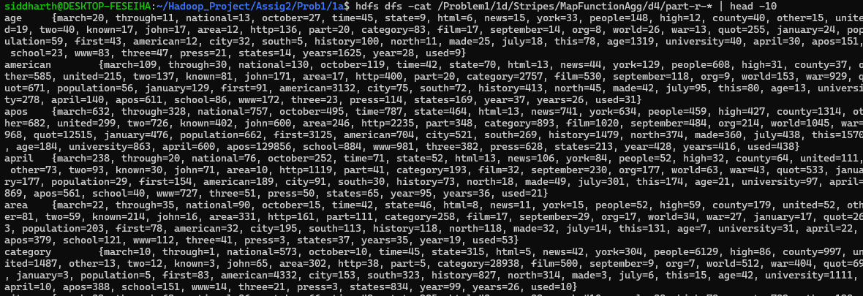

Stripes APPROACH – Map Class Level
Compile-

javac -classpath `hadoop classpath` Stripes_MapClassLevel.java

jar cf Stripes_MapClassLevel.jar Stripes_MapClassLevel*.class

RUN;
time hadoop jar Stripes_MapClassLevel.jar Stripes_MapClassLevel /largerDataset/Wikipedia-EN-20120601_ARTICLES /problem1_Large/output1d/Stripes/MapClassAgg/d1 -topwords /problem1_Large/top50.txt -d 1

D1:
real 1m48.690s
user 1m58.584s
sys 0m11.933s
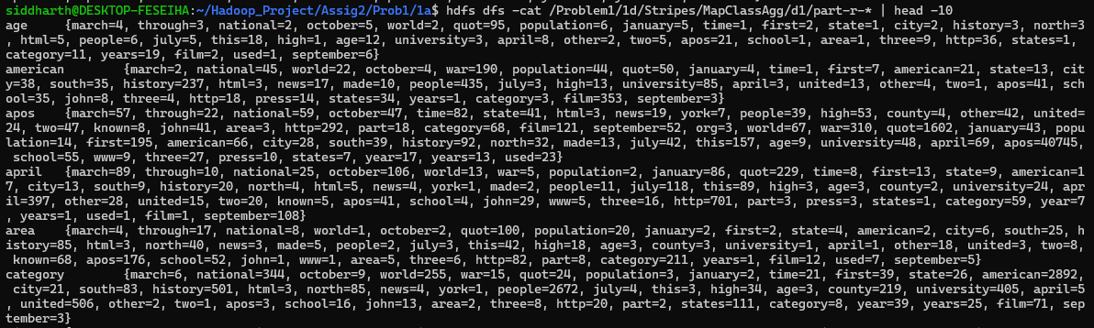
D2:
real 1m39.162s
user 2m0.742s
sys 0m12.899s
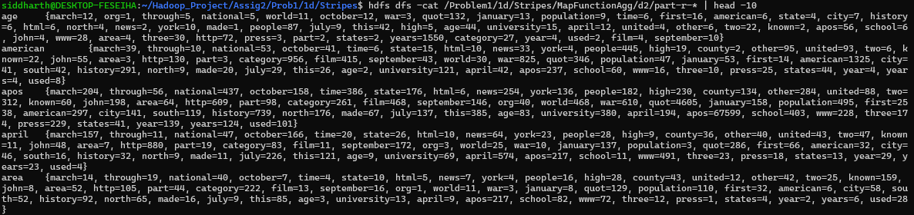
D3:
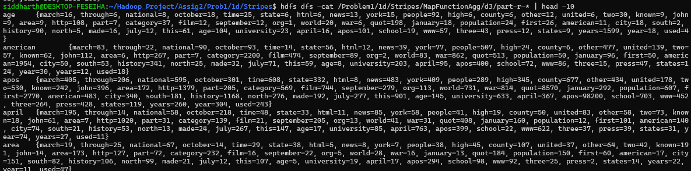
real 1m22.277s
user 1m28.057s
sys 0m9.536s
D4:
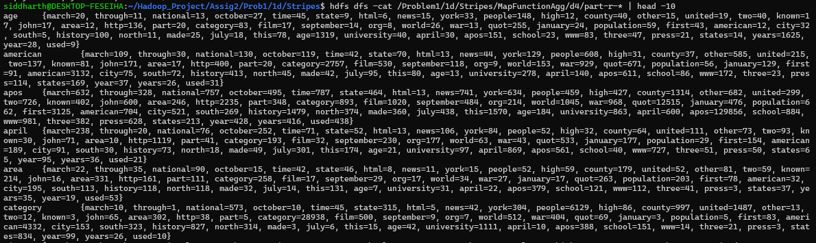
real 1m46.343s
user 2m4.352s
sys 0m12.471s

