PROBLEM 1:

setup() → runs once
map() → runs many times
reduce() → runs many times
cleanup() → runs once at the end [no need to call]

WordCount2Mod Run:
hadoop jar WordCount2Mod.jar WordCount2Mod /problem1/input /problem1/output1a_Meth1 -skippatterns /problem1/stopwords.txt

Using cleanup function

T1-
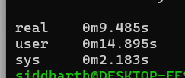
real 0m9.485s
user 0m14.895s
sys 0m2.183s

T2:
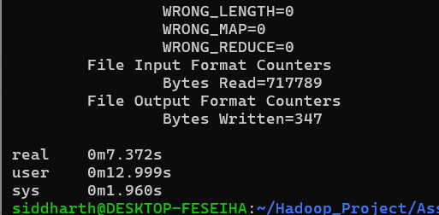
real 0m7.372s
user 0m12.999s
sys 0m1.960s

T3:
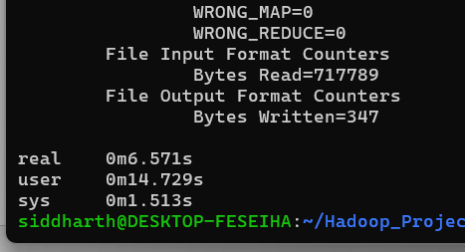

real 0m6.571s
user 0m14.729s
sys 0m1.513s

Method 2:
Using WordCount2 only without modification then later run:
time hadoop jar WordCount2.jar WordCount2 /problem1/input /problem1/output1a_M2/T1 -skippatterns /problem1/stopwords.txt

hdfs dfs -cat /output/part-r-* | sort -k2 -nr | head -50 > top50.txt

T1:
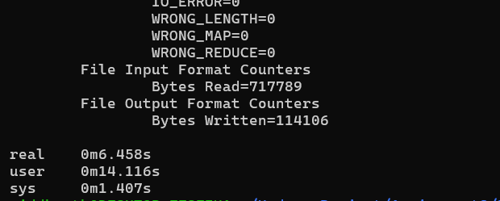

T2:
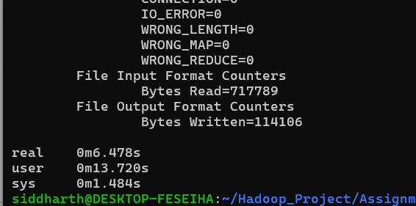
real 0m6.478s
user 0m13.720s
sys 0m1.484s

T3:
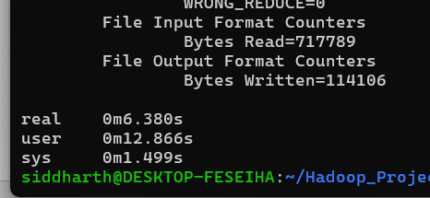
real 0m6.380s
user 0m12.866s
sys 0m1.499s

saved as top50.txt locally

Command- time hadoop jar CoOccurrenceM1.jar CoOccurrenceM1 /problem1/input /problem1/output1bM1/d2 -topwords /problem1/top50.txt -d
M1: CoOccurenceM1.java distance between words is d<=n
D1-
T1-
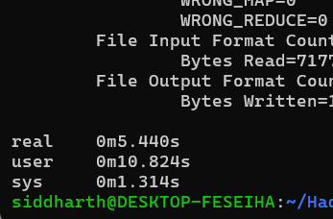
real 0m5.440s
user 0m10.824s
sys 0m1.314s

t2-
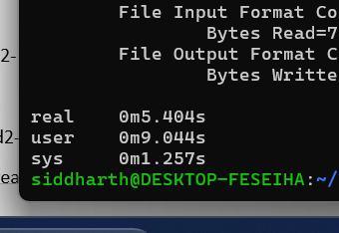
real 0m5.404s
user 0m9.044s
sys 0m1.257s
T3:
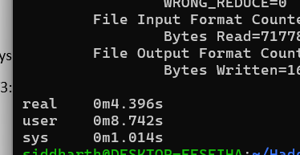
real 0m4.396s
user 0m8.742s
sys 0m1.014s

d2-
T1-
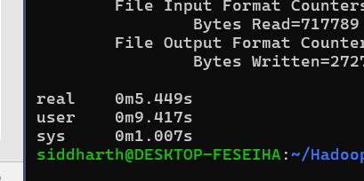

real 0m5.449s
user 0m9.417s
sys 0m1.007s

t2-
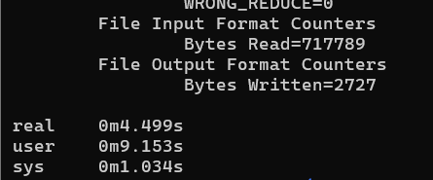
real 0m4.499s
user 0m9.153s
sys 0m1.034s
t3-

real 0m4.575s
user 0m9.449s
sys 0m1.092s

d3-
real 0m5.419s
user 0m11.285s
sys 0m1.251s
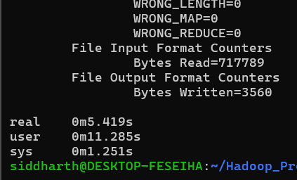

T2-
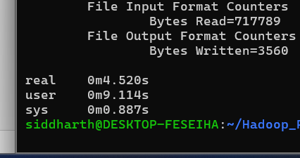

real 0m4.520s
user 0m9.114s
sys 0m0.887s
t3-
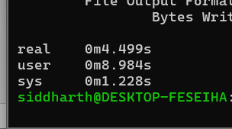
real 0m4.499s
user 0m8.984s
sys 0m1.228s
d4-
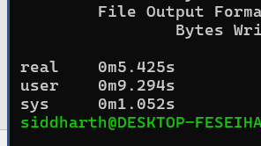
real 0m5.425s
user 0m9.294s
sys 0m1.052s

t2-
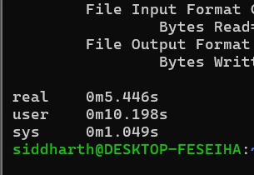
real 0m5.446s
user 0m10.198s
sys 0m1.049s

T3-
real 0m4.732s
user 0m9.686s
sys 0m1.182s
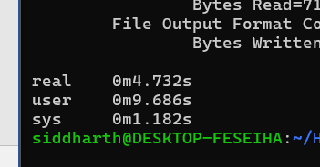

Method 2: distance exactly d
D1;
real 0m7.146s
user 0m11.888s
sys 0m1.843s
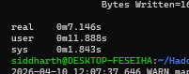

d2:
real 0m5.817s
user 0m11.887s
sys 0m1.340s
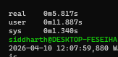

d3:
real 0m4.675s
user 0m9.424s
sys 0m1.099s
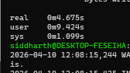

d4:
real 0m5.625s
user 0m10.006s
sys 0m1.243s
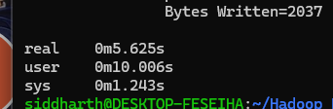

- time hadoop jar CoOccurrenceStripesM1.jar CoOccurrenceStripesM1 /problem1/input /problem1/output1cM1/d1 -topwords /problem1/top50.txt -d 1
D1:
T1-
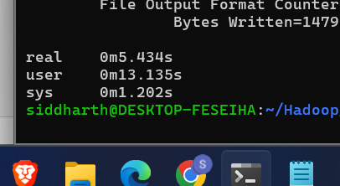
real 0m5.434s
user 0m13.135s
sys 0m1.202s

t2-
real 0m5.421s
user 0m10.125s
sys 0m1.171s
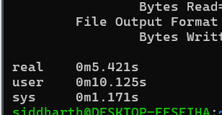

T3-
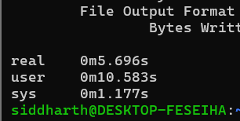
real 0m5.696s
user 0m10.583s
sys 0m1.177s

D2:
T1-
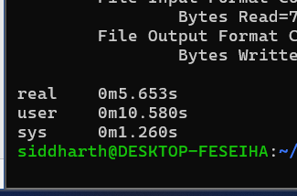
real 0m5.653s
user 0m10.580s
sys 0m1.260s
T2-
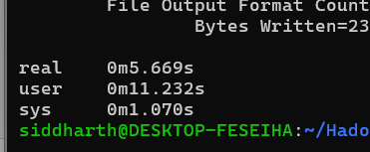
real 0m5.669s
user 0m11.232s
sys 0m1.070s
T3-
real 0m5.548s
user 0m10.992s
sys 0m0.989s
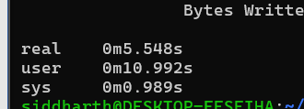

d3:
t1-
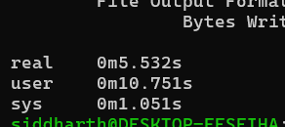
real 0m5.532s
user 0m10.751s
sys 0m1.051s

t2-
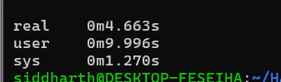
real 0m4.663s
user 0m9.996s
sys 0m1.270s

t3-
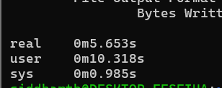
real 0m5.653s
user 0m10.318s
sys 0m0.985s
d4:
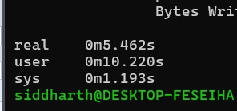
real 0m5.462s
user 0m10.220s
sys 0m1.193s
t2-
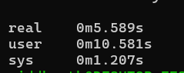
real 0m5.589s
user 0m10.581s
sys 0m1.207s

t3-
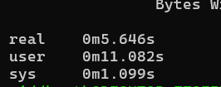
real 0m5.646s
user 0m11.082s
sys 0m1.099s

Problem 1d:
Pairs Map Class Level Aggregation –
D1 :-
T1-
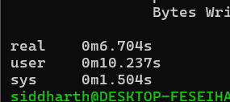
real 0m6.704s
user 0m10.237s
sys 0m1.504s

T2-
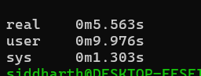
real 0m5.563s
user 0m9.976s
sys 0m1.303s

T3-
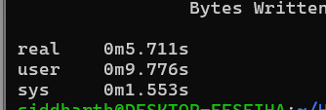
real 0m5.711s
user 0m9.776s
sys 0m1.553s

D2:
T1-
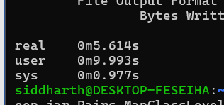
real 0m5.614s
user 0m9.993s
sys 0m0.977s

T2-
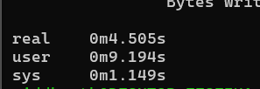
real 0m4.505s
user 0m9.194s
sys 0m1.149s
T3-
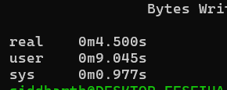
real 0m4.500s
user 0m9.045s
sys 0m0.977s

D3-
T1-
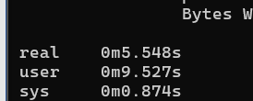
real 0m5.548s
user 0m9.527s
sys 0m0.874s

T2-
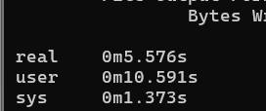
real 0m5.576s
user 0m10.591s
sys 0m1.373s
T3-
real 0m4.563s
user 0m8.918s
sys 0m1.241s
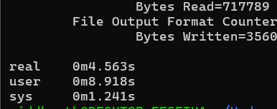
D4-
T1-
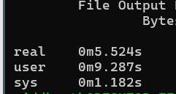

real 0m5.524s
user 0m9.287s
sys 0m1.182s

T2-

real 0m5.607s
user 0m9.841s
sys 0m1.099s
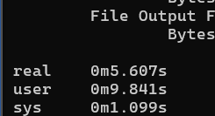
T3-
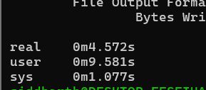
real 0m4.572s
user 0m9.581s
sys 0m1.077s

Pairs_MapFunctionLevel aggregation:
D1:
T1
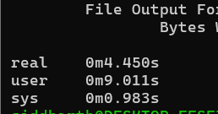
real 0m4.450s
user 0m9.011s
sys 0m0.983s
T2;
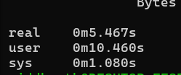
real 0m5.467s
user 0m10.460s
sys 0m1.080s
T3-
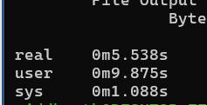
real 0m5.538s
user 0m9.875s
sys 0m1.088s

D2:
T1-
real 0m5.742s
user 0m11.545s
sys 0m1.002s
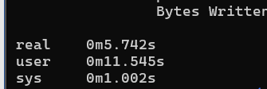

T2-
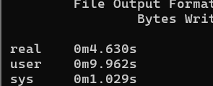
real 0m4.630s
user 0m9.962s
sys 0m1.029s

T3-
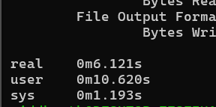
real 0m6.121s
user 0m10.620s
sys 0m1.193s

D3-
T1-
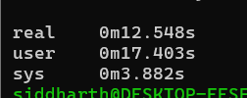
real 0m12.548s
user 0m17.403s
sys 0m3.882s
T2-

real 0m6.713s
user 0m11.356s
sys 0m1.777s

T3-
real 0m6.053s
user 0m10.581s
sys 0m1.243s
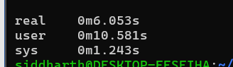
D4:
T1-
real 0m6.428s
user 0m8.856s
sys 0m1.565s
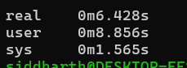
T2-
real 0m4.506s
user 0m9.506s
sys 0m1.015s
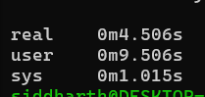
T3-
real 0m6.392s
user 0m11.248s
sys 0m1.662s
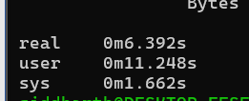

STRIPES : MAP CLASS LEVEL AGGREGATION
D1-
T1:
real 0m6.413s
user 0m10.213s
sys 0m1.442s
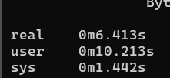
T2:
real 0m5.755s
user 0m9.908s
sys 0m1.030s
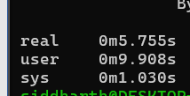
T3:
real 0m5.745s
user 0m11.591s
sys 0m1.651s
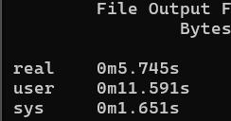
D2:
T1-
real 0m5.824s
user 0m12.444s
sys 0m1.505s
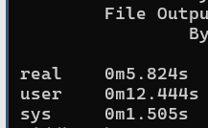
T2:
real 0m5.764s
user 0m11.130s
sys 0m1.413s
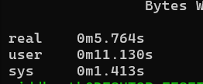
T3:
real 0m5.641s
user 0m10.199s
sys 0m1.189s
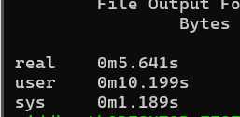

D3:
T1-
real 0m5.657s
user 0m10.976s
sys 0m1.187s
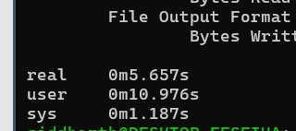
T2-
real 0m5.697s
user 0m10.132s
sys 0m1.041s
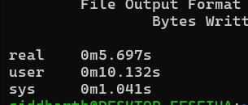
T3:
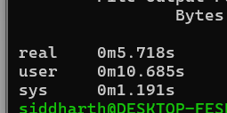
real 0m5.718s
user 0m10.685s
sys 0m1.191s

D4:
T1-
real 0m5.675s
user 0m11.754s
sys 0m1.068s
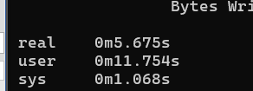
T2:
real 0m5.757s
user 0m11.008s
sys 0m1.251s
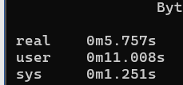
T3-
real 0m5.616s
user 0m10.583s
sys 0m1.037s
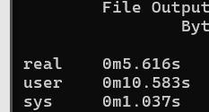

STRIPES MAP FUNCTION LEVEL AGG:
D1:
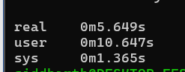
real 0m5.649s
user 0m10.647s
sys 0m1.365s
T2-
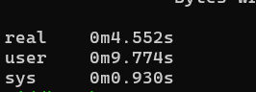
real 0m4.552s
user 0m9.774s
sys 0m0.930s
T3-
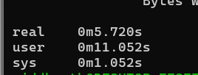
real 0m5.720s
user 0m11.052s
sys 0m1.052s

D2:T1-
real 0m5.725s
user 0m12.064s
sys 0m1.201s
T2-
real 0m5.721s
user 0m12.880s
sys 0m1.063s
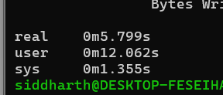
T3-
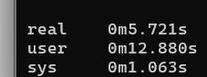
real 0m5.721s
user 0m12.880s
sys 0m1.063s

D3-
T1-
real 0m5.725s
user 0m12.064s
sys 0m1.201s
T2-
real 0m5.815s
user 0m10.994s
sys 0m1.180s
T3-
real 0m5.781s
user 0m11.152s
sys 0m1.235s

d4:
t1;
real 0m5.822s
user 0m10.902s
sys 0m1.436s
T2:
real 0m5.751s
user 0m12.324s
sys 0m1.135s
T3-
real 0m5.781s
user 0m10.900s
sys 0m1.359s

