AWS DEVOPS · CAPSTONE PROJECT · CASE STUDY
NovaCart
Migrating an E-Commerce Platform to a Fully Automated AWS DevOps Pipeline

A real-time, hands-on capstone: VPC · EKS · CodePipeline · Terraform · ArgoCD · CloudWatch
Step-by-step tutorial with architecture diagrams and fully explained commands
Estimated build time: 6 – 10 hours | Level: Intermediate → Advanced

Index
This table of contents is linked to headings throughout the document. In Microsoft Word, right-click and choose "Update Field" to refresh page numbers after opening.

1. Case Study Overview

1.1 The Business Scenario
NovaCart is a fictitious but realistic mid-size e-commerce company processing around 40,000 orders a day. Its entire platform is a single Java monolith deployed manually by SSH-ing into two EC2 instances behind a classic load balancer. Deployments take 45 minutes, happen at midnight to avoid customer impact, and roughly 1 in 5 releases needs a manual rollback. There is no automated testing gate, no infrastructure-as-code, and no centralized monitoring — outages are usually discovered from customer complaints on Twitter before anyone sees a CloudWatch alarm.
You have joined NovaCart as a DevOps Engineer with a mandate: rebuild the delivery pipeline and infrastructure from the ground up on AWS, using Infrastructure as Code, containers, and a fully automated CI/CD pipeline — while keeping the site live throughout the migration.

1.2 Project Objectives
- Stand up a production-grade, multi-AZ VPC using Terraform (no manual console clicking).
- Containerize the application and run it on Amazon EKS instead of hand-managed EC2 instances.
- Build a fully automated CI/CD pipeline: GitHub → CodePipeline → CodeBuild → ECR → EKS.
- Adopt GitOps with Argo CD so the cluster state always matches what is committed to Git.
- Move the database to a managed, Multi-AZ RDS PostgreSQL instance with automated backups.
- Expose the app securely via ALB + Route 53 + ACM (HTTPS, custom domain).
- Implement centralized logging, metrics, dashboards, and alerting (CloudWatch + SNS).
- Bake in security from day one: least-privilege IAM, Secrets Manager, GuardDuty, CloudTrail.
- Reduce deployment time from 45 minutes to under 5, with automatic rollback on failure.

1.3 Target Technology Stack
Layer | Tool / AWS Service | Purpose
Source Control | GitHub | Application code + Infrastructure as Code (IaC) repos
IaC | Terraform | Provision VPC, EKS, RDS, IAM, S3 declaratively
CI | AWS CodePipeline + CodeBuild | Build, test, scan, and push container images
Container Registry | Amazon ECR | Store versioned, scanned Docker images
Orchestration | Amazon EKS (Kubernetes 1.29) | Run and scale the application containers
GitOps / CD | Argo CD | Continuously reconcile cluster state with Git
Ingress | AWS Load Balancer Controller + ALB | Route external HTTPS traffic into the cluster
DNS / TLS | Route 53 + ACM | Custom domain and managed TLS certificates
Database | Amazon RDS (PostgreSQL, Multi-AZ) | Managed, highly available relational data store
Secrets | AWS Secrets Manager | DB credentials and API keys, injected at runtime
Monitoring | CloudWatch, Container Insights | Metrics, logs, dashboards, alarms
Security | GuardDuty, CloudTrail, AWS Config | Threat detection, audit trail, compliance

2. Solution Architecture
The diagram below is the target end-state architecture you will build in this tutorial. Traffic enters through Route 53 and an internet-facing Application Load Balancer in the public subnets, which routes to microservice pods running in EKS across private subnets. The CI/CD pipeline on the left builds and pushes container images that Argo CD then deploys via GitOps. Data lives in RDS and ElastiCache in isolated private data subnets, while CloudWatch, CloudTrail, GuardDuty and Config provide full observability and governance across the account.
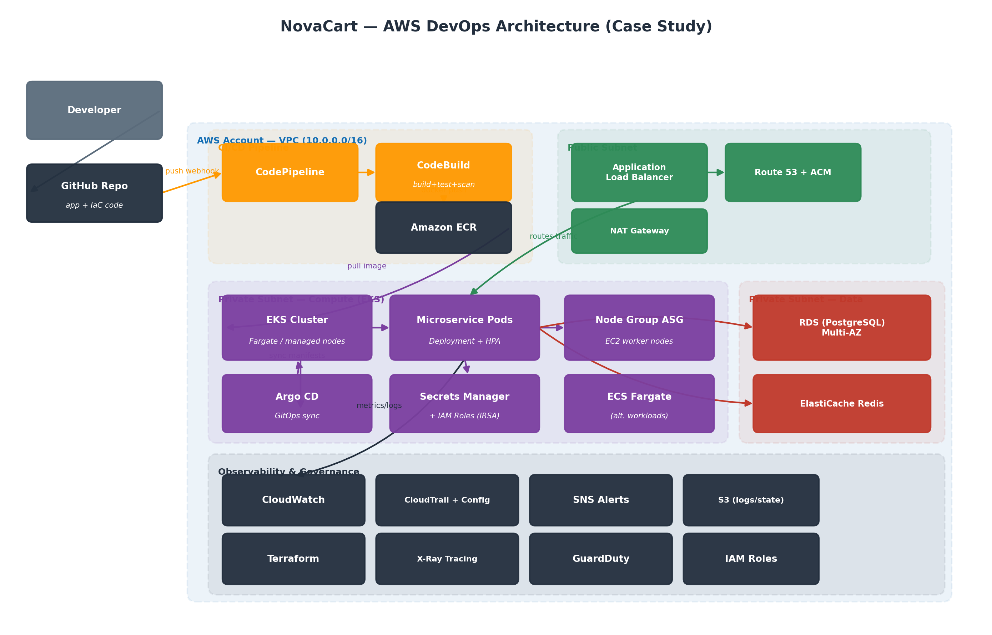
Figure 1 — NovaCart end-to-end AWS DevOps architecture

2.1 Why This Shape?
- Public/private subnet split: only the ALB and NAT gateways sit in public subnets; application pods, the EKS data plane, RDS, and Redis are never internet-reachable directly.
- EKS over raw EC2: declarative deployments, built-in self-healing, horizontal pod autoscaling, and a huge ecosystem of Helm charts (Argo CD, metrics-server, cert-manager, ALB controller).
- GitOps (Argo CD) instead of `kubectl apply` from the pipeline: the pipeline never talks to the cluster directly — it commits a new image tag to a manifests repo, and Argo CD (running inside the cluster) pulls and applies it. This removes the need to give CI long-lived cluster credentials.
- Multi-AZ everywhere (EKS node groups, RDS, ALB) so a single Availability Zone failure does not take the platform down.

3. Prerequisites
Install and verify the following tools before you begin. Version numbers shown are what this tutorial was validated against.
Tool | Minimum Version | Check Command
AWS CLI v2 | 2.15+ | aws --version
Terraform | 1.7+ | terraform -version
kubectl | 1.29+ | kubectl version --client
eksctl | 0.180+ | eksctl version
Docker | 24+ | docker --version
Helm | 3.14+ | helm version
Git | 2.40+ | git --version
Argo CD CLI | 2.10+ | argocd version --client
Note: You also need an AWS account with billing enabled, a registered domain (or a Route 53 hosted zone you control) if you want the HTTPS/custom-domain steps to work end-to-end, and an IAM user or role with administrator access for the initial setup (to be replaced by least-privilege roles later).

4. Step-by-Step Implementation
Every command below is meant to be run from a local terminal (macOS/Linux/WSL) unless otherwise noted. Explanatory notes follow each command block.

4.1 Configure AWS CLI and a Least-Privilege IAM User
aws configure
▸ Sets your default AWS Access Key ID, Secret Access Key, region (e.g. ap-south-1), and output format. Credentials are stored in ~/.aws/credentials.
aws sts get-caller-identity
▸ Confirms the CLI is authenticated and shows exactly which IAM identity (account, user/role ARN) you are operating as — always run this first when debugging permission errors.
aws iam create-group --group-name novacart-devops
aws iam attach-group-policy --group-name novacart-devops \
--policy-arn arn:aws:iam::aws:policy/PowerUserAccess
aws iam create-user --user-name novacart-ci
aws iam add-user-to-group --user-name novacart-ci --group-name novacart-devops
▸ Creates a dedicated IAM group and CI user instead of using your personal/root credentials for automation. PowerUserAccess is a placeholder — in Section 4.11 we tighten this to a scoped custom policy.

4.2 Create the Terraform Remote State Backend
Terraform state must live somewhere shared and locked, not on a laptop, so the whole team (and the pipeline) can safely collaborate.
aws s3api create-bucket --bucket novacart-tfstate-prod \
--region ap-south-1 \
--create-bucket-configuration LocationConstraint=ap-south-1
aws s3api put-bucket-versioning --bucket novacart-tfstate-prod \
--versioning-configuration Status=Enabled
▸ Creates an S3 bucket to store the Terraform state file, with versioning enabled so you can recover a previous state if something corrupts it.
aws dynamodb create-table --table-name novacart-tf-locks \
--attribute-definitions AttributeName=LockID,AttributeType=S \
--key-schema AttributeName=LockID,KeyType=HASH \
--billing-mode PAY_PER_REQUEST
▸ Creates a DynamoDB table used purely as a distributed lock, so two people (or the pipeline and a person) can never run `terraform apply` at the same time and corrupt state.

backend.tf
terraform {
backend "s3" {
bucket = "novacart-tfstate-prod"
key = "eks/terraform.tfstate"
region = "ap-south-1"
dynamodb_table = "novacart-tf-locks"
encrypt = true
}
}

4.3 Provision the VPC
Define a 3-AZ VPC with public subnets (for the ALB/NAT) and private subnets (for EKS nodes and data services) using the community VPC module.

vpc.tf
module "vpc" {
source = "terraform-aws-modules/vpc/aws"
version = "~> 5.5"

name = "novacart-vpc"
cidr = "10.0.0.0/16"

azs = ["ap-south-1a", "ap-south-1b", "ap-south-1c"]
private_subnets = ["10.0.1.0/24", "10.0.2.0/24", "10.0.3.0/24"]
public_subnets = ["10.0.101.0/24", "10.0.102.0/24", "10.0.103.0/24"]

enable_nat_gateway = true
single_nat_gateway = false # one NAT per AZ for HA
enable_dns_hostnames = true

public_subnet_tags = {
"kubernetes.io/role/elb" = "1"
}
private_subnet_tags = {
"kubernetes.io/role/internal-elb" = "1"
}
}
terraform init
▸ Downloads the AWS and VPC module providers and configures the S3 backend created in the previous step.
terraform plan -out=vpc.tfplan
▸ Shows exactly what will be created (3 public + 3 private subnets, 3 NAT gateways, route tables, an internet gateway) before anything is touched.
terraform apply vpc.tfplan
▸ Creates the VPC. Takes roughly 2–3 minutes; NAT gateways are the slowest resource.

4.4 Provision the EKS Cluster

eks.tf
module "eks" {
source = "terraform-aws-modules/eks/aws"
version = "~> 20.0"

cluster_name = "novacart-eks"
cluster_version = "1.29"

vpc_id = module.vpc.vpc_id
subnet_ids = module.vpc.private_subnets

cluster_endpoint_public_access = true

eks_managed_node_groups = {
default = {
min_size = 2
max_size = 6
desired_size = 3
instance_types = ["t3.large"]
capacity_type = "ON_DEMAND"
}
}
}
terraform apply
▸ Provisions the EKS control plane and a managed node group of 3 EC2 worker nodes across the private subnets. This step usually takes 12–15 minutes — most of it is AWS creating the control plane.
aws eks update-kubeconfig --name novacart-eks --region ap-south-1
▸ Writes/merges an entry into ~/.kube/config so kubectl can authenticate to the new cluster using your IAM identity.
kubectl get nodes
▸ Confirms the 3 worker nodes have joined the cluster and are in Ready state.

4.5 Create the ECR Repository
aws ecr create-repository --repository-name novacart/web-app --image-scanning-configuration scanOnPush=true
▸ Creates a private container registry with automatic vulnerability scanning turned on for every pushed image.
aws ecr get-login-password --region ap-south-1 | docker login --username AWS --password-stdin <account-id>.dkr.ecr.ap-south-1.amazonaws.com
▸ Authenticates the local Docker daemon to ECR using a short-lived token (valid 12 hours) instead of a static password.

4.6 Containerize the Application

Dockerfile
FROM eclipse-temurin:21-jre-alpine AS runtime
WORKDIR /app
RUN addgroup -S app && adduser -S app -G app
COPY target/novacart-web.jar app.jar
USER app
EXPOSE 8080
HEALTHCHECK --interval=30s --timeout=3s CMD wget -qO- http://localhost:8080/actuator/health || exit 1
ENTRYPOINT ["java", "-jar", "app.jar"]
docker build -t novacart/web-app:local .
▸ Builds the image locally first so you can smoke-test it before it ever touches the pipeline.
docker run --rm -p 8080:8080 novacart/web-app:local
▸ Runs the container locally; visit http://localhost:8080 to sanity-check it boots before pushing.
docker tag novacart/web-app:local <account-id>.dkr.ecr.ap-south-1.amazonaws.com/novacart/web-app:v1.0.0
docker push <account-id>.dkr.ecr.ap-south-1.amazonaws.com/novacart/web-app:v1.0.0
▸ Tags the image with the ECR repository URI and version, then pushes it — this manual push is just for the first bootstrap image; from here on CodeBuild does this automatically.

4.7 Build the CI Pipeline: CodePipeline + CodeBuild
The pipeline has three stages: Source (GitHub via a CodeStar connection), Build (CodeBuild runs the buildspec below), and Deploy (CodeBuild commits a new image tag to the GitOps manifests repo, which Argo CD then picks up).

buildspec.yml
version: 0.2
phases:
pre_build:
commands:
- echo "Logging in to Amazon ECR..."
- aws ecr get-login-password --region $AWS_REGION | docker login --username AWS --password-stdin $ECR_URI
- IMAGE_TAG=$(echo $CODEBUILD_RESOLVED_SOURCE_VERSION | cut -c 1-8)
build:
commands:
- echo "Running unit tests..."
- mvn -q test
- echo "Building Docker image..."
- docker build -t $ECR_URI:$IMAGE_TAG .
post_build:
commands:
- echo "Scanning image with Trivy..."
- trivy image --exit-code 1 --severity CRITICAL,HIGH $ECR_URI:$IMAGE_TAG
- docker push $ECR_URI:$IMAGE_TAG
- echo "Updating GitOps manifests repo with new image tag..."
- ./scripts/update-manifest.sh $IMAGE_TAG
aws codestar-connections create-connection \
--provider-type GitHub --connection-name novacart-github
▸ Creates the OAuth handshake CodePipeline needs to read your GitHub repo. You must approve the connection once in the AWS Console after running this command.
aws codebuild create-project --cli-input-json file://codebuild-project.json
▸ Registers the CodeBuild project defined by codebuild-project.json, which references the buildspec.yml above and grants it an IAM service role with permission to push to ECR.
aws codepipeline create-pipeline --cli-input-json file://pipeline.json
▸ Wires Source → Build → (manifest update) into a single automated pipeline that triggers on every push to the main branch.

4.8 Kubernetes Manifests

deployment.yaml
apiVersion: apps/v1
kind: Deployment
metadata:
name: web-app
namespace: novacart
spec:
replicas: 3
selector:
matchLabels: { app: web-app }
template:
metadata:
labels: { app: web-app }
spec:
containers:
- name: web-app
image: <account-id>.dkr.ecr.ap-south-1.amazonaws.com/novacart/web-app:v1.0.0
ports: [{ containerPort: 8080 }]
resources:
requests: { cpu: "250m", memory: "512Mi" }
limits: { cpu: "500m", memory: "1Gi" }
readinessProbe:
httpGet: { path: /actuator/health, port: 8080 }
initialDelaySeconds: 15
kubectl create namespace novacart
▸ Isolates NovaCart's resources from other workloads (and from kube-system) with their own namespace boundary for RBAC and resource quotas.
kubectl apply -f k8s/
▸ One-time manual bootstrap so the namespace has something running before Argo CD takes over management in the next section.
kubectl -n novacart get pods -w
▸ Watches pods come up; you should see 3/3 Running once the readiness probe passes.

4.9 GitOps Deployment with Argo CD
helm repo add argo https://argoproj.github.io/argo-helm
helm install argocd argo/argo-cd -n argocd --create-namespace
▸ Installs Argo CD into its own namespace inside the same EKS cluster.
kubectl -n argocd port-forward svc/argocd-server 8080:443
▸ Temporarily exposes the Argo CD UI on localhost so you can log in and grab the initial admin password (or configure SSO).
argocd app create novacart-web \
--repo https://github.com/novacart/gitops-manifests.git \
--path apps/web-app \
--dest-server https://kubernetes.default.svc \
--dest-namespace novacart \
--sync-policy automated --self-heal
▸ Registers the app with Argo CD: it will now continuously watch the gitops-manifests repo and auto-sync any change (like the image tag bump from CodeBuild) into the cluster within seconds, and auto-heal any manual drift.
GitOps Principle: From this point forward, nobody — including the pipeline — runs `kubectl apply` against production. The only way to change what's running is to merge a change into the GitOps repo. This is the core GitOps principle: Git is the single source of truth.

4.10 Ingress: AWS Load Balancer Controller
helm repo add eks https://aws.github.io/eks-charts
helm install aws-load-balancer-controller eks/aws-load-balancer-controller \
-n kube-system \
--set clusterName=novacart-eks \
--set serviceAccount.create=false \
--set serviceAccount.name=aws-load-balancer-controller
▸ Installs the controller that watches Kubernetes Ingress resources and provisions/updates a real AWS ALB automatically — no manual load balancer configuration.

ingress.yaml
apiVersion: networking.k8s.io/v1
kind: Ingress
metadata:
name: web-app
namespace: novacart
annotations:
kubernetes.io/ingress.class: alb
alb.ingress.kubernetes.io/scheme: internet-facing
alb.ingress.kubernetes.io/target-type: ip
alb.ingress.kubernetes.io/certificate-arn: arn:aws:acm:ap-south-1:<account-id>:certificate/<id>
alb.ingress.kubernetes.io/listen-ports: '[{"HTTPS":443}]'
spec:
rules:
- host: shop.novacart.com
http:
paths:
- path: /
pathType: Prefix
backend:
service: { name: web-app-svc, port: { number: 80 } }

4.11 DNS and TLS: Route 53 + ACM
aws acm request-certificate --domain-name shop.novacart.com \
--validation-method DNS --region ap-south-1
▸ Requests a free public TLS certificate from ACM. AWS gives you a CNAME record to add for domain-ownership validation.
aws route53 change-resource-record-sets --hosted-zone-id <zone-id> \
--change-batch file://alias-record.json
▸ Creates an ALIAS record pointing shop.novacart.com at the ALB's DNS name once it's provisioned — ALIAS records are free and resolve faster than a CNAME.

4.12 Managed Database: RDS PostgreSQL
resource "aws_db_instance" "novacart" {
identifier = "novacart-prod"
engine = "postgres"
engine_version = "16.3"
instance_class = "db.t3.large"
allocated_storage = 100
multi_az = true
db_subnet_group_name = module.vpc.database_subnet_group_name
vpc_security_group_ids = [aws_security_group.rds.id]
manage_master_user_password = true # credentials auto-stored in Secrets Manager
backup_retention_period = 7
deletion_protection = true
}
terraform apply
▸ Provisions a Multi-AZ RDS instance. `manage_master_user_password = true` tells Terraform to let RDS generate and store the master password directly in Secrets Manager — the password never appears in state or logs.

4.13 Secrets Injection into Pods
helm repo add secrets-store-csi-driver https://kubernetes-sigs.github.io/secrets-store-csi-driver/charts
helm install csi-secrets-store secrets-store-csi-driver/secrets-store-csi-driver -n kube-system
kubectl apply -f https://raw.githubusercontent.com/aws/secrets-store-csi-driver-provider-aws/main/deployment/aws-provider-installer.yaml
▸ Installs the CSI driver that mounts AWS Secrets Manager secrets directly as files inside pods, so DB credentials never live in a Kubernetes Secret, ConfigMap, or environment variable in plaintext.

4.14 Monitoring and Alerting
aws eks update-addon --cluster-name novacart-eks --addon-name amazon-cloudwatch-observability
▸ Enables Container Insights, which automatically ships pod/node CPU, memory, and log data into CloudWatch without any sidecars to configure manually.
helm repo add prometheus-community https://prometheus-community.github.io/helm-charts
helm install kube-prom prometheus-community/kube-prometheus-stack -n monitoring --create-namespace
▸ Installs Prometheus + Grafana + Alertmanager as a bundled stack for cluster-level and application-level metrics dashboards, complementary to CloudWatch.
aws cloudwatch put-metric-alarm --alarm-name novacart-high-5xx \
--metric-name HTTPCode_Target_5XX_Count --namespace AWS/ApplicationELB \
--statistic Sum --period 60 --threshold 10 --comparison-operator GreaterThanThreshold \
--evaluation-periods 2 --alarm-actions arn:aws:sns:ap-south-1:<account-id>:novacart-alerts
▸ Fires an SNS notification if the ALB sees more than 10 server errors in two consecutive 1-minute windows — this is what would have caught NovaCart's outages before Twitter did.

4.15 Security Hardening
aws guardduty create-detector --enable
▸ Turns on GuardDuty for continuous, ML-based threat detection across your account (unusual API calls, compromised credentials, crypto-mining activity, etc.).
aws cloudtrail create-trail --name novacart-trail --s3-bucket-name novacart-cloudtrail-logs \
--is-multi-region-trail
aws cloudtrail start-logging --name novacart-trail
▸ Creates an immutable, account-wide audit log of every API call made against the account — essential for incident response and compliance.
aws configservice put-configuration-recorder --configuration-recorder file://config-recorder.json
▸ Enables AWS Config to continuously record resource configuration changes and evaluate them against rules (e.g. 'no S3 bucket may be public').

5. CI/CD Pipeline in Detail
The diagram below shows the eight stages a code change passes through, from a developer's git push to a monitored production rollout on EKS.
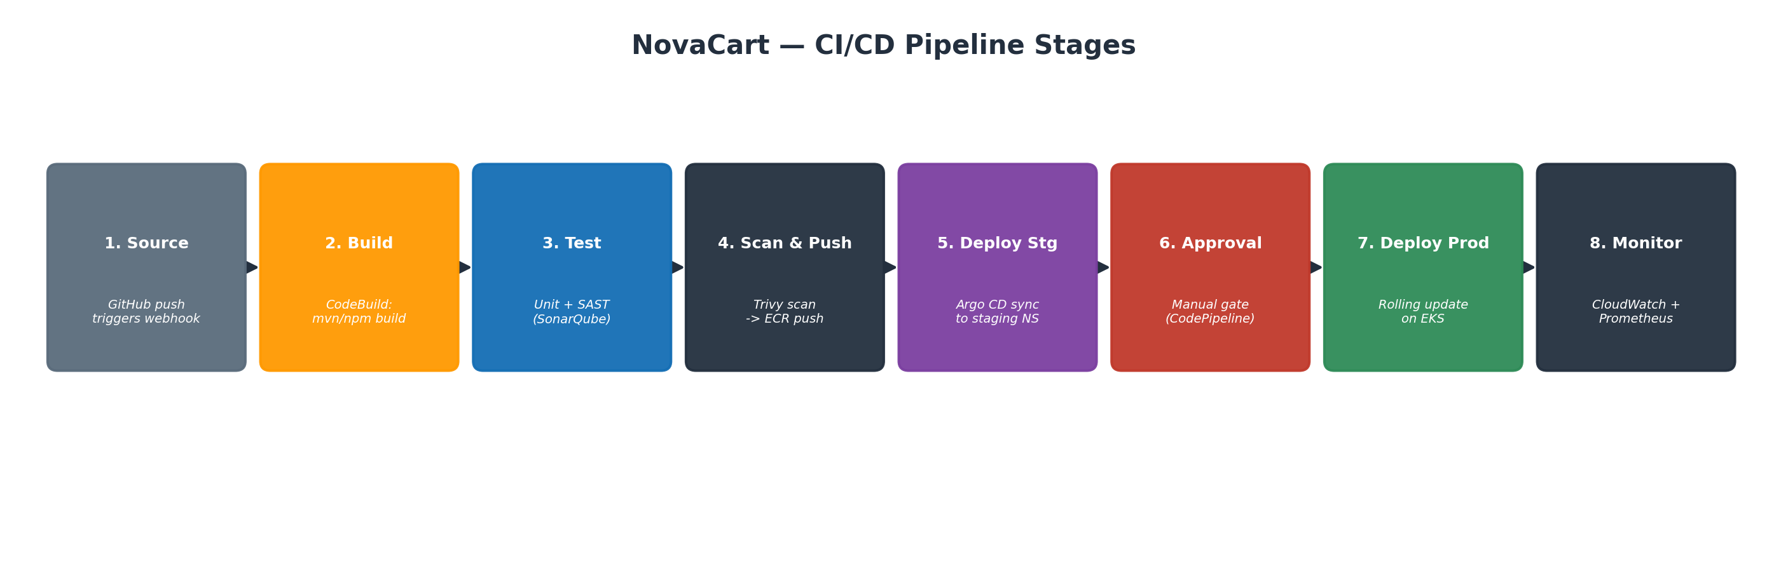
Figure 2 — NovaCart CI/CD pipeline stages
# | Stage | What Happens
1 | Source | A push to the main branch triggers a webhook via the CodeStar GitHub connection.
2 | Build | CodeBuild checks out the code and compiles the application (mvn/npm build).
3 | Test | Unit tests run; SonarQube performs static analysis (SAST) and fails the build below a quality gate.
4 | Scan & Push | Trivy scans the built image for CRITICAL/HIGH CVEs; on pass, the image is pushed to ECR.
5 | Deploy (Staging) | The manifest-update script bumps the image tag in the staging overlay; Argo CD auto-syncs.
6 | Approval | A manual approval action in CodePipeline gates promotion from staging to production.
7 | Deploy (Prod) | The production overlay is updated; Argo CD performs a rolling update with zero downtime.
8 | Monitor | CloudWatch alarms and Grafana dashboards watch error rate, latency, and pod health post-deploy.

6. Testing and Validation

6.1 Smoke Test the Live Endpoint
curl -I https://shop.novacart.com/actuator/health
▸ Confirms the ALB is routing traffic correctly and the app reports healthy (HTTP 200).

6.2 Load Test
hey -z 2m -c 50 https://shop.novacart.com/
▸ Generates sustained load (50 concurrent users for 2 minutes) so you can watch Horizontal Pod Autoscaler add replicas in real time via `kubectl get hpa -n novacart -w`.

6.3 Rollback Test
argocd app rollback novacart-web <previous-revision-id>
▸ Manually verifies the rollback path works: Argo CD redeploys the previous known-good manifest revision in seconds, without touching the pipeline.

7. Cleanup / Teardown
Cost Warning: Run this section when you are done to avoid ongoing AWS charges — NAT gateways, RDS, and EKS control planes bill hourly even when idle.
argocd app delete novacart-web
▸ Tells Argo CD to remove the deployed Kubernetes resources first, cleanly.
helm uninstall kube-prom -n monitoring && helm uninstall argocd -n argocd
▸ Removes the monitoring stack and Argo CD itself.
terraform destroy
▸ Tears down every Terraform-managed resource: EKS cluster, node groups, RDS instance, VPC, NAT gateways — in dependency order.
aws s3 rb s3://novacart-tfstate-prod --force
aws dynamodb delete-table --table-name novacart-tf-locks
▸ Finally removes the Terraform backend itself, once you're certain you no longer need the state history.

8. Troubleshooting Guide
Symptom | Likely Cause | Fix
Pods stuck in Pending | Node group has no capacity / wrong subnet AZ | kubectl describe pod <name>; scale node group or check subnet AZ match
ALB never gets provisioned | LB Controller missing IAM permissions | Verify the IRSA role has the AWSLoadBalancerControllerIAMPolicy attached
ImagePullBackOff | ECR auth expired or wrong image tag | Re-run `aws ecr get-login-password`; confirm tag exists with `aws ecr list-images`
Argo CD app shows OutOfSync forever | A cluster resource was edited manually (kubectl edit) | Let self-heal revert it, or `argocd app sync --force`
Terraform apply fails: state lock | A previous apply crashed mid-run | aws dynamodb delete-item on the LockID, only after confirming no other apply is running
503 from ALB | Target group health checks failing | Check the readinessProbe path/port matches the actual app health endpoint

9. Key Takeaways
- Infrastructure as Code turns a 45-minute manual deploy into a ~5-minute automated, auditable one.
- GitOps (Argo CD) decouples 'what should be running' (Git) from 'who can change the cluster' (nobody, directly) — a major security and reliability win.
- Multi-AZ by default (VPC, EKS nodes, RDS) is the difference between an AZ outage being a non-event versus a 2am page.
- Security is cheapest when built in from step 1 (IAM least privilege, Secrets Manager, image scanning) rather than bolted on after an incident.
- Everything in this tutorial — VPC, EKS, RDS, IAM — is reproducible from Terraform, so a full disaster-recovery rebuild is a `terraform apply` away.

