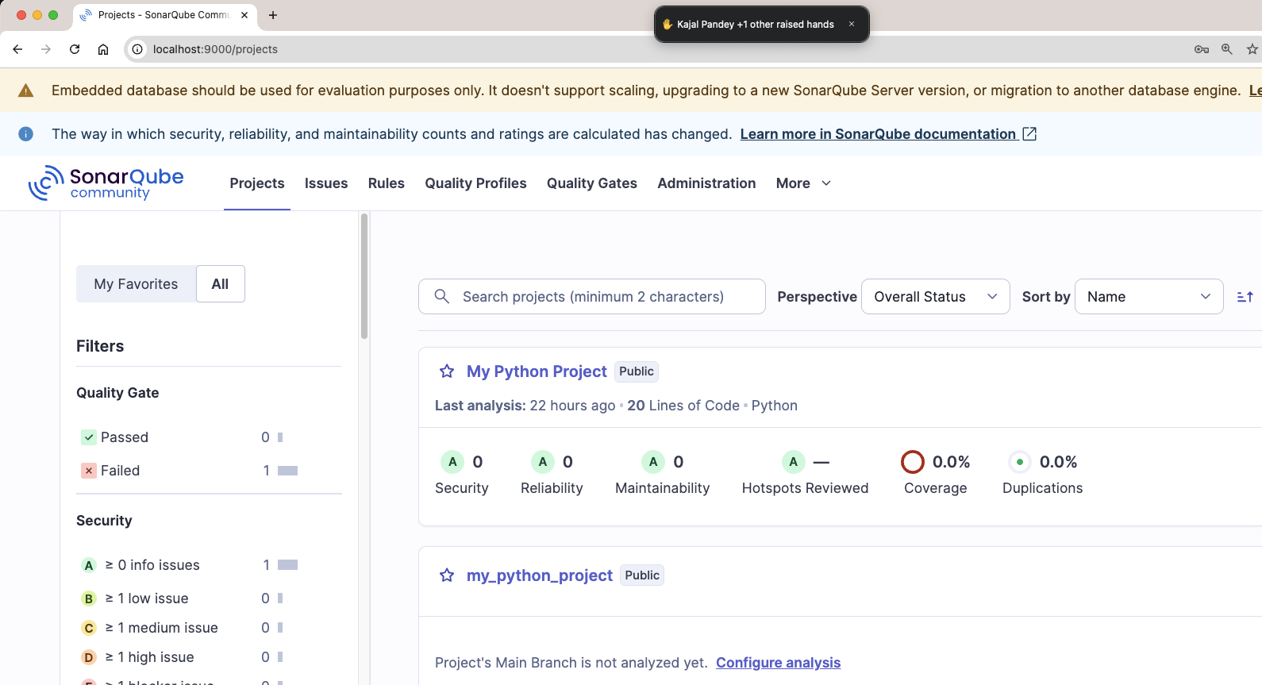

So now we have to create a project in sonarqube

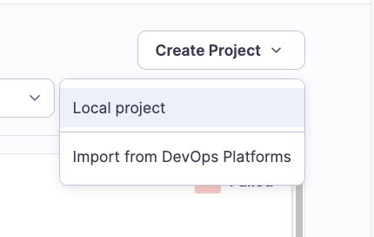

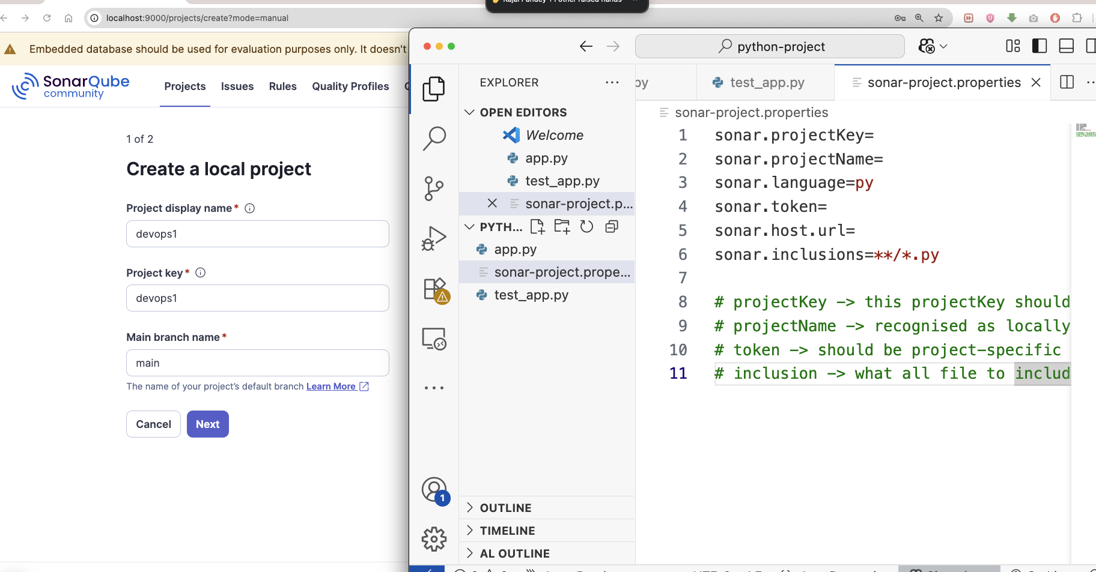

We have to provide the same name as projectKey in props file with seonarqube projectName

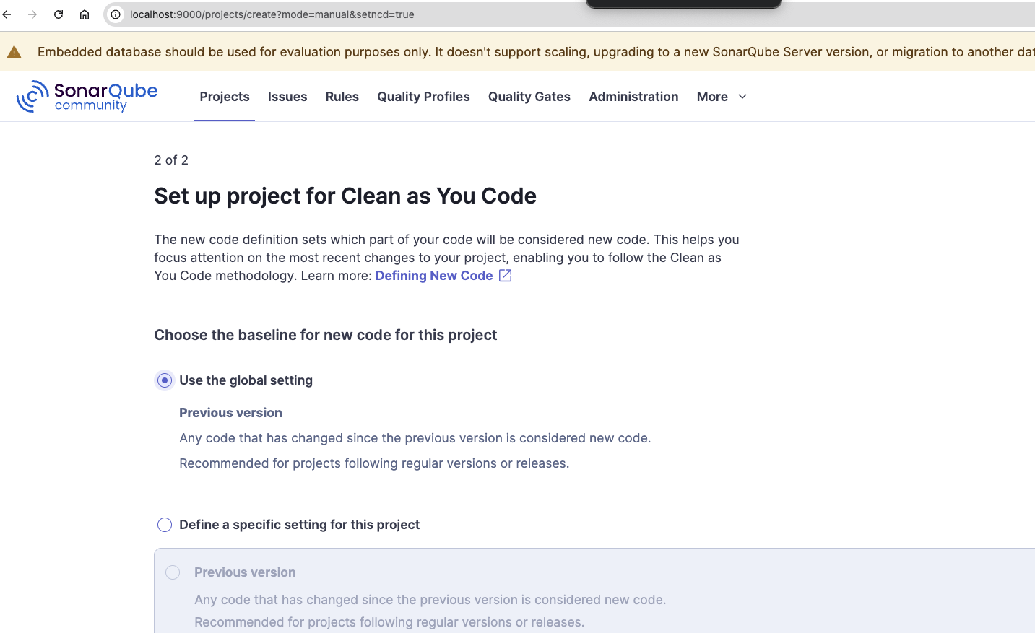

We assumption that: project reporting -> Independent Deployment (LIVE)

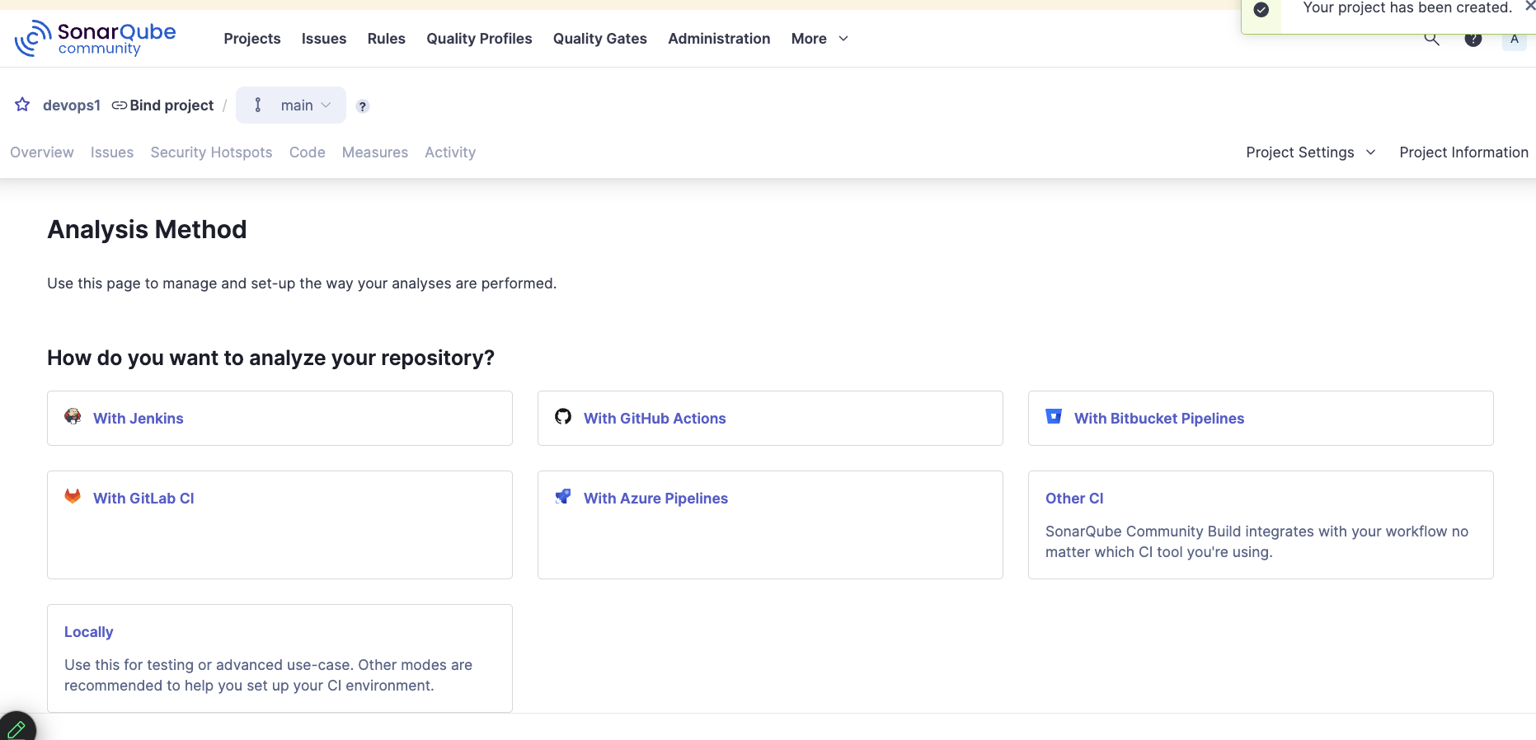

Since we are doing this with Local project:
So select the option Locally

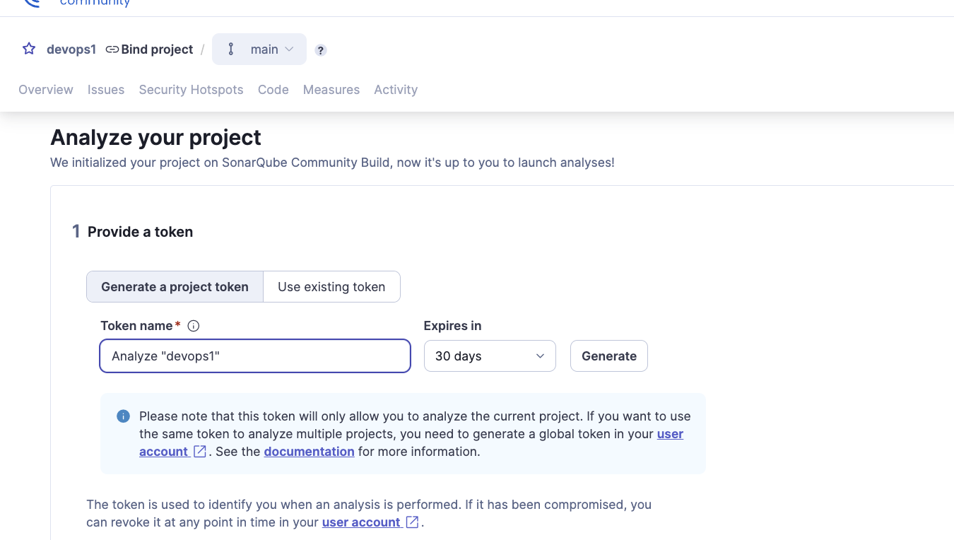

After select locally option: create a token.


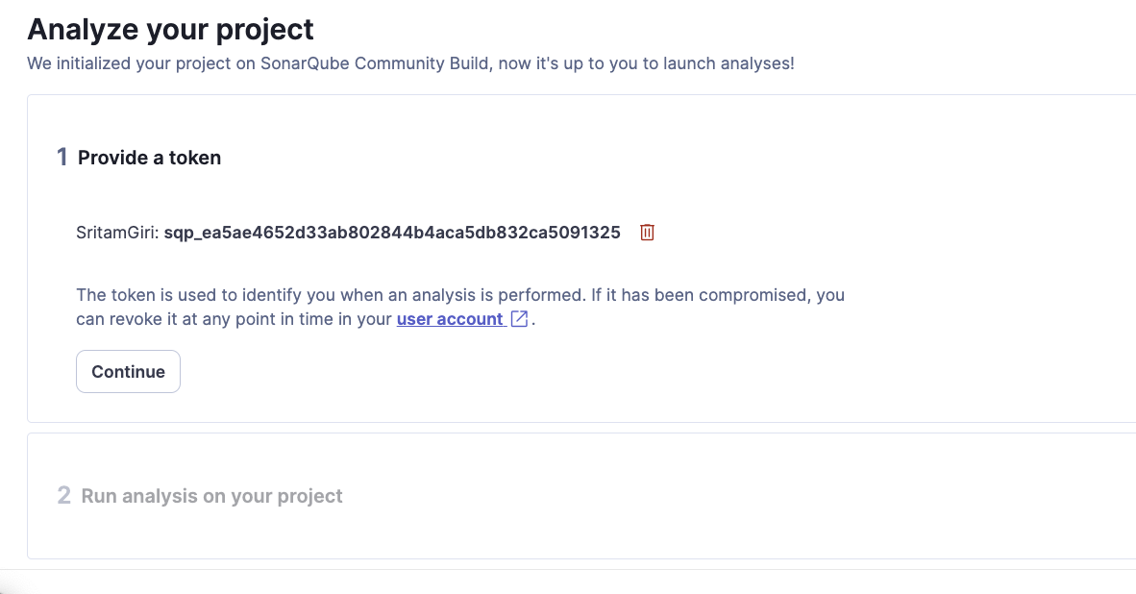
Copy and Paste the Token to you SonarProperties file:
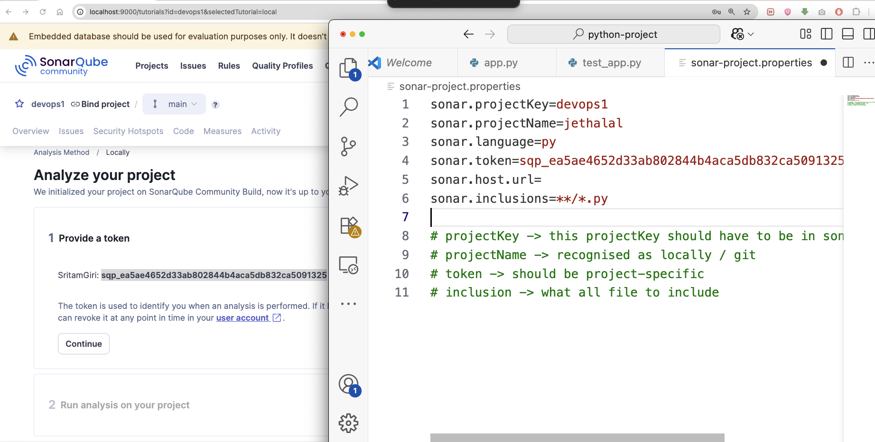

Run the scanner with project;
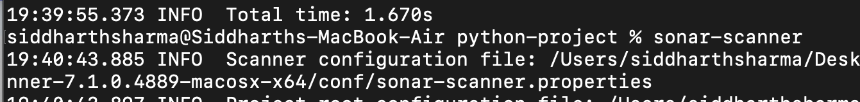

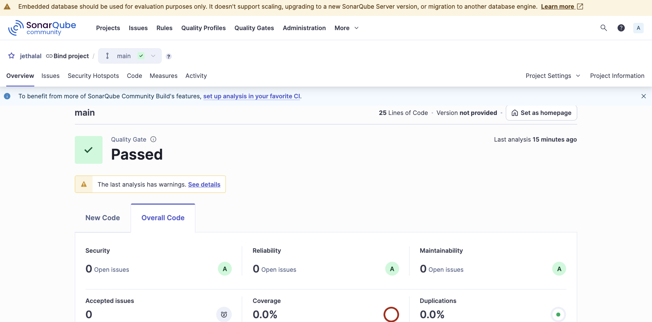

1. Lines of Code (LOC)
- Actual number of non-comment and non-blank lines of code.

2. Bugs
- Defects in code that could cause runtime errors or incorrect behavior.
- Example: Null pointer dereference, array index out of bounds.

3. Vulnerabilities
- Security-related issues in the code that might be exploited.
- Example: SQL Injection, hardcoded passwords.

4. Code Smells
- Maintainability issues that do not affect correctness but make the code harder to understand and maintain.
- Example: Long methods, duplicated code, too many parameters.

5. Security Hotspots
- Code sections that require manual review to determine if there's a security risk.
- Not necessarily vulnerabilities unless confirmed.

Quality Gates

6. Quality Gate
- A set of thresholds defined on key metrics to decide whether a project passes or fails.
- Example: "Code coverage on new code must be > 80%".

7. Passed/Failed
- Indicates whether your project met or failed the conditions in the Quality Gate.

Coverage
- Percentage of code lines tested by unit tests.
- Formula: (Lines covered by tests / Total lines to cover) * 100

15. Line Coverage
- % of lines covered by tests (subset of overall coverage).

16. Branch Coverage
- % of code branches (if/else, switch) covered by tests.

Issues & Rules

27. Issues
- Reported problems (bugs, vulnerabilities, code smells).

28. Rules
- Predefined or custom code quality rules used to analyze your code.

29. Effort to Fix
- Estimated time required to resolve a specific issue.

