

TECHNICAL GUIDE
AWS DevOps in Practice
Five Real-World Case Studies with Solution Architectures
CodePipeline · ECS · ECR · EKS · GitHub Actions · Jenkins · SonarQube · Docker · Terraform
Problem Statements • Reference Architectures • Implementation Walkthroughs
Architecture & Practitioner Series

Notices
This document is provided as an educational reference for learning AWS DevOps practices. It illustrates representative architectures and implementation patterns using fictional companies. Code samples are simplified for clarity and should be reviewed, secured, and tested before any production use. “AWS” and AWS service names are trademarks of Amazon.com, Inc. or its affiliates; this is an independent study guide and is not an official AWS publication.

Contents
How to Use This Guide 3
CASE STUDY 01 4
Microservices Delivery on Amazon ECS Fargate
CASE STUDY 02 9
Kubernetes Platform on Amazon EKS with Terraform
CASE STUDY 03 13
Quality-Gated CI/CD with Jenkins & SonarQube
CASE STUDY 04 17
Multi-Environment Infrastructure as Code with Terraform
CASE STUDY 05 21
Blue / Green Deployment on Amazon EKS via GitHub Actions
APPENDIX 25
Service & Tool Reference

How to Use This Guide
Each case study follows a consistent, exam-and-interview-friendly structure so you can read it as a worked problem or use it as a template for your own designs:
- Scenario - the business context and the pain the team is feeling.
- Problem Statement - the precise challenge to solve, highlighted in an orange panel.
- Requirements & Constraints - the conditions any valid solution must satisfy.
- Solution Overview - the chosen approach explained in plain language.
- Architecture Diagram - an AWS-style reference architecture of the solution.
- Implementation Walkthrough - the key code: Terraform, Dockerfiles, pipelines, and manifests.
- Outcomes - the measurable results, highlighted in a green panel.

Case Studies at a Glance
# | Case study | Primary tools | DevOps theme
1 | Microservices delivery on ECS Fargate | CodePipeline, CodeBuild, ECR, ECS, Docker | Serverless CI/CD
2 | Kubernetes platform on EKS | EKS, Terraform, GitHub Actions, ECR, RDS | IaC + Kubernetes
3 | Quality-gated CI/CD | Jenkins, SonarQube, Docker, ECR, ECS | Quality & security gates
4 | Multi-environment IaC | Terraform, CodePipeline, S3, DynamoDB, WAF | Environment parity
5 | Blue/green on EKS | GitHub Actions, EKS, ECR, ALB, Route 53 | Progressive delivery

CASE STUDY 01 | CONTAINERS & CI/CD

Automated Microservices Delivery on Amazon ECS Fargate
Services used: AWS CodePipeline, AWS CodeBuild, Amazon ECR, Amazon ECS (Fargate), Docker, Application Load Balancer, Amazon CloudWatch.

Scenario
ShopSphere is a fast-growing online retailer running a monolithic application on a fleet of EC2 instances. Every release requires a maintenance window, manual Docker builds on a developer laptop, and an SSH-based deployment that frequently fails halfway through. During seasonal sales the team cannot scale individual features independently, and a single bad deploy has twice taken the entire storefront offline.
Leadership has approved a move to containerized microservices and wants a fully automated, zero-downtime delivery pipeline that any engineer can trigger simply by merging code.
Problem Statement
Design and implement a continuous delivery pipeline that automatically builds a Docker image on every commit to the main branch, stores it in a private registry, and performs a zero-downtime rolling deployment to a container platform - with no servers for the team to patch or manage, full rollback capability, and centralized logging.

Requirements & Constraints
- Trigger: a merge to main in GitHub must start the pipeline automatically (no manual steps).
- Build: produce an immutable, tagged Docker image; tag with the Git commit SHA for traceability.
- Registry: images must be private, encrypted at rest, and scanned for OS vulnerabilities.
- Runtime: serverless containers - the team will not manage EC2 hosts or cluster capacity.
- Deployment: rolling update with health checks; automatic rollback if the new tasks fail to stabilize.
- Observability: all container logs and metrics centralized and queryable.

Solution Overview
The team replaces the manual workflow with a managed CI/CD chain. AWS CodePipeline orchestrates three stages - Source, Build, and Deploy. The Source stage connects to GitHub through an AWS CodeStar connection and fires on every push to main. AWS CodeBuild runs a buildspec that builds the Docker image, tags it with the commit SHA, and pushes it to Amazon ECR, which scans the image on push. The Deploy stage updates an Amazon ECS service running on AWS Fargate, which performs a rolling replacement of tasks behind an Application Load Balancer.
Because Fargate is serverless, ShopSphere never provisions or patches EC2 hosts. ECS deployment circuit breakers automatically roll back to the previous task definition if new tasks fail their health checks, and all stdout/stderr streams flow to Amazon CloudWatch Logs.
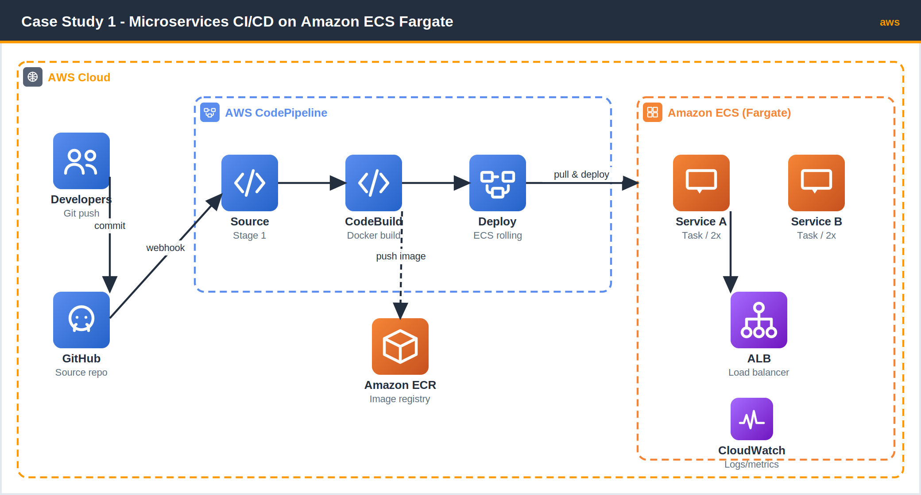
Figure 1.1 - CodePipeline builds a Docker image, stores it in Amazon ECR, and deploys to ECS Fargate behind an ALB.

Implementation Walkthrough

1. Containerize the service
A multi-stage Dockerfile keeps the runtime image small and free of build tooling.
Dockerfile
# ---- build stage ----
FROM node:20-alpine AS build
WORKDIR /app
COPY package*.json ./
RUN npm ci --omit=dev
COPY . .

# ---- runtime stage ----
FROM node:20-alpine
WORKDIR /app
COPY --from=build /app ./
EXPOSE 8080
USER node
CMD ["node", "server.js"]

2. Define the CodeBuild buildspec
The buildspec authenticates to ECR, builds and tags the image with the commit SHA, pushes it, and writes an imagedefinitions.json artifact that the ECS deploy action consumes.
buildspec.yml
version: 0.2
phases:
pre_build:
commands:
- aws ecr get-login-password --region $AWS_REGION \
| docker login --username AWS --password-stdin $REPO_URI
- TAG=${CODEBUILD_RESOLVED_SOURCE_VERSION:0:7}
build:
commands:
- docker build -t $REPO_URI:$TAG .
- docker tag $REPO_URI:$TAG $REPO_URI:latest
post_build:
commands:
- docker push $REPO_URI:$TAG
- docker push $REPO_URI:latest
- printf '[{"name":"web","imageUri":"%s"}]' \
"$REPO_URI:$TAG" > imagedefinitions.json
artifacts:
files: imagedefinitions.json

3. Provision the pipeline (Terraform excerpt)
pipeline.tf
resource "aws_ecr_repository" "web" {
name = "shopsphere/web"
image_scanning_configuration { scan_on_push = true }
encryption_configuration { encryption_type = "KMS" }
}

resource "aws_codepipeline" "web" {
name = "shopsphere-web"
role_arn = aws_iam_role.pipeline.arn

artifact_store {
type = "S3"
location = aws_s3_bucket.artifacts.bucket
}

stage {
name = "Source"
action {
name = "GitHub"
category = "Source"
owner = "AWS"
provider = "CodeStarSourceConnection"
version = "1"
output_artifacts = ["src"]
configuration = {
ConnectionArn = aws_codestarconnections_connection.gh.arn
FullRepositoryId = "shopsphere/web"
BranchName = "main"
}
}
}

stage {
name = "Build"
action {
name = "Docker"
category = "Build"
owner = "AWS"
provider = "CodeBuild"
version = "1"
input_artifacts = ["src"]
output_artifacts = ["build"]
configuration = { ProjectName = aws_codebuild_project.web.name }
}
}

stage {
name = "Deploy"
action {
name = "ECS"
category = "Deploy"
owner = "AWS"
provider = "ECS"
version = "1"
input_artifacts = ["build"]
configuration = {
ClusterName = aws_ecs_cluster.main.name
ServiceName = aws_ecs_service.web.name
FileName = "imagedefinitions.json"
}
}
}
}

4. Enable safe rollouts on the ECS service
ecs_service.tf
resource "aws_ecs_service" "web" {
name = "web"
cluster = aws_ecs_cluster.main.id
task_definition = aws_ecs_task_definition.web.arn
desired_count = 2
launch_type = "FARGATE"

deployment_circuit_breaker {
enable = true # auto-rollback on failed deploy
rollback = true
}

load_balancer {
target_group_arn = aws_lb_target_group.web.arn
container_name = "web"
container_port = 8080
}
}
Outcomes
Release time dropped from a 45-minute manual window to an unattended 6-minute pipeline.
Zero-downtime rolling deploys with automatic rollback eliminated storefront outages from bad releases.
Traceability: every running task maps to an exact commit SHA via its image tag.
No server management: Fargate removed all host patching and capacity planning toil.

CASE STUDY 02 | KUBERNETES & INFRASTRUCTURE AS CODE

Building a Kubernetes Platform on Amazon EKS with Terraform
Services used: Amazon EKS, Terraform, GitHub Actions, Amazon ECR, Docker, Amazon RDS, AWS Load Balancer Controller, Prometheus & Grafana.

Scenario
FinPay, a digital payments startup, is launching a platform composed of a dozen services that must scale independently and run identically across development, staging, and production. The founding engineers built the first environment by clicking through the AWS Console. Three months in, no one can reproduce that environment, the staging cluster has silently drifted from production, and a new region launch has stalled because the setup lives only in one engineer's memory.
The team needs every piece of infrastructure to be version-controlled, peer-reviewed, and reproducible, with application deployments flowing automatically from their Git repository to a managed Kubernetes cluster.
Problem Statement
Provision a production-grade Amazon EKS cluster and all supporting infrastructure (VPC, node groups, database, ingress) entirely as code so that any environment can be created or destroyed reproducibly. Then wire a CI/CD workflow that builds, tests, and deploys containerized services to the cluster on every merge - with horizontal autoscaling and full observability.

Requirements & Constraints
- Reproducibility: the entire stack must be declared in Terraform and stored in Git; no manual console changes.
- Orchestration: Kubernetes (Amazon EKS) for self-healing, autoscaling, and independent service scaling.
- CI/CD: GitHub Actions builds and tests images, pushes to Amazon ECR, and rolls out to EKS.
- State safety: Terraform remote state with locking so concurrent runs cannot corrupt infrastructure.
- Data tier: a managed PostgreSQL database (Amazon RDS) reachable only from inside the cluster's VPC.
- Observability: cluster and application metrics in Prometheus with Grafana dashboards.

Solution Overview
FinPay codifies the platform with reusable Terraform modules: a VPC module lays out public and private subnets across three Availability Zones, the EKS module creates the managed control plane and a managed node group, and an RDS module provisions a Multi-AZ PostgreSQL instance in the private subnets. Terraform state is stored remotely in Amazon S3 with a DynamoDB lock table.
Application delivery runs in GitHub Actions. On every merge to main, the workflow builds the Docker image, runs unit tests and a lint stage, pushes the image to Amazon ECR, and applies the updated Kubernetes manifests with kubectl. A HorizontalPodAutoscaler scales pods on CPU, the AWS Load Balancer Controller provisions an ALB from the Ingress resource, and the kube-prometheus-stack supplies metrics and dashboards.
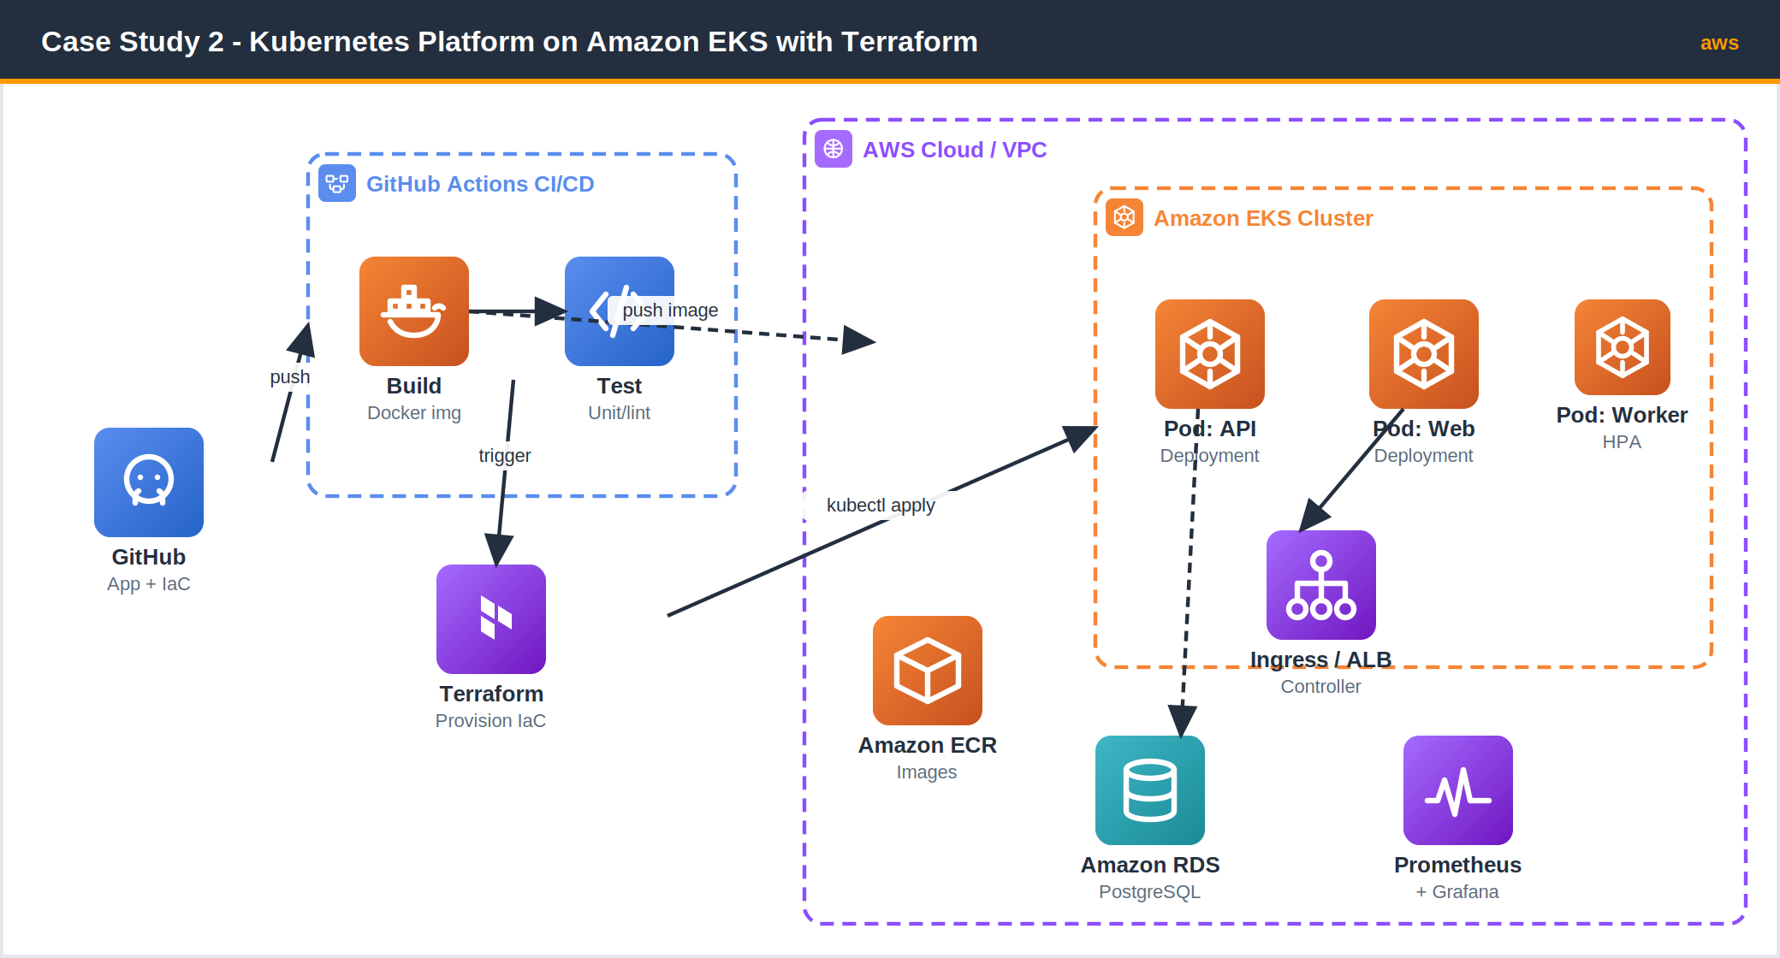
Figure 2.1 - GitHub Actions builds images and Terraform provisions an EKS cluster, RDS, and networking - all from version-controlled code.

Implementation Walkthrough

1. Remote state backend with locking
backend.tf
terraform {
backend "s3" {
bucket = "finpay-tf-state"
key = "platform/eks/terraform.tfstate"
region = "ap-south-1"
dynamodb_table = "finpay-tf-locks" # state locking
encrypt = true
}
}

2. EKS cluster and managed node group
eks.tf
module "eks" {
source = "terraform-aws-modules/eks/aws"
version = "~> 20.0"
cluster_name = "finpay-prod"
cluster_version = "1.30"

vpc_id = module.vpc.vpc_id
subnet_ids = module.vpc.private_subnets

cluster_endpoint_public_access = true

eks_managed_node_groups = {
workers = {
instance_types = ["t3.large"]
min_size = 3
max_size = 10
desired_size = 3
}
}

enable_irsa = true # IAM Roles for Service Accounts
}

3. CI/CD workflow (GitHub Actions)
.github/workflows/deploy.yml
name: build-and-deploy
on:
push: { branches: [ main ] }

permissions:
id-token: write # OIDC -> assume AWS role, no static keys
contents: read

jobs:
ship:
runs-on: ubuntu-latest
steps:
- uses: actions/checkout@v4

- name: Configure AWS credentials (OIDC)
uses: aws-actions/configure-aws-credentials@v4
with:
role-to-assume: ${{ secrets.AWS_DEPLOY_ROLE }}
aws-region: ap-south-1

- name: Login to Amazon ECR
id: ecr
uses: aws-actions/amazon-ecr-login@v2

- name: Run unit tests
run: npm ci && npm test

- name: Build & push image
env:
REG: ${{ steps.ecr.outputs.registry }}
run: |
IMG=$REG/finpay/api:${{ github.sha }}
docker build -t $IMG .
docker push $IMG
echo "IMG=$IMG" >> $GITHUB_ENV

- name: Deploy to EKS
run: |
aws eks update-kubeconfig --name finpay-prod
kubectl set image deployment/api api=$IMG
kubectl rollout status deployment/api --timeout=120s

4. Kubernetes Deployment, Service, and autoscaler
api-deployment.yaml
apiVersion: apps/v1
kind: Deployment
metadata: { name: api }
spec:
replicas: 3
selector: { matchLabels: { app: api } }
template:
metadata: { labels: { app: api } }
spec:
containers:
- name: api
image: REPLACED_BY_CI
ports: [{ containerPort: 8080 }]
readinessProbe:
httpGet: { path: /healthz, port: 8080 }
resources:
requests: { cpu: "250m", memory: "256Mi" }
---
apiVersion: autoscaling/v2
kind: HorizontalPodAutoscaler
metadata: { name: api }
spec:
scaleTargetRef: { apiVersion: apps/v1, kind: Deployment, name: api }
minReplicas: 3
maxReplicas: 12
metrics:
- type: Resource
resource: { name: cpu, target: { type: Utilization, averageUtilization: 65 } }
Outcomes
Reproducible environments: a full clone of production now stands up with one terraform apply.
No drift: every change is a reviewed pull request; the console is read-only.
Elastic scaling: the HPA absorbs payment-volume spikes automatically, scaling pods 3 -> 12.
Faster onboarding: a new region launch dropped from weeks of clicking to a few hours of code review.

CASE STUDY 03 | QUALITY GATES & CONTINUOUS INTEGRATION

Quality-Gated CI/CD with Jenkins and SonarQube
Services used: Jenkins, SonarQube, Docker, Amazon ECR, Amazon ECS, AWS Secrets Manager, Amazon CloudWatch.

Scenario
MediTrack builds software for hospitals and is subject to strict code-quality and security audits. Today, developers merge freely and quality problems - untested code paths, hard-coded credentials, and known-vulnerable dependencies - are only discovered weeks later during manual review. A recent audit flagged a secret committed to source control, putting a major contract at risk.
The compliance team mandates that no image may ship unless it passes an automated quality and security gate, and that the result of every check is recorded for auditors.
Problem Statement
Implement a continuous integration pipeline in Jenkins that automatically analyzes every change with SonarQube and blocks the build whenever the project fails the defined quality gate (coverage, bugs, vulnerabilities, code smells). Only images that pass may be built, pushed to Amazon ECR, and deployed - with no secrets stored in source code.

Requirements & Constraints
- Mandatory gate: a failing SonarQube quality gate must stop the pipeline immediately - no override by developers.
- Coverage threshold: new code must meet a minimum test-coverage percentage.
- Secret hygiene: registry and database credentials come from AWS Secrets Manager, never the repo.
- Image scanning: ECR scans every pushed image; high-severity findings are surfaced to the team.
- Auditability: each pipeline run records the gate result, test report, and image digest.

Solution Overview
Jenkins runs a declarative, multi-stage pipeline. After checkout, the SonarQube Scanner publishes analysis to the SonarQube server; the pipeline then calls waitForQualityGate, which pauses until SonarQube returns a pass/fail verdict via webhook. If the gate fails, the pipeline aborts before any image is built. On success, Jenkins builds the Docker image, retrieves the ECR push credentials from AWS Secrets Manager, pushes the image (triggering an ECR vulnerability scan), and updates the Amazon ECS service. CloudWatch collects deployment and runtime logs for the audit trail.
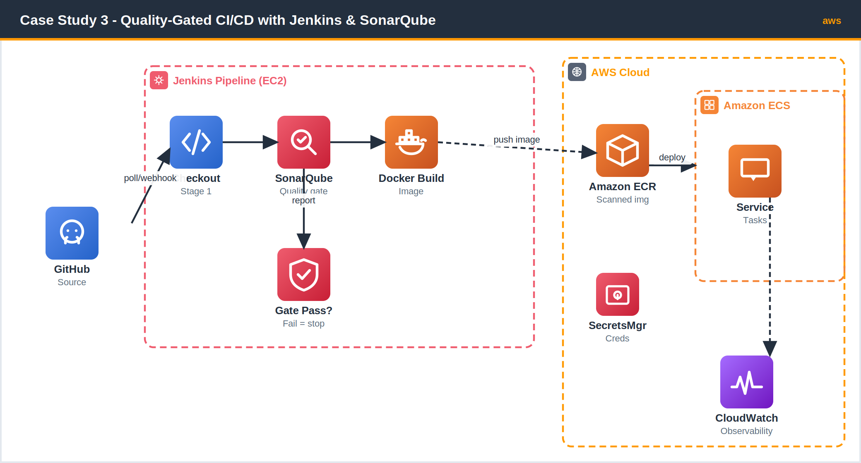
Figure 3.1 - Jenkins runs SonarQube analysis as a hard quality gate before any image is built, pushed to ECR, and deployed to ECS.

Implementation Walkthrough

1. The quality gate Jenkinsfile
The pipeline fails fast: waitForQualityGate with abortPipeline: true halts everything if SonarQube reports a failing gate.
Jenkinsfile
pipeline {
agent any
environment {
REPO = "1234.dkr.ecr.ap-south-1.amazonaws.com/meditrack"
TAG = "${env.GIT_COMMIT.take(7)}"
}
stages {
stage('Checkout') { steps { checkout scm } }

stage('SonarQube Analysis') {
steps {
withSonarQubeEnv('meditrack-sonar') {
sh 'mvn -B verify sonar:sonar'
}
}
}

stage('Quality Gate') {
steps {
timeout(time: 10, unit: 'MINUTES') {
// blocks until SonarQube webhook returns; fails build on a red gate
waitForQualityGate abortPipeline: true
}
}
}

stage('Build & Push Image') {
steps {
withCredentials([usernamePassword(
credentialsId: 'ecr-from-secretsmanager',
usernameVariable: 'U', passwordVariable: 'P')]) {
sh '''
echo "$P" | docker login --username "$U" --password-stdin $REPO
docker build -t $REPO:$TAG .
docker push $REPO:$TAG
'''
}
}
}

stage('Deploy to ECS') {
steps {
sh '''
aws ecs update-service --cluster meditrack \
--service api --force-new-deployment
'''
}
}
}
post {
failure { echo 'Quality gate or build failed - nothing was deployed.' }
}
}

2. Define the SonarQube quality gate
The gate is configured once in SonarQube and applied to the project. A typical hospital-grade gate looks like this:
Metric (on new code) | Operator | Threshold | Action if breached
Coverage | is less than | 80% | Gate fails - build aborts
Duplicated lines | is greater than | 3% | Gate fails - build aborts
Bugs | is greater than | 0 | Gate fails - build aborts
Vulnerabilities | is greater than | 0 | Gate fails - build aborts
Security hotspots reviewed | is less than | 100% | Gate fails - build aborts

3. Pull credentials from Secrets Manager (no secrets in Git)
fetch-secret.sh
# Jenkins retrieves the DB password at deploy time; nothing is committed.
DB_PASSWORD=$(aws secretsmanager get-secret-value \
--secret-id meditrack/prod/db \
--query 'SecretString' --output text | jq -r .password)
Outcomes
Hard quality gate: builds that drop below 80% new-code coverage or introduce a vulnerability are blocked automatically.
Zero committed secrets: all credentials now resolve from AWS Secrets Manager at run time.
Audit-ready: every run links a SonarQube report and image digest, satisfying the compliance review.
Shift-left: issues surface in minutes at commit time instead of weeks later in manual review.

CASE STUDY 04 | MULTI-ENVIRONMENT INFRASTRUCTURE AS CODE

Multi-Environment Infrastructure as Code with Terraform
Services used: Terraform, AWS CodePipeline, GitHub, Amazon S3, Amazon DynamoDB, Amazon EKS, Amazon RDS, Amazon VPC, AWS WAF.

Scenario
StreamFlix operates a video platform across three environments - development, staging, and production - that are supposed to be identical but never are. Each was built by a different engineer at a different time, so production has subtly different security-group rules, instance sizes, and subnet layouts than staging. Bugs that pass in staging fail in production because the environments diverge, and there is no safe, reviewable way to promote an infrastructure change.
The platform team wants a single source of truth for infrastructure that promotes the exact same definitions from dev to staging to production, with a human approval gate before production changes are applied.
Problem Statement
Design a Terraform code structure and an automated delivery pipeline that provisions identical infrastructure across multiple environments from one set of reusable modules. Environment differences must be limited to input variables only, infrastructure changes must be code-reviewed and plan-previewed, and production changes must require explicit manual approval before they are applied.

Requirements & Constraints
- One module, many environments: dev, staging, and prod share the same modules; only variables differ (sizes, replica counts, AZ spread).
- Plan before apply: every change produces a terraform plan that reviewers can inspect.
- Manual approval for prod: production apply cannot run without explicit human sign-off.
- State isolation: each environment keeps separate, locked remote state.
- Stronger production posture: prod adds Multi-AZ databases, an extra subnet tier, and AWS WAF at the edge.

Solution Overview
StreamFlix adopts a layered Terraform layout. Reusable modules under modules/ describe the network, EKS cluster, and database once. Each environment under environments/ supplies only a tfvars file and a backend configuration, so the same module produces a small single-AZ stack in dev and a hardened Multi-AZ stack in production purely through variables.
AWS CodePipeline drives promotion. A push to the infrastructure repository triggers a plan stage that runs terraform plan and publishes the output as an artifact. Lower environments apply automatically; the production stage inserts a manual approval action so a lead must review the plan before terraform apply runs. Remote state lives in Amazon S3 with a DynamoDB lock table per environment.
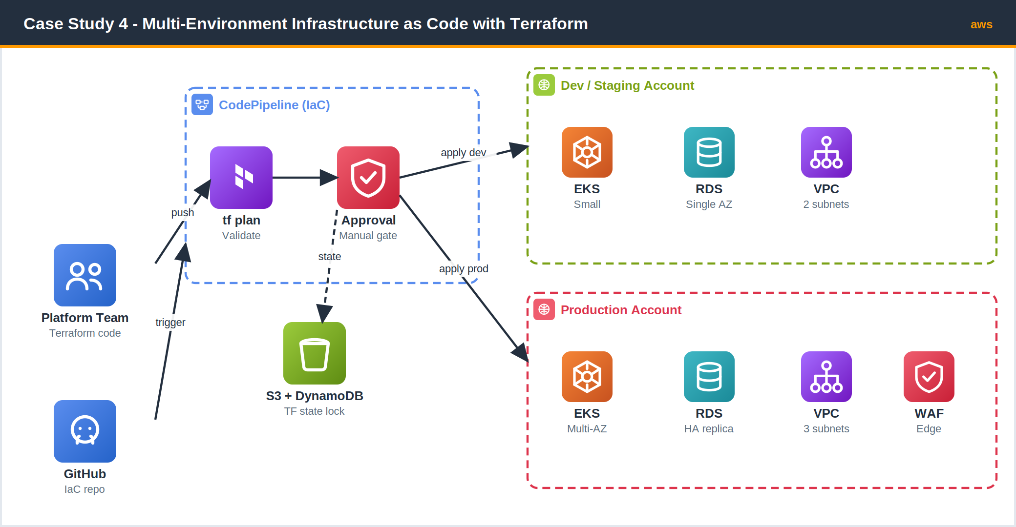
Figure 4.1 - One set of Terraform modules promotes identical infrastructure from dev/staging into a hardened production account, gated by manual approval.

Implementation Walkthrough

1. Repository structure
repo layout
infra/
|-- modules/
| |-- network/ # VPC, subnets, route tables
| |-- eks/ # cluster + node groups
| \-- database/ # RDS instance(s)
\-- environments/
|-- dev/
| |-- main.tf backend.tf
| \-- dev.tfvars
|-- staging/
| \-- staging.tfvars
\-- prod/
\-- prod.tfvars

2. A reusable module consumed by every environment
environments/prod/main.tf
module "network" {
source = "../../modules/network"
cidr_block = var.cidr_block
az_count = var.az_count # 2 in dev, 3 in prod
enable_waf = var.enable_waf # false in dev, true in prod
}

module "database" {
source = "../../modules/database"
instance_size = var.db_instance # db.t3.medium dev, db.r6g.large prod
multi_az = var.db_multi_az # false dev, true prod
}

module "eks" {
source = "../../modules/eks"
cluster_name = "streamflix-${var.env}"
desired_size = var.node_count # 2 dev, 6 prod
}

3. Environment differences live only in variables
Variable | dev.tfvars | staging.tfvars | prod.tfvars
az_count | 2 | 2 | 3
db_instance | db.t3.medium | db.t3.large | db.r6g.large
db_multi_az | false | false | true
node_count | 2 | 3 | 6
enable_waf | false | false | true

4. Plan + manual-approval pipeline (CodePipeline excerpt)
infra-pipeline.tf
stage {
name = "Plan-Prod"
action {
name = "TerraformPlan"
category = "Build"
provider = "CodeBuild"
input_artifacts = ["src"]
output_artifacts = ["plan"]
configuration = { ProjectName = aws_codebuild_project.tf_plan.name }
}
}

stage {
name = "Approve-Prod"
action {
name = "ManualApproval"
category = "Approval"
provider = "Manual" # blocks until a human approves
version = "1"
configuration = {
CustomData = "Review the prod terraform plan before applying."
}
}
}

stage {
name = "Apply-Prod"
action {
name = "TerraformApply"
category = "Build"
provider = "CodeBuild"
input_artifacts = ["plan"]
configuration = { ProjectName = aws_codebuild_project.tf_apply.name }
}
}
Outcomes
Environment parity: dev, staging, and prod are now byte-for-byte the same modules - drift is gone.
Safe promotion: every change is plan-previewed and code-reviewed before it touches infrastructure.
Protected production: no prod change applies without an explicit human approval in the pipeline.
Reusability: spinning up a brand-new environment is now a tfvars file plus a backend block.

CASE STUDY 05 | PROGRESSIVE DELIVERY ON KUBERNETES

Blue / Green Deployment on Amazon EKS via GitHub Actions
Services used: GitHub Actions, Amazon EKS, Amazon ECR, Docker, AWS Load Balancer Controller (ALB Ingress), Amazon Route 53, Amazon CloudWatch, Trivy.

Scenario
CloudDesk sells a B2B SaaS product with a strict 99.95% uptime SLA. Their current rolling deployments occasionally ship a bad version that briefly serves errors to every customer before anyone notices, and rollback means waiting for another full rolling update. A single bad release last quarter breached the SLA and triggered service credits across their entire customer base.
Engineering wants a release strategy where a new version runs in parallel with the old one, is validated with real health checks, receives only a trickle of traffic first, and can be reverted to the previous version instantly if anything looks wrong.
Problem Statement
Implement a blue/green (progressive) deployment workflow on Amazon EKS, driven by GitHub Actions, where a new version is deployed alongside the live version and traffic is shifted gradually only after automated health and security checks pass. A failed check or unhealthy target must trigger an immediate, instant rollback to the previous version with no customer-facing downtime.

Requirements & Constraints
- Parallel versions: the new (green) release must run alongside the live (blue) release before any cutover.
- Image security: every image is scanned (Trivy) and must be free of critical CVEs before deploy.
- Gradual shift: traffic moves blue -> green in weighted steps, not all at once.
- Instant rollback: reverting to blue must be a single, immediate traffic-weight change.
- Automated promotion: GitHub Actions orchestrates build, scan, deploy, health check, and cutover.

Solution Overview
CloudDesk runs two Kubernetes Deployments behind one ALB Ingress - blue (current) and green (candidate). GitHub Actions builds the image, scans it with Trivy, and pushes it to Amazon ECR. It then deploys the green Deployment and waits for its pods to pass readiness probes. Using weighted target groups on the AWS Load Balancer Controller, the workflow shifts traffic to green in steps (for example 10% -> 50% -> 100%), checking CloudWatch target health between steps. If a step is unhealthy, the workflow resets the weight to 100% blue - an instant rollback - and fails the run. Once green is fully live, it becomes the new blue.
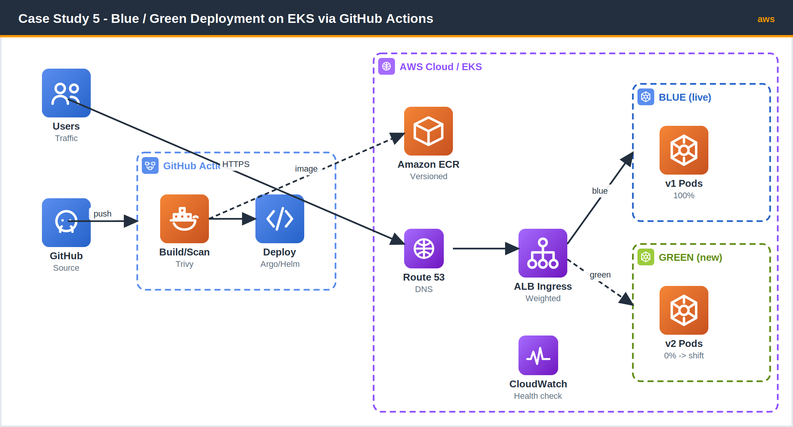
Figure 5.1 - GitHub Actions deploys a green version beside blue and shifts ALB traffic gradually, with instant rollback on a failed health check.

Implementation Walkthrough

1. Build, scan, and gate on critical CVEs
.github/workflows/bluegreen.yml
name: blue-green
on:
push: { branches: [ main ] }

jobs:
release:
runs-on: ubuntu-latest
permissions: { id-token: write, contents: read }
steps:
- uses: actions/checkout@v4

- uses: aws-actions/configure-aws-credentials@v4
with:
role-to-assume: ${{ secrets.AWS_DEPLOY_ROLE }}
aws-region: ap-south-1
- uses: aws-actions/amazon-ecr-login@v2
id: ecr

- name: Build image
run: docker build -t app:${{ github.sha }} .

- name: Scan with Trivy (fail on CRITICAL)
uses: aquasecurity/trivy-action@master
with:
image-ref: app:${{ github.sha }}
severity: CRITICAL
exit-code: '1' # blocks release on a critical CVE

- name: Push to ECR
run: |
IMG=${{ steps.ecr.outputs.registry }}/clouddesk:${{ github.sha }}
docker tag app:${{ github.sha }} $IMG && docker push $IMG

2. Deploy green and shift traffic in weighted steps
promote step (workflow)
- name: Deploy GREEN
run: |
aws eks update-kubeconfig --name clouddesk-prod
kubectl apply -f k8s/green-deployment.yaml
kubectl rollout status deployment/app-green --timeout=120s

- name: Progressive traffic shift with health checks
run: |
for W in 10 50 100; do
kubectl annotate ingress app \
alb.ingress.kubernetes.io/actions.weighted="\
{\"green\":$W,\"blue\":$((100-W))}" --overwrite
sleep 30
UNHEALTHY=$(aws elbv2 describe-target-health \
--target-group-arn $GREEN_TG \
--query "length(TargetHealthDescriptions[?TargetHealth.State!='healthy'])")
if [ "$UNHEALTHY" -gt 0 ]; then
echo "Green unhealthy at ${W}% - rolling back"
kubectl annotate ingress app \
alb.ingress.kubernetes.io/actions.weighted="\
{\"green\":0,\"blue\":100}" --overwrite # INSTANT rollback
exit 1
fi
done

3. Blue and green Deployments behind one Ingress
k8s/ingress.yaml
apiVersion: networking.k8s.io/v1
kind: Ingress
metadata:
name: app
annotations:
kubernetes.io/ingress.class: alb
alb.ingress.kubernetes.io/scheme: internet-facing
alb.ingress.kubernetes.io/target-type: ip
alb.ingress.kubernetes.io/healthcheck-path: /healthz
spec:
rules:
- http:
paths:
- path: /
pathType: Prefix
backend:
service: { name: app-weighted, port: { number: 80 } }
Outcomes
No more blast-radius outages: a bad version only ever sees a small traffic slice before rollback.
Instant rollback: reverting is a single weight change to 100% blue - seconds, not a full redeploy.
Security gate: images with critical CVEs never reach the cluster.
SLA protected: progressive shifts with health checks kept the platform within its 99.95% target.

APPENDIX

Service & Tool Reference
A quick reference for the AWS services and DevOps tools used throughout these case studies.
Tool / Service | Category | Role in these case studies
AWS CodePipeline | Developer Tools | Orchestrates source -> build -> deploy stages and manual approvals.
AWS CodeBuild | Developer Tools | Runs buildspec steps: tests, Docker builds, terraform plan/apply.
Amazon ECR | Containers | Private, encrypted Docker image registry with scan-on-push.
Amazon ECS (Fargate) | Containers | Serverless container runtime with rolling deploys and circuit breakers.
Amazon EKS | Containers | Managed Kubernetes for autoscaling and progressive delivery.
GitHub Actions | CI/CD | Git-native pipelines using OIDC to assume AWS roles (no static keys).
Jenkins | CI/CD | Self-hosted pipeline engine enforcing SonarQube quality gates.
SonarQube | Code Quality | Static analysis and quality gate that can block a build.
Docker | Containers | Builds immutable, multi-stage container images.
Terraform | IaC | Declarative provisioning of all AWS infrastructure as reusable modules.
Amazon S3 + DynamoDB | Storage / DB | Remote Terraform state storage with state locking.
AWS Secrets Manager | Security | Runtime credential retrieval so no secrets live in Git.
Amazon CloudWatch | Observability | Centralized logs, metrics, and deployment health signals.

Common DevOps Patterns Demonstrated
- Immutable artifacts: every image is tagged by commit SHA - the same artifact promotes across environments.
- Shift-left quality: tests, scans, and quality gates run early and can stop a release.
- Infrastructure as Code: environments are reproducible, reviewed, and version-controlled.
- Keyless cloud access: GitHub Actions and pipelines assume IAM roles via OIDC instead of long-lived keys.
- Safe rollouts: circuit breakers, blue/green, and weighted traffic shifting protect availability.


End of guide · AWS DevOps in Practice

