# VIRTUALIZATION

**An overview**

Virtualization relies on software to stimulate hardware and create a virtual computer system. This allows users to run more than one operating system on their device.

A virtual machine is an isolated software container with an operating system and applications inside that acts independently.

**Creation of the virtual machines**

Oracle virtual box was employed in the creation of two virtual machines. The host runs on a windows 10 operating system.

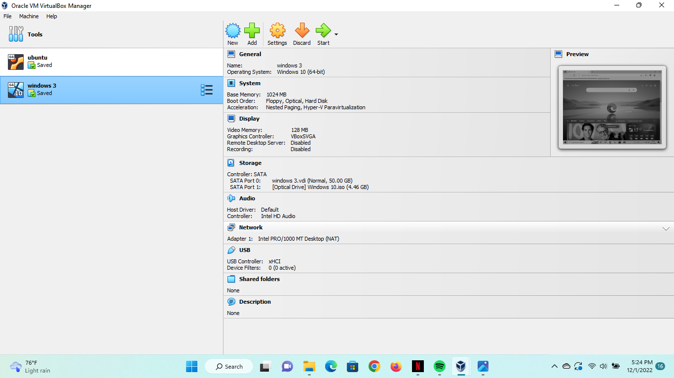

Two virtual machines were created.

* Windows 10 virtual machine
* Ubuntu virtual machine

Windows 10 VIRTUAL MACHINE



Under storage:

The windows 3 virtual machine is set up to take up 1.024 GB RAM with a storage of 50 GB and 1 CPU. It also contains an optical drive for windows10.iso to mirror the original windows operating system

Under Network:

Windows 3 is connected to the internet via NAT network to the network of the host computer.

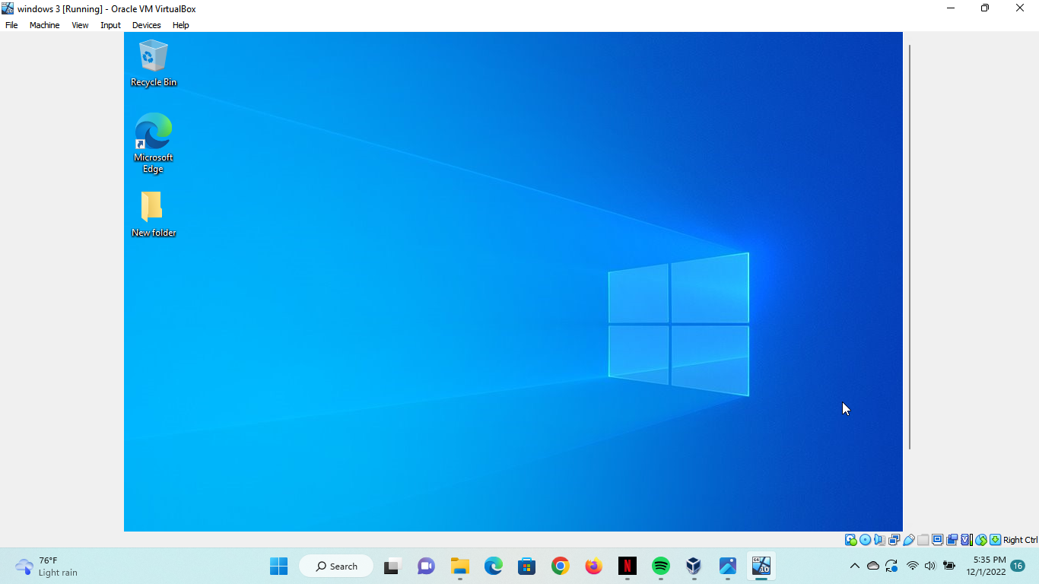

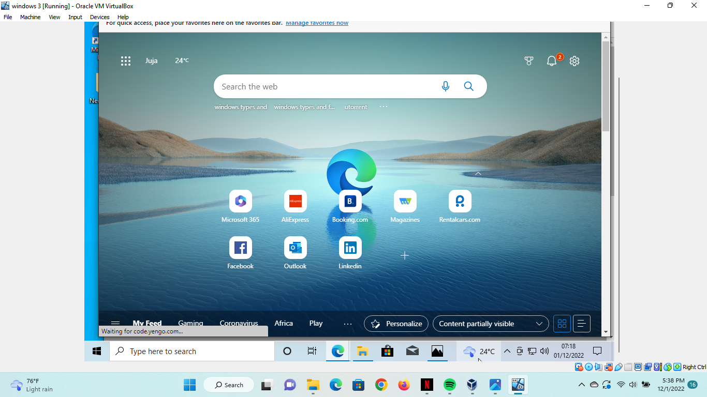

UBUNTU VIRTUAL MACHINE

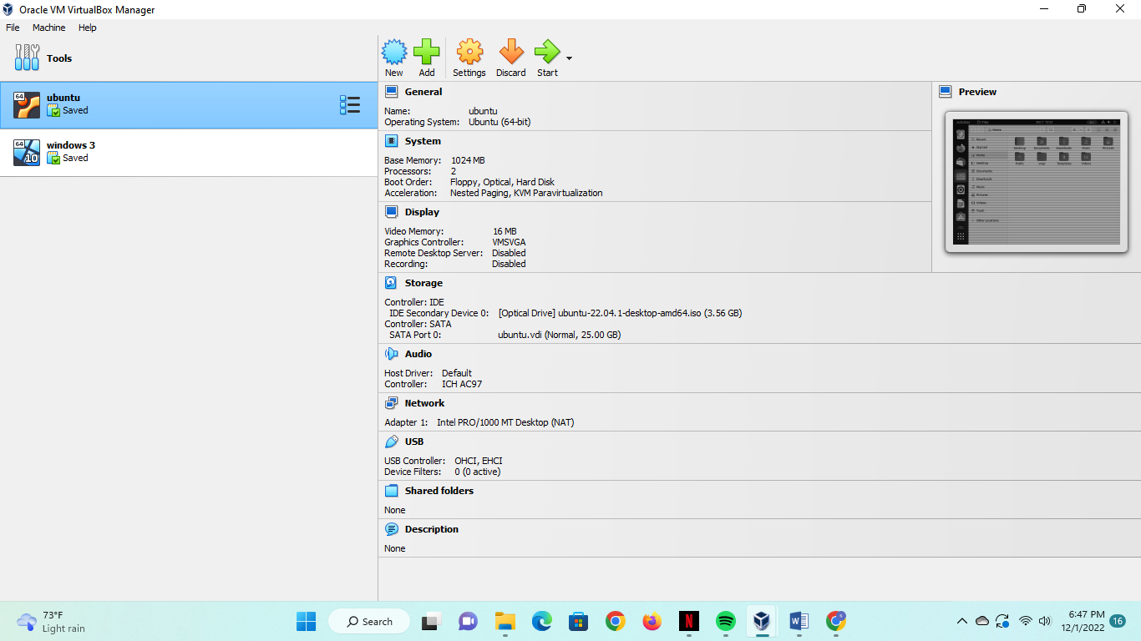

Created an Ubuntu virtual machine using Ubuntu (64 bit) OS.

Under storage;

The virtual machine took up 1.024 GB RAM and 25 GB storage. It contains an Ubuntu.iso image to mirror the Ubuntu operating system.

Under network;

The virtual machine is connected to the internet via NAT netwo9rk to the network of the host computer.

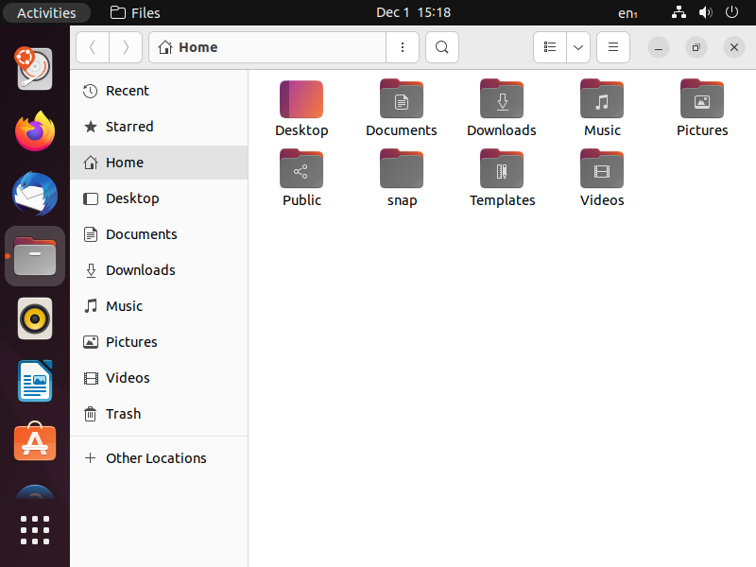

Installed a trial Ubuntu operating system for the VM and it seems to be working just as well.

Difficulties experienced

* My virtual machines were unable to run for a couple of tries but managed to enable virtualization on my operating system.
* The virtual machines slow down my laptop when they are actively running.
* I was unware of the need to install iso images for the virtual machines to run properly which was quite time consuming to install
* Inability to network the two virtual machines.