**Entity Relationship Model for The Conceptual Design**.

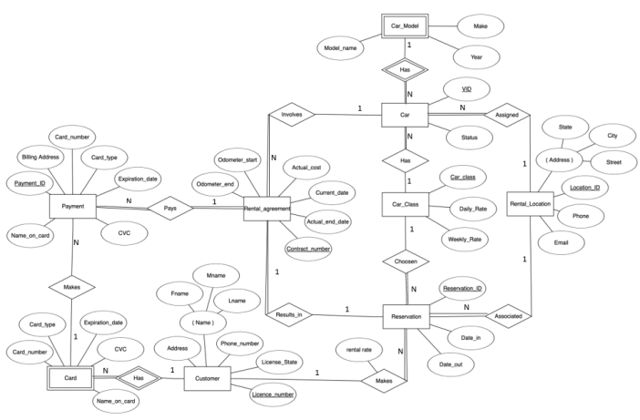

**Relational Schema Design for the Logical Design**

