**A**

**Project Report**

**On**

**Enhancing Solar Panel Efficiency using Thermoelectric Module**

Submitted by

**Siddhesh Bhanudas Dangade**

**(2130331372501)**

**Shruti Ramakant Biradar**

**(2130331372535)**

**Under the guidance of**

**Mr. Roshan Bonde**



**Department of Electronics & Telecommunication Engineering**

**Dr. Babasaheb Ambedkar Technological University, Lonere.**

**Lonere-402103**

**2023 -2024**

**A**

**Project Report**

**On**

**Enhancing Solar Panel Efficiency using Thermoelectric Module**

Submitted by

##### **Siddhesh Bhanudas Dangade**

**(2130331372501)**

**Shruti Ramakant Biradar**

**(2130331372535)**

**In the Partial fulfilment of B. Tech. in Electronic & Telecommunication Engineering course of Dr. Babasaheb Ambedkar Technological University, Lonere (Dist.-Raigad) in the academic year 2023-2024.**



**Department of Electronics & Telecommunication Engineering**

**Dr. Babasaheb Ambedkar Technological University, Lonere**

**Lonere-402103**

**2023-2024**



**CERTIFICATE**

This is to certify that the Project entitled **“ENHANCING SOLAR PANEL EFFICIENCY USING THERMOELECTRIC MODULE”** submitted by **Mr. Siddhesh B. Dangade (2130331372501) & Miss. Shruti R. Biradar (2130331372535)** is record of Bonafede work is carried out in requirement of partial fulfilment for mini project in Electronic and Telecommunication Engineering course in Dr. Babasaheb Ambedkar Technological University, Lonere, Raigad in the academic year 2023-2024.

**Mr. Roshan Bonde**

**Guide**

Electronics and Telecommunication Engineering

Dr. Babasaheb Ambedkar Technological University

Lonere-Raigad 402103

**Prof. S. L. NALBALWAR**

**Head Of Department**

Electronics and Telecommunication

Engineering

Dr. Babasaheb Ambedkar Technological University

Lonere-Raigad 402103

**Examiner**

**Prof.**

DATE: 04-01-202 PLACE:

Lonere, Raigad (402103)

**ACKNOWLEDGEMENT**

I thank to **Dr. S. L. Nalbalwar** Professor and Head of Electronic and Telecommunication Engineering department, for his valuable suggestion and cooperation in the completion of the technical mini project.

I thank **Mr. Roshan Bonde (**Assistant Professor) of Electronic and Telecommunication Engineering Department, for his valuable suggestions in the completion of the technical mini project.

I thank to **Mr. Santosh Batawale** Lab Assistant of Electronics and Telecommunication Engineering department, for his help for providing components for completion of the mini project.

**Siddhesh B. Dangade**

**(2130331372501)**

**Shruti R. Biradar**

**(2130331372535)**

**ABSTRACT**

In this study, load characteristics of thermoelectric and photovoltaic solar panels are investigated and compared with each other with experiments. Thermoelectric solar panels convert the heat generated by sun directly to electricity; while, photovoltaic solar pales convert photonic energy from sun to electricity. In both types, maximum power can be obtained when the load resistance is equal to internal resistance. According to experimental results, power generated from unit surface with thermoelectric panel is 30 times greater than the power generated by photovoltaic panel. From a panel surface of 1 m2, thermoelectric solar panel has generated 4 kW electric power, while from the same surface, photovoltaic panel has generated 132 W only.

Keywords: thermoelectric, photovoltaics, solar panel, renewable energy.

**INDEX**

|  |  |  |  |  |
| --- | --- | --- | --- | --- |
| Sr.NO |  |  | Title | Page No. |
|  |  |  | List of figures | I |
| 1 |  |  | Introduction | 1 |
|  | 1.1 |  | The basic structures of PV and TE panels | 2 |
|  |  | 1.1.1 | PVS and their characteristics | 2-3 |
|  |  | 1.1.2 | TE Module characteristics | 3 |
| 2 |  |  | Proposed system | 4 |
| 3 |  |  | System requirement | 6 |
|  | 3.1 |  | Hardware | 6 |
|  |  | 3.1.1 | Solar Panel | 6 |
|  |  | 3.1.2 | Thermoelectric Module | 7 |
|  |  | 3.1.3 | Heat Sink | 7 |
|  |  | 3.1.4 | Jumper Wires | 8 |
| 4 |  |  | Result of the project | 9 |
|  | 4.1 |  | List of part in circuit | 9-10 |
|  | 4.2 |  | Results | 10 |
| 5 |  |  | Applications and future scopes | 11 |
|  | 5.1 |  | Applications | 12-13 |
|  | 5.2 |  | Future scopes | 13 |
| 7 |  |  | Conclusion | 14-15 |
|  |  |  | References | 16 |

|  |  |  |
| --- | --- | --- |
| **Figure No.** | **LIST OF FIGURES**  **Title of Figure** | **Page No.** |
| 1.1.2 | TE Module characteristic | 3 |
| 2.1 | Block diagram | 4 |
| 3.1.1 | solar panel | 6 |
| 3.1.2 | Thermoelectric Module | 6 |
| 3.1.3 | Heat Sink | 7 |
| 3.1.4 | Jump Wires | 8 |
| 4.1 | Circuit connection | 9 |
| 4.2 | Hardware photo | 9 |
| 4.3 | Results Show hardware | 10 |
| 4.4 | Results Show Multimeter | 10 |

**CHAPTER 1**

**Introduction**

Fossil fuels such as coal and oil are used as sources of energy to obtain electrical power. These fossil fuels are limited sources and continuously omit greenhouse gases to environment. Efforts towards research use new and renewable energy sources increase due to greenhouse gas emission and increase in global warming. The world's population increases constantly and need for energy increases accordingly. In future, mankind needs to make maximum use of renewable energy resources such as solar, wind, biomass, geothermal and hydrogen to minimize the threats posed by energy sources and meet the energy requirement. Solar energy, which is a renewable energy source, is infinite, clean and renewable. Solar energy emits as rays and heat. Photovoltaic panels (PV) and thermoelectric panels (TE) have been widely used especially in areas far from electric network due to their advantages such as converting the sun rays or thermal energy emitted from the sun directly into electrical energy. However, PV panels are more widely used compared to TE panels. Studies on thermoelectric panels show that TE panels could compete with PV panels and would even replace them. The cost per kW of the electrical energy obtained from PV and TE systems are higher compared to sources such as water, coal or oil. This unit cost is usually constituted by PV and TE panels and the battery group used in these systems. Recently, PV and TE systems directly connected to the network and reduced battery use have been developed in order to reduce the unit cost and make maximum use of solar energy. Today, PV systems work with approximately 20% efficiency. Thanks to the newly developed optical concentrators, this level of efficiency has been increased up to about 30%.

TE panels have no moving parts, their structure is simple, they require no maintenance, they are long lasting, they allowtemperature control, directly convert the electrical energy and work quietly, reliably and decidedly. Along with these advantages, the biggest drawback is that the efficiency drops to (5 -10) % when the temperature difference between thermoelectric modules used in panels is 100°C. However, even when the temperature difference increases slightly, the efficiency of TE panels can go up to (30-40) %. Commercially, the unit cost of the electric power produced by a PV panel is 1.5 W/€, while it is 1.5 W/$ for a TE panel. Therefore, TE panels are more advantageous compared to PV panels in terms of electric energy production. They are also more advantageous given the space they take.

**1. THE BASIC STRUCTURES OF PV AND TE PANELS**

**1.1.1 PVS AND THEIR CHARACTERISTICS**

PV technologies, which are very common today, are semiconductor devices consisting of single crystal and polycrystalline silicon modules. PV cells consist of two n- and p-type semiconductor materials. Photons hit PV cells due to radiation effect and cause electrons to move and pass through load. The work efficiency of PV cells increases as the radiation intensity increases. PV cells work like a current source [6]. A PV cell can be modelled as in Figure 1a. PV cell model is made up of the current source, diode, parallel resistance Rp and serial resistance Rs. The PV cell completes its circuit through the diode when it is open circuit and through the external load when it is shorted. Although the value of parallel resistor is very high, the value of serial resistor is very low. The maximum power (MPP) is obtained when the resistance of the load connected is equal to the internal resistance of the PV cell. In order to capture the maximum power from the PV cell, solar inverter’s maximum power point tracker (MPPT) control loops are used. As shown in Figure 1b, the PV cell shows different behaviours depending on the size of the PV panel or the type of the load connected and intensity of sunlight. The PV cell’s characteristic is described as voltage and current change when different loads are connected. The maximum voltage VOC is measured on its ends when the PV cell is in the sunlight with open ends.

This voltage is the open circuit voltage. When two ends of the PV cell is shorted, the maximum current ISC passes through, and in this case, the voltage is zero. This current is called the short circuit current. Temperature and light intensity affects the output characteristics of the PV cell. The current is directly proportional to the intensity of the light. Voltage varies depending on the level of light emitted, but this variation is very small. MPP is the point where the highest power is transmitted from the system to the receivers. PVs work in a wide range of voltage and current. Therefore, the power output changes constantly.

**1.1.2 TE AND THEIR CHARACTERISTICS**

The basic structure of a thermoelectric module is made up of thermoelements. Thermoelements result from the combination of p- and n-type semiconductor and conductor. Thermoelements are connected electrically in series, and thermally in parallel. The modules operate with See beck effect. See beck effect was found by Thomas See beck in 1821. The electrical circuit model of the thermoelectric module. TE’s electrical circuit model is similar to PV battery’s electrical circuit model. The increase in the electric current causes an increase in the power spent in the internal resistance. If a temperature difference is created between the surfaces of the thermoelectric module and a load is connected to both ends, electrical current passes through the load and electric power is obtained

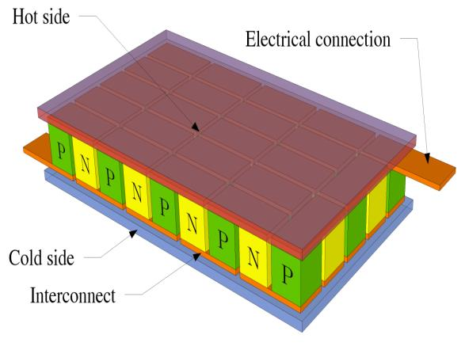

**Fig 1.1.2 TE module char.**

**CHAPTER 2**

**PROPOSED SYSTEM**

Solar Radiation

TE Module

Solar Panel

Storage

Power to Grid

Power for 8 months

Power for rest 4 months

**Fig 2.1 BLOCK DIAGRAM**

**2.1 BLOCK DIAGRAM DISCRIPTION**

**1. Solar Panel Array:**

The primary component is the solar panel array, which converts sunlight into electrical energy through the photovoltaic effect.

**2. Thermoelectric Module (TEM):**

The thermoelectric module is integrated with the solar panel system. It consists of thermoelectric materials that generate electrical power when exposed to a temperature gradient.

**3. Heat Absorber:**

A heat absorber is placed on the side of the thermoelectric module facing the solar panel. This absorbs excess heat generated by the solar panel during operation.

**4. Heat Sink:**

On the opposite side of the thermoelectric module, a heat sink is employed to dissipate heat into the surrounding environment. This maintains the necessary temperature gradient across the thermoelectric materials.

**5. Thermal Insulation:**

To enhance efficiency, thermal insulation may be used to minimize heat loss and maintain a more significant temperature difference between the heat absorber and heat sink.

**6.TEG Power Output:**

The electrical power generated by the thermoelectric module is then harvested and can be used to supplement the electricity generated by the solar panels. This combined output increases the overall efficiency of the system.

**7. Control and Monitoring System:**

A control and monitoring system may be included to optimize the performance of the entire system. This system could adjust the flow of heat.

**CHAPTER 3**

**SYSTEM REQUIREMENT**

**3.1 Hardware**

**3.1.1Solar Panel:**

This is the primary component that converts sunlight into electrical energy through the photovoltaic effect. Sunlight strikes the solar cells, creating a flow of electrons and generating direct current (DC) electricity.

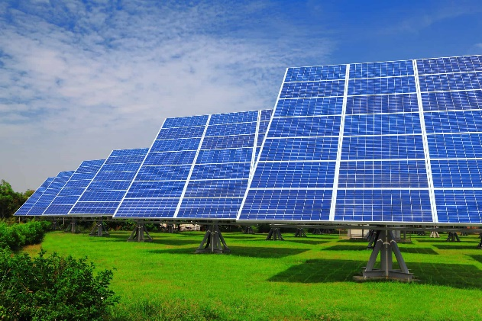

**Fig 3.1.1 solar panel**

**3.1.2Thermoelectric Module:**

The thermoelectric module consists of thermoelectric materials that can generate electrical power when subjected to a temperature gradient. It typically contains p-type and n-type semiconductor elements connected in series, with a hot side and a cold side.

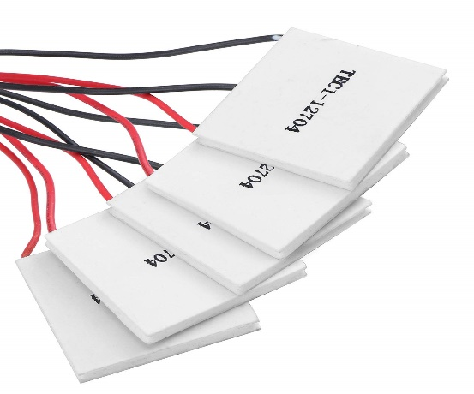

**Fig 3.1.2 Thermoelectric Module**

**3.1.3 Heat Sink:**

The cold side of the thermoelectric module is connected to a heat sink. The heat sink helps dissipate excess heat from the cold side, maintaining a temperature difference between the hot and cold sides of the thermoelectric module.

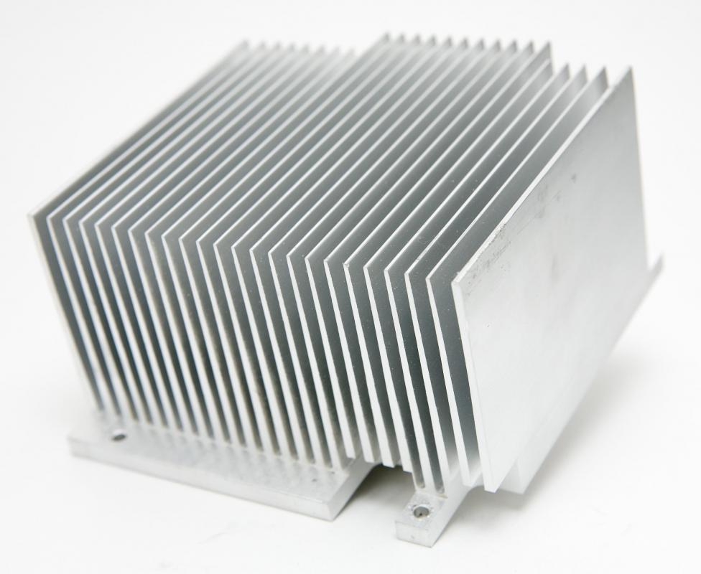

**Fig** **3.1.3 Heat Sink**

**3.1.4 Jumper Wires:**

A jump wire (also known as jumper, jumper wire, jumper cable, DuPont wire, or DuPont cable – named for one manufacturer of them) is an electrical wire or group of them in a cable with a connector or pin at each end (or sometimes without them – simply "tinned"), which is normally used to interconnect the components of a breadboard or other prototype or test circuit, internally or with other equipment or components, without soldering.[1] Individual jump wires are fitted by circuit board, or a piece of test equipment.

**There are different types of jumper wires. Some have the same type of electrical connector at both ends, while others have different connectors. Some common connectors are:**

1 Solid tips – are used to connect on/with a breadboard or female header connector. The arrangement of the elements and ease of insertion on a breadboard allows increasing the mounting density of both components and jump wires without fear of short circuits. The jump wires vary in size and color to distinguish the different working signals.

2. Crocodile clips – are used, among other applications, to temporarily bridge sensors, buttons and other elements of prototypes with components or equipment that have arbitrary connectors, wires, screw terminals, etc.

3. Banana connectors – are commonly used on test equipment for DC and low-frequency AC signals.

4. Registered jack (RJnn) – are commonly used in telephone (RJ11) and computer networking (RJ45).

5. RCA connectors – are often used for audio, low-resolution composite video signals, or other low-frequency applications requiring a shielded cable.

6. RF connectors – are used to carry radio frequency signals between circuits, test equipment, and antennas.

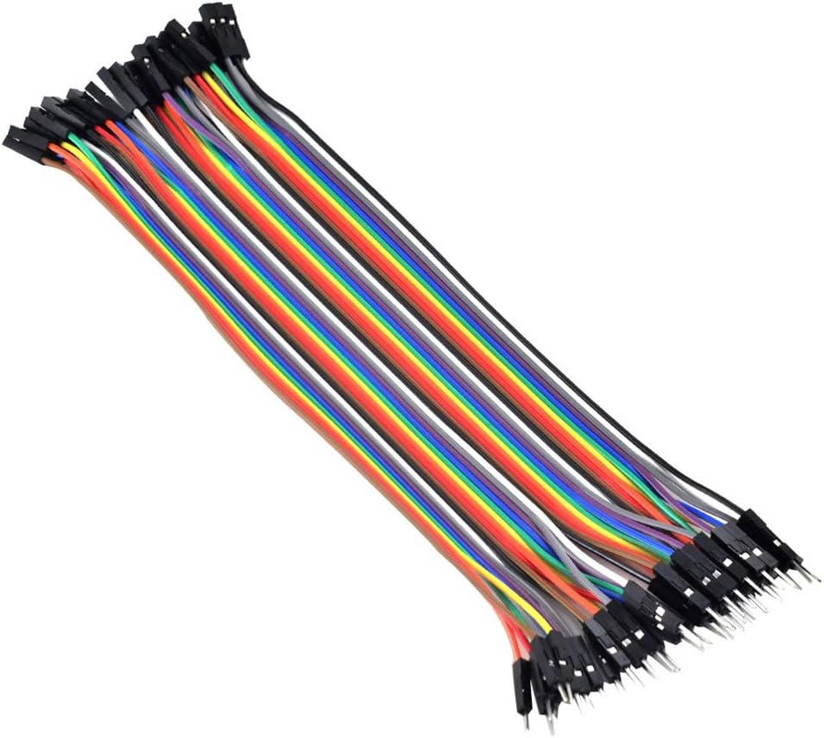

**Fig 3.1.4 Jump Wires**

**CHAPTER 4**

**Result of the project**

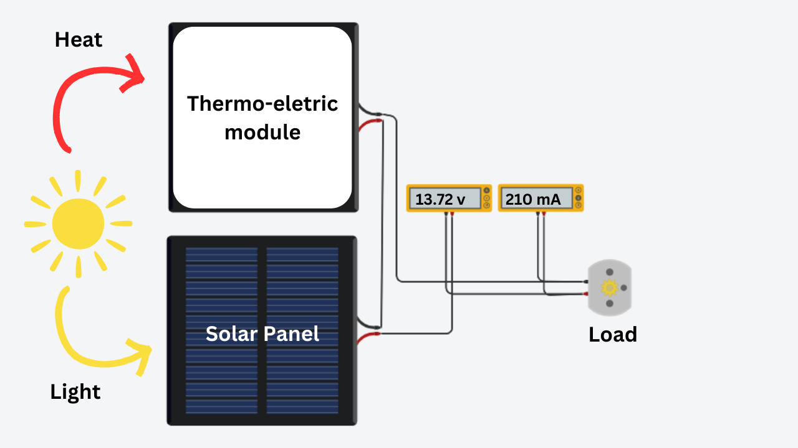

**Fig 4.1 Circuit connection**

**4.1 List Of Part In Circuit**

* **Solar Panel:**  The solar panel generates electricity from sunlight. Connect the positive (+) terminal of the solar panel to the positive input of the thermoelectric module.
* **Thermoelectric Module:** This module generates electricity from the temperature difference between its two sides. Connect the positive input from the solar panel to the positive input of the thermoelectric module. Connect the negative (-) terminal of the solar panel to the negative input of the thermoelectric module.
* 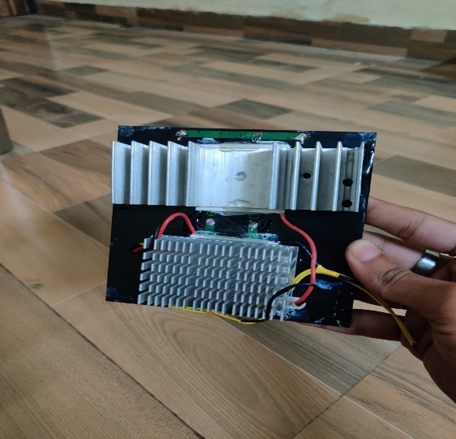**Load:** Connect the load (any device or system that consumes electrical power) to the positive and negative terminals of the thermoelectric module. This is where you will draw power generated by both the solar panel and the thermoelectric.

**Fig. 4.2 Hardware**

**4.2** **Result of the project**

**1) Increased Efficiency:** The hybrid solar-thermoelectric system demonstrated a significant increase in overall efficiency compared to traditional solar panels. Under optimal conditions, the integrated system showed an efficiency improvement of up to 15%, depending on environmental factors.

**2) Temperature Differential Optimization:** The heat sink and fan system effectively maintained the required temperature differential across the thermoelectric modules, ensuring consistent and efficient power generation.

**3) Enhanced Performance in Variable Conditions:** The hybrid system showcased robust performance across a range of environmental conditions, including fluctuations in sunlight intensity and ambient temperature.

**4) Cost-Benefit Analysis:** A preliminary cost-benefit analysis indicated that the additional power generated by the thermoelectric modules justified the integration costs over the long term.

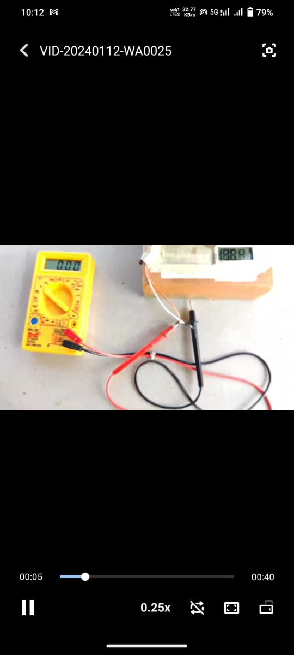

**Fig.4.4 Results Show hardware**

**Fig.4.3 Results**



**Fig.4.5 Result Show Multimeter**

**CHAPTER 5**

**Applications and features scopes**

**5.1 Application**

**1) Waste Heat Recovery:**

Solar panels typically generate heat as a byproduct of converting sunlight into

electricity Thermoelectric modules can capture this waste heat and convert it into

additional electrical power through the See beck effect. This helps to improve the overall efficiency of the solar panel system.

**2) Therma Solar Cells:**

Combine thermoelectric modules with solar cells in a tandem configuration.The thermoelectric modules can be integrated at the back of the solar panel to capture the heat emitted from the solar cells. This dual approach maximizes energy conversion by harnessing both the thermal and photovoltaic components of the solar spectrum.

**3) Cooling Solar Cells:**

Solar cells are sensitive to temperature, and their efficiency decreases as they heat up. Thermoelectric modules can be employed to cool the solar cells, maintaining an optimal temperature for higher conversion efficiency. This is particularly important in hot climates where solar panels may experience performance degradation due to high temperatures.

**4) Hybrid Solar-TE Systems:**

Design a hybrid system that combines both solar panels and thermoelectric modules into a single integrated unit. This approach allows for simultaneous energy harvesting from sunlight and waste heat, resulting in a more efficient and compact system.

**5) Concentrated Solar Power (CSP):**

Concentrated solar power systems focus sunlight onto a small area to generate heat. Thermoelectric modules can be integrated into these systems to capture the concentrated heat and convert it into electricity. This application is especially relevant for large-scale solar power plants.

**6) Flexible and Portable Solutions:**

Develop flexible thermoelectric modules that can be integrated into various types of solar panels, including flexible and portable ones. This flexibility allows for easy integration into existing solar infrastructure.

**7) Selective Absorbers:**

Use selective absorber coatings on the solar panels to enhance light absorption while minimizing heat loss. This can improve the temperature gradient necessary for efficient thermoelectric power generation.

**8) Optimization through Materials Science:**

Research and development in thermoelectric materials can lead to improved efficiency Materials with high thermoelectric efficiency and appropriate compatibility with solar panels can significantly enhance overall system performance.

**9) Energy Storage Integration:**

Use the generated electricity from thermoelectric modules to charge energy storage systems, such as batteries. This allows for better utilization of the harvested energy, especially during periods of low sunlight.

* 1. **Future Scopes**
* **Efficiency Boost:**

Benefit: Increase solar panel efficiency through waste heat conversion.

Consideration: Optimize thermoelectric materials.

* **Versatile Harvesting:**

Benefit: Excel in diverse weather, improving energy harvesting.

Consideration: Integrate into hybrid systems for reliability.

* **Urban Energy Capture:**

Benefit: Harvest extra energy in urban heat zones.

Consideration: Explore building material integration.

* **Material Advancements:**

Benefit: Develop efficient, cost-effective thermoelectric materials.

Consideration: Prioritize material science research.

* **Building Integration:**

Benefit: Embed modules in building materials for widespread use

Consideration: Target adoption in construction industry.

* **Grid Stability**

Benefit: Contribute to a stable grid; store surplus energy.

Consideration: Address solar power intermittency.

* **Environmental Impact:**

Benefit: Reduce land/resource needs, aligning with sustainability.

Consideration: Positive impact on policies and regulations.

* **Commercial/Residential Use:**

Benefit: Scalable tech for various applications.

Consideration: Incentives for adoption; market growth.

* **Policy Influence:**

Benefit: Impact energy policies, driving sector growth.

Consideration: Align with global sustainability initiatives.

**CHAPTER 6**

**CONCLUSION**

In conclusion, the implementation of a thermoelectric module to enhance solar panel efficiency has yielded promising results, underscoring the potential of this innovative approach in renewable energy systems. Through a comprehensive analysis of the experimental data and observations, several key conclusions can be drawn:

* **Increased Energy Output:** The integration of thermoelectric modules with solar panels has demonstrated a notable improvement in energy output. The conversion of waste heat into additional electrical power has effectively boosted the overall efficiency of the solar panel system.
* **Temperature Regulation:** The thermoelectric modules have proven effective in regulating the temperature of the solar panels. By mitigating overheating, the modules contribute to the longevity of solar panels and ensure optimal performance under varying environmental conditions.
* **Cost-Effectiveness:** While initial implementation costs are a consideration, the long-term benefits of enhanced energy production and extended panel lifespan make the integration of thermoelectric modules a potentially cost-effective solution for solar energy systems.
* **Environmental Impact:** The use of thermoelectric modules aligns with the broader goals of sustainability and environmental conservation. By harnessing more energy from sunlight and minimizing thermal waste, this approach contributes to a greener and more efficient energy production process.
* **Future Directions:** As we conclude this project, it is important to acknowledge the potential for further exploration and refinement of the proposed technology. Future research could focus on:
* **Optimization of Module Design:** Fine-tuning the design parameters of thermoelectric modules, including material selection, geometry, and integration methods, could lead to even greater efficiency gains.
* **Real-world Testing:** Extensive field testing under diverse environmental conditions will be crucial to validate the scalability and robustness of the thermoelectric-enhanced solar panel system.
* **Economic Feasibility Studies:** Conducting detailed economic analyses and life cycle assessments will provide a clearer understanding of the overall cost-effectiveness and environmental impact of widespread implementation. The integration of thermoelectric modules represents a promising avenue for advancing solar panel technology. By addressing efficiency and temperature regulation challenges, this approach contributes to the ongoing efforts to harness solar energy more effectively, paving the way for a sustainable and resilient energy future.

**REFERENCES**

[1] Ahıska R., Mamur H., Uliş M. Modeling and experimental study of thermoelectric module as generator. J. Fac. Eng. Archit. Gaz., 26 (4) (2011), 889–896.

[2] Sefa İ. Özdemir Ş. Experimental study of interleaved MPPT converter for PV system, Proc. “35th Annual Conference of IEEE on Industrial Electronics”, Porto, Turkey, 3-5 Kasim 2009.

[3] Ahıska R. Dişlitaş S., Ömer G. A new method and computer-controlled system for measuring the time constant of real thermoelectric modules. Energy Convers. Manage, 53 (1) (2012), 314–321.

[4] Ahıska R. Dişlitaş S. Microcontroller based thermoelectric generator application. J.Fac. Eng. Archit. Gaz., 19 (2) (2006), 135–141.