COURSE: COMPUTER NETWORKS LABORATORY

**CSN-361**

REPORT ON

ASSIGNMENT 5

**MADE BY:**

**Name: Ghetia Siddharth**

**Enrollment Number: 17114033**

**CSE 3rd YEAR**

**Problem Statement 1**:

Using OPNET create Bus topology among a set of N computer nodes out of which two nodes are source and the rest are sink nodes.

Model the traffic of source and sink nodes individually and demonstrate the packet transfer between them using Ethcoax (Ethernet using coaxial) cables. Use network scale as the “campus” of area 1km x 1km.



**Algorithms and data structures used in the implementation:**

Various **Data Structures/Objects** used are:

1. **ethcoax_station:**

This represents an Ethernet station that connects to an Ethernet bus at 10Mbps. It can generate packet and can also receive packets.

It has various attributes as shown:

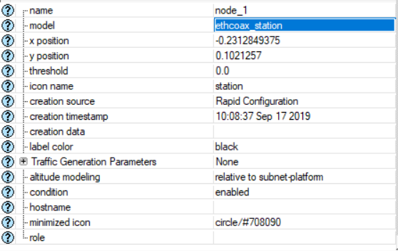

1. **eth_coax:**

It represents an Ethernet bus which can connect nodes with bus receivers and transmitters via taps. This bus connects Ethernet stations at 10Mbps.

It has following attributes:

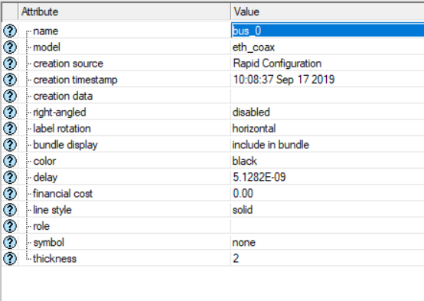

1. **eth_tap:**

It represents a link i.e. Ethernet bus tap that connects a node with bus receivers and transmitters to a bus at 10Mbps.

It has various attributes as shown in figure:

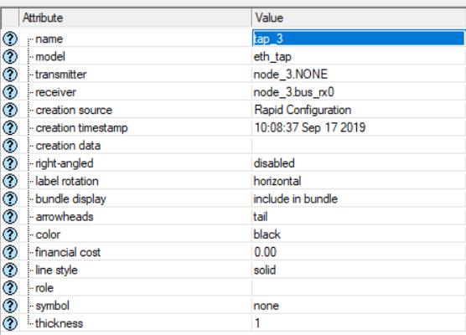

**Algorithm:**

**To create the required network:**

**STEPS:**

* 1. Create a new project
  2. Create a new Scenario with required properties: Ethoax, Campus, 1 Km x 1 Km, etc.
  3. Then create a rapid configuration for bus topology with required properties like number of nodes, etc.
  4. Then apply appropriate properties to various elements as required (traffic properties, delay properties, etc.).
  5. Then select the statistics that you want to study and specify their properties as required.
  6. Finally run the simulation for specified time and study the statistics obtained (run the simulation for different configurations or attributes settings)

**CONCLUSION:**

* There are various Traffic generation parameters :

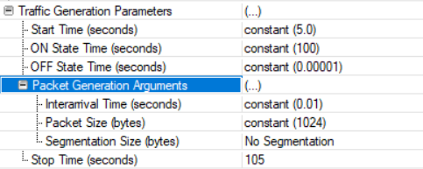

* Each of these parameters have several possible values and of different types.
* Example : Interarrival time of constant(0.01) signifies that packet will be generated in 0.01 sec i.e. 100 Packets/sec. This is one of the simplest value there are other distributions possible which are quite complex like exponential(10), triangular(min,max), etc. which represents different types of distributions along with the parameters mentioned.
* We can also change the delay of the eth_coax attribute which will affect the pattern obtained for Packets received and Packets Transmitted for global attributes.

**Snapshots (for different cases):**

**NETWORK DESIGNED (for N=8):**

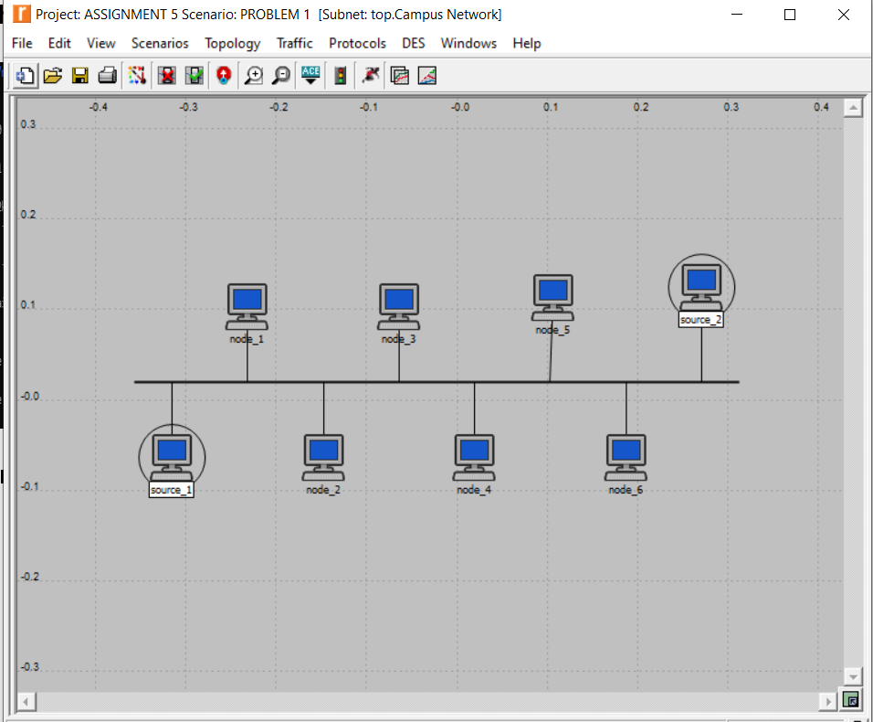

**FOR SOURCE 1(CONFIGURATION): FOR SOURCE 2:**

* + 1. **Start time: constant(5) 1. Start time: constant(5)**
    2. **ON State time: constant(100) 2. ON State time: constant(100)**
    3. **OFF State time: constant(0.00001) 3. OFF State time: constant(0.00001)**
    4. **Stop time: 105 4. Stop time: 105**
    5. **Packet Generation Arguments: 5. Packet Generation Arguments:**
       1. **Interarrival time: constant(0.01) i) Interarrival time: constant(0.005)**
       2. **Packet Size: constant(1024) ii) Packet Size: constant(1024)**

**DELAY IN ETH_COAX CABLE: 5.1282E-09**

**FOR OTHER NODES THE TRAAFIC GENERATION PROPERTIES ARE SET AS NONE (since sink)**

**SHOWING ONLY GLOBAL STATISTICS (OTHER STATISTICAL DATA IS ALSO AVAILABLE):**

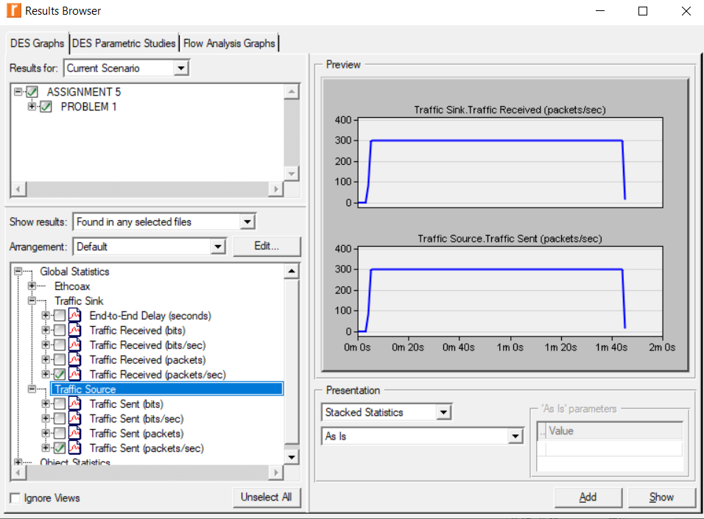

**FOR SOURCE 1(CONFIGURATION): FOR SOURCE 2:**

* + 1. **Start time: constant(5) 1. Start time: constant(5)**
    2. **ON State time: constant(100) 2. ON State time: constant(100)**
    3. **OFF State time: constant(0.00001) 3. OFF State time: constant(0.00001)**
    4. **Stop time: 105 4. Stop time: 105**
    5. **Packet Generation Arguments: 5. Packet Generation Arguments:**
       1. **Interarrival time: constant(0.01) i) Interarrival time: constant(0.005)**
       2. **Packet Size: constant(1024) ii) Packet Size: constant(1024)**

**DELAY IN ETH_COAX CABLE: 0.01 SEC**

**FOR OTHER NODES THE TRAAFIC GENERATION PROPERTIES ARE SET AS NONE (since sink)**

**SHOWING ONLY GLOBAL STATISTICS (OTHER STATISTICAL DATA IS ALSO AVAILABLE):**

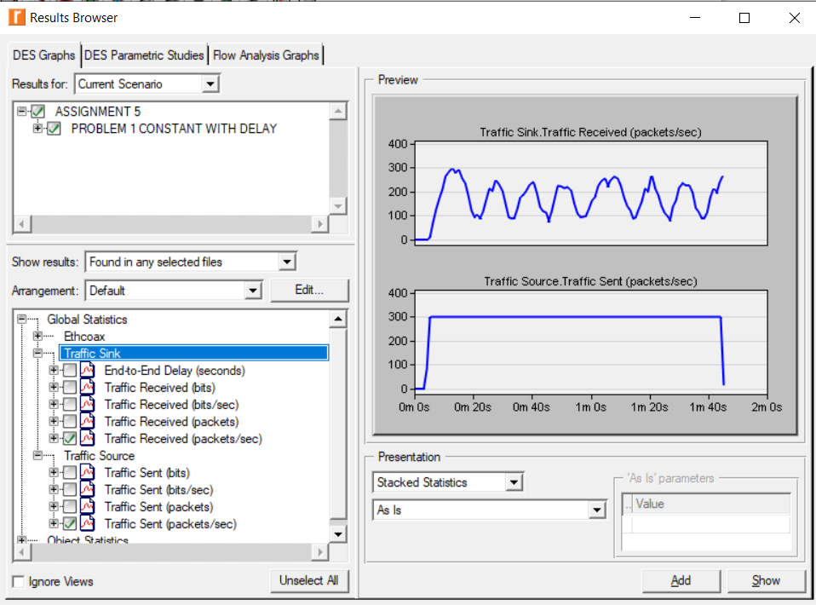

**FOR SOURCE 1(CONFIGURATION): FOR SOURCE 2:**

* + 1. **Start time: constant(5) 1. Start time: constant(5)**
    2. **ON State time: exponential(100) 2. ON State time: exponential(100)**
    3. **OFF State time: exponential (0.0001) 3. OFF State time: exponential (0.0001)**
    4. **Stop time: 105 4. Stop time: 105**
    5. **Packet Generation Arguments: 5. Packet Generation Arguments:**
       1. **Interarrival time: exponential(1) i) Interarrival time: exponential (1)**
       2. **Packet Size: constant(1024) ii) Packet Size: constant(1024)**

**DELAY IN ETH_COAX CABLE: 5.1282E-09**

**FOR OTHER NODES THE TRAAFIC GENERATION PROPERTIES ARE SET AS NONE (since sink)**

**SHOWING ONLY GLOBAL STATISTICS (OTHER STATISTICAL DATA IS ALSO AVAILABLE):**

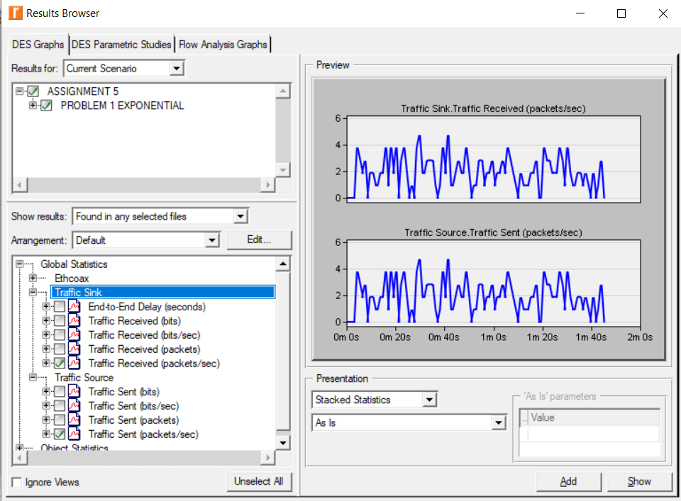

**FOR SOURCE 1(CONFIGURATION): FOR SOURCE 2:**

* + 1. **Start time: constant(5) 1. Start time: constant(5)**
    2. **ON State time: exponential(100) 2. ON State time: exponential(100)**
    3. **OFF State time: exponential (0.0001) 3. OFF State time: exponential (0.0001)**
    4. **Stop time: 105 4. Stop time: 105**
    5. **Packet Generation Arguments: 5. Packet Generation Arguments:**
       1. **Interarrival time: exponential(1) i) Interarrival time: exponential (1)**
       2. **Packet Size: constant(1024) ii) Packet Size: constant(1024)**

**DELAY IN ETH_COAX CABLE: 0.01 sec**

**FOR OTHER NODES THE TRAAFIC GENERATION PROPERTIES ARE SET AS NONE (since sink)**

**SHOWING ONLY GLOBAL STATISTICS (OTHER STATISTICAL DATA IS ALSO AVAILABLE):**

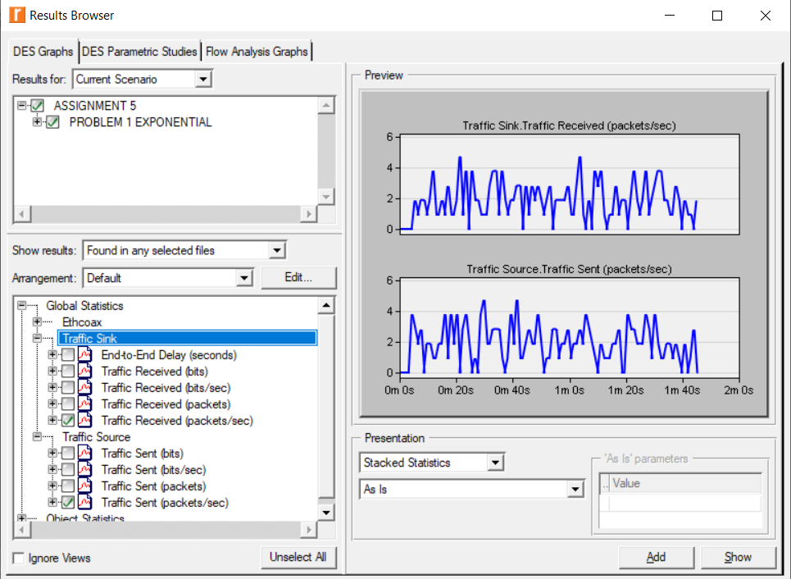

**,etc.**

We can run the simulation for several other configurations

**Problem Statement 2**:

Using OPNET create Star topology among a set of N computer nodes out of which one node is source and the rest are sink nodes.

Model the traffic of source and sink nodes individually and demonstrate the packet transfer between them using Ethcoax (Ethernet using coaxial) cables. Use network scale as the “campus” of area 1km x 1km.



Since ehtcoax cannot used for this we have used Ethernet for the same

**Algorithms and data structures used in the implementation:**

Various **Data Structures/Objects** used are:

1. **ethernet_station:**

This represents an Ethernet station that connects to an Ethernet bus at 10Mbps. It can generate packet and can also receive packets.

It has various attributes as shown:

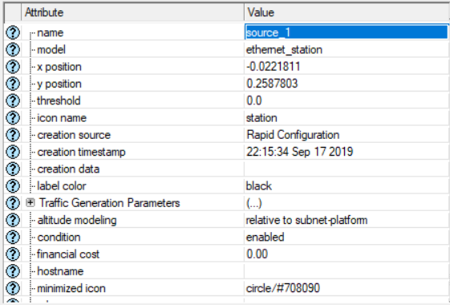

1. **ethernet16_hub:**

It represents an Ethernet hub supporting up to 16 Ethernet connections.

It has following attributes:

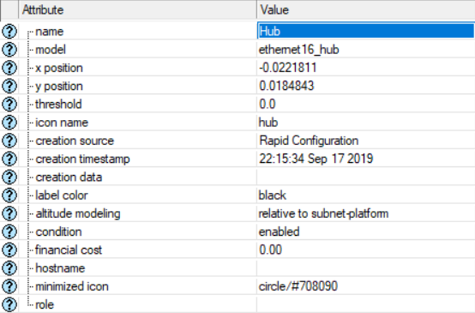

1. **10BaseT(link):**

It is a duplex link which represents an Ethernet connection with 10Mbps..

It has various attributes as shown in figure (and more):

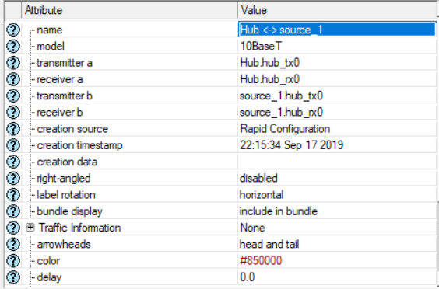

**Algorithm:**

**To create the required network:**

**STEPS:**

* 1. Create a new project
  2. Create a new Scenario with required properties: Ethoax or Ethernet, Campus, 1 Km x 1 Km, etc.
  3. Then create a rapid configuration for star topology with required properties like number of nodes, etc.
  4. Then apply appropriate properties to various elements as required (traffic properties, delay properties, etc.).
  5. Then select the statistics that you want to study and specify their properties as required.
  6. Finally run the simulation for specified time and study the statistics obtained (run the simulation for different configurations or attributes settings)

**CONCLUSION:**

* There are various Traffic generation parameters :



* Each of these parameters have several possible values and of different types.
* Example : Interarrival time of constant(0.01) signifies that packet will be generated in 0.01 sec i.e. 100 Packets/sec. This is one of the simplest value there are other distributions possible which are quite complex like exponential(10), triangular(min,max), etc. which represents different types of distributions along with the parameters mentioned.
* We can also change the delay of the 10BaseT link which will affect the pattern obtained for Packets received and Packets Transmitted for global attributes.

**Snapshots (for different cases):**

**NETWORK DESIGNED (for N=6):**

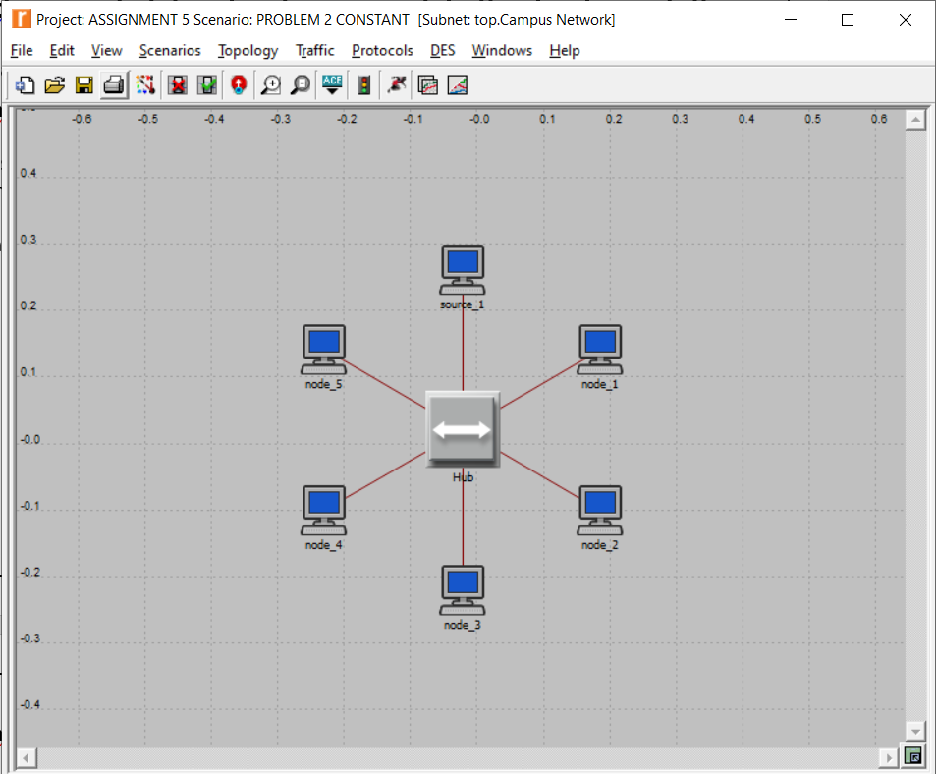

**FOR SOURCE 1(CONFIGURATION):**

* + 1. **Start time: constant(5)**
    2. **ON State time: constant(100)**
    3. **OFF State time: constant(0.00001)**
    4. **Stop time: 105**
    5. **Packet Generation Arguments:** 
       1. **Interarrival time: constant(0.01)**
       2. **Packet Size: constant(1024)**

**DELAY IN 10BaseT CABLE: 0**

**FOR OTHER NODES THE TRAAFIC GENERATION PROPERTIES ARE SET AS NONE (since sink)**

**SHOWING ONLY GLOBAL STATISTICS (OTHER STATISTICAL DATA IS ALSO AVAILABLE):**

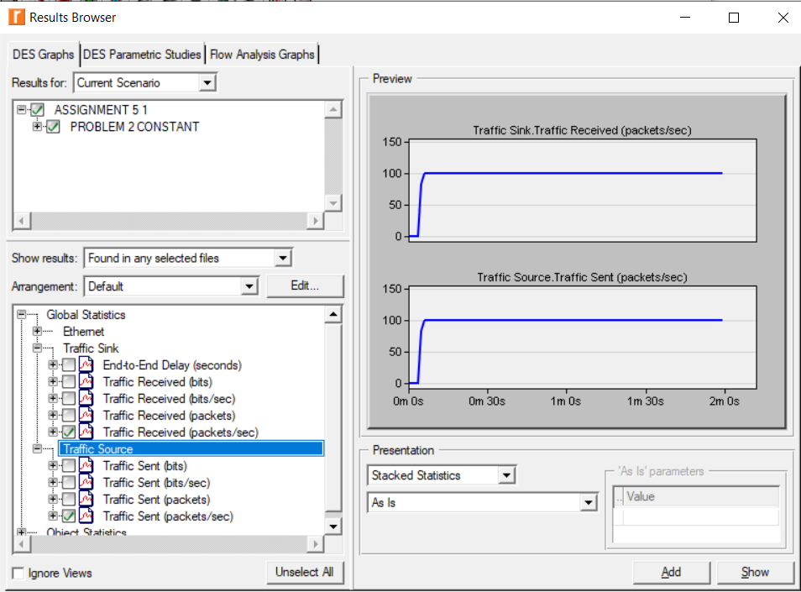

**FOR SOURCE 1(CONFIGURATION):**

* + 1. **Start time: constant(5)**
    2. **ON State time: constant(100)**
    3. **OFF State time: constant(0.00001)**
    4. **Stop time: 105**
    5. **Packet Generation Arguments:** 
       1. **Interarrival time: constant(0.01)**
       2. **Packet Size: constant(1024)**

**DELAY IN 10BaseT CABLE: 2.0**

**FOR OTHER NODES THE TRAAFIC GENERATION PROPERTIES ARE SET AS NONE (since sink)**

**SHOWING ONLY GLOBAL STATISTICS (OTHER STATISTICAL DATA IS ALSO AVAILABLE):**

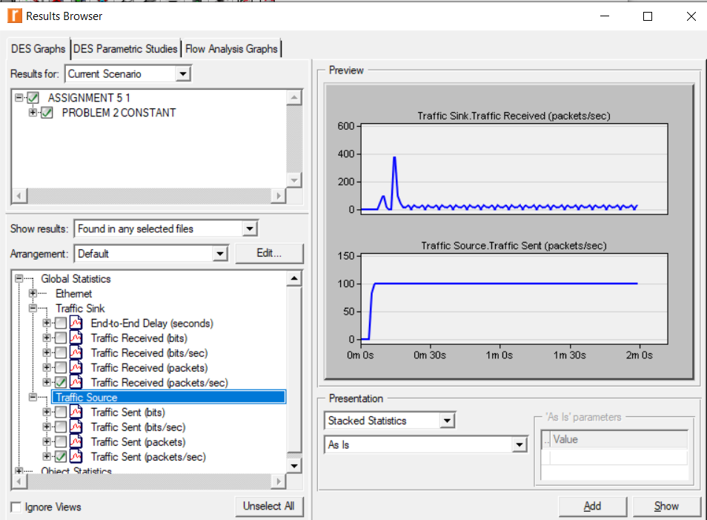

**FOR SOURCE 1(CONFIGURATION):**

* + 1. **Start time: constant(5)**
    2. **ON State time: exponential(100)**
    3. **OFF State time: exponential (0.00001)**
    4. **Stop time: 105**
    5. **Packet Generation Arguments:** 
       1. **Interarrival time: exponential (1)**
       2. **Packet Size: constant(1024)**

**DELAY IN 10BaseT CABLE: 0**

**FOR OTHER NODES THE TRAAFIC GENERATION PROPERTIES ARE SET AS NONE (since sink)**

**SHOWING ONLY GLOBAL STATISTICS (OTHER STATISTICAL DATA IS ALSO AVAILABLE):**

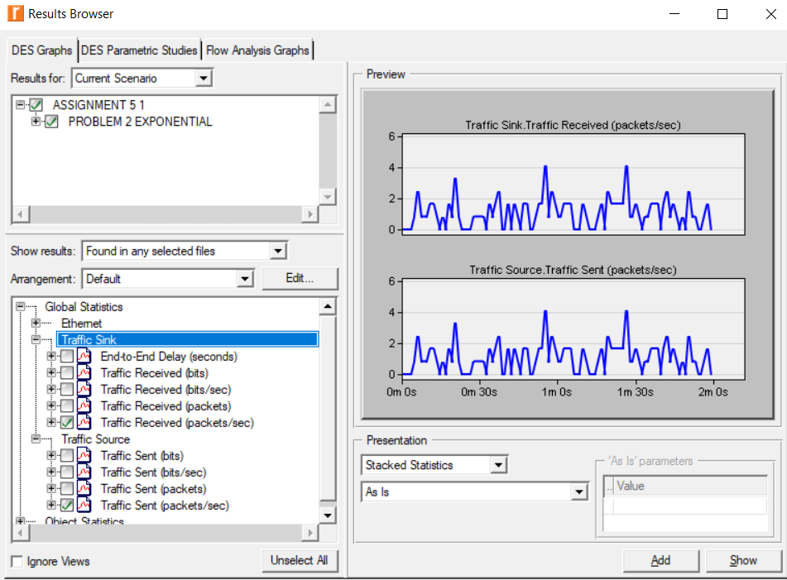

**FOR SOURCE 1(CONFIGURATION):**

* + 1. **Start time: constant(5)**
    2. **ON State time: exponential(100)**
    3. **OFF State time: exponential (0.00001)**
    4. **Stop time: 105**
    5. **Packet Generation Arguments:** 
       1. **Interarrival time: exponential (1)**
       2. **Packet Size: constant(1024)**

**DELAY IN 10BaseT CABLE: 2.0**

**FOR OTHER NODES THE TRAAFIC GENERATION PROPERTIES ARE SET AS NONE (since sink)**

**SHOWING ONLY GLOBAL STATISTICS (OTHER STATISTICAL DATA IS ALSO AVAILABLE):**

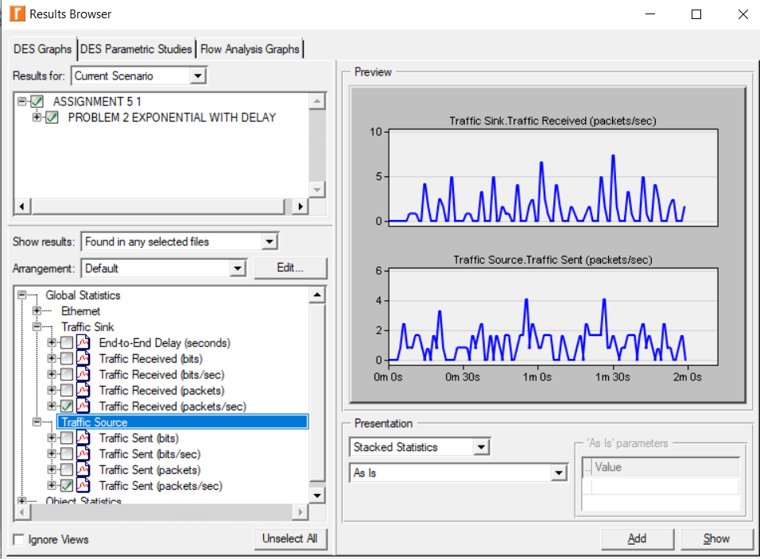

**,etc.**

We can run the simulation for several other configurations