**Software Engineering and Tools Lab**

**Assignment 2**

**(Module 2- Software Development Frameworks)**

**Name: Pavan Krishnat Shinde**

**PRN:** 2019BTECS00110

**Batch:** T5

**----------------------------------------------------------------------------------------------------------------**

**Framework:** Ruby in Rails

**About:**

Ruby on Rails is an open-source software used to build web applications. Rails is a framework used to create websites using the general-purpose programming language Ruby. Ruby ranks amongst the top ten programming languages predominantly because of the voguishness of Rails.

Ruby on Rails was built by David Heinemeier Hansson and is often just called “Rails”. It amalgamates Ruby with HTML, JavaScript, and CSS to manufacture a web application that operates on a web server. It is generally considered to be a server-side web application development platform. Rails catalyze the process of buildings complex sites.

1. **Original author**

David Heinemeier Hansson extracted Ruby on Rails from his work on the project management tool Basecamp at the web application company also called Basecamp (37Signals at the time).

1. **Developers**

David Heinemeier Hansson

1. **Initial release**

Rails 1.0

July 2004

But did not share commit rights to the project until February 2005

1. **Stable release**

7.0.1

1. **Preview release**

Nil

1. **Repository (with cloud support )**

<https://github.com/rails/rails>

1. **Written in (Languages)**

Ruby

1. **Operating System support**

Microsoft Windows

Linux flavors

macOS

1. **Platform, portability**

Server-side web application platform

1. **Available in (Total languages)**

one

1. **List of languages supported**

Rails combine the Ruby programming language with HTML, CSS, and JavaScript to create a web application that runs on a web server.

1. **Type (Programming tool, integrated development environment , etc.)**

1.**RubyMine** if you want a graphical user interface debugger for Ruby

2.**Aptana Studio** that provides integrated support with Rails

1. **Website**

[**https://rubyonrails.org/**](https://rubyonrails.org/)

1. **Features**

* **Cost-effective:** Ruby on Rails is a 100% free and open-source framework. From a developer’s point of view, it is easy to use, and with the add-on advantage of tons of gems, the developer can save plenty of time and effort.
* **Secure**: The framework is installed and enabled with some security measures by default. When you use Ruby in Rails, you are following a secure development process.
* **Flexibility:** While creating web applications in Rails uses front-end and back-end abilities; these are simpler and easier to create. A single-page web application uses Rails at the backend and maybe any other framework like Angular for the front end. This makes the application depend on Rails for the best qualities.
* **Productivity:** Using Ruby to create your web application lets you develop features extremely fast. This happens because Ruby effortlessly combines the 3rd party software libraries. It is amongst the most productive programming languages.
* **Consistent**: Ruby on Rails helps keep a project organized and decipherable as the developers have to follow standardized file storage and programming conventions. Plus, it saves a lot of time.

1. **Size (in MB, GB, etc.)**

57.8 MB

1. **Privacy and Security**

Yes

1. **Type of software (Open source/License)**

MIT License

1. **If License- Provide details.**

The MIT License is a permissive free software license originating at the Massachusetts Institute of Technology (MIT) in the late 1980s. As a permissive license, it puts only very limited restrictions on reuse and has, therefore, high license compatibility.

1. **Latest version**

7.0.2

1. **Cloud support (Yes/No)**

Yes

1. **Applicability**

* Web applications of nearly any sort, with typical functionalities
* Content management systems
* Prototypes or MVPs
* E-commerce stores, large and small
* Accounting platforms and many others

1. **Drawbacks (if any)**

* It can be hard to find good documentation.
* The main frustration we hear from developers working in Rails is the boot speed of the Rails framework.
* The most cited argument against Ruby on Rails is that it’s “slow”.
* Rails supports multithreading, though some of the IO libraries do not, as they keep hold of the GIL (Global Interpreter Lock). This means if you’re not careful, requests will get queued up behind the active request and can introduce performance issues.

**2.Implement linear regression problem using Google colab (Perform preprocessing, training and testing**

**Used Dataset:** <https://archive.ics.uci.edu/ml/datasets/Computer+Hardware>

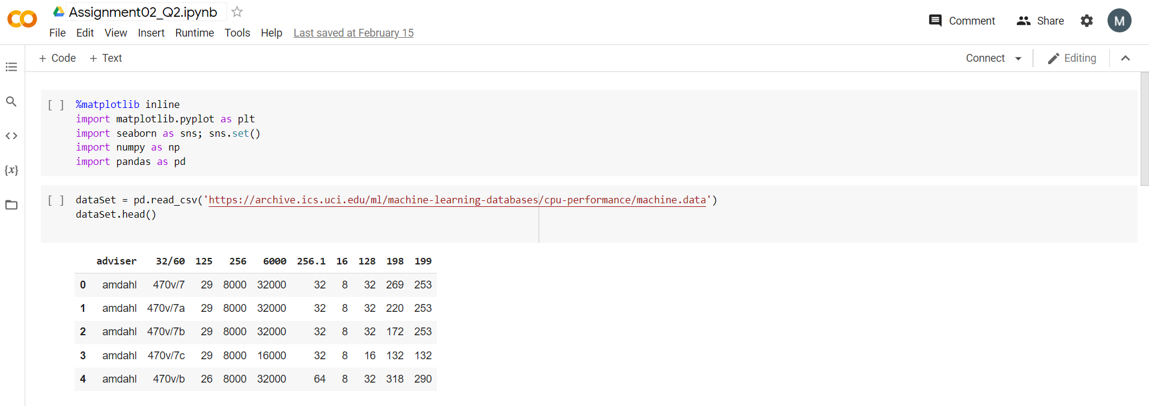

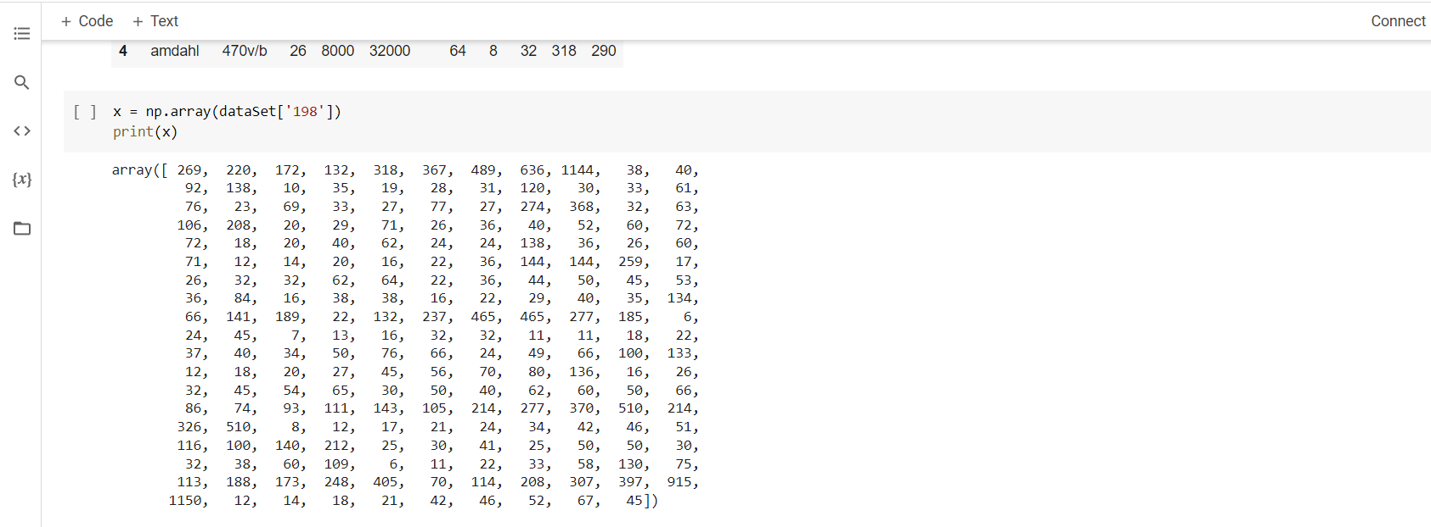

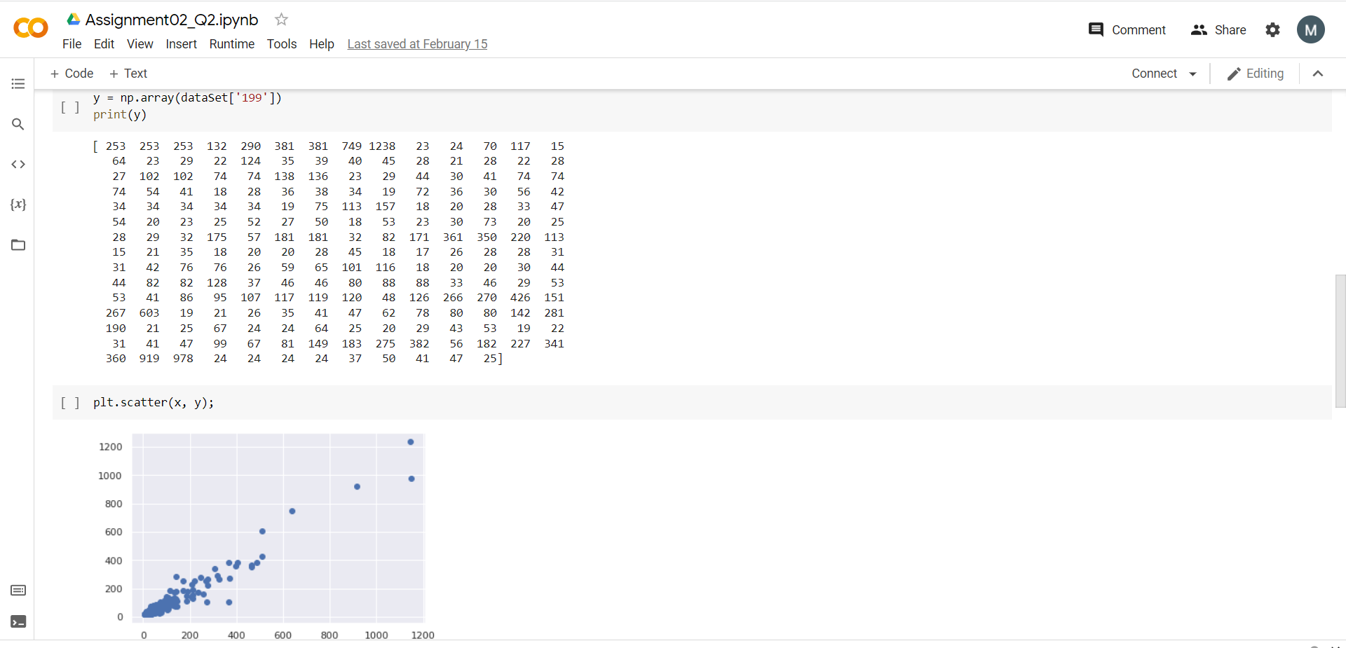

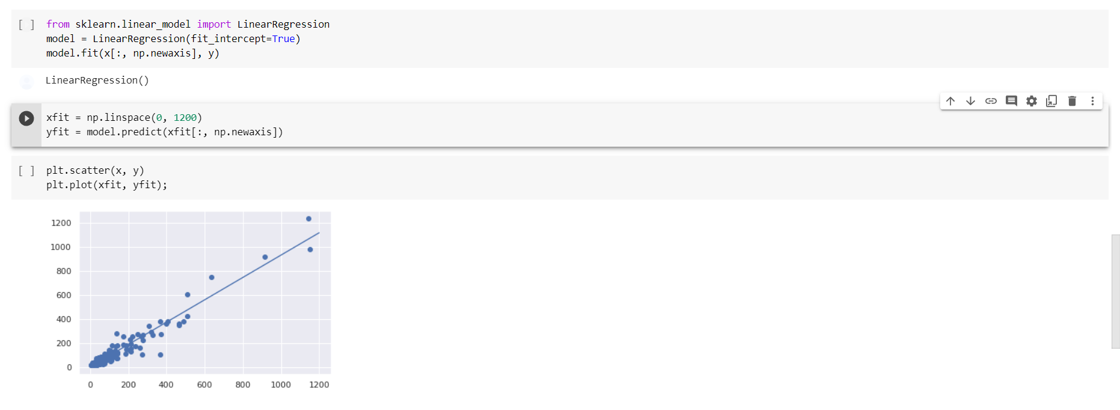

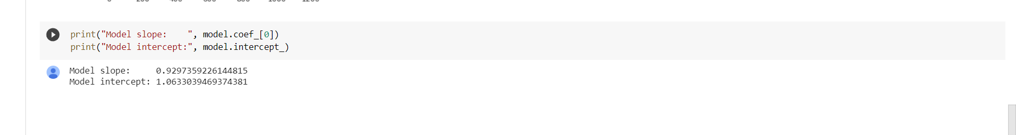

**Google Colab link:**

[https://colab.research.google.com/drive/1ZKI4vYDirkA1ziVs_wyA6YRtZlBpaWFm#scrollTo=xcbAs8P5se3p](https://colab.research.google.com/drive/1ZKI4vYDirkA1ziVs_wyA6YRtZlBpaWFm%23scrollTo=xcbAs8P5se3p)