# Planning a web project

1. Overview of Planning phase  
   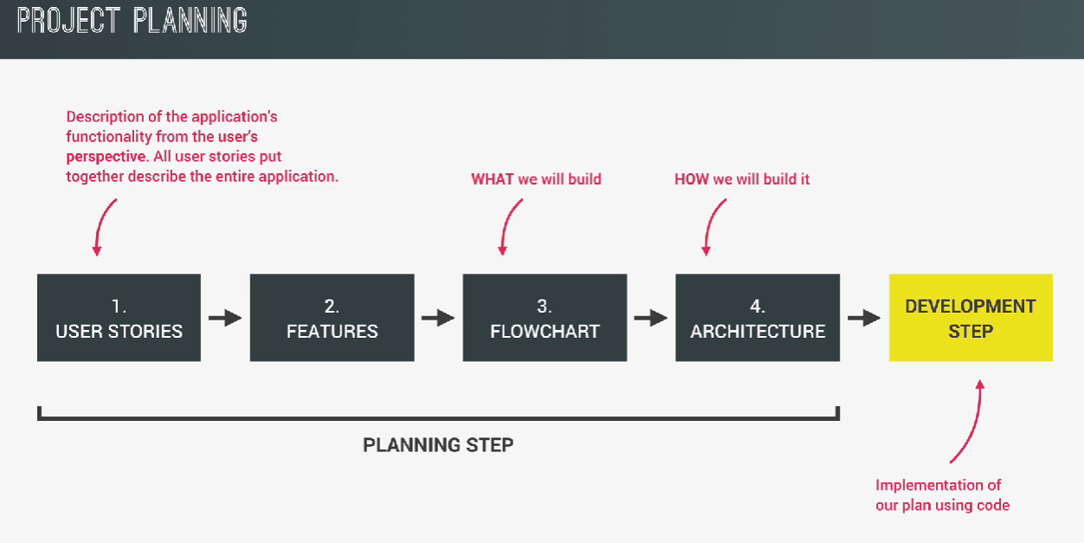
2. User Stories (User requirements as stories)
   1. Thinking of user requirements by taking a walk in their shoe and come up with user stories.
   2. 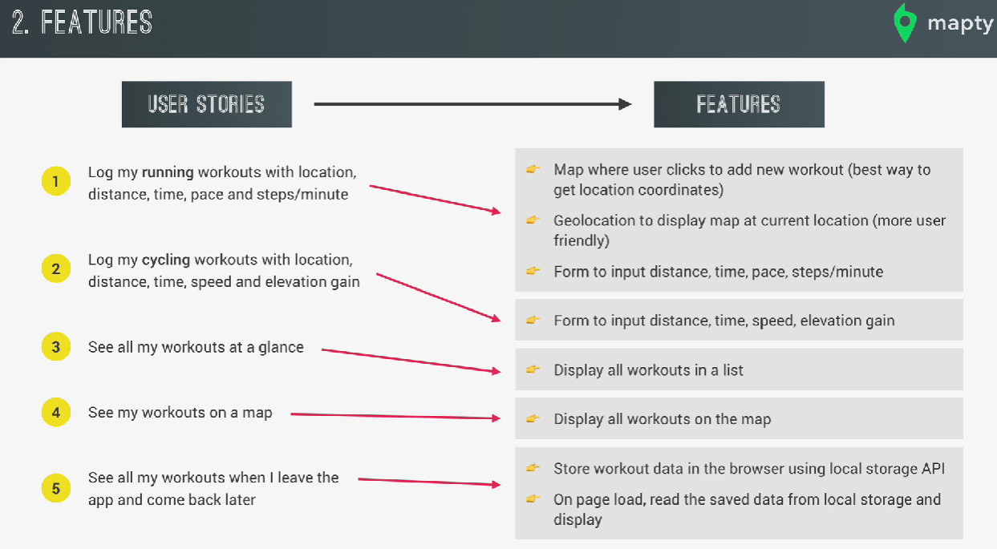Make App features based on these stories.
3. Flowchart
   1. Contains all the different features that we are going to implement. It also contains how these different parts of the app are going to interact with each other.
   2. 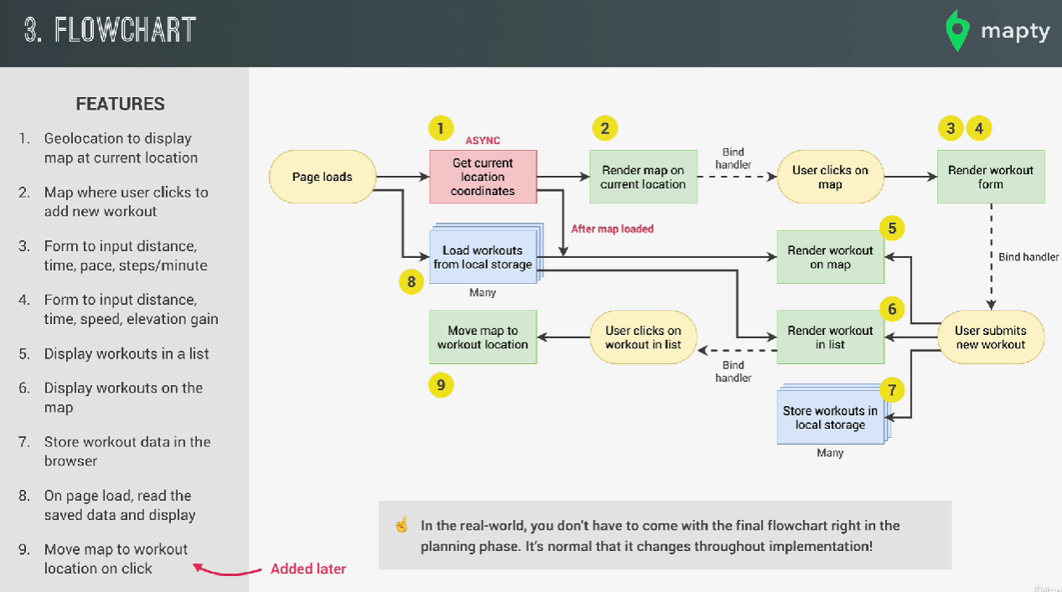Starting a Flowchart: It’s always a good idea to start with an event, ex: page loading since all the top level code will be executed when the page gets loaded.
   3. Contains info only on what our program should do and not how it should do it. Doesn’t talk about the language, frameworks etc. used. That part is for the “Architecture” step.
   4. **Note:** In the case of either flowchart or Architecture, we do not have to figure out the final form on the first try. In almost all cases, you improvise as we go.  
      After an initial draft, we can simply start coding and start to implement the features. Then, as we start needing more organization and ways to manage our data, we can loop back to the draft and improvise.

# Architecture

1. Since our application is small, we have a single class of ‘App’ that handles all the possible events, if our app was larger, we would have separate classes for UI, business logic etc.