**INDEX**

**Subject:** Software Engineering (3150711)

**Enrollment No:** 180170107030

**Name of the Student:** Gabu Siddharth Merambhai

|  |  |  |  |  |  |  |
| --- | --- | --- | --- | --- | --- | --- |
| No. | AIM | CO | Date | Page No. | Marks(Out of 10) | Faculty Signature |
| 1. | Prepare the project abstract and identify the appropriate process model. | CO1 | 09/7/2020 | 1 |  |  |
| 2. | To Prepare Software Requirement Specification for your project  Definition. | CO2 | 16/7/2020 | 3 |  |  |
| 3. | Estimation of Project Metrics for your project definition. | CO2 | 23/7/2020 | 9 |  |  |
| 4. | To Prepare Use Case Diagrams and Data Flow Diagrams for your  Project definition. | CO3 | 30/7/2020 | 12 |  |  |
| 5. | To Prepare E-R diagram and data dictionary for your project definition. | CO3 | 06/8/2020 | 14 |  |  |
| 6. | To Prepare the Activity Diagram and swim lane diagram for the Project. | CO3 | 13/8/2020 | 16 |  |  |
| 7. | Identify Domain Classes from the Problem Statements and To prepare  Class Diagram | CO4 | 03/9/2020 | 18 |  |  |
| 8. | Designing Test Cases for your project definition. | CO4 | 10/9/2020 | 19 |  |  |
| 9. | To prepare test cases using testing tools. | CO4 | 17/9/2020 | 23 |  |  |
| 10. | To install version control tool and study its features. | CO5 | 1/10/2020 | 27 |  |  |
| 11 | Assignment 3 |  |  |  |  |  |

**Practical - 1**

Team members:

Pranav Dodiya 180170107027

Siddharth Gabu 180170107030

Chandrarajsinh Gohil 180170107033

Defination: **ConvertO**

Main Features: Extra Features:

* PDF To Word - Docs
* PDF Signature - OCR
* PDF Add Watermark - Sort by & Import
* PDF Export To Images
* PDF Compression
* PDF Merge
* PDF Extract to Text
* PDF Page Adjustment
* PDF Password

**Abstract:**

You can convert your PDF file into Word file. Its easier. You can add your Signature in The PDF. You can add your Watermark in your PDF file.You can export your any image in your PDF. As you know size of PDF is a big factor. So, you can adjust your PDF size by compressing it. You can merge your PDFs. You can Extract your text from your PDF. You can adjust your pages of the PDF. You can change the page number or order of the pages. This is also useful feature, If your PDF content is confidential then you can keep your PDF by setting the password. Any time you open PDF, it will for the password. It supports the Docs files also. So, you can edit your docs file, read it or convert it in the PDF. OCR is Optical Character Recognition which converts images of typed, handwritten or printed text into machine-encoded text, whether from a scanned document, a photo of a document. These features are also useful, You can sort you PDF by date, by Size or by name and import files like PDF or Word file.

ConvertO that enables you to convert to PDF format and vice versa. While converting to PDF (Word to PDF, JPG to PDF, ePub to PDF, etc.) you can merge all files into a single PDF, as well as use various output file settings.

**Model: Iterative Model**

Testing and debugging during smaller iteration is easy. Less costly to change the scope/requirements.

**Practical - 2**

**Software Requirement Specifications**

Team members:

Pranav Dodiya 180170107027

Siddharth Gabu 180170107030

Chandrarajsinh Gohil 180170107033

**INDEX**

1. Introduction.................................................................3
2. Objective.....................................................................3
3. Project Category..........................................................3
4. Technology Used.........................................................3
5. Software requirement..................................................4
6. Hardware requirement.................................................4
7. Feasibility study...........................................................4
8. Design..........................................................................4
9. Project planning and scheduling..................................4
10. Testing…………………………………..................5
11. Future scope and enhancements...............................5
12. Bibliography.............................................................5
13. **Introduction:**

ConvertO is file format project. Users can edit, compress, merge, save to other formats as well as extract text etc. Many type of features are available. In other words, sometimes we ran out of space so, we provide secure online storage. We believe in that your privacy should be our first concern.

ConvertO can deal with pdf, docs, xsls, jpg, png, txt, html, xml, epub, etc. Users can create their account and store important document in provided free space.

1. **Objective:**

There are several objective of this websites are following given bellows:

* + - It provides the facility to the customers who want to store and convert documents to lack of time.
    - With the help of it we can save the time and money also.
    - No need to download application access over internet.
    - It provides better security and good delivery service to the customer

1. **Project category:**

* It is Web based project PHP as backend and MySQL Database.

1. **Technology used:**
   * + It is a web based environment with latest PHP as the server side scripting language and MySQL as the relational DBMS. Clients will be Google Chrome based. Mozilla Firefox etc can also be used.
     + All front-end design is done using HTML5 with JavaScript, jquery, APIs, Cascading Style Sheets (CSS) and Bootstrap.
     + Internet Technologies: JavaScript, HTML5,jquery,Java Script PHP and Apache Server(XAMPP).
2. **Software Requirement:**
   * + Sublime, Atom – text editors
     + Eclipse IDE
     + Firefox, Chrome – Browsers
     + Netbeans, Notepad++
3. **Hardware Requirement:**
   * + Minimum 1 GB RAM
     + Intel dual core 1.6 GHz
     + 5 GB space
4. **Feasibility study:**

* Our software is financially affordable. Team members are experienced in their field.

1. **Design:**

In this web-based project, We used html, CSS, JavaScript and database for web-development. ER diagram is given below.

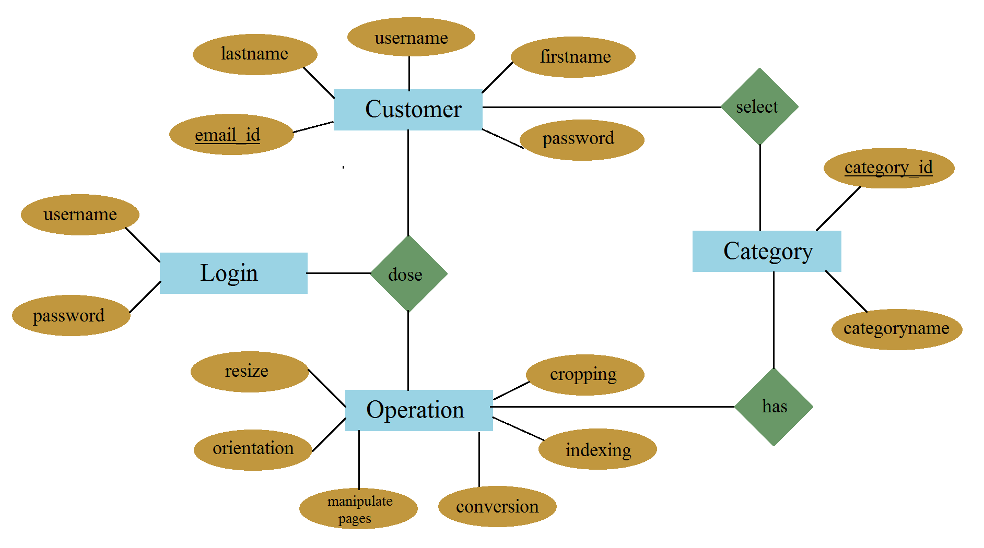

1. **Project planning and scheduling:**

* The development time including database design, screen designing and coding and testing is one month. First two months the screen, database design and system design will be over. Second and third month is for developing modules, architecture design and coding the site. Rest will be for testing and error correction

|  |  |  |  |  |
| --- | --- | --- | --- | --- |
|  | 1 – 2 months | 3 – 4 months | 4 – 5 months | 5 – 6 months |
| Requirement Gathering |  |  |  |  |
| Gathering Design |  |  |  |  |
| Test Cases |  |  |  |  |
| Coding |  |  |  |  |
| Quality Assurance |  |  |  |  |
| Testing |  |  |  |  |
| Build |  |  |  |  |
|  |  |  |  |  |

1. **Testing:**

* Unit Testing
* Integration Testing
* System Testing
* Sanity Testing
* Smoke Testing
* Interface Testing
* Regression Testing
* Beta/Acceptance Testing

1. **Future scope and enhancement:**
   * + This software will to reduce manual effort and time. It also provides security. The proposed system is user-friendly and every aspects of this system can be easily understood and the user can operate the system easily. We have planned to develop this software as independent in nature and cost effective. As the saying goes “There is always scope for the improvement in every system”, even this system could be improved at various stages.
2. **Bibliography:**
   * + An Introduction to Database System – C. J. Date
     + Programming PHP - Rasmus Lerdorf

**Practical 3: Estimation of Project Metrics**

**COCOMO MODEL**

Cocomo (Constructive Cost Model) is a regression model based on LOC, i.e. **number of Lines of Code**. It is a procedural cost estimate model for software projects and often used as a process of reliably predicting the various parameters associated with making a project such as size, effort, cost, time and quality.

In COCOMO, projects are categorized into three types:

1. **Organic:**

(Simple business systems, simple inventory management systems)

1. **Semidetached**

(Developing a new operating system (OS), a Database Management System (DBMS))

1. **Embedded**

(Example: - ATM, Air Traffic control. Strongly coupled with hardware)

Project domain: ConvertO Web

Since the project definition is well understood and already made in the past it falls under Organic category. So values of variable are:

**a = 2.4 b = 1.05 c = 2.5 d = 0.38 KLoC = 75**

***BASIC MODEL:***

*Effort, E=a*(KLOC)b*

*=2.4(75)1.05*

*=223.37 person month*

*Time = c*(Effort)d*

*=2.5(223.37)0.38*

*=19.52 months*

*Person Required = Effort /Time*

*= 223.37/19.52*

*= 11.44 Persons*

**INTERMEDIATE MODEL**

|  |  |  |  |  |  |
| --- | --- | --- | --- | --- | --- |
| **Cost Drivers** | **Very Low** | **Low** | **Nominal** | **High** | **Very High** |
| **Product Attributes** |  | | | | |
| Required Software Reliability | 0.75 | 0.88 | 1 | 1.15 | 1.40 |
| Size of Application Database | NA | 0.94 | 1.08 | 1.16 |
| Complexity of The Product | 0.70 | 0.85 | 1.15 | 1.30 |
| **Hardware Attributes** |  | | | | |
| Runtime Performance Constraints | NA | NA | 1 | 1.11 | 1.30 |
| Memory Constraints | NA | 1.06 | 1.21 |
| Volatility of the virtual machine environment | 0.87 | 1.15 | 1.30 |
| Required turnabout time | 0.94 | 1.07 | 1.15 |
| **Personnel attributes** |  | | | | |
| Analyst capability | 1.46 | 1.19 | 1 | 0.86 | 0.71 |
| Applications experience | 1.29 | 1.13 | 0.91 | 0.82 |
| Software engineer capability | 1.42 | 1.17 | 0.86 | 0.70 |
| Virtual machine experience | 1.21 | 1.10 | 0.90 | NA |
| Programming language experience | 1.14 | 1.07 | 0.95 | NA |
| **Project Attributes** |  | | | | |
| Application of software engineering methods | 1.24 | 1.10 | 1 | 0.91 | 0.82 |
| Use of software tools | 1.24 | 1.10 | 0.91 | 0.83 |
| Required development schedule | 1.23 | 1.08 | 1.04 | 1.10 |

E=a(KLoc)b*(EAF)

Where EAF (Effort Adjustment Factor) is multiplication of 15 attributes using suitable values for each of them On rating scale of very low to Extra High.

* Software Reliability = High (1.15)
* Software Engineer capability = High (0.86)
* Application of Software Engg. Methods = High (0.91)
* Required Development Schedule= Low (1.23)
* Rest are Nominal so 1

*EAF=1.15*0.86*0.91*1.23*1*

*=1.1069877*

*Effort, E=a(KLoc)b*(EAF)*

*=2.4*(75)1.05*(1.1069877)*

*= 247.047 Person Months*

*Time =c(E)d*

*=2.5*(247.047)0.38*

*=20.28 Months*

*Persons required = Effort/Time*

*=247.047/20.28*

*=12.18~12 Persons*

**Practical – 4**

 Use Case Diagrams:

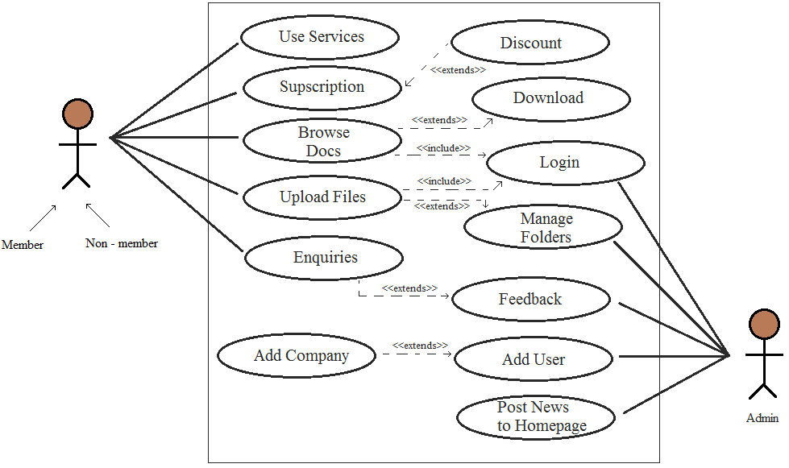

**ConvertO Web**

Data Flow Diagram:

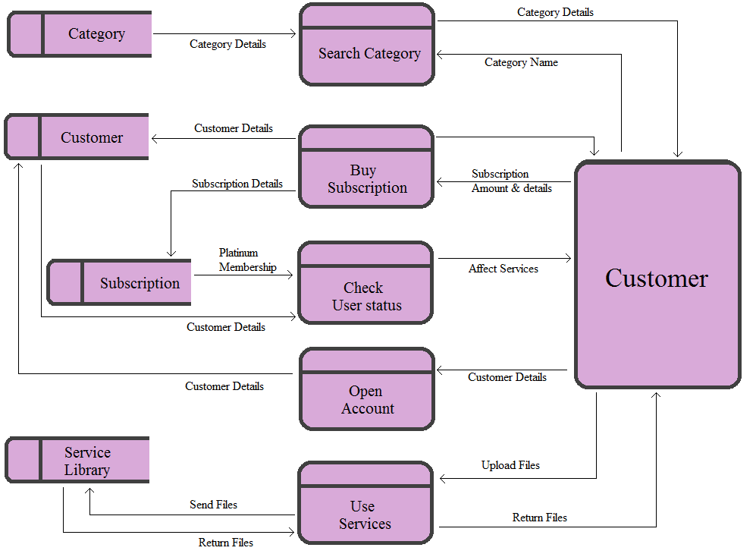

**Practical – 5**

**E – R diagram:**

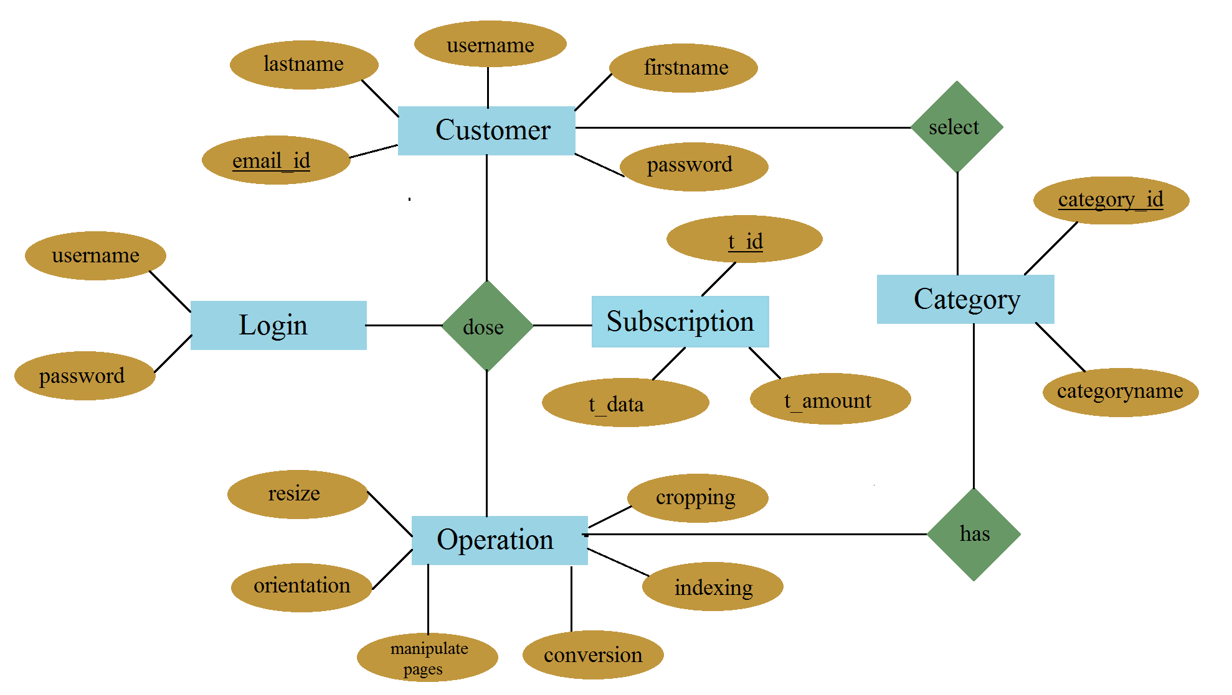

|  |  |  |  |  |  |  |
| --- | --- | --- | --- | --- | --- | --- |
| **Data Item** | **Data Type** | **Data Format** | **Number Of Bytes for Storage** | **Description** | **Example** | **validation** |
| **Email_id** | string |  | 120 | Email address  customer | - | JS validation |
| **Last name** | string |  | 25 | Last name of customer | Gabu |  |
| **First name** | string |  | 25 | First name customer | Siddharth |  |
| **User name** | string |  | 20 | User name | Sid_pro |  |
| **Password** | string |  | 50 | Password of account | @beli44 |  |
| **T_id** | string | XNNNNNN | 7 | Transaction id of transaction | M123456 |  |
| **T_date** | Floating point(Date format) | DD/MM/YYYY | 4 | Transaction date | 02/11/2019 |  |
| **T_amount** | Floating point(Currency format) | ₹NN.NN | 4 | Transaction amount | ₹50.44 |  |
| **Category name** | string |  | 25 | Category names of services | wordtoany |  |
| **Category_id** | Number | NN | 2 | Category id of category names | 13 |  |
| **Platinum**  **Membership?** | Boolean | X | 1 | True(T) or False(F) | T |  |
| **Subscription**  **cost** | Floating Point(Currency format) | ₹NN.NN | 4 | Cost of members subscription | ₹50.44 | Cost>0  Cost<₹100.00 |

**Data Dictionary:**

**Practical – 6**

**Aim:** To Prepare the Activity Diagram and swim lane diagram for the Project.

Activity diagram :

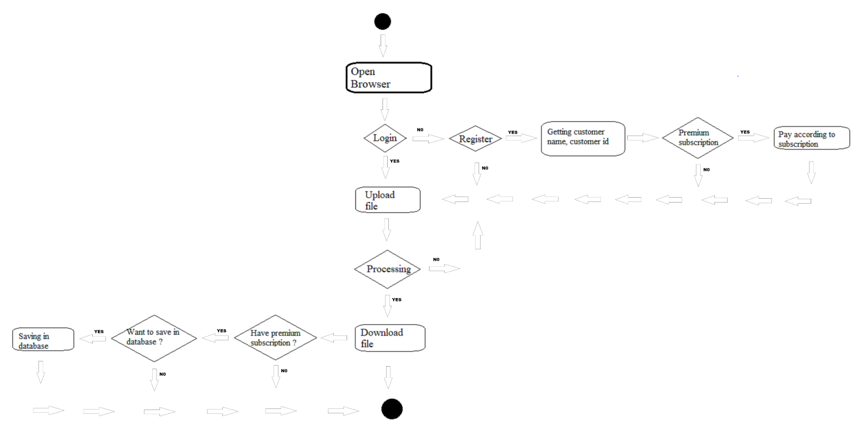

Swim lane diagram :

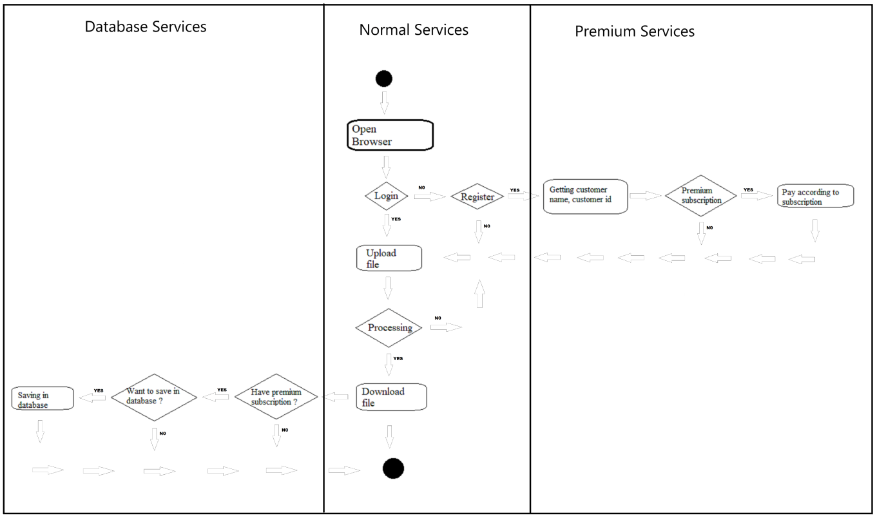

**Practical – 7**

**Aim:** Identify Domain Classes from the Problem Statements and prepare Class Diagram.

Domain Classes: Person, Customer, User, Database, Administrator, Company

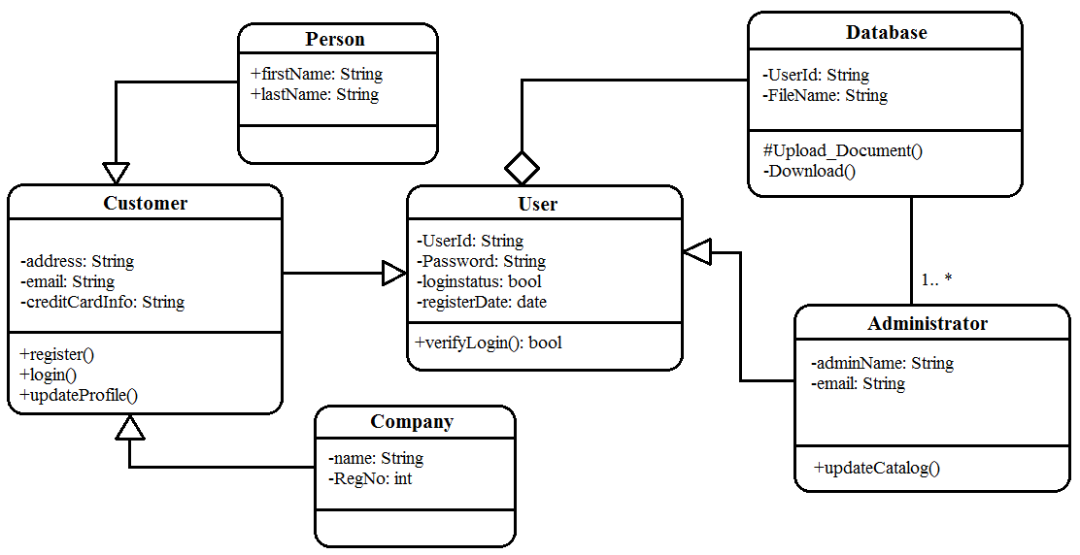

**Practical – 8**

**Aim:** Design test cases for project definition

|  |  |  |  |  |  |  |
| --- | --- | --- | --- | --- | --- | --- |
| **Test Case ID** | **Test Scenario** | **Test Steps** | **Test Data** | **Expected Results** | **Actual Results** | **Pass/Fail** |
| TC01 | Verify the login of ConvertO | 1. Go to site <http://ConvertO.com> 2. Enter UserId 3. Enter Password 4. Click Submit | <valid username>  <valid password> | Successful login | As Expected | Pass |
| TC02 | Verify the login of ConvertO | 1. Go to site <http://ConvertO.com> 2. Enter UserId 3. Enter Password 4. Click Submit | <valid username>  <invalid password> | A Message “Userid and password doesn’t match” shown | As Expected | Pass |
| TC03 | Verify the login of ConvertO | 1. Go to site <http://ConvertO.com> 2. Enter UserId 3. Enter Password 4. Click Submit | <invalid username>  <valid password> | A Message “Userid and password doesn’t match” shown | As Expected | Pass |
| TC04 | Verify the login of ConvertO | 1. Go to site <http://ConvertO.com> 2. Enter UserId 3. Enter Password 4. Click Submit | <invalid username>  <invalid password> | A Message “Userid and password doesn’t match” shown | As Expected | Pass |
| TC05 | Verify the login of ConvertO | 1. Go to site <http://ConvertO.com> 2. Enter UserId 3. Enter Password 4. Click Submit | <valid CAPTCHA> | Success | As Expected | Pass |
| TC06 | Verify the payment of ConvertO | 1. Go to site <http://ConvertO.com> 2. Login to account 3. Select premium services 4. Enter Card details 5. Click Submit | <valid expiry date>  <valid card number>  <valid CVV number> | Successful payment | As Expected | Pass |
| TC07 | Verify the payment of ConvertO | 1. Go to site <http://ConvertO.com> 2. Login to account 3. Select premium services 4. Enter Card details 5. Click Submit | <valid expiry date>  <valid card number>  <valid CVV number> | A Message “Card details are wrong” shown | As Expected | Pass |
| TC08 | Verify the payment of ConvertO | 1. Go to site <http://ConvertO.com> 2. Login to account 3. Select premium services 4. Enter Card details 5. Click Submit | <valid expiry date>  <valid card number>  <valid CVV number> | A Message “Card details are wrong” shown | As Expected | Pass |
| TC09 | Verify the payment of ConvertO | 1. Go to site <http://ConvertO.com> 2. Login to account 3. Select premium services 4. Enter Card details 5. Click Submit | <valid expiry date>  <valid card number>  <valid CVV number> | A Message “Card details are wrong” shown | As Expected | Pass |
| TC10 | Verify the payment of ConvertO | 1. Go to site <http://ConvertO.com> 2. Login to account 3. Select premium services 4. Enter Card details 5. Click Submit | <valid expiry date>  <valid card number>  <valid CVV number> | A Message “Card details are wrong” shown | As Expected | Pass |
| TC11 | Verify the File upload of ConvertO | 1. Go to site <http://ConvertO.com> 2. Click Upload | <valid file type> | Successful File uploaded | As Excepted | Pass |
| TC12 | Verify the File upload of ConvertO | 1. Go to site <http://ConvertO.com> 2. Click Upload | <invalid file type> | A Message “Choose appropriate file type” shown | As Excepted | Pass |
| TC13 | Verify the File upload of ConvertO | 1. Go to site <http://ConvertO.com> 2. Click Upload | <No file selected> | A Message “please select file first ” shown | As Excepted | Pass |
| TC14 | Verify the File upload of ConvertO | 1. Go to site <http://ConvertO.com> 2. Click Upload | <valid multiple files> | Successfully multiple file uploaded | As Excepted | Pass |
| TC15 | Verify the Compatibility of ConvertO | 1. Open browser 2. Go to site <http://ConvertO.com> | <website is displaying properly> | Successful | As Excepted | Pass |
| TC16 | Verify Privacy Policy & FAQ of ConvertO | 1. Open browser 2. Go to site <http://ConvertO.com> 3. Go to Privacy Policy page | <Privacy Policy & FAQ> | Successful  clearly defined | As Excepted | Pass |
| TC17 | Verify loading Time of ConvertO | 1. Open browser 2. Login to google console 3. Go to site <http://ConvertO.com> | <page load time> | Successful  acceptable range | As Excepted | Pass |
| TC18 | Verify Email Client of ConvertO | 1. Open browser 2. Go to site <http://ConvertO.com> | <email clients> | Successful | As Excepted | Pass |

**Practical – 9**

**Aim:** To prepare test cases using testing tools.

TestLink is a test management tool used for project management, bug tracking and test management. It follows a centralized test management concept that helps to communicate easily for rapid development of tasks across QA teams and other stakeholders. It keeps the requirement specification and test specification in sync. TestLink is open source test management tool. There is no license is required to use TestLink.

TestLink Uses:

* Useful in tracking all QA activities from the first phase of software testing lifecycle.
* Useful in Project Management, Task Tracking, Requirement Management and Test Management.
* Supports all macro level activities performed by QA.
* Useful in performing QA tasks such as writing test cases, execution reports, etc.
* Supports both manual as well as automated test execution.

Fig 9.1 show ConvertO test project is created in testlink GUI.

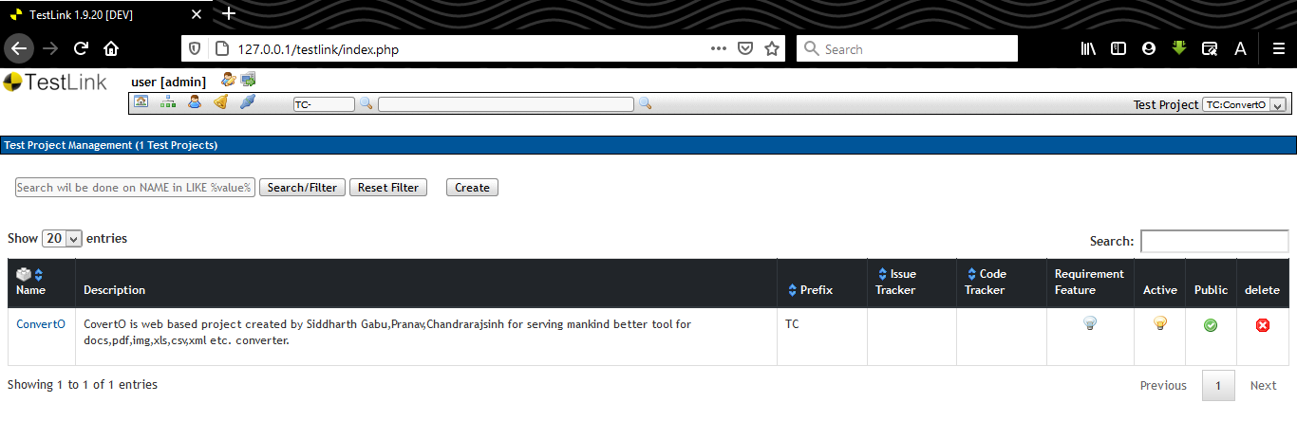

Fig 9.1

Fig 10.2 show that all test case are prepared using testlink tool.

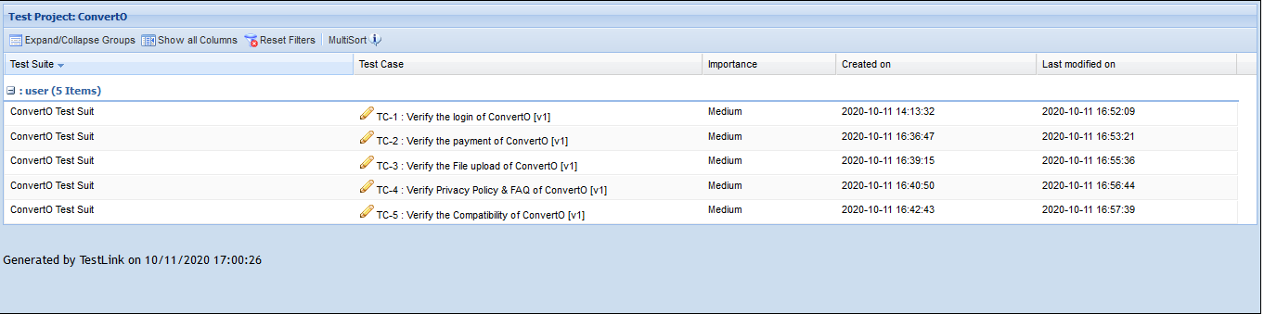

Fig 9.2

Below are Test cases that were prepared using testlink testing tool.

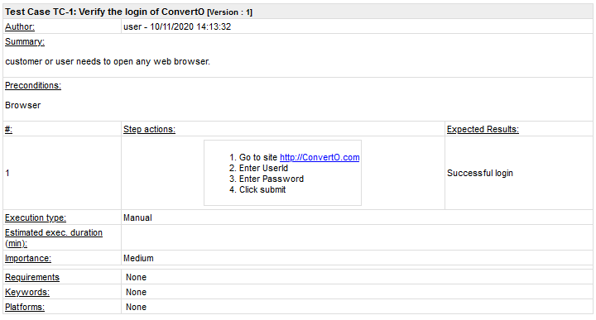

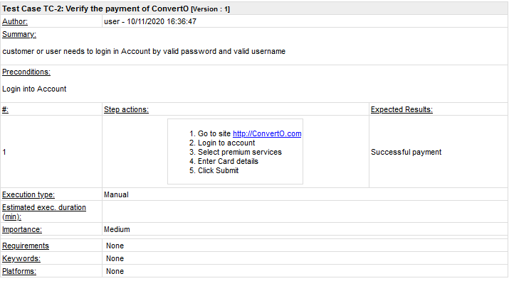

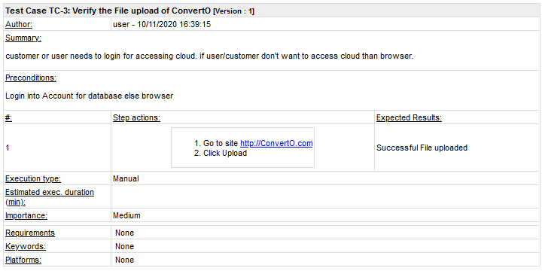

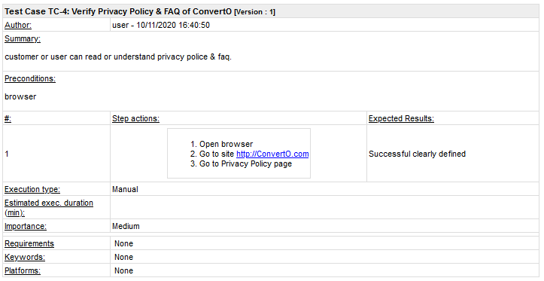

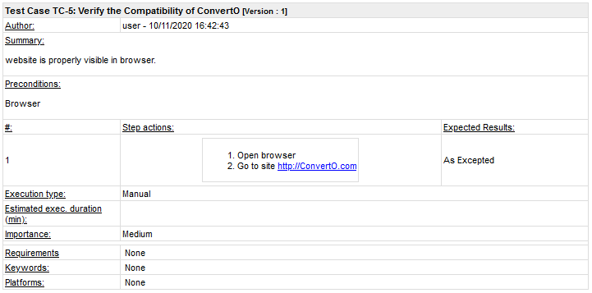

**Practical – 10**

**Aim:** To install version control tool and study its features.

**Git** is a free, cross-platform and open-source distributed version control tools available nowadays which provides strong support for non-linear development and is capable of efficiently handling everything from small to very large projects with speed and efficiency. Local branching, convenient staging areas, and multiple workflows are some important features of git. It also offers a wide variety of tools to help us navigate through the history and each instance of the source contains the entire history tree, which helps a lot during development even without Internet.

Super-fast and Cross-platform.

Offline full history tree

Distributed, peer-to-peer model

Easy and clear track of code changes

Cheap branch operations and robust.

Amazing command-line as git bash.

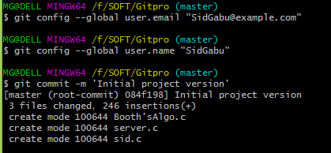

**Git add** - Add file contents to the index

This command updates the index using the current content found in the working tree, to prepare the content staged for the next commit. It typically adds the current content of existing paths as a whole, but with some options it can also be used to add content with only part of the changes made to the working tree files applied, or remove paths that do not exist in the working tree anymore.

**Git status** - Show the working tree status

Displays paths that have differences between the index file and the current HEAD commit, paths that have differences between the working tree and the index file, and paths in the working tree that are not tracked by Git .

**Git commit** - Record changes to the repository

Create a new commit containing the current contents of the index and the given log message describing the changes. The new commit is a direct child of HEAD, usually the tip of the current branch, and the branch is updated to point.

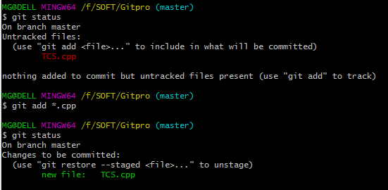

**Git merge** - Join two or more development histories together

Incorporates changes from the named commits (since the time their histories diverged from the current branch) into the current branch. This command is used by git pull to incorporate changes from another repository and can be used by hand to merge changes from one branch into another.

**Git fetch** - Download objects and refs from another repository

Fetch branches and/or tags (collectively, "refs") from one or more other repositories, along with the objects necessary to complete their histories. Remote-tracking branches are updated.

**Git pull** - Fetch from and integrate with another repository or a local branch

More precisely git pull runs git fetch with the given parameters and calls git merge to merge the retrieved branch heads into the current branch. With rebase it runs git rebase instead of git merge.

**Git push** - Update remote refs along with associated objects

Updates remote refs using local refs, while sending objects necessary to complete the given refs.

**Git show** - Show various types of objects

Shows one or more objects (blobs, trees, tags and commits).

For commits it shows the log message and textual diff. It also presents the merge commit in a special format as produced by git diff-tree --cc.

**Assignment:1**

**Aim: Study principles, tools of DevOps and write down various advantages and disadvantages of DevOps.**

**The Principles Of DevOps**

DevOps implementation can vary as departments across large enterprises have separate goals, processes, tools, and even distinct cultures. However, there are several inherent DevOps principles that repeatedly insist on collaborative relationships and shared learning between departments. These DevOps principles prioritize increasing work velocity for improved deployment rates, while simultaneously enhancing predictability, flexibility, scalability, and security of the production environment. To incorporate DevOps principles into enterprise processes, senior executives need to evangelize DevOps as a holistic, widespread business approach across all departments within an organization. Core DevOps principles should shape and guide company-wide objectives. These principles include:

* Implementing process improvement strategies to curtail feedback loops with emphasis on resolving software defects proactively and continuously
* Building a culture of experimentation where developers can fail fast in a penalty-free environment, learn from successes and failures, and recast minor mistakes as sources for future innovations
* Employing an organizational growth mindset where individuals freely exchange knowledge among colleagues
* Using automation tools to drive efficiencies
* Sharing continuous feedback with the entire organization
* Motivating development, quality assurance, deployment, and operations teams to collaborate on common organizational goals

**Docker**

* Docker is a Linux-based open-source platform that focuses on containers, meaning you package up the software with its dependencies and ship everything together as a unit—no need to worry about managing dependencies separately. It’s portable and highly secure, you can use any language with it, and it integrates well with a number of other tools, such as Jenkins, Ansible, and Bamboo. Research firm Forrester cited Docker as a leader in the enterprise container platform category for Q4 2018.

**Ansible**

* CIO says “Ansible has become the DevOps darling for software automation.” This open-source tool for automating software provisioning, configuration management, and application deployment is easy to use—you don’t even need to have a dedicated systems administrator—yet can handle highly complex deployments. Plus, it’s agentless and uses a simple syntax written in the YAML language. NASA uses Ansible.

**Git**

* Git is a highly popular open-source tool used by industry giants such as Microsoft, Amazon, and Facebook. It allows you to track the progress of your development work and coordinate work among team members. Git is great for experimenting, because you can revert to previously saved versions of your work, and you can also create branches separately and then add in the new features when they’re ready. You’ll need to host a repository for the work as well, such as GitHub.

**Puppet**

* Puppet lets you manage and automate software inspection, delivery, and operation. This open-source tool has a solid track record and thousands of modules and is easily integrated with many other platforms. While the free version is great for smaller projects, consider Puppet Enterprise if your projects tend to be larger. Puppet Enterprise lets you manage multiple teams and thousands of resources.

**Chef**

* This powerful open-source configuration management tool lets you turn infrastructure into a code to manage data, attributes, roles, environments, and more. As a Puppet competitor, it supports multiple platforms and easily integrates with cloud-based platforms. Regardless of the size of your infrastructure, Chef can automate your infrastructure configuration and application deployment, as well as manage configurations across your network.

**Jenkins**

* Jenkins is known for quickly finding issues in code. It’s a free, open-source tool used for automating the delivery pipeline, and lets you test and report changes almost in real-time. Jenkins has a huge plugin ecosystem (more than a thousand plugins), so it integrates with pretty much every other DevOps tool out there. Plus, it runs out of the box on Windows, Mac OS X, and Linux.

**Nagios**

* Used to find and correct problems in networks and infrastructure, Nagios is one of the most popular free and open-source monitoring tools. There are two Nagios editions: Nagios Core and Nagios XI; the latter offers many more features for even greater functionality. You can use Nagios to monitor applications, services, network protocols, and more, and it lets you keep records of things like outages and failures. Forum support is available for both editions.

**Splunk**

* Splunk makes machine data and logs accessible to and usable by everyone on the team. While machine data contains a lot of info that can improve productivity and efficiency, it’s hard to analyze and visualize without a tool like Splunk. Developers can build custom Splunk applications and integrate Splunk data into other applications. The company itself has won several awards and is on the Forbes Digital 100 list.

**Bamboo**

* Bamboo is similar to Jenkins but isn’t free. For the cost, you’ll get prebuilt functionalities—which means there are far fewer plugins (because you won’t need them). Bamboo also has a highly intuitive user interface with features such as auto-completion. All in all, it can save you a lot of time when compared to open-source tools, depending on what you’re trying to accomplish.

**ELK Stack**

* This is actually three open-source tools combined: Elasticsearch, Logstash, and Kibana. All are managed by Elastic. Elasticsearch is a search and analytics engine. Logstash collects input from various sources, and Elasticsearch stores that info. Kibana is the visualization layer. Together, they’re often used for centralized logging in IT environments. ELK stack is considered simple yet robust, and there are multiple plugins as well as an active support community.

**Kubernetes**

* A relatively new container orchestration platform (it was released in 2015), Kubernetes lets you manage hundreds of containers. You can deploy your containerized apps to a group of computers, and Kubernetes automates their distribution and scheduling. Note that Docker and Kubernetes can be used together and are not direct competitors; Kubernetes is simply an orchestration platform (meaning it’s not a complete solution by itself), while Docker lets you build, distribute and run containers.

**Selenium**

* This open-source tool for automating tests for web applications is used by Google, IBM, and other big-name companies. It’s used only for web applications—not desktop or mobile ones. Test scripts can be written in several languages, including Python and Java, and it works with any browser and with Windows, Mac, and Linux operating systems. You can integrate it with Docker and Jenkins to achieve continuous testing.

**Vagrant**

* Vagrant allows you to build and manage virtual machine environments in a single workflow—meaning that whether you’re a developer, an operator or a designer, you’ll have the same simple workflow as everyone else on the team. Vagrant, which is open source, aims to mirror a production environment so bugs can be fixed early in the production process. It can be integrated with Chef, Puppet, Ansible and more.

**Maven**

* This open-source tool from Apache automates the build process and resolution of dependencies and is used primarily for Java projects. It is based on the concept of a project object model, relies on XML and has predefined targets for performing common tasks. Most of Maven’s functionality comes through plugins.

**Gradle**

* Gradle builds on Apache Ant and Maven and has been growing steadily in popularity since its introduction in 2009. With this open-source build automation tool, you can write code in Java, C++, Python, and other languages and, unlike Maven and Ant (which use XML), it uses a Groovy-based domain-specific language for describing builds. Gradle was designed for multi-project builds and is quite a bit faster than Maven, due to its incremental builds, build cache and daemon.

**Advantages and Disadvantages of DevOps**

Advantages:

* It is great approach for quick development and deployment of applications.
* It responds faster to the market changes to improve business growth.
* It escalate business profits by decreasing the software delivery time and transportation cost.
* Its clear descriptive process gives clarity on product development and delivery.
* Improves customer experience and satisfaction.

Disadvantages:

* DevOps professional or expert developers are less available.
* Adopting new DevOps technology into the industries is hard to cope in short span of time.
* Developing with DevOps Is expensive. Skilled consultants would charge more.
* Lack of DevOps knowledge could be a problem in continuous integration of automation projects.