**Assignment – 1 Finite Automata**

Team member 1:180170107030

Team member 2:180170107033

Team member 3:180170107046

Team member 4:180170107048

Let Σ = {a,b}. Construct Finite automata for the following languages:

1. L={Where every string starts and ends with same symbol}

Fig-a1 shows Finite automata for string that start & end with same symbol

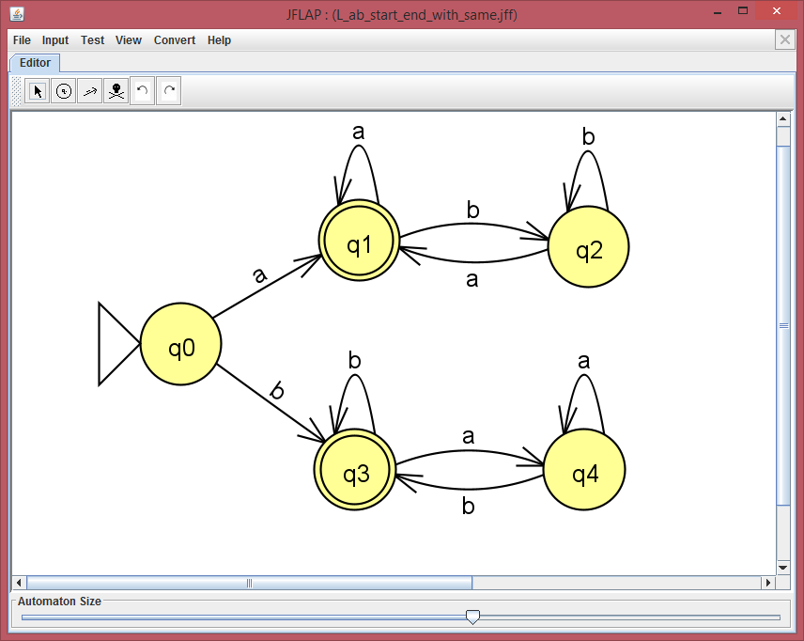

Fig-a1

Fig-a2 FA is accepting valid strings that start & end with same symbol.

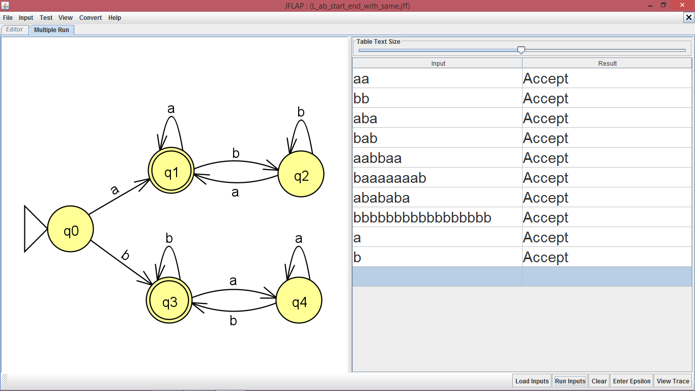

Fig-a2

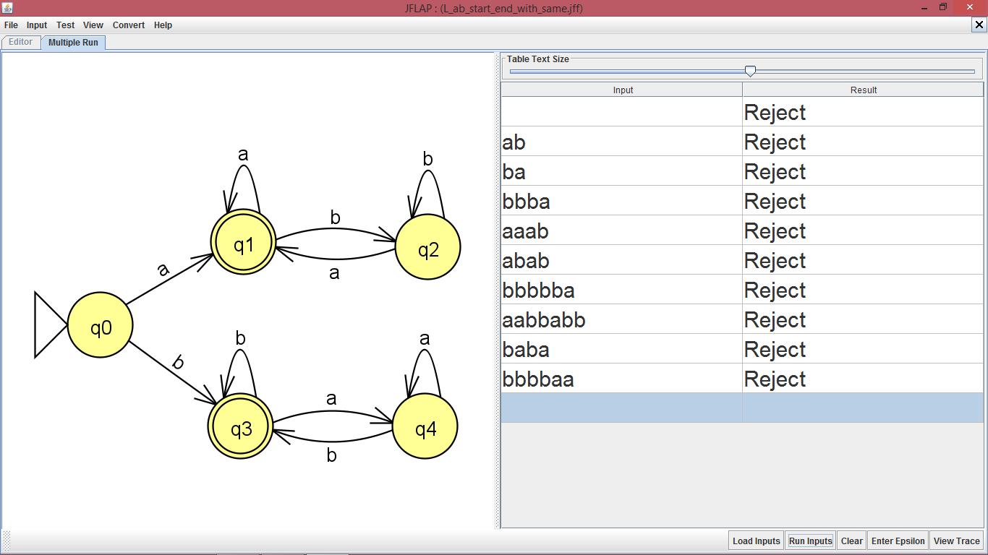 Fig-a3 FA is rejecting Invalid strings that not start & end with same symbol.

Fig-a3

1. L={Where every string starts and ends with different symbol}

Fig-b1 shows Finite automata for string that start & end with different symbol

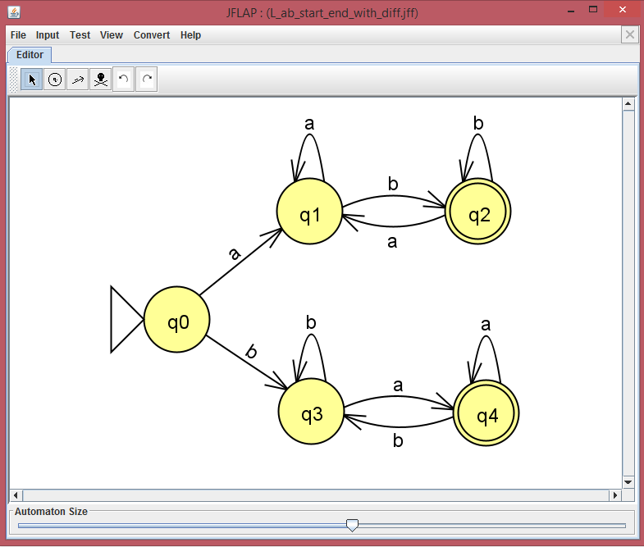

Fig-b1

Fig-b2 FA is accepting valid strings that start & end with different symbol.

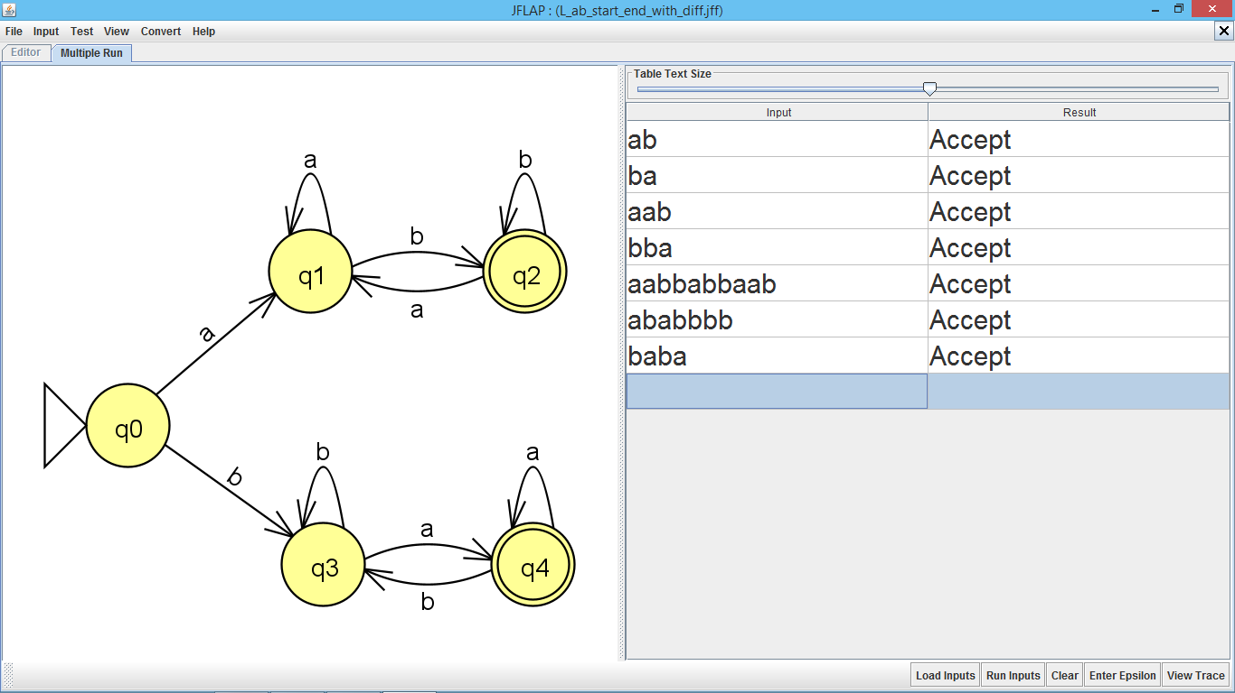

Fig-b2

Fig-b3 FA is rejecting Invalid strings that not start & end with different symbol.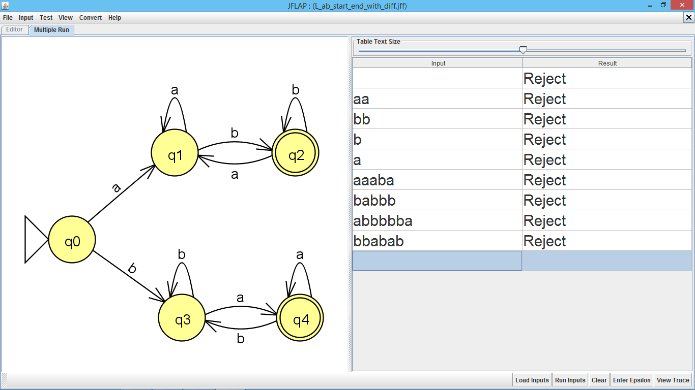

Fig-b3

1. L={Where the 2nd symbol from R.H.S is always ‘a’}

Fig-c1 shows FA for string that has 2nd symbol from R.H.S is always ‘a’

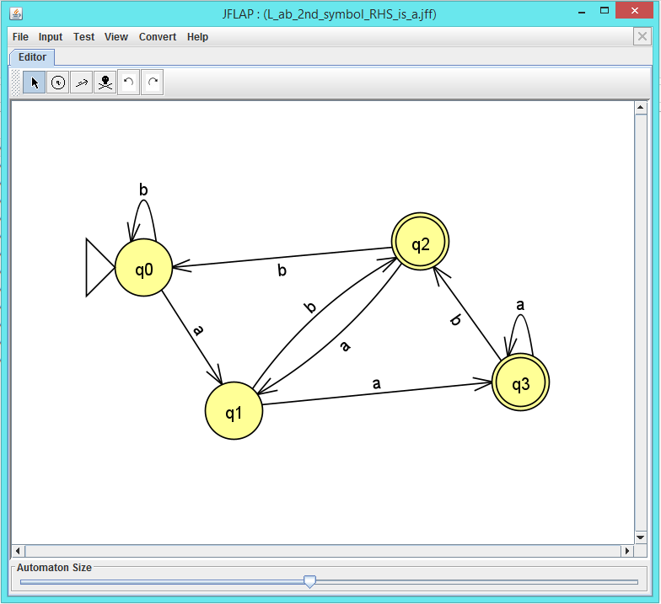

Fig-c1

Fig-c2 FA is accepting valid strings that has 2nd symbol from R.H.S is always ‘a’.

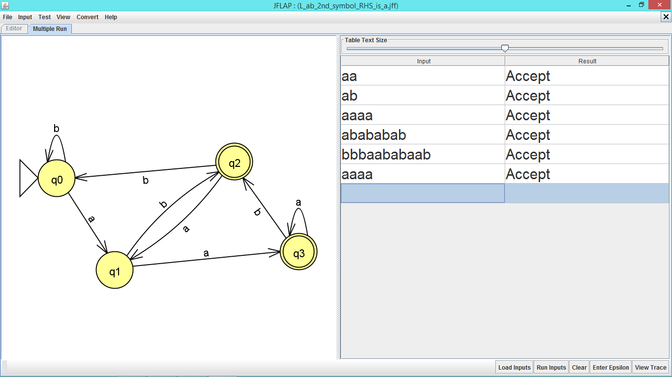

Fig-c2

Fig-c3 FA is rejecting Invalid strings that not has 2nd symbol from R.H.S is always ‘a’.

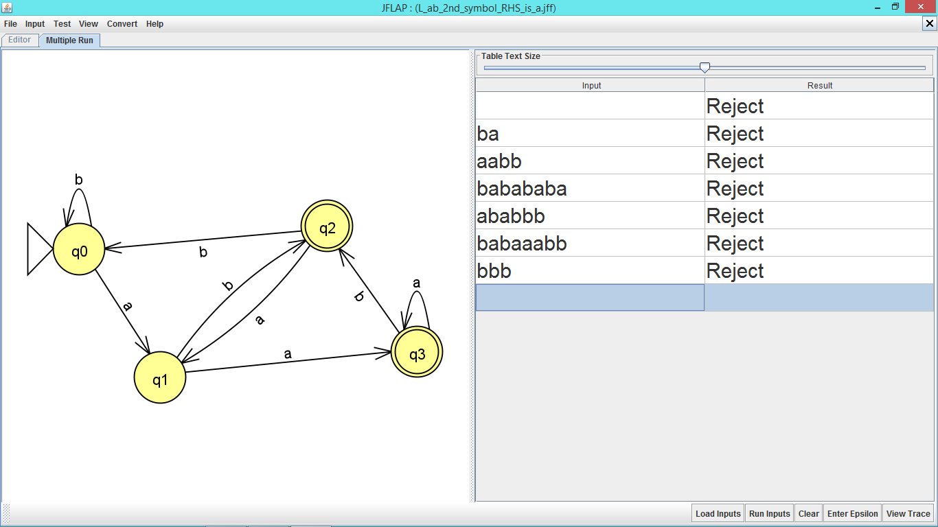

Fig-c3

1. L={Where the 4th symbol from L.H.S is always ‘b’}

Fig-d1 shows FA for string that has 4th symbol from L.H.S is always ‘b’

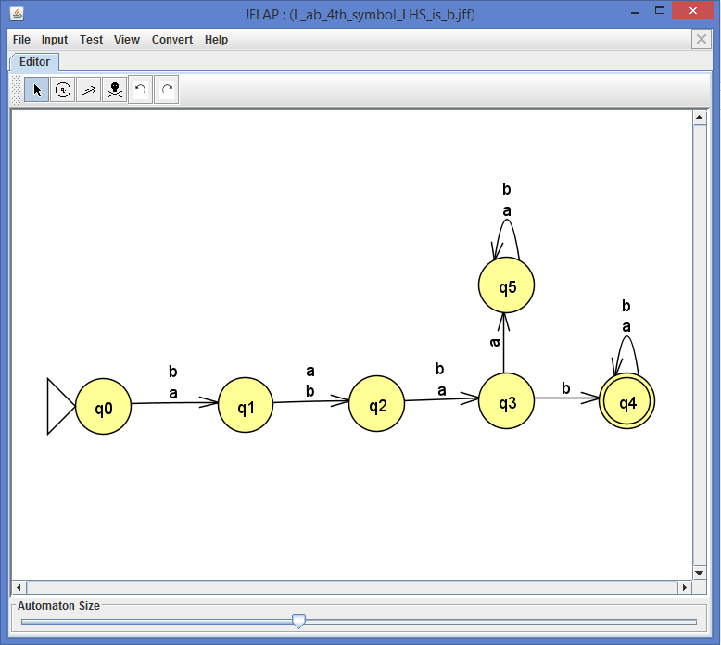

Fig-d1

Fig-d2 FA is accepting valid strings that has 4th symbol from L.H.S is always ‘b’.

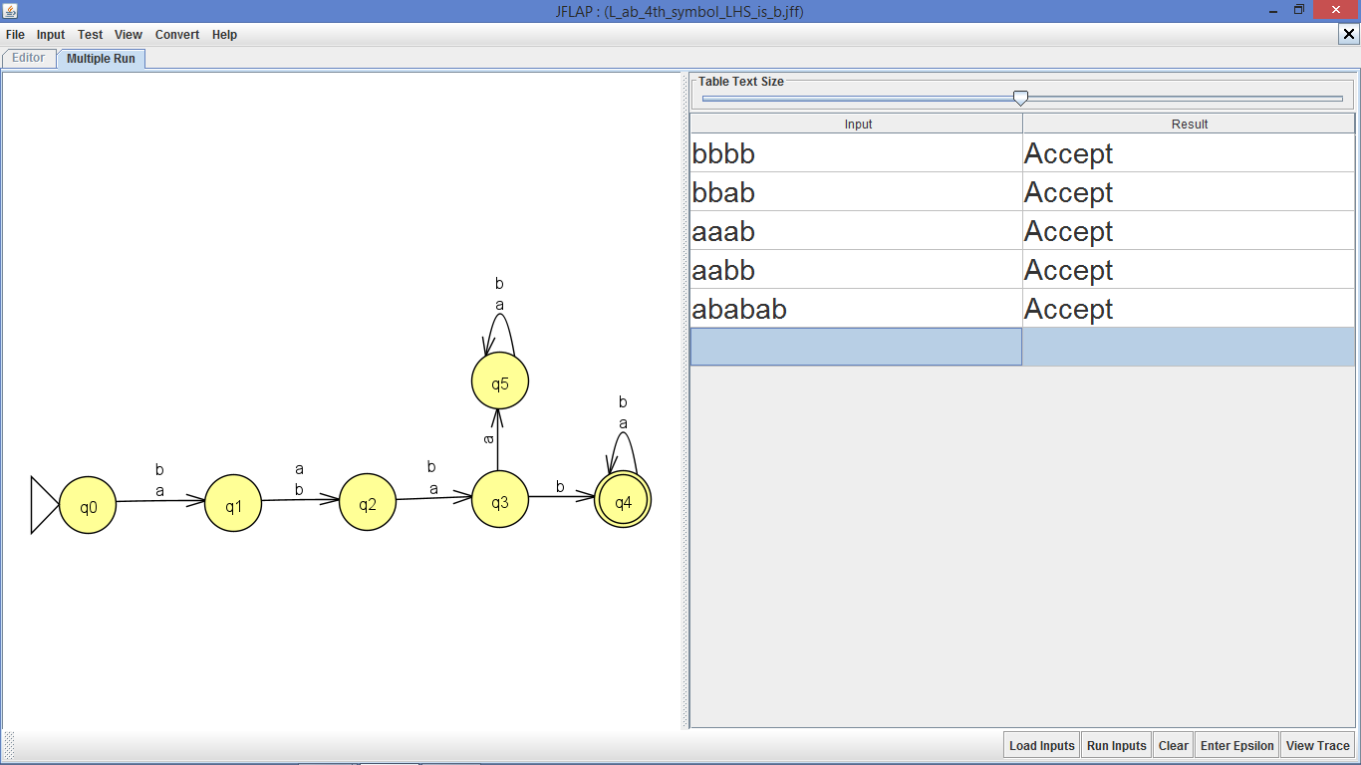

Fig-d2

Fig-d3 FA is rejecting Invalid strings that not has 4th symbol from L.H.S is always ‘b’.

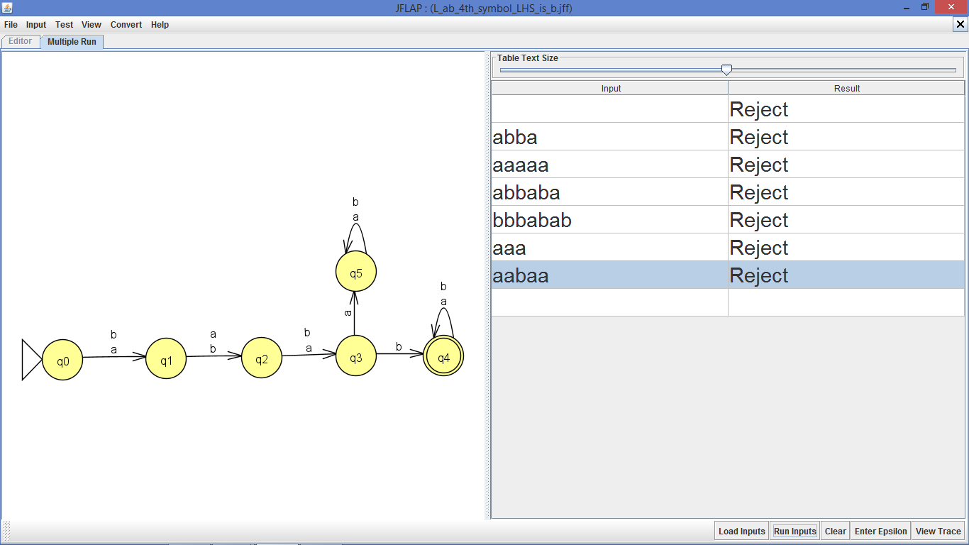

Fig-d3

1. L={Where every string is congruent to 2(mod 3)}

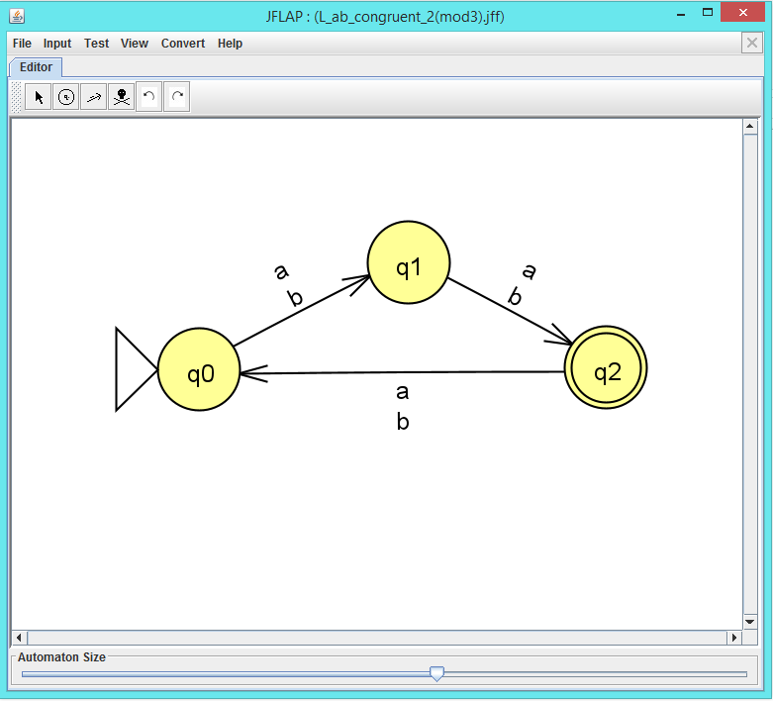Fig-e1 shows FA for string that is congruent to 2(mod 3).

Fig-e1

Fig-e2 FA is accepting valid strings that is congruent to 2(mod 3).

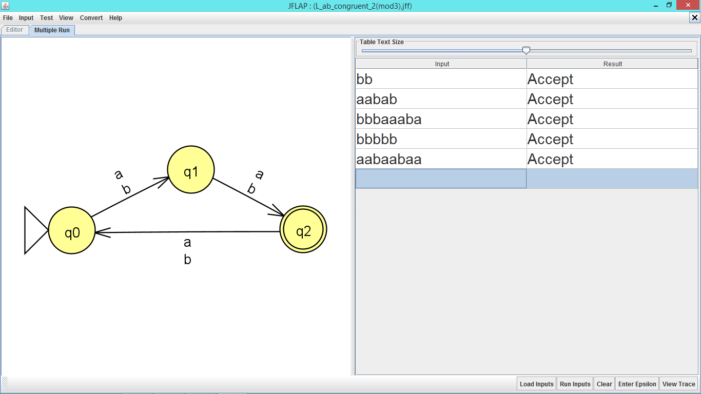

Fig-e2

Fig-e3 FA is rejecting Invalid strings that is not congruent to 2(mod 3).

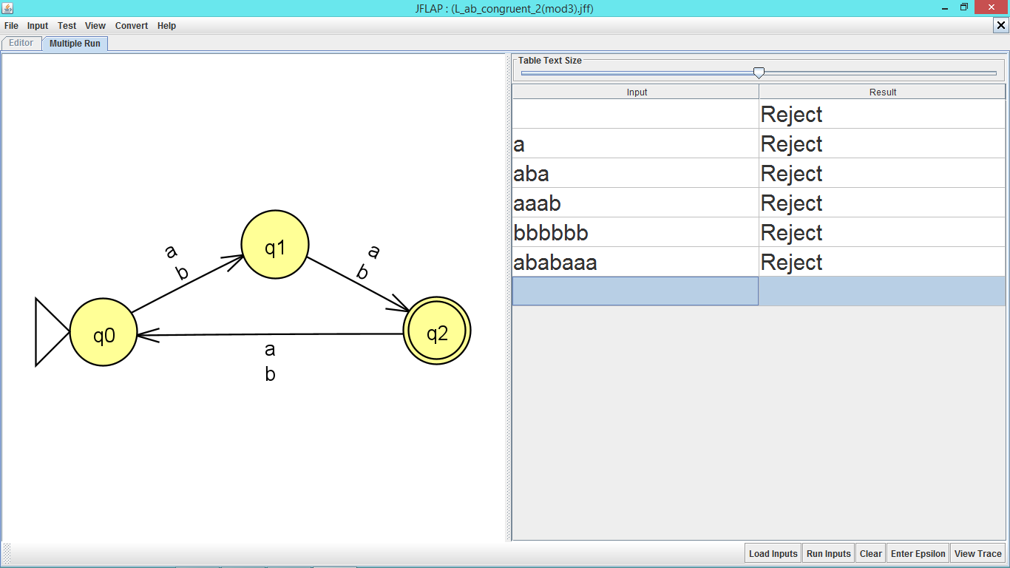

Fig-e3

1. L={Where no. of ‘a’ is even “and” no. of ‘b’ is odd}

Fig-f1 shows FA for string that has no. of ‘a’ is even “and” no. of ‘b’ is odd

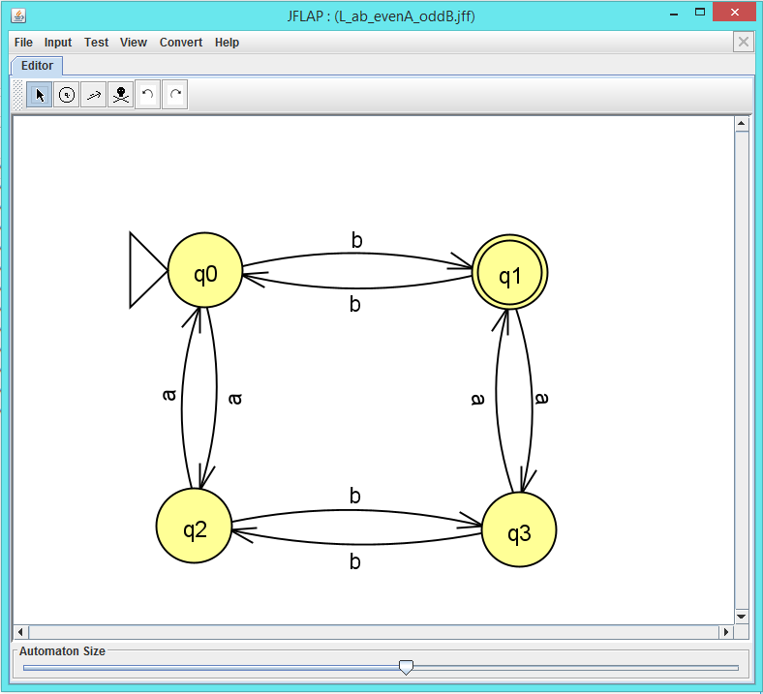

Fig-f1

Fig-f2 FA is accepting valid strings that has no. of ‘a’ is even “and” no. of ‘b’ is odd

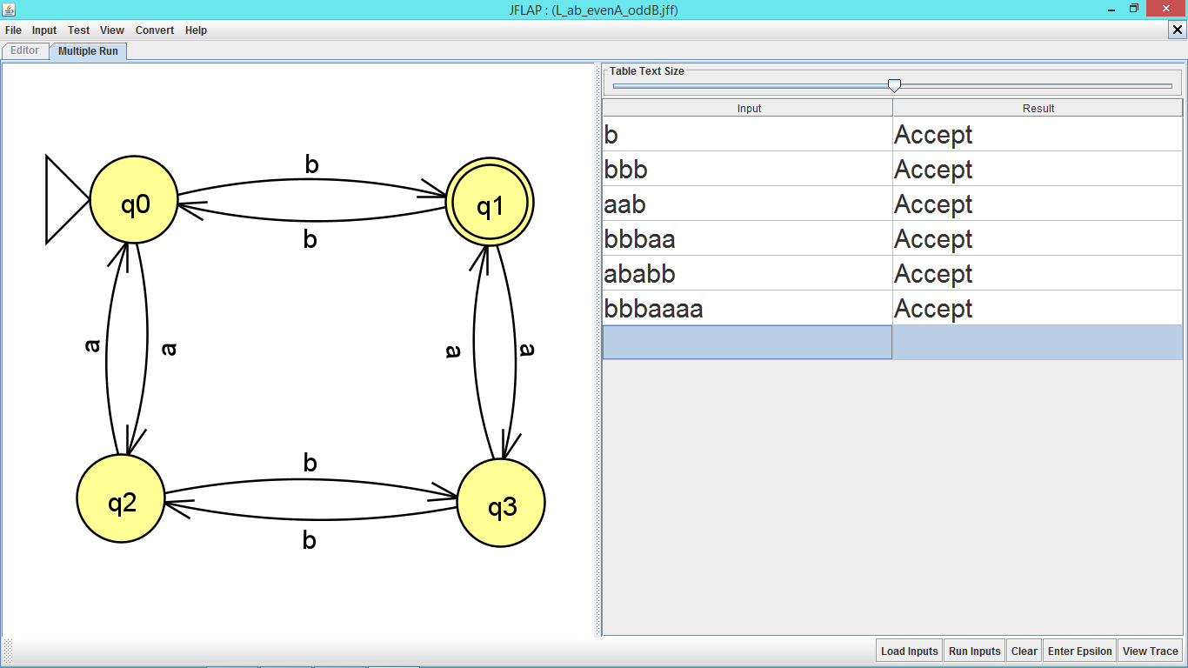

Fig-f2

Fig-f3 FA is rejecting Invalid strings that has not no. of ‘a’ is even “and” no. of ‘b’ is odd

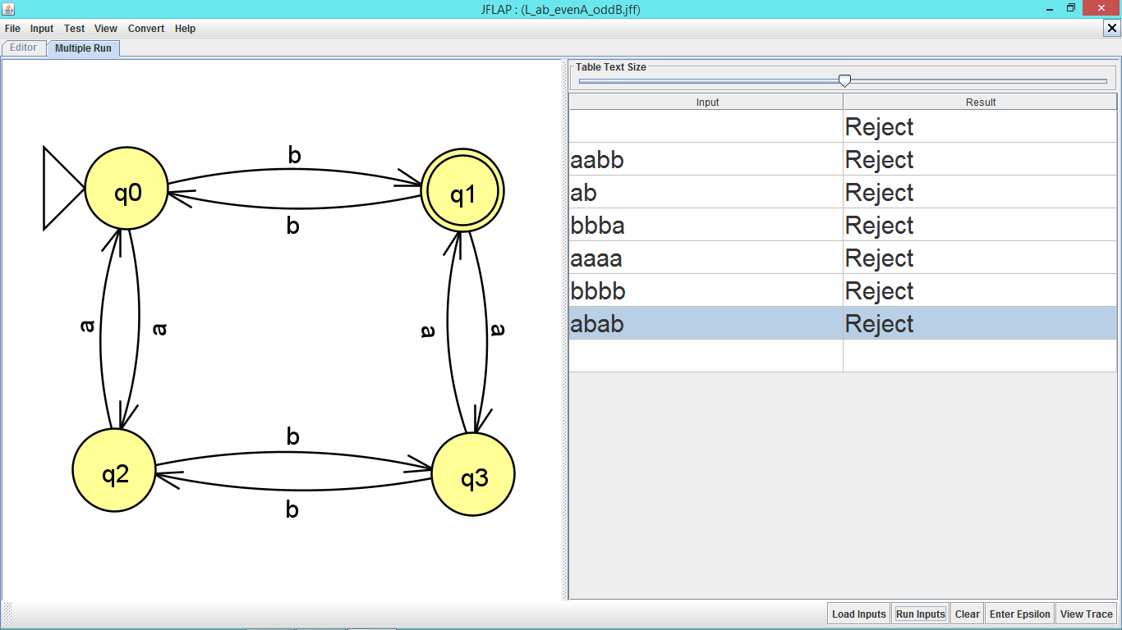

Fig-f3

1. L={Where no. of ‘a’ is odd “or” no. of ‘b’ is even}

Fig-g1 shows FA for string that has no. of ‘b’ is even “or” no. of ‘a’ is odd

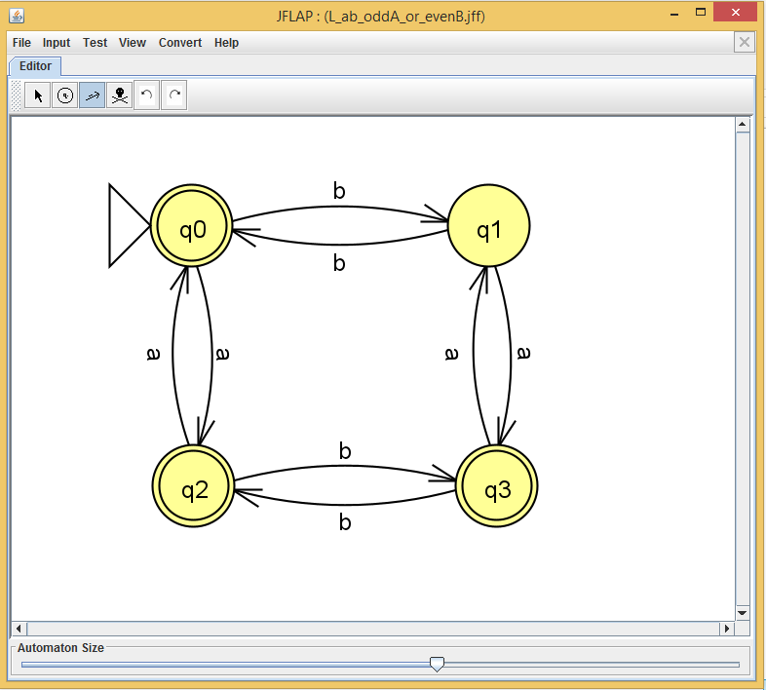

Fig-g1

Fig-g2 FA is accepting valid strings that has no. of ‘b’ is even “or” no. of ‘a’ is odd

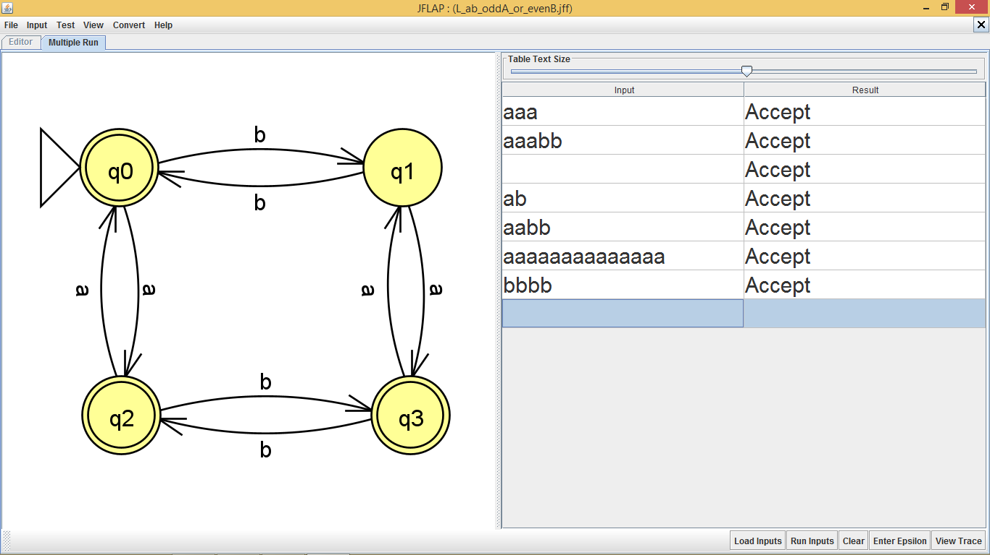

Fig-g2

Fig-g3 FA is rejecting Invalid strings that has not no. of ‘b’ is even “or” no. of ‘a’ is odd

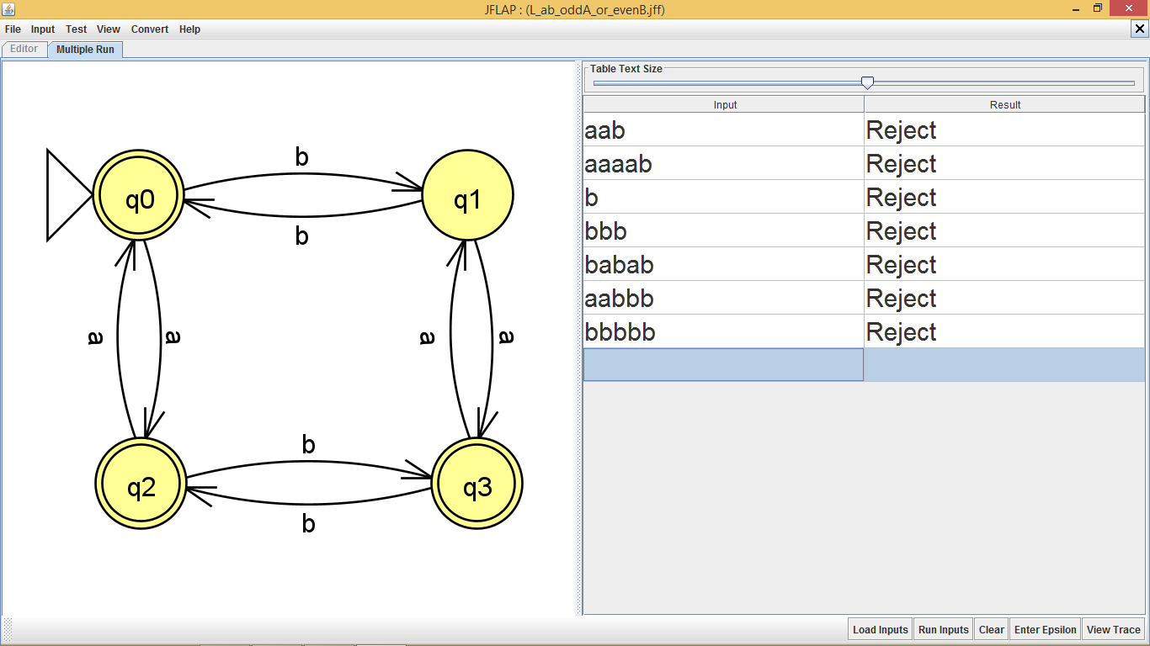

Fig-g3