**Vishwakarma Government Engineering College, Chandkheda**

**Computer Engineering Department**

**Big Data Analytics (3170722)**

**Practical list – winter 2021**

|  |  |  |  |
| --- | --- | --- | --- |
| **#** | **Aim of Practical** | **CO** | **Page** |
| 1 | To Demonstrate Installation and Configuration of MongoDB client Server. | CO1 | 1 |
| 2 | Write the Mongodb queries for creating database, collection, inserting documents, updating document, deleting documents. | CO1 | 3 |
| 3 | Write the MongoDB queries for the given collection. | CO1 | 6 |
| 4 | Write MongoDB queries for aggregate methods such as Count, Limit, Sort and similar to LIKE predicate in SQL. | CO1 | 10 |
| 5 | To Demonstrate the Installation and Configuration of Single node and multimode Hadoop clusters. | CO4 | 17 |
| 6 | To Develop a Map Reduce program for Word count for Hadoop cluster. | CO2 | 27 |
| 7 | To study stream mining using case study approach. | CO3 | 32 |
| 8 | To demonstrate Pig and Hive SQL queries using various operators. | CO3 | 40 |
| 9 | To show the Installation steps for the SPARK on single node system. | CO3 | 44 |
| 10 | Develop a word count program using SPARK. | CO3 | 46 |

**Practical – 1**

**Aim:** To Demonstrate Installation and Configuration of MongoDB client Server.

STEP 1: Download the installer

1. In the Version dropdown, select the version of MongoDB to download.
2. In the Platform dropdown, select Windows.
3. In the Package dropdown, select msi.
4. Click Download.

STEP 2: Run the MongoDB installer

• Choose Setup Type

You can choose either the Complete (recommended for most users) or Custom setup type. The Complete setup option installs MongoDB and the MongoDB tools to the default location. The Custom setup option allows you to specify which executables are installed and where.

• Service Configuration

Starting in MongoDB 4.0, you can set up MongoDB as a Windows service during the install or just install the binaries.



Fig 1.1 installation

STEP 3: Create database directory.

* Create the data directory where MongoDB stores data. MongoDB's default data directory path is the absolute path \data\db on the drive from which you start MongoDB.

STEP 4: Start your MongoDB database

To start MongoDB, run exe.

"C:\Program Files\MongoDB\Server\5.0\bin\mongod.exe" --dbpath="c:\data\db"

The --dbpath option points to your database directory.

**Practical – 2**

**Aim:** Write the Mongodb queries for creating database, collection, inserting

documents, updating document, deleting documents.

|  |
| --- |
| > show dbs  admin 0.000GB  config 0.000GB  local 0.000GB  mydb 0.000GB  > use test  switched to db test  > show dbs  admin 0.000GB  config 0.000GB  local 0.000GB  mydb 0.000GB  > db.createCollection('students')  { "ok" : 1 }  > show dbs  admin 0.000GB  config 0.000GB  local 0.000GB  mydb 0.000GB  test 0.000GB  > db.students.insertMany([{ "_id": NumberInt(0), "name":"aimee Zank", "scores":[ { "score":1.463179736705023, "type":"exam" }, { "score":11.78273309957772, "type":"quiz" }, { "score":35.8740349954354, "type":"homework" } ] },  { "_id": NumberInt(4), "name":"Zachary Langlais", "scores":[ { "score":78.68385091304332, "type":"exam" }, { "score":90.2963101368042, "type":"quiz" }, { "score":34.41620148042529, "type":"homework" } ] },  { "_id": NumberInt(5), "name":"Wilburn Spiess", "scores":[ { "score":44.87186330181261, "type":"exam" }, { "score":25.72395114668016, "type":"quiz" }, { "score":63.42288310628662, "type":"homework" } ] },  { "_id": NumberInt(7), "name":"Salena Olmos", "scores":[ { "score":90.37826509157176, "type":"exam" }, { "score":42.48780666956811, "type":"quiz" }, { "score":96.52986171633331, "type":"homework" } ] },  { "_id": NumberInt(12), "name":"Quincy Danaher", "scores":[ { "score":54.29841278520669, "type":"exam" }, { "score":85.61270164694737, "type":"quiz" }, { "score":80.40732356118075, "type":"homework" } ] },  { "_id": NumberInt(13), "name":"Jessika Dagenais", "scores":[ { "score":90.47179954427436, "type":"exam" }, { "score":90.3001402468489, "type":"quiz" }, { "score":95.17753772405909, "type":"homework" } ] },  { "_id": NumberInt(14), "name":"Alix Sherrill", "scores":[ { "score":25.15924151998215, "type":"exam" }, { "score":68.64484047692098, "type":"quiz" }, { "score":24.68462152686763, "type":"homework" } ] },  { "_id": NumberInt(15), "name":"Tambra Mercure", "scores":[ { "score":69.1565022533158, "type":"exam" }, { "score":3.311794422000724, "type":"quiz" }, { "score":45.03178973642521, "type":"homework" } ] },  { "_id": NumberInt(9), "name":"Sanda Ryba", "scores":[ { "score":97.00509953654694, "type":"exam" }, { "score":97.80449632538915, "type":"quiz" }, { "score":25.27368532432955, "type":"homework" } ] },  { "_id": NumberInt(21), "name":"Rosana Vales", "scores":[ { "score":46.2289476258328, "type":"exam" }, { "score":98.34164225207036, "type":"quiz" }, { "score":36.18769746805938, "type":"homework" } ] },  { "_id": NumberInt(22), "name":"Margart Vitello", "scores":[ { "score":75.04996547553947, "type":"exam" }, { "score":10.23046475899236, "type":"quiz" }, { "score":96.72520512117761, "type":"homework" } ] },  { "_id": NumberInt(24), "name":"Jesusa Rickenbacker", "scores":[ { "score":86.0319702155683, "type":"exam" }, { "score":1.967495200433389, "type":"quiz" }, { "score":61.10861071547914, "type":"homework" } ] },  { "_id": NumberInt(2), "name":"Corliss Zuk", "scores":[ { "score":67.03077096065002, "type":"exam" }, { "score":6.301851677835235, "type":"quiz" }, { "score":66.28344683278382, "type":"homework" } ] },  { "_id": NumberInt(1), "name":"Aurelia Menendez", "scores":[ { "score":60.06045071030959, "type":"exam" }, { "score":52.79790691903873, "type":"quiz" }, { "score":71.76133439165544, "type":"homework" } ] },  { "_id": NumberInt(6), "name":"Jenette Flanders", "scores":[ { "score":37.32285459166097, "type":"exam" }, { "score":28.32634976913737, "type":"quiz" }, { "score":81.57115318686338, "type":"homework" } ] },  { "_id": NumberInt(8), "name":"Daphne Zheng", "scores":[ { "score":22.13583712862635, "type":"exam" }, { "score":14.63969941335069, "type":"quiz" }, { "score":75.94123677556644, "type":"homework" } ] },  { "_id": NumberInt(10), "name":"Denisha Cast", "scores":[ { "score":45.61876862259409, "type":"exam" }, { "score":98.35723209418343, "type":"quiz" }, { "score":55.90835657173456, "type":"homework" } ] },  { "_id": NumberInt(11), "name":"Marcus Blohm", "scores":[ { "score":78.42617835651868, "type":"exam" }, { "score":82.58372817930675, "type":"quiz" }, { "score":87.49924733328717, "type":"homework" } ] },  { "_id": NumberInt(16), "name":"Dodie Staller", "scores":[ { "score":7.772386442858281, "type":"exam" }, { "score":31.84300235104542, "type":"quiz" }, { "score":80.52136407989194, "type":"homework" } ] },  { "_id": NumberInt(17), "name":"Fletcher Mcconnell", "scores":[ { "score":39.41011069729274, "type":"exam" }, { "score":81.13270307809924, "type":"quiz" }, { "score":97.70116640402922, "type":"homework" } ] },  { "_id": NumberInt(20), "name":"Tressa Schwing", "scores":[ { "score":42.17439799514388, "type":"exam" }, { "score":71.99314840599558, "type":"quiz" }, { "score":81.23972632069464, "type":"homework" } ] },  { "_id": NumberInt(19), "name":"Gisela Levin", "scores":[ { "score":44.51211101958831, "type":"exam" }, { "score":0.6578497966368002, "type":"quiz" }, { "score":93.36341655949683, "type":"homework" } ] },  { "_id": NumberInt(23), "name":"Tamika Schildgen", "scores":[ { "score":45.65432764125526, "type":"exam" }, { "score":64.32927049658846, "type":"quiz" }, { "score":83.53933351660562, "type":"homework" } ] },  { "_id": NumberInt(18), "name":"Verdell Sowinski", "scores":[ { "score":62.12870233109035, "type":"exam" }, { "score":84.74586220889356, "type":"quiz" }, { "score":81.58947824932574, "type":"homework" } ] }])  db.friends.update(search term,new data)  db.collection.updateOne(<filter>, <update>, <options>)  db.collection.updateMany(<filter>, <update>, <options>)  db.collection.replaceOne(<filter>, <update>, <options>)  > db.friends.update({},{$set:{gender:"Male"}})  WriteResult({ "nMatched" : 1, "nUpserted" : 0, "nModified" : 1 })  > db.friends.update({},{$set:{gender:"Male"}},{multi:true})  WriteResult({ "nMatched" : 3, "nUpserted" : 0, "nModified" : 2 })  > db.friends.update({},{$unset:{gender:"Male"}},{multi:true})  WriteResult({ "nMatched" : 3, "nUpserted" : 0, "nModified" : 3 })  > show collections  students  > db.students.drop()  True |

**Practical – 3**

**Aim:** Solve following queries using various mongodb search criteria.

(a) Find the document wherein the name of student has value ‘Fletcher Mcconnell’.

|  |
| --- |
| > db.students.find({name:"Fletcher Mcconnell"})  {"_id": 17, "name": "Fletcher Mcconnell", "scores": [{"score": 39.41011069729274, "type": "exam"}, {"score": 81.13270307809924, "type": "quiz"}, {"score": 97.70116640402922, "type": "homework"}] } |

(b) Display name of students from student collection.

|  |
| --- |
| > db.students.find({},{name:true,_id:false})  {"name": "aimee Zank"}  {"name": "Zachary Langlais"}  {"name": "Wilburn Spiess"}  {"name": "Salena Olmos"}  {"name": "Quincy Danaher"}  {"name": "Jessika Dagenais"}  {"name": "Alix Sherrill"}  {"name": "Tambra Mercure"}  {"name": "Sanda Ryba"}  {"name": "Rosana Vales"}  {"name": "Margart Vitello"}  {"name": "Jesusa Rickenbacker"}  {"name": "Corliss Zuk"}  {"name": "Aurelia Menendez"}  {"name": "Jenette Flanders"}  {"name": "Daphne Zheng"}  {"name": "Denisha Cast"}  {"name": "Marcus Blohm"}  {"name": "Dodie Staller"}  {"name": "Fletcher Mcconnell"} |

(c) Display name of student with id of the student having id value 22.

|  |
| --- |
| > db.students.find({_id:22})  {"_id": 22, "name": "Margart Vitello", "scores": [{"score": 75.04996547553947, "type": "exam"}, {"score": 10.23046475899236, "type": "quiz"}, {"score": 96.72520512117761, "type": "homework"}] } |

(d) display documents with students id with 1 to 3.

|  |
| --- |
| > db.students.find({_id:{$gt:0,$lt:4}})  {"_id": 1, "name": "Aurelia Menendez", "scores": [{"score": 60.06045071030959, "type": "exam"}, {"score": 52.79790691903873, "type": "quiz"}, {"score": 71.76133439165544, "type": "homework"}] }  {"_id": 2, "name": "Corliss Zuk", "scores": [{"score": 67.03077096065002, "type": "exam"}, {"score": 6.301851677835235, "type": "quiz"}, {"score": 66.28344683278382, "type": "homework"}] } |

(e) display documents with students name is ‘Tressa Schwing’ and ‘exam’ score greater than 85.35.

|  |
| --- |
| > db.students.find({name:"Tressa Schwing","scores.type":"exam","scores.score":{$gt:80.35}})  {"_id": 20, "name": "Tressa Schwing", "scores": [{"score": 42.17439799514388, "type": "exam"}, {"score": 71.99314840599558, "type": "quiz"}, {"score": 81.23972632069464, "type": "homework"}] } |

(f) dispaly all documents with ‘homework’ type score is less than 95.

|  |
| --- |
| > db.students.find({ scores:{ $elemMatch:{score:{$lt:95.0},type:"homework"} } })  { "_id" : 0, "name" : "aimee Zank", "scores" : [ { "score" : 1.463179736705023, "type" : "exam" }, { "score" : 11.78273309957772, "type" : "quiz" }, { "score" : 35.8740349954354, "type" : "homework" } ] }  { "_id" : 4, "name" : "Zachary Langlais", "scores" : [ { "score" : 78.68385091304332, "type" : "exam" }, { "score" : 90.2963101368042, "type" : "quiz" }, { "score" : 34.41620148042529, "type" : "homework" } ] }  { "_id" : 5, "name" : "Wilburn Spiess", "scores" : [ { "score" : 44.87186330181261, "type" : "exam" }, { "score" : 25.72395114668016, "type" : "quiz" }, { "score" : 63.42288310628662, "type" : "homework" } ] }  { "_id" : 12, "name" : "Quincy Danaher", "scores" : [ { "score" : 54.29841278520669, "type" : "exam" }, { "score" : 85.61270164694737, "type" : "quiz" }, { "score" : 80.40732356118075, "type" : "homework" } ] }  { "_id" : 14, "name" : "Alix Sherrill", "scores" : [ { "score" : 25.15924151998215, "type" : "exam" }, { "score" : 68.64484047692098, "type" : "quiz" }, { "score" : 24.68462152686763, "type" : "homework" } ] }  { "_id" : 15, "name" : "Tambra Mercure", "scores" : [ { "score" : 69.1565022533158, "type" : "exam" }, { "score" : 3.311794422000724, "type" : "quiz" }, { "score" : 45.03178973642521, "type" : "homework" } ] }  { "_id" : 9, "name" : "Sanda Ryba", "scores" : [ { "score" : 97.00509953654694, "type" : "exam" }, { "score" : 97.80449632538915, "type" : "quiz" }, { "score" : 25.27368532432955, "type" : "homework" } ] }  { "_id" : 21, "name" : "Rosana Vales", "scores" : [ { "score" : 46.2289476258328, "type" : "exam" }, { "score" : 98.34164225207036, "type" : "quiz" }, { "score" : 36.18769746805938, "type" : "homework" } ] }  { "_id" : 24, "name" : "Jesusa Rickenbacker", "scores" : [ { "score" : 86.0319702155683, "type" : "exam" }, { "score" : 1.967495200433389, "type" : "quiz" }, { "score" : 61.10861071547914, "type" : "homework" } ] }  { "_id" : 2, "name" : "Corliss Zuk", "scores" : [ { "score" : 67.03077096065002, "type" : "exam" }, { "score" : 6.301851677835235, "type" : "quiz" }, { "score" : 66.28344683278382, "type" : "homework" } ] }  { "_id" : 1, "name" : "Aurelia Menendez", "scores" : [ { "score" : 60.06045071030959, "type" : "exam" }, { "score" : 52.79790691903873, "type" : "quiz" }, { "score" : 71.76133439165544, "type" : "homework" } ] }  { "_id" : 6, "name" : "Jenette Flanders", "scores" : [ { "score" : 37.32285459166097, "type" : "exam" }, { "score" : 28.32634976913737, "type" : "quiz" }, { "score" : 81.57115318686338, "type" : "homework" } ] }  { "_id" : 8, "name" : "Daphne Zheng", "scores" : [ { "score" : 22.13583712862635, "type" : "exam" }, { "score" : 14.63969941335069, "type" : "quiz" }, { "score" : 75.94123677556644, "type" : "homework" } ] }  { "_id" : 10, "name" : "Denisha Cast", "scores" : [ { "score" : 45.61876862259409, "type" : "exam" }, { "score" : 98.35723209418343, "type" : "quiz" }, { "score" : 55.90835657173456, "type" : "homework" } ] }  { "_id" : 11, "name" : "Marcus Blohm", "scores" : [ { "score" : 78.42617835651868, "type" : "exam" }, { "score" : 82.58372817930675, "type" : "quiz" }, { "score" : 87.49924733328717, "type" : "homework" } ] }  { "_id" : 16, "name" : "Dodie Staller", "scores" : [ { "score" : 7.772386442858281, "type" : "exam" }, { "score" : 31.84300235104542, "type" : "quiz" }, { "score" : 80.52136407989194, "type" : "homework" } ] }  { "_id" : 20, "name" : "Tressa Schwing", "scores" : [ { "score" : 42.17439799514388, "type" : "exam" }, { "score" : 71.99314840599558, "type" : "quiz" }, { "score" : 81.23972632069464, "type" : "homework" } ] }  { "_id" : 19, "name" : "Gisela Levin", "scores" : [ { "score" : 44.51211101958831, "type" : "exam" }, { "score" : 0.6578497966368002, "type" : "quiz" }, { "score" : 93.36341655949683, "type" : "homework" } ] }  { "_id" : 23, "name" : "Tamika Schildgen", "scores" : [ { "score" : 45.65432764125526, "type" : "exam" }, { "score" : 64.32927049658846, "type" : "quiz" }, { "score" : 83.53933351660562, "type" : "homework" } ] }  { "_id" : 18, "name" : "Verdell Sowinski", "scores" : [ { "score" : 62.12870233109035, "type" : "exam" }, { "score" : 84.74586220889356, "type" : "quiz" }, { "score" : 81.58947824932574, "type" : "homework" } ] } |

(g) retrieve all documents with ‘quize’ score between 80 and 90 inclusively.

|  |
| --- |
| > db.students.find({ scores:{ $elemMatch:{score:{$gte:80,$lte:90},type:"homework"} } })  { "_id" : 12, "name" : "Quincy Danaher", "scores" : [ { "score" : 54.29841278520669, "type" : "exam" }, { "score" : 85.61270164694737, "type" : "quiz" }, { "score" : 80.40732356118075, "type" : "homework" } ] }  { "_id" : 6, "name" : "Jenette Flanders", "scores" : [ { "score" : 37.32285459166097, "type" : "exam" }, { "score" : 28.32634976913737, "type" : "quiz" }, { "score" : 81.57115318686338, "type" : "homework" } ] }  { "_id" : 11, "name" : "Marcus Blohm", "scores" : [ { "score" : 78.42617835651868, "type" : "exam" }, { "score" : 82.58372817930675, "type" : "quiz" }, { "score" : 87.49924733328717, "type" : "homework" } ] }  { "_id" : 16, "name" : "Dodie Staller", "scores" : [ { "score" : 7.772386442858281, "type" : "exam" }, { "score" : 31.84300235104542, "type" : "quiz" }, { "score" : 80.52136407989194, "type" : "homework" } ] }  { "_id" : 20, "name" : "Tressa Schwing", "scores" : [ { "score" : 42.17439799514388, "type" : "exam" }, { "score" : 71.99314840599558, "type" : "quiz" }, { "score" : 81.23972632069464, "type" : "homework" } ] }  { "_id" : 23, "name" : "Tamika Schildgen", "scores" : [ { "score" : 45.65432764125526, "type" : "exam" }, { "score" : 64.32927049658846, "type" : "quiz" }, { "score" : 83.53933351660562, "type" : "homework" } ] }  { "_id" : 18, "name" : "Verdell Sowinski", "scores" : [ { "score" : 62.12870233109035, "type" : "exam" }, { "score" : 84.74586220889356, "type" : "quiz" }, { "score" : 81.58947824932574, "type" : "homework" } ] } |

**Practical – 4**

**Aim:** Write MongoDB queries for aggregate methods such as Count, Limit, Sort and similar to LIKE predicate in SQL.

(a) Display documents in the ascending order of _id.

|  |
| --- |
| > db.students.find({}).sort({_id:1})  {"_id": 0, "name": "aimee Zank", "scores": [{"score": 1.463179736705023, "type": "exam"}, {"score": 11.78273309957772, "type": "quiz"}, {"score": 35.8740349954354, "type": "homework"}] }  {"_id": 1, "name": "Aurelia Menendez", "scores": [{"score": 60.06045071030959, "type": "exam"}, {"score": 52.79790691903873, "type": "quiz"}, {"score": 71.76133439165544, "type": "homework"}] }  {"_id": 2, "name": "Corliss Zuk", "scores": [{"score": 67.03077096065002, "type": "exam"}, {"score": 6.301851677835235, "type": "quiz"}, {"score": 66.28344683278382, "type": "homework"}] }  {"_id": 4, "name": "Zachary Langlais", "scores": [{"score": 78.68385091304332, "type": "exam"}, {"score": 90.2963101368042, "type": "quiz"}, {"score": 34.41620148042529, "type": "homework"}] }  {"_id": 5, "name": "Wilburn Spiess", "scores": [{"score": 44.87186330181261, "type": "exam"}, {"score": 25.72395114668016, "type": "quiz"}, {"score": 63.42288310628662, "type": "homework"}] }  {"_id": 6, "name": "Jenette Flanders", "scores": [{"score": 37.32285459166097, "type": "exam"}, {"score": 28.32634976913737, "type": "quiz"}, {"score": 81.57115318686338, "type": "homework"}] }  {"_id": 7, "name": "Salena Olmos", "scores": [{"score": 90.37826509157176, "type": "exam"}, {"score": 42.48780666956811, "type": "quiz"}, {"score": 96.52986171633331, "type": "homework"}] }  {"_id": 8, "name": "Daphne Zheng", "scores": [{"score": 22.13583712862635, "type": "exam"}, {"score": 14.63969941335069, "type": "quiz"}, {"score": 75.94123677556644, "type": "homework"}] }  {"_id": 9, "name": "Sanda Ryba", "scores": [{"score": 97.00509953654694, "type": "exam"}, {"score": 97.80449632538915, "type": "quiz"}, {"score": 25.27368532432955, "type": "homework"}] }  {"_id": 10, "name": "Denisha Cast", "scores": [{"score": 45.61876862259409, "type": "exam"}, {"score": 98.35723209418343, "type": "quiz"}, {"score": 55.90835657173456, "type": "homework"}] }  {"_id": 11, "name": "Marcus Blohm", "scores": [{"score": 78.42617835651868, "type": "exam"}, {"score": 82.58372817930675, "type": "quiz"}, {"score": 87.49924733328717, "type": "homework"}] }  {"_id": 12, "name": "Quincy Danaher", "scores": [{"score": 54.29841278520669, "type": "exam"}, {"score": 85.61270164694737, "type": "quiz"}, {"score": 80.40732356118075, "type": "homework"}] }  {"_id": 13, "name": "Jessika Dagenais", "scores": [{"score": 90.47179954427436, "type": "exam"}, {"score": 90.3001402468489, "type": "quiz"}, {"score": 95.17753772405909, "type": "homework"}] }  {"_id": 14, "name": "Alix Sherrill", "scores": [{"score": 25.15924151998215, "type": "exam"}, {"score": 68.64484047692098, "type": "quiz"}, {"score": 24.68462152686763, "type": "homework"}] }  {"_id": 15, "name": "Tambra Mercure", "scores": [{"score": 69.1565022533158, "type": "exam"}, {"score": 3.311794422000724, "type": "quiz"}, {"score": 45.03178973642521, "type": "homework"}] }  {"_id": 16, "name": "Dodie Staller", "scores": [{"score": 7.772386442858281, "type": "exam"}, {"score": 31.84300235104542, "type": "quiz"}, {"score": 80.52136407989194, "type": "homework"}] }  {"_id": 17, "name": "Fletcher Mcconnell", "scores": [{"score": 39.41011069729274, "type": "exam"}, {"score": 81.13270307809924, "type": "quiz"}, {"score": 97.70116640402922, "type": "homework"}] }  {"_id": 18, "name": "Verdell Sowinski", "scores": [{"score": 62.12870233109035, "type": "exam"}, {"score": 84.74586220889356, "type": "quiz"}, {"score": 81.58947824932574, "type": "homework"}] }  {"_id": 19, "name": "Gisela Levin", "scores": [{"score": 44.51211101958831, "type": "exam"}, {"score": 0.6578497966368002, "type": "quiz"}, {"score": 93.36341655949683, "type": "homework"}] }  {"_id": 20, "name": "Tressa Schwing", "scores": [{"score": 42.17439799514388, "type": "exam"}, {"score": 71.99314840599558, "type": "quiz"}, {"score": 81.23972632069464, "type": "homework"}] }  Type "it"for more  > it  {"_id": 21, "name": "Rosana Vales", "scores": [{"score": 46.2289476258328, "type": "exam"}, {"score": 98.34164225207036, "type": "quiz"}, {"score": 36.18769746805938, "type": "homework"}] }  {"_id": 22, "name": "Margart Vitello", "scores": [{"score": 75.04996547553947, "type": "exam"}, {"score": 10.23046475899236, "type": "quiz"}, {"score": 96.72520512117761, "type": "homework"}] }  {"_id": 23, "name": "Tamika Schildgen", "scores": [{"score": 45.65432764125526, "type": "exam"}, {"score": 64.32927049658846, "type": "quiz"}, {"score": 83.53933351660562, "type": "homework"}] }  {"_id": 24, "name": "Jesusa Rickenbacker", "scores": [{"score": 86.0319702155683, "type": "exam"}, {"score": 1.967495200433389, "type": "quiz"}, {"score": 61.10861071547914, "type": "homework"}] } |

(b) Display documents in the descending order of name.

|  |
| --- |
| > db.students.find({},{name:true}).sort({"name":-1})  {"_id": 0, "name": "aimee Zank"}  {"_id": 4, "name": "Zachary Langlais"}  {"_id": 5, "name": "Wilburn Spiess"}  {"_id": 18, "name": "Verdell Sowinski"}  {"_id": 20, "name": "Tressa Schwing"}  {"_id": 23, "name": "Tamika Schildgen"}  {"_id": 15, "name": "Tambra Mercure"}  {"_id": 9, "name": "Sanda Ryba"}  {"_id": 7, "name": "Salena Olmos"}  {"_id": 21, "name": "Rosana Vales"}  {"_id": 12, "name": "Quincy Danaher"}  {"_id": 22, "name": "Margart Vitello"}  {"_id": 11, "name": "Marcus Blohm"}  {"_id": 24, "name": "Jesusa Rickenbacker"}  {"_id": 13, "name": "Jessika Dagenais"}  {"_id": 6, "name": "Jenette Flanders"}  {"_id": 19, "name": "Gisela Levin"}  {"_id": 17, "name": "Fletcher Mcconnell"}  {"_id": 16, "name": "Dodie Staller"}  {"_id": 10, "name": "Denisha Cast"}  Type "it"for more  > it  {"_id": 8, "name": "Daphne Zheng"}  {"_id": 2, "name": "Corliss Zuk"}  {"_id": 1, "name": "Aurelia Menendez"}  {"_id": 14, "name": "Alix Sherrill"} |

(c) Display documents first in the ascending order of _id and then descending order of name.

|  |
| --- |
| > db.students.find({},{name:true}).sort({_id:1,"name":-1})  {"_id": 0, "name": "aimee Zank"}  {"_id": 1, "name": "Aurelia Menendez"}  {"_id": 2, "name": "Corliss Zuk"}  {"_id": 4, "name": "Zachary Langlais"}  {"_id": 5, "name": "Wilburn Spiess"}  {"_id": 6, "name": "Jenette Flanders"}  {"_id": 7, "name": "Salena Olmos"}  {"_id": 8, "name": "Daphne Zheng"}  {"_id": 9, "name": "Sanda Ryba"}  {"_id": 10, "name": "Denisha Cast"}  {"_id": 11, "name": "Marcus Blohm"}  {"_id": 12, "name": "Quincy Danaher"}  {"_id": 13, "name": "Jessika Dagenais"}  {"_id": 14, "name": "Alix Sherrill"}  {"_id": 15, "name": "Tambra Mercure"}  {"_id": 16, "name": "Dodie Staller"}  {"_id": 17, "name": "Fletcher Mcconnell"}  {"_id": 18, "name": "Verdell Sowinski"}  {"_id": 19, "name": "Gisela Levin"}  {"_id": 20, "name": "Tressa Schwing"}  Type "it"for more  > it  {"_id": 21, "name": "Rosana Vales"}  {"_id": 22, "name": "Margart Vitello"}  {"_id": 23, "name": "Tamika Schildgen"}  {"_id": 24, "name": "Jesusa Rickenbacker"} |

(d) Display all documents except first two from students collection.

|  |
| --- |
| > db.students.find().sort({_id:1}).skip(2)  { "_id" : 2, "name" : "Corliss Zuk", "scores" : [ { "score" : 67.03077096065002, "type" : "exam" }, { "score" : 6.301851677835235, "type" : "quiz" }, { "score" : 66.28344683278382, "type" : "homework" } ] }  { "_id" : 4, "name" : "Zachary Langlais", "scores" : [ { "score" : 78.68385091304332, "type" : "exam" }, { "score" : 90.2963101368042, "type" : "quiz" }, { "score" : 34.41620148042529, "type" : "homework" } ] }  { "_id" : 5, "name" : "Wilburn Spiess", "scores" : [ { "score" : 44.87186330181261, "type" : "exam" }, { "score" : 25.72395114668016, "type" : "quiz" }, { "score" : 63.42288310628662, "type" : "homework" } ] }  { "_id" : 6, "name" : "Jenette Flanders", "scores" : [ { "score" : 37.32285459166097, "type" : "exam" }, { "score" : 28.32634976913737, "type" : "quiz" }, { "score" : 81.57115318686338, "type" : "homework" } ] }  { "_id" : 7, "name" : "Salena Olmos", "scores" : [ { "score" : 90.37826509157176, "type" : "exam" }, { "score" : 42.48780666956811, "type" : "quiz" }, { "score" : 96.52986171633331, "type" : "homework" } ] }  { "_id" : 8, "name" : "Daphne Zheng", "scores" : [ { "score" : 22.13583712862635, "type" : "exam" }, { "score" : 14.63969941335069, "type" : "quiz" }, { "score" : 75.94123677556644, "type" : "homework" } ] }  { "_id" : 9, "name" : "Sanda Ryba", "scores" : [ { "score" : 97.00509953654694, "type" : "exam" }, { "score" : 97.80449632538915, "type" : "quiz" }, { "score" : 25.27368532432955, "type" : "homework" } ] }  { "_id" : 10, "name" : "Denisha Cast", "scores" : [ { "score" : 45.61876862259409, "type" : "exam" }, { "score" : 98.35723209418343, "type" : "quiz" }, { "score" : 55.90835657173456, "type" : "homework" } ] }  { "_id" : 11, "name" : "Marcus Blohm", "scores" : [ { "score" : 78.42617835651868, "type" : "exam" }, { "score" : 82.58372817930675, "type" : "quiz" }, { "score" : 87.49924733328717, "type" : "homework" } ] }  { "_id" : 12, "name" : "Quincy Danaher", "scores" : [ { "score" : 54.29841278520669, "type" : "exam" }, { "score" : 85.61270164694737, "type" : "quiz" }, { "score" : 80.40732356118075, "type" : "homework" } ] }  { "_id" : 13, "name" : "Jessika Dagenais", "scores" : [ { "score" : 90.47179954427436, "type" : "exam" }, { "score" : 90.3001402468489, "type" : "quiz" }, { "score" : 95.17753772405909, "type" : "homework" } ] }  { "_id" : 14, "name" : "Alix Sherrill", "scores" : [ { "score" : 25.15924151998215, "type" : "exam" }, { "score" : 68.64484047692098, "type" : "quiz" }, { "score" : 24.68462152686763, "type" : "homework" } ] }  { "_id" : 15, "name" : "Tambra Mercure", "scores" : [ { "score" : 69.1565022533158, "type" : "exam" }, { "score" : 3.311794422000724, "type" : "quiz" }, { "score" : 45.03178973642521, "type" : "homework" } ] }  { "_id" : 16, "name" : "Dodie Staller", "scores" : [ { "score" : 7.772386442858281, "type" : "exam" }, { "score" : 31.84300235104542, "type" : "quiz" }, { "score" : 80.52136407989194, "type" : "homework" } ] }  { "_id" : 17, "name" : "Fletcher Mcconnell", "scores" : [ { "score" : 39.41011069729274, "type" : "exam" }, { "score" : 81.13270307809924, "type" : "quiz" }, { "score" : 97.70116640402922, "type" : "homework" } ] }  { "_id" : 18, "name" : "Verdell Sowinski", "scores" : [ { "score" : 62.12870233109035, "type" : "exam" }, { "score" : 84.74586220889356, "type" : "quiz" }, { "score" : 81.58947824932574, "type" : "homework" } ] }  { "_id" : 19, "name" : "Gisela Levin", "scores" : [ { "score" : 44.51211101958831, "type" : "exam" }, { "score" : 0.6578497966368002, "type" : "quiz" }, { "score" : 93.36341655949683, "type" : "homework" } ] }  { "_id" : 20, "name" : "Tressa Schwing", "scores" : [ { "score" : 42.17439799514388, "type" : "exam" }, { "score" : 71.99314840599558, "type" : "quiz" }, { "score" : 81.23972632069464, "type" : "homework" } ] }  { "_id" : 21, "name" : "Rosana Vales", "scores" : [ { "score" : 46.2289476258328, "type" : "exam" }, { "score" : 98.34164225207036, "type" : "quiz" }, { "score" : 36.18769746805938, "type" : "homework" } ] }  { "_id" : 22, "name" : "Margart Vitello", "scores" : [ { "score" : 75.04996547553947, "type" : "exam" }, { "score" : 10.23046475899236, "type" : "quiz" }, { "score" : 96.72520512117761, "type" : "homework" } ] }  Type "it" for more  > it  { "_id" : 23, "name" : "Tamika Schildgen", "scores" : [ { "score" : 45.65432764125526, "type" : "exam" }, { "score" : 64.32927049658846, "type" : "quiz" }, { "score" : 83.53933351660562, "type" : "homework" } ] }  { "_id" : 24, "name" : "Jesusa Rickenbacker", "scores" : [ { "score" : 86.0319702155683, "type" : "exam" }, { "score" : 1.967495200433389, "type" : "quiz" }, { "score" : 61.10861071547914, "type" : "homework" } ] } |

(e) Display 5th and 6th documents from the students collection.

|  |
| --- |
| > db.students.find().sort({_id:1}).skip(4).limit(2)  { "_id" : 5, "name" : "Wilburn Spiess", "scores" : [ { "score" : 44.87186330181261, "type" : "exam" }, { "score" : 25.72395114668016, "type" : "quiz" }, { "score" : 63.42288310628662, "type" : "homework" } ] }  { "_id" : 6, "name" : "Jenette Flanders", "scores" : [ { "score" : 37.32285459166097, "type" : "exam" }, { "score" : 28.32634976913737, "type" : "quiz" }, { "score" : 81.57115318686338, "type" : "homework" } ] } |

(f) Display total number of documents in the students collection.

|  |
| --- |
| > db.students.find().length()  24 |

(g) Display last three documents from the students collection.

|  |
| --- |
| > db.students.find().sort({_id:-1}).limit(3)  { "_id" : 24, "name" : "Jesusa Rickenbacker", "scores" : [ { "score" : 86.0319702155683, "type" : "exam" }, { "score" : 1.967495200433389, "type" : "quiz" }, { "score" : 61.10861071547914, "type" : "homework" } ] }  { "_id" : 23, "name" : "Tamika Schildgen", "scores" : [ { "score" : 45.65432764125526, "type" : "exam" }, { "score" : 64.32927049658846, "type" : "quiz" }, { "score" : 83.53933351660562, "type" : "homework" } ] }  { "_id" : 22, "name" : "Margart Vitello", "scores" : [ { "score" : 75.04996547553947, "type" : "exam" }, { "score" : 10.23046475899236, "type" : "quiz" }, { "score" : 96.72520512117761, "type" : "homework" } ] } |

(h) Find the ids of students whose name begins with the letter “A”.

|  |
| --- |
| > db.students.find({name:{$regex:/^A/}},{name:1})  { "_id" : 14, "name" : "Alix Sherrill" }  { "_id" : 1, "name" : "Aurelia Menendez" } |

(i) Display all documents in which student name ends with the letter ’r’.

|  |
| --- |
| > db.students.find({name:{$regex:/r$/}})  { "_id" : 12, "name" : "Quincy Danaher", "scores" : [ { "score" : 54.29841278520669, "type" : "exam" }, { "score" : 85.61270164694737, "type" : "quiz" }, { "score" : 80.40732356118075, "type" : "homework" } ] }  { "_id" : 24, "name" : "Jesusa Rickenbacker", "scores" : [ { "score" : 86.0319702155683, "type" : "exam" }, { "score" : 1.967495200433389, "type" : "quiz" }, { "score" : 61.10861071547914, "type" : "homework" } ] }  { "_id" : 16, "name" : "Dodie Staller", "scores" : [ { "score" : 7.772386442858281, "type" : "exam" }, { "score" : 31.84300235104542, "type" : "quiz" }, { "score" : 80.52136407989194, "type" : "homework" } ] } |

(j) Find all documents in student name contains‘t’ in any position.

|  |
| --- |
| > db.students.find({name:{$regex:/t/}})  { "_id" : 22, "name" : "Margart Vitello", "scores" : [ { "score" : 75.04996547553947, "type" : "exam" }, { "score" : 10.23046475899236, "type" : "quiz" }, { "score" : 96.72520512117761, "type" : "homework" } ] }  { "_id" : 6, "name" : "Jenette Flanders", "scores" : [ { "score" : 37.32285459166097, "type" : "exam" }, { "score" : 28.32634976913737, "type" : "quiz" }, { "score" : 81.57115318686338, "type" : "homework" } ] }  { "_id" : 10, "name" : "Denisha Cast", "scores" : [ { "score" : 45.61876862259409, "type" : "exam" }, { "score" : 98.35723209418343, "type" : "quiz" }, { "score" : 55.90835657173456, "type" : "homework" } ] }  { "_id" : 16, "name" : "Dodie Staller", "scores" : [ { "score" : 7.772386442858281, "type" : "exam" }, { "score" : 31.84300235104542, "type" : "quiz" }, { "score" : 80.52136407989194, "type" : "homework" } ] }  { "_id" : 17, "name" : "Fletcher Mcconnell", "scores" : [ { "score" : 39.41011069729274, "type" : "exam" }, { "score" : 81.13270307809924, "type" : "quiz" }, { "score" : 97.70116640402922, "type" : "homework" } ] } |

**Practical – 5**

**Aim:** To Demonstrate the Installation and Configuration of Single node and multimode Hadoop clusters.

1. Download JDK 8 and set it up

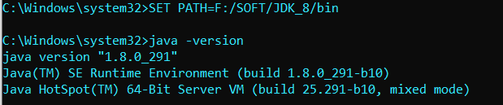

Fig 6.1 – JAVA 8

1. Download Hadoop and extract the files

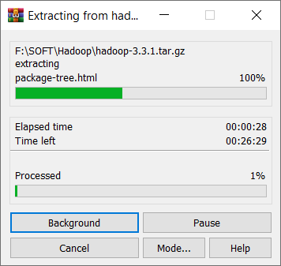

Fig 6.2 – Hadoop installation

1. Go To -> F:\SOFT\Hadoop\hadoop-3.3.1

create folder name "data"

1. Go To -> F:\SOFT\Hadoop\hadoop-3.3.1\data

create two folder name "datanode" and "namenode"

1. Go To -> F:\SOFT\Hadoop\hadoop-3.3.1\etc\hadoop

Edit files:

**core-site.xml**

Repalce <configuration> with below

<configuration>

<property>

<name>**fs.default.name**</name>

<value>**hdfs://localhost:9000**</value>

</property>

</configuration>

**hadoop-env.cmd**

Set JAVA_HOME

@rem The java implementation to use. Required.

**set** JAVA_HOME**=**F:\SOFT\JDK_8

**hdfs-site.xml**

Repalce <configuration> with below

<configuration>

<property>

<name>**dfs.replication**</name>

<!-- we are working on local computer so we set it to 1

by default it is 3-->

<value>**1**</value>

</property>

<property>

<name>**dfs.namenode.name.dir**</name>

<value>**file:///F:/SOFT/Hadoop/hadoop-3.3.1/data/namenode**</value>

</property>

<property>

<name>**dfs.datanode.data.dir**</name>

<value>**/F:/SOFT/Hadoop/hadoop-3.3.1/data/datanode**</value>

</property>

</configuration>

**mapred-site.xml**

Repalce <configuration> with below

<configuration>

<property>

<name>**mapreduce.framework.name**</name>

<value>**yarn**</value>

</property>

</configuration>

**yarn-site.xml**

Repalce <configuration> with below

<configuration>

<!-- Site specific YARN configuration properties -->

<property>

<name>**yarn.nodemanager.aux-services**</name>

<value>**mapreduce_shuffle**</value>

</property>

<property>

<name>**yarn.nodemanager.auxservices.mapreduce.shuffle.class**</name>

<value>**org.apache.hadoop.mapred.ShuffleHandler**</value>

</property>

</configuration>

1. Add to Path variable

F:\SOFT\Hadoop\hadoop-3.3.1\bin

F:\SOFT\Hadoop\hadoop-3.3.1\sbin

Create new Path

HADOOP_HOME

F:\SOFT\Hadoop\hadoop-3.3.1\bin

1. check installation

***>>hdfs namenode -format***

above command will give you warning that winutils.exe is missing.

so, download it and past it in the path that warning is showing

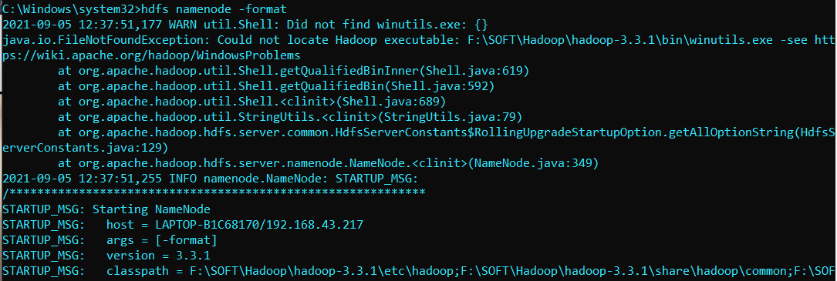

Fig 6.3 – winutil.exe

***>>start-dfs***

after above command if your datanode get shutdown than inspect error it will

cause by clusterID that is different from namenode's clusterID.

so, copy datanode's clusterID and run below command

***>>hdfs namenode -format -clusterID CID-4ee3ccb3-8bdb-42e9-9edb-a7f297540a77***

***>>start-dfs***

***>>start-yarn***

After above commands you have **new 4 cmd window** if any of them don’t get shutdown than installation is successful

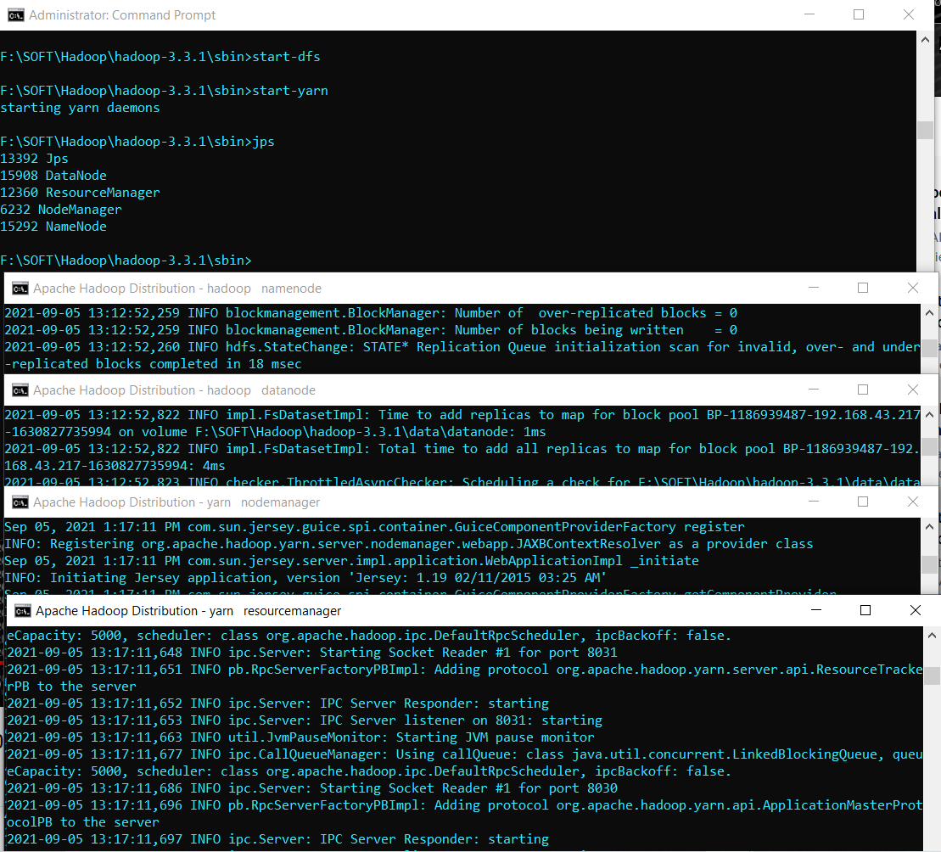

Fig 6.4 – Hadoop single node

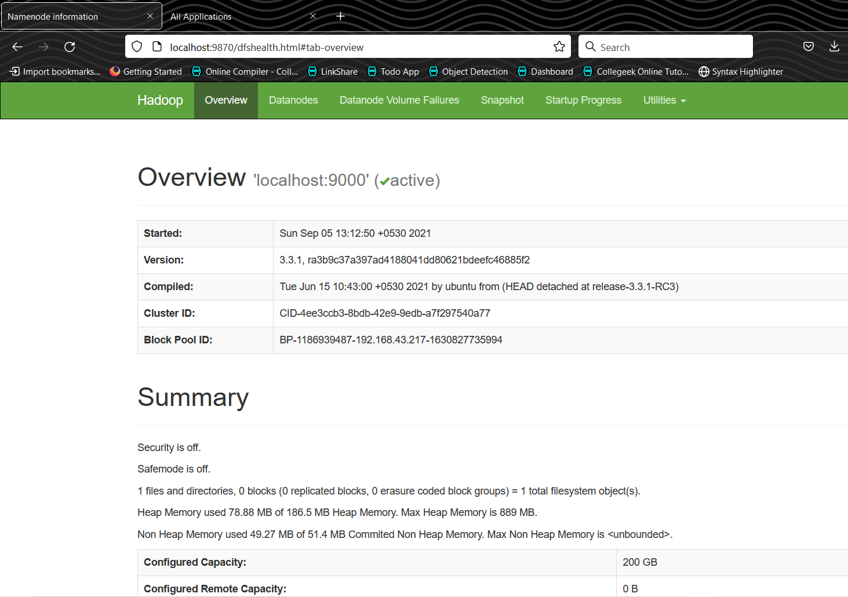

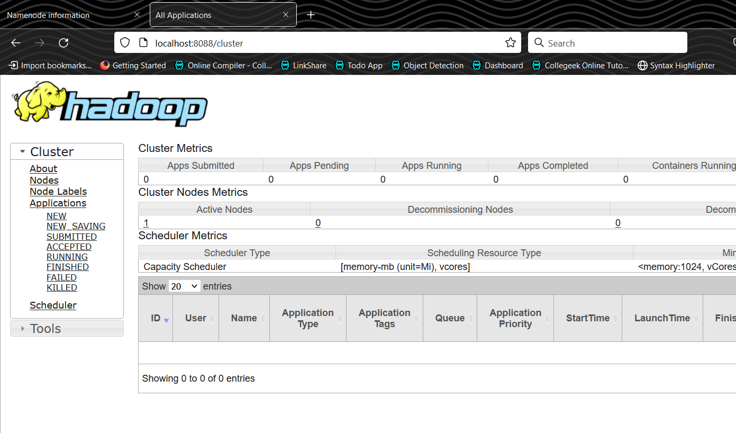

Fig 6.5 & Fig 6.6 – Hadoop web interface

1. close the hadoop

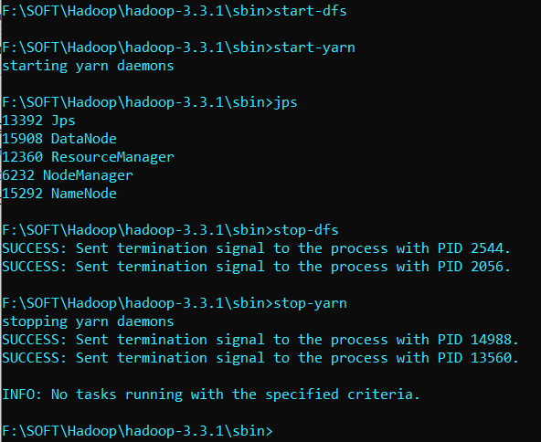

Fig 6.9 – closing of hadoop

**Multinode Hadoop Cluster**

Strat ec2 instance and install java and hadoop

Download the latet version of JAVA

add-apt-repository ppa:webupd8team/java && apt-get install oracle-java9-installer -y

Download the latest version of Hadoop Software.

wget <http://apache.mirror.gtcomm.net/hadoop/common/hadoop-2.9.0/hadoop-2.9.0.tar.gz>

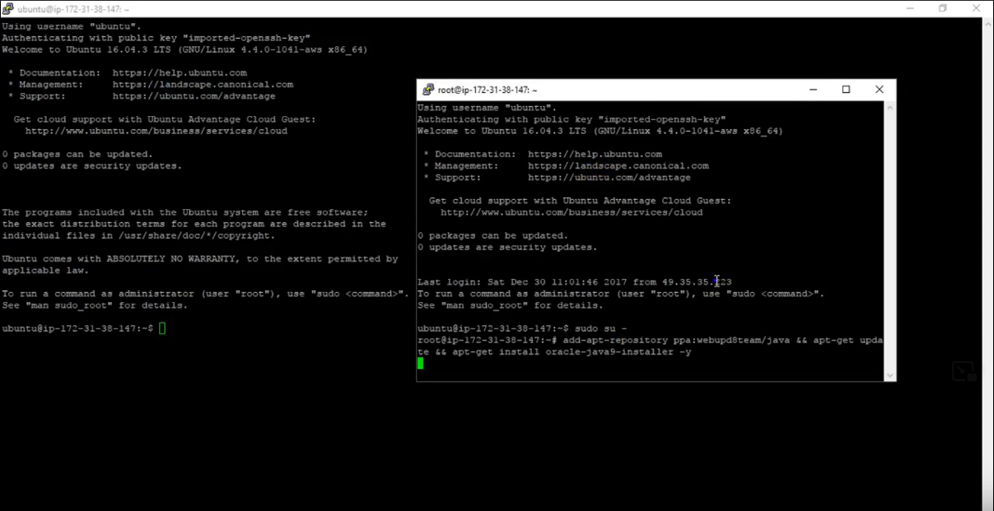

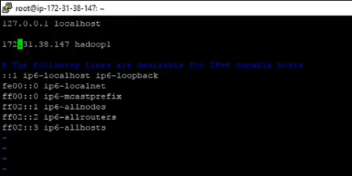 Fig 6.10 install java and hadoop

Fig 6.11 setup ip of instance

Create the required Hadoop. Users.

addgroup hadoop

adduser --ingroup hadoop yarn

adduser --ingroup hadoop hdfs

adduser --ingroup hadeep mapred

Create the required directories.

mkdir -p /opt/yarn/hadoop/

mkdir -p /var/data/hadoop/hdfs/nn

mkdir -p /var/data/hadoop/hdfs/snn

mkdir -p /var/data/hadoop/hdfs/dn

mkdir -p /var/data/hadoop/hdfs/tmp

chown -R hdfs:hadoop /var/data/

mkdir -p /var/log/hadoop/logs

chmod -R 777 /var/log/hadoop

chown -R yarn:hadoop /var/log/hadoop

chown -R hdfs:hadoop /opt/yarn/hadoop/

chmod -R 777 /opt/yarn/hadoop/

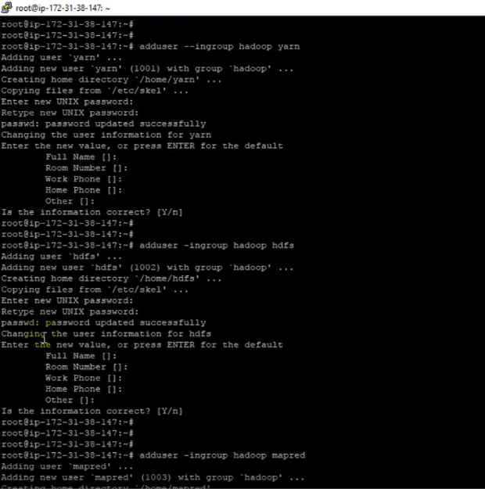

Fig 6.12 setup hadoop users

Edit all files that we have edited during single node hadoop cluster setup

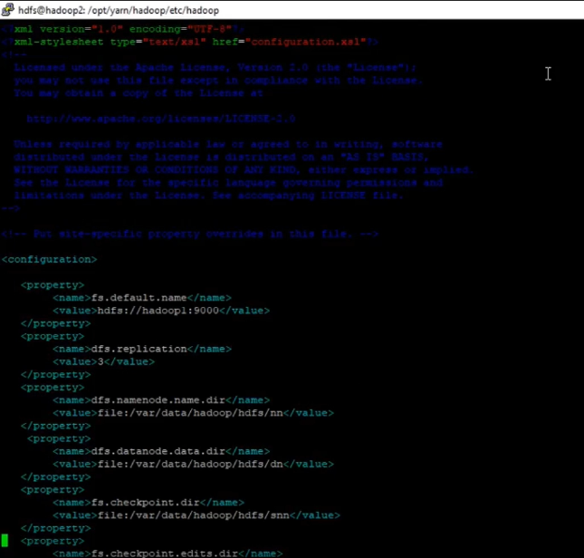

Fig 6.13 edit all xml files

After strat datanode and namenode

Than yarn service by

Start-dfs

Start-yarn

And Hadoop multimode setup is done.

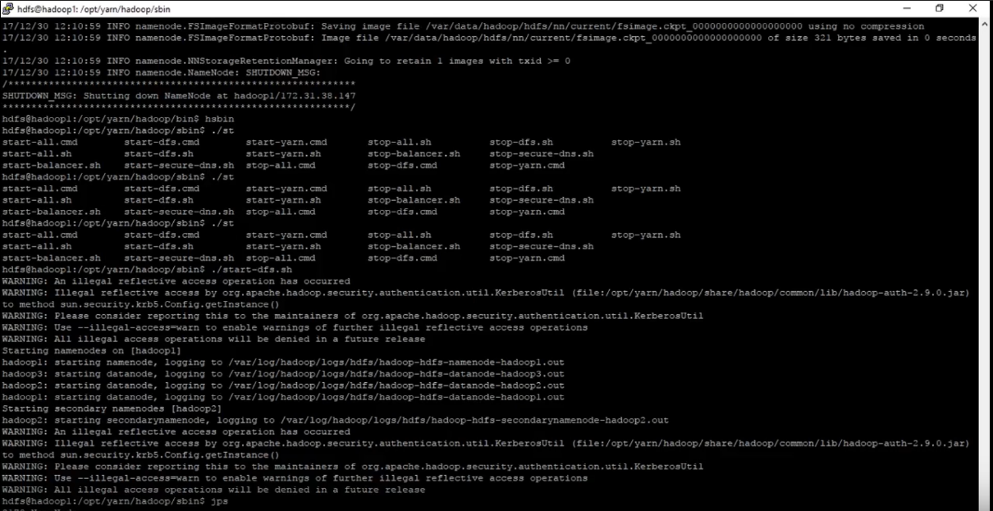

Fig 6.14 Hadoop multinode cluster setup

**Practical – 6**

**Aim:** To Develop a Map Reduce program for Word count for Hadoop cluster.

First we will create **input** directory to store input file **data.txt** that contains **some words** and we will use example program of **mapreduce.jar** to count word in data.txt file. Output will be storing in **out** directory.

HDFS: Hadoop Distributed File System

YARN: Yet Another Resource Negotiator

|  |
| --- |
| F:\SOFT\Hadoop\hadoop-3.3.1\sbin>start-dfs  F:\SOFT\Hadoop\hadoop-3.3.1\sbin>start-yarn  starting yarn daemons  F:\SOFT\Hadoop\hadoop-3.3.1\sbin>jps  10960 ResourceManager  7904 Jps  10916 NameNode  13336 NodeManager  10940 DataNode  F:\SOFT\Hadoop\hadoop-3.3.1\sbin>hadoop fs -mkdir /input  F:\SOFT\Hadoop\hadoop-3.3.1\sbin>hadoop fs -put "F:\work of pro\SEM7\3170722-Big Data\data.txt" /input  F:\SOFT\Hadoop\hadoop-3.3.1\sbin>hadoop fs -ls /input  Found 1 items  -rw-r--r-- 1 gabur supergroup 110 2021-09-05 15:04 /input/data.txt  F:\SOFT\Hadoop\hadoop-3.3.1\sbin>hadoop fs -cat /input/data.txt  big data  hadoop  hi  hello  good  big data  big data  hadoop  hello  good  bad  morning  hadoop  big data  hi  F:\SOFT\Hadoop\hadoop-3.3.1\sbin>hadoop jar F:\SOFT\Hadoop\hadoop-3.3.1\share\hadoop\mapreduce\hadoop-mapreduce-examples-3.3.1.jar  An example program must be given as the first argument.  Valid program names are:  aggregatewordcount: An Aggregate based map/reduce program that counts the words in the input files.  aggregatewordhist: An Aggregate based map/reduce program that computes the histogram of the words in the input files.  bbp: A map/reduce program that uses Bailey-Borwein-Plouffe to compute exact digits of Pi.  dbcount: An example job that count the pageview counts from a database.  distbbp: A map/reduce program that uses a BBP-type formula to compute exact bits of Pi.  grep: A map/reduce program that counts the matches of a regex in the input.  join: A job that effects a join over sorted, equally partitioned datasets  multifilewc: A job that counts words from several files.  pentomino: A map/reduce tile laying program to find solutions to pentomino problems.  pi: A map/reduce program that estimates Pi using a quasi-Monte Carlo method.  randomtextwriter: A map/reduce program that writes 10GB of random textual data per node.  randomwriter: A map/reduce program that writes 10GB of random data per node.  secondarysort: An example defining a secondary sort to the reduce.  sort: A map/reduce program that sorts the data written by the random writer.  sudoku: A sudoku solver.  teragen: Generate data for the terasort  terasort: Run the terasort  teravalidate: Checking results of terasort  wordcount: A map/reduce program that counts the words in the input files.  wordmean: A map/reduce program that counts the average length of the words in the input files.  wordmedian: A map/reduce program that counts the median length of the words in the input files.  wordstandarddeviation: A map/reduce program that counts the standard deviation of the length of the words in the input files.  F:\SOFT\Hadoop\hadoop-3.3.1\sbin>hadoop jar F:\SOFT\Hadoop\hadoop-3.3.1\share\hadoop\mapreduce\hadoop-mapreduce-examples-3.3.1.jar wordcount /input /out  2021-09-05 15:15:28,223 INFO client.DefaultNoHARMFailoverProxyProvider: Connecting to ResourceManager at /0.0.0.0:8032  2021-09-05 15:15:29,775 INFO mapreduce.JobResourceUploader: Disabling Erasure Coding for path: /tmp/hadoop-yarn/staging/gabur/.staging/job_1630834150687_0001  2021-09-05 15:15:30,184 INFO input.FileInputFormat: Total input files to process : 1  2021-09-05 15:15:30,569 INFO mapreduce.JobSubmitter: number of splits:1  2021-09-05 15:15:30,827 INFO mapreduce.JobSubmitter: Submitting tokens for job: job_1630834150687_0001  2021-09-05 15:15:30,828 INFO mapreduce.JobSubmitter: Executing with tokens: []  2021-09-05 15:15:31,148 INFO conf.Configuration: resource-types.xml not found  2021-09-05 15:15:31,149 INFO resource.ResourceUtils: Unable to find 'resource-types.xml'.  2021-09-05 15:15:31,719 INFO impl.YarnClientImpl: Submitted application application_1630834150687_0001  2021-09-05 15:15:31,787 INFO mapreduce.Job: The url to track the job: http://LAPTOP-B1C68170:8088/proxy/application_1630834150687_0001/  2021-09-05 15:15:31,789 INFO mapreduce.Job: Running job: job_1630834150687_0001  2021-09-05 15:15:44,011 INFO mapreduce.Job: Job job_1630834150687_0001 running in uber mode : false  2021-09-05 15:15:44,013 INFO mapreduce.Job: map 0% reduce 0%  2021-09-05 15:15:50,102 INFO mapreduce.Job: map 100% reduce 0%  2021-09-05 15:15:57,181 INFO mapreduce.Job: map 100% reduce 100%  2021-09-05 15:15:58,204 INFO mapreduce.Job: Job job_1630834150687_0001 completed successfully  2021-09-05 15:15:58,363 INFO mapreduce.Job: Counters: 54  File System Counters  FILE: Number of bytes read=96  FILE: Number of bytes written=548319  FILE: Number of read operations=0  FILE: Number of large read operations=0  FILE: Number of write operations=0  HDFS: Number of bytes read=211  HDFS: Number of bytes written=58  HDFS: Number of read operations=8  HDFS: Number of large read operations=0  HDFS: Number of write operations=2  HDFS: Number of bytes read erasure-coded=0  Job Counters  Launched map tasks=1  Launched reduce tasks=1  Data-local map tasks=1  Total time spent by all maps in occupied slots (ms)=4236  Total time spent by all reduces in occupied slots (ms)=4756  Total time spent by all map tasks (ms)=4236  Total time spent by all reduce tasks (ms)=4756  Total vcore-milliseconds taken by all map tasks=4236  Total vcore-milliseconds taken by all reduce tasks=4756  Total megabyte-milliseconds taken by all map tasks=4337664  Total megabyte-milliseconds taken by all reduce tasks=4870144  Map-Reduce Framework  Map input records=15  Map output records=19  Map output bytes=173  Map output materialized bytes=96  Input split bytes=101  Combine input records=19  Combine output records=8  Reduce input groups=8  Reduce shuffle bytes=96  Reduce input records=8  Reduce output records=8  Spilled Records=16  Shuffled Maps =1  Failed Shuffles=0  Merged Map outputs=1  GC time elapsed (ms)=109  CPU time spent (ms)=1855  Physical memory (bytes) snapshot=496582656  Virtual memory (bytes) snapshot=743444480  Total committed heap usage (bytes)=347602944  Peak Map Physical memory (bytes)=295948288  Peak Map Virtual memory (bytes)=414810112  Peak Reduce Physical memory (bytes)=200634368  Peak Reduce Virtual memory (bytes)=328728576  Shuffle Errors  BAD_ID=0  CONNECTION=0  IO_ERROR=0  WRONG_LENGTH=0  WRONG_MAP=0  WRONG_REDUCE=0  File Input Format Counters  Bytes Read=110  File Output Format Counters  Bytes Written=58  F:\SOFT\Hadoop\hadoop-3.3.1\sbin>hadoop fs -ls /out  Found 2 items  -rw-r--r-- 1 gabur supergroup 0 2021-09-05 15:15 /out/_SUCCESS  -rw-r--r-- 1 gabur supergroup 58 2021-09-05 15:15 /out/part-r-00000  F:\SOFT\Hadoop\hadoop-3.3.1\sbin>hadoop fs -cat /out/*  bad 1  big 4  data 4  good 2  hadoop 3  hello 2  hi 2  morning 1 |

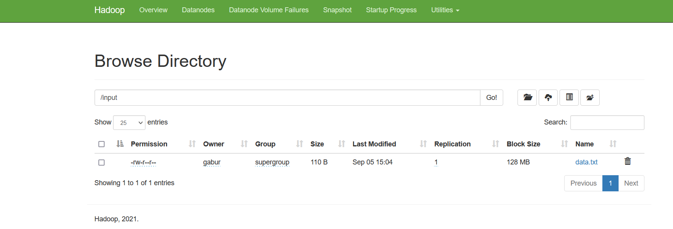

Fig 8.1 data.txt

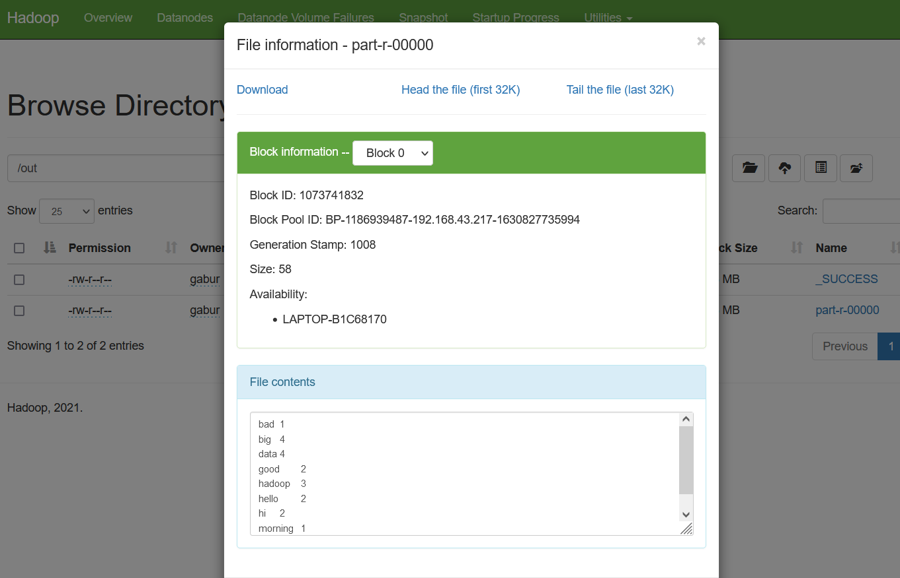

Fig 8.2 output of word count

**Practical – 7**

**Aim:** To study stream mining using case study approach.

**Introduction:**

**Data Stream Mining** (also known as stream learning) is the process of extracting knowledge structures from continuous, rapid data records. A data stream is an ordered sequence of instances that in many applications of data stream mining can be read only once or a small number of times using limited computing and storage capabilities.

In many data stream mining applications, **the goal** is to predict the class or value of new instances in the data stream given some knowledge about the class membership or values of previous instances in the data stream.

Machine learning techniques can be used to learn this prediction task from labeled examples in an automated fashion. Often, concepts from the field of incremental learning are applied to cope with structural changes, on-line learning and real-time demands. In many applications, especially operating within non-stationary environments, the distribution underlying the instances or the rules underlying their labeling may change over time, i.e. the goal of the prediction, **the class to be predicted or the target value to be predicted, may change over time**. This problem is referred to as **concept drift**. Detecting concept drift is a **central issue** to data stream mining. Other challenges that arise when applying machine learning to streaming data include: **partially and delayed labeled data, recovery from concept drifts, and temporal dependencies**.

Examples of data streams include computer network traffic, phone conversations, ATM transactions, web searches, and sensor data. **Data stream mining** can be considered a subfield of data mining, machine learning, and knowledge discovery.

**Data-Stream-Management System:**

We can view a stream processor as a kind of data-management system, the high-level organization of which is suggested in Fig. Any number of streams can enter the system.

Each stream can provide elements at its own schedule; they need not have the same data rates or data types, and the time between elements of one stream need not be uniform. The fact that the rate of arrival of stream elements is not under the control of the system distinguishes stream processing from the processing of data that goes on within a database-management system.

The latter system controls the rate at which data is read from the disk, and therefore never has to worry about data getting lost as it attempts to execute queries. Streams may be archived in a large archival store, but we assume it is not possible to answer queries from the archival store. It could be examined only under special circumstances using time-consuming retrieval processes.

There is also a working store, into which summaries or parts of streams may be placed, and which can be used for answering queries. The working store might be disk, or it might be main memory, depending on how fast we need to process queries.But either way, it is of sufficiently limited capacity that it cannot store all the data from all the streams.

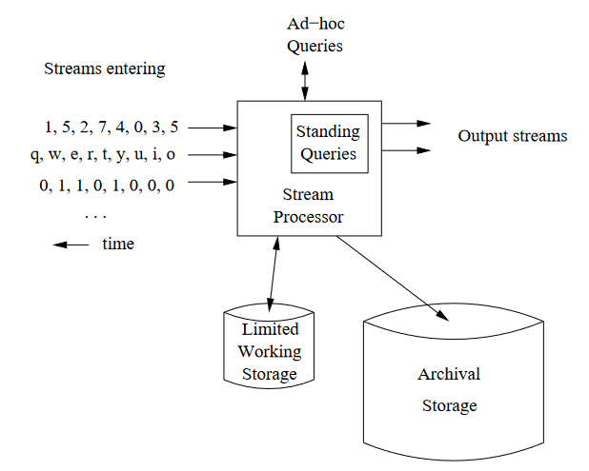

Fig 7.1 data-stream-management system

**Examples of Stream Sources:**

**Sensor Data**

Imagine a temperature sensor bobbing about in the ocean, sending back to a base station a reading of the surface temperature each hour. The data produced by this sensor is a stream of real numbers. It is not a very interesting stream, since the data rate is so low. It would not stress modern technology, and the entire stream could be kept in main memory, essentially forever.

Now, give the sensor a GPS unit, and let it report surface height instead of temperature.

The surface height varies quite rapidly compared with temperature, so we might have the sensor send back a reading every tenth of a second. If it sends a 4-byte real number each time, then it produces 3.5 megabytes per day. It will still take some time to fill up main memory, let alone a single disk. But one sensor might not be that interesting.

To learn something about ocean behavior, we might want to deploy a million sensors, each sending back a stream, at the rate of ten per second. A million sensors isn’t very many; there would be one for every 150 square miles of ocean. Now we have 3.5 terabytes arriving every day, and we definitely need to think about what can be kept in working storage and what can only be archived.

**Image Data**

Satellites often send down to earth streams consisting of many terabytes of images per day. Surveillance cameras produce images with lower resolution than satellites, but there can be many of them, each producing a stream of images at intervals like one second. London is said to have six million such cameras, each producing a stream.

**Internet and Web Traffic**

A switching node in the middle of the Internet receives streams of IP packets from many inputs and routes them to its outputs. Normally, the job of the switch is to transmit data and not to retain it or query it. But there is a tendency to put more capability into the switch, e.g., the ability to detect denial-of-service attacks or the ability to reroute packets based on information about congestion in the network. Web sites receive streams of various types. For example, Google receives several hundred million search queries per day. Yahoo! accepts billions of “clicks” per day on its various sites. Many interesting things can be learned from these streams.

**Data stream mining methods:**

For extracting knowledge or patterns from data streams, it is crucial to develop methods that analyze and process streams of data in multidimensional, multi-level, single pass and online manner. These methods should not be limited to data streams only, because they are also needed when we have large volume of data. Moreover, because of the limitation of data streams, the proposed methods are based on statistic, calculation and complexity theories. For example, by using summarization techniques that are derived from statistic science, we can confront with memory limitation. In addition, some of the techniques in computation theory can be used for implementing time and space efficient algorithms. By using these techniques we can also use common data mining approaches by enforcing some changes in data streams. Some solutions have been proposed based on data stream mining problems and challenges.

These solutions can be categorized to data-based and task-based solutions. This classification is depicted in Fig 7.2. Data-based techniques refer to summarizing the whole dataset or choosing a subset of the incoming stream to be analyzed. Sampling, load and sketching techniques represent the former one. Synopsis data structures and aggregation represent the later one. Task-based techniques are those methods that modify existing techniques or invent new ones in order to address the computational challenges of data stream processing. Approximation algorithms, sliding window and algorithm output granularity represent this category.

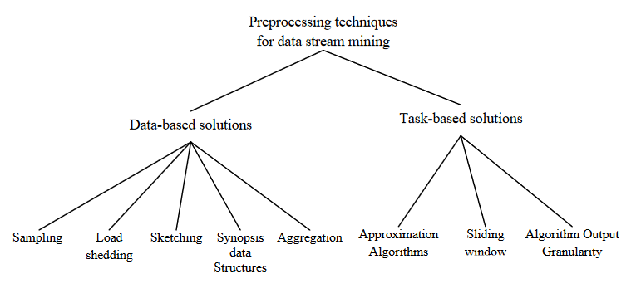

Fig 7.2 classification of data stream methods

**Sampling** refers to the process of probabilistic choice of a data item to be processed or not. The problem with using sampling in the context of data stream analysis is the unknown dataset size. Thus the treatment of data stream should follow a special analysis to find the error bounds. Another problem with sampling is that it would be important to check for anomalies for surveillance analysis as an application in mining data streams. Sampling may not be the right choice for such an application. Sampling also does not address the problem of fluctuating data rates. It would be worth investigating the relationship among the three parameters: data rate, sampling rate and error bounds.

**Load shedding** refers to the process of dropping a sequence of data streams. Load shedding has been used successfully in querying data streams. It has the same problems of sampling. Load shedding is difficult to be used with mining algorithms because it drops chunks of data streams that could be used in the structuring of the generated models or it might represent a pattern of interest in time series analysis.

**Sketching** is the process of randomly project a subset of the features. It is the process of vertically sample the incoming stream. Sketching has been applied in comparing different data streams and in aggregate queries. The major drawback of sketching is that of accuracy. It is hard to use it in the context of data stream mining.

**Creating synopsis** of data refers to the process of applying summarization techniques that are capable of summarizing the incoming stream for further analysis. Wavelet analysis, histograms, quantiles and frequency moments have been proposed as synopsis data structures. Since synopsis of data does not represent all the characteristics of the dataset, approximate answers are produced when using such data structures.

The process in which the input stream is represented in a summarized form is called **Aggregation**. This aggregate data can be used in data mining algorithms. The main problem of this method is that highly fluctuating data distributions reduce the method’s efficiency.

**Approximation algorithms** have their roots in algorithm design. It is concerned with design algorithms for computationally hard problems. These algorithms can result in an approximate solution with error bounds. The idea is that mining algorithms are considered hard computational problems given its features of continuality and speed and the generating environment that is featured by being resource constrained. Approximation algorithms have attracted researchers as a direct solution to data stream mining problems. However, the problem of data rates with regard with the available resources could not be solved using approximation algorithms. Other tools should be used along with these algorithms in order to adapt to the available resources. Approximation algorithms have been used in.

The inspiration behind **sliding window** is that the user is more concerned with the analysis of most recent data streams. Thus the detailed analysis is done over the most recent data items and summarized versions of the old ones.

The **algorithm output granularity (AOG)** introduces the first resource-aware data analysis approach that can cope with fluctuating very high data rates according to the available memory and the processing speed represented in time constraints. The AOG performs the local data analysis on a resource constrained device that generates or receive streams of information. AOG has three main stages. Mining followed by adaptation to resources and data stream rates represent the first two stages. Merging the generated knowledge structures when running out of memory represents the last stage. AOG has been used in clustering, classification and frequency counting. The function of the AOG algorithm is depicted in

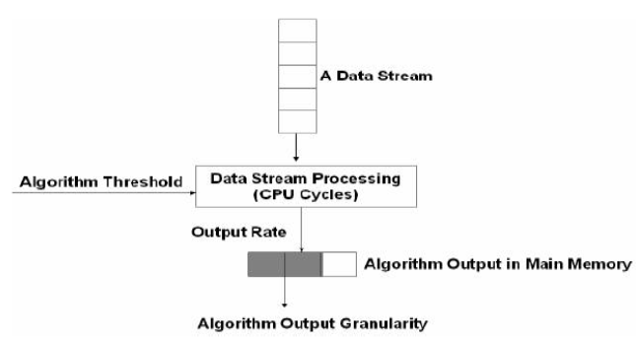

Fig 7.3 The AOG algorithm

**Classification of data stream challenges:**

There are different challenges in data stream mining that cause many research issues in this field. Regarding to data stream requirements, developing stream mining algorithms is needed more studying than traditional mining methods. We can classify stream mining challenges in 5 categories;

Irregular rate of arrival and variant data

Arrival rate over time,

Quality of mining results,

Bounded memory size and huge amount of data streams,

Limited resources, e.g., memory space and computation power and to facilitate data analysis and take a quick decision for users. In the following each of them will be described.

One of the most important issues in data stream mining is optimization of memory space consumed by the mining algorithm. Memory management is a main challenge in stream processing because many real data streams have irregular arrival rate and variation of data arrival rate over time. In many applications like sensor networks, stream mining algorithms with high memory cost is not applicable. Therefore, it is necessary to develop summarizing techniques for collecting valuable information from data streams. Data pre-processing is an important and time consuming phase in the knowledge discovery process and must be taken into consideration when mining data streams. Designing a light-weight preprocessing techniques that can guarantee quality of the mining results is crucial. The challenge here is to automate such a process and integrate it with the mining techniques.

By considering the size of memory and the huge amount of data stream that continuously arrive to the system, it is needed to have a compact data structure to store, update and retrieve the collected information. Without such a data structure, the efficiency of mining algorithm will largely decrease. Even if we store the information in disks, the additional I/O operations will increase the processing time.

While it is impossible to rescan the entire input data, incremental maintaining of data structure is indispensable. Furthermore, novel indexing, storage and querying techniques are required to manage continuous and changing flow of data streams. It is crucial to consider the limited resources such as memory space and computation power for reaching accurate estimates in data streams mining. If stream data mining algorithms consume the available resources without any consideration, the accuracy of their results would decrease dramatically. In several papers this issue is discussed and their solutions for resource-aware mining are proposed. One of the proposed solutions is AOG which use a control parameter to control its output rate according to memory, time constraints and data stream rate. Also in another algorithm is proposed that not only reduces the memory required for data storage but also retains good approximation given limited resources like memory space and computation power.

Visualization is a powerful way to facilitate data analysis. Absence of suitable tools for visualization of mining result makes many problems in data analysis and quick decision making by user. This challenge still is a research issue that one of the proposed approaches is intelligent monitoring.

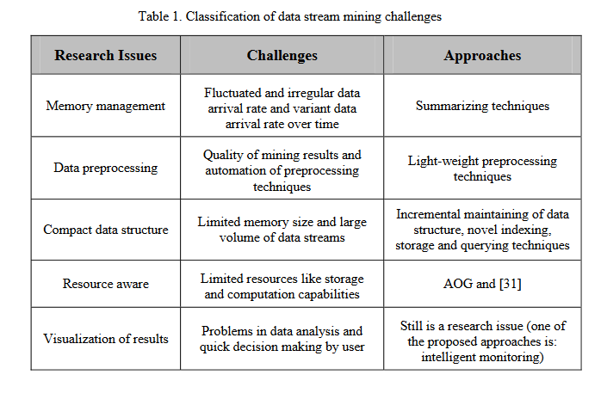

Fig 7.3 Classification of data stream mining challenges

**Practical – 8**

**Aim:** To demonstrate Pig and Hive SQL queries using various operators.

|  |
| --- |
| F:\SOFT\pig\pig-0.17.0\bin>pig -x local  2021-09-27 19:02:27,629 INFO pig.ExecTypeProvider: Trying ExecType : LOCAL  2021-09-27 19:02:27,630 INFO pig.ExecTypeProvider: Picked LOCAL as the ExecType  2021-09-27 19:02:27,958 [main] INFO org.apache.pig.Main - Apache Pig version 0.17.0 (r1797386) compiled Jun 02 2017, 15:41:58  2021-09-27 19:02:27,959 [main] INFO org.apache.pig.Main - Logging error messages to: F:\SOFT\Hadoop\hadoop-3.3.1\logs\pig_1632749547955.log  2021-09-27 19:02:27,980 [main] INFO org.apache.pig.impl.util.Utils - Default bootup file C:\Users\gabur/.pigbootup not found  2021-09-27 19:02:28,130 [main] INFO org.apache.hadoop.conf.Configuration.deprecation - mapred.job.tracker is deprecated. Instead, use mapreduce.jobtracker.address  2021-09-27 19:02:28,132 [main] INFO org.apache.pig.backend.hadoop.executionengine.HExecutionEngine - Connecting to hadoop file system at: file:///  2021-09-27 19:02:28,428 [main] INFO org.apache.hadoop.conf.Configuration.deprecation - io.bytes.per.checksum is deprecated. Instead, use dfs.bytes-per-checksum  2021-09-27 19:02:28,456 [main] INFO org.apache.pig.PigServer - Pig Script ID for the session: PIG-default-ba48df0c-6cea-44d2-9782-69f8b73cce92  2021-09-27 19:02:28,456 [main] WARN org.apache.pig.PigServer - ATS is disabled since yarn.timeline-service.enabled set to false  grunt> agriculture= LOAD 'F:/work of pro/SEM7/3170722-Big Data/archive/crop_production.csv' using PigStorage (',') as ( State_Name:chararray , District_Name:chararray , Crop_Year:int , Season:chararray , Crop:chararray , Area:int , Production:int );  2021-09-27 19:03:34,719 [main] INFO org.apache.hadoop.conf.Configuration.deprecation - io.bytes.per.checksum is deprecated. Instead, use dfs.bytes-per-checksum  grunt> describe agriculture;  agriculture: {State_Name: chararray,District_Name: chararray,Crop_Year: int,Season: chararray,Crop: chararray,Area: int,Production: int}  grunt> statewisecrop = GROUP agriculture BY State_Name;  grunt> desc  desc describe  grunt> describe statewisecrop;  statewisecrop: {group: chararray,agriculture: {(State_Name: chararray,District_Name: chararray,Crop_Year: int,Season: chararray,Crop: chararray,Area: int,Production: int)}}  grunt> STORE statewisecrop INTO 'F:/work of pro/SEM7/3170722-Big Data/archive/statewiseinfo';  HadoopVersion PigVersion UserId StartedAt FinishedAt Features  3.3.1 0.17.0 gabur 2021-09-27 19:06:08 2021-09-27 19:06:13 GROUP_BY  Success!  Job Stats (time in seconds):  JobId Maps Reduces MaxMapTime MinMapTime AvgMapTime MedianMapTime MaxReduceTime MinReduceTime  AvgReduceTime MedianReducetime Alias Feature Outputs  job_local2107346029_0001 1 1 n/a n/a n/a n/a n/a n/a n/a n/a agriculture,statewisecrop GROUP_BY F:/work of pro/SEM7/3170722-Big Data/archive/statewiseinfo,  Input(s):  Successfully read 246092 records from: "F:/work of pro/SEM7/3170722-Big Data/archive/crop_production.csv"  Output(s):  Successfully stored 34 records in: "F:/work of pro/SEM7/3170722-Big Data/archive/statewiseinfo"  Counters:  Total records written : 34  Total bytes written : 0  Spillable Memory Manager spill count : 0  Total bags proactively spilled: 0  Total records proactively spilled: 0  Job DAG:  job_local2107346029_0001  grunt> cropinfo = FOREACH( GROUP agriculture BY Crop )  >> GENERATE group AS Crop, SUM(agriculture.Area) as AreaPerCrop ,  >> SUM(agriculture.Production) as ProductionPerCrop;  2021-09-27 19:10:10,159 [main] INFO org.apache.hadoop.conf.Configuration.deprecation - io.bytes.per.checksum is deprecated. Instead, use dfs.bytes-per-checksum  grunt> describe cropinfo;  cropinfo: {Crop: chararray,AreaPerCrop: long,ProductionPerCrop: long}  F:\SOFT\hive\apache-hive-2.3.9-bin\bin>hive  SLF4J: Class path contains multiple SLF4J bindings.  SLF4J: Found binding in [jar:file:/F:/SOFT/hive/apache-hive-2.3.9-bin/lib/log4j-slf4j-impl-2.6.2.jar!/org/slf4j/impl/StaticLoggerBinder.class]  SLF4J: Found binding in [jar:file:/F:/SOFT/Hadoop/hadoop-3.3.1/share/hadoop/common/lib/slf4j-log4j12-1.7.30.jar!/org/slf4j/impl/StaticLoggerBinder.class]  SLF4J: See http://www.slf4j.org/codes.html#multiple_bindings for an explanation.  SLF4J: Actual binding is of type [org.apache.logging.slf4j.Log4jLoggerFactory]  2021-09-27T16:49:32,538 INFO [main] org.apache.hadoop.hive.conf.HiveConf - Found configuration file file:/F:/SOFT/hive/apache-hive-2.3.9-bin/conf/hive-site.xml  hive> create database demo;  OK  Time taken: 6.606 seconds  hive> show databases;  OK  default  demo  Time taken: 0.179 seconds, Fetched: 2 row(s)  hive> create table demo.employee (Id int, Name string , Salary float);  OK  Time taken: 2.333 seconds  hive> describe demo.employee;  OK  id int  name string  salary float  Time taken: 0.403 seconds, Fetched: 3 row(s)  hive> INSERT INTO TABLE employee VALUES (1, 'Gaurav' ,30000),(2, 'Aryan' ,20000),(3, 'Vishal' ,40000),(4, 'Siddharth' ,60000),(5, 'Henry' ,25000),(6, 'Chirag' ,60000),(7, 'Lisa' ,25000),(8, 'Ronit' ,20000);  Loading data to table demo.employee  MapReduce Jobs Launched:  Stage-Stage-1: Map: 1 Cumulative CPU: 3.061 sec HDFS Read: 4645 HDFS Write: 204 SUCCESS  Total MapReduce CPU Time Spent: 3 seconds 61 msec  OK  Time taken: 28.138 seconds  hive> select * from employee;  OK  1 Gaurav 30000.0  2 Aryan 20000.0  3 Vishal 40000.0  4 Siddharth 60000.0  5 Henry 25000.0  6 Chirag 60000.0  7 Lisa 25000.0  8 Ronit 20000.0  Time taken: 0.839 seconds, Fetched: 8 row(s)  hive> select id, name, (salary * 10) /100 from employee;  OK  1 Gaurav 3000.0  2 Aryan 2000.0  3 Vishal 4000.0  4 Siddharth 6000.0  5 Henry 2500.0  6 Chirag 6000.0  7 Lisa 2500.0  8 Ronit 2000.0  Time taken: 0.938 seconds, Fetched: 8 row(s)  hive> select * from employee where salary >= 25000;  OK  1 Gaurav 30000.0  3 Vishal 40000.0  4 Siddharth 60000.0  5 Henry 25000.0  6 Chirag 60000.0  7 Lisa 25000.0  Time taken: 0.943 seconds, Fetched: 6 row(s)  hive> select Id, Name, sqrt(Salary) from employee;  OK  1 Gaurav 173.20508075688772  2 Aryan 141.4213562373095  3 Vishal 200.0  4 Siddharth 244.94897427831782  5 Henry 158.11388300841898  6 Chirag 244.94897427831782  7 Lisa 158.11388300841898  8 Ronit 141.4213562373095  Time taken: 0.654 seconds, Fetched: 8 row(s) |

**Practical – 9**

**Aim:** To show the Installation steps for the SPARK on single node system.

Step1: Download SPARK and extract the files

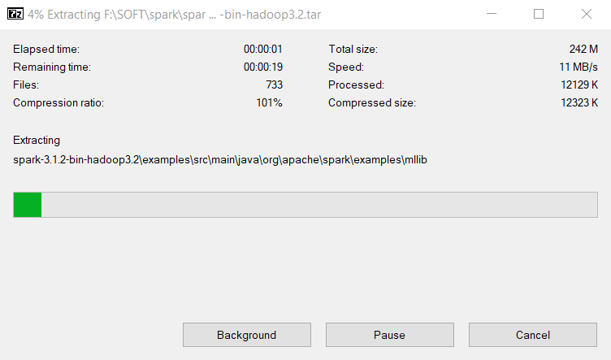

Fig 9.1 spark installation

Step 2: download winutils.exe and set up path variable

SPARK_HOME

F:\SOFT\spark\spark-3.1.2-bin-hadoop3.2

In Path

%SPARK_HOME%\bin

Already setup winutils.exe in Hadoop installation

Step 3: check installation

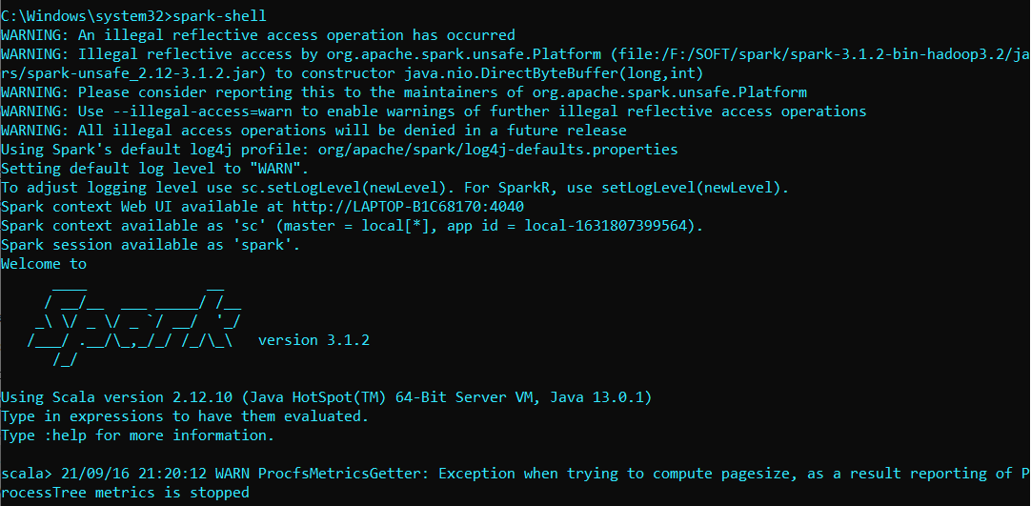

Fig 9.2 – Spark shell

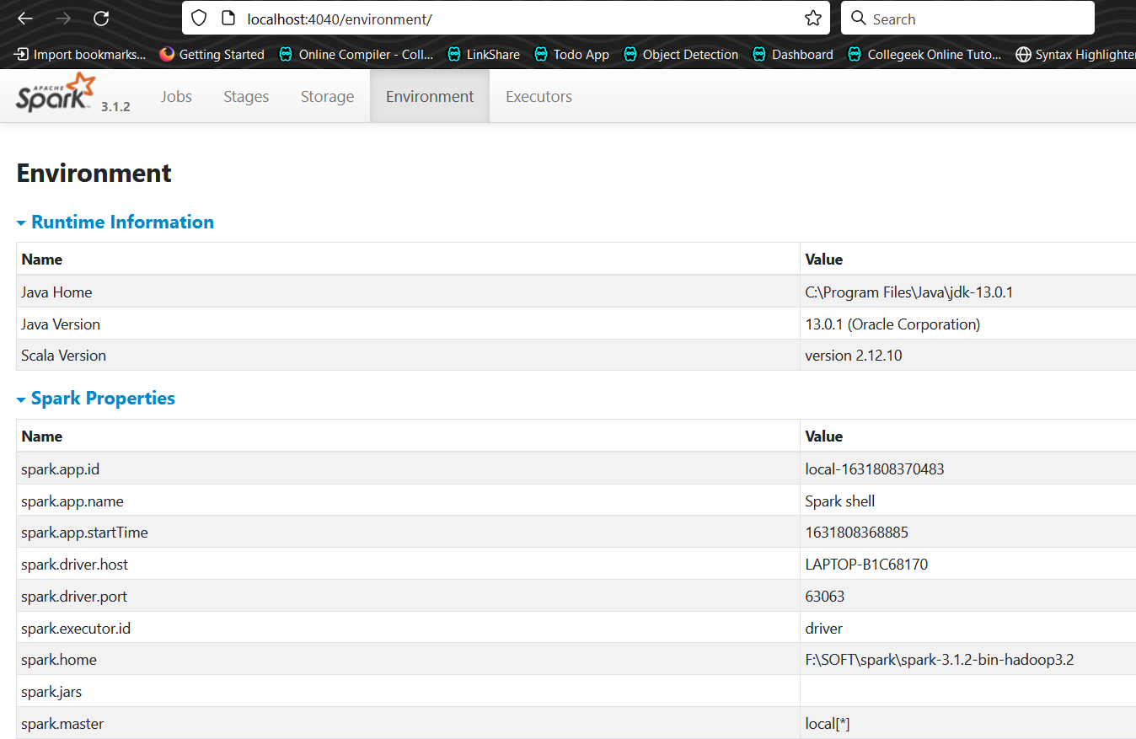

Fig 9.3 – Spark UI

**Practical – 10**

**Aim:** Develop a word count program using SPARK.

First start hadoop ***start-dfs*** for input file that contains list of words.

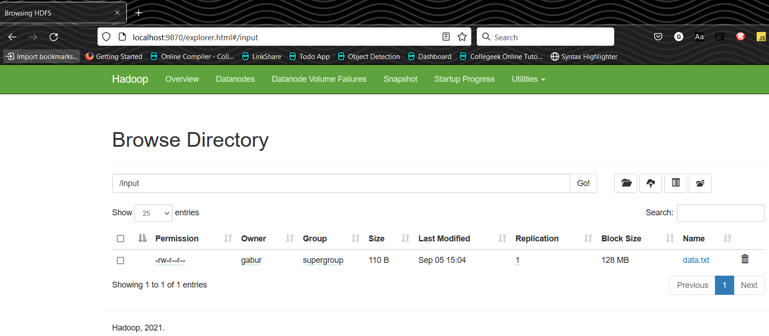

Fig 10.1 – Hadoop files

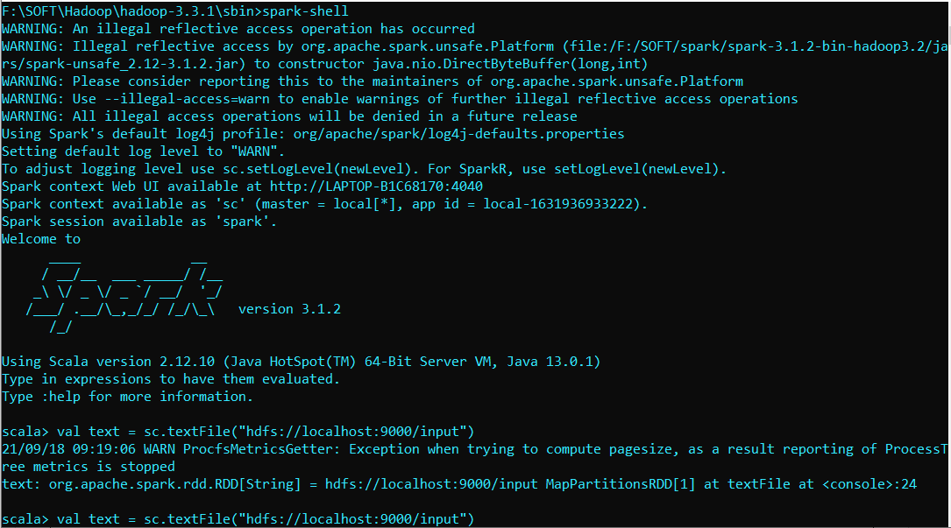

Fig 10.2 – Spark input file

Using spark action we can see file content.

|  |
| --- |
| scala> text.collect;  res0: Array[String] = Array(big data, hadoop, hi, hello, good, big data, big data, hadoop, hello, good, bad, morning, hadoop, big data, hi) |

Create Map of string => int for every word in file.

|  |
| --- |
| scala> val mapf = text.map(word => (word,1))  mapf: org.apache.spark.rdd.RDD[(String, Int)] = MapPartitionsRDD[4] at map at <console>:25  scala> mapf.collect;  res1: Array[(String, Int)] = Array((big data,1), (hadoop,1), (hi,1), (hello,1), (good,1), (big data,1), (big data,1), (hadoop,1), (hello,1), (good,1), (bad,1), (morning,1), (hadoop,1), (big data,1), (hi,1)) |

Reduce map to get count of words

|  |
| --- |
| scala> val reducef = mapf.reduceByKey(_+_);  reducef: org.apache.spark.rdd.RDD[(String, Int)] = ShuffledRDD[5] at reduceByKey at <console>:25  scala> reducef.collect;  res2: Array[(String, Int)] = Array((big data,4), (hello,2), (morning,1), (hadoop,3), (hi,2), (bad,1), (good,2))  scala> reducef.collect.foreach(println)  (big data,4)  (hello,2)  (morning,1)  (hadoop,3)  (hi,2)  (bad,1)  (good,2)  scala> val tablef = reducef.toDF("word","count")  tablef: org.apache.spark.sql.DataFrame = [word: string, count: int]  scala> tablef.collect;  res4: Array[org.apache.spark.sql.Row] = Array([big data,4], [hello,2], [morning,1], [hadoop,3], [hi,2], [bad,1], [good,2])  scala> tablef.show;  +--------+-----+  | word|count|  +--------+-----+  |big data| 4|  | hello| 2|  |morning| 1|  | hadoop| 3|  | hi| 2|  | bad| 1|  | good| 2|  +--------+-----+  scala> :quit  F:\SOFT\Hadoop\hadoop-3.3.1\sbin>stop-dfs  SUCCESS: Sent termination signal to the process with PID 17560.  SUCCESS: Sent termination signal to the process with PID 4964. |

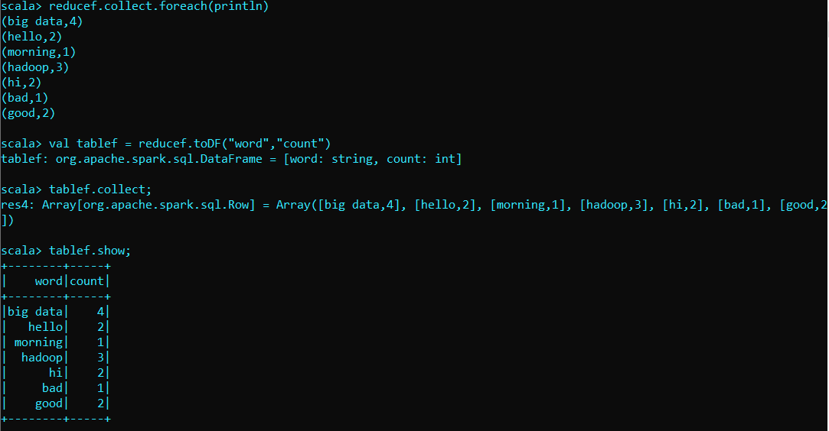

Fig 10.3 word count