

COURSE: CSC262 – INTRODUCTION TO ARTIFICIAL INTELLIGENCE
SUDOKU SOLVER
An Intelligent Puzzle Solver Using Hybrid CSP and Backtracking

Group # 09
Muhammad Nafay Anjum (FA24-BCS-078)
Sidra Tul Muntaha (FA24-BCS-097)

SUBMITTED TO: Ms. Farah Saeed

SUBMISSION DATE: 4th April 2026

Table of Contents
No. | Section Title | Pg
— | Abstract | 4
1 | Introduction | 5
2 | Proposed System | 5
3 | Advantages / Benefits | 6
— | Objectives | 6
4 | Scope | 7
 | 4.1 In-Scope Features | 7
 | 4.2 Out-of-Scope Features | 8
5 | Modules | 8
 | 5.1 Solver & Logic | 8
 | 5.2 User Interface | 9
— | Methodology | 10
6 | Limitations / Constraints | 10
7 | Tools & Technologies | 11
8 | Algorithm Explanation | 12
 | 8.1 Solver Working | 12
 | 8.2 Pseudocode | 12
 | 8.3 Approach | 13
 | 8.4 Flowchart | 13
9 | System Design / Architecture | 14
 | 9.1 Architecture Diagram | 14
 | 9.2 Module Description | 15
 | 9.3 Project Structure | 15
10 | Implementation Details | 16
 | 10.1 Core Class | 16
 | 10.2 Validation | 16
 | 10.3 CSP (Naked Singles) | 17
 | 10.4 CSP (Hidden Singles) | 17
 | 10.5 MRV Heuristic | 18
 | 10.6 Backtracking | 18
 | 10.7 Puzzle Generation | 19
 | 10.8 GUI | 20
11 | Results | 21
 | 11.1 Landing Screen | 21
 | 11.2 Difficulty Selection | 21
 | 11.3 Solving Visualization | 22
 | 11.4 Background Design | 23
 | 11.5 Performance | 23
12 | Discussion | 24
 | 12.1 What Worked | 24
 | 12.2 Limitations | 24
13 | Conclusion | 24
14 | References | 25

SUDOKU SOLVER
An Intelligent Puzzle Solver Using Hybrid CSP and Backtracking

Abstract
This project presents the development of an AI-based Sudoku Solver application that leverages a hybrid approach combining Constraint Satisfaction Problem (CSP) techniques with optimized Backtracking search to solve Sudoku puzzles of varying difficulty levels. The application is built using Python and features an interactive graphical user interface developed with the Pygame library. The solver employs advanced CSP constraint propagation methods—including Naked Singles and Hidden Singles—to deterministically fill cells using logical deduction, and falls back to Backtracking enhanced with the Minimum Remaining Values (MRV) heuristic for cells that cannot be resolved through constraint propagation alone.
The system is capable of generating valid Sudoku puzzles with unique solutions across three difficulty levels (Easy, Medium, and Hard), and provides real-time visual feedback during the solving process through color-coded animations that distinguish between CSP-solved and backtracking-solved cells. This project demonstrates the practical application of fundamental AI concepts covered in the CSC262 curriculum, including search algorithms, constraint satisfaction, and heuristic optimization, while delivering an engaging and educational user experience.

1. Introduction
Sudoku is a popular number puzzle played on a 9×9 grid divided into nine 3×3 boxes. The goal is to fill every cell with a digit from 1 to 9, making sure no number repeats in any row, column, or box.
This project is an AI-based Sudoku Solver built in Python using Pygame. It uses a hybrid approach that combines Constraint Satisfaction Problem (CSP) techniques with Backtracking search to solve puzzles automatically. The application can generate puzzles at three difficulty levels (Easy, Medium, Hard) and visually shows the solving process step by step using colorful animations.

2. Proposed System
The proposed system is an intelligent Sudoku solver that uses AI techniques to solve puzzles efficiently. It works in two main phases to complete a partially filled 9×9 Sudoku grid. Given a partially filled 9×9 Sudoku grid, the problem is to complete the grid such that:
1. Each row contains all digits from 1 to 9 without repetition.
2. Each column contains all digits from 1 to 9 without repetition.
3. Each of the nine 3×3 sub-grids (boxes) contains all digits from 1 to 9 without repetition.
This problem is formally classified as a Constraint Satisfaction Problem (CSP), where:
• Variables: The 81 cells of the grid (each cell is a variable).
• Domains: {1, 2, 3, 4, 5, 6, 7, 8, 9} for each empty cell.
• Constraints: All-different constraints for each row, column, and 3×3 box.
The challenge is to develop an efficient algorithm that can solve puzzles of varying difficulty (Easy: 35 cells removed, Medium: 45 cells removed, Hard: 55 cells removed) in real time while providing visual feedback to the user.
Overall, the system combines logic and search techniques to solve Sudoku puzzles quickly and effectively.

3. Advantages/Benefits of Proposed System
Label | Advantage / Benefit | Description
A | Hybrid Solving Efficiency | Combines CSP constraint propagation with Backtracking and MRV heuristic. Logical cells are solved quickly, while complex ones are handled efficiently without exhaustive search.
B | Educational Visualization | Real-time solving animation with color-coded cells helps users understand how AI algorithms work, making it a useful learning tool.
C | Multiple Difficulty Levels | Supports Easy, Medium, and Hard puzzles with increasing complexity, allowing users to experience different challenge levels.
D | Guaranteed Unique Solutions | Each generated puzzle has exactly one valid solution, ensured through a validation process.
E | User-Friendly Interface | Provides an intuitive GUI with clear layout, difficulty selection, interactive grid, and smooth visual effects.
F | Practical AI Demonstration | Demonstrates key AI concepts like search algorithms, CSP, and heuristics in a single practical application.

Objectives
The main objectives of this project are:
• Solve Sudoku puzzles using AI techniques (CSP + Backtracking).
• Generate valid puzzles with unique solutions at Easy, Medium, and Hard levels.
• Build an interactive GUI using Pygame with real-time solving animation.
• Use the MRV heuristic to make backtracking faster.
• Show the difference between CSP-solved and backtracking-solved cells using colors.

4. Scope
In-Scope Features:
The following functionalities are included in the scope of this project:
- Hybrid AI Solver
  - Combines Constraint Satisfaction Problem (CSP) techniques:
    - Naked Singles
    - Hidden Singles
  - Uses Backtracking search enhanced with the Minimum Remaining Values (MRV) heuristic for complex cases.
- Sudoku Puzzle Generation
  - Generates valid 9×9 Sudoku puzzles.
  - Ensures unique solutions for every puzzle.
  - Supports three difficulty levels:
    - Easy
    - Medium
    - Hard
- Graphical User Interface (GUI)
  - Developed using the Pygame library.
  - Includes:
    - Landing screen
    - Difficulty selection menu
    - Sudoku grid display
    - Interactive buttons and dialogs
- Solving Visualization
  - Displays step-by-step solving process.
  - Uses color-coded animations to distinguish:
    - CSP-based solutions
    - Backtracking-based solutions
- Constraint Validation
  - Ensures all Sudoku rules are maintained:
    - Unique values in each row
    - Unique values in each column
    - Unique values in each 3×3 box

Out-of-Scope Features:
The following features are not included in this project:
- Manual puzzle input by the user
- Undo/Redo functionality
- Timer or score tracking system
- Saving or loading puzzles from files
- Multiplayer or competitive modes

5. Modules
The Sudoku Solver project is divided into two main modules. Each module handles a specific part of the system, working together to generate, display, and solve Sudoku puzzles.

5.1 Module 1: Solver & Logic (sudoku_core.py)
This module is the core of the application. It handles all the logic related to the Sudoku puzzle, including generation, validation, and solving.
Main Responsibilities:
- Stores the Sudoku grid as a 9×9 matrix (2D list)
- Checks whether a number placement is valid (row, column, and box rules)
- Generates a complete Sudoku grid using backtracking
- Creates puzzles by removing numbers based on difficulty level

- Solves puzzles using a hybrid AI approach:
  - CSP techniques (Naked Singles and Hidden Singles)
  - Backtracking with MRV heuristic

Additional Features:
- Keeps track of cells solved by:
  - CSP methods
  - Backtracking
- Helps the GUI display different colors for each solving method

5.2 Module 2: User Interface (themed_gui.py)
This module is responsible for the visual appearance and user interaction of the application. It is built using the Pygame library.
Main Features:
- Displays a landing screen with options like Start, Settings, and Exit
- Provides a difficulty selection screen (Easy, Medium, Hard)
- Shows the Sudoku grid where the puzzle is displayed
- Includes buttons such as:
  - Solve
  - New Puzzle
  - Back
Visualization:
- Shows the solving process step-by-step
- Uses colors to differentiate:
  - CSP-solved cells
  - Backtracking-solved cells
- Updates the grid in real-time to create a smooth animation
Extra UI Elements:
- Information and settings dialogs
- Clean layout with buttons and visual effects

Methodology
The solver uses a two-phase hybrid approach:
Phase 1 — CSP (Constraint Satisfaction):
• The solver looks at each empty cell and checks what values are possible.
• Naked Singles: If a cell has only one possible value, it fills it in right away.
• Hidden Singles: If a number can only go in one spot in a row, column, or box, it gets placed there.
• This keeps repeating until no more cells can be filled this way.
Phase 2 — Backtracking:
• If CSP cannot finish the puzzle, the solver picks the cell with the fewest options (MRV heuristic).
• It tries a value, and if it leads to a dead end, it goes back and tries the next one.
• This continues until the puzzle is completely solved.
Puzzle Generation:
• A full valid grid is created first using backtracking with random numbers.
• Then cells are removed one by one, making sure the puzzle still has only one solution.
• Easy removes 35 cells, Medium removes 45, and Hard removes 55.

6. System Limitations/Constraints
No. | Limitation / Constraint | Description
1 | No Manual Input | Users cannot enter their own Sudoku puzzles. The system only works with automatically generated puzzles.
2 | No Undo/Redo Feature | Once the solving process starts, users cannot reverse or step back through previous actions.
3 | No Timer or Scoring System | The application does not track time, moves, or scores, as it is designed for solving demonstration only.
4 | Limited CSP Techniques | Advanced techniques like AC-3 (Arc Consistency) or constraint learning are not implemented, which could improve efficiency for harder puzzles.
5 | No Save/Load Feature | Users cannot save puzzles or reload previous ones; each session generates a new puzzle.

7. Tools and Technologies
Category | Tool / Technology | Version | Rationale
IDE | Visual Studio Code | 1.96+ | Lightweight and extensible code editor with strong Python support and an integrated terminal.
Programming Language | Python | 3.13 | Main language used for development; widely used in AI with strong library support.
Library | Pygame | 2.6+ | Used to create the graphical user interface and interactive game elements.
Library | python-docx | 1.1+ | Enables generation and formatting of Word documents programmatically.
AI Technique | Constraint Satisfaction Problem (CSP) | — | Used to model Sudoku as a constraint-based problem and apply logical solving techniques.
Algorithm | Backtracking Search | — | Ensures a solution is found by systematically exploring possible values and backtracking when needed.
Heuristic | MRV (Minimum Remaining Values) | — | Improves efficiency by selecting the variable with the fewest possible values first.

8. Algorithm Explanation

8.1 How the Solver Works
The solver works in two phases:
Phase 1 — CSP (fills cells using logic):
• Go through every empty cell.
• Check what numbers are allowed (not already in the same row, column, or box).
• If only one number is possible → fill it in (Naked Single).
• If a number can only fit in one spot in a row/column/box → fill it in (Hidden Single).
• Keep repeating until no more cells can be filled this way.
Phase 2 — Backtracking (fills remaining cells by trying values):
• Pick the empty cell with the least options (MRV heuristic).
• Try a valid number in that cell.
• Move to the next empty cell and repeat.
• If a dead end is reached, go back and try a different number.
• Continue until the puzzle is solved.

8.2 Pseudocode
FUNCTION HybridSolve(grid):
REPEAT:
FOR each empty cell:
IF only 1 value possible:
Fill it in (Naked Single)

FOR each row/column/box:
IF a number fits in only 1 spot:
Fill it in (Hidden Single)

IF puzzle is complete: RETURN TRUE
UNTIL no more progress

RETURN Backtrack(grid)

FUNCTION Backtrack(grid):
Pick empty cell with fewest options (MRV)
IF no empty cell: RETURN TRUE

FOR each valid value:
Place value
IF Backtrack(grid) succeeds: RETURN TRUE
Remove value (backtrack)

RETURN FALSE

8.3 Why This Approach?
• CSP solves many cells instantly without guessing, which saves time.
• Backtracking guarantees a solution will always be found.
• MRV picks the hardest cell first, so wrong guesses are caught early.
• This is how humans solve Sudoku too — logic first, then trial and error.

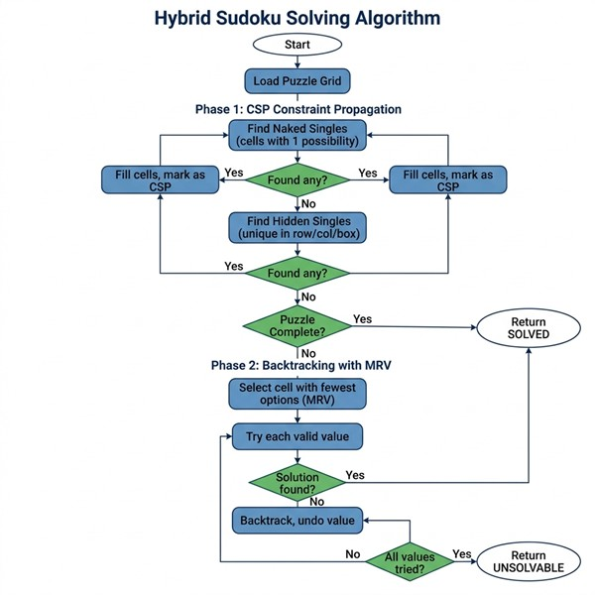
8.4 Algorithm Flowchart
Figure 1: Flowchart of the Hybrid Solving Algorithm

9. System Design / Architecture

9.1 System Architecture Diagram
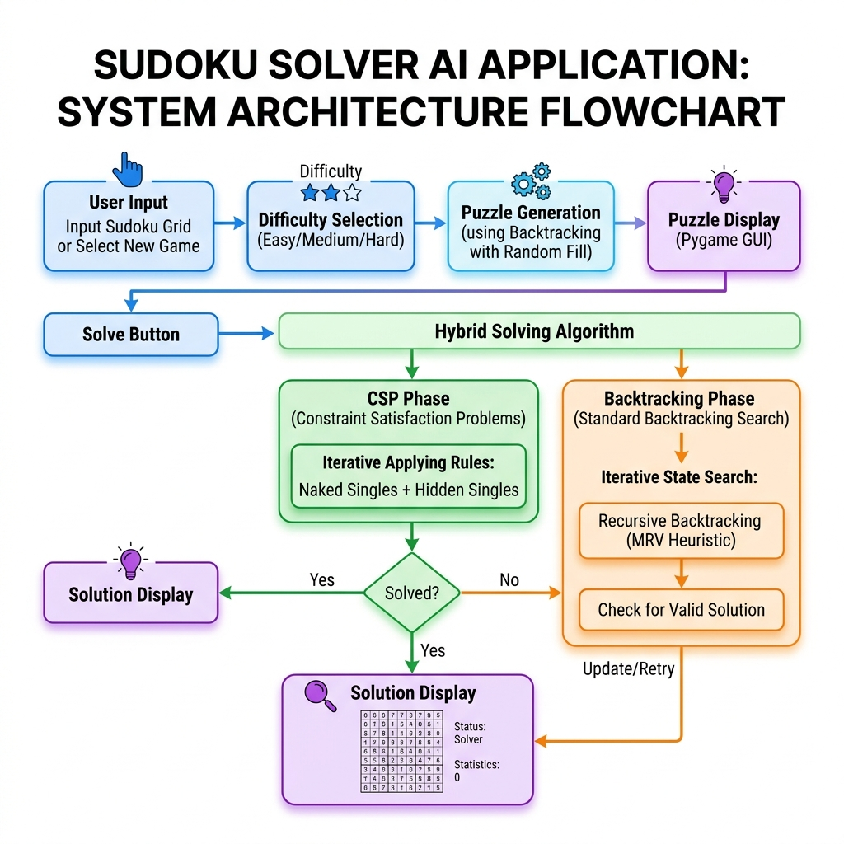
Figure 2: System Architecture of the Sudoku Solver

9.2 Module Description
The system is organized into the following modules:
1. Sudoku Engine (Sudoku class in sudoku_core.py):
• Grid management and validation
• Puzzle generation with unique-solution guarantee
• Hybrid solver (CSP + Backtracking)
• Visual solving with real-time updates
2. GUI Layer (Pygame-based):
• Landing screen with title and navigation
• Difficulty selection screen
• Grid modal with interactive controls
• Settings and Info dialogs
3. Puzzle Generator:
• Random grid filling using backtracking
• Cell removal with uniqueness validation
• Difficulty-based removal thresholds

9.3 Project Structure
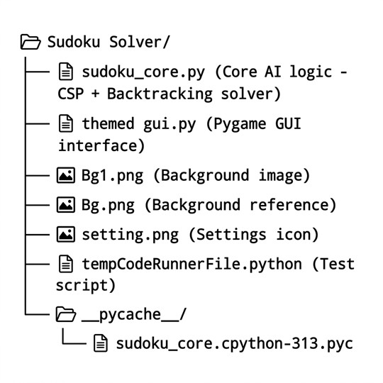
Figure 3: Project Folder Structure

10. Implementation Details

10.1 Core Sudoku Class
The Sudoku class in sudoku_core.py encapsulates all puzzle logic and solving algorithms. The constructor initializes the 9×9 grid, tracking variables for original and solution grids, and separate sets for CSP-solved and backtracking-solved cells:
class Sudoku:
def __init__(self):
self.grid = [[0 for _ in range(9)] for _ in range(9)]
self.original_grid = None
self.solution_grid = None
self.backtrack_cells = set()
self.csp_cells = set()
self.solving_complete = False
self.random_colors = self.generate_random_colors()
The class maintains separate sets for CSP-solved and backtracking-solved cells, enabling the visual distinction between the two solving methods during the animation.

10.2 Constraint Validation (is_valid)
The is_valid method enforces all three Sudoku constraints—row uniqueness, column uniqueness, and 3×3 box uniqueness—in a single function call:
def is_valid(self, num, row, col):
# Check row and column
for i in range(9):
if self.grid[row][i] == num or self.grid[i][col] == num:
return False
# Check 3x3 box
start_row, start_col = 3 * (row // 3), 3 * (col // 3)
for i in range(3):
for j in range(3):
if self.grid[start_row + i][start_col + j] == num:
return False
return True

10.3 CSP — Naked Singles Implementation
Naked Singles are identified by computing the domain (set of possible values) for each empty cell. If a cell's domain contains exactly one value, that value is assigned immediately:
# Inside solve() method — Naked Singles
for row in range(9):
for col in range(9):
if self.grid[row][col] == 0:
possible_values = self.get_possible_values(row, col)
if len(possible_values) == 1:
self.grid[row][col] = possible_values[0]
self.csp_cells.add((row, col))
progress_made = True

10.4 CSP — Hidden Singles Implementation
Hidden Singles check each row, column, and 3×3 box for digits that can only be placed in one specific position within that unit. Unlike Naked Singles (which look at single cells), Hidden Singles look at entire units:
def find_hidden_singles(self, ...):
# Check rows
for row in range(9):
for num in range(1, 10):
possible_cols = []
for col in range(9):
if self.grid[row][col] == 0 and self.is_valid(num, row, col):
possible_cols.append(col)
if len(possible_cols) == 1:
self.grid[row][possible_cols[0]] = num
self.csp_cells.add((row, possible_cols[0]))
# Similar logic applied to columns and 3x3 boxes...

10.5 MRV Heuristic Implementation
The Minimum Remaining Values (MRV) heuristic selects the most constrained empty cell—the one with the fewest possible values—as the next cell to assign during backtracking. This heuristic improves performance by causing failures to be detected earlier in the search:
def get_empty_cell(self):
min_possibilities = 10
best_cell = None
for row in range(9):
for col in range(9):
if self.grid[row][col] == 0:
possibilities = self.count_possibilities(row, col)
if possibilities < min_possibilities and possibilities > 0:
min_possibilities = possibilities
best_cell = (row, col)
return best_cell

10.6 Backtracking Implementation
The backtracking algorithm uses recursion to systematically explore the solution space. It leverages the MRV heuristic for cell selection and maintains the backtrack_cells set for visual tracking:
def solve_backtracking(self, ...):
empty_cell = self.get_empty_cell() # MRV heuristic
if not empty_cell:
return True # Puzzle solved
row, col = empty_cell
for num in self.get_possible_values(row, col):
if self.is_valid(num, row, col):
self.grid[row][col] = num
self.backtrack_cells.add((row, col))
if self.solve_backtracking(...):
return True
self.grid[row][col] = 0 # Backtrack
self.backtrack_cells.discard((row, col))
return False

10.7 Puzzle Generation
Puzzles are generated through a multi-step process with strict uniqueness validation. First, a complete valid grid is created using randomized backtracking (fill_grid()). Then, cells are systematically removed based on difficulty level. To ensure the puzzle always has exactly one valid answer, every single cell removal is tested. If removing a cell creates multiple possible solutions, that cell is restored.
def generate_puzzle(self, difficulty="medium"):
"""Generates a puzzle by removing numbers while ensuring a unique solution."""
max_retries = 5
retry_count = 0
while retry_count < max_retries:
self.grid = [[0 for _ in range(9)] for _ in range(9)]
self.fill_grid()
self.solution_grid = copy.deepcopy(self.grid)
# Determine difficulty
if difficulty == "easy": cells_to_remove = 35
elif difficulty == "medium": cells_to_remove = 45
elif difficulty == "hard": cells_to_remove = 55
attempts = 0
max_attempts = cells_to_remove * 5
removed = 0
while removed < cells_to_remove and attempts < max_attempts:
row, col = random.randint(0, 8), random.randint(0, 8)
if self.grid[row][col] == 0:
attempts += 1
continue
backup = self.grid[row][col]
self.grid[row][col] = 0
# Check that the puzzle still has a unique solution
grid_copy = copy.deepcopy(self.grid)
if self._has_unique_solution(grid_copy):
removed += 1 # Removal is safe, keeps unique solution
else:
self.grid[row][col] = backup # Restore — removal creates multiple solutions
attempts += 1

10.8 GUI Implementation
The graphical interface is built using Pygame and consists of multiple screens:
• Landing Screen: Displays the title with a stylized background and navigation buttons.
• Difficulty Selection: Allows the user to choose Easy, Medium, or Hard difficulty.
• Grid Modal: Shows the puzzle grid with Solve, Back, and New Puzzle buttons.
• Settings/Info Dialogs: Semi-transparent modal overlays for app information.
The GUI features hover effects on buttons, semi-transparent modal overlays with rounded corners, and real-time animation during the solving process with 50ms refresh intervals.

11. Results

11.1 Landing Screen
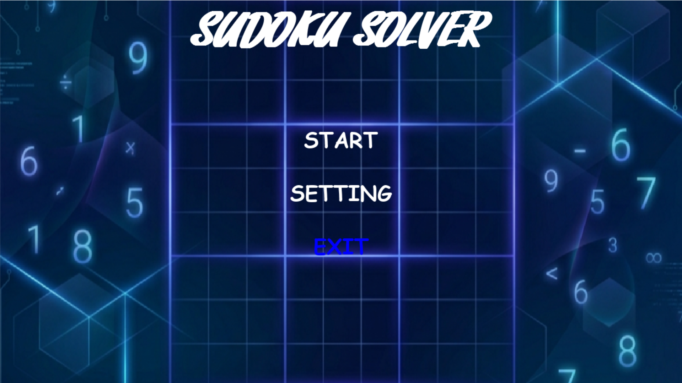
Figure 4: Main Landing Screen of the Sudoku Solver

11.2 Difficulty Selection
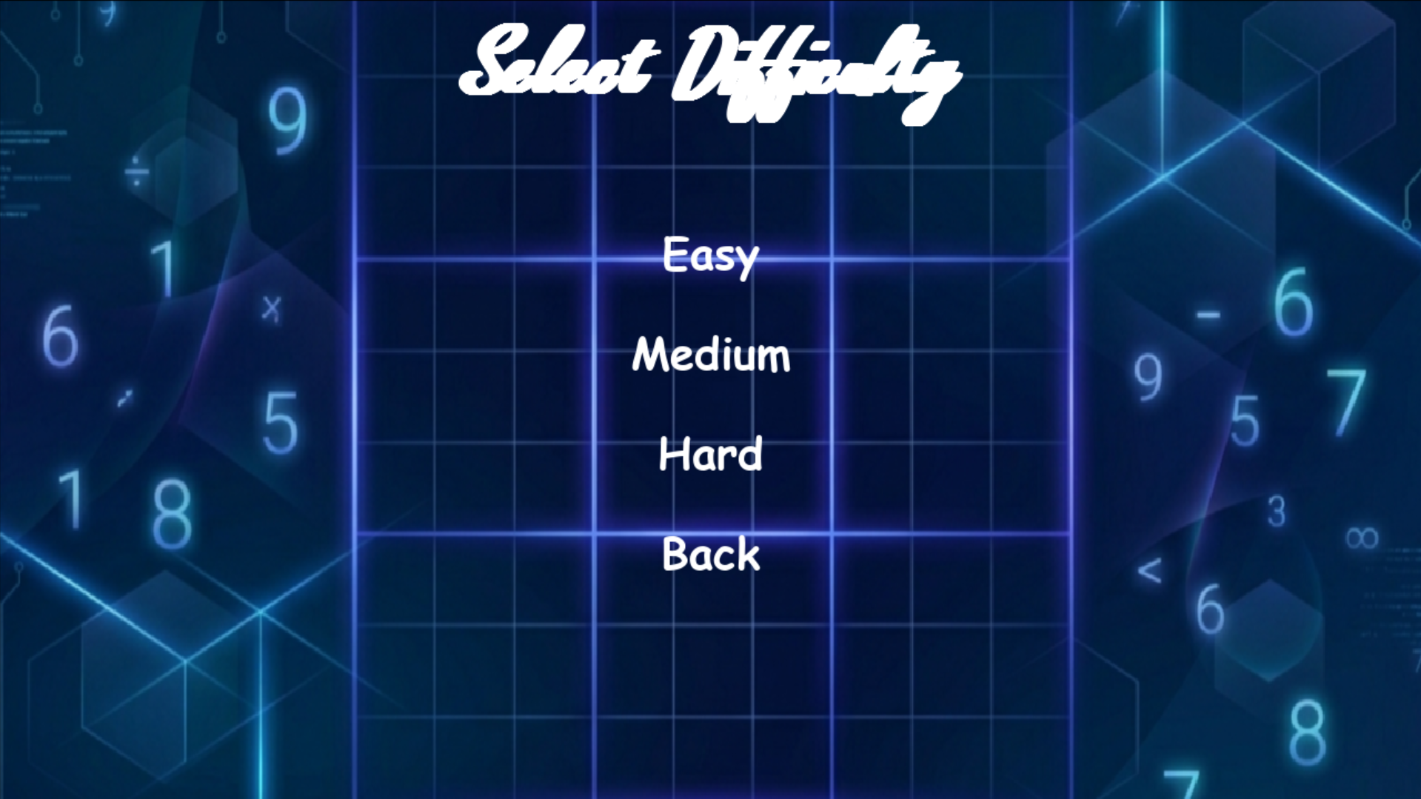
Figure 5: Difficulty Selection Screen

11.3 Puzzle Solving Visualization
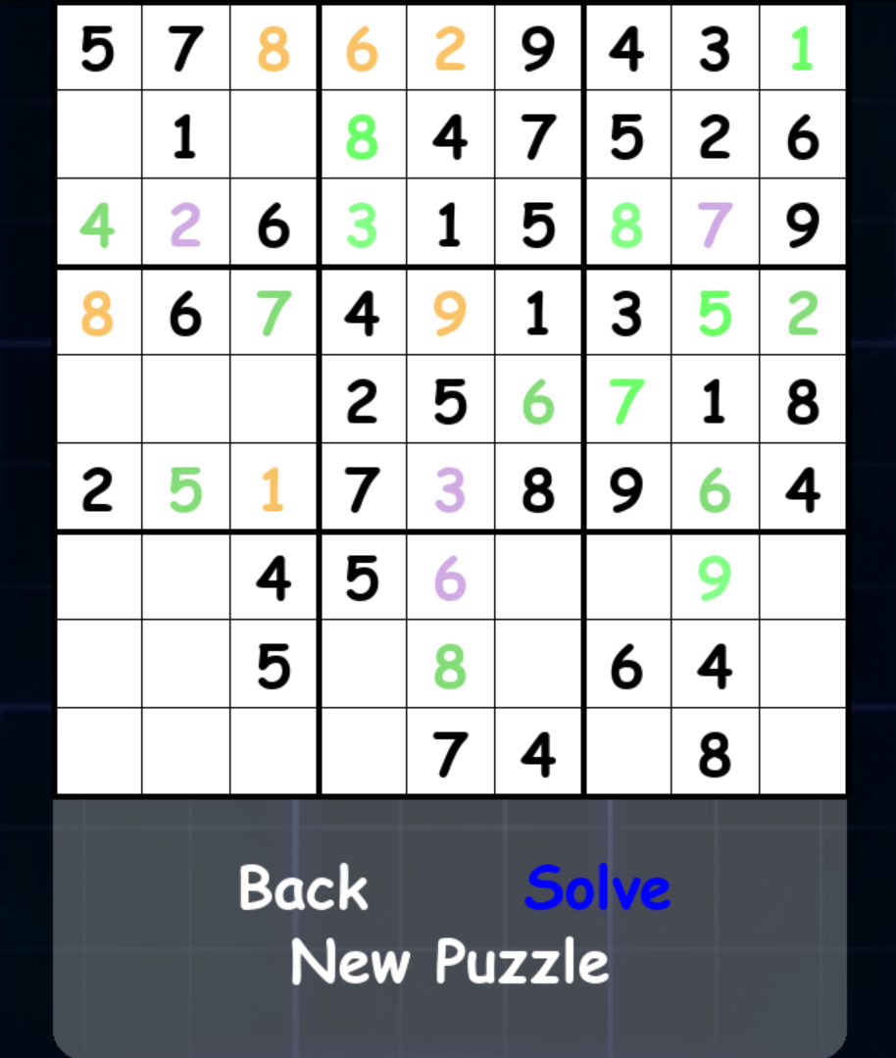
Figure 6: Real-time Solving Visualization with Color-Coded Cells

11.4 Background Design

Figure 7: Custom Background Image with Floating Numbers Theme

11.5 Performance Analysis
Difficulty | Cells Removed | CSP Cells Solved | Backtrack Cells Solved
Easy | 35 | ~30-35 (86-100%) | ~0-5 (0-14%)
Medium | 45 | ~25-35 (56-78%) | ~10-20 (22-44%)
Hard | 55 | ~15-25 (27-45%) | ~30-40 (55-73%)

Key Observations:
• Easy puzzles are almost entirely solved by CSP constraint propagation alone.
• Medium puzzles require a balanced mix of both techniques.
• Hard puzzles rely more heavily on backtracking, but CSP still reduces the search space significantly.
• The MRV heuristic ensures backtracking is efficient even for hard puzzles.

12. Discussion

12.1 What Worked Well
• The hybrid approach (CSP + Backtracking) works well for all difficulty levels.
• The visual animation makes it easy to see how the solver fills in cells.
• Color coding helps distinguish between logic-based and trial-based solutions.
• Puzzle generation always creates puzzles with exactly one answer.
• MRV heuristic makes backtracking much faster by choosing the best cell first.

12.2 Limitations
• Users cannot type in their own puzzles.
• No undo/redo buttons.
• No timer or score tracking.
• More advanced CSP techniques (like AC-3) are not included.
• Puzzles cannot be saved or loaded.

13. Conclusion
This project successfully demonstrates the application of Artificial Intelligence techniques to solve Sudoku puzzles through a hybrid approach combining Constraint Satisfaction Problem (CSP) methods with optimized Backtracking search. The implementation effectively applies core AI concepts from the CSC262 curriculum, including search algorithms, constraint propagation, and heuristic optimization.
The hybrid solver proves effective across all difficulty levels: CSP constraint propagation handles the majority of cells in easy puzzles, while backtracking with the MRV heuristic efficiently resolves harder cases. The interactive Pygame GUI with real-time visual feedback provides an educational and engaging experience, clearly demonstrating how AI algorithms work in practice.
The project validates that combining multiple AI techniques—rather than relying on a single approach—yields superior results in terms of both efficiency and completeness. This mirrors real-world AI applications where hybrid systems often outperform individual algorithms.
Overall, the Sudoku Solver serves as a comprehensive practical demonstration of fundamental AI concepts, reinforcing theoretical knowledge gained through CSC262 lectures and lab sessions with hands-on implementation experience.

14. References
- Russell, S., & Norvig, P. (2020). Artificial Intelligence: A Modern Approach (4th ed.). Pearson.
- CSC262 Course Material. (2026). Introduction to Artificial Intelligence – Lecture Slides (1–10). Department of Computer Science, COMSATS University.
- CSC262 Lab Manual. (2022). Artificial Intelligence Lab Manual (Labs 1–10). Department of Computer Science.
- Pygame Community. (2024). Pygame Documentation. https://www.pygame.org/docs/
- Simonis, H. (2005). Sudoku as a Constraint Satisfaction Problem. CP Workshop on Modeling and Reformulating Constraint Satisfaction Problems.
- Norvig, P. (2006). Solving Every Sudoku Puzzle. https://norvig.com/sudoku.html
- Python Software Foundation. (2024). Python Documentation. https://docs.python.org/3/

