UNIVERSITY OF HARIPUR
Department of Information Technology

LAB 2: LINUX COMMANDS AND FILE MANAGEMENT

Submitted By: Sidra Ishtiaq
Roll Number: F24-1176
SECTION : C
Program: BS Software Engineering
Semester: 5th
Submitted To: Sir Ihtisham Asif

STEP 1: Create a Directory
Command 1: Create Roll Number Directory
mkdir F24-1176
Explanation: The mkdir command creates a new directory named F24-1176. This directory is used to store the student's files.
Command 2: Enter the Directory
cd F24-1176
Explanation: The cd command changes the current working directory to F24-1176.
Command 3: Verify Directory Location
pwd
Explanation: The pwd command displays the full path of the current working directory.
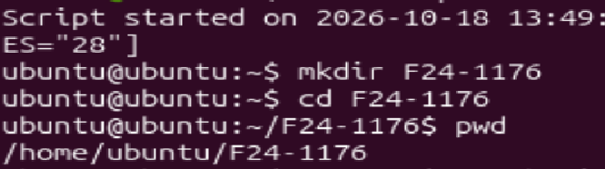
STEP 2: Create a Text File
Command 4: Create File
touch Sidra.txt
Explanation: The touch command creates an empty file named Sidra.txt if it does not already exist.
Command 5: Verify File Creation
ls
Explanation: The ls command lists files and directories in the current directory.
Expected output: Sidra.txt
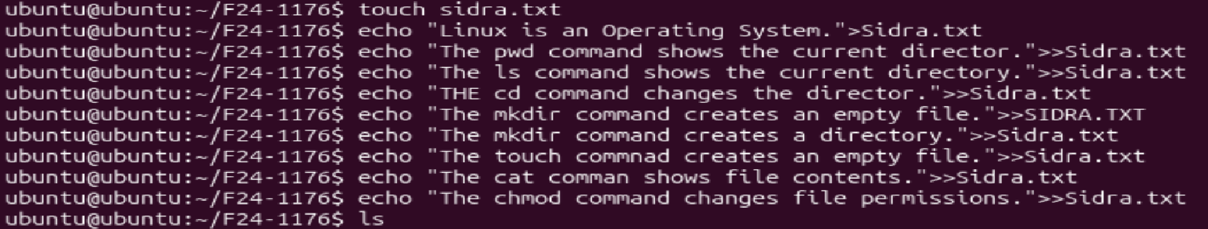
STEP 3: Write Text into the File Using echo
Command 6: Write the First Line
echo "Linux is an operating system." > Sidra.txt
Explanation: The echo command outputs text. The > operator redirects it into Sidra.txt, replacing existing content.
Command 7: Append the Second Line
echo "The pwd command shows the current directory." >> Sidra.txt
Explanation: The >> operator appends text to the end of the file without deleting existing content.
Command 8: Append the Third Line
echo "The ls command lists files and directories." >> Sidra.txt
Explanation: This command adds another line to Sidra.txt.
Command 9: Append the Fourth Line
echo "The cd command changes the directory." >> Sidra.txt
Explanation: This command appends a description of the cd command.
Command 10: Append the Fifth Line
echo "The mkdir command creates a directory." >> Sidra.txt
Explanation: This command appends a description of the mkdir command.
Command 11: Append the Sixth Line
echo "The touch command creates an empty file." >> Sidra.txt
Explanation: This command appends a description of the touch command.
Command 12: Append the Seventh Line
echo "The cat command displays file contents." >> Sidra.txt
Explanation: This command appends a description of the cat command.
Command 13: Append the Eighth Line
echo "The chmod command changes file permissions." >> Sidra.txt
Explanation: This command appends a description of the chmod command.
STEP 4: Display the File Contents
Command 14: Display File Content
cat Sidra.txt
Explanation: The cat command displays the complete contents of Sidra.txt in the terminal.
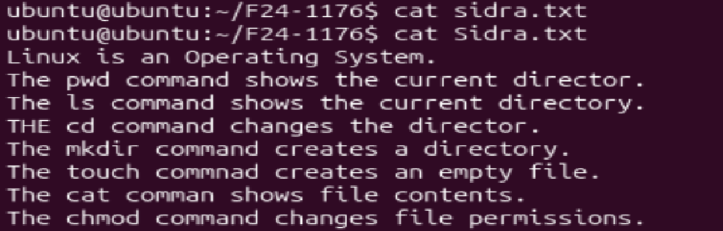

STEP 5: Check File Permissions
Command 15: Display File Details
ls -l Sidra.txt
Explanation: The ls -l command displays detailed information about the file, including permissions, owner, size, and modification time.
STEP 6: Save File Permissions in info.txt
Command 16: Save File Details
ls -l Sidra.txt > info.txt
Explanation: This command saves the detailed information and permissions of Sidra.txt into info.txt.
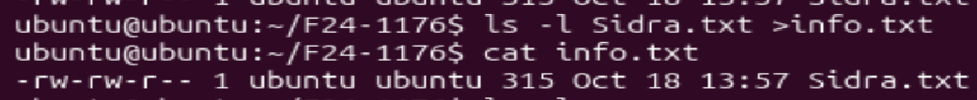
Command 16: Display info.txt
cat info.txt
Explanation: This command displays the information saved in info.txt.
Command 17: Verify Both Files
ls -l
Explanation: This command lists the files in the current directory. The output should include Sidra.txt and info.txt.
[