**Lab # 10**

**Objective: To implemet preserving user state in distributed applications.**

**Task :Create a simple login logout and profile page and use cookie to preserve user state but use MVC architecture.**

**Index.html:**

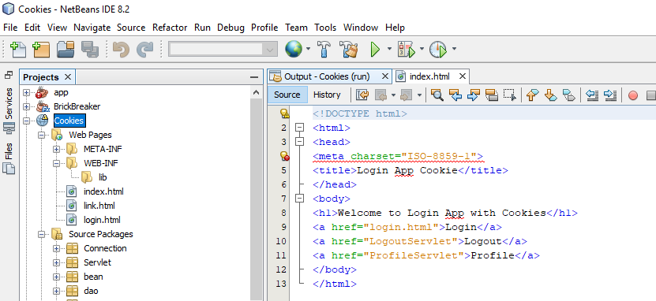

**Link.html**

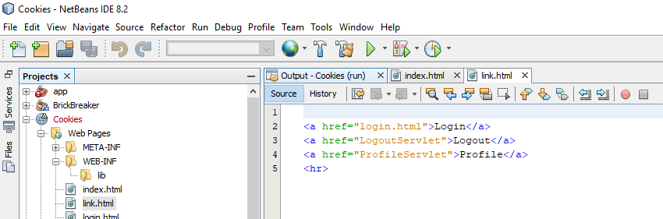

**Login.html**

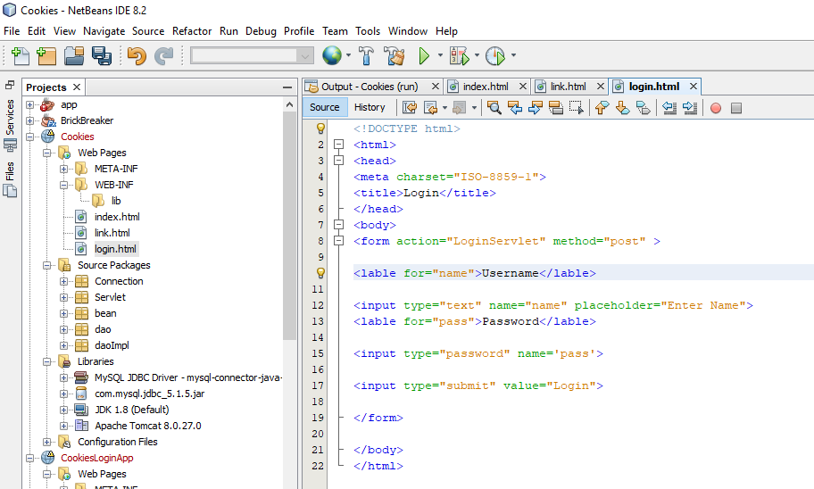

**Package:Connection**

**DBConnection.java**

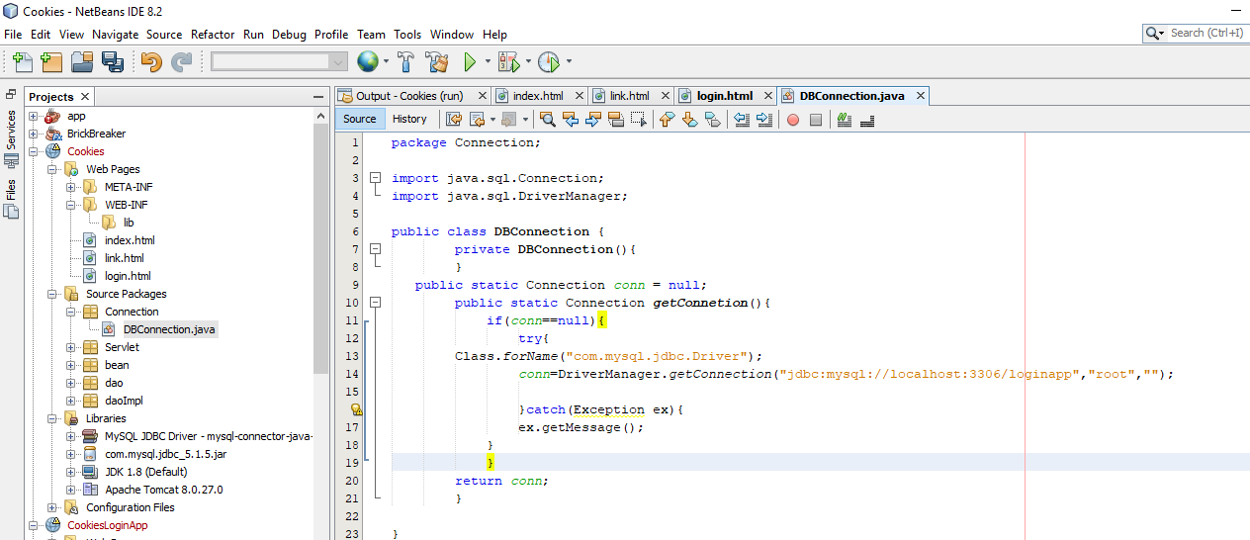

**Package:Servlet**

**LoginServlet.java**

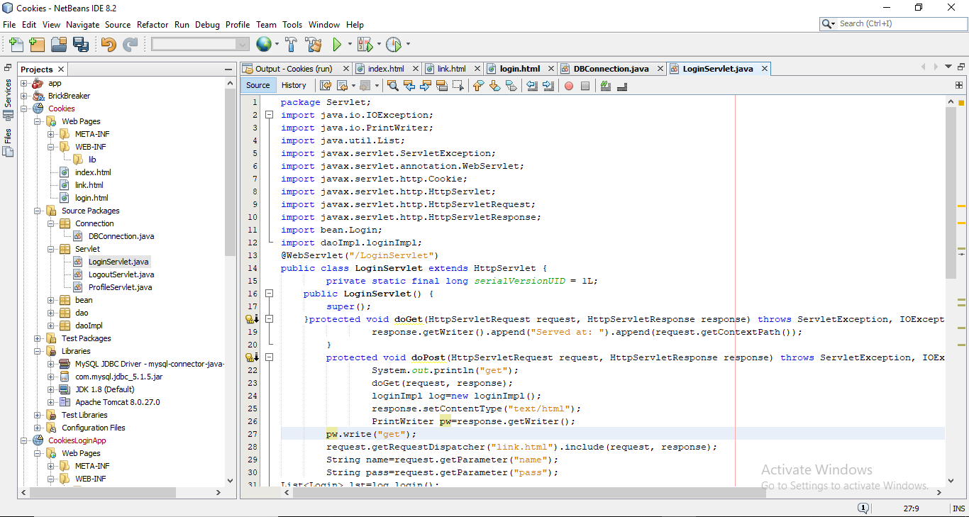

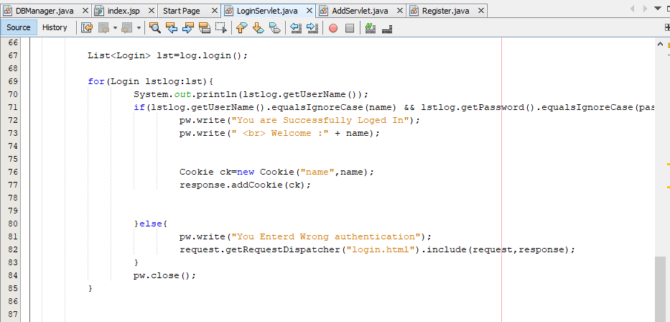

**Package:Servlet**

**LogoutServlet.java**

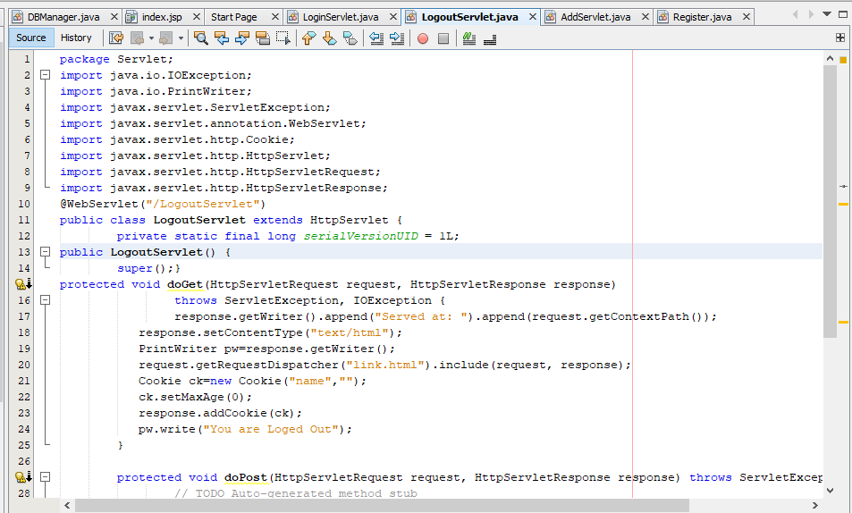

**Package:Servlet**

**ProfileServlet.java**

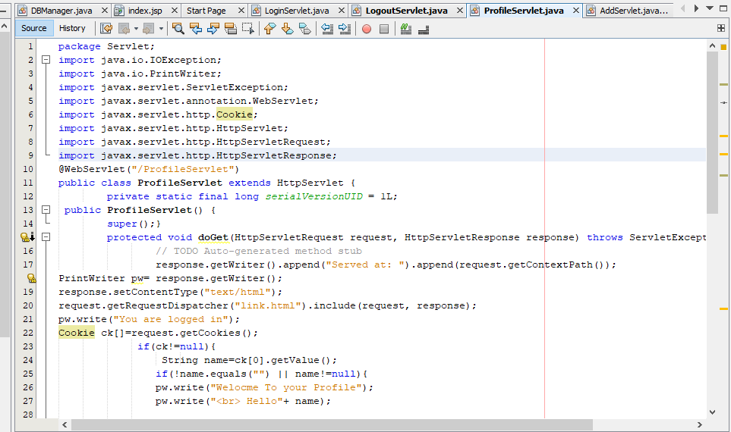

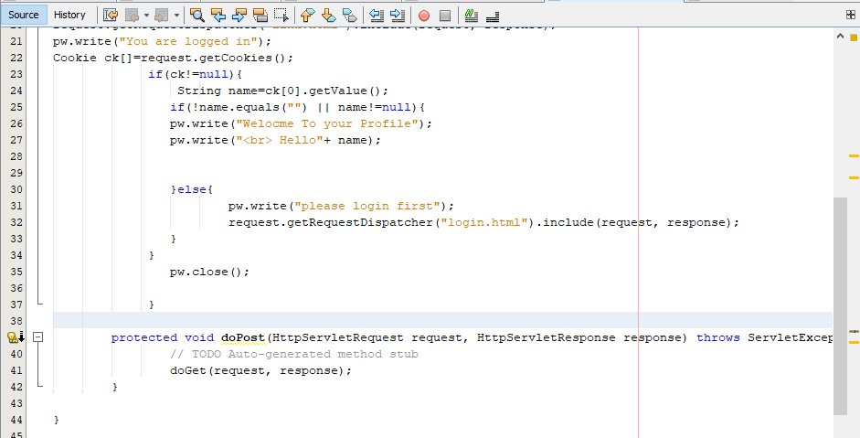

**Package:Bean**

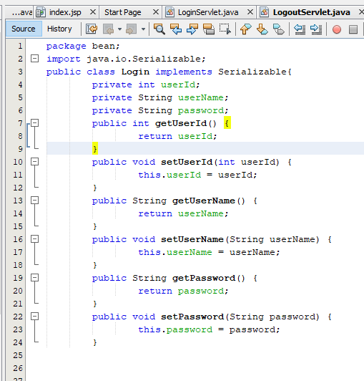

**Package:dao**

**Login.java**

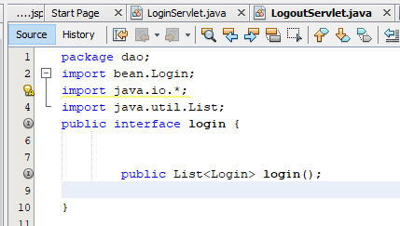

**Package:daoImpl**

**LoginImpl.java**

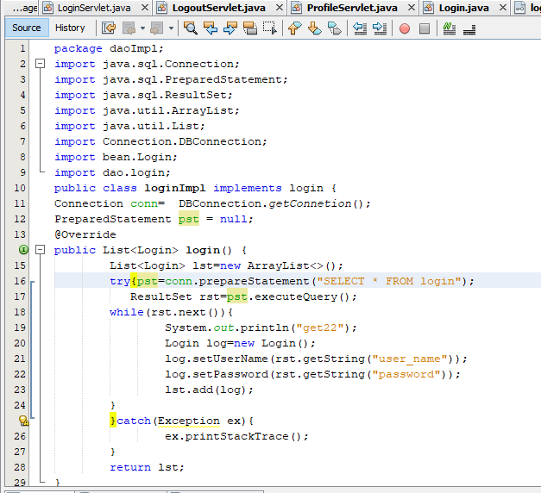

**OUTPUT:**

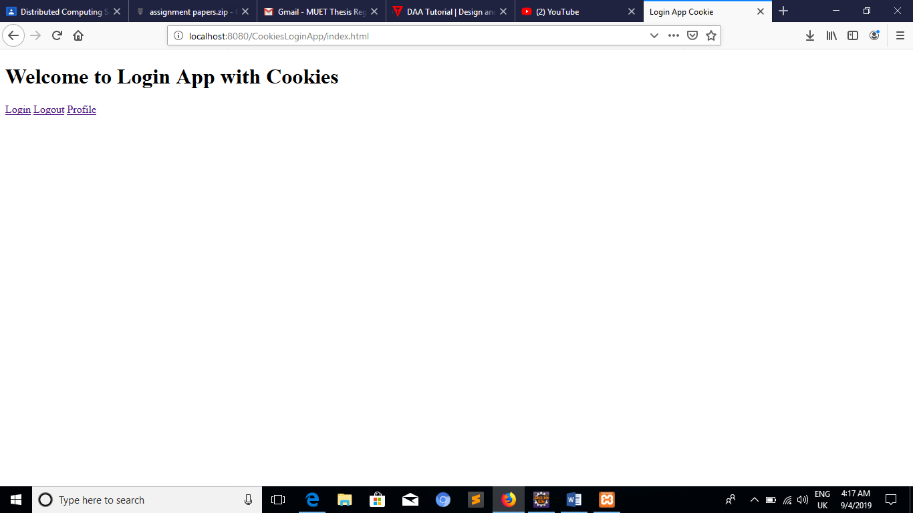

**Login Profile page**

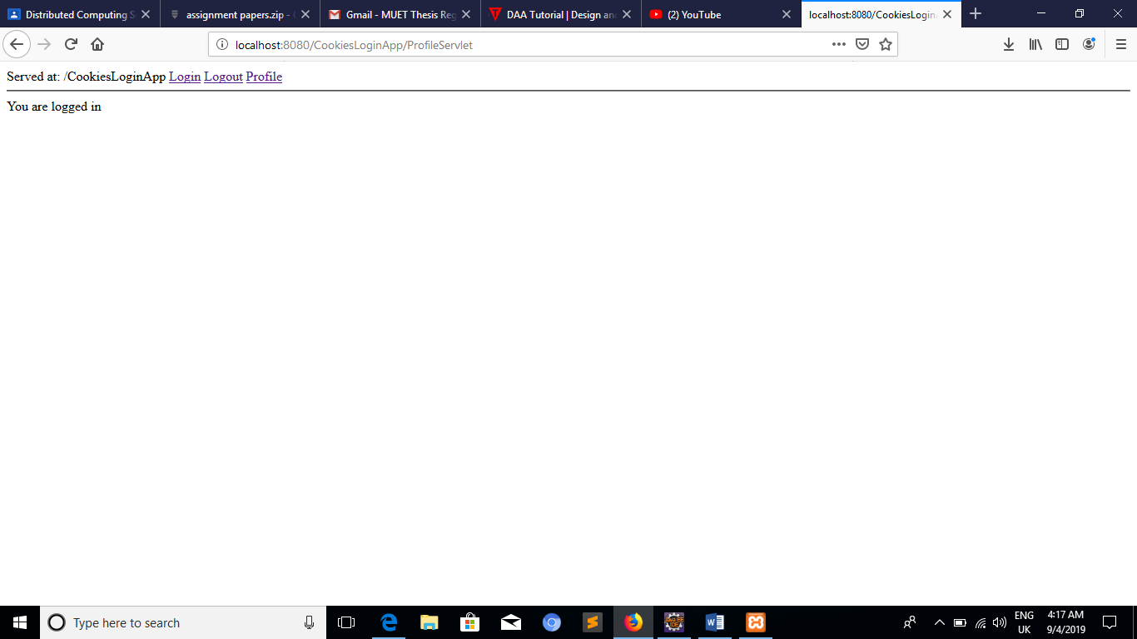

**Logout page**

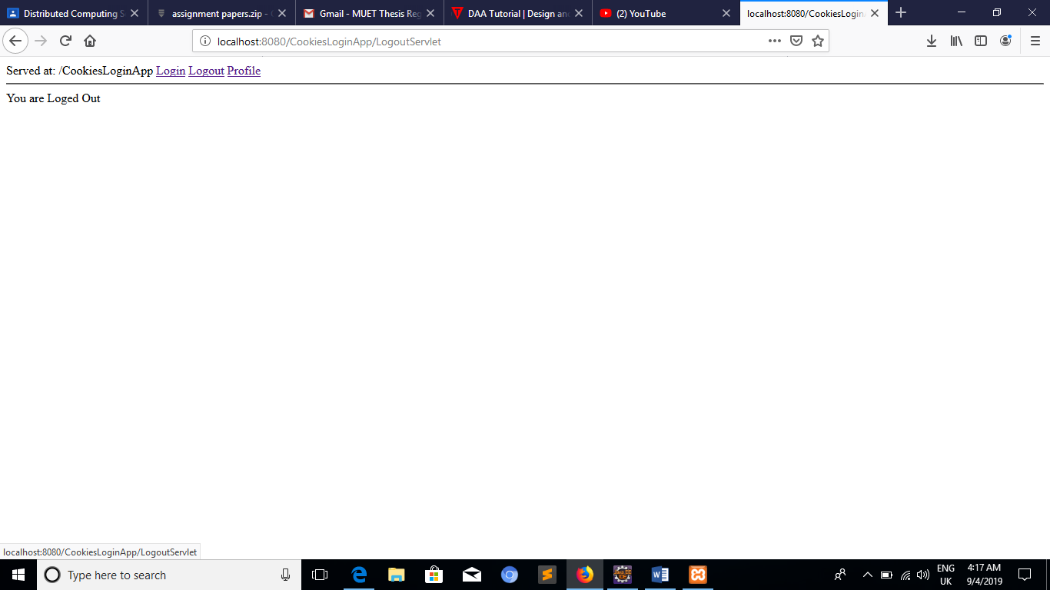

**Table that check the username and password**

