**LAB # 04**

**OBJECTIVE: RMI CallBack.**

**Task 01 :Develop the RMI Callback application of Payroll and PayrollMessage services for calculating the earnings.**

PayRoll.java(Server Interface):

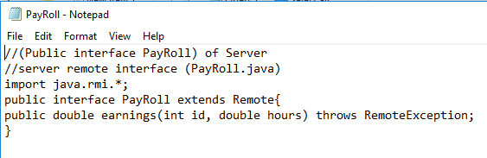

PayRollImpl.java(Server Remote Object):

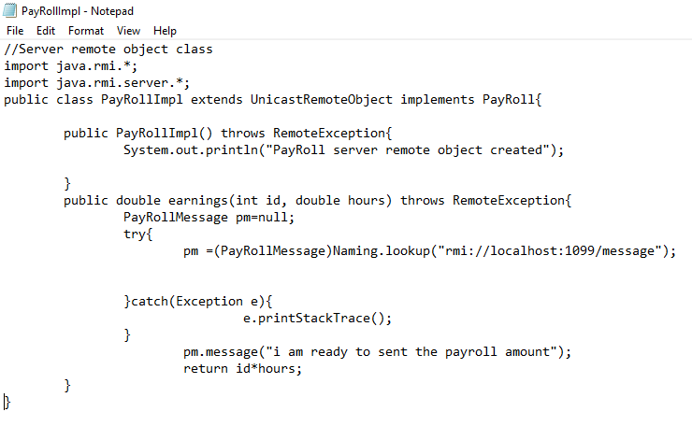

ServerMainClass.java

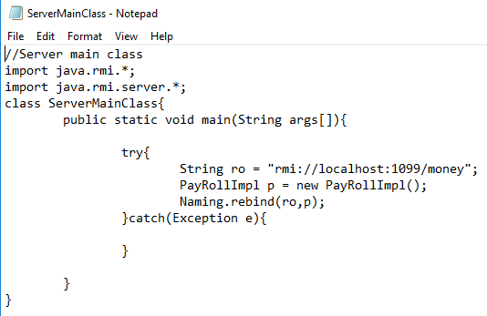

PayRollMessage.java(Client Interface):

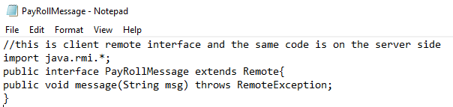

PayRollMessageImpl.java(Client Remote Object Class):

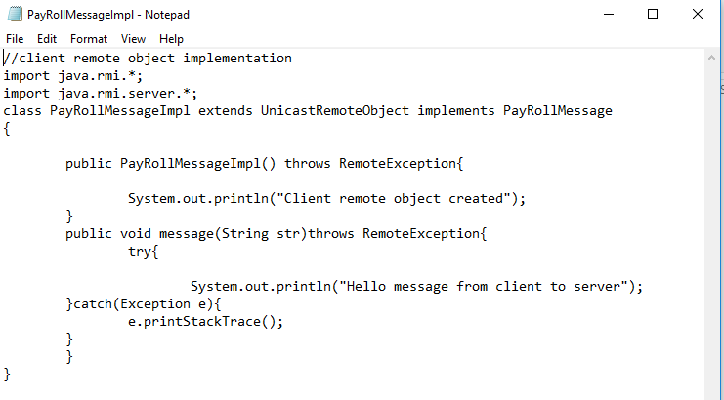

ClientMainClass.java

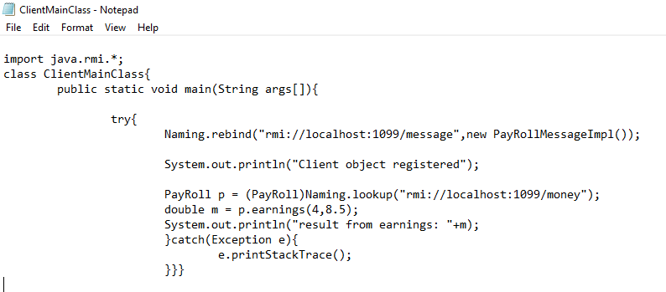

Generating Proxy:

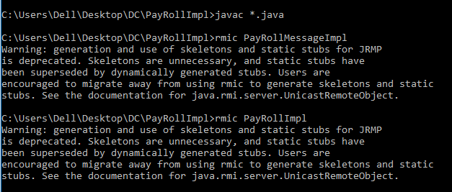

ServerMainClass:



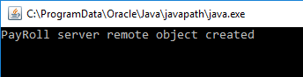

RMI REGISTRY:



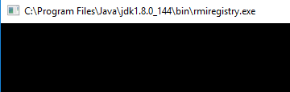

ClientMainClass:

