**Lab # 05**

**OBJECTIVE: RMI OBJECT SERIALIZATION**

**Api.java**

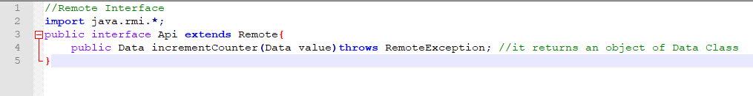

**ApiImpl.java**

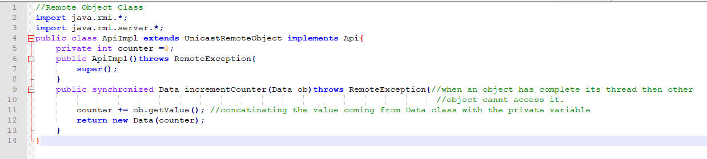

**Data.java:**

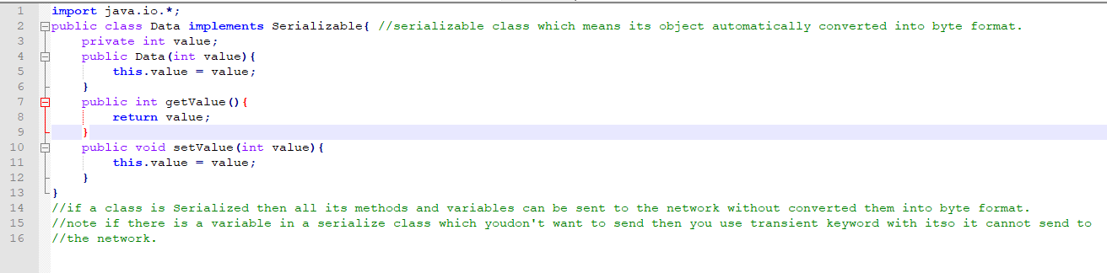

**ServerApi.java:**

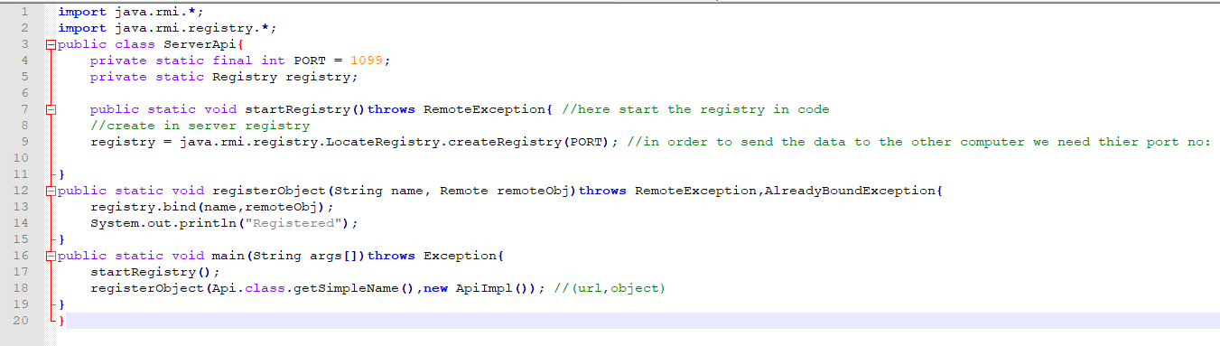

**ClientApi.java**

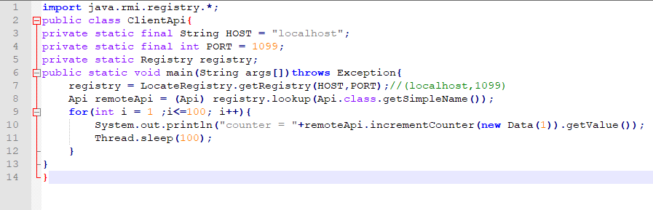

**COMPILE ALL CLASSES:**

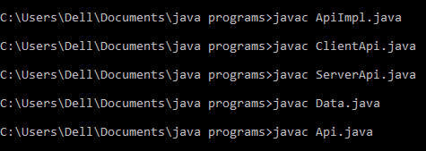

**GENERATE PROXY:**

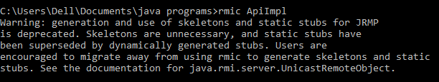

**SERVER OUTPUT:**



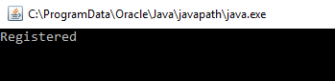

**CLIENT OUTPUT:**

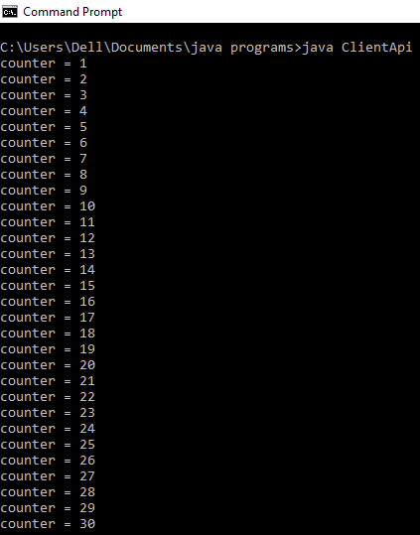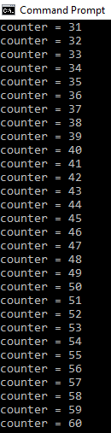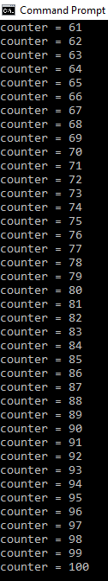

**Task 02: Built the code of your choice that implements the serialization logic.**

**This Program will print the Table of 2 upto 10.**

**Api.java (Remote Interface)**

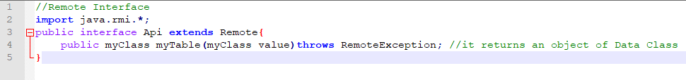

**ApiImpl.java (Remote Object Class)**

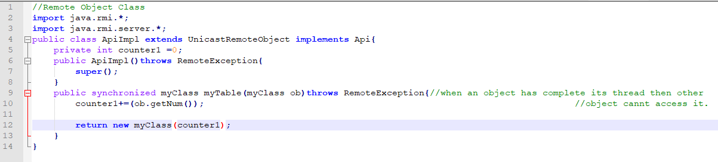

**MyClass.java (Serialized Class)**

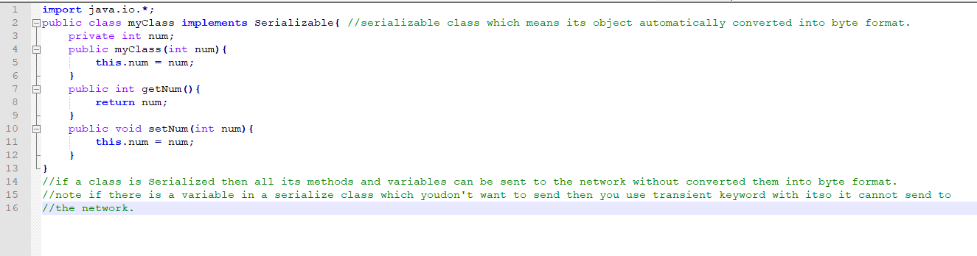

**ClientApi.java**

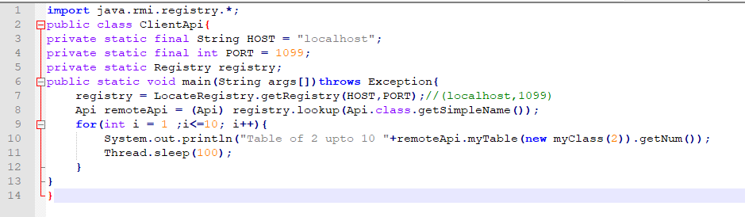

**ServerApi.java**

