**LAB # 06**

**OBJECTIVE: To learn RMI-IIOP**

**Task:**uCreate RMI IIOP application in which take a sentence at runtime on the client application and let the server return its reverse.  
E.g. input could be: subject is distributed computing   
output should be: computing distributed is subject.

**Subject.java**

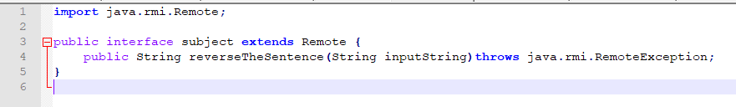

**SubjectImpl.java**

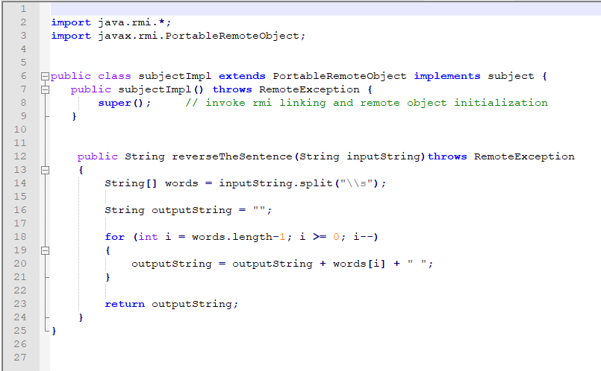

**SubjectServer.java**

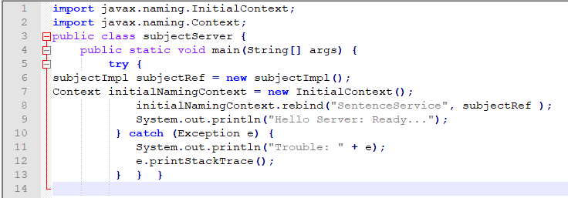

**SubjectClient.java**

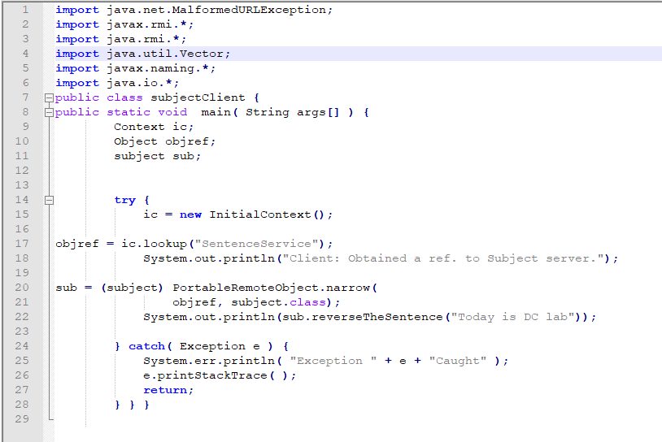

**OUTPUT:**

Compile all classes:



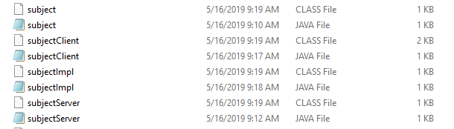

Create Stub and Tie:



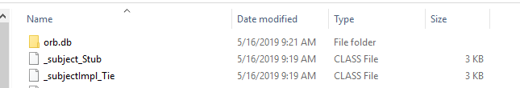

Start Naming Service:



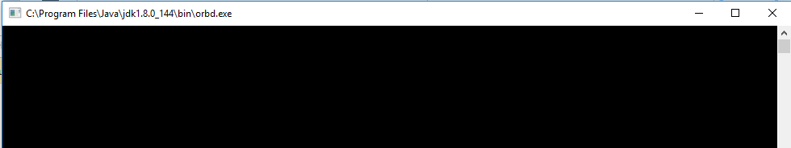

Start Server:



Start Client:

