**LAB # 08**

**OBJECTIVE: To learn XML schema and parsing an XML document.**

**Task # 01: Create an XML document structuring information for a store. (shopping store of your choice)**

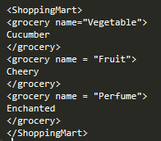

**Task # 02: Create DTD for store XML Document. And validate on** [**http://www.w3schools.com/xml/xml_validator.asp**](http://www.w3schools.com/xml/xml_validator.asp)

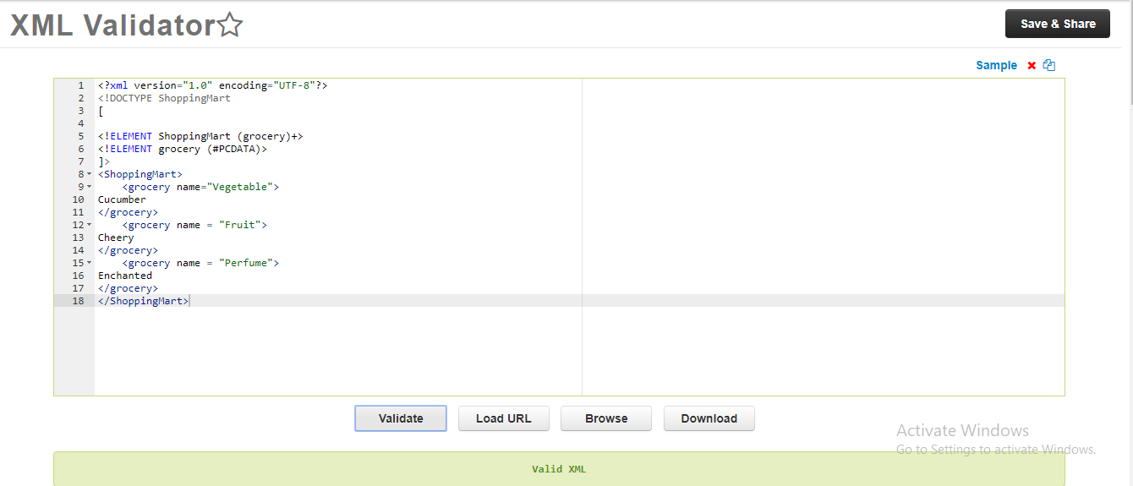

**Task #03: Write XML Schema for the following XML document and then validate the XML document along with its schema on the following website:**

<?xml version=“1.0” ?>

<movies>  
 <movie genre=“crime">  
 <title lang="en">The Godfather</title>  
 <year>1972</year>  
 <rating>9.2</rating>  
 </movie>  
 <movie genre=“horror">  
 <title lang="en">The conjuring</title>  
 <year>2013</year>  
 <rating>7.5</rating>  
 </movie>  
 <movie genre=“adventure">  
 <title lang="en">Everest</title>  
 <year>2015</year>  
 <rating>7.4</rating>  
 </movie>  
 </movies>

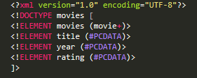

* DTD of above XML.

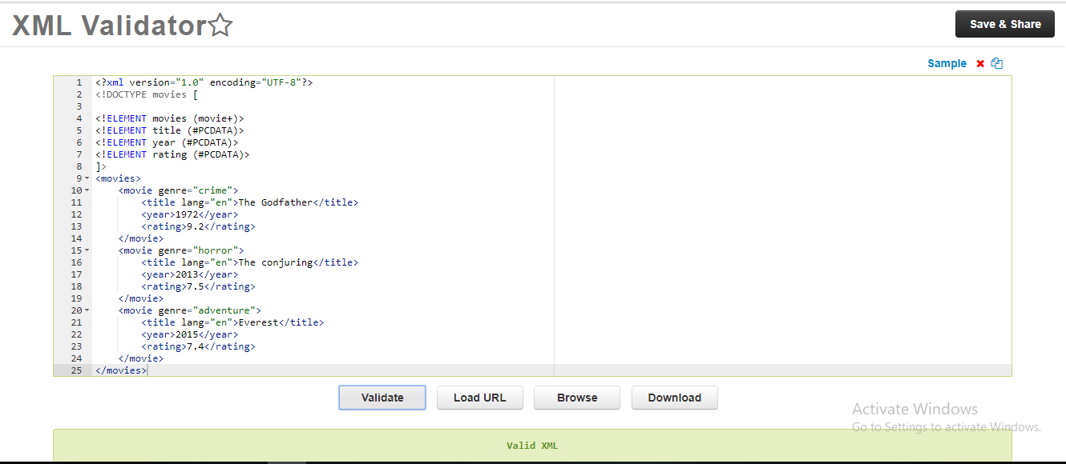

* XML ALONG WITH DTD VALIDATION.

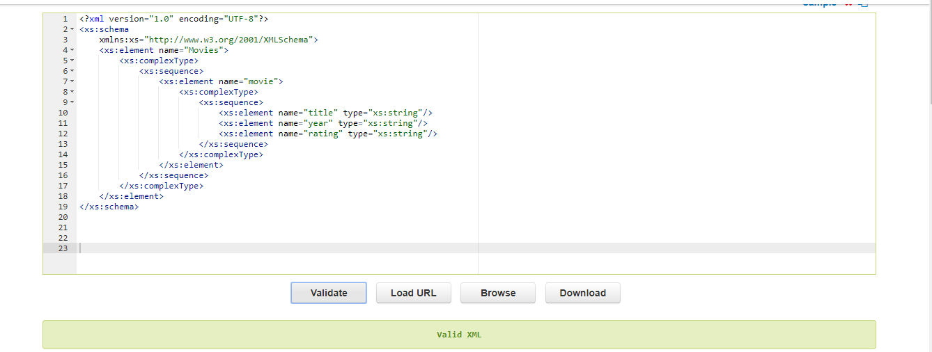

* VALIDATION OF XML SCHEMA.

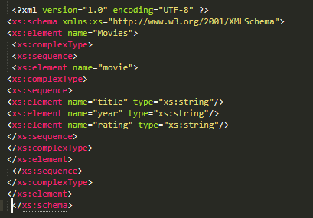 XML Schema of above XML document.

* VALIDATION OF XML

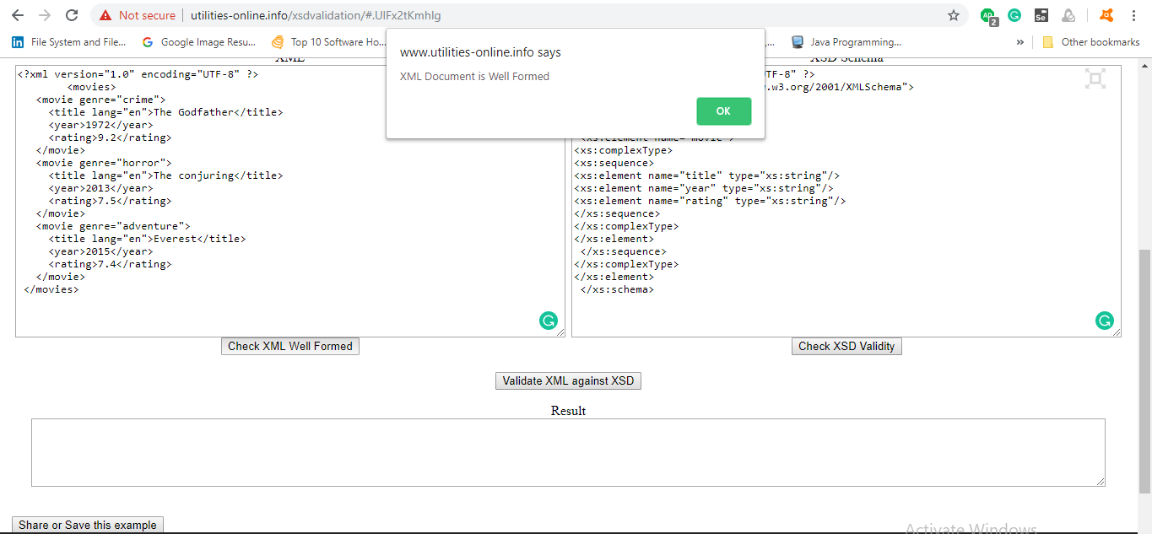

* VALIDATION OF SCHEMA.

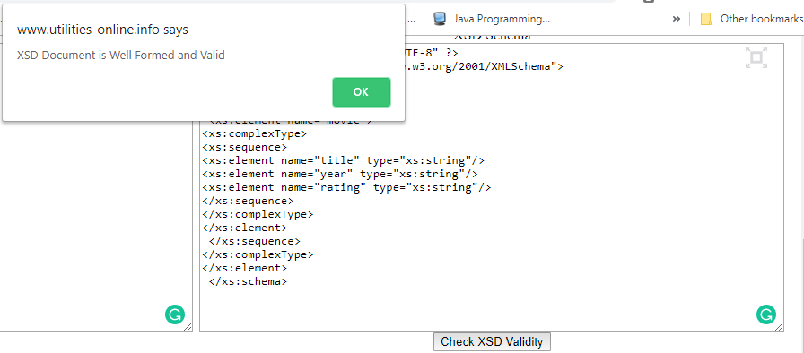

**Task # 04: Write an XML instance for following schema and then parse that document in Java using either DOM or SAX API.**

<?xml version=“1.0” ?>

<xs:schema xmlns:xs=“http://www.w3.org/2001/XMLSchema”>

<xs:element name="person“ type="persontype"/>

<xs:complexType name="persontype">  
 <xs:sequence>  
 <xs:element name="firstname“ type="xs:string"/>  
 <xs:element name="lastname" type="xs:string"/>  
 <xs:element name=“date_of_birth” type=“date”/>

</xs:sequence>  
 </xs:complexType>

<xs:complexType name=“date”>

<xs:sequence>

<xs:element name=“day” type=“xs:integer”/>

<xs:element name=“month” type=“xs:integer”/>

<xs:element name=“year” type=“xs:integer”/>

</xs:sequence>

</xs:complexType>

</xs:schema>

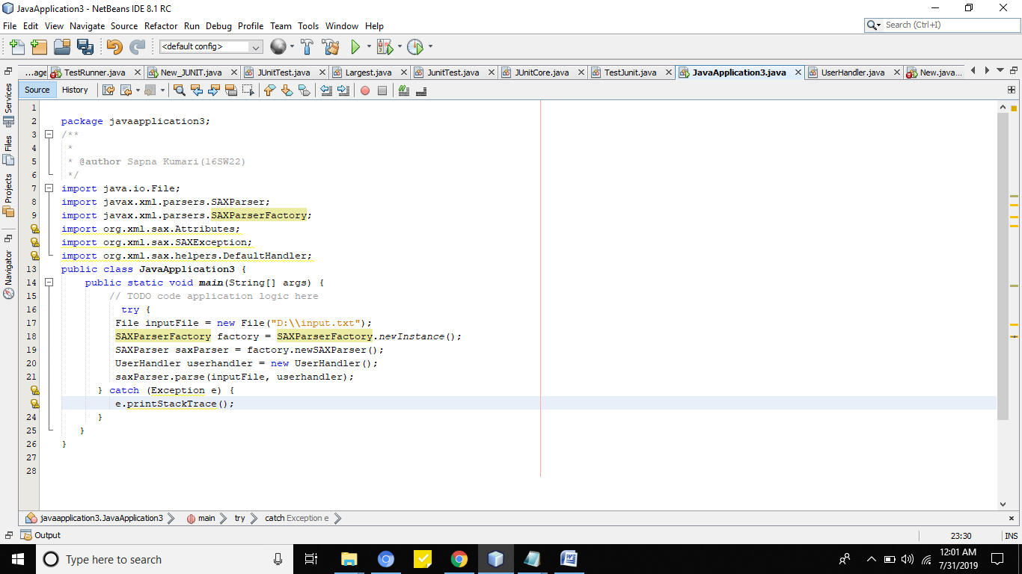

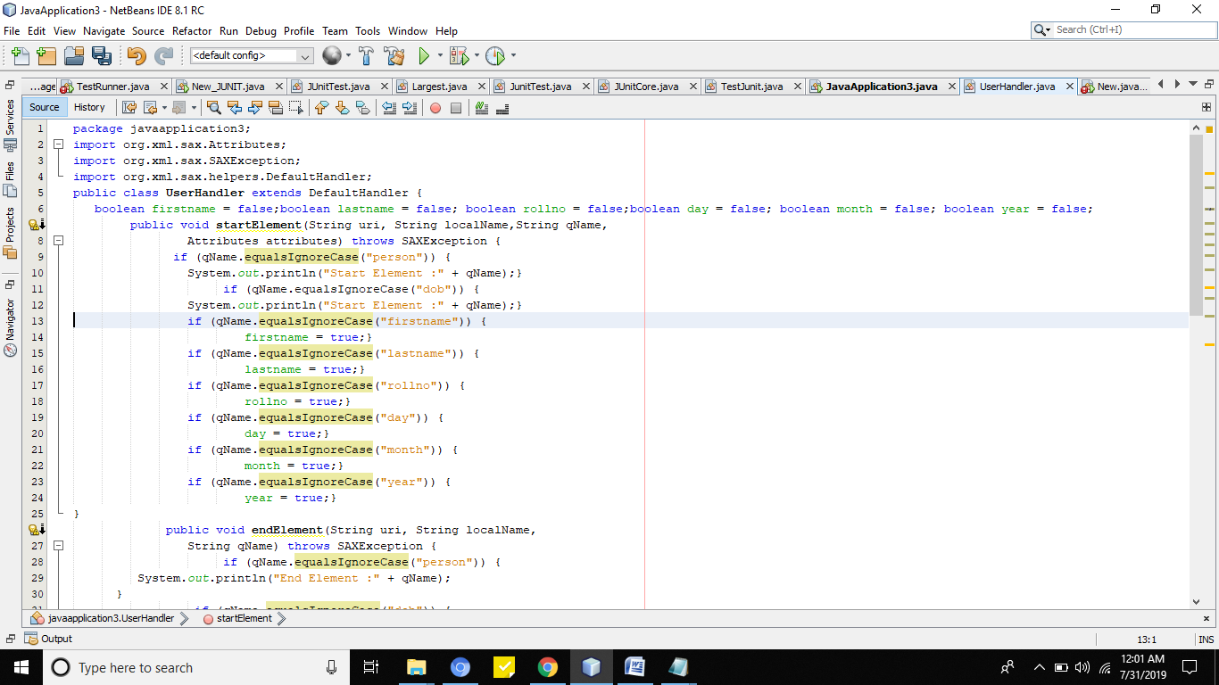

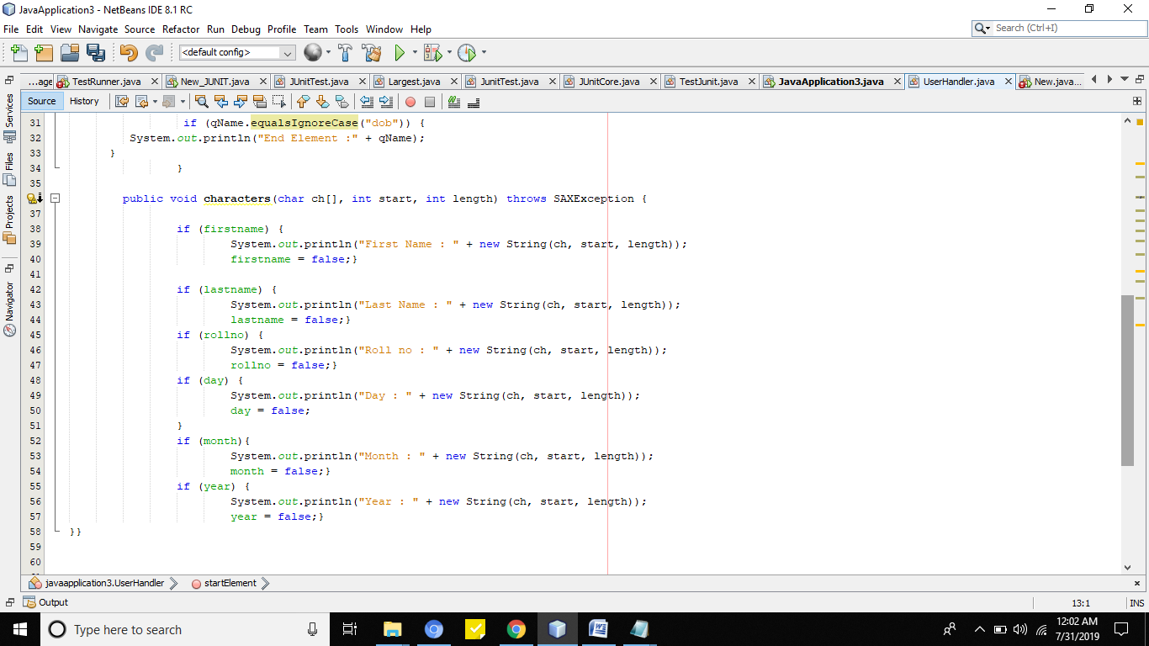

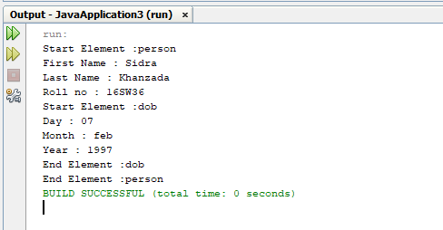

* **Text File**

