**LAB # 04**

**OBJECTIVE: To learn report generation in OLTP systems.**

Generate an OLTP system report which displays the following results:

1. **Total sales in a month** (Use only order table).
2. **Profit/loss in a month** (Use product (to account for purchasing costs), expenditure as well as order tables).
3. **Highest selling product of the month** (By highest sold quantity).
4. **Lowest selling product of the month** (By lowest sold quantity).

**Hint:**

Create a report table to hold all the above results from queries after they are executed in the stored procedure and then create a stored procedure in the similar manner as shown above.

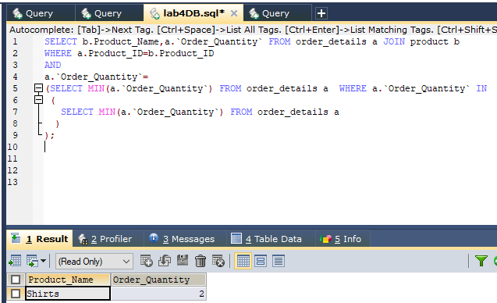

**Lowest selling product of the month** (By lowest sold quantity).

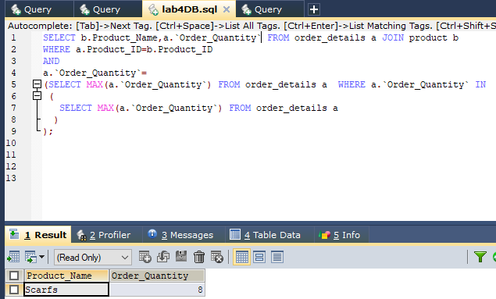

**Highest selling product of the month** (By highest sold quantity).

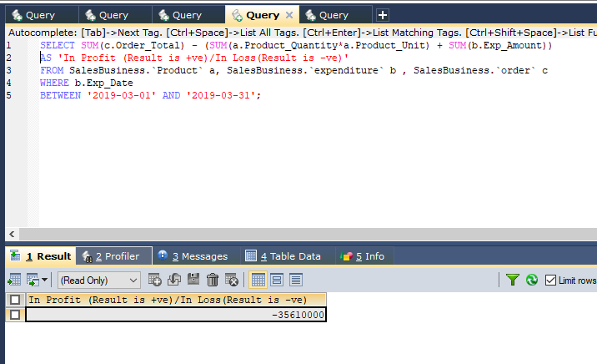

**Profit/loss in a month** (Use product (to account for purchasing costs), expenditure as well as order tables).

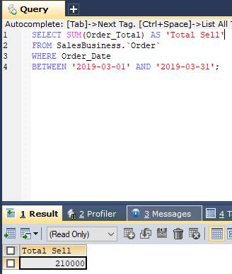

**Total sales in a month** (Use only order table).

* **PROCEDURE CODE:**

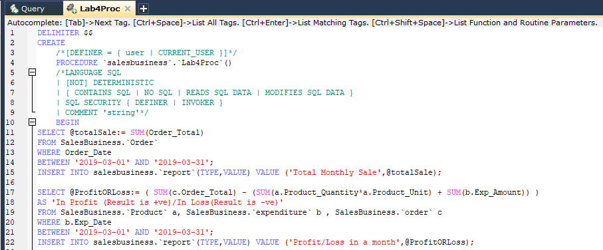

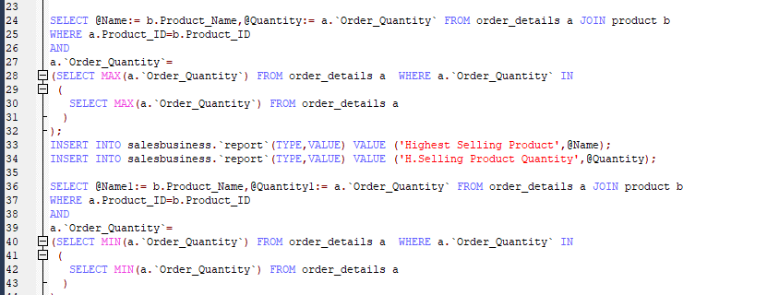

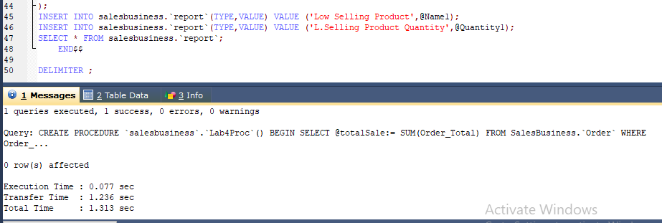

* **GENERATED REPORT RESULT:**

