**LAB # 09**

**OBJECTIVE: To learn ETL process for DWHs using Integration Services.**

**TASK # 01: Lab1 dealt with extracted data from a single flat file source, transformed the data using Lookup transformations, and finally loaded the data into the FactCurrency fact table of the AdventureWorksDW2014 sample database.**

**However, a typical ETL process would extract data from multiple flat file sources and you have to do so. The sample files can be downloaded from the link below:**

<https://padlet.com/rubeeajaff/m0y6wnh2ifk1>   
  
And the steps to be followed are found at the following link:  
  
<https://docs.microsoft.com/en-us/sql/integration-services/lesson-2-adding-looping-with-ssis?view=sql-server-2017>

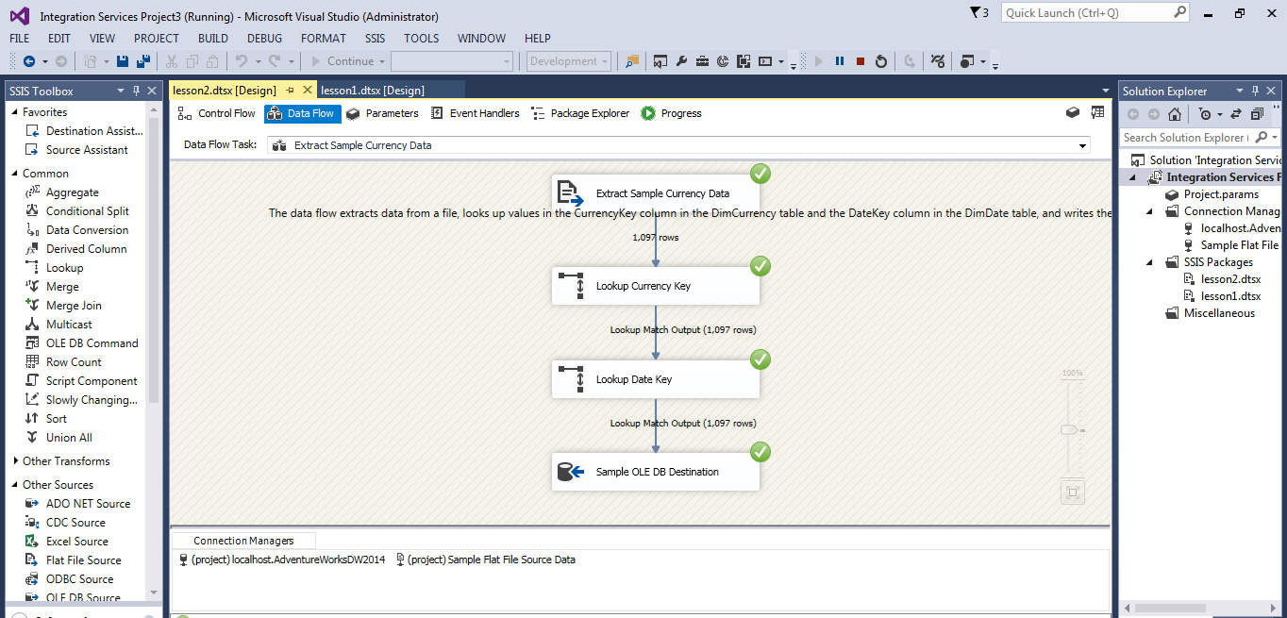

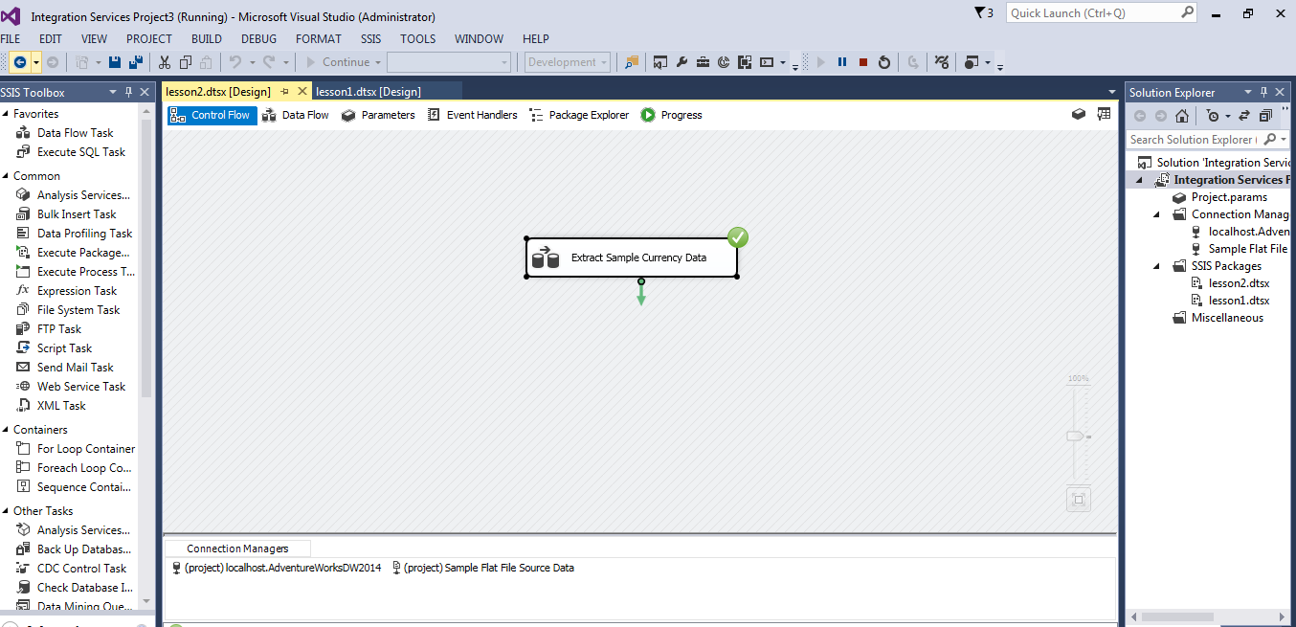

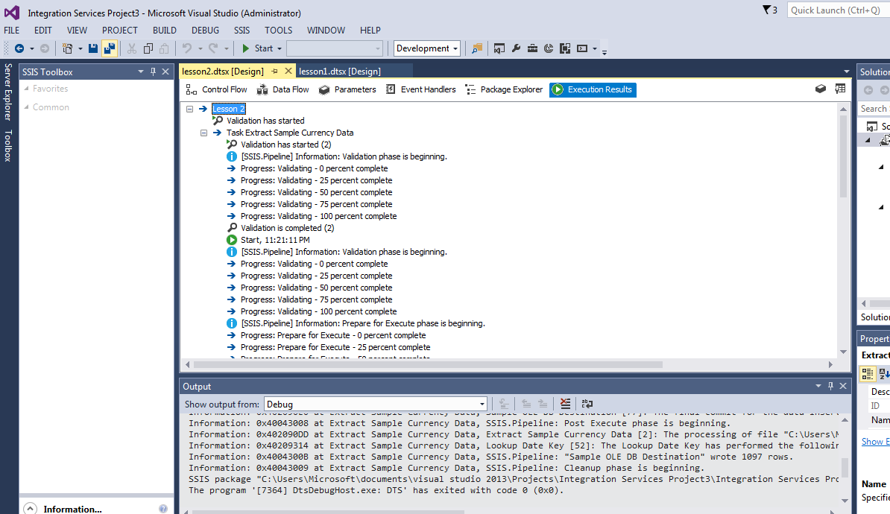

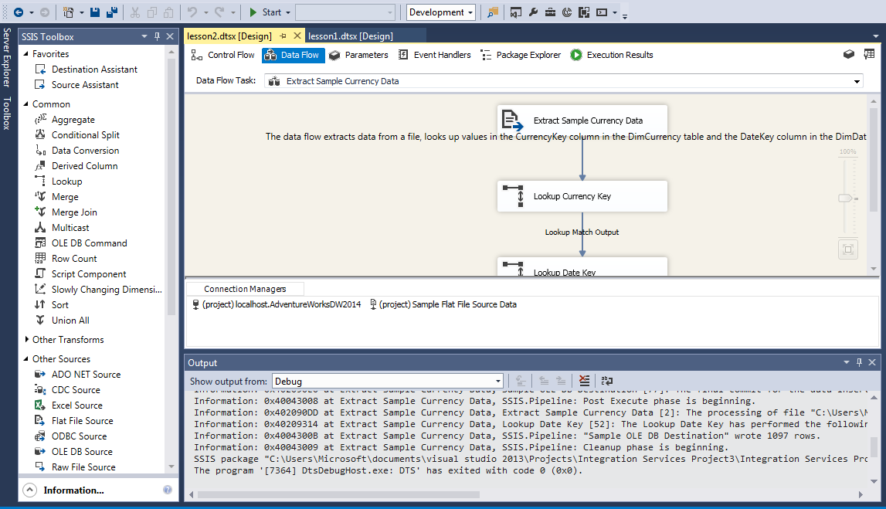

**Class task 02:**

