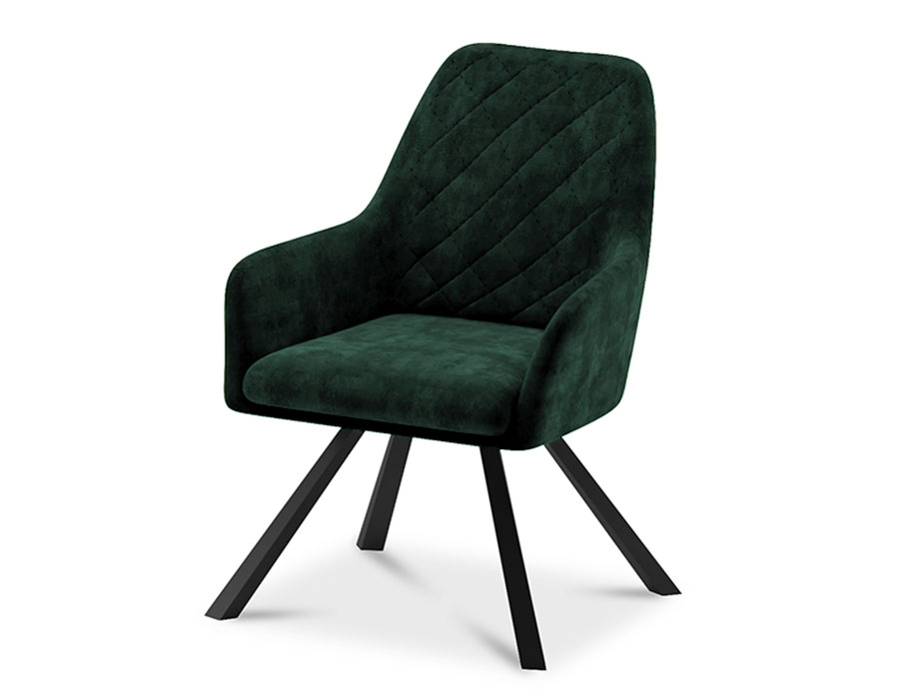

**Comfort**Seat

The Comfort Seat is designed with one thing in mind: providing optimal comfort. This chair is a perfect combination of style and coziness. With its plush cushioning and ergonomic design, it offers a comfortable seating experience. The Comfort Seat features a sleek and modern design that easily complements any interior decor. Whether you need extra seating in the living room or a cozy reading nook in the bedroom, this chair is a versatile addition to your space. Its simple yet stylish appearance, along with its durable construction, ensures long-lasting enjoyment. Sit back, relax, and unwind in the luxurious comfort of the Comfort Seat.

Price: $99.99

Availability: In Stock

Location: Lahore