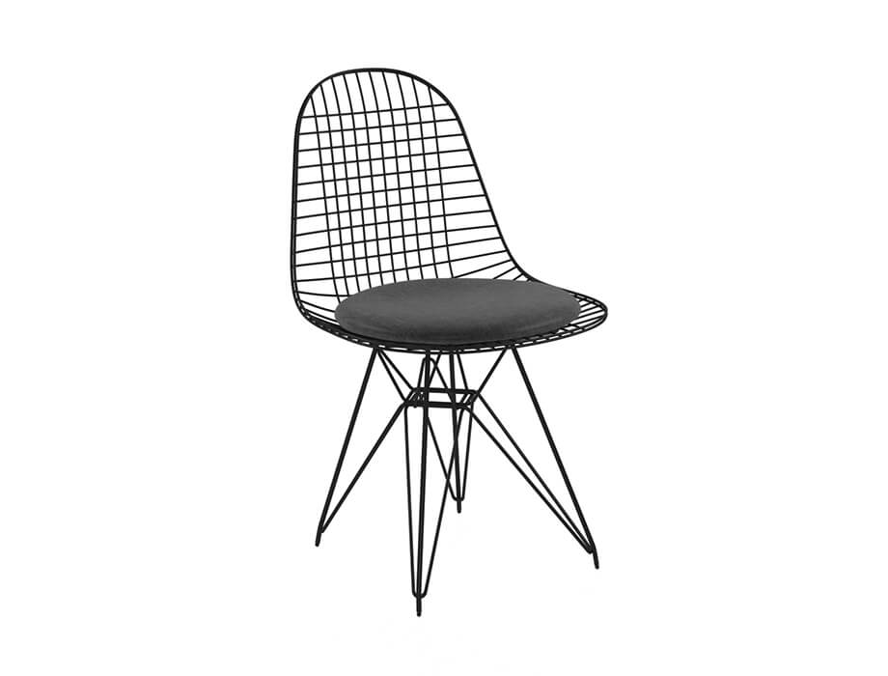

**Modern** Comfort

The Modern Comfort chair offers a contemporary twist on traditional comfort. With its sleek lines and modern design, this chair adds a touch of sophistication to any space. The combination of high-quality materials and expert craftsmanship ensures both durability and style. The Modern Comfort chair features padded armrests and a cushioned seat, providing a cozy and relaxing seating experience. Whether you're entertaining guests or enjoying some quiet time, this chair is the perfect companion. Embrace the modern aesthetic and indulge in the luxurious comfort of the Modern Comfort chair.

Price: $159.99

Availability: In Stock

Location: Karachi